ATIC Accessibility
To support the accessible community in making informed travel decisions for their individual needs

This report prepared for:
Business name: | Lola by Escape The Ordinary Collection
Address: | 538 Little Lonsdale Street Melbourne
Town: | Melbourne
Contact for enquiries: | Patricia Grimsley
Contact Number: | 0421334270
Contact Email: | Patricia.anne.grimsley@gmail.com
Website: | https://escapetheordinarycollection.com/
Date: | 2026-10-19 19:14

ATIC Accessibility
The following pages provides travellers with information on the businesses facilities and amenities which aims to support the traveller to make an informed decision on whether the business is suitable for their individual needs.
OVERVIEW 4
Business Overview 4
Bookings 4
Emergency Management 4
Communications 5
Other Information 5
Guide Dog and Service Animals 5
GENERAL 7
Pre-arrival, arrival and reception 7
Cognitive Impairment Support 7
Car Park and Access amenities 7
Internal Spaces 8
External Paths 8
ACCOMMODATION 10
Bedrooms 10
Room Amenities 10
Bathrooms 11
COMMON AREAS 13
Report Disclaimer 15

OVERVIEW

Business Overview

The business has the following products/services available
- Accommodation
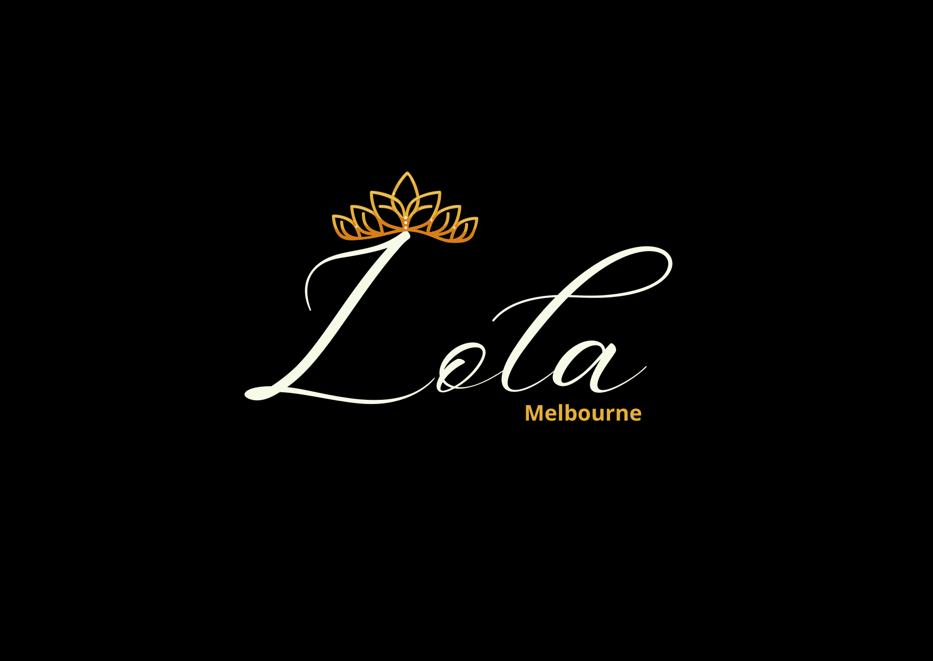

Bookings

The business offers the following methods for bookings and enquiries:
- Phone
- Email
- Webportal
- Our website supports Screen Readers
- Our forms have high contract boxes and submit boxes

Emergency Management
- Emergency and evacuation procedures are explained on arrival
- There are Audible device/s to alert occupants to evacuate with instructions on how to evacuate.
- Exit signs are clear and easy to see
- Exit access is free and clear at all times
We ensure exit access is free and clear at all times by:
Exit access at Lola is ensured to be free and clear at all times through a two-fold approach: firstly, the building adheres strictly to body corporate standards which prohibit all residents from storing anything in shared public spaces. Secondly, Lola itself is specifically furnished and arranged to ensure that all exit pathways within the apartment remain unobstructed.
- Exits and access to exists are greater than 900mm
- Exit doors are able to be opened by all occupants
- Exits including stairwells, have bright edges used on the steps.
- The evacuation point is clearly marked by a sign
- In addition, the following further information can assist guests:
Lola encourages guests to proactively contact the host prior to or during their stay to discuss any needs for additional assistance should an emergency occur, allowing the business to be aware and prepare accordingly.
- In addition, the following further information can assist guests:
n the event a guest requires assisted rescue, this procedure would be carried out by the trained emergency staff who are in attendance at the time of the emergency, such as fire services or paramedics.

Communications
- Our business offers the following alternative communication methods
- Plain English

Not specified
- There is easy to read signage and information (e.g. menus and emergency information)

Other Information
- The business accepts the companion card

Guide Dog and Service Animals
The business provides the following services for services animals:
While service animals are warmly welcomed at Lola and we fully understand our legal obligations, please note that as an apartment, we don't provide a dedicated secure area with shade and water, or a specific on-site toilet area; however, the balcony is secure, and Flagstaff Gardens is conveniently located nearby for toilet breaks. We also encourage guests to bring their own animal bedding, bowls, and other supplies to ensure their service animal's comfort.

GENERAL

Pre-arrival, arrival and reception
The business has the following in place to support guests during pre-arrival, arrival and reception
- There is a reception/public entryway.

As Lola is a short-term rental located within Dockside Tower and operates without a dedicated reception area, all questions regarding reception-specific amenities like seating, counters, clipboards for check-in, communication aids (tablets, pen and paper, picture boards), hearing loops, or specific lighting for lip readers are not applicable (NA). All guest interactions, including check-in and information dissemination, are handled remotely and digitally, meaning physical large print information sheets or registration forms are also not available.
- Information and maps are available in written form
- Keys are available for each guest
- In addition, the following further information can assist guests:
To accommodate guests with fatigue-related disabilities and prevent disadvantages from wait times, Lola ensures immediate access upon arrival: guests arriving by car can directly access the car park and then the lift to the 10th floor, while those arriving by foot can enter the building lobby and access the lift without any delay.
- In addition, the following further information can assist guests:
Guests are provided with photos in advance to familiarise them with the building's access points.

Cognitive Impairment Support
- Documents are available in plain English for people with cognitive impairment (This may include instructions, guides, menus and general information)
- A space for parents and children on the Autism Spectrum

Car Park and Access amenities
The business has the following Car Park and Access amenities
- A drop off zone
- Level or ramped access from the car park to the entrance
- The accessible entrance is clearly signed from the parking bay
- Kerb ramps are in place where a pavement or walkway needs to be crossed
- In addition, the following further information can assist guests:
TRAIN/BUS/TRAM ACCESSIBILITY:
While Lola itself does not directly provide detailed accessibility guides for public transport, it is located in Melbourne CBD, which has an extensive public transport network with increasing accessibility features.
Guests are advised that:
Public Transport Victoria (PTV) is the central resource for all public transport information in Melbourne. Their website (ptv.vic.gov.au) and app offer a journey planner that allows users to filter for accessible services and stops.Train Stations: Major CBD stations like Southern Cross and Melbourne Central have accessible features including lifts, ramps, and accessible toilets. PTV and Metro Trains websites provide specific accessibility details for each station.Tram Stops: Many tram routes in the CBD, particularly within the Free Tram Zone, feature upgraded level-access stops and low-floor trams. The Yarra Trams website and the 'tramTRACKER' app can provide real-time information on tram accessibility.Bus Stops: Most buses in Melbourne are low-floor and equipped with ramps. Bus drivers are trained to assist passengers with mobility needs.INTERCOM SYSTEM:There is no intercom system at the entrance of the car park as the car park operates on a self-access basis, with guests gaining entry using a scanner.

Internal Spaces
- Tableware/glassware contrast with the table surface or table cloth

External Paths
External paths of travel
- Surfaces are concrete, asphalt, smooth paving or hard packed fine gravel (max aggregate size 13mm)
- Pathways are wider than 900mm

Given that Lola is situated on Little Lonsdale Street, which is on flat ground with all footpaths featuring ramps, the concerns regarding long, sloped paths needing resting places or the identification of steps as non-wheelchair accessible are not applicable for direct access to the building.
- In addition, the following further information can assist guests:
Ensuring a smooth and easy arrival, guests will be sent photos illustrating the apartment's access points prior to their stay. This allows for familiarisation with the building's layout and entry. Complementing this, the host also makes a personal phone callto each guest, confirming they possess all vital check-in information and offering an opportunity to address any queries or clarify access specifics.
- In addition, the following further information can assist guests:
There are no steps either to or within the apartment itself. However, please note there is a small 'lip' on the sliding door leading to the balcony.
- In addition, the following further information can assist guests:
Lola is a private short-term rental apartment, it is not a public facility and does not provide public toilets or specialis+ed adult change facilities, registered changing places, or medical equipment such as adult change tables or hoists. The toilet within the apartment is part of the private bathroom provided for guests' personal use.

ACCOMMODATION

Bedrooms
The bedrooms have the following facilities/amenities in place
- There are 2 rooms available to guests who use a wheelchair
  - Layout of room Image(s)
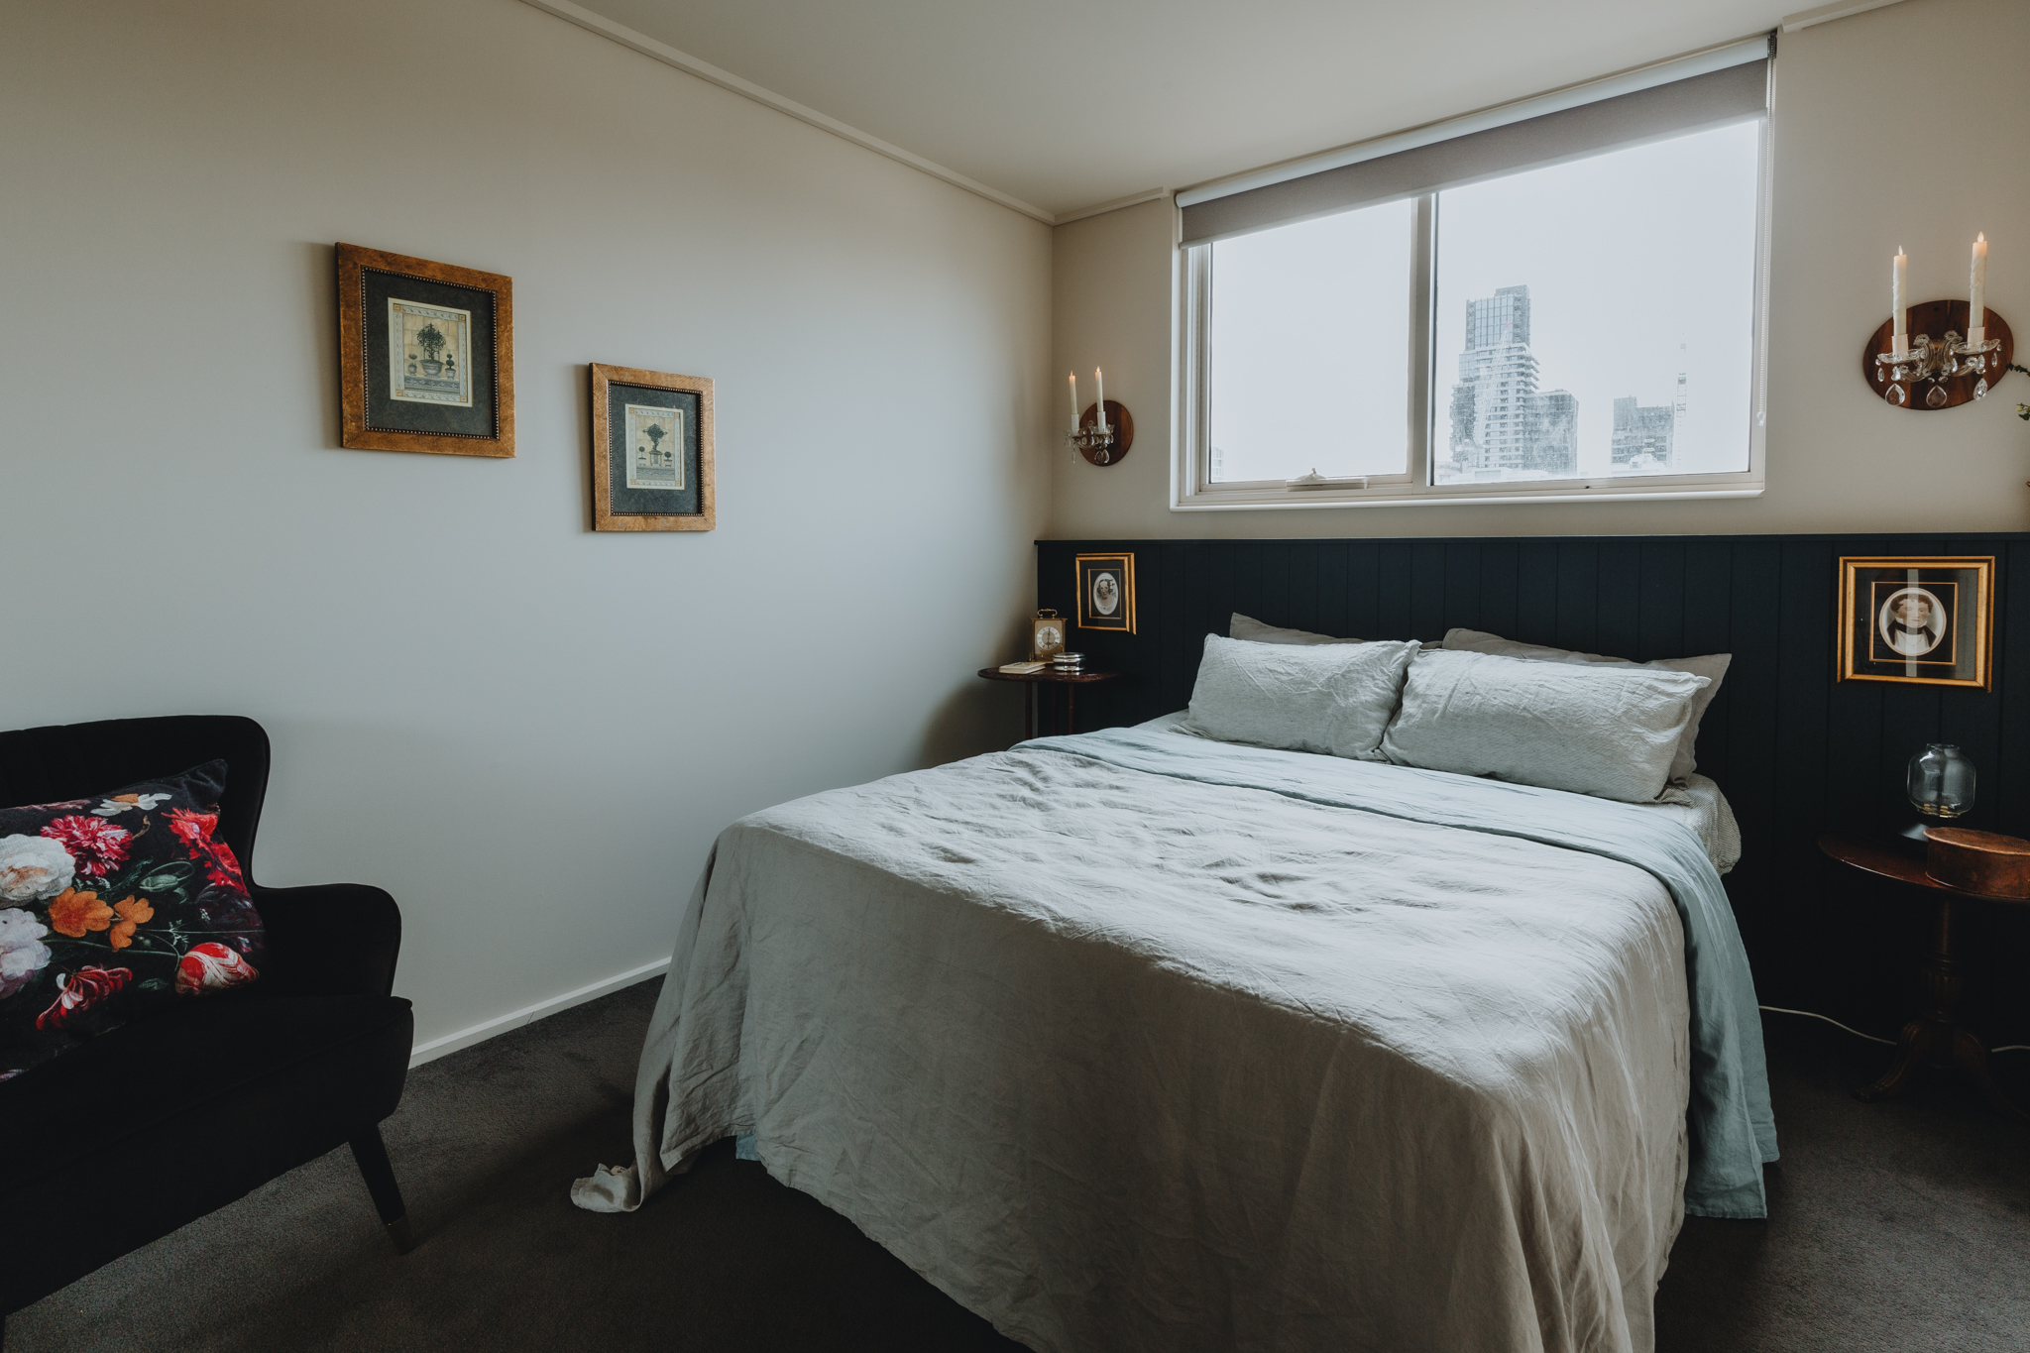
Master Bedroom - queen bed
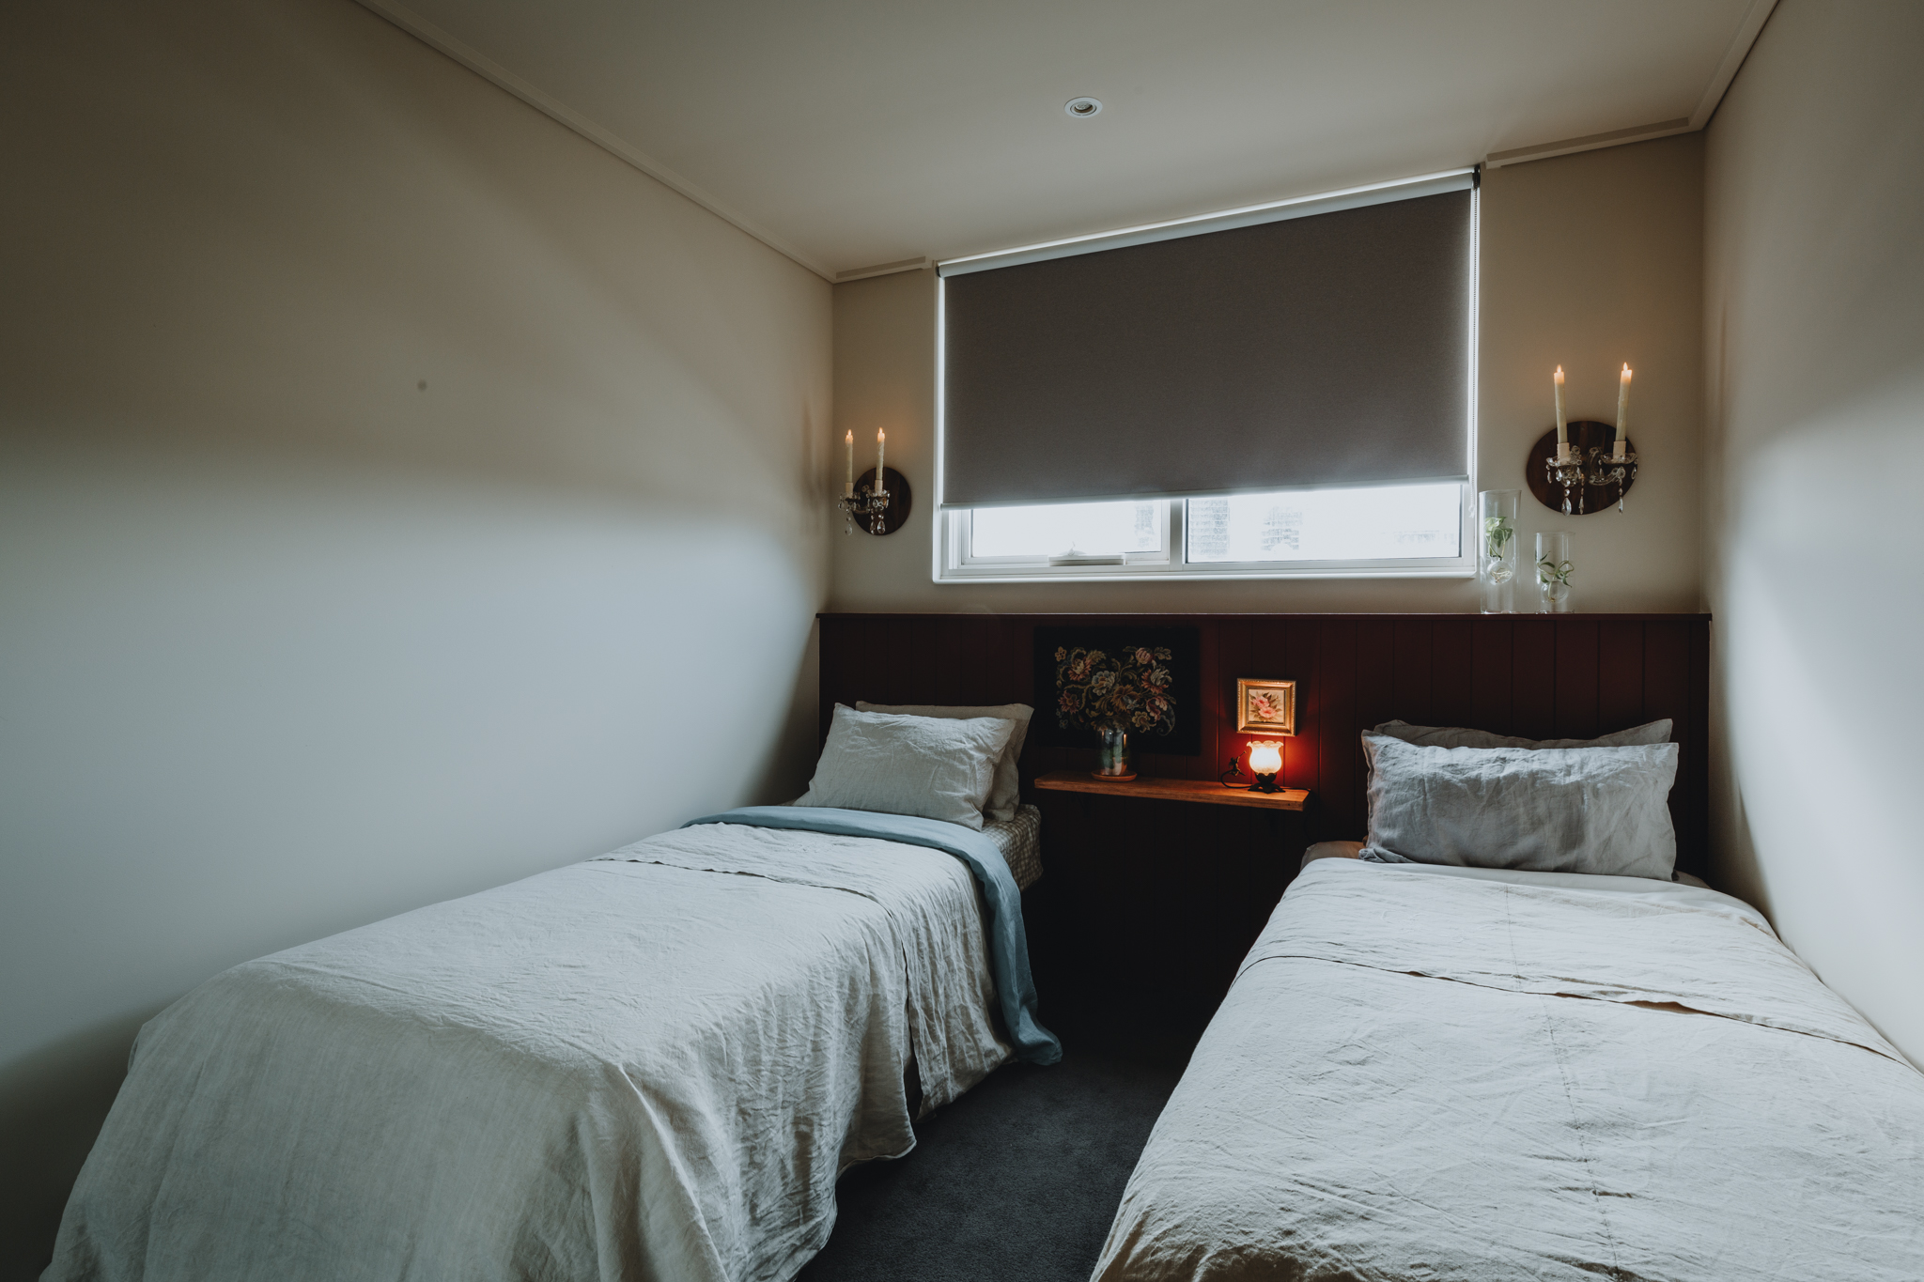
Bedroom -2 king singles

Room Amenities
- Televisions are equipped with closed captioning capability
- There is contrast between the walls, skirtings, floor and furniture
- There is a clear path through the room
- The edges of all furniture and fixtures are rounded
- Housekeeping procedures instruct staff not to reposition furniture that has been moved
- Doors open fully against the adjoining wall
- There is a clear opening at least 850mm wide
- There luggage racks for at least two suitcases
- There at least one chair with rigid arms
- Wardrobe and drawer handles are easy to grip
- The bedside lamp switch is easy to reach from the bed
- There is at least 850mm clear space beside the bed
- The bed height is no higher than 680mm from the floor
- There is at least 130mm clearance under the bed
- The business offers a range of non-allergenic bedding
- Non-allergenic cleaning products are used
- In addition, the following further information can assist guests:
As a private short-term rental apartment, Lola does not provide specialised accessibility equipment such as vibrating alarm clocks or landline phones with features like hearing loop compatibility, volume control, visual ringing indicators, or SMS capabilities.

Guests are encouraged to bring their own personal devices, such as smartphones, which often offer these functions or can be used with their own hearing aids.

For communication with the host, guests can readily use their personal mobile phones via calls or text messages. Additionally, while the apartment features a modern aesthetic, the wardrobe handles are made of glass, which means they are not specifically chosen for high colour contrast to the doors and drawers. Guests with visual impairments can use tactile identification or request detailed photos and guidance from the host prior to or upon arrival.

Bathrooms
The bathrooms have the following facilities/amenities in place
- All heating appliances and hot water pipes are protected or insulated
- All shower, bath and basin taps are clearly differentiated between hot and cold
- Fixtures and fittings have rounded edges
- The hot water is thermostatically controlled to 41 degrees
- The door is at least 850mm wide
- There is a minimum of 850mm beside the toilet
- Handrails are fitted
- There is a minimum of 1400mm of clear space in front of the toilet
- The toilet seat is a contrasting colour to the floor
- The toilet seat is 460mm above the floor
- A range of non-allergenic toiletries are available
  - Bathroom Image(s)
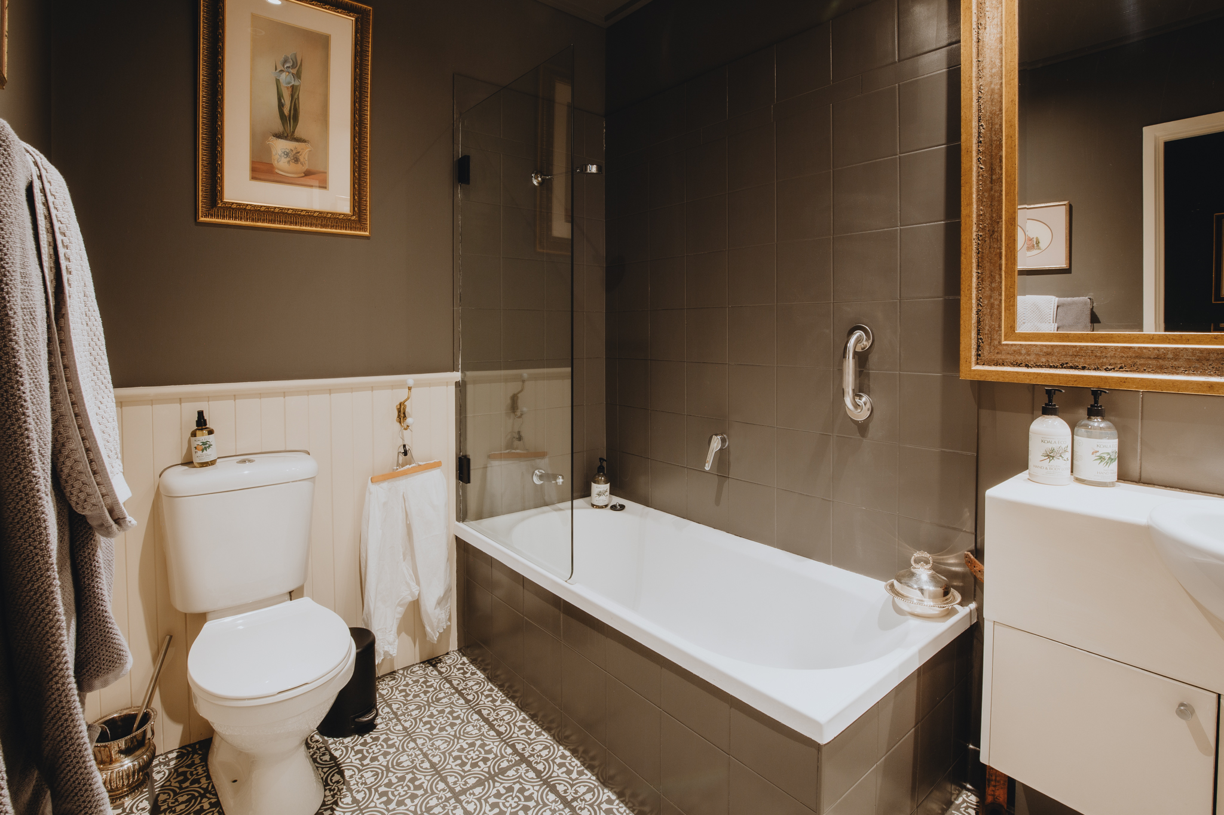
Bathroom
- In addition, the following further information can assist guests:
Please note that the shower in the apartment is located over the bath, and a grab rail is fitted for assistance.

COMMON AREAS

Report Disclaimer
Please note that this business report, provided as a result of the use of the diagnostic assessment, is for information purposes only.
Australian Tourism Industry Council (ATIC) cannot guarantee the accuracy of respondent’s answers, or that they are fully representative of your business. Therefore, ATIC does not warrant or guarantee any particular outcome in respect of your businesses self-assessment.
This report is intended as guidance only for your business and should not be relied on for future marketing considerations. ATIC recommends that you seek your own independent advice as well as the results from the diagnostic.
Links to external web sites are inserted for convenience and do not constitute endorsement of material at those sites, or any associated organisation, product or service.
ATIC does not:
- Assume any legal liability for the accuracy, completeness, or usefulness of any information from this report or any links provided; or
- Accept responsibility for any loss associated directly or indirectly from the use of this report.

