ATIC Accessibility
To support the accessible community in making informed travel decisions for their individual needs

This report prepared for:
Business name: | Goolwa River Retreat
Address: | 150 Sexton Rd
Town: | Torrumbarry
Contact for enquiries: | Nicole Weightman
Contact Number: | 0417472791
Contact Email: | Info@goolwariverretreat.com.au
Website: | https://goolwariverretreat.com.au/
Date: | 2026-10-15 11:30

ATIC Accessibility
The following pages provides travellers with information on the businesses facilities and amenities which aims to support the traveller to make an informed decision on whether the business is suitable for their individual needs.
OVERVIEW 4
Business Overview 4
Bookings 4
Emergency Management 4
Guide Dog and Service Animals 4
GENERAL 6
Pre-arrival, arrival and reception 6
Cognitive Impairment Support 6
Car Park and Access amenities 6
Entry 7
Internal Spaces 7
Public areas 7
External Paths 8
Steps 8
Public Toilets/Adult change facilities 8
ACCOMMODATION 9
Room Amenities 9
Bathrooms 9
COMMON AREAS 11
Parks and gardens 11
Report Disclaimer 13

OVERVIEW

Business Overview

The business has the following products/services available
- Accommodation

Our business caters for the following disability types:
- Deaf or low hearing
- Limited mobility
- Cognitive or people on the Autism Spectrum

Bookings

The business offers the following methods for bookings and enquiries:
- Phone
- Email
- Webportal
- Our website supports Screen Readers

Emergency Management
- The business has an emergency management and evacuation plan for guests with a disability
- Emergency and evacuation procedures are explained on arrival
- Guests with disabilities are noted in the guest log book for emergency and evacuation purposes

Guide Dog and Service Animals
- The business provides a secure area with shade and water for service animals
- The business provides a toilet area for service animals
The business provides the following services for services animals:
Not specified

GENERAL

Pre-arrival, arrival and reception
The business has the following in place to support guests during pre-arrival, arrival and reception
- Booking information and websites are compatible with screen readers
- There is a reception/public entryway.
- Seating available at reception
- A lower counter at reception/ticket office
- A tablet with text to voice or pen and paper at reception to aid in communication
- Lighting in the reception area is even and glare free
- Large print information sheets and registration forms

Clip board isn’t necessary as the lower desk has a bench to write on for guests with needs
- Information and maps are available in written form
- A familiarisation tour
- Keys are available for each guest
- Luggage assistance
- In addition, the following further information can assist guests:
We greet the guests at reception upon arrival . We can do the checking from the car if necessary. The guests can drive directly to the accomodation where we can assist with bringing luggage inside .

Cognitive Impairment Support
- Documents are available in plain English for people with cognitive impairment (This may include instructions, guides, menus and general information)
- A space for parents and children on the Autism Spectrum

Car Park and Access amenities
The business has the following Car Park and Access amenities
- A drop off zone
- Designated disabled parking bays

Entry
The business has the following amenities/systems in place for entry
- A drop off point close to the entrance
- A path of access to the building is slip resistance and even
- A path of access to the building is clear of obstruction
- Glass doors are fitted with a visual sighting strip
- Door handles are of a contrasting colour to the door
- Signage is written in a contrasting colour
- The entry door is a minimum of 850mm wide
- The entry door has self opening or a light opening pressure (for manual operations)
- The entrance sill is less than 13mm
- There a clear space of at least 1500mm x 1500mm in front of all doors.
- The entrance door mats have a thickness less than 13mm and a width of 7500mm or greater
- In addition, the following further information can assist guests:
All accommodations are single story so lifts aren’t required

Internal Spaces
- Clear and unobstructed routes through and between buildings
- Interior walls are matte or low sheen
- Floors, walls, counters and furniture are of contrasting colours
- Tableware/glassware contrast with the table surface or table cloth
- Floor surfaces are hard or short pile carpet
- Seating is available for guests unable to stand for long periods
- Accessible facilities are clearly signed and visible from all areas
- All corridors greater than 900mm
- There is a quiet space for parents and children on the Autism Spectrum

Public areas
The public areas have the following amenities in place
- Display units, Televisions, Video displays etc. are open captioned
- Even lighting
- Seating

External Paths
External paths of travel
- Surfaces are concrete, asphalt, smooth paving or hard packed fine gravel (max aggregate size 13mm)
- Pathways are wider than 900mm
- There 3 successive steps or less on any path or at any doorway

Steps
Steps
- There are steps.
- All steps or staircases have enclosed risers
- The underside of all staircases are enclosed or protected to a height of at least 2 metres

Public Toilets/Adult change facilities
Public Toilets/Adult change facilities have the following amenities are in place
- There is an accessible toilet for public use
- The door is at least 850mm wide
- There is a minimum of 850mm beside the toilet
- Handrails are fitted
- The toilet seat is 460mm above the floor
- The toilet seat of a contrasting colour to the floor
- The toilet seat is460mm above the floor

ACCOMMODATION

Room Amenities
- Lower hanging rails are in wardrobes
- In addition, the following further information can assist guests:
We have an emergency letter that will be sent automatically through our system incase of any situation that requires assembly to the evacuation point . This will be emailed directly to all guests .
- Televisions are equipped with closed captioning capability
- There is contrast between the walls, skirtings, floor and furniture
- There is a clear path through the room
- Wardrobe handles are a contrasting colour to the doors and draws
- Housekeeping procedures instruct staff not to reposition furniture that has been moved
- There is a clear opening at least 850mm wide
- There luggage racks for at least two suitcases
- There at least one chair with rigid arms
- Wardrobe and drawer handles are easy to grip
- The bedside lamp switch is easy to reach from the bed
- There is at least 850mm clear space beside the bed
- The bed height is no higher than 680mm from the floor
- There is at least 130mm clearance under the bed
- The business offers a range of non-allergenic bedding
- Non-allergenic cleaning products are used

Bathrooms
The bathrooms have the following facilities/amenities in place
- All heating appliances and hot water pipes are protected or insulated
- All shower, bath and basin taps are clearly differentiated between hot and cold
- The hot water is thermostatically controlled to 41 degrees
- The door is at least 850mm wide
- There is a minimum of 850mm beside the toilet
- Handrails are fitted
- There is a minimum of 1400mm of clear space in front of the toilet
- The toilet seat is a contrasting colour to the floor
- The toilet seat is 460mm above the floor
- There is a portable shower head on flexible hose
- A door is fitted to the shower
- A door is fitted to the showers with an outward swing at minimum width of 900 mm
  - Bathroom Image(s)
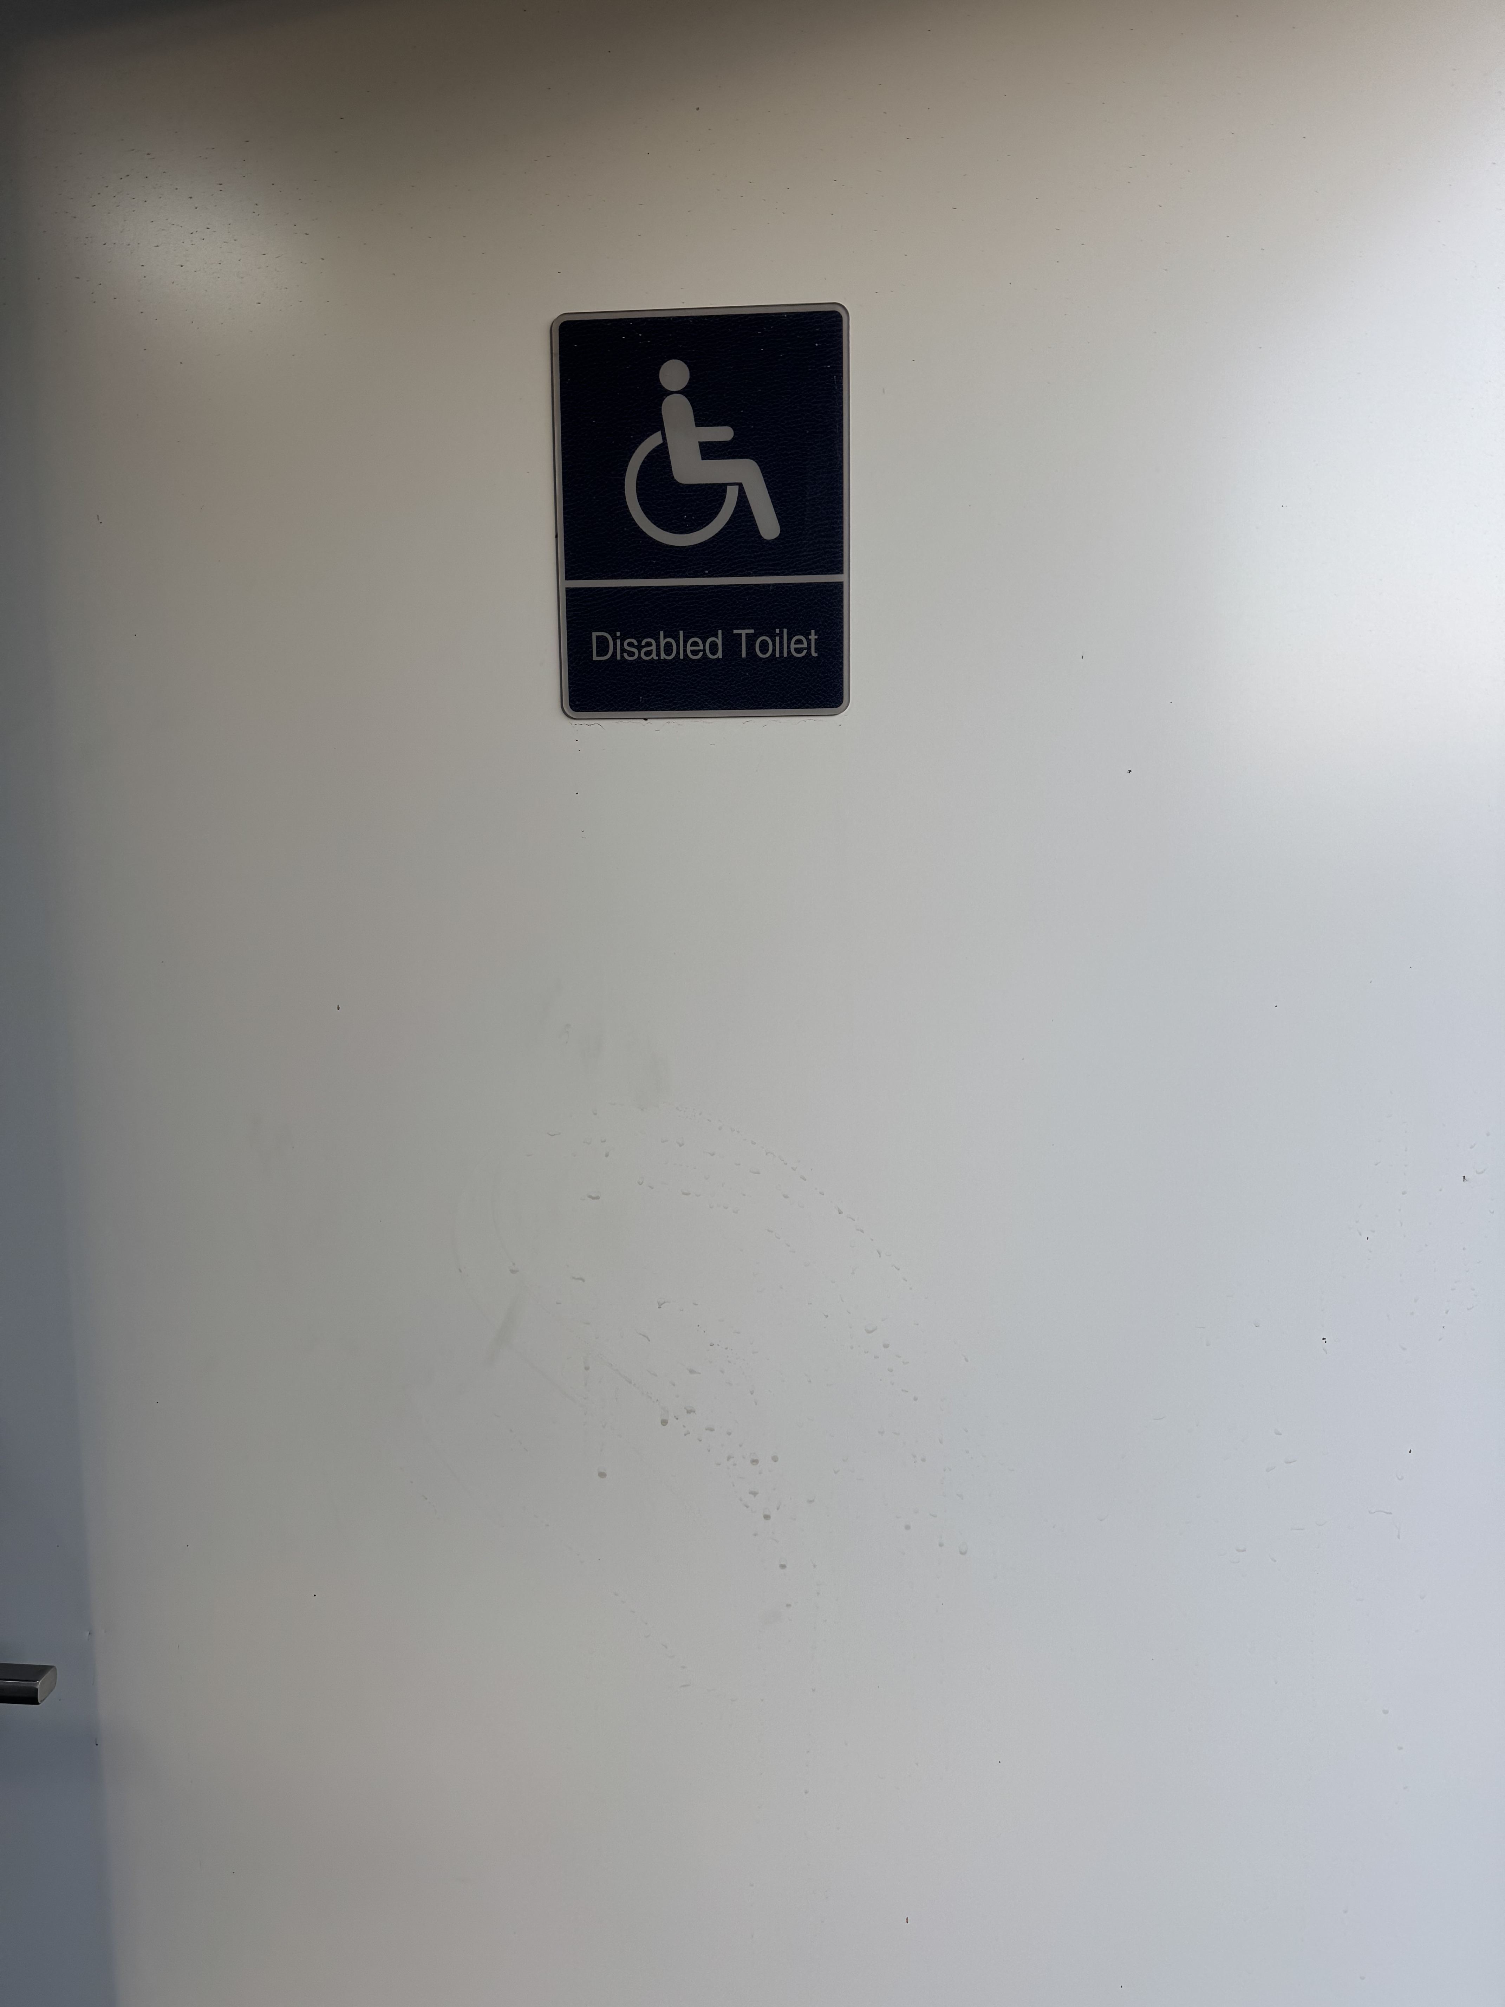
IMG_9944

COMMON AREAS

Parks and gardens
- The following parks and gardens amenities are available
- Accessible toilets
- Accessible toilets are signed at regular intervals
- Seats are provided at regular intervals
- The park or garden contains sensory experiences
- Accessible BBQs
- The park contains a fishing platform
- The fishing platform has seating
  - Parks and Gardens Access/Entry Image(s)
IMG_9944
- Handrails and stairs are built as per state/territory building code.
- Slip resistance surfaces are used.
- A handrail is available and at 865-965mm in height.
- The handrail is continuously graspable along entire length at least one side.
  - Parks and Gardens Stair entry and exit Image(s)

Report Disclaimer
Please note that this business report, provided as a result of the use of the diagnostic assessment, is for information purposes only.
Australian Tourism Industry Council (ATIC) cannot guarantee the accuracy of respondent’s answers, or that they are fully representative of your business. Therefore, ATIC does not warrant or guarantee any particular outcome in respect of your businesses self-assessment.
This report is intended as guidance only for your business and should not be relied on for future marketing considerations. ATIC recommends that you seek your own independent advice as well as the results from the diagnostic.
Links to external web sites are inserted for convenience and do not constitute endorsement of material at those sites, or any associated organisation, product or service.
ATIC does not:
- Assume any legal liability for the accuracy, completeness, or usefulness of any information from this report or any links provided; or
- Accept responsibility for any loss associated directly or indirectly from the use of this report.

