ATIC Accessibility
To support the accessible community in making informed travel decisions for their individual needs

This report prepared for:
Business name: | Darwin Harbour Cruises
Address: | 7 Stokes Hill Rd
Town: | Darwin City
Contact for enquiries: | Melanie Lewis
Contact Number: | 0889423131
Contact Email: | info@darwinharbourcruises.com.au
Website: | www.darwinharbourcruises.com.au
Date: | 2026-10-07 11:56

ATIC Accessibility
The following pages provides travellers with information on the businesses facilities and amenities which aims to support the traveller to make an informed decision on whether the business is suitable for their individual needs.
OVERVIEW 4
Business Overview 4
Bookings 4
Emergency Management 4
Communications 5
Other Information 5
Guide Dog and Service Animals 5
GENERAL 6
Pre-arrival, arrival and reception 6
Cognitive Impairment Support 6
Car Park and Access amenities 6
Entry 7
Internal Spaces 7
Public areas 7
Displays, exhibits, commentary and live performances 8
External Paths 8
Steps 8
Ramps 9
TOUR OPERATORS 10
Tour/Transport Services 10
Guides 10
FOOD AND DRINK 11
Dining Spaces 11
Report Disclaimer 15

OVERVIEW

Business Overview

The business has the following products/services available
- Tour/Transport
- Food and Drink

Our business caters for the following disability types:
- Deaf or low hearing
- Limited mobility
- Food allergies or intolerances
- Cognitive or people on the Autism Spectrum
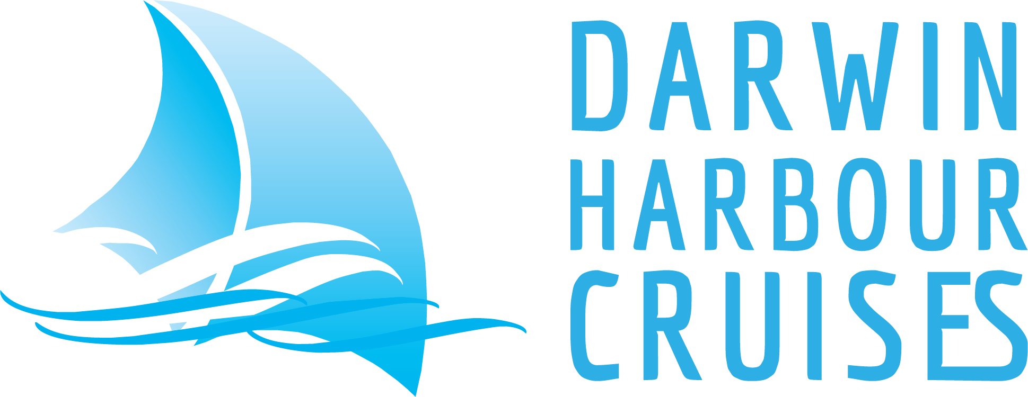

Bookings

The business offers the following methods for bookings and enquiries:
- Phone
- Email
- Webportal
- Staff have undergone disability awareness and training

Emergency Management
- The business has an emergency management and evacuation plan for guests with a disability
- Emergency and evacuation procedures are explained on arrival
- Guests with disabilities are noted in the guest log book for emergency and evacuation purposes

Communications
- An accessibility guide is available on the website

https://accreditation.qualitytourismaustralia.com/report/AccessReportPublicHtml2/fb51698b-44fd-4596-83c8-b4a9d233f48a
- Our website meets WCAG 2.0 accessibility standards

Other Information
- For bookings made onsite, the ticket booth/counter/box office is accessible for people using a wheelchair

Guide Dog and Service Animals
The business provides the following services for services animals:
Given the nature of the business, service animals are not encourage to board, unless familar with marine conditions and animal life jacket is provided by the animals owner.

GENERAL

Pre-arrival, arrival and reception
The business has the following in place to support guests during pre-arrival, arrival and reception
- There is a reception/public entryway.
- Seating available at reception
- A lower counter at reception/ticket office
- A tablet with text to voice or pen and paper at reception to aid in communication
- Picture Board at reception to aid in communication
- Lighting in the reception area is even and glare free

Checkin process is done at boarding and just requires guest to state their booking name to enter so no registration forms required for complettion.
- Information and maps are available in written form
- A familiarisation tour
- In addition, the following further information can assist guests:
Boarding times are published and have a 20 minute window. Seating is provided at the Dock gate. Once onboard guests are shown to their pre-allocated seat immediately.

Cognitive Impairment Support
- Documents are available in plain English for people with cognitive impairment (This may include instructions, guides, menus and general information)
- A "social script" guide to your premises or attraction describing the sights, sounds and smells to aid parents/carers prepare visitors in advance
- The 'social script' is available in word and other editable formats
- Quiet periods or early opening times for people on the Autism Spectrum
- A space for parents and children on the Autism Spectrum
- Access has alternative procedures and clear written instructions with universal access symbols

Car Park and Access amenities
The business has the following Car Park and Access amenities
- A drop off zone
- Designated disabled parking bays
- Level or ramped access from the car park to the entrance
- The accessible entrance is clearly signed from the parking bay
- Kerb ramps are in place where a pavement or walkway needs to be crossed
- In addition, the following further information can assist guests:
The carpark is at Stokes Hill Wharf which has designated disabled carparks. This carpark is under the management of Darwin Waterfront Corporation.

Entry
The business has the following amenities/systems in place for entry
- A drop off point close to the entrance
- A path of access to the building is slip resistance and even
- A path of access to the building is clear of obstruction
- Self opening entry doors or fitted with a self closer
- Glass doors are fitted with a visual sighting strip
- Door jams/doors are of a contrasting colour to surrounding walls
- Door handles are of a contrasting colour to the door
- Signage is written in a contrasting colour
- Signage is written in a Sans Serif font and use upper and lower case letters

Internal Spaces
- Floors, walls, counters and furniture are of contrasting colours
- Tableware/glassware contrast with the table surface or table cloth
- Floor surfaces are hard or short pile carpet
- Seating is available for guests unable to stand for long periods
The width of the smallest corridor is:
760mm
- There is a quiet space for parents and children on the Autism Spectrum
- In addition, the following further information can assist guests:
Quiet spaces can be arranged with prior planning and subject to availability at time of booking.

Public areas
The public areas have the following amenities in place
- Even lighting
- Seating

Displays, exhibits, commentary and live performances
For displays, exhibits, commentary and live performances the following amenities are in place
- Seating
- A written transcript where audio description is provided i.e. display commentary, tour commentary
- In addition, the following further information can assist guests:
We have a QR code for written commentary to be read if it can not be heard.

External Paths
External paths of travel
- Surfaces are concrete, asphalt, smooth paving or hard packed fine gravel (max aggregate size 13mm)
The width of the smallest pathway is:
760mm for the entry into the vessel and into the marine toilets.
- Any paths having steps are clearly identified as non-wheelchair accessible

Steps
Steps
- There are steps.
- Top and bottom steps are easily distinguished through colour contrast or the use of TGSIs (Tactile Ground Surface Indicators)
- All steps or staircases have enclosed risers
- Handrails fitted to all open sets of steps
- Handrails extend 300mm beyond the top and bottom step
- In addition, the following further information can assist guests:
On the vessel flights of stairs are the only way to access the onboard toilets. 15 stairs to the Captains Deck toilets and 12 stairs to the Bridge Deck toilet. To walk onto the vessel the doorframe is 10cm in height to step over.

Ramps
Ramps have the following amenities are in place
- There are ramps.
- Hand rails are fitted
- Ramps have a raised edge of at least 100mm
- In addition, the following further information can assist guests:
Accessible toilets are available at Stokes Hill Wharf for pre and post cruise but not available on the vessel.

TOUR OPERATORS

Tour/Transport Services
The tour/transport services have the following facilities/amenities in place
- Buses/Coaches
- 0 vehicles have wheelchair lifts or ramps
- 0 vehicles have low floors with ramped entry
The maximum wheelchair capacity available in the fleet is:
0
- Commentary is available in written format

Guides
- Use of clear/simple English
- Correct pronunciation for lip readers
- Marine
- In addition, the following further information can assist guests:
Our Cruise Director and Cruise Attendants will provide assistance for guests with hearing disabilities.

FOOD AND DRINK

Dining Spaces
The dining spaces have the following facilities/amenities in place
- The smallest doorway is 620mm wide
- Chairs are moveable to allow for wheelchairs to be seated at the tables
- All glass doors and full height windows have contrast markings
- There are areas of full lighting
- There are large print menus
- There are Plain English menus

Our business caters for the following dietary requirements
- Sugar free (diabetic)
- Gluten free (celiac)
- Lactose free (dairy free)
- Low fat and fibre with no gastric content
- Low potassium
- Low sodium
- Nut free
- Additive free
- Vegetarian
- Vegan
- In addition, the following further information can assist guests:
Our dinner product is a buffet with items all separate for guests to build their own meals. Guests with registered dietary requirements are invited to the buffet first to avoid cross contamination.
- There is a sample menu available online
Sample menu is available here -
https://www.darwinharbourcruises.com.au/wp-content/uploads/2025/01/00186DHC-Menu-Buffet-2025.pdf
  - Food and Beverage Image(s)
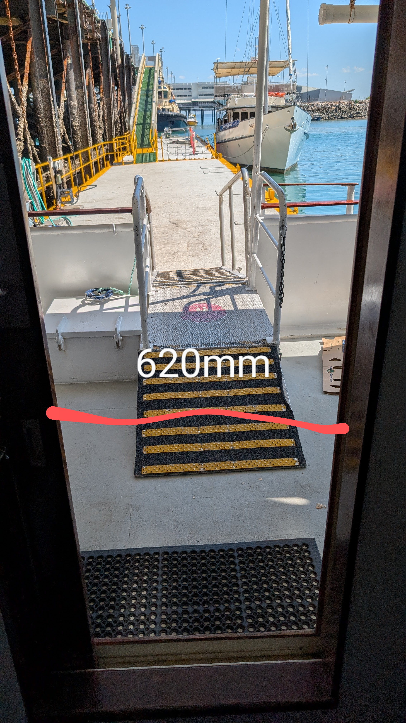
PXL_20250813_042957767~2
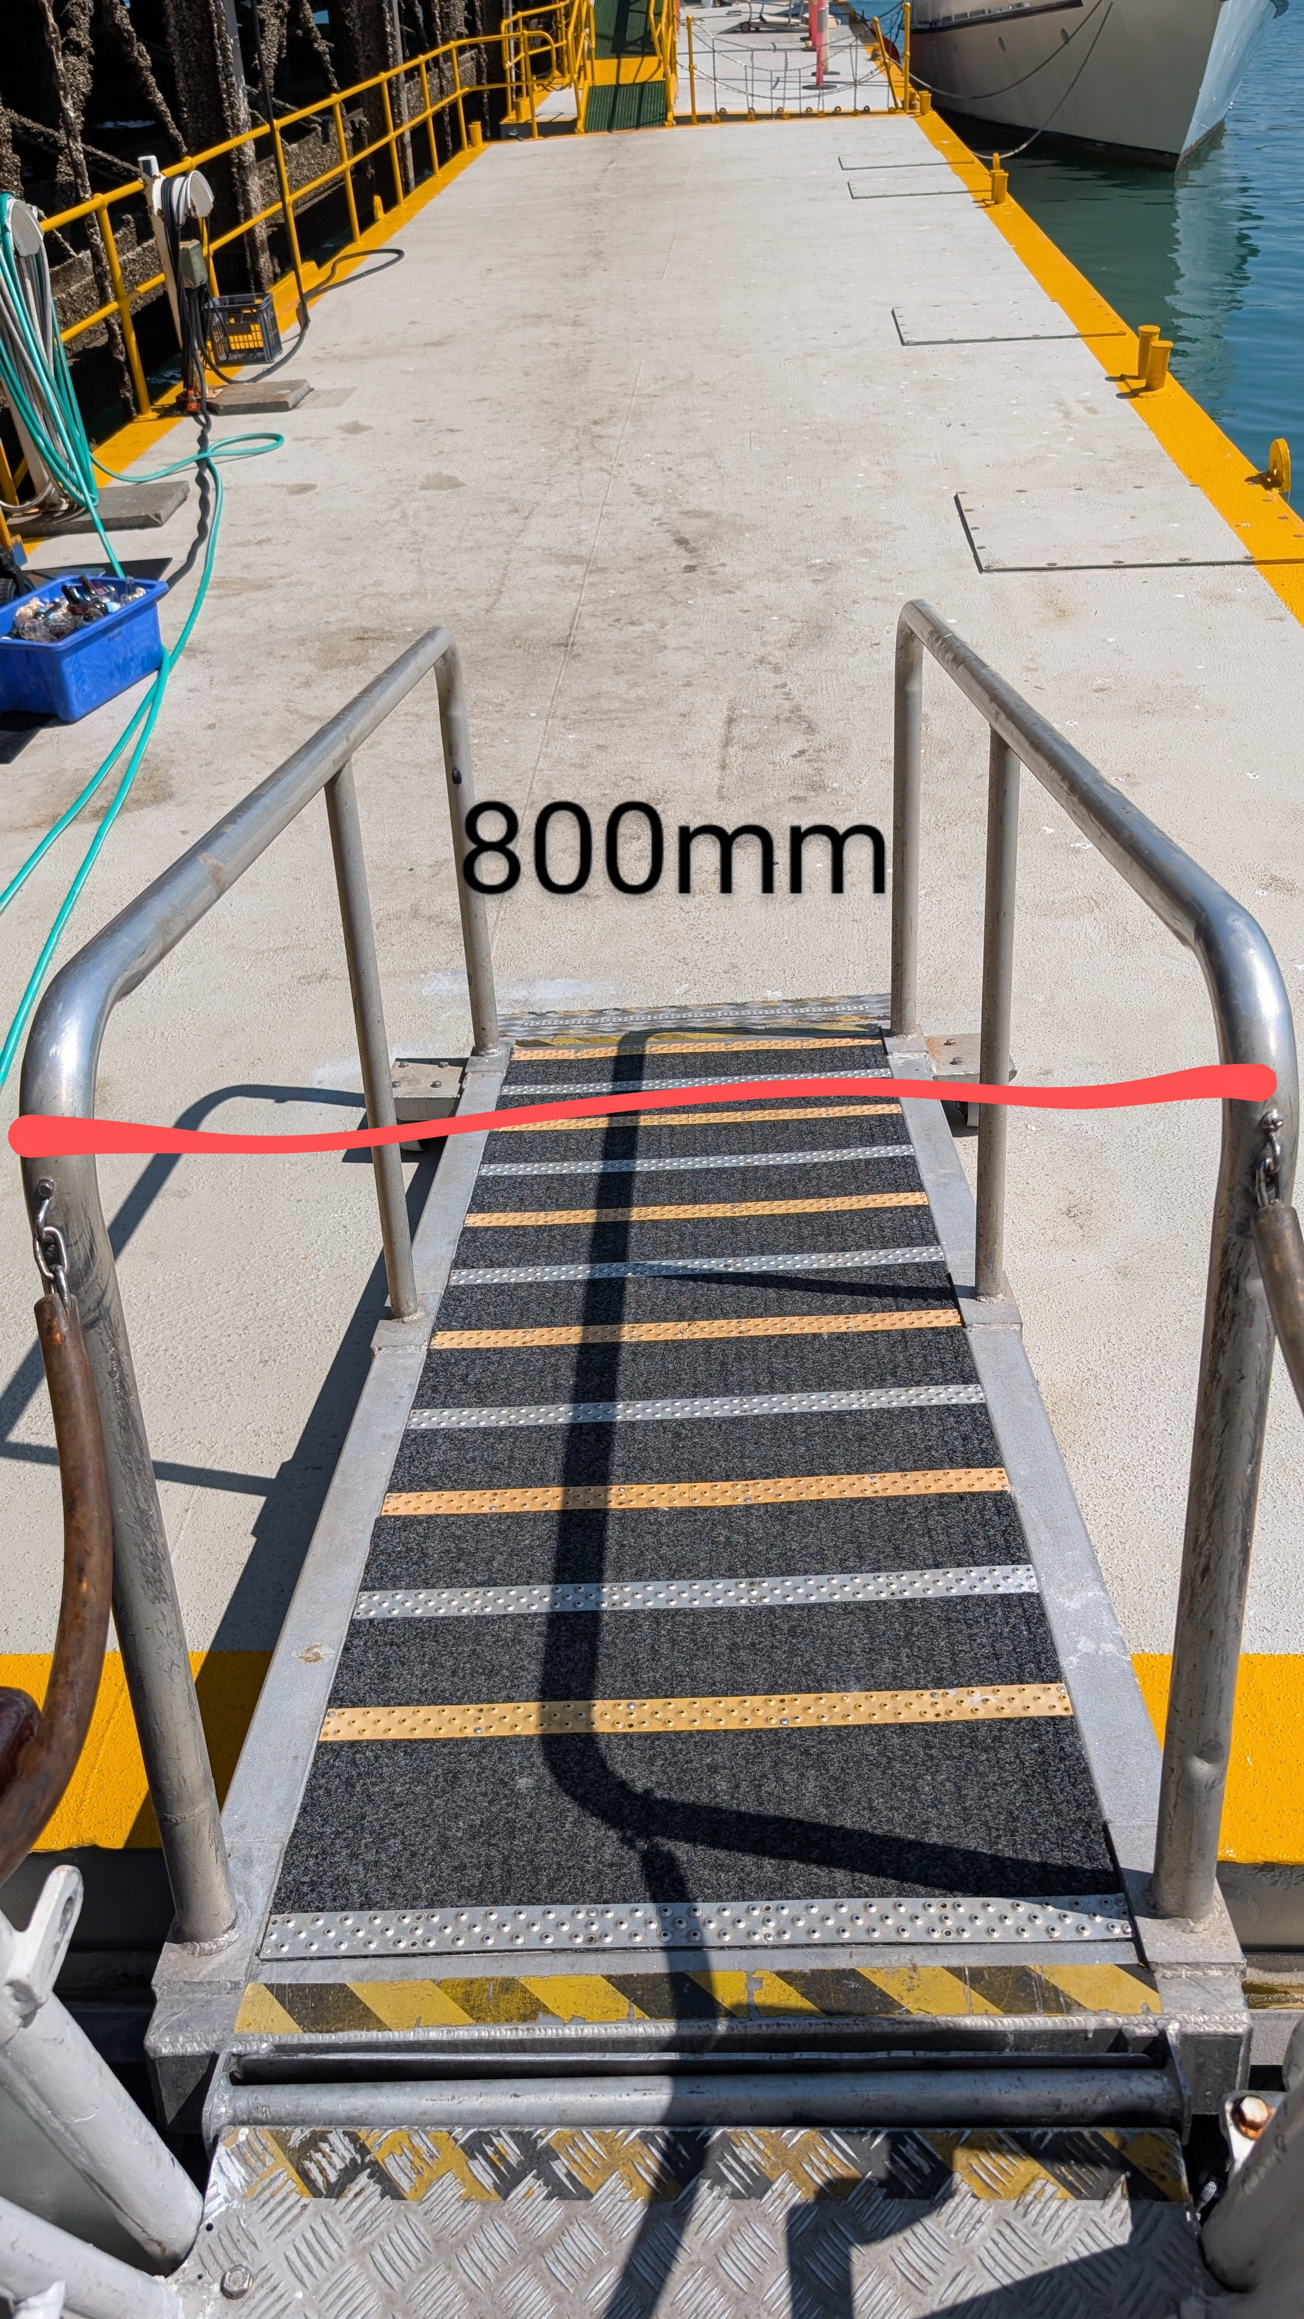
PXL_20250813_043009180~2
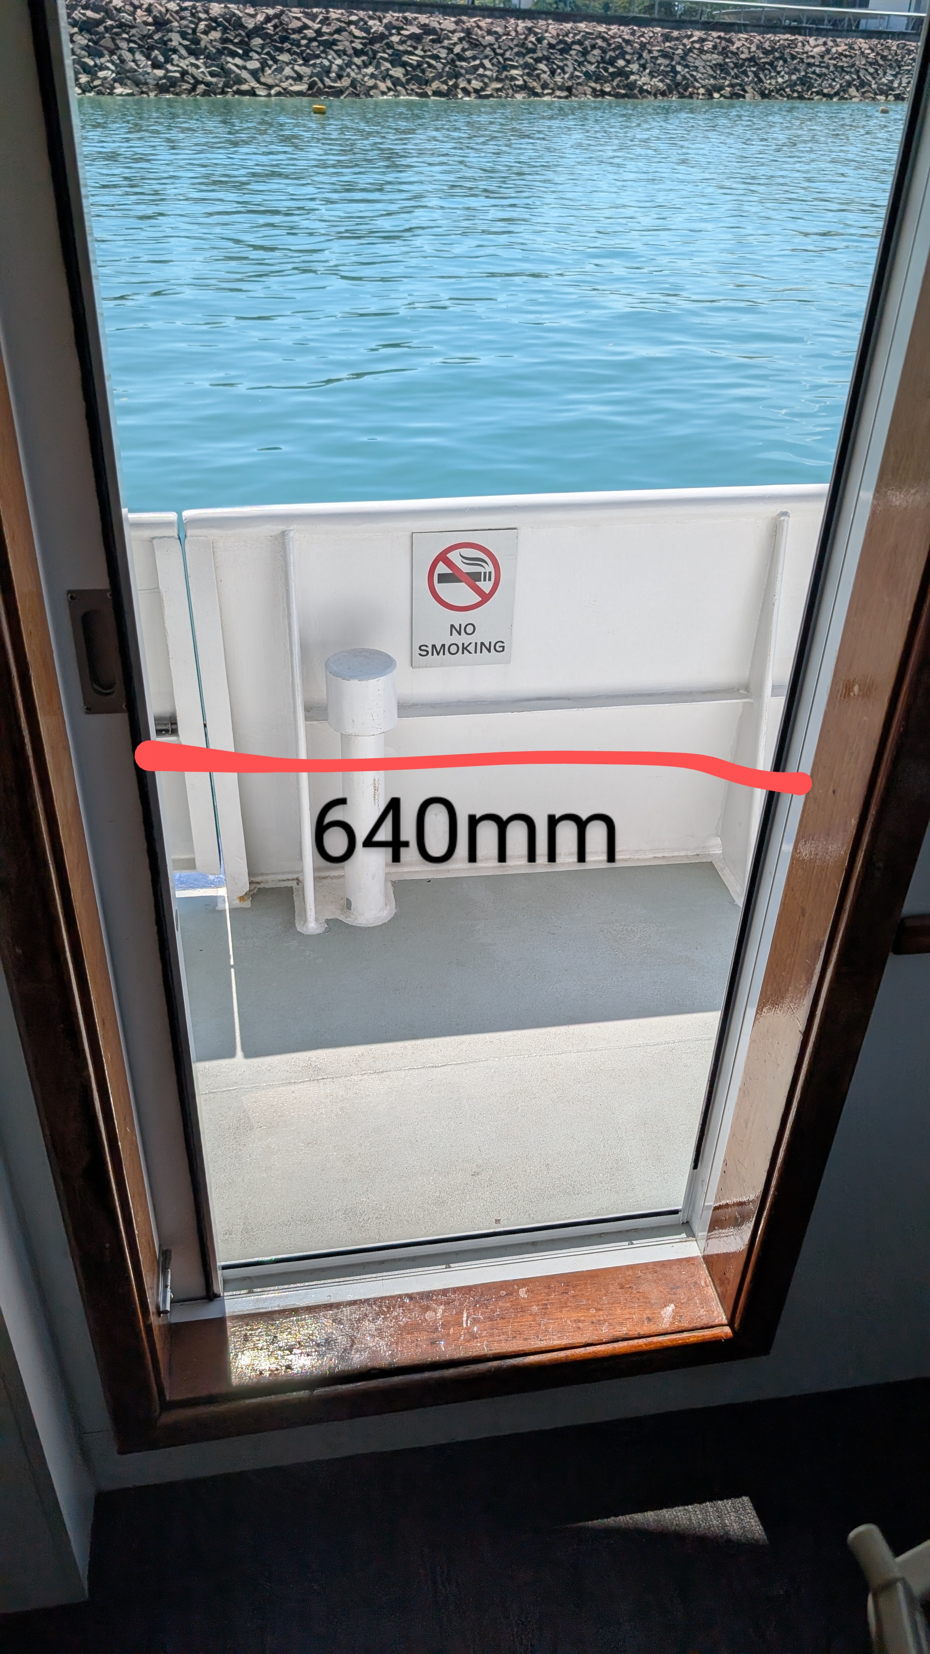
PXL_20250813_042643125~2

Report Disclaimer
Please note that this business report, provided as a result of the use of the diagnostic assessment, is for information purposes only.
Australian Tourism Industry Council (ATIC) cannot guarantee the accuracy of respondent’s answers, or that they are fully representative of your business. Therefore, ATIC does not warrant or guarantee any particular outcome in respect of your businesses self-assessment.
This report is intended as guidance only for your business and should not be relied on for future marketing considerations. ATIC recommends that you seek your own independent advice as well as the results from the diagnostic.
Links to external web sites are inserted for convenience and do not constitute endorsement of material at those sites, or any associated organisation, product or service.
ATIC does not:
- Assume any legal liability for the accuracy, completeness, or usefulness of any information from this report or any links provided; or
- Accept responsibility for any loss associated directly or indirectly from the use of this report.

