ATIC Accessibility
To support the accessible community in making informed travel decisions for their individual needs

This report prepared for:
Business name: | The Margaret River Truffle Farm
Address: | 8 Lovejoy Road
Town: | Cowaramup
Contact for enquiries: | Benjamin Warner
Contact Number: | 0459 960 978
Contact Email: | info@themargaretrivertrufflefarm.com.au
Website: | https://themargaretrivertrufflefarm.com.au/
Date: | 2026-10-20 03:47

ATIC Accessibility
The following pages provides travellers with information on the businesses facilities and amenities which aims to support the traveller to make an informed decision on whether the business is suitable for their individual needs.
OVERVIEW 4
Business Overview 4
Bookings 4
Emergency Management 5
Communications 5
Guide Dog and Service Animals 5
GENERAL 6
Cognitive Impairment Support 6
Car Park and Access amenities 6
Entry 6
Internal Spaces 7
Public areas 7
Displays, exhibits, commentary and live performances 7
External Paths 7
Public Toilets/Adult change facilities 8
FOOD AND DRINK 9
Dining Spaces 9
Report Disclaimer 12

OVERVIEW

Business Overview

The business has the following products/services available
- Food and Drink

Our business caters for the following disability types:
- Blind or low vision
- Limited mobility
- Wheelchairs or mobility scooters
- Food allergies or intolerances
- Cognitive or people on the Autism Spectrum
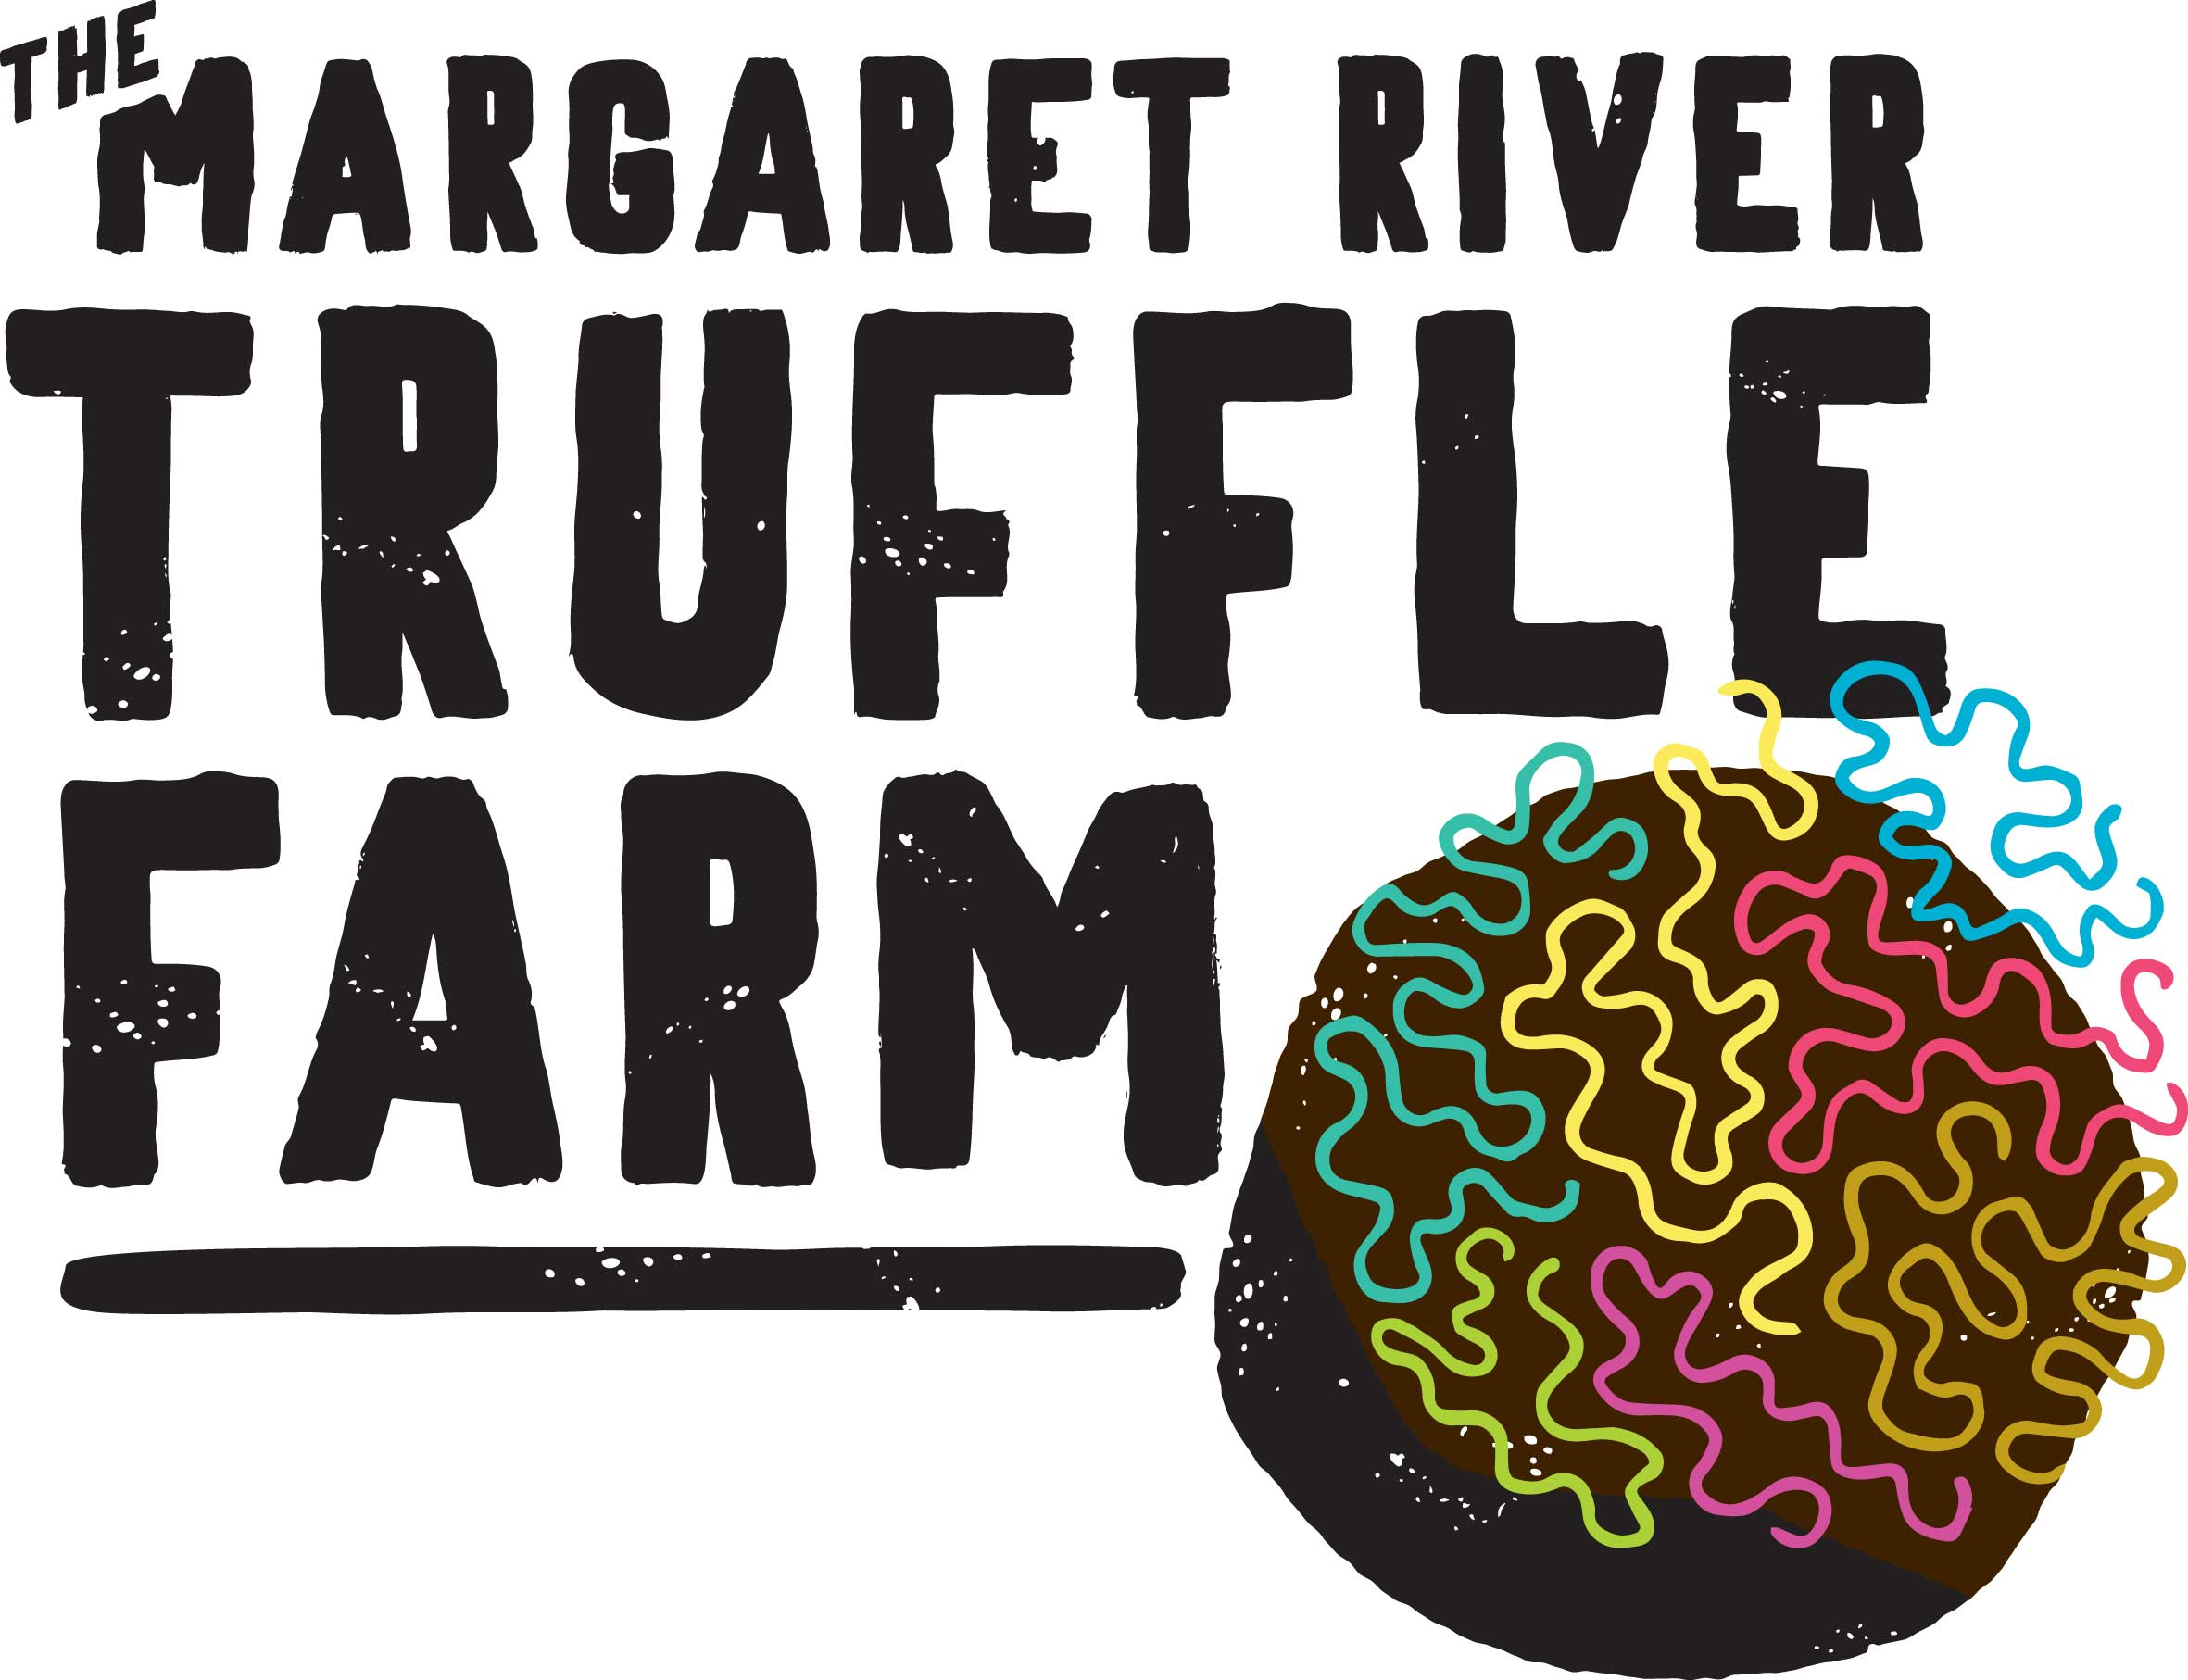

Bookings

The business offers the following methods for bookings and enquiries:
- Phone
- Email
- Webportal
- Our forms have high contract boxes and submit boxes

Emergency Management
- Emergency and evacuation procedures are explained on arrival
- Guests with disabilities are noted in the guest log book for emergency and evacuation purposes

Communications
- Our business offers the following alternative communication methods
- Plain English
- Braille Displays

Not specified
- There is easy to read signage and information (e.g. menus and emergency information)

Guide Dog and Service Animals
- The business provides a toilet area for service animals
The business provides the following services for services animals:
Due to biosecurity risks, and the risks to our animals posed by service dogs, we offer a Service Dogs Special product that is conducted in a controlled manner, outside of the orchards, as a truffle hunt demonstration. Attendees with service dogs must contact by email to arrange a session to cater for this.

GENERAL
- In addition, the following further information can assist guests:
We do not have wait times
- In addition, the following further information can assist guests:
We are a small 100% guided experience rendering all of the above non applicable

Cognitive Impairment Support
- Quiet periods or early opening times for people on the Autism Spectrum
- A space for parents and children on the Autism Spectrum

Car Park and Access amenities
The business has the following Car Park and Access amenities
- A drop off zone
- Designated disabled parking bays
- Level or ramped access from the car park to the entrance
- The accessible entrance is clearly signed from the parking bay

Entry
The business has the following amenities/systems in place for entry
- A drop off point close to the entrance
- A path of access to the building is slip resistance and even
- A path of access to the building is clear of obstruction
- Glass doors are fitted with a visual sighting strip
- Door jams/doors are of a contrasting colour to surrounding walls
- Door handles are of a contrasting colour to the door
- Signage is written in a contrasting colour
- The entry door is a minimum of 850mm wide
- The entry door has self opening or a light opening pressure (for manual operations)
- The entrance sill is less than 13mm
- There a clear space of at least 1500mm x 1500mm in front of all doors.
- The entrance door mats have a thickness less than 13mm and a width of 7500mm or greater

Internal Spaces
- Clear and unobstructed routes through and between buildings
- Interior walls are matte or low sheen
- Floors, walls, counters and furniture are of contrasting colours
- Any protruding or overhanging obstructions are at least 2meters above the floor or are protected
- Tableware/glassware contrast with the table surface or table cloth
- Floor surfaces are hard or short pile carpet
- Seating is available for guests unable to stand for long periods
- Accessible facilities are clearly signed and visible from all areas
- All corridors greater than 900mm
- There is a quiet space for parents and children on the Autism Spectrum

Public areas
The public areas have the following amenities in place
- Even lighting
- Seating

Displays, exhibits, commentary and live performances
For displays, exhibits, commentary and live performances the following amenities are in place
- Seating
- Wheelchair accessible spaces/seating

External Paths
External paths of travel
- Surfaces are concrete, asphalt, smooth paving or hard packed fine gravel (max aggregate size 13mm)
- Pathways are wider than 900mm

no steps

no steps

Public Toilets/Adult change facilities
Public Toilets/Adult change facilities have the following amenities are in place
- There is an accessible toilet for public use
- The door is at least 850mm wide
- There is a minimum of 850mm beside the toilet
- Handrails are fitted
- The toilet seat is 460mm above the floor
- The toilet seat of a contrasting colour to the floor
- The toilet seat is460mm above the floor

FOOD AND DRINK

Dining Spaces
The dining spaces have the following facilities/amenities in place
- The entrance has level access
- The doorway is at least 850mm wide
- There is level access through the dining area
- Chairs are moveable to allow for wheelchairs to be seated at the tables
- All glass doors and full height windows have contrast markings
- There are areas of full lighting
- There are large print menus
- There are Plain English menus
- There is an accessible toilet

Our business caters for the following dietary requirements
- Sugar free (diabetic)
- Gluten free (celiac)
- Lactose free (dairy free)
- Nut free
- Additive free
- Vegetarian
- Halal
- In addition, the following further information can assist guests:
We have an approved medium risk kitchen and all staff are trained as safe food handling supervisors
  - Food and Beverage Image(s)
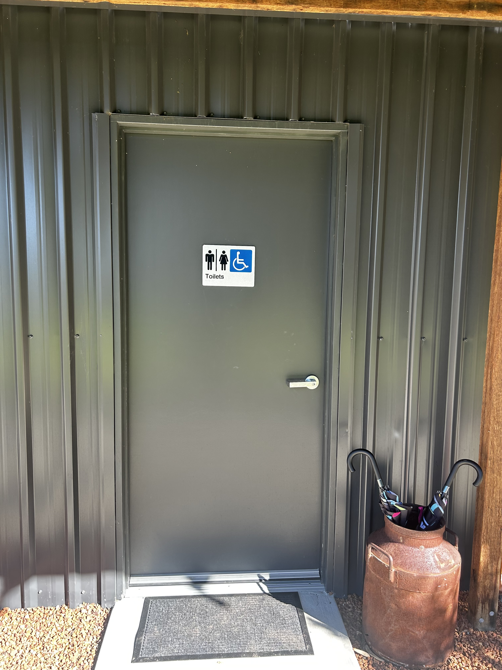
IMG_3163
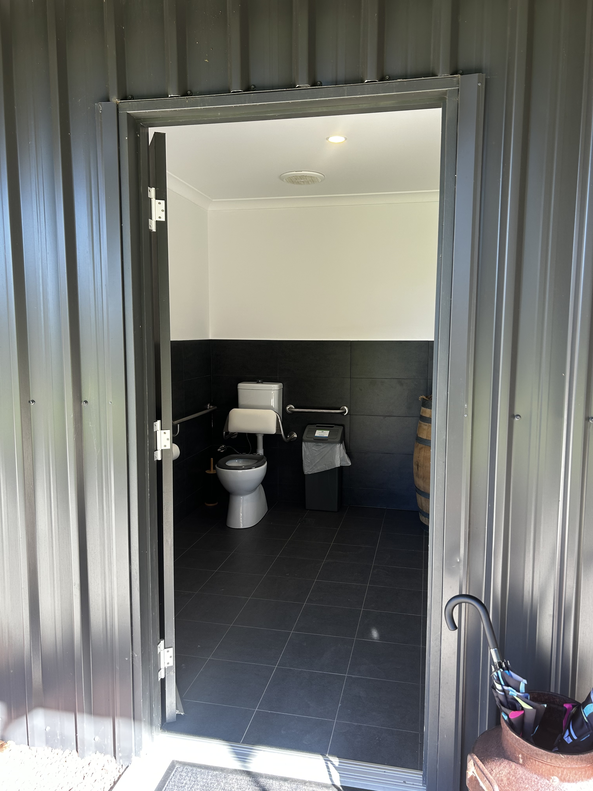
IMG_3164
IMG_3164
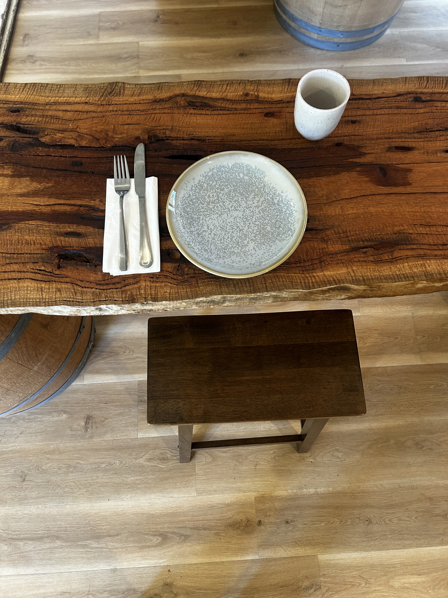
IMG_3167

Report Disclaimer
Please note that this business report, provided as a result of the use of the diagnostic assessment, is for information purposes only.
Australian Tourism Industry Council (ATIC) cannot guarantee the accuracy of respondent’s answers, or that they are fully representative of your business. Therefore, ATIC does not warrant or guarantee any particular outcome in respect of your businesses self-assessment.
This report is intended as guidance only for your business and should not be relied on for future marketing considerations. ATIC recommends that you seek your own independent advice as well as the results from the diagnostic.
Links to external web sites are inserted for convenience and do not constitute endorsement of material at those sites, or any associated organisation, product or service.
ATIC does not:
- Assume any legal liability for the accuracy, completeness, or usefulness of any information from this report or any links provided; or
- Accept responsibility for any loss associated directly or indirectly from the use of this report.

