ATIC Accessibility
To support the accessible community in making informed travel decisions for their individual needs

This report prepared for:
Business name: | AQWA The Aquarium of Western Australia
Address: | 91 Southside Drive
Town: | Hillarys
Contact for enquiries: | Glenn Shoebridge
Contact Number: | (08) 9447 7500
Contact Email: | reception@aqwa.com.au
Website: | www.aqwa.com.au
Date: | 2026-10-24 17:10

ATIC Accessibility
The following pages provides travellers with information on the businesses facilities and amenities which aims to support the traveller to make an informed decision on whether the business is suitable for their individual needs.
OVERVIEW 4
Business Overview 4
Bookings 4
Emergency Management 4
Other Information 5
Guide Dog and Service Animals 5
GENERAL 6
Pre-arrival, arrival and reception 6
Cognitive Impairment Support 6
Car Park and Access amenities 6
Entry 7
Lifts 7
Internal Spaces 7
Public areas 8
Displays, exhibits, commentary and live performances 8
External Paths 8
Steps 9
Ramps 9
Public Toilets/Adult change facilities 9
ATTRACTIONS 11
Attractions Basics 11
Zoos and Wildlife Parks 11
COMMON AREAS 13
FOOD AND DRINK 14
Dining Spaces 14
ADVENTURE ACTIVITIES 15
Report Disclaimer 17

OVERVIEW

Business Overview

The business has the following products/services available
- Attraction
- Food and Drink
- Adventure

Our business caters for the following disability types:
- Limited mobility
- Wheelchairs or mobility scooters
- Food allergies or intolerances
- Cognitive or people on the Autism Spectrum


Bookings

The business offers the following methods for bookings and enquiries:
- Phone
- Email
- Webportal
- Our website supports Screen Readers
- Our forms have high contract boxes and submit boxes

Emergency Management
- There are Audible device/s to alert occupants to evacuate with instructions on how to evacuate.
- Exit signs are clear and easy to see
- Exit access is free and clear at all times
We ensure exit access is free and clear at all times by:
Clearly marked emergency exit doors. Visitor services staff (Tour Guides, Operations Manager, Duty Managers) who actively direct groups to move on if gathering in access ways and who manage crowds during busy periods.
- Exits and access to exists are greater than 900mm
- Exit doors are able to be opened by all occupants
- Exits including stairwells, have bright edges used on the steps.
- In addition, the following further information can assist guests:
Assigned staff visually clear designated areas during an emergency. Priority assistance will be given to any patrons using wheelchairs/scooters/mobility aids or who appear unsure or unaware of the exit path.
- In addition, the following further information can assist guests:
Assigned staff visually clear designated areas during an emergency. They will use verbal and visual prompts (warden hats). Staff will direct wheelchair/scooter/mobility aid users to nearest emergency exit and in the case of fire/inability to use the lift, they will direct patrons to the designated refuge space to shelter in place. Emergency services have direct external access to this refuge.

Other Information
- For bookings made onsite, the ticket booth/counter/box office is accessible for people using a wheelchair
- The business accepts the companion card

Guide Dog and Service Animals
- The business provides a secure area with shade and water for service animals
The business provides the following services for services animals:
A public grassed area available for toileting that can be accessed before, during (with pass-out) or after accessing the building. Water and shade available at the Cafe Terrace within the building (no pass-out needed) for rest and hydration.

GENERAL

Pre-arrival, arrival and reception
The business has the following in place to support guests during pre-arrival, arrival and reception
- Booking information and websites are compatible with screen readers
- There is a reception/public entryway.
- Seating available at reception
- A clipboard to allow check-in/ticket purchase whilst seated
- A tablet with text to voice or pen and paper at reception to aid in communication
- Lighting in the reception area is even and glare free

Forms are not required for entry. Any forms required for additional/paid Experiences will be available online.
- Information and maps are available in written form
- Advertising material, web sites and social media contain information relating to phone numbers available for non-voice communication e: Text, SMS, email and fax

One access gate (to the outdoor Marina Bay zone) requires staff assistance to open.
- In addition, the following further information can assist guests:
Adjacent to Reception, both an indoor waiting space and a quiet, shaded outdoor waiting space are available.

Cognitive Impairment Support
- Documents are available in plain English for people with cognitive impairment (This may include instructions, guides, menus and general information)

Car Park and Access amenities
The business has the following Car Park and Access amenities
- A drop off zone
- Designated disabled parking bays
- Level or ramped access from the car park to the entrance
- The accessible entrance is clearly signed from the parking bay
- Kerb ramps are in place where a pavement or walkway needs to be crossed

Entry
The business has the following amenities/systems in place for entry
- A drop off point close to the entrance
- A path of access to the building is slip resistance and even
- A path of access to the building is clear of obstruction
- Self opening entry doors or fitted with a self closer
- Glass doors are fitted with a visual sighting strip
- Signage is written in a contrasting colour
- The entry door is a minimum of 850mm wide
- The entry door has self opening or a light opening pressure (for manual operations)
- The entrance sill is less than 13mm
- The entrance door mats have a thickness less than 13mm and a width of 7500mm or greater

Lifts
- Premises has lifts
- In addition, the following further information can assist guests:
Buttons are marked with braille.An emergency call-out phone is located within the lift.

Internal Spaces
- Clear and unobstructed routes through and between buildings
- Interior walls are matte or low sheen
- Floors, walls, counters and furniture are of contrasting colours
- Any protruding or overhanging obstructions are at least 2meters above the floor or are protected
- Floor surfaces are hard or short pile carpet
- Seating is available for guests unable to stand for long periods
- Accessible facilities are clearly signed and visible from all areas
- All corridors greater than 900mm
- In addition, the following further information can assist guests:
While there is no dedicated, enclosed 'quiet space', AQWA has particular exhibit areas suitable for sensory respite with seating. The Coral Reef underwater gallery, the Coral Reef viewing deck and the Marina Bay picnic area (weather permitting)are spaces guests may find useful.

Public areas
The public areas have the following amenities in place
- Seating

Displays, exhibits, commentary and live performances
For displays, exhibits, commentary and live performances the following amenities are in place
- Seating
- Wheelchair accessible spaces/seating

External Paths
External paths of travel
- Pathways are wider than 900mm

All essential pathways are flat or have ramps.
- Step free routes clearly signed
- In addition, the following further information can assist guests:
AQWA’s main entry and exit is accessible by ramp, to the right of the central stairwell. If possible, have someone assist you in using the ramp, as it is long and somewhat steep. An AQWA staff member will be happy to help if needed.

AQWA has one stepped landing that is not accessible by wheelchair/scooter: the Great Southern stairwell. However, the main lift takes wheelchair/scooter users from Upper Level to Lower Level, bypassing only this transitional landing.

AQWA has one area which is stepped and only accessible via an alternate route with staff assistance: boardwalk to Marina Bay ends with a viewing/waiting platform, or the stepped area can be accessed via an alternate routevia access gate with staff assistance.

Steps
Steps
- There are steps.
- Top and bottom steps are easily distinguished through colour contrast or the use of TGSIs (Tactile Ground Surface Indicators)
- All steps or staircases have enclosed risers
- The underside of all staircases are enclosed or protected to a height of at least 2 metres
- Handrails fitted to all open sets of steps
- Where steps are present are there three steps or less
- In addition, the following further information can assist guests:
AQWA’s main entry and exit is accessible by ramp, to the right of the central stairwell. If possible, have someone assist you in using the ramp, as it is long and somewhat steep. An AQWA staff member will be happy to help if needed.

AQWA’s Coral Reef Underwater Gallery is accessible by ramp, to the right of the central stairwell.

AQWA's Marina Bay picnic area is accessible by an access gate with staff assistance. Please flag an AQWA staff member who will be happy to help access the gate.

Ramps
Ramps have the following amenities are in place
- There are ramps.
- Hand rails are fitted

Public Toilets/Adult change facilities
Public Toilets/Adult change facilities have the following amenities are in place
- There is an accessible toilet for public use
- The door is at least 850mm wide
- There is a minimum of 850mm beside the toilet
- Handrails are fitted
- The toilet seat is 460mm above the floor
- The toilet seat is460mm above the floor

ATTRACTIONS

Attractions Basics
- A park map is available here:

https://www.aqwa.com.au/visit/

Zoos and Wildlife Parks
- Guide and service dogs are welcome
- In addition, the following further information can assist guests:
Full access to all public areas. No access to special behind the scenes or staff only areas such as kitchens, tanks.
- A secure area with shade and water for service dogs is available
- Displays have glass or mesh viewing panels for children or people seated in wheelchairs
- Signage is positioned between 800mm and 1200mm above the ground
- In addition, the following further information can assist guests:
No.
- Seating is provided at regular intervals
- Aviaries and other enclosures provide level access
- Airlocks provide sufficient room for a wheelchair
  - Image(s)
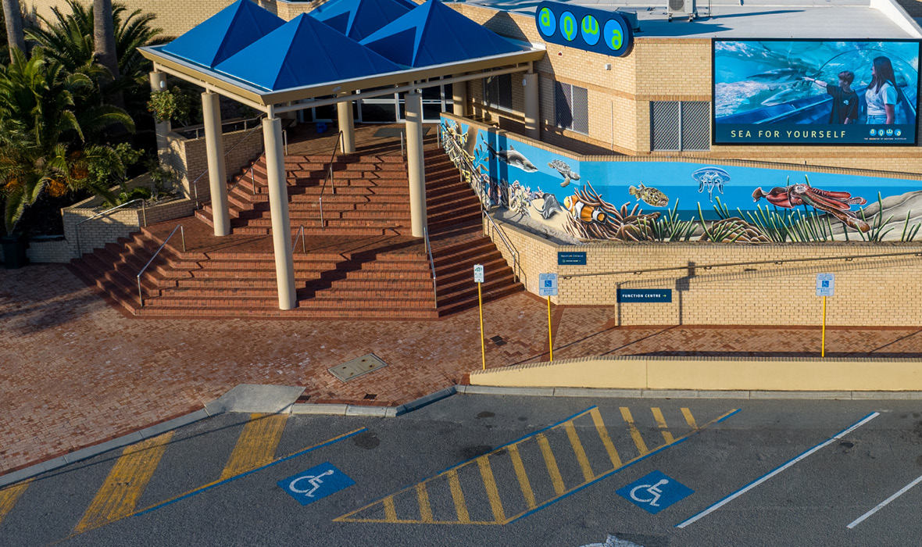
Car Park - ACROD Bays and Ramped Kurb Location
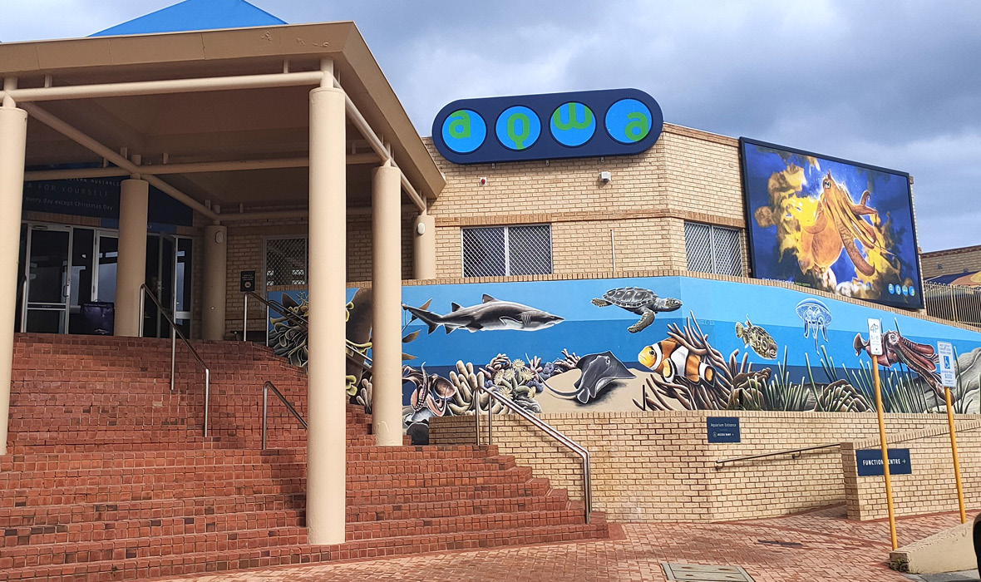
Entry and Exit - Main Stairwell and Ramp Entry

COMMON AREAS

FOOD AND DRINK

Dining Spaces
The dining spaces have the following facilities/amenities in place
- The entrance has level access
- The doorway is at least 850mm wide
- There is level access through the dining area
- Chairs are moveable to allow for wheelchairs to be seated at the tables
- All glass doors and full height windows have contrast markings
- There are areas of full lighting
- There are large print menus
- There are Plain English menus
- There is an accessible toilet

Our business caters for the following dietary requirements
- Gluten free (celiac)
- Lactose free (dairy free)
- Vegetarian
- Vegan
- Kosher
- Halal
- In addition, the following further information can assist guests:
Dedicated fryer and preparation station for gluten free and veg/vegan options. All meat is from a halal certified supplier. Milk alternatives available for drinks.

ADVENTURE ACTIVITIES

Report Disclaimer
Please note that this business report, provided as a result of the use of the diagnostic assessment, is for information purposes only.
Australian Tourism Industry Council (ATIC) cannot guarantee the accuracy of respondent’s answers, or that they are fully representative of your business. Therefore, ATIC does not warrant or guarantee any particular outcome in respect of your businesses self-assessment.
This report is intended as guidance only for your business and should not be relied on for future marketing considerations. ATIC recommends that you seek your own independent advice as well as the results from the diagnostic.
Links to external web sites are inserted for convenience and do not constitute endorsement of material at those sites, or any associated organisation, product or service.
ATIC does not:
- Assume any legal liability for the accuracy, completeness, or usefulness of any information from this report or any links provided; or
- Accept responsibility for any loss associated directly or indirectly from the use of this report.

