ATIC Accessibility
To support the accessible community in making informed travel decisions for their individual needs

This report prepared for:
Business name: | LL TRAVEL
Address: | 10 Emander Dr
Town: | Dianella
Contact for enquiries: | Chenglin Li
Contact Number: | 0451988169
Contact Email: | lltravel.wa@gmail.com
Website: | /
Date: | 2026-10-24 18:46

ATIC Accessibility
The following pages provides travellers with information on the businesses facilities and amenities which aims to support the traveller to make an informed decision on whether the business is suitable for their individual needs.
OVERVIEW 3
Business Overview 3
Bookings 4
Emergency Management 4
Guide Dog and Service Animals 4
GENERAL 5
Displays, exhibits, commentary and live performances 5
TOUR OPERATORS 6
Route Planning 6
Guides 6
Report Disclaimer 9

OVERVIEW

Business Overview

The business has the following products/services available
- Tour/Transport

Our business caters for the following disability types:
- Limited mobility
- Food allergies or intolerances
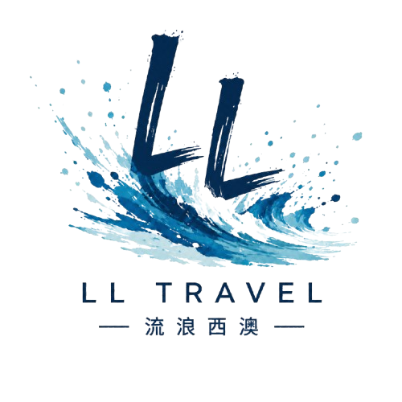

Bookings

The business offers the following methods for bookings and enquiries:
- Email

Emergency Management
- The business has an emergency management and evacuation plan for guests with a disability
- Emergency and evacuation procedures are explained on arrival
- Guests with disabilities are noted in the guest log book for emergency and evacuation purposes

Guide Dog and Service Animals
The business provides the following services for services animals:
Assistance animals are welcome on suitable tours and transport services. Guests travelling with an assistance animal are encouraged to contact LL Travel Pty Ltd before booking so we can discuss vehicle suitability, available space, itinerary pace, rest stops, shade and water arrangements. As LL Travel Pty Ltd operates mobile tour and charter services rather than a fixed venue, we do not provide a dedicated secure area or toilet area for service animals. Water can be provided upon request, and regular rest stops can be arranged during the journey where practical.

GENERAL
- In addition, the following further information can assist guests:
预订可通过电话、电子邮件或在线方式提前安排。由于我们不设公共售票处或现场接待处，客人无需在现场排队。行程时间、休息地点和游览节奏均可在出行前商定。

Displays, exhibits, commentary and live performances
For displays, exhibits, commentary and live performances the following amenities are in place
- In addition, the following further information can assist guests:
LL Travel Pty Ltd provides verbal tour commentary during private tours, charter transport and small group travel experiences. We do not currently provide wheelchair accessible vehicle spaces, hearing loops or written transcripts of tour commentary.

Guests with hearing, mobility or communication requirements are encouraged to contact us before booking so we can discuss suitable communication methods, vehicle access, itinerary pace and rest stop arrangements. Written information can be provided by email, SMS or WeChat where practical.
The width of the smallest pathway is:
LL Travel Pty Ltd does not own or operate fixed public pathways, visitor facilities or attraction premises. Tours may visit public attractions, national parks, beaches, lookouts and regional locations where pathway surfaces, gradients, steps and accessibility conditions vary. Guests with mobility requirements are encouraged to contact us before booking so we can discuss the suitability of planned stops.

LL Travel Pty Ltd does not own or operate fixed public pathways, visitor facilities or attraction premises. Tours may visit public attractions, national parks, beaches, lookouts and regional locations where pathway surfaces, gradients, steps and accessibility conditions vary. Guests with mobility requirements are encouraged to contact us before booking so we can discuss the suitability of planned stops.

LL Travel Pty Ltd does not own or operate fixed public pathways, visitor facilities or attraction premises. Tours may visit public attractions, national parks, beaches, lookouts and regional locations where pathway surfaces, gradients, steps and accessibility conditions vary. Guests with mobility requirements are encouraged to contact us before booking so we can discuss the suitability of planned stops.

TOUR OPERATORS

Route Planning
- Route Planning
- In addition, the following further information can assist guests:
LL Travel Pty Ltd does not provide an accessible toilet on board the vehicle and does not operate as a specialist accessible tour provider. Many tours travel to regional and remote areas of Western Australia, including national parks, beaches, lookouts, roadside stops and natural attractions. Accessibility conditions, including accessible toilets, sealed pathways, ramps, level access and suitable parking, may be limited or unavailable at some locations, particularly in remote areas. Guests with accessibility requirements are encouraged to contact us before booking so we can discuss the proposed itinerary, vehicle access, walking distances, rest stops and whether the tour is suitable for their individual needs.

- Overnight Stops
The total number of wheelchair passengers that can be catered for at overnight stops are:
0
- Walking Tours

Guides

Guides have been trained in the following
- Use of clear/simple English
- In addition, the following further information can assist guests:
Tour stops vary depending on the confirmed itinerary. Examples of third-party attractions, facilities and service providers may include:
DBCA / Explore Parks WA — exploreparks.dbca.wa.gov.au
Nambung National Park / Pinnacles Desert — exploreparks.dbca.wa.gov.au
Kalbarri National Park — exploreparks.dbca.wa.gov.au
Rottnest Island / Wadjemup — rottnestisland.com
Busselton Jetty — busseltonjetty.com.au
Local cafes, restaurants, accommodation providers, visitor centres, roadhouses, public toilets and rest stops depending on the route and destination.
These locations and providers are not owned or operated by LL Travel Pty Ltd.
- In addition, the following further information can assist guests:
Tours may include stops at public attractions, national parks, beaches, lookouts, cafes, restaurants, accommodation providers, visitor centres, roadhouses, public toilets, rest stops and other third-party locations that are not owned or operated by LL Travel Pty Ltd.
Accessibility features, toilets, pathways, parking, ramps, seating, step-free access and other facilities at these locations may vary and may be limited or unavailable in some regional or remote areas of Western Australia. Guests with accessibility requirements are encouraged to contact us before booking so we can discuss the proposed itinerary, vehicle access, walking distances, rest stops and whether the tour is suitable for their individual needs.

Report Disclaimer
Please note that this business report, provided as a result of the use of the diagnostic assessment, is for information purposes only.
Australian Tourism Industry Council (ATIC) cannot guarantee the accuracy of respondent’s answers, or that they are fully representative of your business. Therefore, ATIC does not warrant or guarantee any particular outcome in respect of your businesses self-assessment.
This report is intended as guidance only for your business and should not be relied on for future marketing considerations. ATIC recommends that you seek your own independent advice as well as the results from the diagnostic.
Links to external web sites are inserted for convenience and do not constitute endorsement of material at those sites, or any associated organisation, product or service.
ATIC does not:
- Assume any legal liability for the accuracy, completeness, or usefulness of any information from this report or any links provided; or
- Accept responsibility for any loss associated directly or indirectly from the use of this report.

