ATIC Accessibility
To support the accessible community in making informed travel decisions for their individual needs

This report prepared for:
Business name: | The Pickers Hut
Address: | 1329 Elderslie Road
Town: | Broadmarsh
Contact for enquiries: | Courtney Bell
Contact Number: | 0418129344
Contact Email: | enquiries@invercarronfarm.com.au
Website: | https://www.thepickershut.com.au/
Date: | 2026-09-21 21:50

ATIC Accessibility
The following pages provides travellers with information on the businesses facilities and amenities which aims to support the traveller to make an informed decision on whether the business is suitable for their individual needs.
OVERVIEW 4
Business Overview 4
Bookings 4
Communications 5
Guide Dog and Service Animals 5
GENERAL 6
Pre-arrival, arrival and reception 6
Cognitive Impairment Support 6
Car Park and Access amenities 6
Entry 6
Internal Spaces 7
Public areas 7
External Paths 7
Steps 8
ACCOMMODATION 9
Bedrooms 9
Room Amenities 9
Bathrooms 10
COMMON AREAS 11
FOOD AND DRINK 12
Dining Spaces 12
EVENTS 13
Events 13
Report Disclaimer 15

OVERVIEW

Business Overview

The business has the following products/services available
- Accommodation
- Food and Drink
- Event

Our business caters for the following disability types:
- Blind or low vision
- Deaf or low hearing
- Limited mobility
- Wheelchairs or mobility scooters
- Food allergies or intolerances
- Cognitive or people on the Autism Spectrum
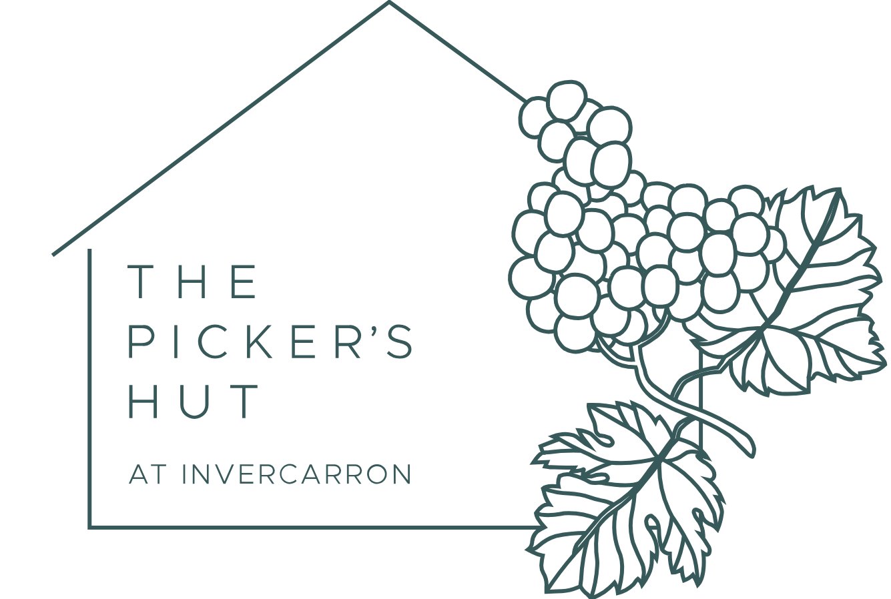

Bookings

The business offers the following methods for bookings and enquiries:
- Phone
- Email
- Webportal
- Our website supports Screen Readers
- Our forms have high contract boxes and submit boxes

Communications
- Our website meets WCAG 2.0 accessibility standards
- Our business offers the following alternative communication methods
- Plain English

Not specified
- There is easy to read signage and information (e.g. menus and emergency information)

Guide Dog and Service Animals
- The business provides a secure area with shade and water for service animals
- The business provides a toilet area for service animals
- Bowls, bedding, etc. are provided for service animals
The business provides the following services for services animals:
The hut is located on a farm so plenty of space, and we can provide water bowls.

GENERAL

Pre-arrival, arrival and reception
The business has the following in place to support guests during pre-arrival, arrival and reception
- Booking information and websites are compatible with screen readers
- Information and maps are available in written form
- A familiarisation tour
- In addition, the following further information can assist guests:
N/A - we are a single building with no reception.
- In addition, the following further information can assist guests:
There is always someone available to talk to if required.

Cognitive Impairment Support
- Documents are available in plain English for people with cognitive impairment (This may include instructions, guides, menus and general information)
- A space for parents and children on the Autism Spectrum

Car Park and Access amenities
The business has the following Car Park and Access amenities
- A drop off zone
- In addition, the following further information can assist guests:
The hut is located in a vineyard on a working farm. We are a single stand alone building with plenty of parking surrounding the hut.

Entry
The business has the following amenities/systems in place for entry
- A drop off point close to the entrance
- A path of access to the building is slip resistance and even
- A path of access to the building is clear of obstruction
- Glass doors are fitted with a visual sighting strip
- Door jams/doors are of a contrasting colour to surrounding walls
- Door handles are of a contrasting colour to the door
- Signage is written in a contrasting colour
- The entry door is a minimum of 850mm wide
- The entrance sill is less than 13mm
- There a clear space of at least 1500mm x 1500mm in front of all doors.
- The entrance door mats have a thickness less than 13mm and a width of 7500mm or greater
- In addition, the following further information can assist guests:
We are a single site, single storey building.

Internal Spaces
- Clear and unobstructed routes through and between buildings
- Interior walls are matte or low sheen
- Floors, walls, counters and furniture are of contrasting colours
- Any protruding or overhanging obstructions are at least 2meters above the floor or are protected
- Tableware/glassware contrast with the table surface or table cloth
- Floor surfaces are hard or short pile carpet
- Seating is available for guests unable to stand for long periods
- All corridors greater than 900mm
- There is a quiet space for parents and children on the Autism Spectrum
- In addition, the following further information can assist guests:
We are a single site, single storey building set on a farm, and the whole area is quiet.

Public areas
The public areas have the following amenities in place
- Even lighting
- In addition, the following further information can assist guests:
There are no public areas, as it is a single site building.

External Paths
External paths of travel
- Surfaces are concrete, asphalt, smooth paving or hard packed fine gravel (max aggregate size 13mm)
- Pathways are wider than 900mm
- In addition, the following further information can assist guests:
There is one step at the front door and two steps into the building at the deck to the side.

Steps
Steps
- There are steps.
- The underside of all staircases are enclosed or protected to a height of at least 2 metres
- Where steps are present are there three steps or less

ACCOMMODATION

Bedrooms
The bedrooms have the following facilities/amenities in place
- There are 2 rooms available to guests who use a wheelchair
- Bedroom furniture can be re-arranged on request
  - Layout of room Image(s)
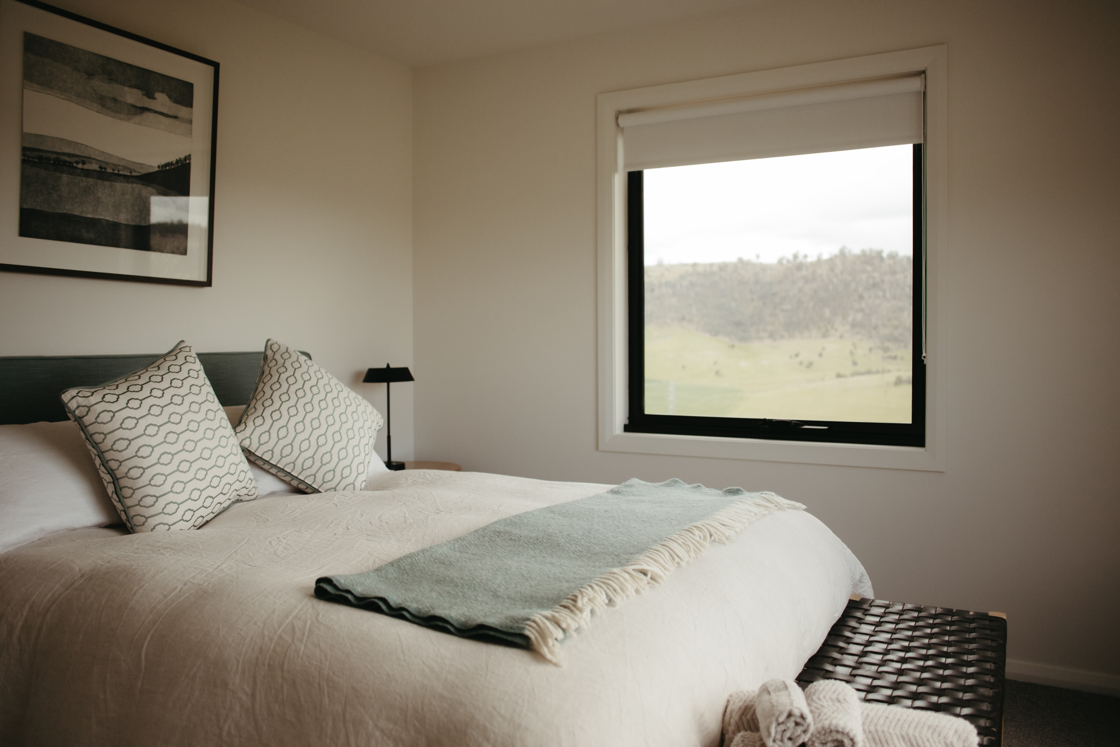
AMP-9404

Room Amenities
- Lower hanging rails are in wardrobes
- In addition, the following further information can assist guests:
The emergency procedures are on the back of the toilet door, and there are multiple exits.
- Televisions are equipped with closed captioning capability
- There is contrast between the walls, skirtings, floor and furniture
- There is a clear path through the room
- The edges of all furniture and fixtures are rounded
- Wardrobe handles are a contrasting colour to the doors and draws
- Housekeeping procedures instruct staff not to reposition furniture that has been moved
- Doors open fully against the adjoining wall
- There is a clear opening at least 850mm wide
- There luggage racks for at least two suitcases
- Wardrobe and drawer handles are easy to grip
- The bedside lamp switch is easy to reach from the bed
- There is at least 850mm clear space beside the bed
- The business offers a range of non-allergenic bedding

Bathrooms
The bathrooms have the following facilities/amenities in place
- All heating appliances and hot water pipes are protected or insulated
- All shower, bath and basin taps are clearly differentiated between hot and cold
- Fixtures and fittings have rounded edges
- The hot water is thermostatically controlled to 41 degrees
- The door is at least 850mm wide
- The width beside the toilet is NA.
- There is a minimum of 1400mm of clear space in front of the toilet
- The toilet seat is a contrasting colour to the floor
- The toilet seat is 460mm above the floor
- There is a portable shower head on flexible hose
  - Bathroom Image(s)
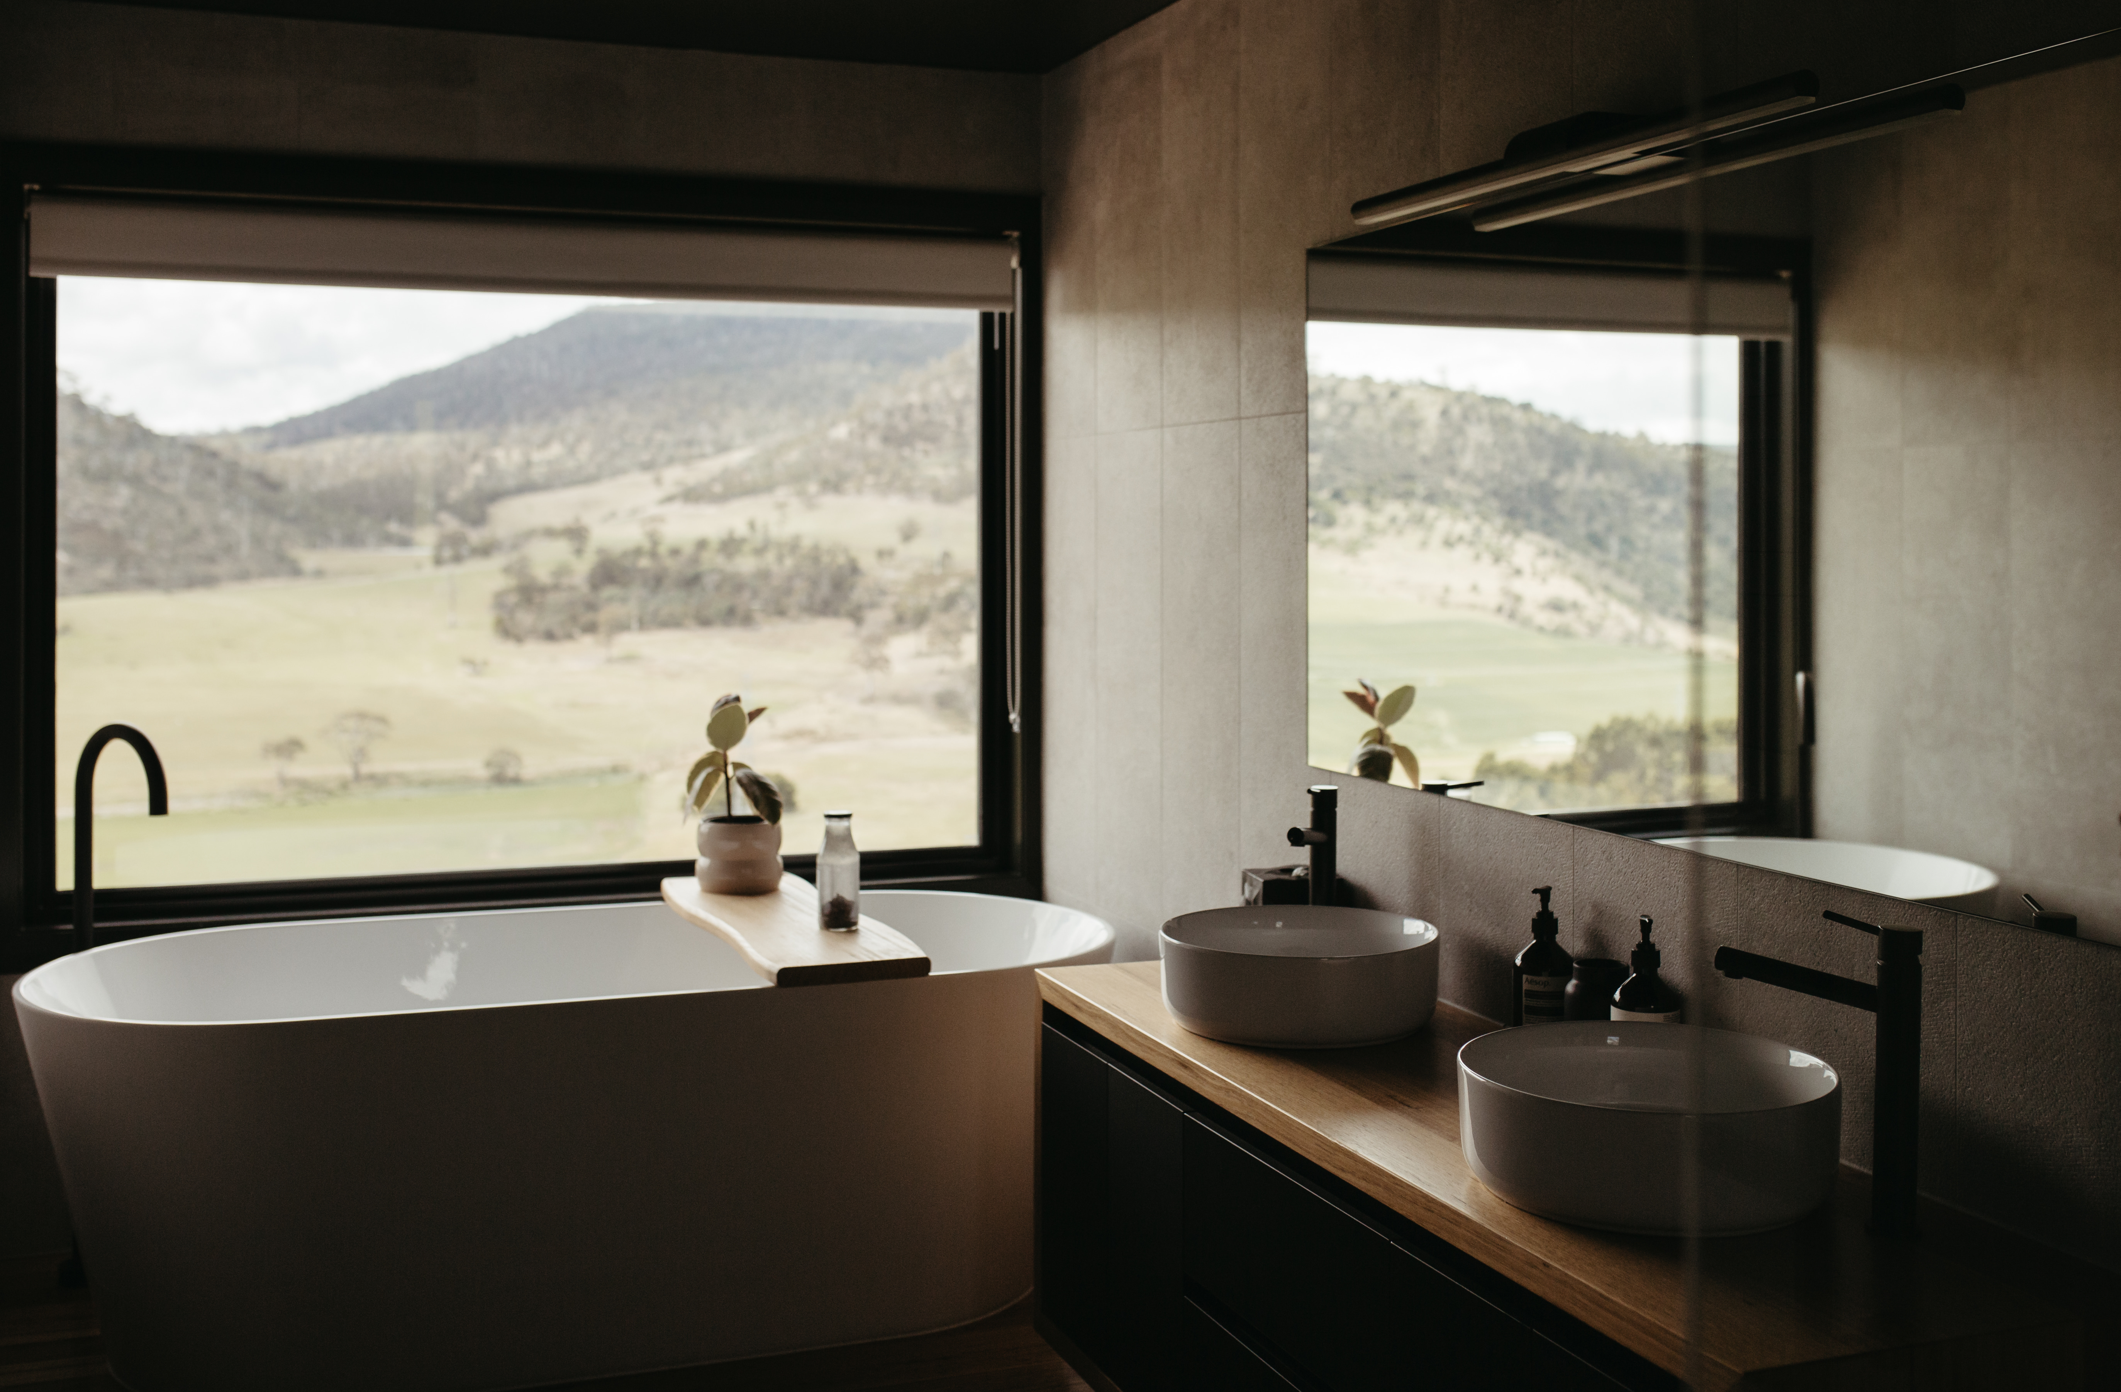
AMP-0101

COMMON AREAS

FOOD AND DRINK

Dining Spaces
The dining spaces have the following facilities/amenities in place
- The doorway is at least 850mm wide
- There is level access through the dining area
- Chairs are moveable to allow for wheelchairs to be seated at the tables
- All glass doors and full height windows have contrast markings
- There are areas of full lighting

Our business caters for the following dietary requirements
- Sugar free (diabetic)
- Gluten free (celiac)
- Lactose free (dairy free)
- Low fat and fibre with no gastric content
- Nut free
- Additive free
- Vegetarian
- Vegan
- In addition, the following further information can assist guests:
All food is packaged separately.
  - Food and Beverage Image(s)
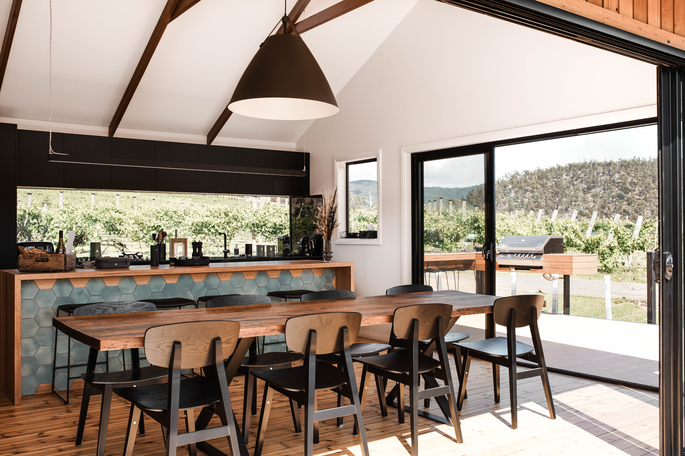
Kitchen

EVENTS

Events
Events have the following facilities/amenities in place
- There is good circulation space with the number of people expected to allow people with a disability to move around freely
- Food and water is available for guide and service animals
- The event is outdoors
- Portable accessible toilets are available
- Seating is at regular intervals
- Accessible car parking is available
- There are designated drop-off points
- In addition, the following further information can assist guests:
We only hold two public events per year; Southern Open Vineyards in March, and Spring in the Vines in November. We are located on a working farm and vineyard, which means uneven access at times. We will always try our best to make space for wheelchairs and people with accessibility issues. Please call us to discuss.

Report Disclaimer
Please note that this business report, provided as a result of the use of the diagnostic assessment, is for information purposes only.
Australian Tourism Industry Council (ATIC) cannot guarantee the accuracy of respondent’s answers, or that they are fully representative of your business. Therefore, ATIC does not warrant or guarantee any particular outcome in respect of your businesses self-assessment.
This report is intended as guidance only for your business and should not be relied on for future marketing considerations. ATIC recommends that you seek your own independent advice as well as the results from the diagnostic.
Links to external web sites are inserted for convenience and do not constitute endorsement of material at those sites, or any associated organisation, product or service.
ATIC does not:
- Assume any legal liability for the accuracy, completeness, or usefulness of any information from this report or any links provided; or
- Accept responsibility for any loss associated directly or indirectly from the use of this report.

