ATIC Accessibility
To support the accessible community in making informed travel decisions for their individual needs

This report prepared for:
Business name: | Tasman Sea Salt
Address: | 97 Mayfield Jetty Road
Town: | Little Swanport
Contact for enquiries: | Alice Laing
Contact Number: | 0417282026
Contact Email: | info@tasmanseasalt.com.au
Website: | www.tasmanseasalt.com.au
Date: | 2026-10-04 21:14

ATIC Accessibility
The following pages provides travellers with information on the businesses facilities and amenities which aims to support the traveller to make an informed decision on whether the business is suitable for their individual needs.
OVERVIEW 4
Business Overview 4
Bookings 4
Emergency Management 5
Communications 5
Other Information 6
Guide Dog and Service Animals 6
GENERAL 7
Pre-arrival, arrival and reception 7
Cognitive Impairment Support 7
Car Park and Access amenities 7
Entry 7
Internal Spaces 8
Public areas 8
External Paths 8
Public Toilets/Adult change facilities 9
FOOD AND DRINK 10
Dining Spaces 10
Report Disclaimer 13

OVERVIEW

Business Overview

The business has the following products/services available
- Food and Drink

Our business caters for the following disability types:
- Blind or low vision
- Deaf or low hearing
- Limited mobility
- Wheelchairs or mobility scooters
- Food allergies or intolerances
- Cognitive or people on the Autism Spectrum
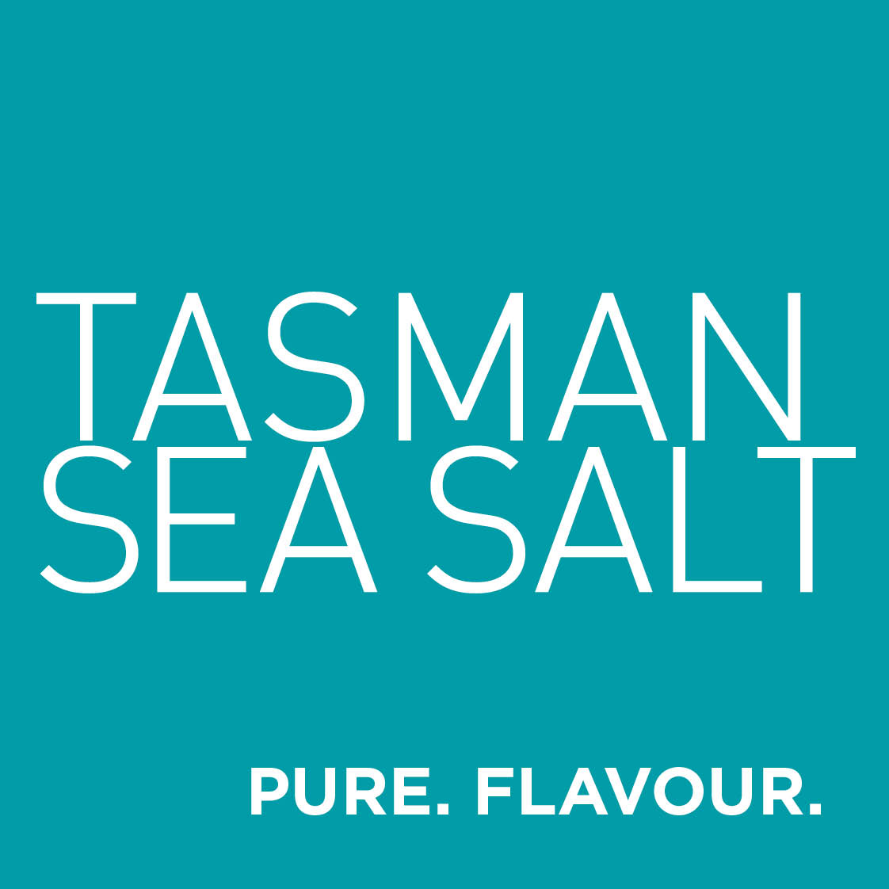

Bookings

The business offers the following methods for bookings and enquiries:
- Phone
- Email
- Webportal
- Our website supports Screen Readers
- Our forms have high contract boxes and submit boxes
- Staff have undergone disability awareness and training

Emergency Management
- The business has an emergency management and evacuation plan for guests with a disability
- Emergency and evacuation procedures are explained on arrival
- Guests with disabilities are noted in the guest log book for emergency and evacuation purposes

Communications
- An accessibility guide is available on the website

https://tasmanseasalt.com.au/pages/tours-tastings
- Our website meets WCAG 2.0 accessibility standards
- Our business offers the following alternative communication methods
- Plain English
- Magnifiers

Signs and price lists printed in large fonts. Verbal descriptions available.
- There is easy to read signage and information (e.g. menus and emergency information)

Yes. Tasman Sea Salt provides alternative communication aids including written communication pads, large print information sheets, visual cue cards, communication preference cards and staff-supported flexible communication methods. Additional supports are available on request.

Other Information
- For bookings made onsite, the ticket booth/counter/box office is accessible for people using a wheelchair

Guide Dog and Service Animals
- The business provides a secure area with shade and water for service animals
- The business provides a toilet area for service animals
The business provides the following services for services animals:
Service animals welcome onsite and on the experience. Water bowls, shade provided.

GENERAL

Pre-arrival, arrival and reception
The business has the following in place to support guests during pre-arrival, arrival and reception
- Booking information and websites are compatible with screen readers
- Information and maps are available in written form
- A familiarisation tour
- In addition, the following further information can assist guests:
All Tasman Sea Salt tours and tastings are small group experiences lasting between 45 - 75 minutes. Tasman Sea Salt recognises that some guests experience fatigue related to disability or health conditions. To reduce disadvantage from wait times, seating is available during check-in and prior to tours, tours aim to commence on time, guests are advised of any delays, and flexible pacing/rest opportunities are available during the experience. Modified or shortened experiences can also be offered where practical.

Cognitive Impairment Support
- Documents are available in plain English for people with cognitive impairment (This may include instructions, guides, menus and general information)
- Quiet periods or early opening times for people on the Autism Spectrum
- A space for parents and children on the Autism Spectrum

Car Park and Access amenities
The business has the following Car Park and Access amenities
- A drop off zone
- Designated disabled parking bays
- Level or ramped access from the car park to the entrance
- The accessible entrance is clearly signed from the parking bay

Entry
The business has the following amenities/systems in place for entry
- A drop off point close to the entrance
- A path of access to the building is slip resistance and even
- A path of access to the building is clear of obstruction
- Glass doors are fitted with a visual sighting strip
- Door jams/doors are of a contrasting colour to surrounding walls
- Door handles are of a contrasting colour to the door
- Signage is written in a contrasting colour
- Signage is written in a Sans Serif font and use upper and lower case letters
- The entry door is a minimum of 850mm wide
- The entry door has self opening or a light opening pressure (for manual operations)
- The entrance sill is less than 13mm
- There a clear space of at least 1500mm x 1500mm in front of all doors.

Internal Spaces
- Clear and unobstructed routes through and between buildings
- Interior walls are matte or low sheen
- Floors, walls, counters and furniture are of contrasting colours
- Tableware/glassware contrast with the table surface or table cloth
- Floor surfaces are hard or short pile carpet
- Seating is available for guests unable to stand for long periods
- Accessible facilities are clearly signed and visible from all areas
- All corridors greater than 900mm
- There is a quiet space for parents and children on the Autism Spectrum

Public areas
The public areas have the following amenities in place
- Even lighting
- Seating

External Paths
External paths of travel
- Surfaces are concrete, asphalt, smooth paving or hard packed fine gravel (max aggregate size 13mm)
- Pathways are wider than 900mm
- There 3 successive steps or less on any path or at any doorway

Tasman Sea Salt is fully step free

Public Toilets/Adult change facilities
Public Toilets/Adult change facilities have the following amenities are in place
- There is an accessible toilet for public use
- The door is at least 850mm wide
- There is a minimum of 850mm beside the toilet
- Handrails are fitted
- The toilet seat is 460mm above the floor
- There is 3m mm of clear space in front of the toilet
- The toilet seat of a contrasting colour to the floor
- The toilet seat is460mm above the floor

FOOD AND DRINK

Dining Spaces
The dining spaces have the following facilities/amenities in place
- The entrance has level access
- The doorway is at least 850mm wide
- There is level access through the dining area
- Chairs are moveable to allow for wheelchairs to be seated at the tables
- All glass doors and full height windows have contrast markings
- There are areas of full lighting
- There are large print menus
- There are Plain English menus
- There is an accessible toilet

Our business caters for the following dietary requirements
- Sugar free (diabetic)
- Gluten free (celiac)
- Lactose free (dairy free)
- Nut free
- Additive free
- Vegetarian
- Vegan
- In addition, the following further information can assist guests:
We adhere to a strict food safety policy and have Food Safety Supervisor accreditation. All foods are stored separately and prepared separately using different equipment.
  - Food and Beverage Image(s)
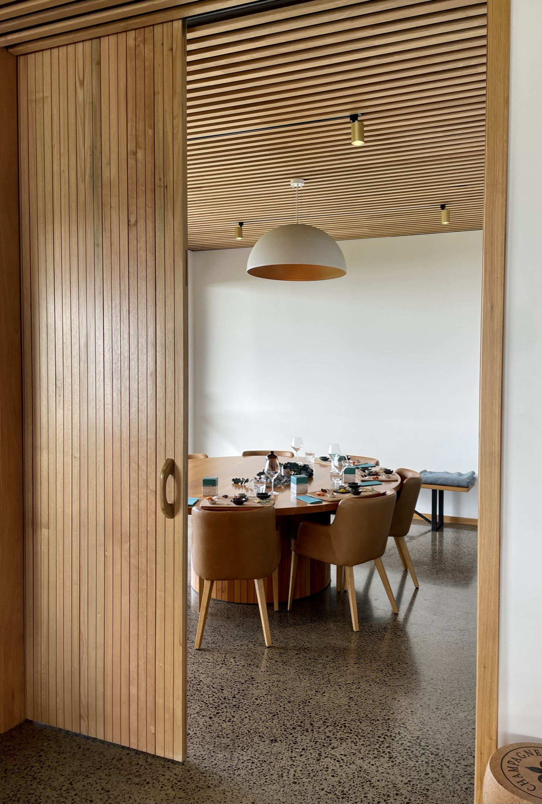
IMG_1932.JPEG
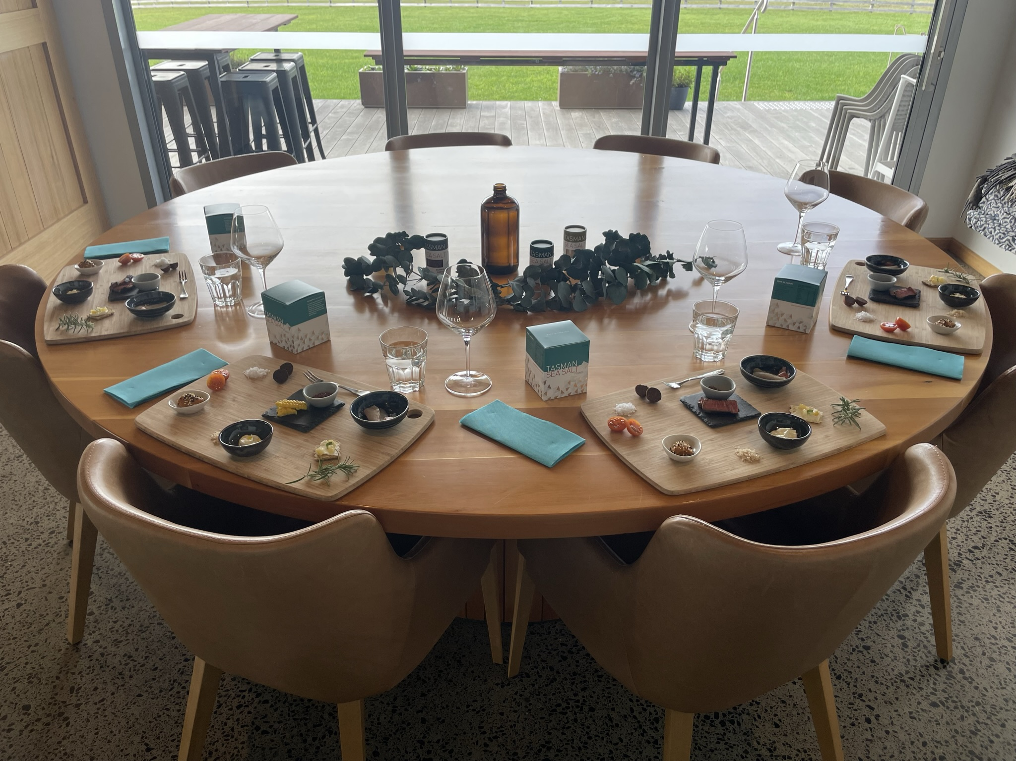
IMG_1924.JPEG

Report Disclaimer
Please note that this business report, provided as a result of the use of the diagnostic assessment, is for information purposes only.
Australian Tourism Industry Council (ATIC) cannot guarantee the accuracy of respondent’s answers, or that they are fully representative of your business. Therefore, ATIC does not warrant or guarantee any particular outcome in respect of your businesses self-assessment.
This report is intended as guidance only for your business and should not be relied on for future marketing considerations. ATIC recommends that you seek your own independent advice as well as the results from the diagnostic.
Links to external web sites are inserted for convenience and do not constitute endorsement of material at those sites, or any associated organisation, product or service.
ATIC does not:
- Assume any legal liability for the accuracy, completeness, or usefulness of any information from this report or any links provided; or
- Accept responsibility for any loss associated directly or indirectly from the use of this report.

