ATIC Accessibility
To support the accessible community in making informed travel decisions for their individual needs

This report prepared for:
Business name: | Two Hands Wines
Address: | 273 Neldner Road
Town: | Marananga
Contact for enquiries: | Luke Willis
Contact Number: | 08 8568 7907
Contact Email: | luke@twohandswines.com
Website:
Date: | 2026-10-15 08:58

ATIC Accessibility
The following pages provides travellers with information on the businesses facilities and amenities which aims to support the traveller to make an informed decision on whether the business is suitable for their individual needs.
OVERVIEW 4
Business Overview 4
Bookings 4
Emergency Management 5
Communications 5
Guide Dog and Service Animals 5
GENERAL 6
Pre-arrival, arrival and reception 6
Cognitive Impairment Support 6
Car Park and Access amenities 6
Entry 6
Internal Spaces 7
Public areas 7
External Paths 7
Steps 7
Public Toilets/Adult change facilities 7
FOOD AND DRINK 9
Dining Spaces 9
Report Disclaimer 14

OVERVIEW

Business Overview

The business has the following products/services available
- Food and Drink

Our business caters for the following disability types:
- Limited mobility
- Wheelchairs or mobility scooters
- Food allergies or intolerances

Bookings

The business offers the following methods for bookings and enquiries:
- Phone
- Email
- Webportal
- Our website supports Screen Readers
- Our forms have high contract boxes and submit boxes

Emergency Management
- Exit signs are clear and easy to see
- Exit access is free and clear at all times
We ensure exit access is free and clear at all times by:
Standard Operating Procedure
- Exits and access to exists are greater than 900mm
- Exit doors are able to be opened by all occupants
- Exits to the emergency evacuation point does not include stairways
- In addition, the following further information can assist guests:
No such procedure in place
- In addition, the following further information can assist guests:
No such procedure in place

Communications
- Our website meets WCAG 2.0 accessibility standards

Guide Dog and Service Animals
- The business provides a secure area with shade and water for service animals
- Bowls, bedding, etc. are provided for service animals
The business provides the following services for services animals:
Not specified

GENERAL

Pre-arrival, arrival and reception
The business has the following in place to support guests during pre-arrival, arrival and reception
- Booking information and websites are compatible with screen readers
- In addition, the following further information can assist guests:
NA

Cognitive Impairment Support
- Documents are available in plain English for people with cognitive impairment (This may include instructions, guides, menus and general information)

Car Park and Access amenities
The business has the following Car Park and Access amenities
- A drop off zone
- Designated disabled parking bays
- Level or ramped access from the car park to the entrance
- Kerb ramps are in place where a pavement or walkway needs to be crossed

Entry
The business has the following amenities/systems in place for entry
- A drop off point close to the entrance
- A path of access to the building is slip resistance and even
- A path of access to the building is clear of obstruction
- Door handles are of a contrasting colour to the door
- Signage is written in a contrasting colour
- The entry door is a minimum of 850mm wide
- There a clear space of at least 1500mm x 1500mm in front of all doors.

Internal Spaces
- Clear and unobstructed routes through and between buildings
- Interior walls are matte or low sheen
- Floors, walls, counters and furniture are of contrasting colours
- Tableware/glassware contrast with the table surface or table cloth
- Floor surfaces are hard or short pile carpet
- Seating is available for guests unable to stand for long periods
- Accessible facilities are clearly signed and visible from all areas
- All corridors greater than 900mm

Public areas
The public areas have the following amenities in place
- Even lighting
- Seating

External Paths
External paths of travel
- Surfaces are concrete, asphalt, smooth paving or hard packed fine gravel (max aggregate size 13mm)
- Paths or slopes longer than 15 metres have resting places or seats
- Pathways are wider than 900mm
- There 3 successive steps or less on any path or at any doorway

Steps
Steps
- There are steps.

Public Toilets/Adult change facilities
Public Toilets/Adult change facilities have the following amenities are in place
- There is an accessible toilet for public use
- The door is at least 850mm wide
- There is a minimum of 850mm beside the toilet
- Handrails are fitted
- The toilet seat is 460mm above the floor
- The toilet seat of a contrasting colour to the floor
- The toilet seat is460mm above the floor
- There is a registered changing places facility
- There is a 'Changing Place' within Not specified of our business

FOOD AND DRINK

Dining Spaces
The dining spaces have the following facilities/amenities in place
- The doorway is at least 850mm wide
- There is level access through the dining area
- Chairs are moveable to allow for wheelchairs to be seated at the tables
- All glass doors and full height windows have contrast markings
- There are areas of full lighting
- There are Plain English menus
- There is an accessible toilet

Our business caters for the following dietary requirements
- Sugar free (diabetic)
- Gluten free (celiac)
- Lactose free (dairy free)
- Low fat and fibre with no gastric content
- Low potassium
- Nut free
- Vegetarian
- Vegan
- Kosher
- Halal
- In addition, the following further information can assist guests:
Standard operating procedure in place, separate cutting boards and knives used.
  - Food and Beverage Image(s)
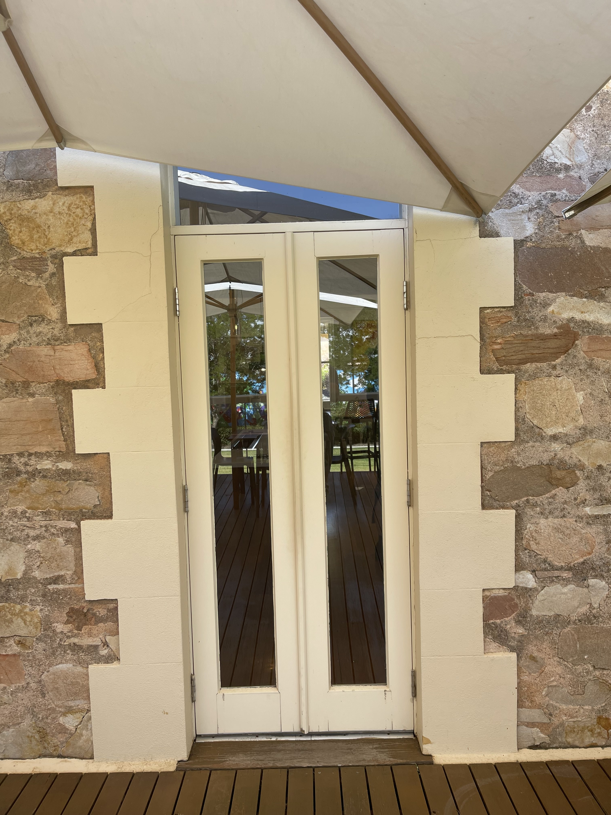
IMG_0931
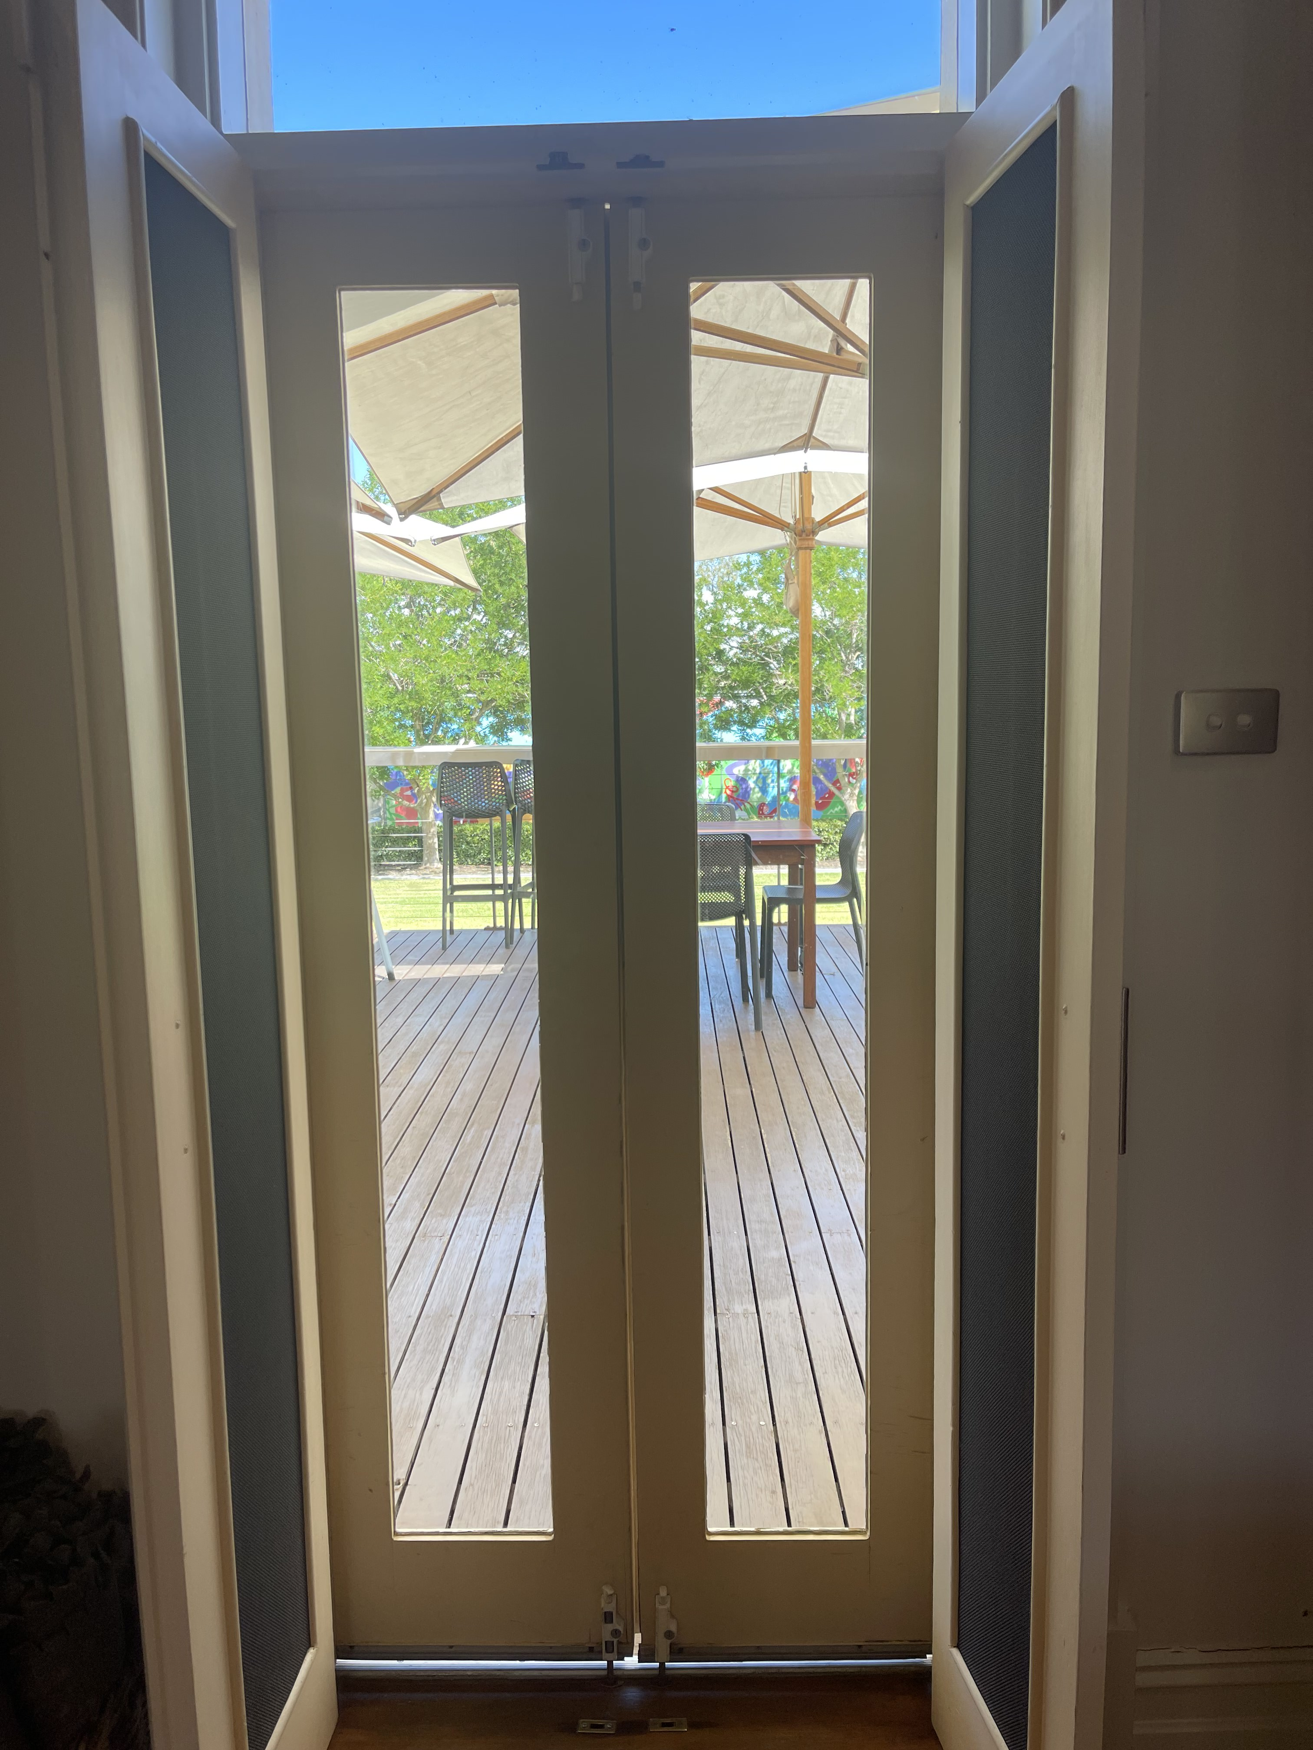
IMG_0929
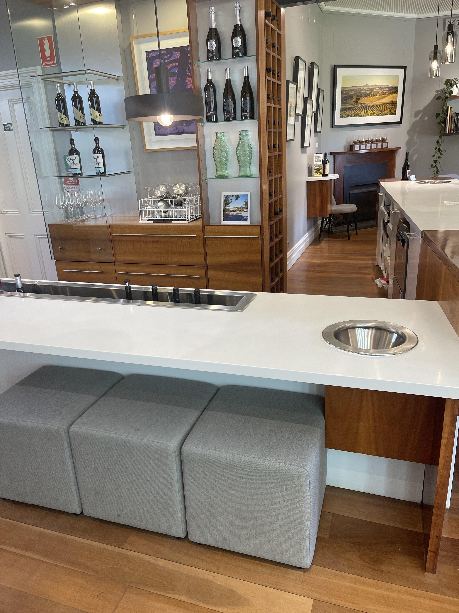
IMG_0928
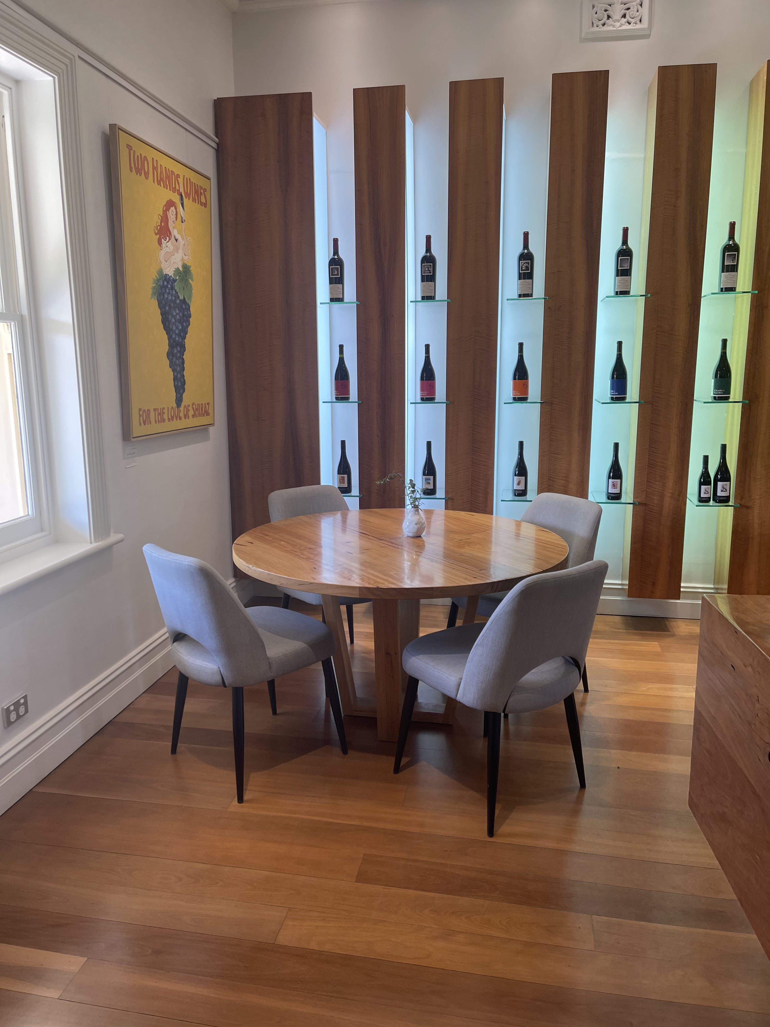
IMG_0927
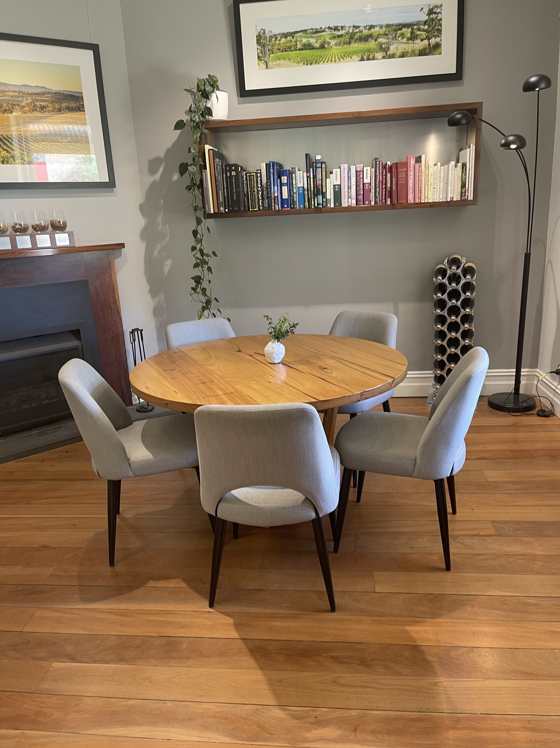
IMG_0926
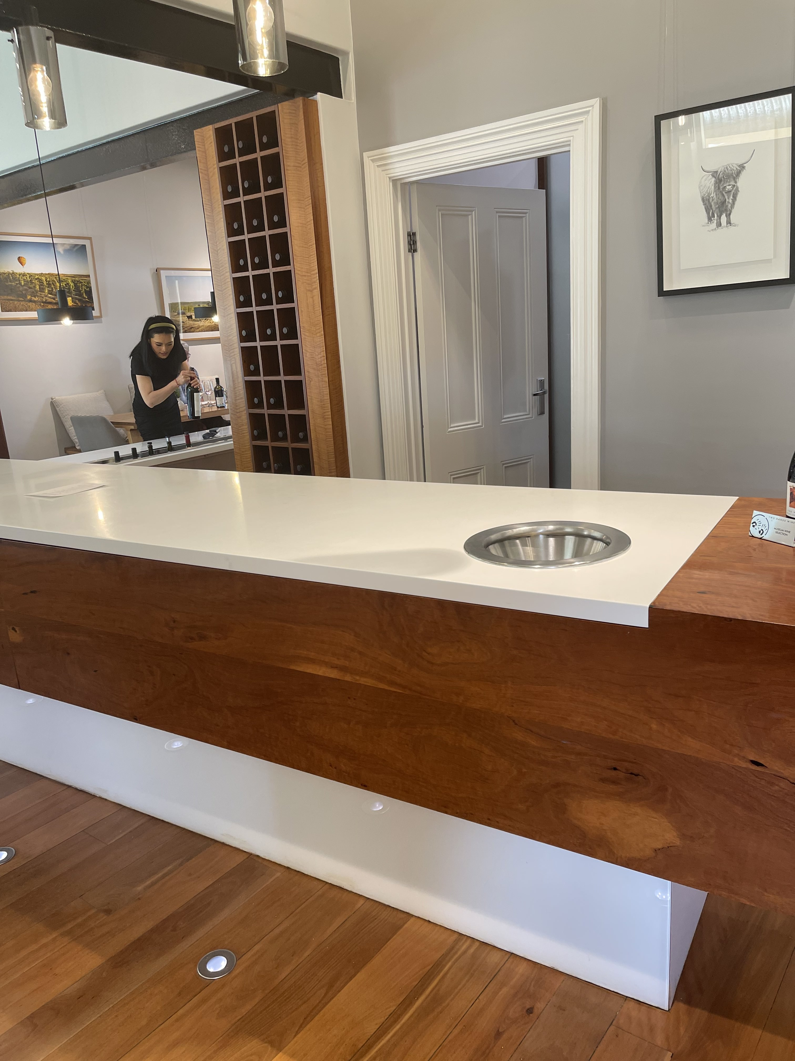
IMG_0925
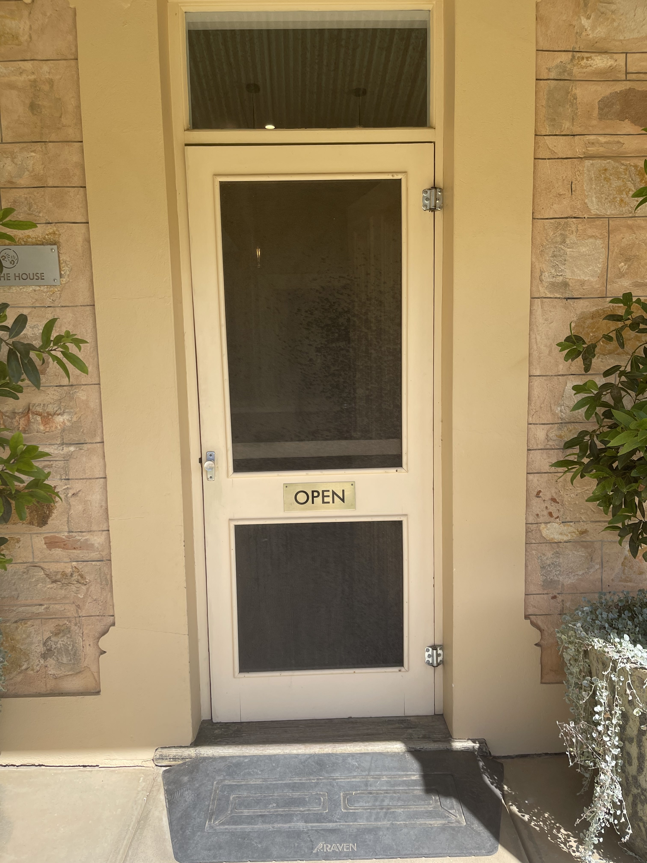
IMG_0924
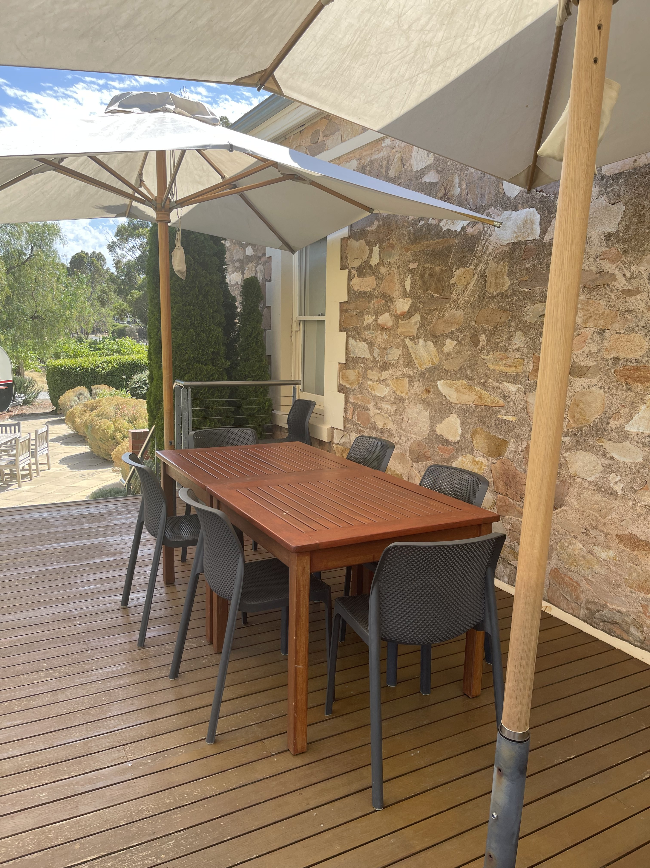
IMG_0932
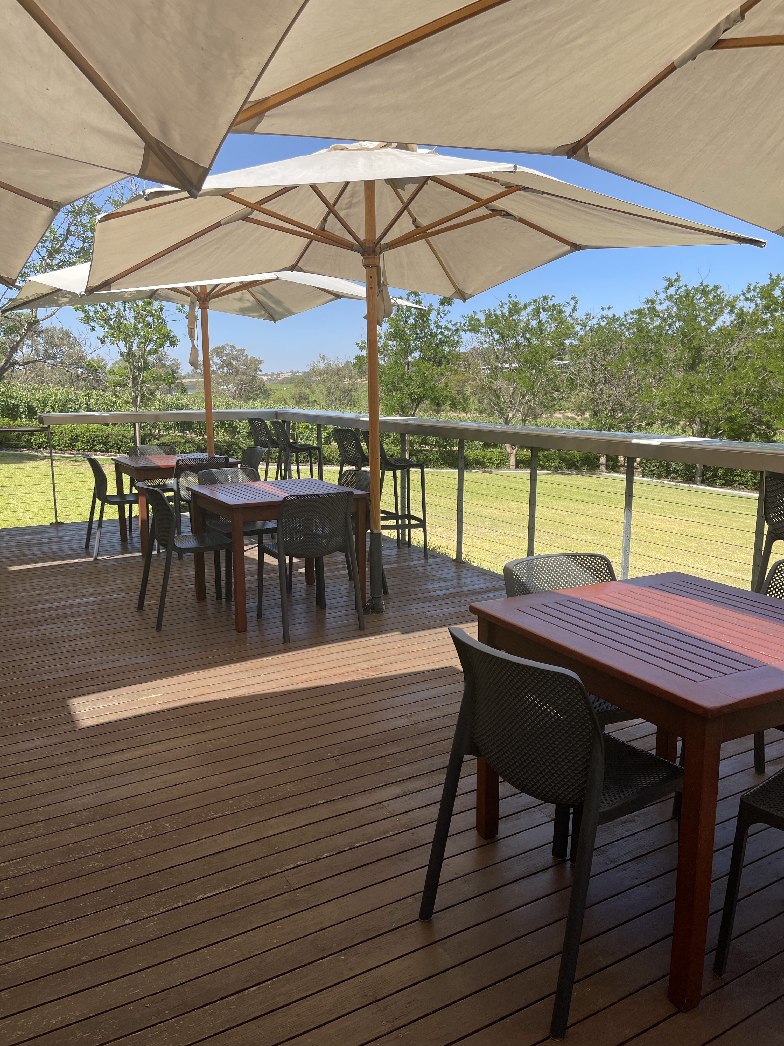
IMG_0930

Report Disclaimer
Please note that this business report, provided as a result of the use of the diagnostic assessment, is for information purposes only.
Australian Tourism Industry Council (ATIC) cannot guarantee the accuracy of respondent’s answers, or that they are fully representative of your business. Therefore, ATIC does not warrant or guarantee any particular outcome in respect of your businesses self-assessment.
This report is intended as guidance only for your business and should not be relied on for future marketing considerations. ATIC recommends that you seek your own independent advice as well as the results from the diagnostic.
Links to external web sites are inserted for convenience and do not constitute endorsement of material at those sites, or any associated organisation, product or service.
ATIC does not:
- Assume any legal liability for the accuracy, completeness, or usefulness of any information from this report or any links provided; or
- Accept responsibility for any loss associated directly or indirectly from the use of this report.

