ATIC Accessibility
To support the accessible community in making informed travel decisions for their individual needs

This report prepared for:
Business name: | Forest Rise Chalets & Lodge
Address: | 231 Yelverton Road
Town: | Yelverton
Contact for enquiries: | Benson Holland
Contact Number: | 08 9755 7110
Contact Email: | relax@forestrise.com.au
Website: | www.forestrise.com.au
Date: | 2026-11-01 23:59

ATIC Accessibility
The following pages provides travellers with information on the businesses facilities and amenities which aims to support the traveller to make an informed decision on whether the business is suitable for their individual needs.
OVERVIEW 4
Business Overview 4
Bookings 4
Emergency Management 4
Guide Dog and Service Animals 5
GENERAL 6
Pre-arrival, arrival and reception 6
Cognitive Impairment Support 6
Car Park and Access amenities 6
Internal Spaces 6
External Paths 7
Steps 7
ACCOMMODATION 8
Room Amenities 8
Bathrooms 8
COMMON AREAS 9
Parks and gardens 9
Report Disclaimer 13

OVERVIEW

Business Overview

The business has the following products/services available
- Accommodation

Our business caters for the following disability types:
- Limited mobility
- Food allergies or intolerances
- Cognitive or people on the Autism Spectrum
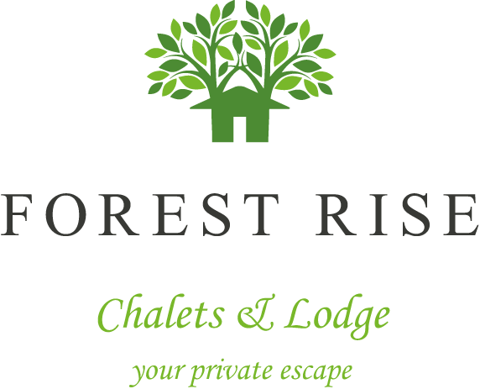

Bookings

The business offers the following methods for bookings and enquiries:
- Phone
- Email
- Webportal
- Our forms have high contract boxes and submit boxes

Emergency Management
- Exit access is free and clear at all times
We ensure exit access is free and clear at all times by:
Daily visual inspections
- Exit doors are able to be opened by all occupants
- Exits to the emergency evacuation point does not include stairways
- The evacuation point is clearly marked by a sign
- In addition, the following further information can assist guests:
Through Guest correspondence when booking either via phone conversation or email correspondence, this is noted on their reservation.
- In addition, the following further information can assist guests:
Rescue them as accordingly required as per our evacuation procedures
- Guests with disabilities are noted in the guest log book for emergency and evacuation purposes

Guide Dog and Service Animals
- The business provides a secure area with shade and water for service animals
- The business provides a toilet area for service animals
The business provides the following services for services animals:
Not specified

GENERAL

Pre-arrival, arrival and reception
The business has the following in place to support guests during pre-arrival, arrival and reception
- There is a reception/public entryway.
- Seating available at reception
- A lower counter at reception/ticket office
- A clipboard to allow check-in/ticket purchase whilst seated
- Lighting in the reception area is even and glare free

All our registration forms are electronically we do not require any physical paperwork to be completed.
- Keys are available for each guest
- In addition, the following further information can assist guests:
We operate with a self-check in process and can be flexible on arrival and departure times depending on occupancy. There is no wait time with check in or check out.

Cognitive Impairment Support
- Documents are available in plain English for people with cognitive impairment (This may include instructions, guides, menus and general information)
- Quiet periods or early opening times for people on the Autism Spectrum
- A space for parents and children on the Autism Spectrum

Car Park and Access amenities
The business has the following Car Park and Access amenities
- A drop off zone
- Designated disabled parking bays
- Level or ramped access from the car park to the entrance

Internal Spaces
- Tableware/glassware contrast with the table surface or table cloth

External Paths
External paths of travel
- Pathways are wider than 900mm
- There 3 successive steps or less on any path or at any doorway

Steps
Steps
- There are steps.
- Top and bottom steps are easily distinguished through colour contrast or the use of TGSIs (Tactile Ground Surface Indicators)
- The underside of all staircases are enclosed or protected to a height of at least 2 metres
- Where steps are present are there three steps or less

ACCOMMODATION

Room Amenities
- Televisions are equipped with closed captioning capability
- There is contrast between the walls, skirtings, floor and furniture
- There is a clear path through the room
- Wardrobe handles are a contrasting colour to the doors and draws
- Housekeeping procedures instruct staff not to reposition furniture that has been moved
- Doors open fully against the adjoining wall
- Openings are a minimum of 760mm wide
- Wardrobe and drawer handles are easy to grip
- The bedside lamp switch is easy to reach from the bed
- There is at least 850mm clear space beside the bed
- The business offers a range of non-allergenic bedding
- Non-allergenic cleaning products are used

Bathrooms
The bathrooms have the following facilities/amenities in place
- All heating appliances and hot water pipes are protected or insulated
- All shower, bath and basin taps are clearly differentiated between hot and cold
- Fixtures and fittings have rounded edges
- The hot water is thermostatically controlled to 41 degrees
- The width of the door is 760mm.
- There is a minimum of 850mm beside the toilet
- There is a minimum of 1400mm of clear space in front of the toilet
- The toilet seat is a contrasting colour to the floor
- The toilet seat is 460mm above the floor
- A range of non-allergenic toiletries are available
- There is a portable shower head on flexible hose
- A door is fitted to the shower

COMMON AREAS

Parks and gardens
- The following parks and gardens amenities are available
- Direction signage contains distances
  - Parks and Gardens Access/Entry Image(s)
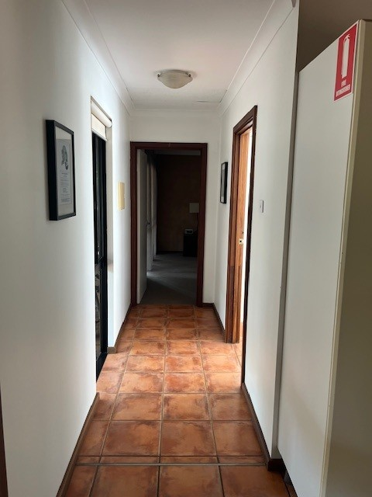
Chalet Accessibility Hallway Pic
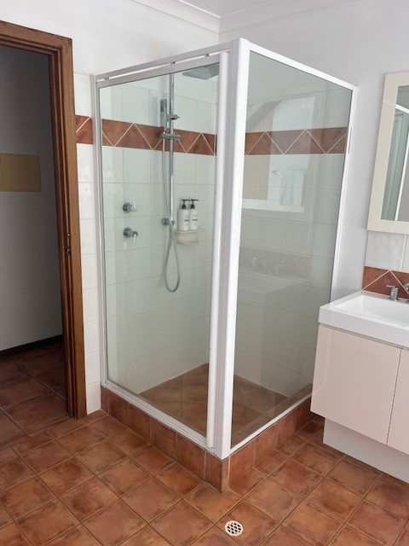
Chalet Accessibility Shower enclosed Pic 1
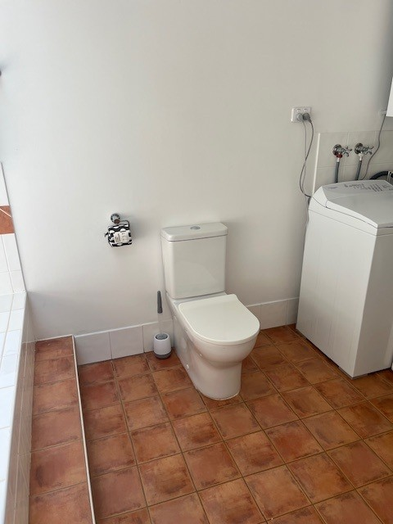
Chalet Accessibility WC pic 1
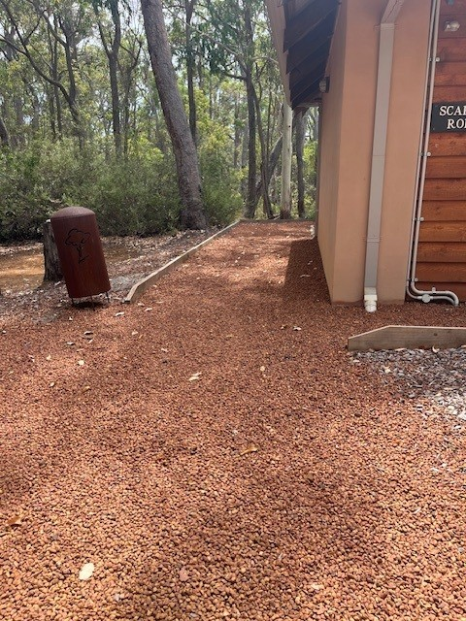
Chalet Accessibility Entrance pic 1
- Handrails and stairs are built as per state/territory building code.
  - Parks and Gardens Stair entry and exit Image(s)
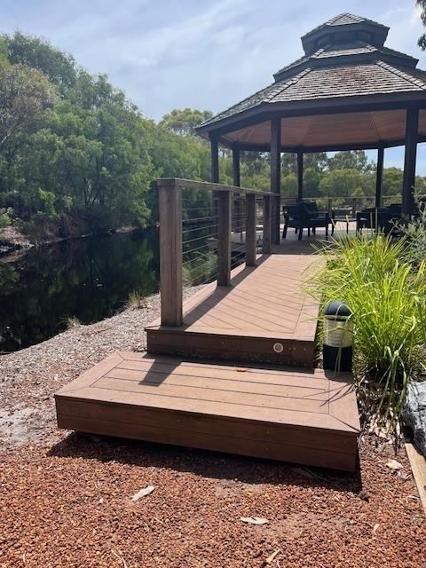
Gazebo Accessibility Stair Pic

Report Disclaimer
Please note that this business report, provided as a result of the use of the diagnostic assessment, is for information purposes only.
Australian Tourism Industry Council (ATIC) cannot guarantee the accuracy of respondent’s answers, or that they are fully representative of your business. Therefore, ATIC does not warrant or guarantee any particular outcome in respect of your businesses self-assessment.
This report is intended as guidance only for your business and should not be relied on for future marketing considerations. ATIC recommends that you seek your own independent advice as well as the results from the diagnostic.
Links to external web sites are inserted for convenience and do not constitute endorsement of material at those sites, or any associated organisation, product or service.
ATIC does not:
- Assume any legal liability for the accuracy, completeness, or usefulness of any information from this report or any links provided; or
- Accept responsibility for any loss associated directly or indirectly from the use of this report.

