ATIC Accessibility
To support the accessible community in making informed travel decisions for their individual needs

This report prepared for:
Business name: | Ivory Palms Resort
Address: | 73 Hilton
Town: | Noosaville
Contact for enquiries: | Therese Moran
Contact Number: | 07 5473 1700
Contact Email: | ivorypalms@property-vine.com.au
Website: | www.ivorypalmsresort.com.au
Date: | 2026-10-12 14:17

ATIC Accessibility
The following pages provides travellers with information on the businesses facilities and amenities which aims to support the traveller to make an informed decision on whether the business is suitable for their individual needs.
OVERVIEW 4
Business Overview 4
Bookings 4
Emergency Management 4
Other Information 5
Guide Dog and Service Animals 5
GENERAL 6
Pre-arrival, arrival and reception 6
Cognitive Impairment Support 6
Car Park and Access amenities 6
Entry 7
Internal Spaces 7
Public areas 8
External Paths 8
Steps 8
Ramps 8
Public Toilets/Adult change facilities 9
ACCOMMODATION 10
Room Amenities 10
Bathrooms 10
COMMON AREAS 12
Play Spaces 12
Swimming pools, spas and waterparks 13
Report Disclaimer 15

OVERVIEW

Business Overview

The business has the following products/services available
- Accommodation

Our business caters for the following disability types:
- Blind or low vision
- Limited mobility
- Food allergies or intolerances

Bookings

The business offers the following methods for bookings and enquiries:
- Phone
- Email
- Webportal

Emergency Management
- Exit signs are clear and easy to see
- Exit access is free and clear at all times
We ensure exit access is free and clear at all times by:
Gardening and maintenance department do daily cleans and rounds of the property to ensure clear paths
- Exit doors are able to be opened by all occupants
- Exits including stairwells, have bright edges used on the steps.
- The evacuation point is clearly marked by a sign
- In addition, the following further information can assist guests:
Management & Staff are made aware of any guests with accessibility requirements during the reservation & check-in process and on-site management advised.
- In addition, the following further information can assist guests:
In the event of an emergency, emergency services will be contacted firstly. Management to attend.
- Guests with disabilities are noted in the guest log book for emergency and evacuation purposes

Other Information
- For bookings made onsite, the ticket booth/counter/box office is accessible for people using a wheelchair

Guide Dog and Service Animals
- The business provides a secure area with shade and water for service animals
- The business provides a toilet area for service animals
The business provides the following services for services animals:
Grassed areas surround the property

GENERAL

Pre-arrival, arrival and reception
The business has the following in place to support guests during pre-arrival, arrival and reception
- There is a reception/public entryway.
- Seating available at reception
- A clipboard to allow check-in/ticket purchase whilst seated
- A tablet with text to voice or pen and paper at reception to aid in communication
- Picture Board at reception to aid in communication
- Lighting in the reception area is even and glare free
- Large print information sheets and registration forms
- Information and maps are available in written form
- A familiarisation tour
- Keys are available for each guest
- Luggage assistance
- In addition, the following further information can assist guests:
Online check in
Contact free check-in

- In addition, the following further information can assist guests:
Check-in can be completed online prior to arrival to ensure a seamless check-in with prompt service upon arrival.Keys can be placed in a safe for a contact free check-in in the event the express check-in is completed.

Cognitive Impairment Support
- Documents are available in plain English for people with cognitive impairment (This may include instructions, guides, menus and general information)

Car Park and Access amenities
The business has the following Car Park and Access amenities
- A drop off zone
- Designated disabled parking bays
- Level or ramped access from the car park to the entrance
- The accessible entrance is clearly signed from the parking bay
- Kerb ramps are in place where a pavement or walkway needs to be crossed
- In addition, the following further information can assist guests:
A drop off area is available in front of reception with level access to guest reception/check-in area

Entry
The business has the following amenities/systems in place for entry
- A drop off point close to the entrance
- A path of access to the building is slip resistance and even
- A path of access to the building is clear of obstruction
- Self opening entry doors or fitted with a self closer
- Door handles are of a contrasting colour to the door
- Signage is written in a contrasting colour
- The entry door is a minimum of 850mm wide
- The entry door has self opening or a light opening pressure (for manual operations)
- The entrance sill is less than 13mm
- There a clear space of at least 1500mm x 1500mm in front of all doors.
- In addition, the following further information can assist guests:
Double doors access reception which are not self opening however are self closing. Our reception staff can assist with access if required. No door mats are applicable.
- In addition, the following further information can assist guests:
No lifts onsite

Internal Spaces
- Clear and unobstructed routes through and between buildings
- Interior walls are matte or low sheen
- Floor surfaces are hard or short pile carpet
- Seating is available for guests unable to stand for long periods
- Accessible facilities are clearly signed and visible from all areas
- All corridors greater than 900mm

Public areas
The public areas have the following amenities in place
- Even lighting
- Seating
- In addition, the following further information can assist guests:
Natural light for reception with seating available

External Paths
External paths of travel
- Surfaces are concrete, asphalt, smooth paving or hard packed fine gravel (max aggregate size 13mm)
- Pathways are wider than 900mm
- There 3 successive steps or less on any path or at any doorway
- Any paths having steps are clearly identified as non-wheelchair accessible
- In addition, the following further information can assist guests:
Areas that have a small number of steps have coloured strips to outline. These can be avoided by taking a longer route if required.

Steps
Steps
- There are steps.
- Top and bottom steps are easily distinguished through colour contrast or the use of TGSIs (Tactile Ground Surface Indicators)
- All steps or staircases have enclosed risers
- The underside of all staircases are enclosed or protected to a height of at least 2 metres
- Handrails fitted to all open sets of steps
- Handrails extend 300mm beyond the top and bottom step
- Where steps are present are there three steps or less
- In addition, the following further information can assist guests:
Steps can be avoided in general access area if needed

Ramps
Ramps have the following amenities are in place
- There are ramps.
- Hand rails are fitted
- Ramps have a raised edge of at least 100mm
- In addition, the following further information can assist guests:
Ramp is over the pool although not required as you can access the other side on flat ground

Public Toilets/Adult change facilities
Public Toilets/Adult change facilities have the following amenities are in place
- There is an accessible toilet for public use
- The door is at least 850mm wide
- There is a minimum of 850mm beside the toilet
- Handrails are fitted
- The toilet seat is 460mm above the floor
- There is 1440 mm of clear space in front of the toilet
- The toilet seat of a contrasting colour to the floor
- The toilet seat is460mm above the floor
- In addition, the following further information can assist guests:
A disabled toilet is available in the vicinity of the pool

ACCOMMODATION

Room Amenities
- There is a clear path through the room
- Housekeeping procedures instruct staff not to reposition furniture that has been moved
- There is a clear opening at least 850mm wide
- There luggage racks for at least two suitcases
- There at least one chair with rigid arms
- Wardrobe and drawer handles are easy to grip
- The bedside lamp switch is easy to reach from the bed
- The bed height is no higher than 680mm from the floor
- There is at least 130mm clearance under the bed
- The business offers a range of non-allergenic bedding
- In addition, the following further information can assist guests:
Apartments are individually furnished. Apartments do not have rails or wider door openings.
Guests can request apartments on one level for those with reduced mobility.

Bathrooms
The bathrooms have the following facilities/amenities in place
- All heating appliances and hot water pipes are protected or insulated
- All shower, bath and basin taps are clearly differentiated between hot and cold
- Fixtures and fittings have rounded edges
- The hot water is thermostatically controlled to 41 degrees
- The door is at least 850mm wide
- The width beside the toilet is varies.
- There is varies mm of clear space in front of the toilet
- The actual height of the toilet seat is 400.
- There is a portable shower head on flexible hose
- A door is fitted to the shower
  - Bathroom Image(s)
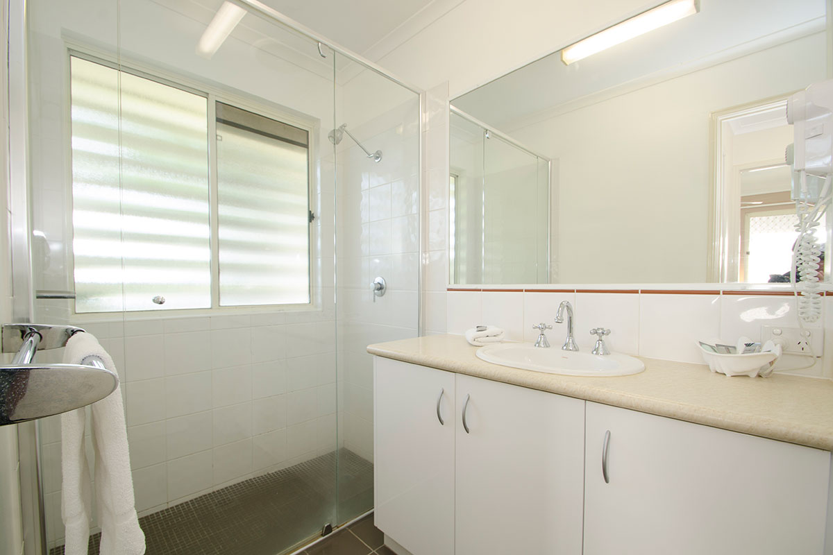
Bathroom
- In addition, the following further information can assist guests:
Bathroom layouts do vary and we recommend guests discussing options with our staff

COMMON AREAS

Play Spaces
- Level access is provided to play spaces
- Ramps provided are at least 25% of elevated sections of the play space
- The surface of the play space is of a composite or rubberized material
- The play space contains cognitive play panels
- The play space contains tactile play panels or activities
- The space contain colour contrasting elements
  - Image(s)
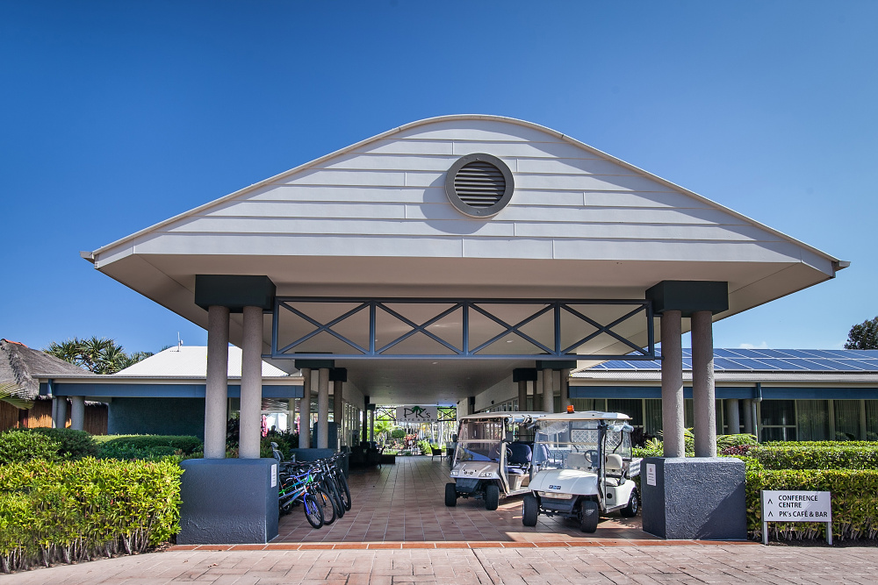
IMG_9699
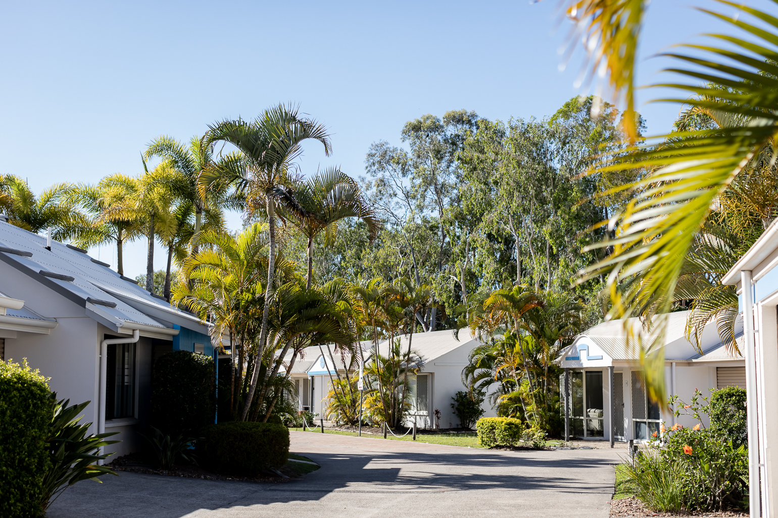
entrances
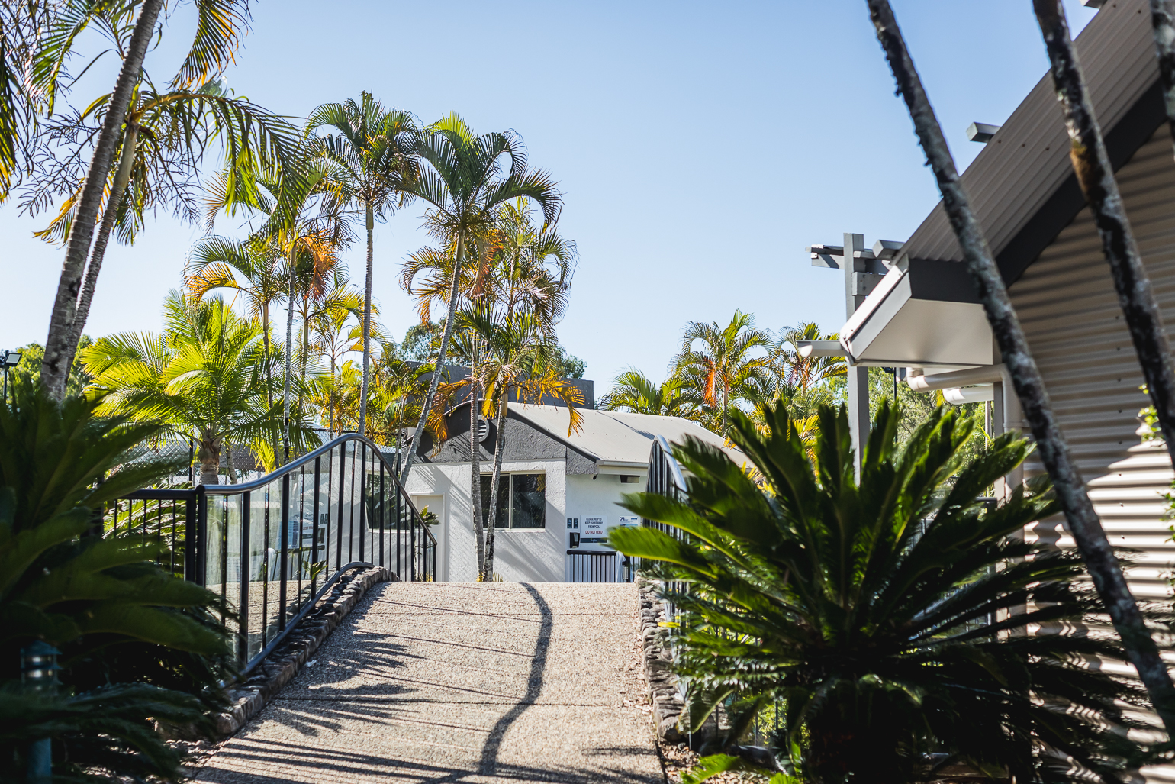
rampoverpool

Swimming pools, spas and waterparks
- The following swimming pools, spas and waterparks amenities are available
- Unisex change facilities with an accessible toilet
  - Pool Access Image(s)
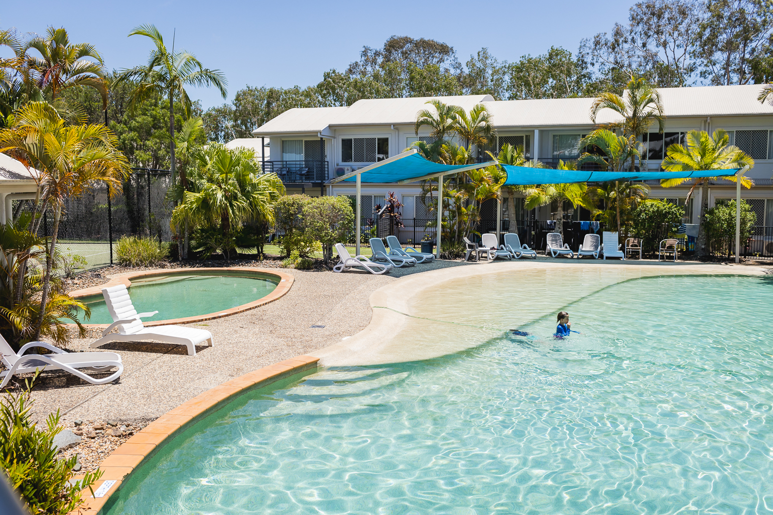
walkin pool3
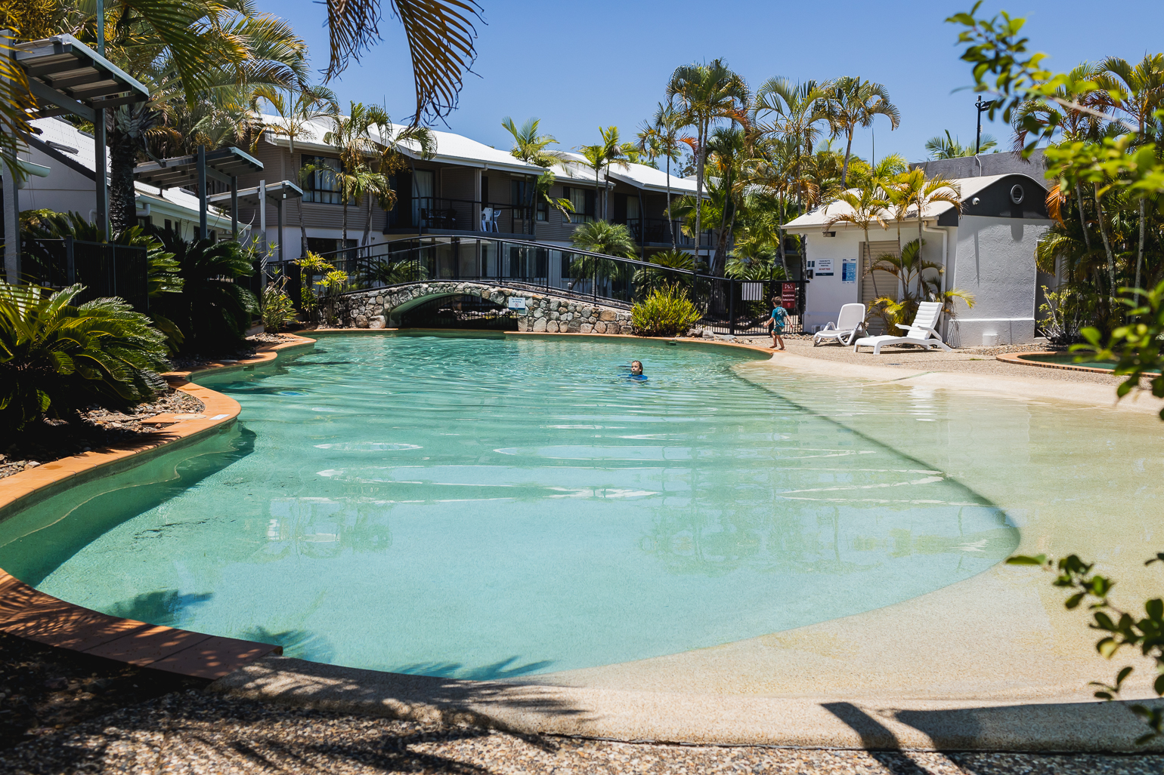
walkinpool2

Report Disclaimer
Please note that this business report, provided as a result of the use of the diagnostic assessment, is for information purposes only.
Australian Tourism Industry Council (ATIC) cannot guarantee the accuracy of respondent’s answers, or that they are fully representative of your business. Therefore, ATIC does not warrant or guarantee any particular outcome in respect of your businesses self-assessment.
This report is intended as guidance only for your business and should not be relied on for future marketing considerations. ATIC recommends that you seek your own independent advice as well as the results from the diagnostic.
Links to external web sites are inserted for convenience and do not constitute endorsement of material at those sites, or any associated organisation, product or service.
ATIC does not:
- Assume any legal liability for the accuracy, completeness, or usefulness of any information from this report or any links provided; or
- Accept responsibility for any loss associated directly or indirectly from the use of this report.

