ATIC Accessibility
To support the accessible community in making informed travel decisions for their individual needs

This report prepared for:
Business name: | Forage Safaris
Address: | 21 Savory Crescent
Town: | Yalyalup
Contact for enquiries: | Jan Stewart
Contact Number: | 0439906661
Contact Email: | foragesafaris@gmail.com
Website: | https://www.foragesafaris.com.au/
Date: | 2026-09-25 00:16

ATIC Accessibility
The following pages provides travellers with information on the businesses facilities and amenities which aims to support the traveller to make an informed decision on whether the business is suitable for their individual needs.
OVERVIEW 4
Business Overview 4
Bookings 4
Emergency Management 4
Communications 5
Other Information 5
Guide Dog and Service Animals 5
GENERAL 6
Pre-arrival, arrival and reception 6
Cognitive Impairment Support 6
Car Park and Access amenities 6
Public Toilets/Adult change facilities 7
TOUR OPERATORS 8
Tour/Transport Services 8
Route Planning 8
Guides 8
Report Disclaimer 11

OVERVIEW

Business Overview

The business has the following products/services available
- Tour/Transport

Our business caters for the following disability types:
- Blind or low vision
- Deaf or low hearing
- Limited mobility
- Food allergies or intolerances
- Cognitive or people on the Autism Spectrum

Bookings

The business offers the following methods for bookings and enquiries:
- Phone
- Email
- Webportal
- Our website supports Screen Readers
- Our forms have high contract boxes and submit boxes

Emergency Management
- The business has an emergency management and evacuation plan for guests with a disability
- Emergency and evacuation procedures are explained on arrival
- Guests with disabilities are noted in the guest log book for emergency and evacuation purposes

Communications
- An accessibility guide is available on the website

https://www.foragesafaris.com.au/accessibility-guide
- Our website meets WCAG 2.0 accessibility standards
- Our business offers the following alternative communication methods
- Plain English
- Magnifiers

Not specified
- There is easy to read signage and information (e.g. menus and emergency information)

Other Information
- The business accepts the companion card

Guide Dog and Service Animals
- The business provides a secure area with shade and water for service animals
- The business provides a toilet area for service animals
- Bowls, bedding, etc. are provided for service animals
The business provides the following services for services animals:
With prior notice we are able to accommodate service animals and include a safe and comfortable place in the vehicle, cold water, and access to rest and relieve themselves whilst on tour.

GENERAL

Pre-arrival, arrival and reception
The business has the following in place to support guests during pre-arrival, arrival and reception
- Booking information and websites are compatible with screen readers
- Information and maps are available in written form
- In addition, the following further information can assist guests:
As all our tours are tailored we would factor this into the tour duration and planning.
- In addition, the following further information can assist guests:
As much information that we receive about our passengers will ensure that we are prepare to deliver them a wonderful experience on tour.

Cognitive Impairment Support
- Documents are available in plain English for people with cognitive impairment (This may include instructions, guides, menus and general information)
- A space for parents and children on the Autism Spectrum

Car Park and Access amenities
The business has the following Car Park and Access amenities
- A drop off zone
- Designated disabled parking bays
- Level or ramped access from the car park to the entrance
- The accessible entrance is clearly signed from the parking bay
- In addition, the following further information can assist guests:
As we are not a premise, only a tour vehicle, we have no car park or entrance as we collect guests from their accommodation
The width of the smallest pathway is:
Irrelevant question as we are not a premise, we are a tour vehicle

Irrelevant question as we are not a premise, we are a tour vehicle

Irrelevant question as we are not a premise, we are a tour vehicle and we depend on the producers we visit to have the correct accessibility
- In addition, the following further information can assist guests:
Once guests have booked and provided us with details on any disabilities then we will send the clients an update on the vehicle and options with their tour confirmation.
- In addition, the following further information can assist guests:
Steps are not needed as our vehicle is low to the ground

Public Toilets/Adult change facilities
Public Toilets/Adult change facilities have the following amenities are in place
- There is an accessible toilet for public use
- The door is Our tour vehicle door slides open to 820mm wide wide
- There is a minimum of 850mm beside the toilet
- Handrails are fitted
- The toilet seat is 460mm above the floor
- The toilet seat of a contrasting colour to the floor
- The toilet seat is460mm above the floor
- In addition, the following further information can assist guests:
We are not a premises. We do have not a toilet on board the vehicle, I have answered these questions as per the requirements for each stop that visit and where the bathroom facilities can be used.

TOUR OPERATORS

Tour/Transport Services
The tour/transport services have the following facilities/amenities in place
- Buses/Coaches
- Nil vehicles have wheelchair lifts or ramps
- 1 vehicles have low floors with ramped entry
The maximum wheelchair capacity available in the fleet is:
1
- Commentary is available in written format

Route Planning
- Route Planning
- The tour route includes stops with accessible toilet facilities
- In addition, the following further information can assist guests:
Our vehicle is a small 8 seater kia carnival with no toilet on site but we stop regularly and have access to many accessible toilets in the region.
- Lunch stop venues are accessible
- Sightseeing and photo opportunity stops are step free
- Walking Tours
- Operated on a step free route
- Multi-paced to account for slower walkers

Guides

Guides have been trained in the following
- Use of clear/simple English
  - Image(s)
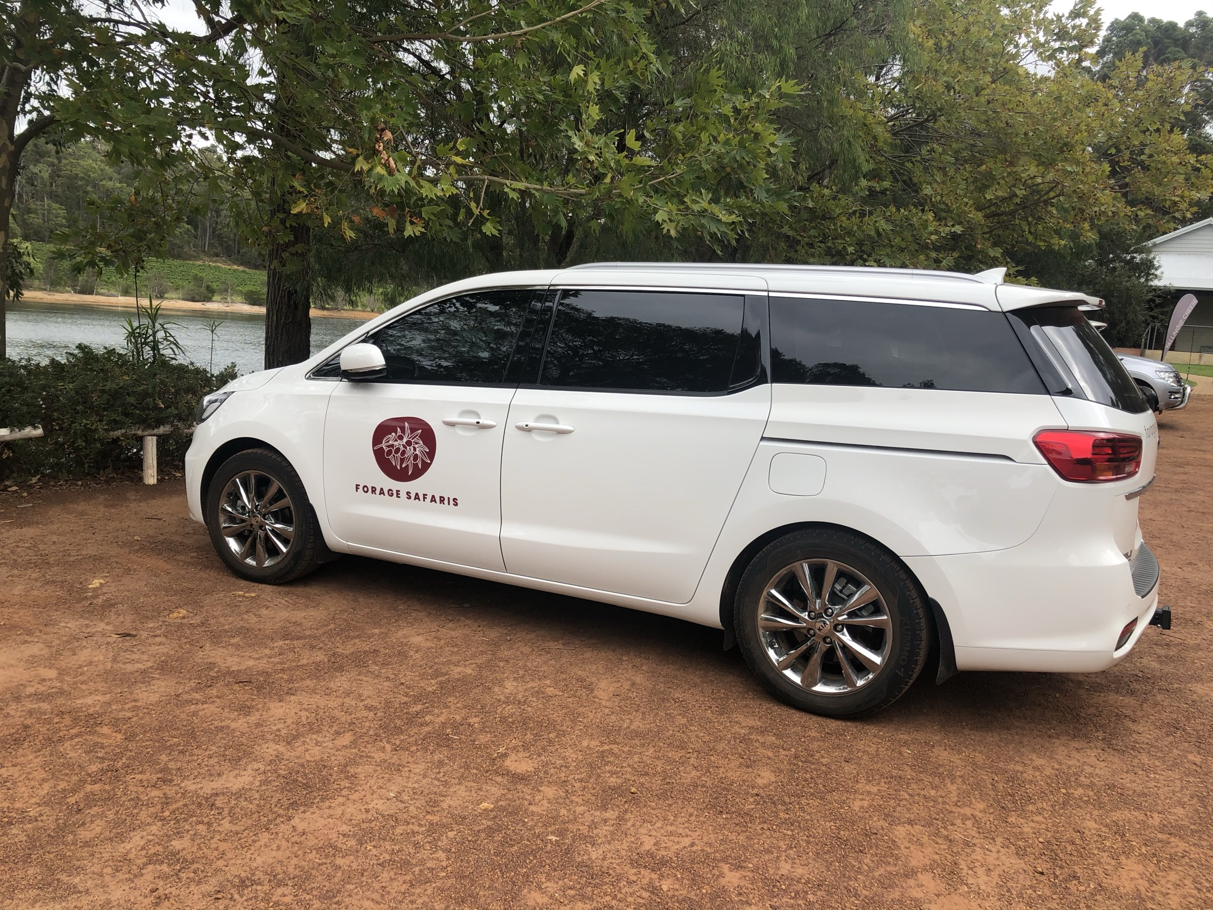
Abbey Vale Precinct
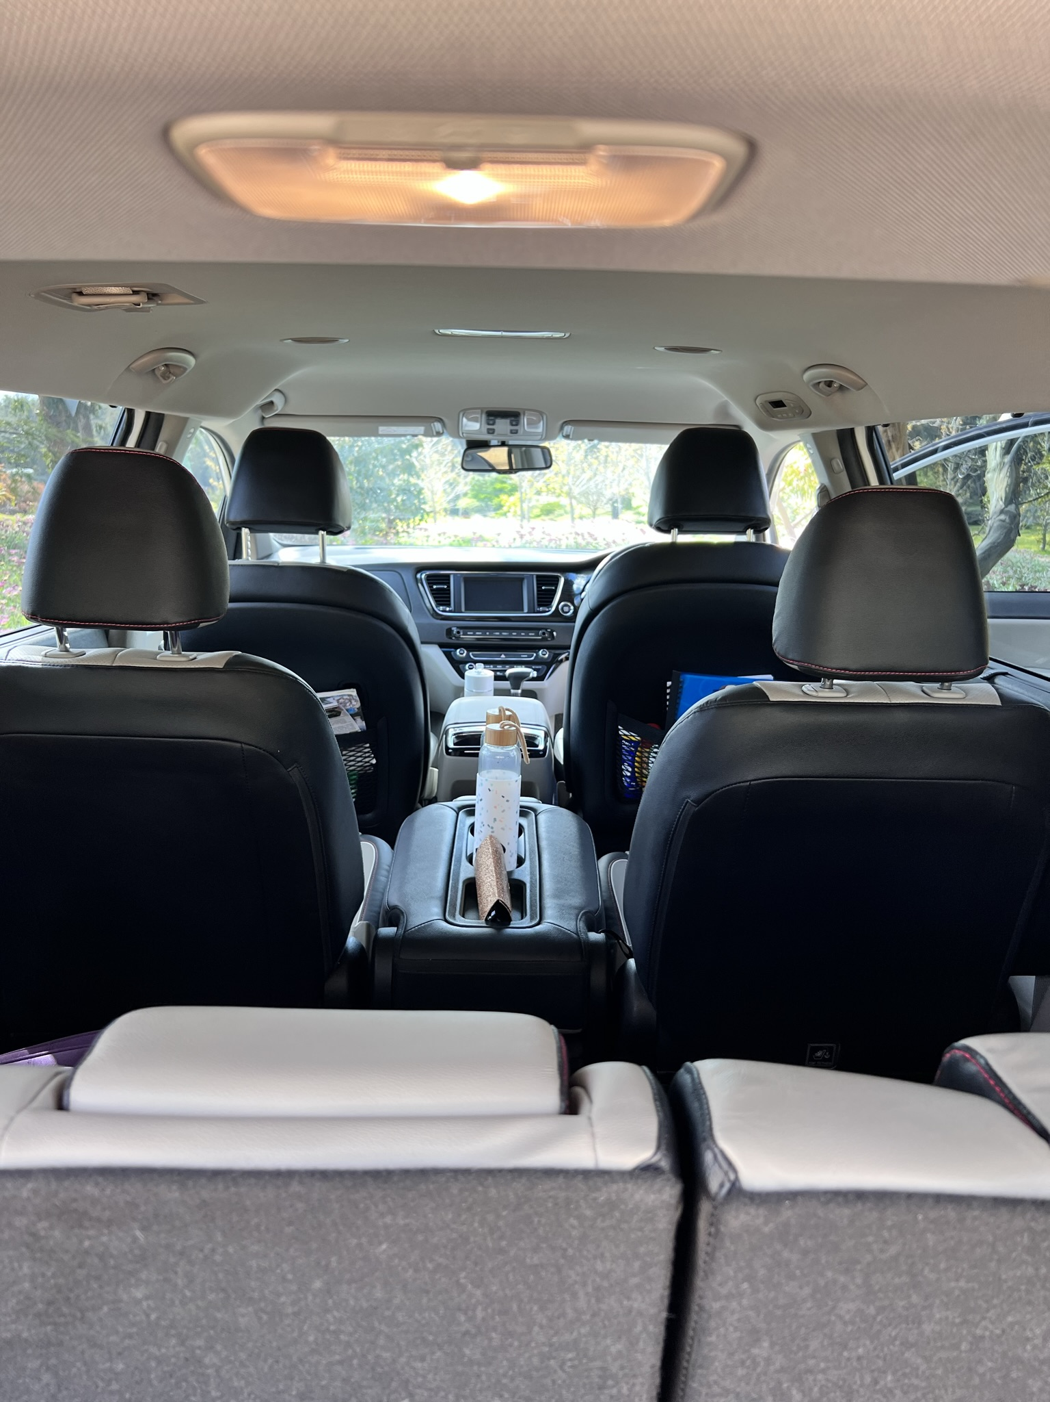
Car view
- In addition, the following further information can assist guests:
The tours vary with the seasons and clients interests, I visit up to 100 different properties around the Margaret River Region, most properties can be found on https://www.margaretriver.com/
Including Providore, Vasse Felix, Leeuwin Estate, Voyager Estate, Brown Hill Estate, Berry Farm, Miss Chows, Passel Estate, Howard Park, Margaret River Chocolate Factory, Eagle Bay Olives, Vasse Virgin and more
- In addition, the following further information can assist guests:
Please clearly provide as much information as possible on all passengers to ensure that we can prepare and offer a wonderful inclusive tour

Report Disclaimer
Please note that this business report, provided as a result of the use of the diagnostic assessment, is for information purposes only.
Australian Tourism Industry Council (ATIC) cannot guarantee the accuracy of respondent’s answers, or that they are fully representative of your business. Therefore, ATIC does not warrant or guarantee any particular outcome in respect of your businesses self-assessment.
This report is intended as guidance only for your business and should not be relied on for future marketing considerations. ATIC recommends that you seek your own independent advice as well as the results from the diagnostic.
Links to external web sites are inserted for convenience and do not constitute endorsement of material at those sites, or any associated organisation, product or service.
ATIC does not:
- Assume any legal liability for the accuracy, completeness, or usefulness of any information from this report or any links provided; or
- Accept responsibility for any loss associated directly or indirectly from the use of this report.

