ATIC Accessibility
To support the accessible community in making informed travel decisions for their individual needs

This report prepared for:
Business name: | Australian Journeys
Address: | 24a Andrew street
Town: | Ringwood
Contact for enquiries: | Adam Firmin
Contact Number: | 0411788289
Contact Email: | info@australianjourneys.com.au
Website: | www.australianjourneys.com.au
Date: | 2026-10-27 21:30

ATIC Accessibility
The following pages provides travellers with information on the businesses facilities and amenities which aims to support the traveller to make an informed decision on whether the business is suitable for their individual needs.
OVERVIEW 3
Business Overview 3
Bookings 3
Emergency Management 3
Communications 4
Guide Dog and Service Animals 4
GENERAL 5
Pre-arrival, arrival and reception 5
Displays, exhibits, commentary and live performances 5
TOUR OPERATORS 6
Tour/Transport Services 6
Route Planning 6
Guides 6
Report Disclaimer 9

OVERVIEW

Business Overview

The business has the following products/services available
- Tour/Transport

Our business caters for the following disability types:
- Blind or low vision
- Deaf or low hearing
- Limited mobility
- Food allergies or intolerances
- Cognitive or people on the Autism Spectrum


Bookings

The business offers the following methods for bookings and enquiries:
- Phone
- Email
- Webportal
- Our website supports Screen Readers
- Our forms have high contract boxes and submit boxes

Emergency Management
- Exit signs are clear and easy to see
- Exit access is free and clear at all times
We ensure exit access is free and clear at all times by:
yes as state requirement for buses
- In addition, the following further information can assist guests:
his is integrated into our pre-tour communication and booking processes. During booking, guests are invited to share any specific needs, medical conditions, mobility concerns, or accessibility requirements in a confidential and respectful manner.
- In addition, the following further information can assist guests:
In the event of an emergency, guides follow a documented response protocol: Quickly assess the situation and prioritize the safety of all guests Provide calm, clear instructions verbally and visually Assist guests with limited mobility or special needs first, without compromising their dignity Use mobility aids if necessary or coordinate with emergency services for support Keep the group informed and reassured while maintaining overall control of the situation 4. Collaboration with Emergency Services If professional rescue is required, guides communicate guest-specific needs to first responders (e.g., inability to walk, oxygen requirements, or autism spectrum considerations). Our emergency contact list and guest medical info (provided voluntarily) are on hand and securely stored for such scenarios.
- Guests with disabilities are noted in the guest log book for emergency and evacuation purposes

Communications
- Our website meets WCAG 2.0 accessibility standards
- Our business offers the following alternative communication methods
- Plain English

our customers are in vehicles only

Guide Dog and Service Animals
The business provides the following services for services animals:
as a CPV driver we are not allowed to reject people with service animals as part of agreeing to provide transport

GENERAL

Pre-arrival, arrival and reception
The business has the following in place to support guests during pre-arrival, arrival and reception
- Booking information and websites are compatible with screen readers
- In addition, the following further information can assist guests:
any attractions we would be visiting would would know prior to the tour commencement. We would provide this information during the booking process

Displays, exhibits, commentary and live performances
For displays, exhibits, commentary and live performances the following amenities are in place
- Seating
- A written transcript where audio description is provided i.e. display commentary, tour commentary
The width of the smallest pathway is:
our customers are in vehicles only

our customers are in vehicles only

our customers are in vehicles only
- In addition, the following further information can assist guests:
our customers are in vehicles only

TOUR OPERATORS

Tour/Transport Services
The tour/transport services have the following facilities/amenities in place
- Buses/Coaches
- None vehicles have wheelchair lifts or ramps
- None vehicles have low floors with ramped entry
The maximum wheelchair capacity available in the fleet is:
0
- Commentary is available in written format

Route Planning
- Route Planning
- The tour route includes stops with accessible toilet facilities
- In addition, the following further information can assist guests:
If advised during booking process that an accessible toilet is required we will build the itinerary to allow for this through out the day
- Lunch stop venues are accessible
- Sightseeing and photo opportunity stops are step free
- Walking Tours
- Operated on a step free route
- Multi-paced to account for slower walkers

Guides

Guides have been trained in the following
- Use of clear/simple English
  - Image(s)
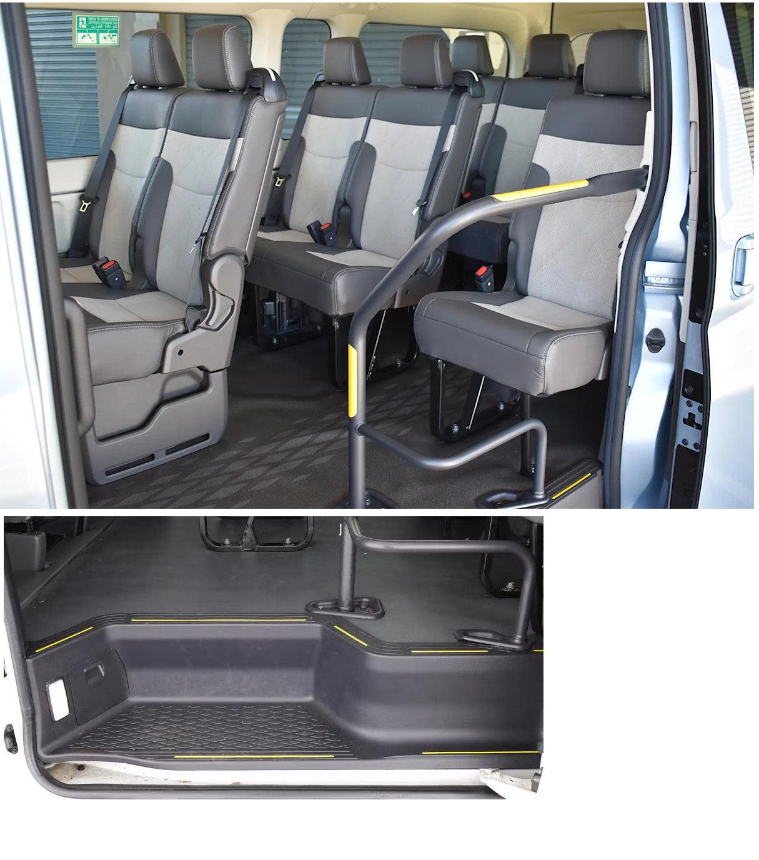
11 seater mini bus interior
- In addition, the following further information can assist guests:
Puffing Billy
Phillip Island Nature parks
Moonlit Sanctuary
Pt Leo Estate
Rare Hare winery
Rahona Valley Winery
Barmah Park Cellar Door &amp; Restaurant
Rochford Wines
Oakridge Wines
Chandon
Healesville Sanctuary

As a private Tour operator we visit many more this list is not complete but mentions

Report Disclaimer
Please note that this business report, provided as a result of the use of the diagnostic assessment, is for information purposes only.
Australian Tourism Industry Council (ATIC) cannot guarantee the accuracy of respondent’s answers, or that they are fully representative of your business. Therefore, ATIC does not warrant or guarantee any particular outcome in respect of your businesses self-assessment.
This report is intended as guidance only for your business and should not be relied on for future marketing considerations. ATIC recommends that you seek your own independent advice as well as the results from the diagnostic.
Links to external web sites are inserted for convenience and do not constitute endorsement of material at those sites, or any associated organisation, product or service.
ATIC does not:
- Assume any legal liability for the accuracy, completeness, or usefulness of any information from this report or any links provided; or
- Accept responsibility for any loss associated directly or indirectly from the use of this report.

