ATIC Accessibility
To support the accessible community in making informed travel decisions for their individual needs

This report prepared for:
Business name: | THE GERALD APARTMENT HOTEL
Address: | 25 Cathedral Avenue
Town: | Geraldton
Contact for enquiries: | Gemma Clark
Contact Number: | 0414394809
Contact Email: | hello@thegerald.com.au
Website: | www.thegerald.com.au
Date: | 2026-11-08 21:30

ATIC Accessibility
The following pages provides travellers with information on the businesses facilities and amenities which aims to support the traveller to make an informed decision on whether the business is suitable for their individual needs.
OVERVIEW 4
Business Overview 4
Bookings 4
Emergency Management 5
Communications 5
Other Information 5
Guide Dog and Service Animals 5
GENERAL 6
Pre-arrival, arrival and reception 6
Cognitive Impairment Support 6
Car Park and Access amenities 7
Entry 7
Lifts 7
Internal Spaces 7
Public areas 8
External Paths 8
Steps 8
Ramps 9
Public Toilets/Adult change facilities 9
ACCOMMODATION 10
Bedrooms 10
Room Amenities 12
Bathrooms 12
COMMON AREAS 14
FOOD AND DRINK 15
Dining Spaces 15
EVENTS 18
Events 18
Report Disclaimer 20

OVERVIEW

Business Overview

The business has the following products/services available
- Accommodation
- Food and Drink
- Event

Our business caters for the following disability types:
- Blind or low vision
- Deaf or low hearing
- Limited mobility
- Wheelchairs or mobility scooters
- Food allergies or intolerances
- Cognitive or people on the Autism Spectrum

Bookings

The business offers the following methods for bookings and enquiries:
- Phone
- Email
- Webportal
- Our website supports Screen Readers
- Our forms have high contract boxes and submit boxes
- Staff have undergone disability awareness and training

Emergency Management
- The business has an emergency management and evacuation plan for guests with a disability
- Emergency and evacuation procedures are explained on arrival
- Guests with disabilities are noted in the guest log book for emergency and evacuation purposes

Communications
- Our website meets WCAG 2.0 accessibility standards
- Our business offers the following alternative communication methods
- Plain English
- Braille Displays

Not specified
- There is easy to read signage and information (e.g. menus and emergency information)

Other Information
- For bookings made onsite, the ticket booth/counter/box office is accessible for people using a wheelchair
- The business accepts the companion card

Guide Dog and Service Animals
The business provides the following services for services animals:
Not specified

GENERAL

Pre-arrival, arrival and reception
The business has the following in place to support guests during pre-arrival, arrival and reception
- Booking information and websites are compatible with screen readers
- There is a reception/public entryway.
- Seating available at reception
- A lower counter at reception/ticket office
- A clipboard to allow check-in/ticket purchase whilst seated
- A tablet with text to voice or pen and paper at reception to aid in communication
- Lighting in the reception area is even and glare free
- Large print information sheets and registration forms
- Information and maps are available in written form
- A familiarisation tour
- Keys are available for each guest
- Luggage assistance
- In addition, the following further information can assist guests:
Pre-arrival Communication: Guests with fatigue-related disabilities can contact the hotel in advance to inform them of their needs. This allows the hotel to prepare accommodations and streamline the check-in process.
Priority Check-in: Upon arrival, guests can notify the hotel staff of their pre-arranged accommodations. They will be given priority check-in to minimize wait times at the reception desk wherever possible.
Comfortable Waiting Area: During the check-in process, guests can relax in a comfortable waiting area equipped with supportive seating and access to refreshments.
Virtual Check-in Option: Alternatively, guests can choose to complete the check-in process online before arrival. This allows them to bypass the reception desk entirely and head straight to their apartment upon arrival.
Empathetic Support: Hotel staff are trained to provide empathetic support and clear communication to assist guests with fatigue-related disabilities throughout the check-in process.

Cognitive Impairment Support
- Documents are available in plain English for people with cognitive impairment (This may include instructions, guides, menus and general information)
- A space for parents and children on the Autism Spectrum

Car Park and Access amenities
The business has the following Car Park and Access amenities
- A drop off zone
- Designated disabled parking bays
- Level or ramped access from the car park to the entrance
- The accessible entrance is clearly signed from the parking bay
- Kerb ramps are in place where a pavement or walkway needs to be crossed

Entry
The business has the following amenities/systems in place for entry
- A drop off point close to the entrance
- A path of access to the building is slip resistance and even
- A path of access to the building is clear of obstruction
- Self opening entry doors or fitted with a self closer
- Glass doors are fitted with a visual sighting strip
- Door jams/doors are of a contrasting colour to surrounding walls
- Door handles are of a contrasting colour to the door
- Signage is written in a contrasting colour
- Signage is written in a Sans Serif font and use upper and lower case letters
- The entry door is a minimum of 850mm wide
- The entry door has self opening or a light opening pressure (for manual operations)
- The entrance sill is less than 13mm
- There a clear space of at least 1500mm x 1500mm in front of all doors.
- The entrance door mats have a thickness less than 13mm and a width of 7500mm or greater

Lifts
- Premises has lifts

Internal Spaces
- Clear and unobstructed routes through and between buildings
- Interior walls are matte or low sheen
- Floors, walls, counters and furniture are of contrasting colours
- Any protruding or overhanging obstructions are at least 2meters above the floor or are protected
- Tableware/glassware contrast with the table surface or table cloth
- Floor surfaces are hard or short pile carpet
- Seating is available for guests unable to stand for long periods
- Accessible facilities are clearly signed and visible from all areas
- All corridors greater than 900mm
- There is a quiet space for parents and children on the Autism Spectrum

Public areas
The public areas have the following amenities in place
- Display units, Televisions, Video displays etc. are open captioned
- Even lighting
- Seating

External Paths
External paths of travel
- Surfaces are concrete, asphalt, smooth paving or hard packed fine gravel (max aggregate size 13mm)
- Pathways are wider than 900mm
- There 3 successive steps or less on any path or at any doorway
- Step free routes clearly signed

Steps
Steps
- There are steps.
- Top and bottom steps are easily distinguished through colour contrast or the use of TGSIs (Tactile Ground Surface Indicators)
- All steps or staircases have enclosed risers
- The underside of all staircases are enclosed or protected to a height of at least 2 metres
- Handrails fitted to all open sets of steps
- Handrails extend 300mm beyond the top and bottom step

Ramps
Ramps have the following amenities are in place
- There are ramps.
- All fixed ramps are 1:14 or less
- Hand rails are fitted
- Long ramps (more than 10m) are 1:20 or less
- Ramps have a raised edge of at least 100mm

Public Toilets/Adult change facilities
Public Toilets/Adult change facilities have the following amenities are in place
- There is an accessible toilet for public use
- The door is at least 850mm wide
- There is a minimum of 850mm beside the toilet
- Handrails are fitted
- The toilet seat is 460mm above the floor
- There is 2 metres mm of clear space in front of the toilet
- The toilet seat of a contrasting colour to the floor
- The toilet seat is460mm above the floor

ACCOMMODATION

Bedrooms
The bedrooms have the following facilities/amenities in place
- There are 2 rooms available to guests who use a wheelchair
- Bedroom furniture can be re-arranged on request
  - Layout of room Image(s)
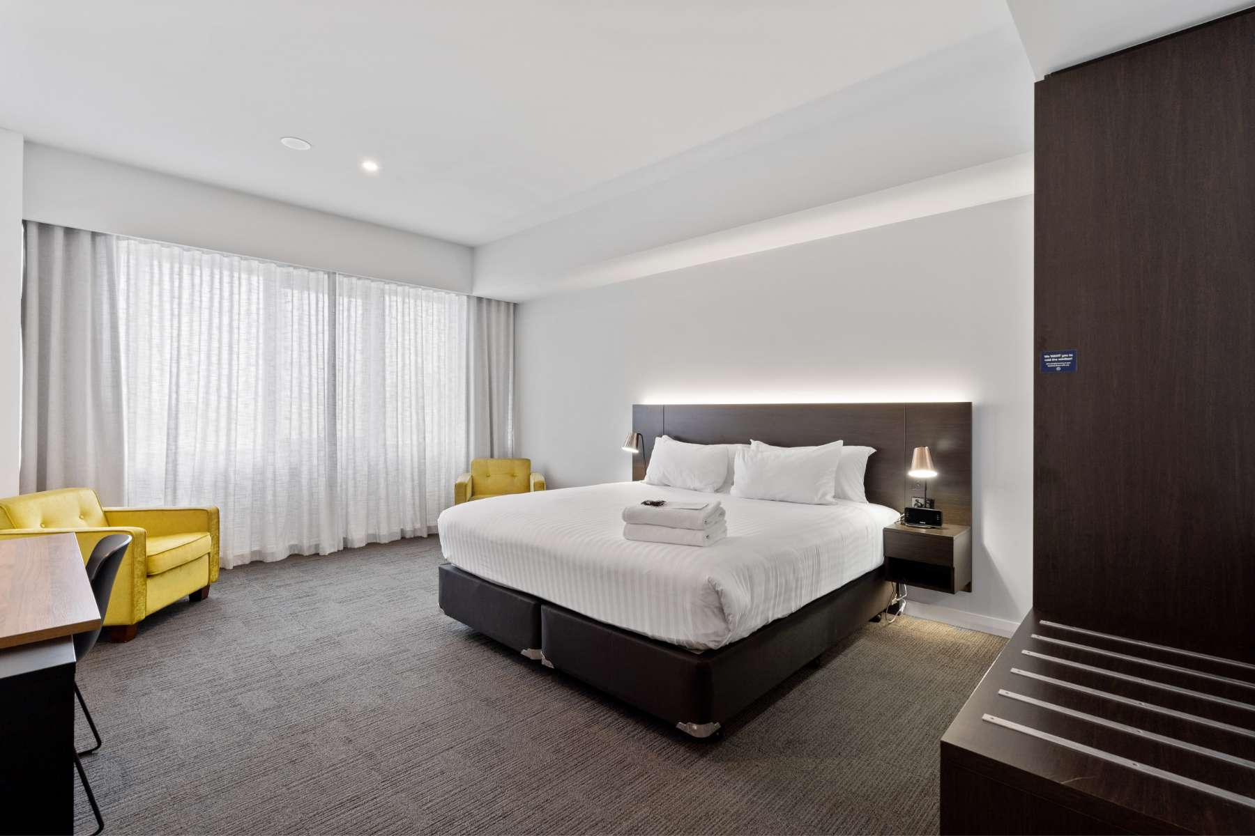
Classic-King-Studio-Wheelchair-Friendly-–-1
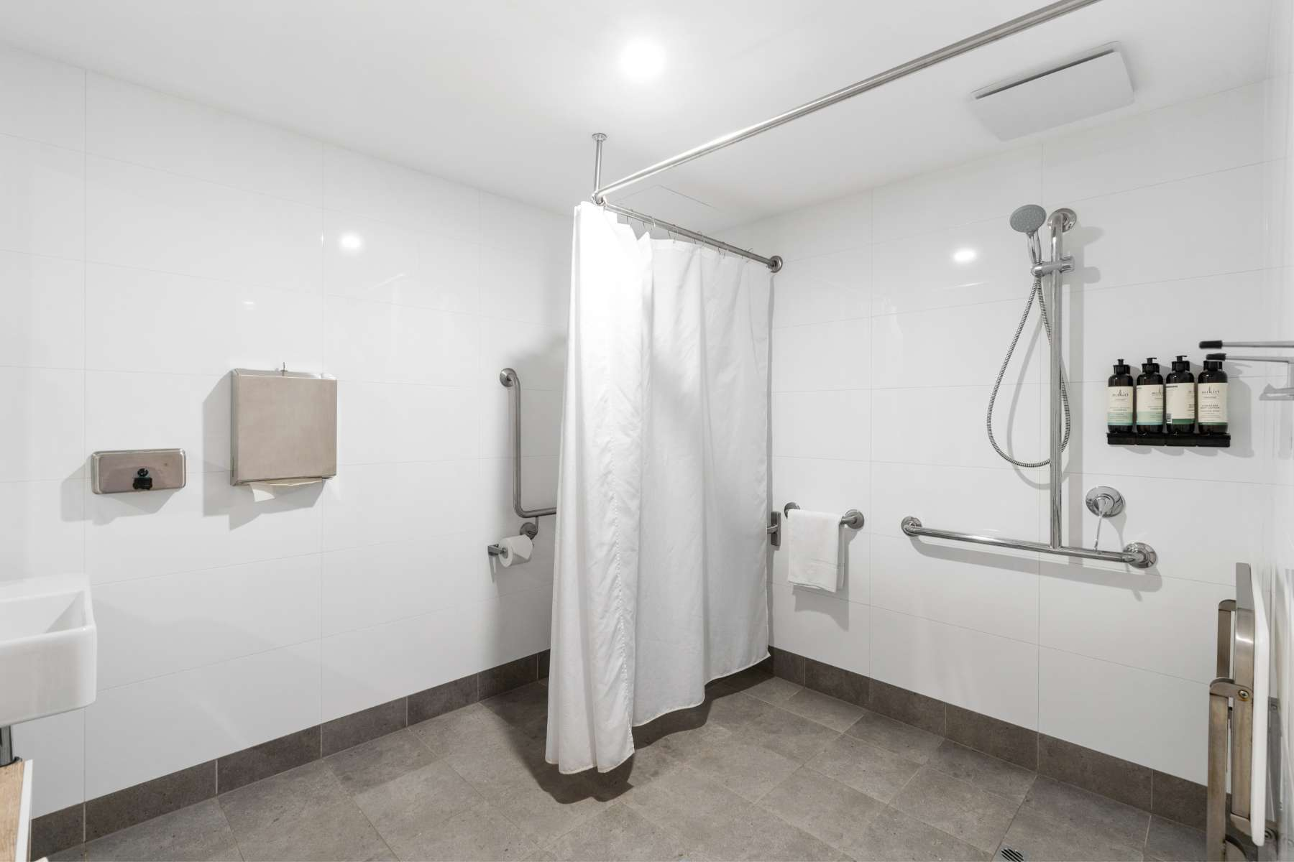
Classic-King-Studio-Wheelchair-Friendly-–-2
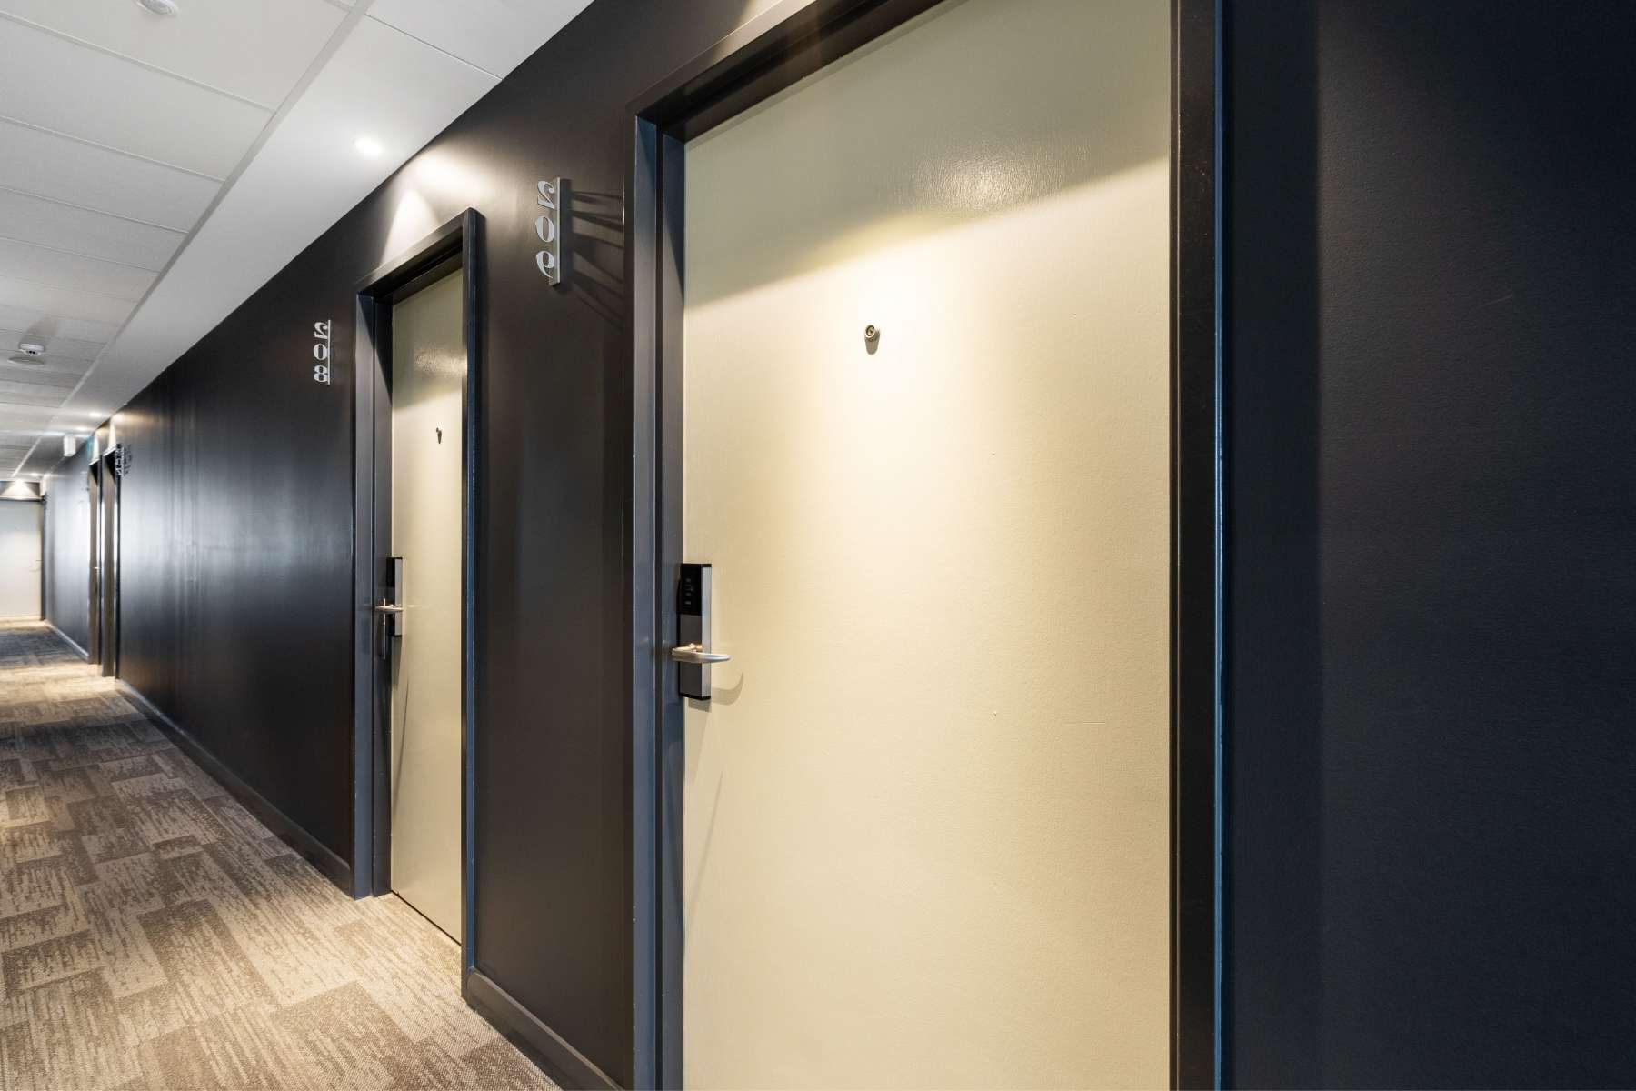
Classic-King-Studio-Wheelchair-Friendly-–-3
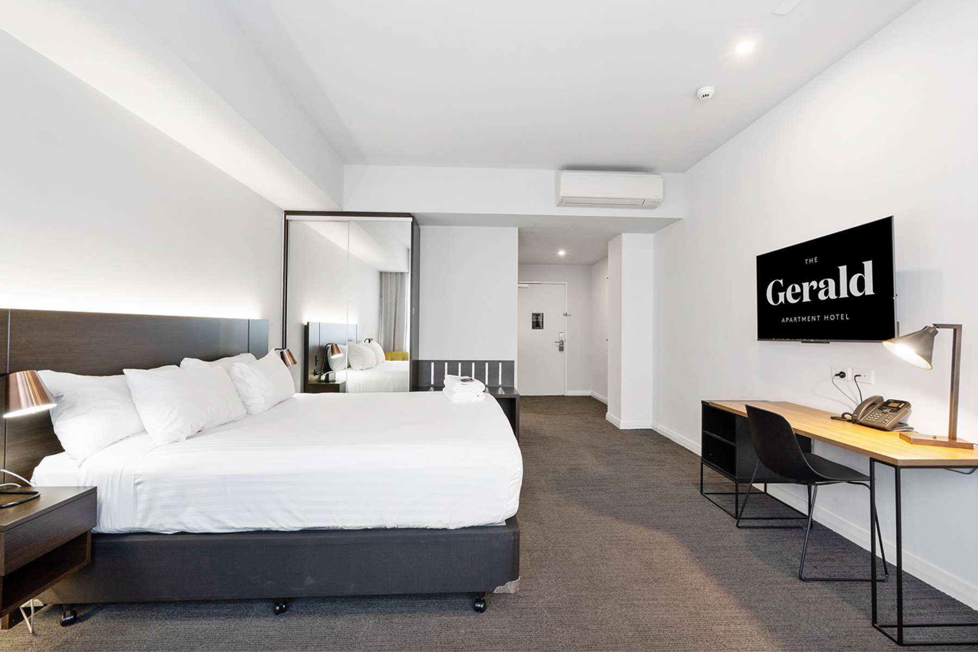
Classic-King-Studio-Wheelchair-Friendly-–-7
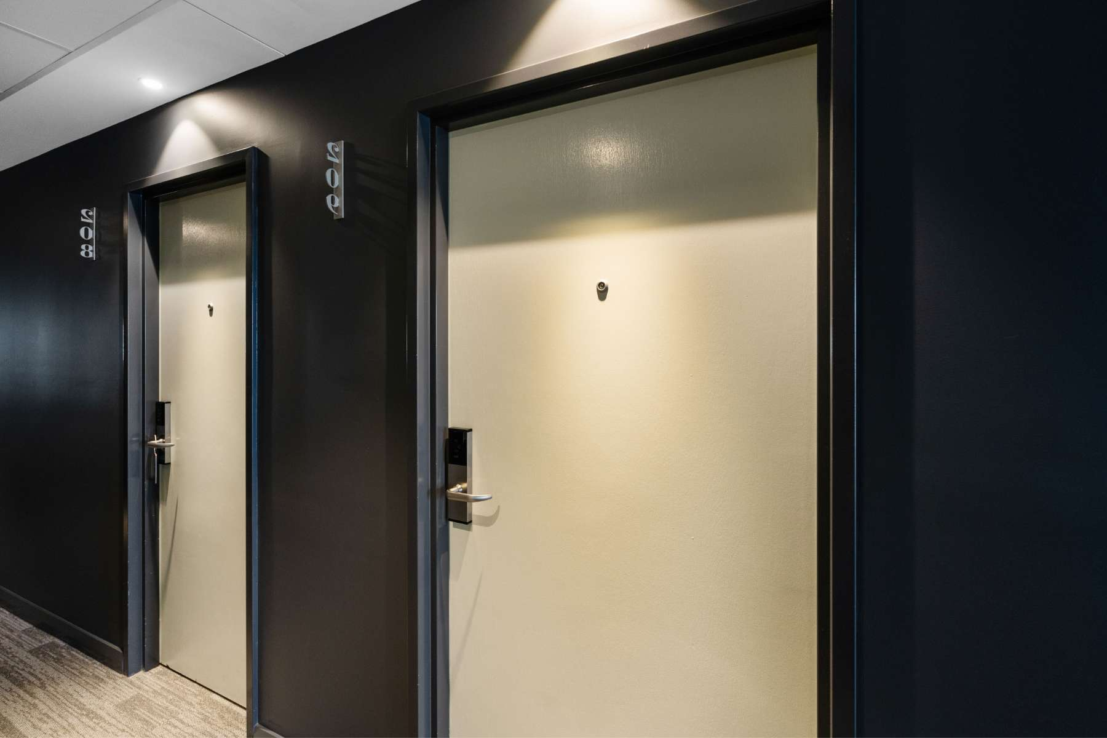
Classic-King-Studio-Wheelchair-Friendly-–-6
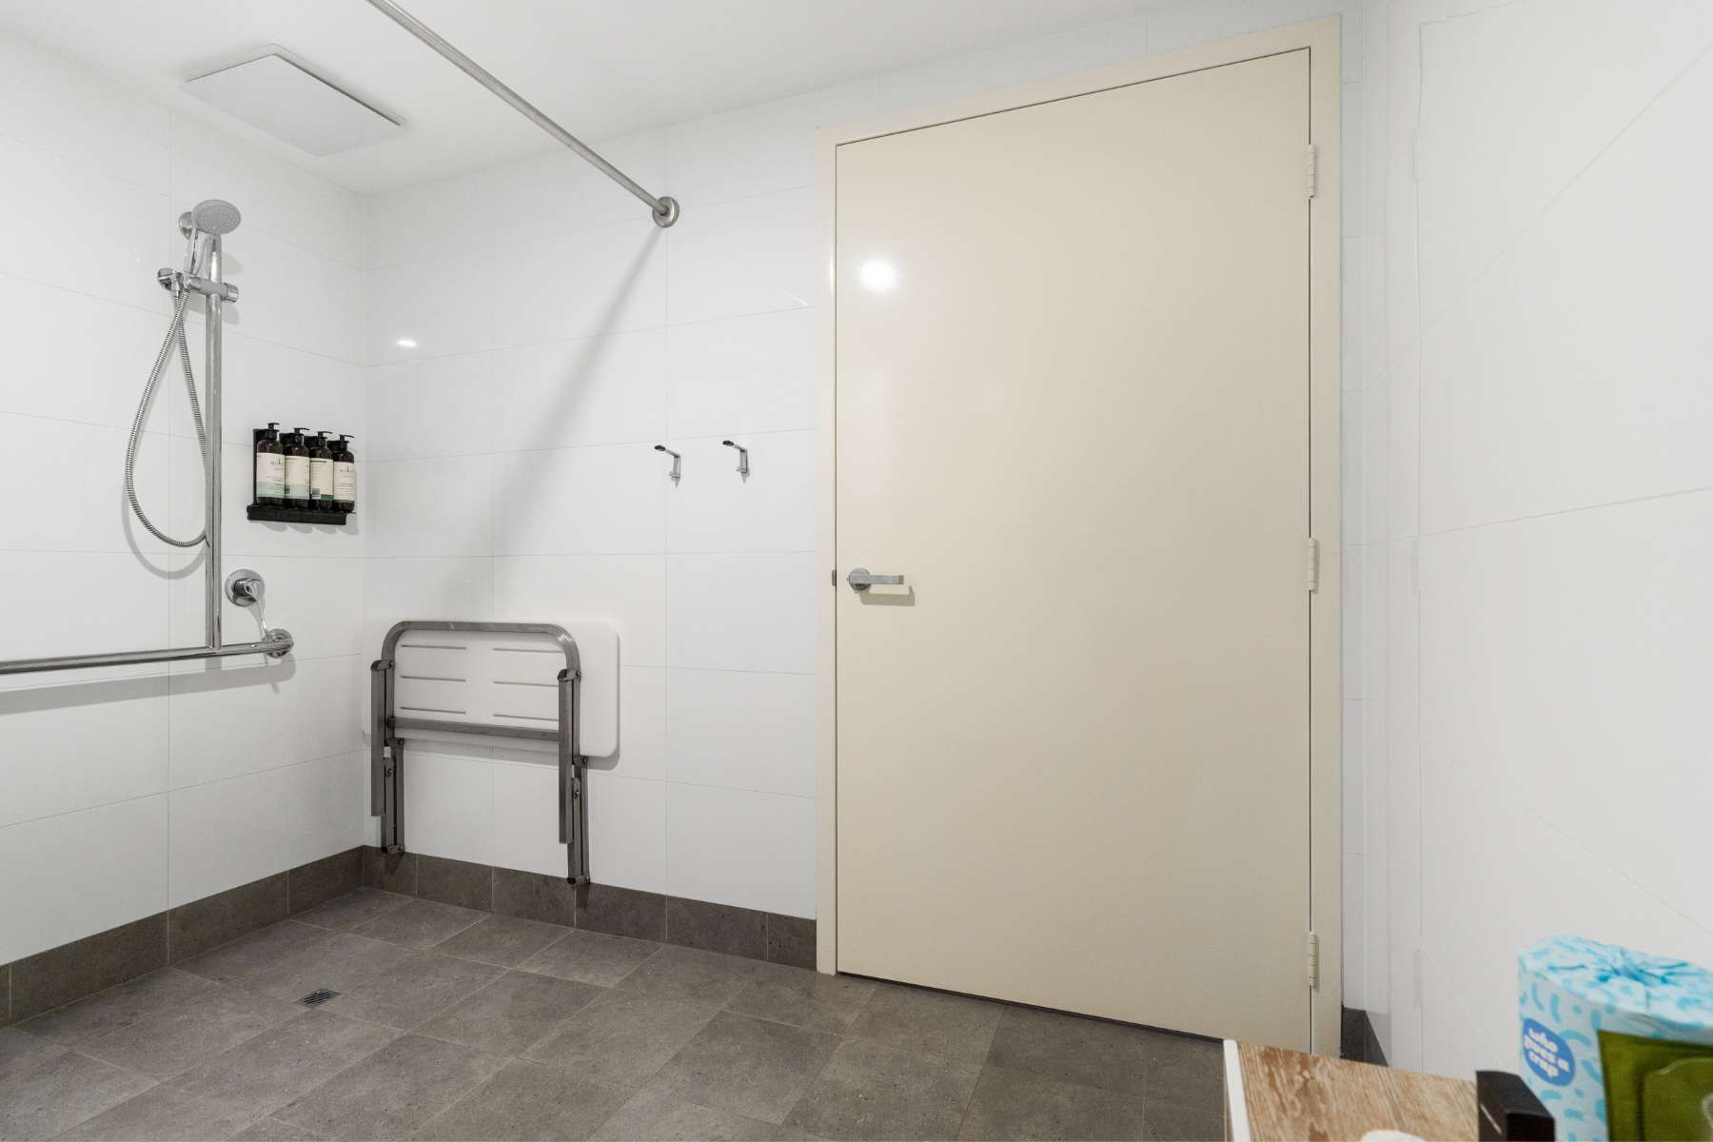
Classic-King-Studio-Wheelchair-Friendly-–-5
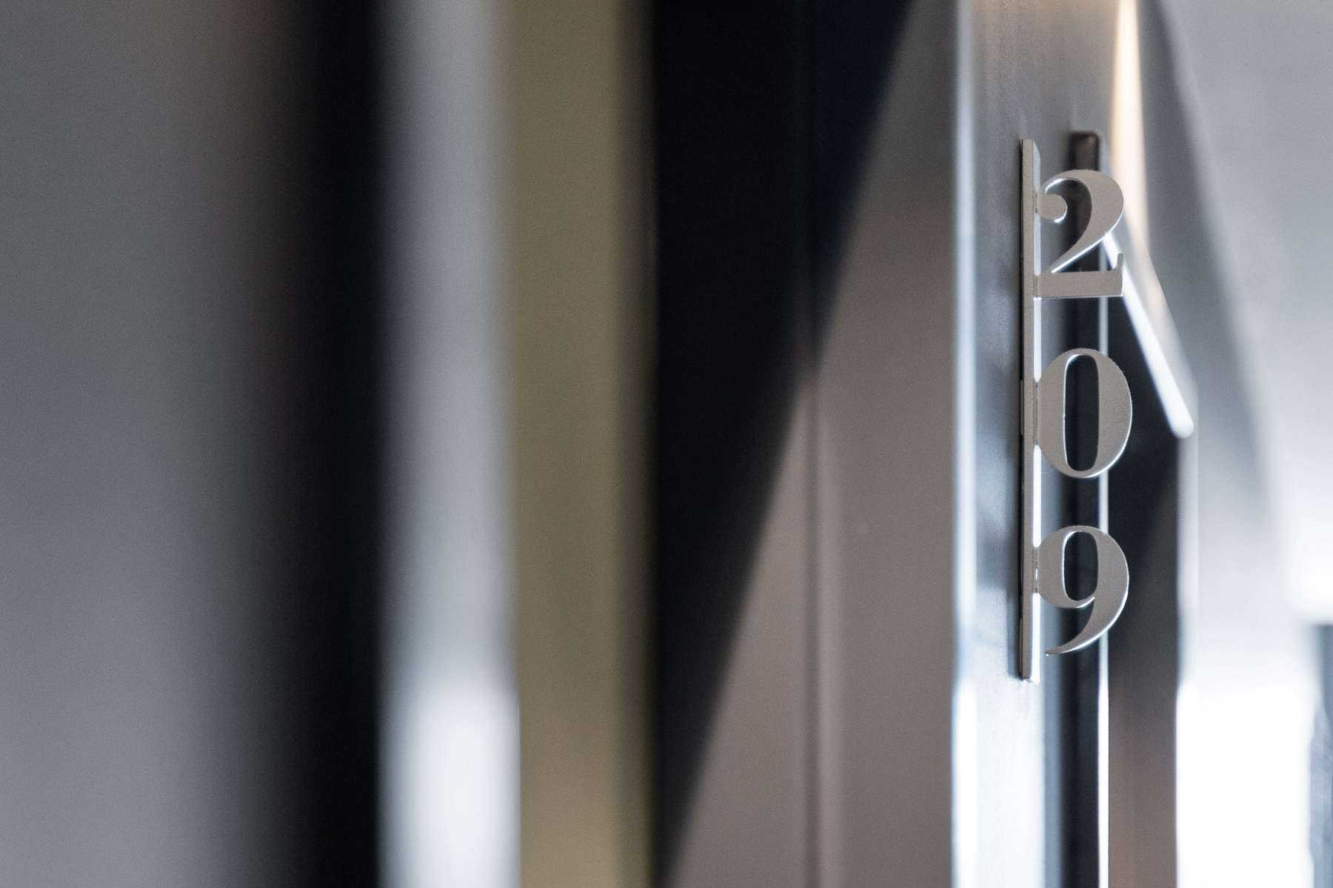
Classic-King-Studio-Wheelchair-Friendly-–-4

Room Amenities
- Lower hanging rails are in wardrobes
- Visual alarm is fitted to the room
- Televisions are equipped with closed captioning capability
- Room phones have volume control
- Room phones have a visual ringing indicator
- There is contrast between the walls, skirtings, floor and furniture
- There is a clear path through the room
- Wardrobe handles are a contrasting colour to the doors and draws
- Housekeeping procedures instruct staff not to reposition furniture that has been moved
- Doors open fully against the adjoining wall
- There is a clear opening at least 850mm wide
- There luggage racks for at least two suitcases
- There at least one chair with rigid arms
- Wardrobe and drawer handles are easy to grip
- The bedside lamp switch is easy to reach from the bed
- There is at least 850mm clear space beside the bed
- The bed height is no higher than 680mm from the floor
- There is at least 130mm clearance under the bed
- Non-allergenic cleaning products are used

Bathrooms
The bathrooms have the following facilities/amenities in place
- All heating appliances and hot water pipes are protected or insulated
- All shower, bath and basin taps are clearly differentiated between hot and cold
- Fixtures and fittings have rounded edges
- The hot water is thermostatically controlled to 41 degrees
- The door is at least 850mm wide
- There is a minimum of 850mm beside the toilet
- Handrails are fitted
- There is a minimum of 1400mm of clear space in front of the toilet
- The toilet seat is a contrasting colour to the floor
- The toilet seat is 460mm above the floor
- A range of non-allergenic toiletries are available
- There is a roll-in shower with fold down fixed seat or a shower chair
- There is a portable shower head on flexible hose
  - Bathroom Image(s)
Classic-King-Studio-Wheelchair-Friendly-–-5

COMMON AREAS

FOOD AND DRINK

Dining Spaces
The dining spaces have the following facilities/amenities in place
- The entrance has level access
- The doorway is at least 850mm wide
- There is level access through the dining area
- Chairs are moveable to allow for wheelchairs to be seated at the tables
- All glass doors and full height windows have contrast markings
- There are areas of full lighting
- There are Plain English menus
- There is an accessible toilet

Our business caters for the following dietary requirements
- Sugar free (diabetic)
- Gluten free (celiac)
- Lactose free (dairy free)
- Nut free
- Vegetarian
- Vegan
- Halal
- In addition, the following further information can assist guests:
All Staff are qualified with a food safety handling certification
Separate Work Areas: Use different areas for handling raw meats, vegetables, and cooked foods.Color-Coded Tools: Assign specific colors to cutting boards and utensils for different food groups (e.g., red for meat, green for veggies) to avoid mixing.Clean Surfaces: Wash and sanitize countertops, cutting boards, and utensils before and after use with hot, soapy water.Store Smartly: Keep raw meats separate from ready-to-eat foods in the fridge. Store raw meats on lower shelves to prevent drips.Safe Thawing: Thaw frozen foods in the fridge, under cold water, or in the microwave, not at room temperature.Use Separate Tools: Use different utensils and gloves for raw and cooked foods, and wash hands thoroughly.Cook Well: Cook meats to safe temperatures using a food thermometer to kill bacteria.One-Time Marinades: Don't reuse marinades from raw meats. If you want sauce, set some aside before marinating.First In, First Out: Rotate food supplies to use the oldest items first to avoid spoilage.Training: Train staff on these simple rules and supervise their compliance.Regular Checks: Have someone oversee food handling regularly to ensure rules are followed.Keep Records: Document procedures and conduct occasional checks to maintain standards.

- There is a sample menu available online
Sample menu is available here -
https://webbox-assets.siteminder.com/assets/ajjddvrnrxdnrlfd/7d033be5-1968-4bb7-8086-769f8974f7f8.png
  - Food and Beverage Image(s)
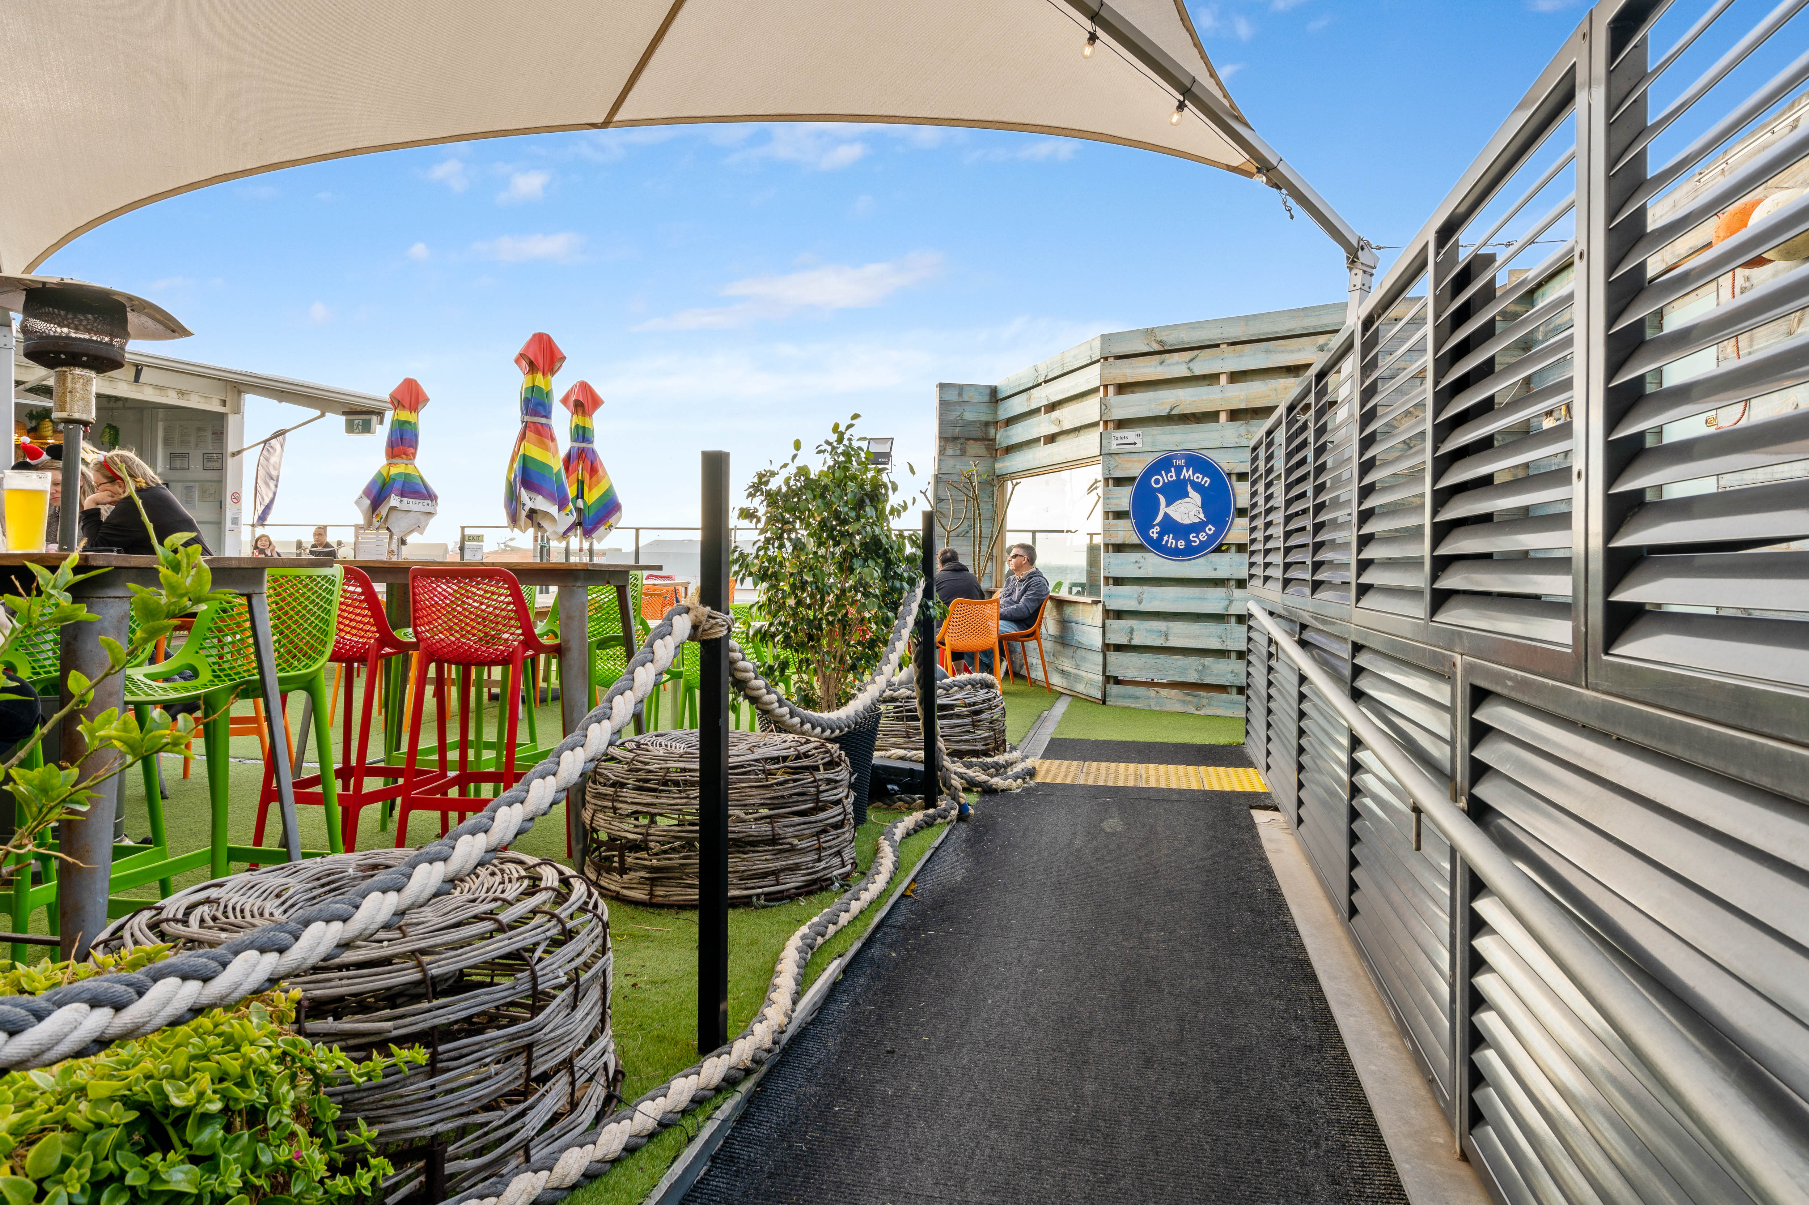
DSC03255 (1)
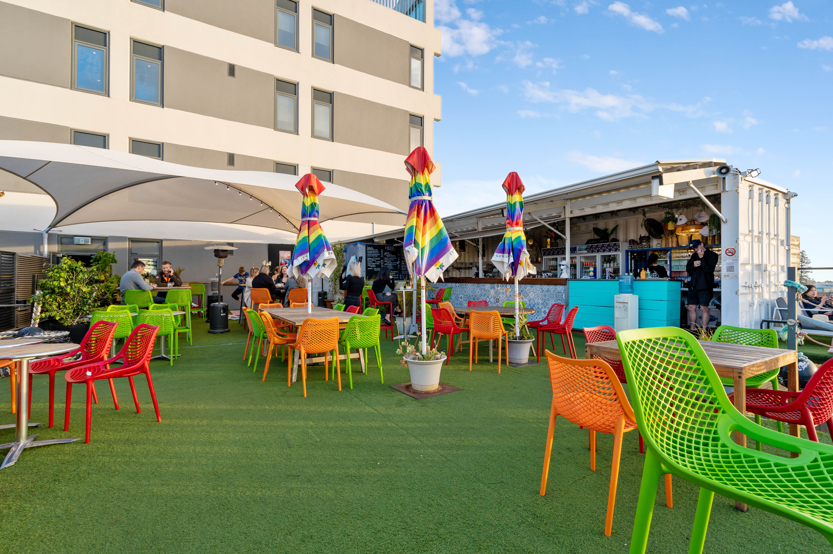
DSC03259
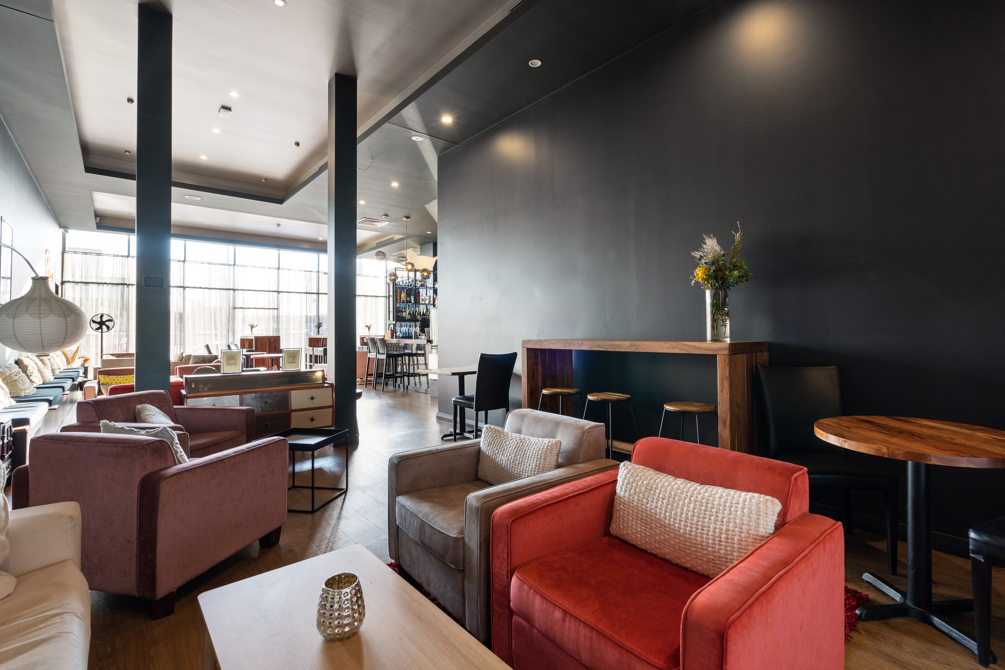
DSC03239 copy
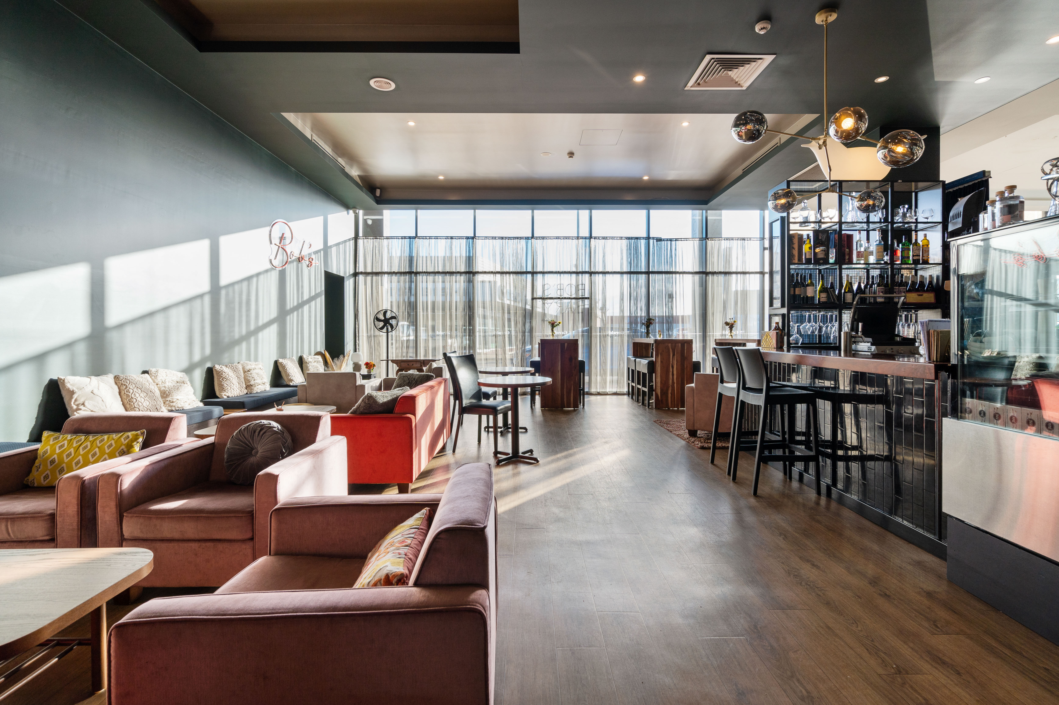
DSC03241 copy

EVENTS

Events
Events have the following facilities/amenities in place
- There is step free access throughout the venue
- Reception, registration desks or ticket offices have a lower counter section
- All ancillary areas are step free e.g. breakout rooms, dining areas, outside areas and exhibition spaces
- Accessible toilets are available at the venue
- There is clear signage throughout the venue including accessible routes and accessible facilities
- Wheelchair designated seating is provided
- We cater for a range of seating and viewing options
- We cater for varying group sizes
- There is good circulation space with the number of people expected to allow people with a disability to move around freely
- Accessible car parking is available
- There are designated drop-off points
- There is an event map available
- The event map shows accessible facilities
- Quiet rooms, marquees or spaces are available

Report Disclaimer
Please note that this business report, provided as a result of the use of the diagnostic assessment, is for information purposes only.
Australian Tourism Industry Council (ATIC) cannot guarantee the accuracy of respondent’s answers, or that they are fully representative of your business. Therefore, ATIC does not warrant or guarantee any particular outcome in respect of your businesses self-assessment.
This report is intended as guidance only for your business and should not be relied on for future marketing considerations. ATIC recommends that you seek your own independent advice as well as the results from the diagnostic.
Links to external web sites are inserted for convenience and do not constitute endorsement of material at those sites, or any associated organisation, product or service.
ATIC does not:
- Assume any legal liability for the accuracy, completeness, or usefulness of any information from this report or any links provided; or
- Accept responsibility for any loss associated directly or indirectly from the use of this report.

