ATIC Accessibility
To support the accessible community in making informed travel decisions for their individual needs

This report prepared for:
Business name: | Blue Tree Gallery
Address: | 1420 Cradle Mountain Rd
Town: | Moina
Contact for enquiries: | Aimee Rowland
Contact Number: | 0477729377
Contact Email: | Info@bluetreegallery.com.au
Website: | bluetreegallery.com.au
Date: | 2026-09-22 19:52

ATIC Accessibility
The following pages provides travellers with information on the businesses facilities and amenities which aims to support the traveller to make an informed decision on whether the business is suitable for their individual needs.
OVERVIEW 4
Business Overview 4
Bookings 6
Emergency Management 6
Communications 6
Guide Dog and Service Animals 7
GENERAL 8
Pre-arrival, arrival and reception 8
Cognitive Impairment Support 9
Car Park and Access amenities 9
Entry 10
Internal Spaces 11
Public areas 12
Displays, exhibits, commentary and live performances 12
External Paths 13
Steps 13
Ramps 14
ATTRACTIONS 16
Attractions Basics 16
COMMON AREAS 19
FOOD AND DRINK 20
Dining Spaces 20
Report Disclaimer 24

OVERVIEW

Business Overview

The business has the following products/services available
- Attraction
- Food and Drink

Our business caters for the following disability types:
- Deaf or low hearing
- Limited mobility
- Wheelchairs or mobility scooters
- Food allergies or intolerances
- Cognitive or people on the Autism Spectrum
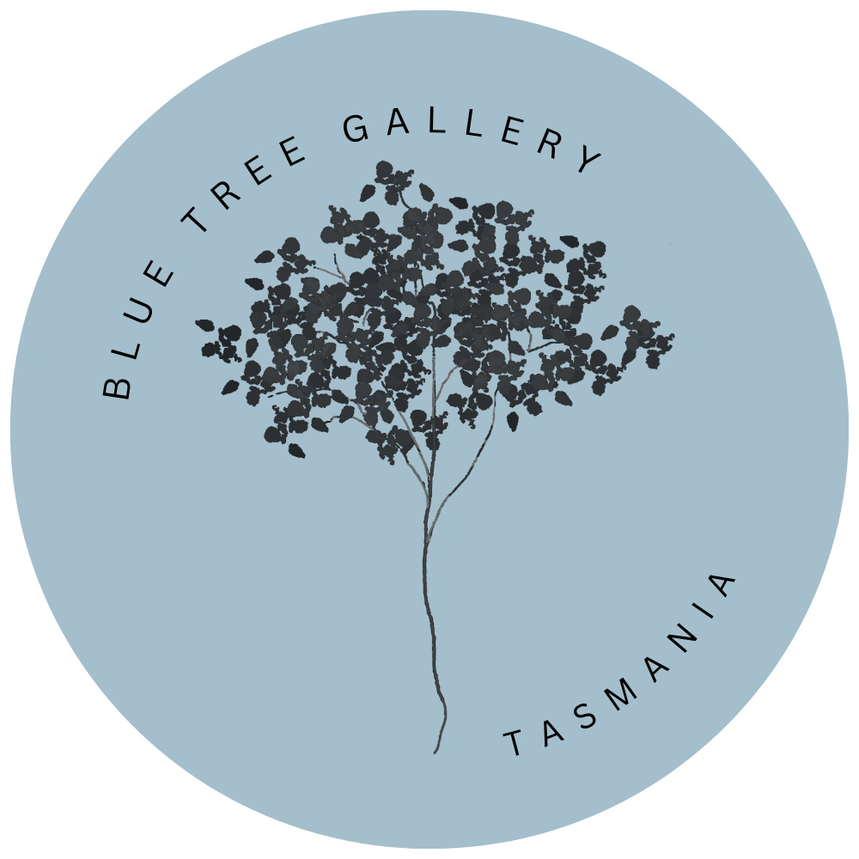

Bookings

The business offers the following methods for bookings and enquiries:
- Phone
- Email
- Webportal
- Our website supports Screen Readers
- Our forms have high contract boxes and submit boxes
- Staff have undergone disability awareness and training

Emergency Management
- The business has an emergency management and evacuation plan for guests with a disability
- Emergency and evacuation procedures are explained on arrival
- Guests with disabilities are noted in the guest log book for emergency and evacuation purposes

Communications
- An accessibility guide is available on the website

https://www.bluetreegallery.com.au/accessibility-statement
- Our website meets WCAG 2.0 accessibility standards
- Our business offers the following alternative communication methods
- Plain English
- Magnifiers

Not specified
- There is easy to read signage and information (e.g. menus and emergency information)
- There are Picture boards
  - Picture Boards Image(s)
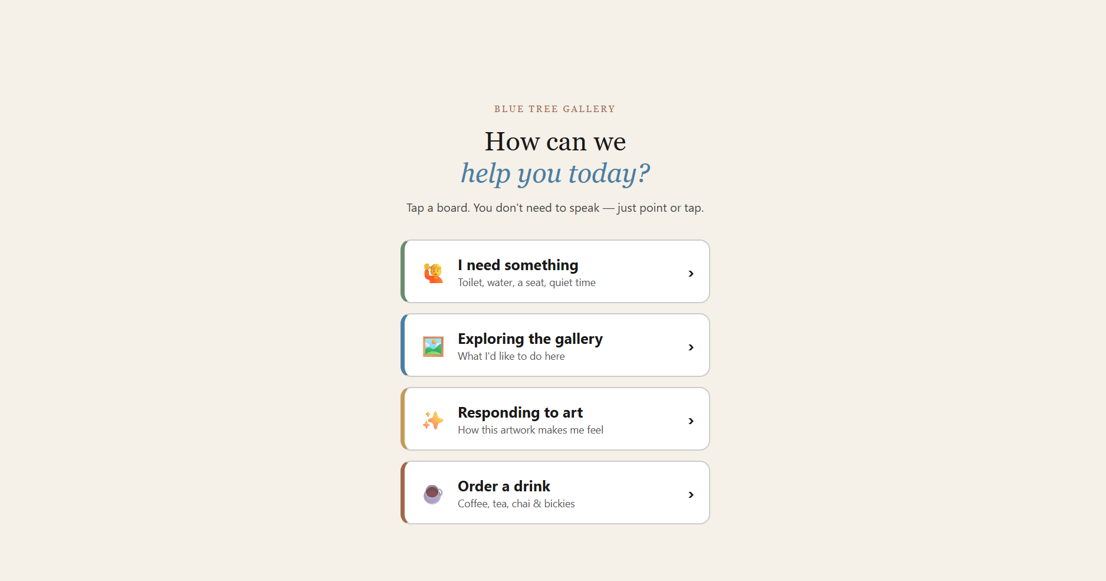
Interactive Picture Board

This interactive picture board allows visitors to share their needs without needing verbal communication.

Guide Dog and Service Animals
- The business provides a secure area with shade and water for service animals
- The business provides a toilet area for service animals
- Bowls, bedding, etc. are provided for service animals
The business provides the following services for services animals:
At Blue Tree Gallery, we welcome all service animals and aim to provide a comfortable experience for both our guests Our Services Include: Full Access: Service animals are permitted in all public areas of the gallery and shop. Outdoor Relief Area: While we do not have a designated toileting area, we are located on a spacious property and can guide visitors to a nearby patch of grass or suitable outdoor area for animal toileting. Water Bowl on Request: We’re happy to provide fresh water for service animals during the visit. Assistance Upon Arrival: If help is required to navigate the gallery or identifying the best space for a service animal to rest, we’re here to assist. Calm Environment: Our quiet and low-stimulus space can be helpful for animals in training or those who need a calm setting. No Separation Requests: We will never ask a guest to separate from their service animal under any circumstance. We follow the Australian Disability Discrimination Act (1992), which recognises accredited assistance animals as legally entitled to accompany their handler in public spaces.

GENERAL

Pre-arrival, arrival and reception
The business has the following in place to support guests during pre-arrival, arrival and reception
- Booking information and websites are compatible with screen readers
- Information and maps are available in written form
- A familiarisation tour
- In addition, the following further information can assist guests:
We operate in a quiet, low-traffic environment, so wait times are rarely an issue.

Visitors are served as soon as they arrive, generally, there is no need to queue.

Seating is available inside and outside the gallery for rest and recovery.

If a visitor needs assistance or priority support, we are happy to provide it, no need to explain.

We encourage guests to let us know if they need anything in advance so we can tailor the visit to their needs.

- In addition, the following further information can assist guests:
Let us know your needs: If there’s anything we can do to support your visit - accessibility, sensory needs, or anything else - we’d love to hear from you in advance or when you arrive.

Quiet environment: Blue Tree Gallery is a calm, low-sensory space. We don’t play loud background music and avoid strong lighting or scents.

Companion welcome: Support people and companions are always welcome, and we’re happy to assist both guests.

No need to explain: You don’t need to disclose personal details. If you need extra time, space, or support - just ask.

Flexible timing: You’re welcome to stay as long as you need or visit briefly. We value slow, meaningful experiences.

Accessible communication: We use plain language in our signage and communication, and can provide written information if needed.

Service animals:Assistance animals are welcome throughout the gallery. Water and outdoor toileting areas can be arranged.

Parking and access: Free parking is available on site. Entry is step-free, though some surfaces are gravel or bark.

Cognitive Impairment Support
- Documents are available in plain English for people with cognitive impairment (This may include instructions, guides, menus and general information)
- A "social script" guide to your premises or attraction describing the sights, sounds and smells to aid parents/carers prepare visitors in advance
- The 'social script' is available in word and other editable formats
- Quiet periods or early opening times for people on the Autism Spectrum
- A space for parents and children on the Autism Spectrum

Car Park and Access amenities
The business has the following Car Park and Access amenities
- A drop off zone
- Designated disabled parking bays
- Level or ramped access from the car park to the entrance
- The public transport services available are:

We provide details that Blue Tree Gallery is in an isolated area and is really only accessible by car but these details can also be shared.
- In addition, the following further information can assist guests:
Guests are encouraged to let us know in advance if they have any specific access or support needs.

The gallery is on a private property with limited signage, but we are available to guide or assist.

Visitors may remain in their car and call us if they would like help entering or navigating the space.

We aim to provide a calm, respectful environment where all guests are welcome to go at their own pace.

Entry
The business has the following amenities/systems in place for entry
- A drop off point close to the entrance
- A path of access to the building is clear of obstruction
- Glass doors are fitted with a visual sighting strip
- Door jams/doors are of a contrasting colour to surrounding walls
- Door handles are of a contrasting colour to the door
- Signage is written in a contrasting colour
- Signage is written in a Sans Serif font and use upper and lower case letters
- The entry door is a minimum of 850mm wide
- The entry door has self opening or a light opening pressure (for manual operations)
- The entrance sill is less than 13mm
- The entrance door mats have a thickness less than 13mm and a width of 7500mm or greater
- In addition, the following further information can assist guests:
If you need help entering the building or navigating the space, we’re always happy to assist; no need to explain.

The clear space infront of inward opening doors is at 1200mm x 1200mm

You’re welcome to call ahead or signal from your car if easier.

We continue to make small improvements and appreciate feedback to help us become more accessible for all visitors.

- In addition, the following further information can assist guests:
The entire gallery is on ground level, with step-free access throughout.

There are no internal stairs or changes in floor height that require lift access.

If you have specific mobility concerns or require assistance, we’re happy to help ensure your visit is smooth and comfortable.

Internal Spaces
- Clear and unobstructed routes through and between buildings
- Interior walls are matte or low sheen
- Floor surfaces are hard or short pile carpet
- Seating is available for guests unable to stand for long periods
- Accessible facilities are clearly signed and visible from all areas
- All corridors greater than 900mm
- There is a quiet space for parents and children on the Autism Spectrum
- In addition, the following further information can assist guests:
We aim to create a calm, welcoming environment. Noise and visual stimuli are kept minimal to support guests with sensory sensitivities.

If you or your child needs a quieter moment, please let us know, We are flexible and supportive.

Public areas
The public areas have the following amenities in place
- Even lighting
- Seating
- In addition, the following further information can assist guests:
While we do not have technology-based aids like hearing loops or captions, we are committed to inclusive communication.

Our staff are happy to speak slowly, face guests directly, or provide written support if needed.

The calm layout and open design of the gallery can assist guests who rely on visual cues or lip reading.

Displays, exhibits, commentary and live performances
For displays, exhibits, commentary and live performances the following amenities are in place
- Seating
- Wheelchair accessible spaces/seating
- A written transcript where audio description is provided i.e. display commentary, tour commentary
- In addition, the following further information can assist guests:
Our exhibitions are designed to be experienced at your own pace. We welcome guests to sit, pause, and engage however suits them best.

If you require information about an artwork in a different format, we are happy to assist or provide written summaries.

External Paths
External paths of travel
- Pathways are wider than 900mm

There is no steps required to access on either paths or entry

There are no paths with steps
- In addition, the following further information can assist guests:
While surfaces are stable, they may not suit all wheelchairs or other mobility aids due to the chip bark.

We’re happy to assist with mobility or entry needs and encourage guests to contact us in advance.

The flat, open site and small scale of the gallery means most access needs can be supported personally and quickly.

Steps
Steps
- There are steps.
- Top and bottom steps are easily distinguished through colour contrast or the use of TGSIs (Tactile Ground Surface Indicators)
- The underside of all staircases are enclosed or protected to a height of at least 2 metres
- Where steps are present are there three steps or less
- In addition, the following further information can assist guests:
We recommend using the step-free entrance, which is easily accessible and open to all visitors.

If you'd like assistance or directions on arrival, we're always happy to help.

Ramps
Ramps have the following amenities are in place
- There are ramps.
- All fixed ramps are 1:14 or less
- Long ramps (more than 10m) are 1:20 or less
- In addition, the following further information can assist guests:
Our fixed ramp provides step-free entry and has a gradient of approximately 1:6.7, with a 15cm rise over 1 metre. While suitable for some, this may be too steep for unassisted wheelchair users or those with limited mobility.

There are no handrails or raised sides, so guests may prefer support when using the ramp.

If you're unsure whether the ramp suits your needs, we encourage you to call ahead, we’re more than happy to assist on arrival.

- In addition, the following further information can assist guests:
We do not currently offer on-site toilet facilities for visitors.

The closest accessible public toilet is located at Gowrie Park, Cradle Mountain or Wilmot (Approximately all 15-20minutes away

If toilet access is essential for your visit, we recommend contacting us in advance so we can help identify the best options nearby.

We are aware that this may limit access for some visitors and continue to explore future options to improve this.

ATTRACTIONS

Attractions Basics
- A park map is available here:

https://www.bluetreegallery.com.au/accessibility-statement
  - Image(s)
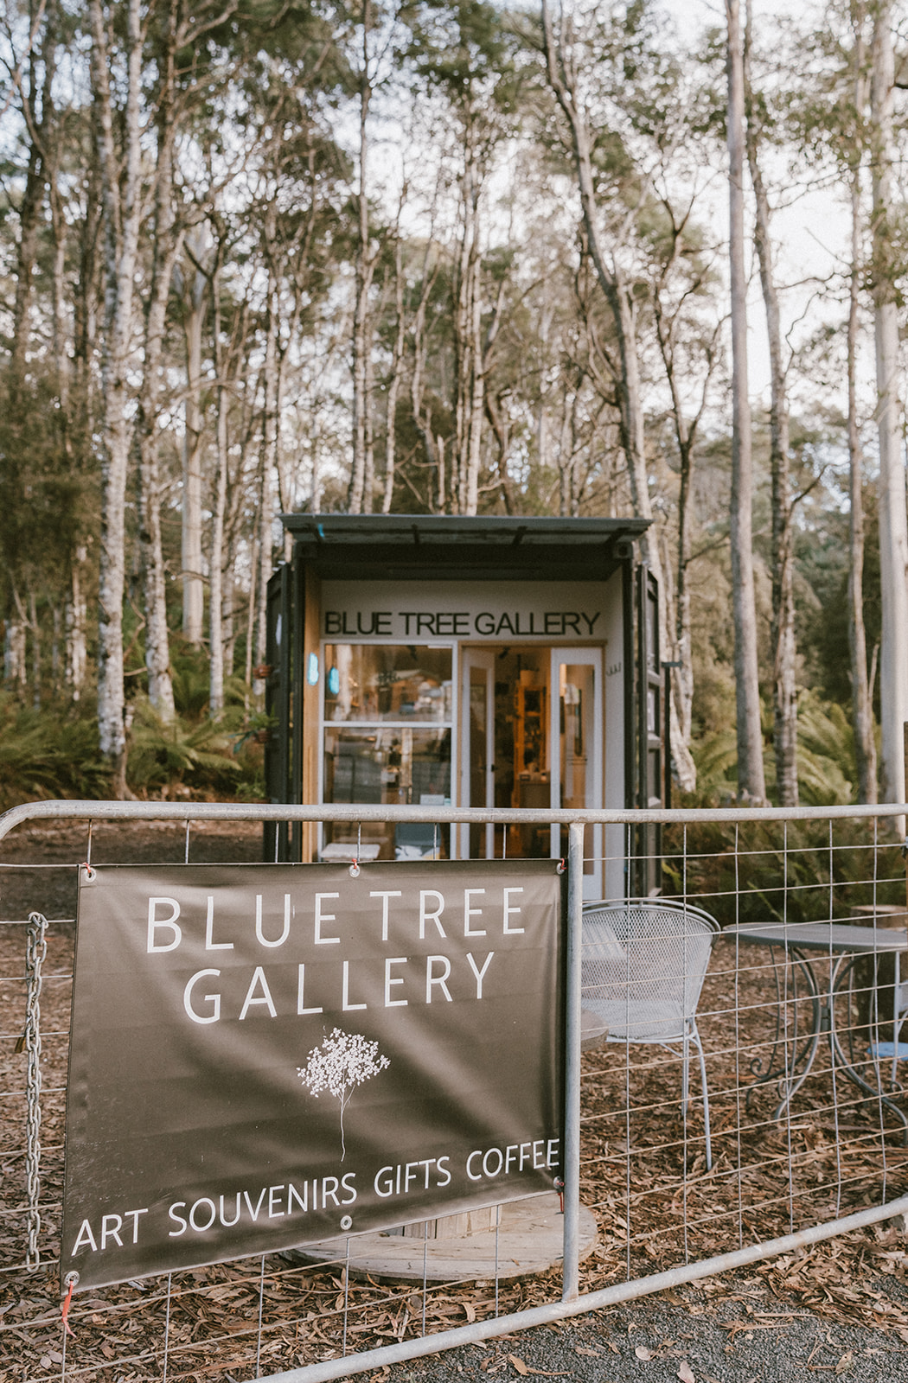
Main Entrance
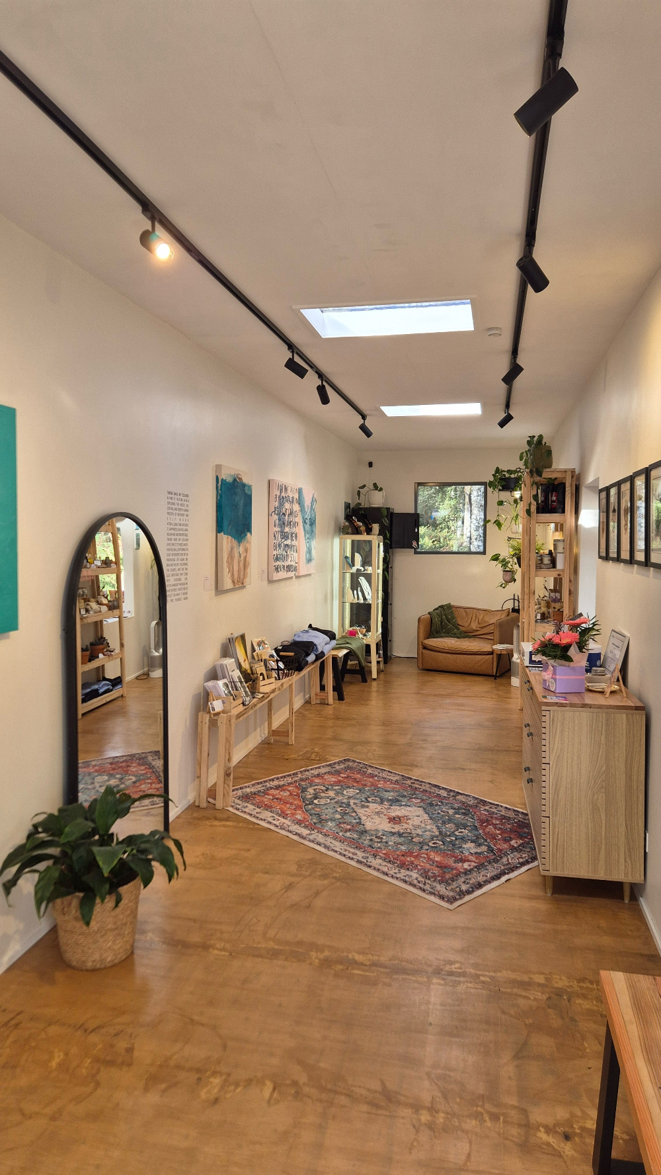
Internal_view_of_Blue_Tree_Gallery
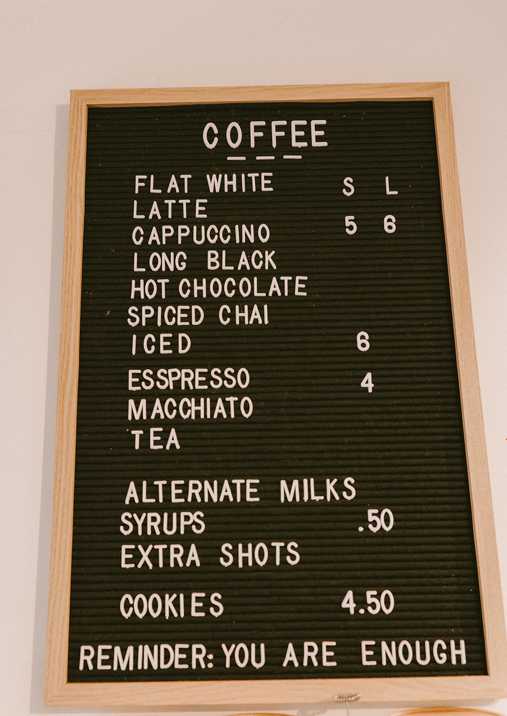
Menu
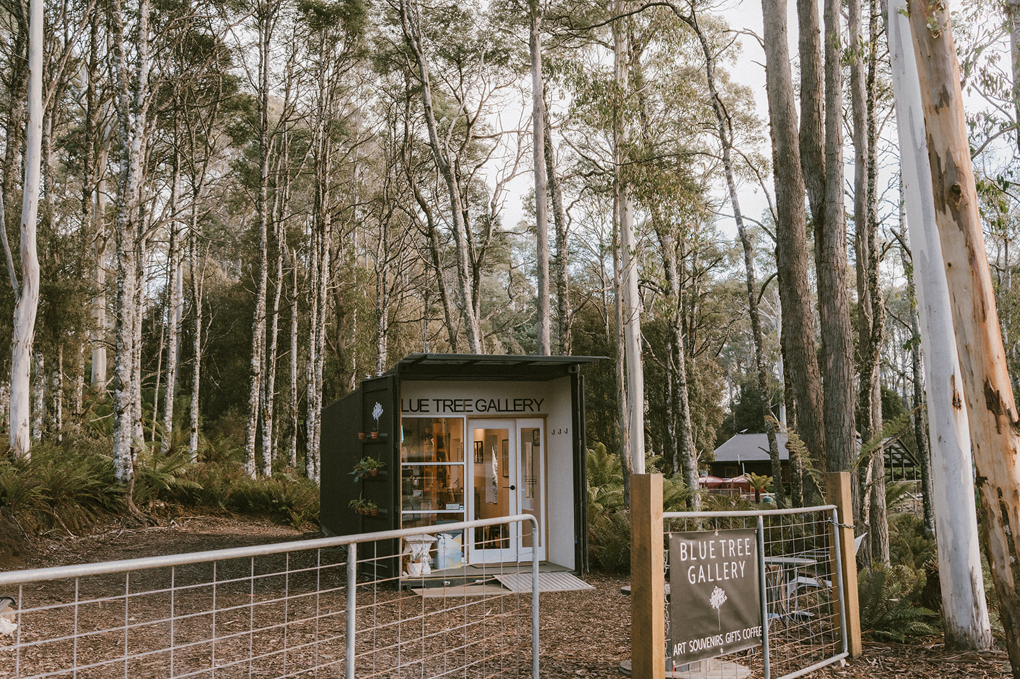
Gallery Entrance Parking down side
- In addition, the following further information can assist guests:
Images included show key access areas to help plan a visit confidently.

Parking is located close to the entry on level ground — while not marked, it is easy to navigate and shown in our images.

The ramp entry is gently sloped but steeper than standard recommendations (approx. 1:6.7 gradient).

Inside the gallery, you’ll see wide, open pathways and uncluttered layout, suitable for mobility aids.

Images also show available seating for guests who may need to rest throughout their visit.

We’ve included photos of display areas and the gift shop space, demonstrating room to move and access items.

The gallery is quiet and low-stimulus, photos of a calm corner reflect this welcoming environment.

If using a mobility aid or visiting with a service animal, the images give a realistic sense of spacing and comfort.

We do not currently offer public toilet facilities accessible toilets are located off-site (please contact us for directions).

If further support is needed or there are specific needs, we encourage you to contact us before your visit. We’re always happy to help.

COMMON AREAS

FOOD AND DRINK

Dining Spaces
The dining spaces have the following facilities/amenities in place
- The entrance has level access
- The doorway is at least 850mm wide
- There is level access through the dining area
- Chairs are moveable to allow for wheelchairs to be seated at the tables
- All glass doors and full height windows have contrast markings
- There are areas of full lighting
- There are Plain English menus

Our business caters for the following dietary requirements
- Sugar free (diabetic)
- Gluten free (celiac)
- Lactose free (dairy free)
- Low fat and fibre with no gastric content
- Low potassium
- Low sodium
- Nut free
- Additive free
- Organic
- Vegetarian
- Vegan
- Kosher
- Halal
- In addition, the following further information can assist guests:
All food handling (e.g. coffee preparation) is done with clean hands and designated utensils.

We store food and drinks separately from art materials, cleaning products, or non-food items.

Surfaces used for preparing or serving food and drink are wiped down regularly with food-safe cleaning products.

Gluten-free and other dietary-sensitive items are stored separately and handled with care, but we are not an allergen-free environment.

We do not prepare complex meals on site, which significantly limits the risk of cross-contact.

Milk alternatives and dairy products are poured using separate jugs to minimise cross-over.

Visitors are encouraged to inform us of any allergies or sensitivities; we will do our best to accommodate or provide product information.

- There is a sample menu available online
Sample menu is available here -
https://www.bluetreegallery.com.au/coffee
  - Food and Beverage Image(s)
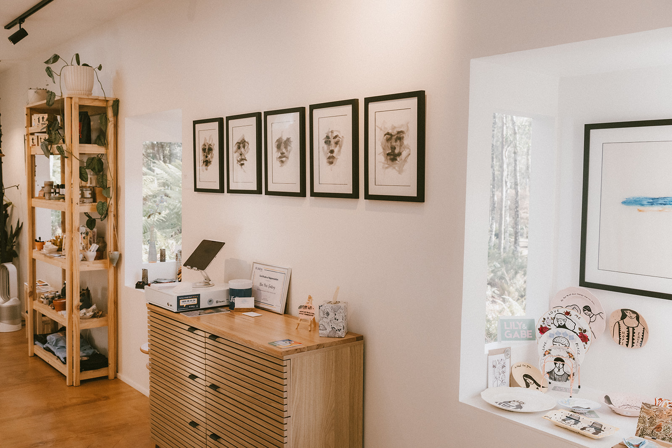
Pay Order Counter
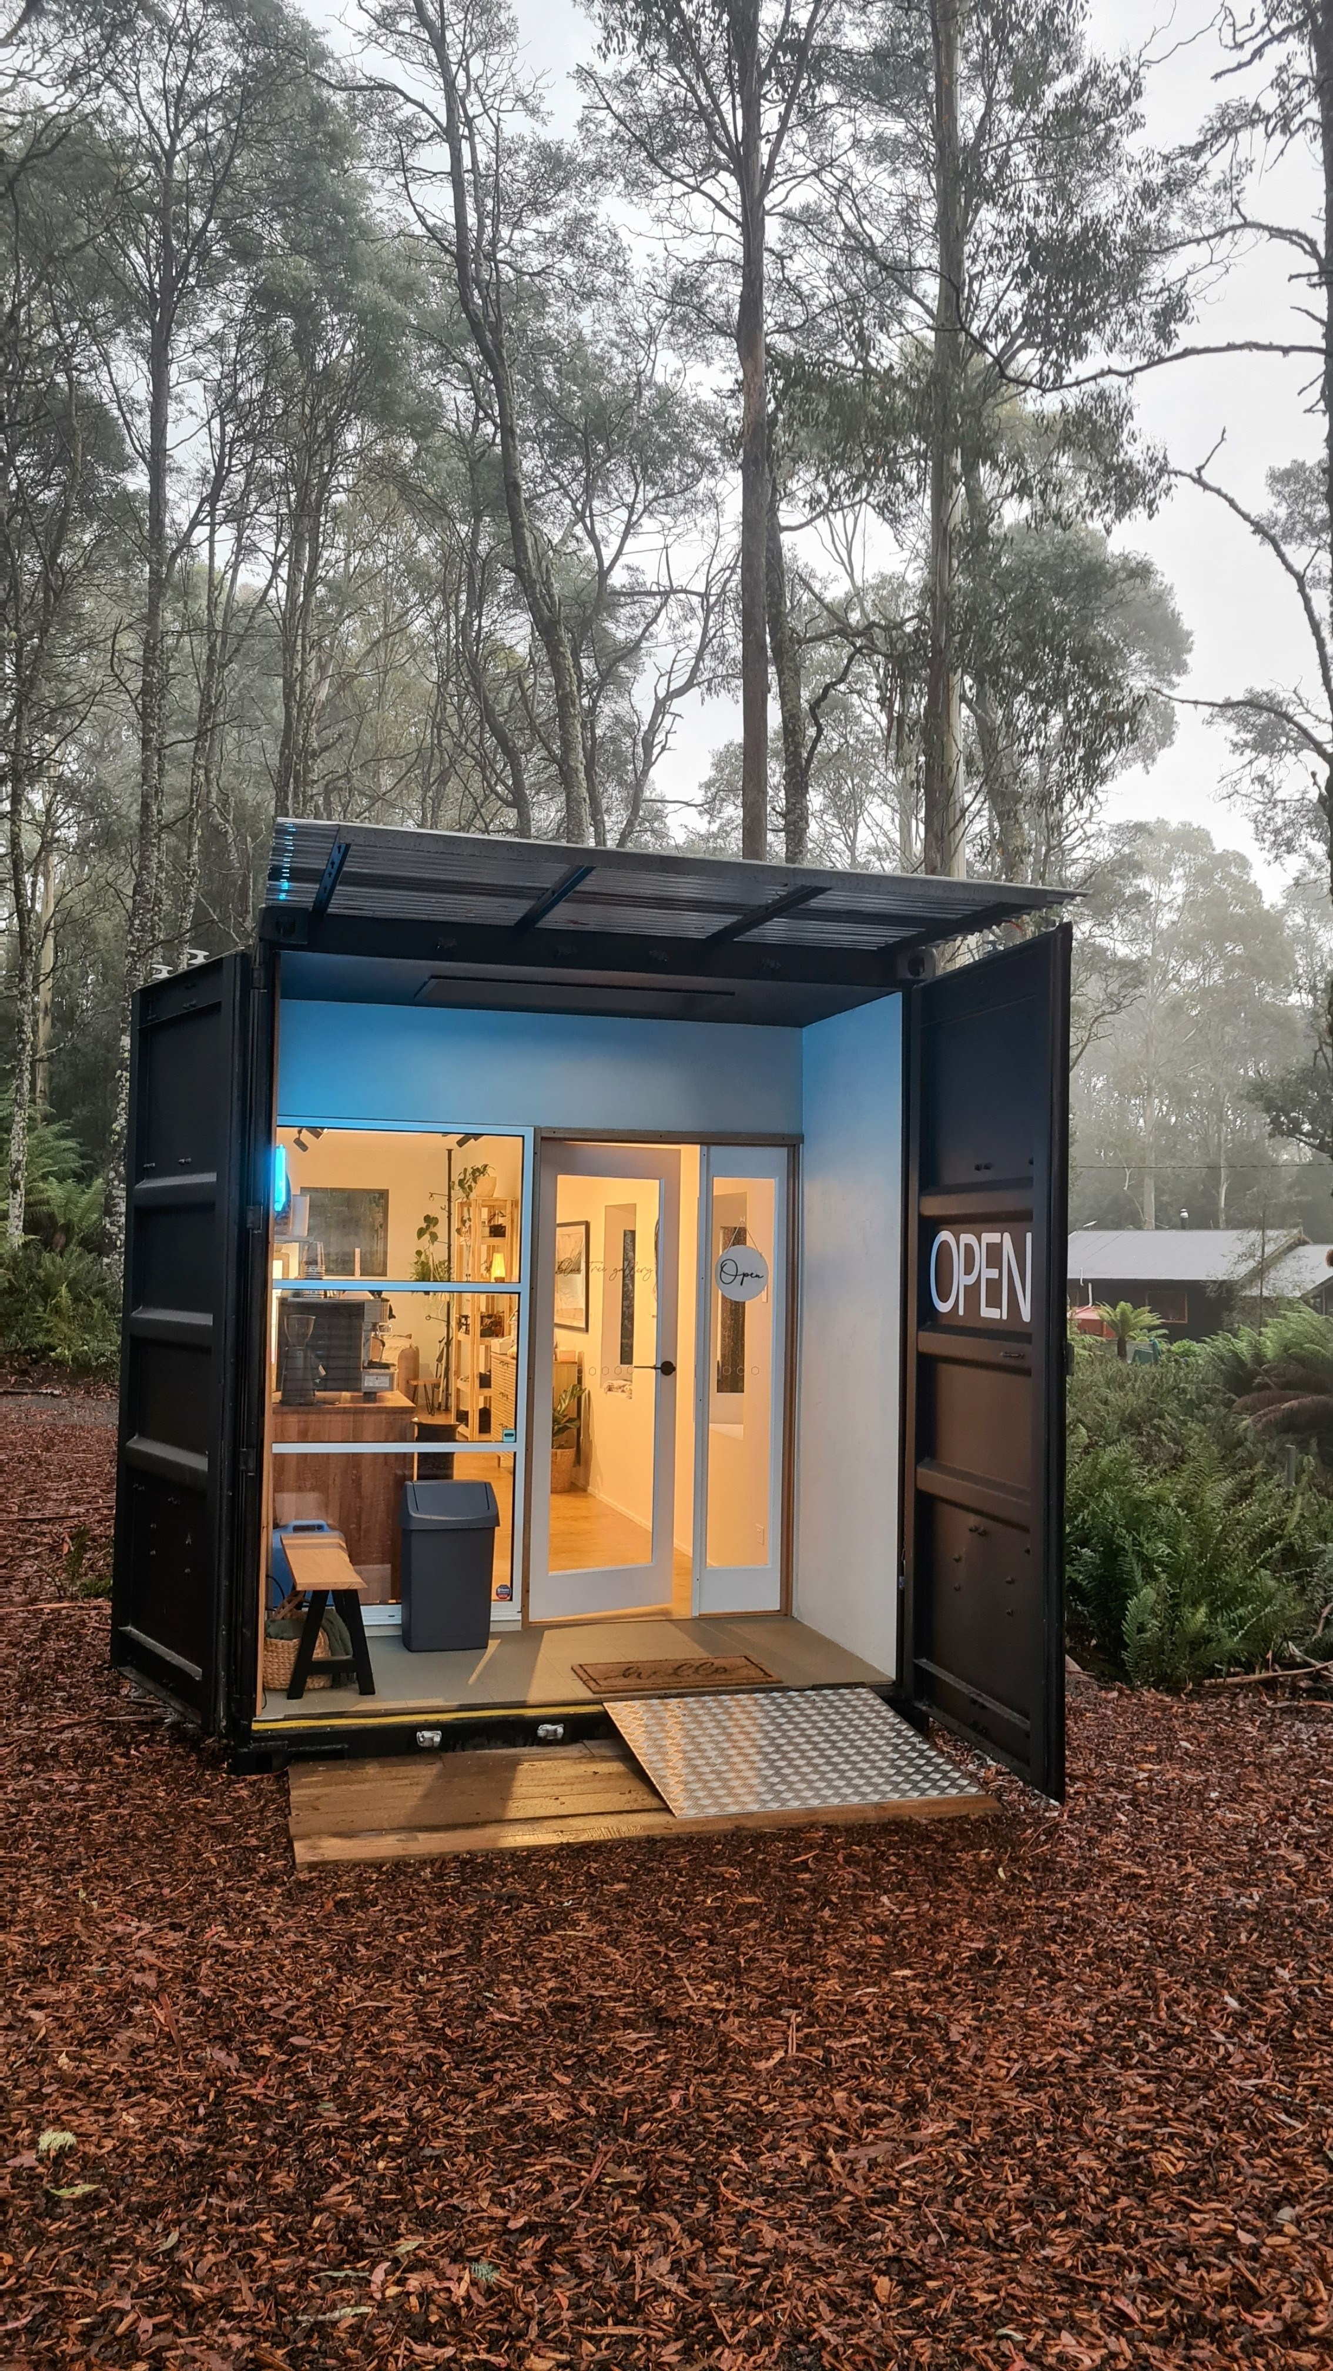
Entry and Doors
- In addition, the following further information can assist guests:
Images of our entry and doors show the step-free access and ramp available for visitors using mobility aids. The door is manually operated - assistance is available if needed.

While we don’t operate a traditional café or bar, the servery area for coffee is visible and within easy reach.

Our order and pay counter is intentionally non-traditional — staff stand on the same side as visitors to reduce physical and social barriers. There is no fixed counter, which allows for flexible, person-centred interaction.

The entire space is designed to feel calm, open, and welcoming for guests with mobility, sensory, or fatigue-related access needs.

If you need any assistance during your visit, please ask; we’re happy to adapt and support however we can.

Report Disclaimer
Please note that this business report, provided as a result of the use of the diagnostic assessment, is for information purposes only.
Australian Tourism Industry Council (ATIC) cannot guarantee the accuracy of respondent’s answers, or that they are fully representative of your business. Therefore, ATIC does not warrant or guarantee any particular outcome in respect of your businesses self-assessment.
This report is intended as guidance only for your business and should not be relied on for future marketing considerations. ATIC recommends that you seek your own independent advice as well as the results from the diagnostic.
Links to external web sites are inserted for convenience and do not constitute endorsement of material at those sites, or any associated organisation, product or service.
ATIC does not:
- Assume any legal liability for the accuracy, completeness, or usefulness of any information from this report or any links provided; or
- Accept responsibility for any loss associated directly or indirectly from the use of this report.

