ATIC Accessibility
To support the accessible community in making informed travel decisions for their individual needs

This report prepared for:
Business name: | Your Exclusive Tours
Address: | U3 4 Elm Street
Town: | Bayswater
Contact for enquiries: | Robert Rees
Contact Number: | 0413315906
Contact Email: | info@yourexclusivetours.com.au
Website: | www.yourexclusivetours.com.au
Date: | 2026-10-24 12:54

ATIC Accessibility
The following pages provides travellers with information on the businesses facilities and amenities which aims to support the traveller to make an informed decision on whether the business is suitable for their individual needs.
OVERVIEW 4
Business Overview 4
Bookings 4
Emergency Management 5
Communications 5
Guide Dog and Service Animals 5
GENERAL 6
Pre-arrival, arrival and reception 6
Cognitive Impairment Support 6
Displays, exhibits, commentary and live performances 6
Steps 7
TOUR OPERATORS 8
Tour/Transport Services 8
Route Planning 8
Guides 8
Report Disclaimer 12

OVERVIEW

Business Overview

The business has the following products/services available
- Tour/Transport

Our business caters for the following disability types:
- Blind or low vision
- Deaf or low hearing
- Limited mobility
- Wheelchairs or mobility scooters
- Food allergies or intolerances
- Cognitive or people on the Autism Spectrum


Bookings

The business offers the following methods for bookings and enquiries:
- Phone
- Email
- Webportal
- Our website supports Screen Readers
- Our forms have high contract boxes and submit boxes

Emergency Management
- The business has an emergency management and evacuation plan for guests with a disability
- Emergency and evacuation procedures are explained on arrival
- Guests with disabilities are noted in the guest log book for emergency and evacuation purposes

Communications
- An accessibility guide is available on the website

https://yourexclusivetours.com.au/accessibility-inclusion-statement/
- Our business offers the following alternative communication methods
- Plain English

Not specified
- There is easy to read signage and information (e.g. menus and emergency information)

Guide Dog and Service Animals
The business provides the following services for services animals:
We have not yet had the opportunity to transport a service animal but should we need to do so, we'd ensure that either ourselves, or or guests, had all necessary equipment to transport one safely and comfortably.

GENERAL

Pre-arrival, arrival and reception
The business has the following in place to support guests during pre-arrival, arrival and reception
- Booking information and websites are compatible with screen readers
- In addition, the following further information can assist guests:
All tours are privately booked. We meet our guests at a prearranged time and we depart as soon as they are assembled. Should we need to wait for multiple couples within a single booking, we have the vehicle open and ready to go - guests can rest at any time.
- In addition, the following further information can assist guests:
All guests have access to our vehicle at any time. If they choose not to participate at a specific stop, they are welcome to wait in the vehicle. If there is a 2nd guide on the tour, they stay with the guest.

Cognitive Impairment Support
- Documents are available in plain English for people with cognitive impairment (This may include instructions, guides, menus and general information)
- Quiet periods or early opening times for people on the Autism Spectrum
- A space for parents and children on the Autism Spectrum

Displays, exhibits, commentary and live performances
For displays, exhibits, commentary and live performances the following amenities are in place
- Seating
- Wheelchair accessible spaces/seating
The width of the smallest pathway is:
We do not have a premsies with pathways. Where guests have mobility restrictions, we ensure that all tour stops are accessible to them.

We do not have a premsies with pathways. Where guests have mobility restrictions, we ensure that all tour stops are accessible to them.

We do not have a premsies with pathways. Where guests have mobility restrictions, we ensure that all tour stops are accessible to them.

Steps
Steps
- There are steps.
- Top and bottom steps are easily distinguished through colour contrast or the use of TGSIs (Tactile Ground Surface Indicators)
- Handrails fitted to all open sets of steps
- Where steps are present are there three steps or less
- In addition, the following further information can assist guests:
All vehicles have grab rails at the doors where steps are required to enter or exit.
- In addition, the following further information can assist guests:
When these items are required by guests, we ensure that sufficient time and stops are made at premises with these facilities.

TOUR OPERATORS

Tour/Transport Services
The tour/transport services have the following facilities/amenities in place
- Buses/Coaches
- 0 vehicles have wheelchair lifts or ramps
- 0 vehicles have low floors with ramped entry
The maximum wheelchair capacity available in the fleet is:
4

Route Planning
- Route Planning
- The tour route includes stops with accessible toilet facilities
- In addition, the following further information can assist guests:
As all tours are private, they are also highly customisable. Where we have guests with accessibility issues we vary the itinerary to ensure all stops are suitable to them.
- Lunch stop venues are accessible
- Sightseeing and photo opportunity stops are step free

Guides
- AUSLAN
- Use of clear/simple English
- Correct pronunciation for lip readers
- There is a audio description of surroundings
  - Image(s)
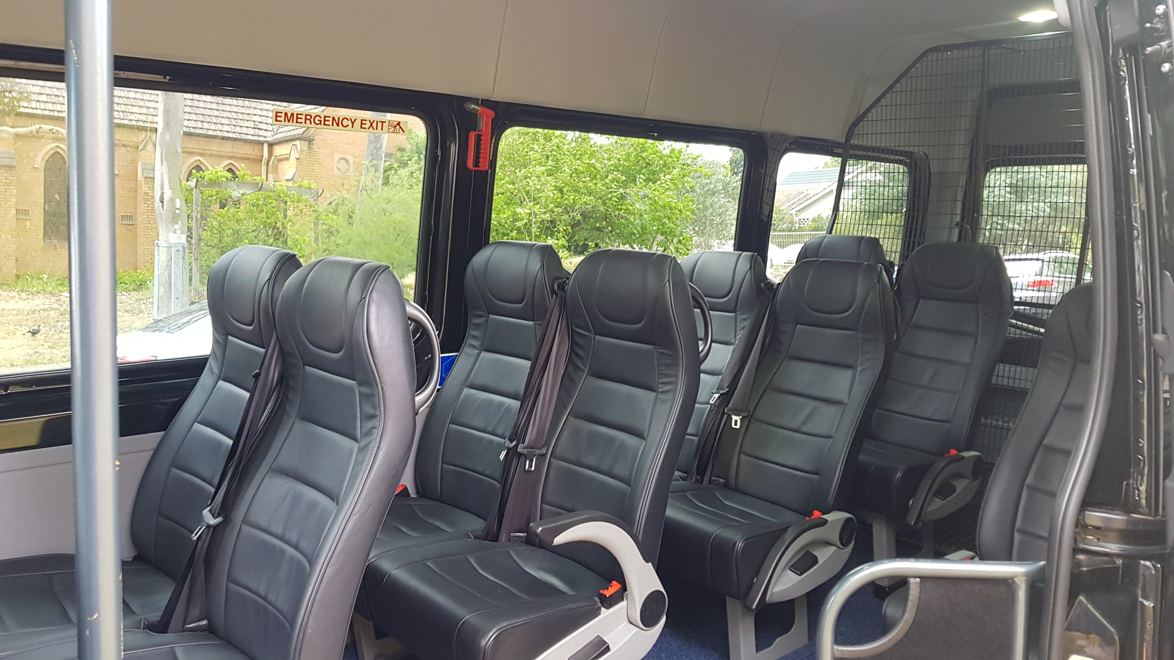
20191203_111524
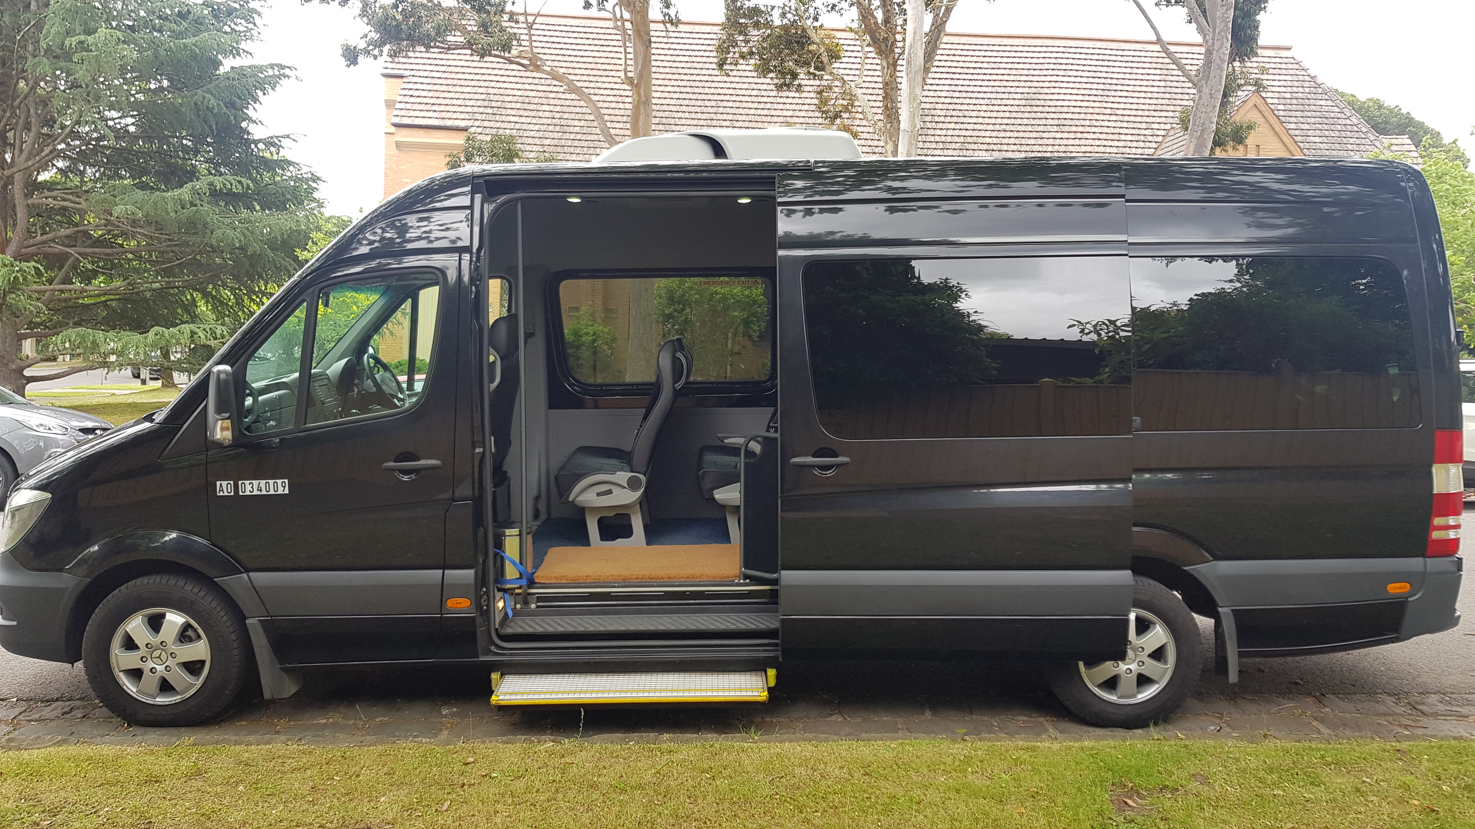
20191203_111631
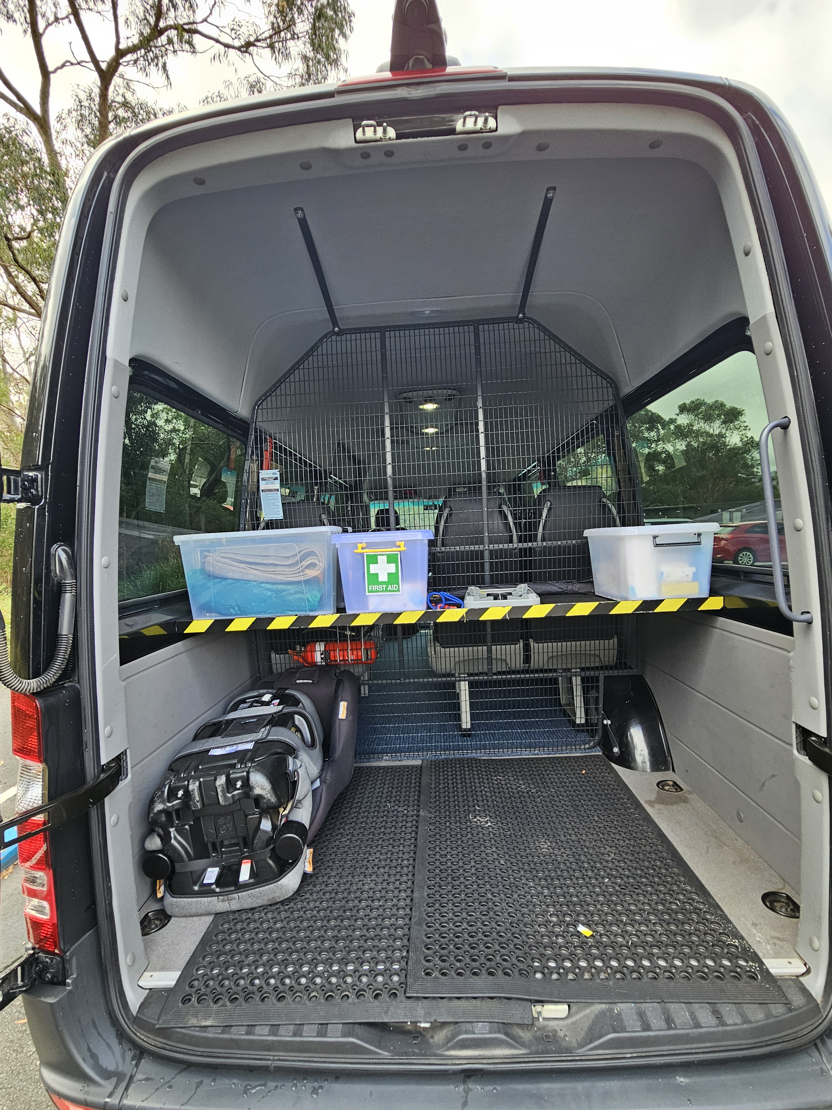
20250529_114437
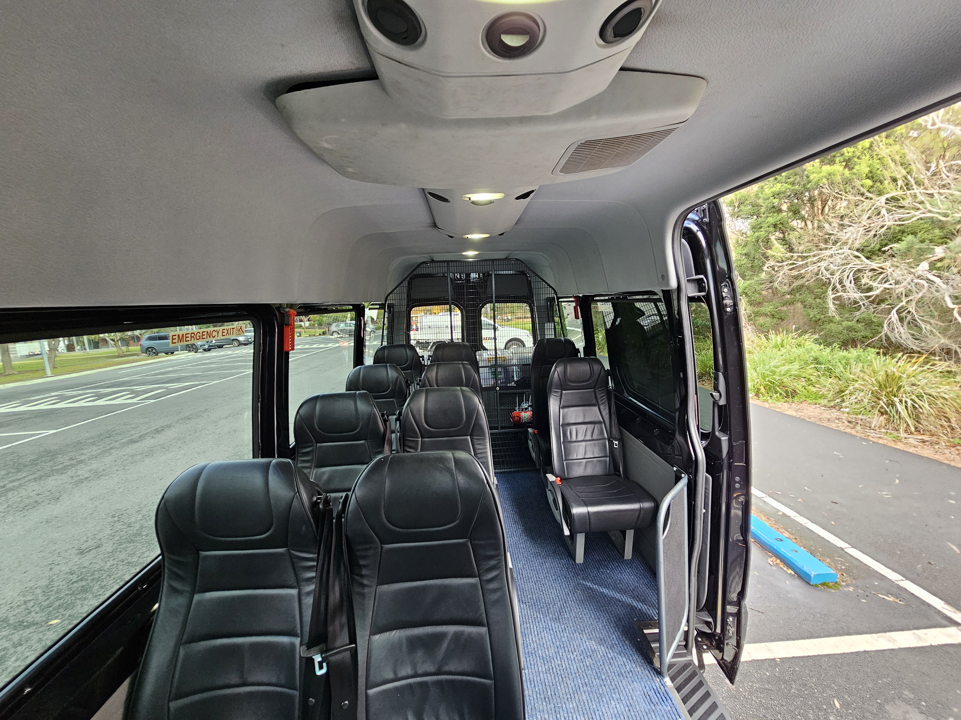
20250529_114658
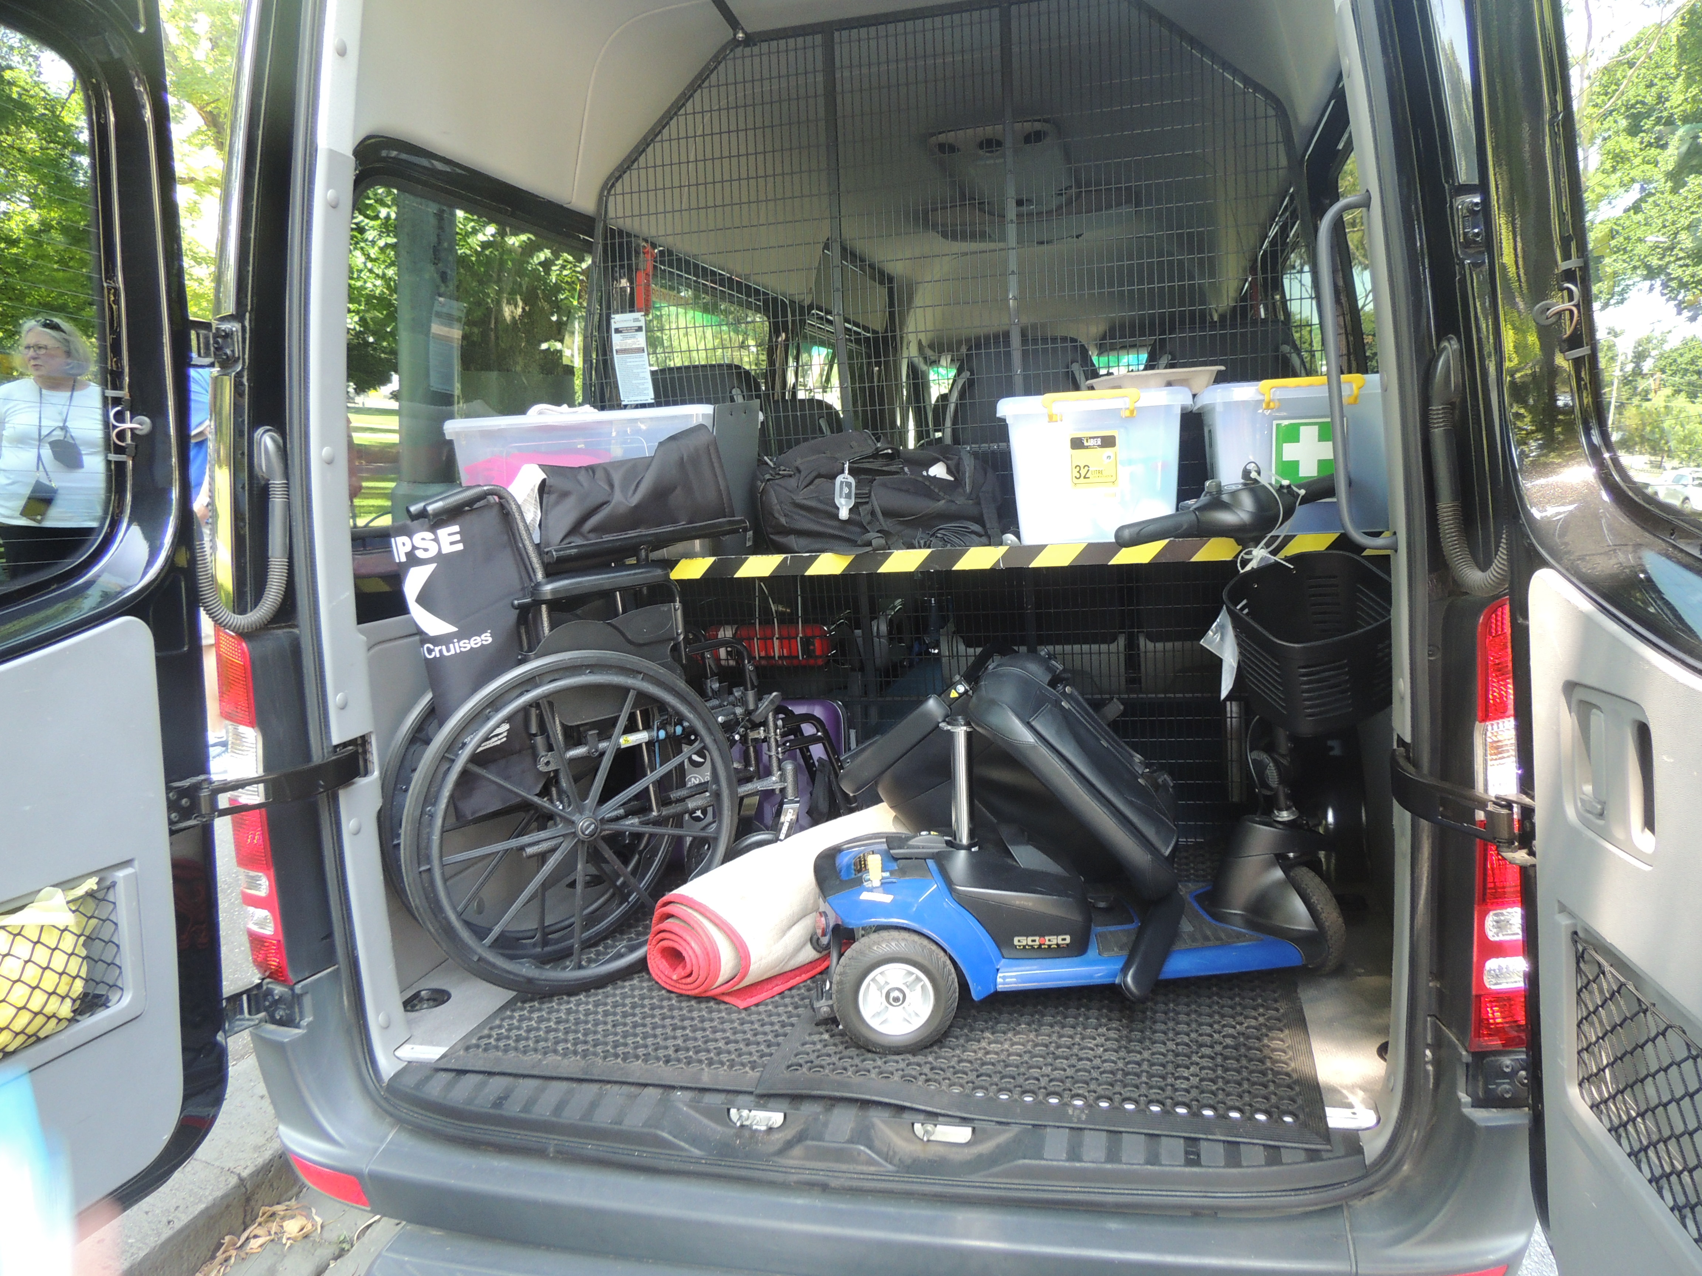
DSCN4084.JPG
- In addition, the following further information can assist guests:
Please note re: above photos - we have included photos of our Sprinter vehicle as it's the largest and the one we're most likely to use in the event of carrying guests with accessibility aids.

Report Disclaimer
Please note that this business report, provided as a result of the use of the diagnostic assessment, is for information purposes only.
Australian Tourism Industry Council (ATIC) cannot guarantee the accuracy of respondent’s answers, or that they are fully representative of your business. Therefore, ATIC does not warrant or guarantee any particular outcome in respect of your businesses self-assessment.
This report is intended as guidance only for your business and should not be relied on for future marketing considerations. ATIC recommends that you seek your own independent advice as well as the results from the diagnostic.
Links to external web sites are inserted for convenience and do not constitute endorsement of material at those sites, or any associated organisation, product or service.
ATIC does not:
- Assume any legal liability for the accuracy, completeness, or usefulness of any information from this report or any links provided; or
- Accept responsibility for any loss associated directly or indirectly from the use of this report.

