ATIC Accessibility
To support the accessible community in making informed travel decisions for their individual needs

This report prepared for:
Business name: | Valentino Holidays Pty Ltd
Address: | 62 Mcdowell Street
Town: | Welshpool
Contact for enquiries: | Thanh Phan
Contact Number: | 0413 71 8899
Contact Email: | australia@valentinoholidays.com.au
Website: | www.valentinoholidays.com.au
Date: | 2026-10-14 11:10

ATIC Accessibility
The following pages provides travellers with information on the businesses facilities and amenities which aims to support the traveller to make an informed decision on whether the business is suitable for their individual needs.
OVERVIEW 4
Business Overview 4
Bookings 4
Emergency Management 5
Guide Dog and Service Animals 5
GENERAL 6
Pre-arrival, arrival and reception 6
Car Park and Access amenities 6
Entry 6
Internal Spaces 7
Public areas 7
External Paths 7
TOUR OPERATORS 8
Tour/Transport Services 8
Route Planning 8
Guides 8
FOOD AND DRINK 9
Report Disclaimer 11

OVERVIEW

Business Overview

The business has the following products/services available
- Tour/Transport

Our business caters for the following disability types:
- Limited mobility
- Wheelchairs or mobility scooters
- Food allergies or intolerances
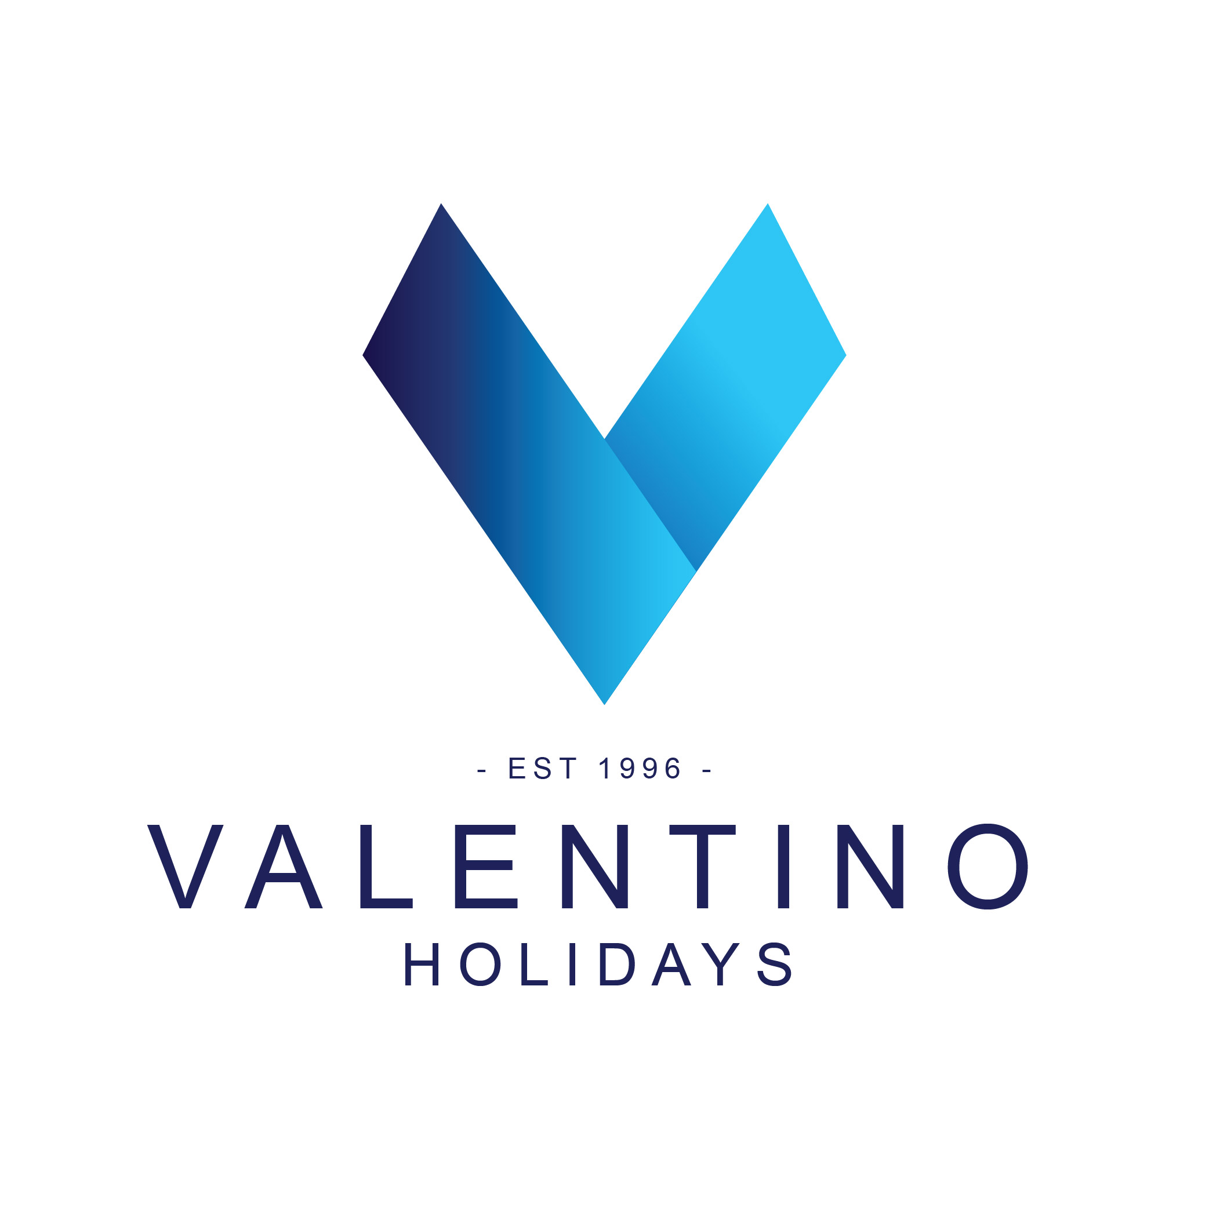

Bookings

The business offers the following methods for bookings and enquiries:
- Phone
- Email

Emergency Management
- The business has an emergency management and evacuation plan for guests with a disability
- Emergency and evacuation procedures are explained on arrival
- Guests with disabilities are noted in the guest log book for emergency and evacuation purposes

Guide Dog and Service Animals
The business provides the following services for services animals:
We can provide the water for service animal during the tour

GENERAL

Pre-arrival, arrival and reception
The business has the following in place to support guests during pre-arrival, arrival and reception
- There is a reception/public entryway.
- Seating available at reception
- A tablet with text to voice or pen and paper at reception to aid in communication
- Large print information sheets and registration forms

Our office reception area is fitted with standard white light bulb
- Information and maps are available in written form
- A familiarisation tour
- In addition, the following further information can assist guests:
All meetings are highly encourage to be pre-booked

Car Park and Access amenities
The business has the following Car Park and Access amenities
- A drop off zone
- Kerb ramps are in place where a pavement or walkway needs to be crossed
- In addition, the following further information can assist guests:
We are tour operator so all the pickup and drop off locations are based on customer request. Our drivers are ensure to pickup and drop off customers at the closest meeting place (if no accessible parking available)

Entry
The business has the following amenities/systems in place for entry
- A drop off point close to the entrance
- A path of access to the building is slip resistance and even
- A path of access to the building is clear of obstruction
- Door jams/doors are of a contrasting colour to surrounding walls
- Door handles are of a contrasting colour to the door
- Signage is written in a contrasting colour
- The entry door is a minimum of 850mm wide
- The entrance sill is less than 13mm
- There a clear space of at least 1500mm x 1500mm in front of all doors.

Internal Spaces
- Clear and unobstructed routes through and between buildings
- Interior walls are matte or low sheen
- Floors, walls, counters and furniture are of contrasting colours
- Any protruding or overhanging obstructions are at least 2meters above the floor or are protected
- Floor surfaces are hard or short pile carpet
- Seating is available for guests unable to stand for long periods
- All corridors greater than 900mm

Public areas
The public areas have the following amenities in place
- Seating

External Paths
External paths of travel
- Surfaces are concrete, asphalt, smooth paving or hard packed fine gravel (max aggregate size 13mm)
- Pathways are wider than 900mm
- There 3 successive steps or less on any path or at any doorway

TOUR OPERATORS

Tour/Transport Services
The tour/transport services have the following facilities/amenities in place
- Buses/Coaches
- 0 vehicles have wheelchair lifts or ramps
- 0 vehicles have low floors with ramped entry
The maximum wheelchair capacity available in the fleet is:
0

Route Planning
- Route Planning
- The tour route includes stops with accessible toilet facilities
- In addition, the following further information can assist guests:
Our company does not have wheelchair accessible vehicle. However, we can rent the certified wheelchair accessible vehicle from registered business for transportation
- Lunch stop venues are accessible
- Sightseeing and photo opportunity stops are step free
- Overnight Stops
- For overnight stays, wheelchair accessible rooms are available
- The accommodation provider used for overnight stops has been independently verified as accessible, please contact us for further information
The total number of wheelchair passengers that can be catered for at overnight stops are:
1

Guides
- Use of clear/simple English
- Correct pronunciation for lip readers
- In addition, the following further information can assist guests:
Public sightseeing, shopping mall such as Westfield Carousel, DFO Perth, Hotels in Perth City area (with accessible room)

FOOD AND DRINK
- The smallest doorway is Not Applicable as we do not operate the dining spaces wide

Report Disclaimer
Please note that this business report, provided as a result of the use of the diagnostic assessment, is for information purposes only.
Australian Tourism Industry Council (ATIC) cannot guarantee the accuracy of respondent’s answers, or that they are fully representative of your business. Therefore, ATIC does not warrant or guarantee any particular outcome in respect of your businesses self-assessment.
This report is intended as guidance only for your business and should not be relied on for future marketing considerations. ATIC recommends that you seek your own independent advice as well as the results from the diagnostic.
Links to external web sites are inserted for convenience and do not constitute endorsement of material at those sites, or any associated organisation, product or service.
ATIC does not:
- Assume any legal liability for the accuracy, completeness, or usefulness of any information from this report or any links provided; or
- Accept responsibility for any loss associated directly or indirectly from the use of this report.

