ATIC Accessibility
To support the accessible community in making informed travel decisions for their individual needs

This report prepared for:
Business name: | Seashells Scarborough
Address: | 178 The Esplanade
Town: | Scarborough
Contact for enquiries: | Mari-Liis Martinfeld
Contact Number: | 0893416644
Contact Email: | scarborough@seashells.com.au
Website: | www.seashells.com.au
Date: | 2026-10-07 19:46

ATIC Accessibility
The following pages provides travellers with information on the businesses facilities and amenities which aims to support the traveller to make an informed decision on whether the business is suitable for their individual needs.
OVERVIEW 4
Business Overview 4
Bookings 4
Emergency Management 5
Communications 5
Other Information 6
Guide Dog and Service Animals 6
GENERAL 7
Pre-arrival, arrival and reception 7
Cognitive Impairment Support 7
Car Park and Access amenities 7
External Paths 8
Steps 8
Ramps 8
ACCOMMODATION 9
Bedrooms 9
Room Amenities 9
Bathrooms 10
COMMON AREAS 12
Swimming pools, spas and waterparks 12
Report Disclaimer 16

OVERVIEW

Business Overview

The business has the following products/services available
- Accommodation

Our business caters for the following disability types:
- Blind or low vision
- Deaf or low hearing
- Limited mobility
- Wheelchairs or mobility scooters
- Food allergies or intolerances
- Cognitive or people on the Autism Spectrum
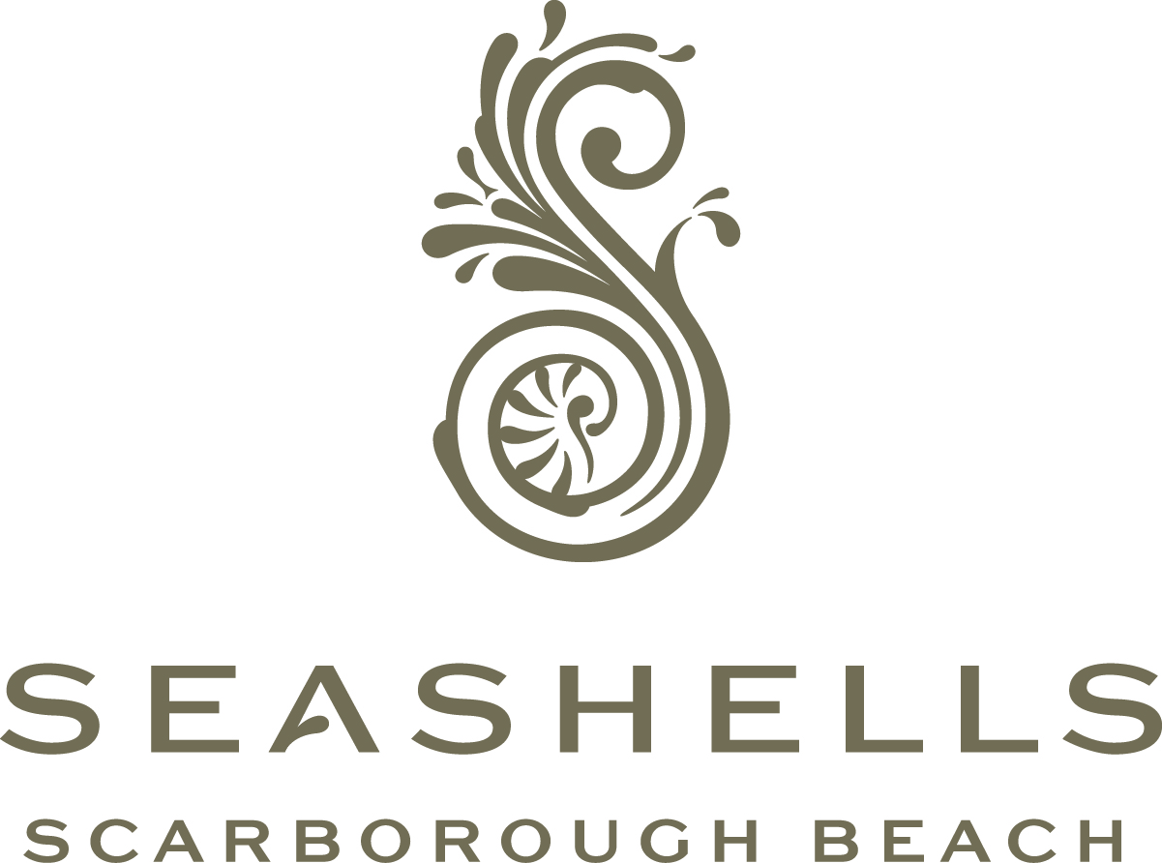

Bookings

The business offers the following methods for bookings and enquiries:
- Phone
- Email
- Webportal
- Staff have undergone disability awareness and training

Emergency Management
- The business has an emergency management and evacuation plan for guests with a disability
  - A copy of the plan is available on request.
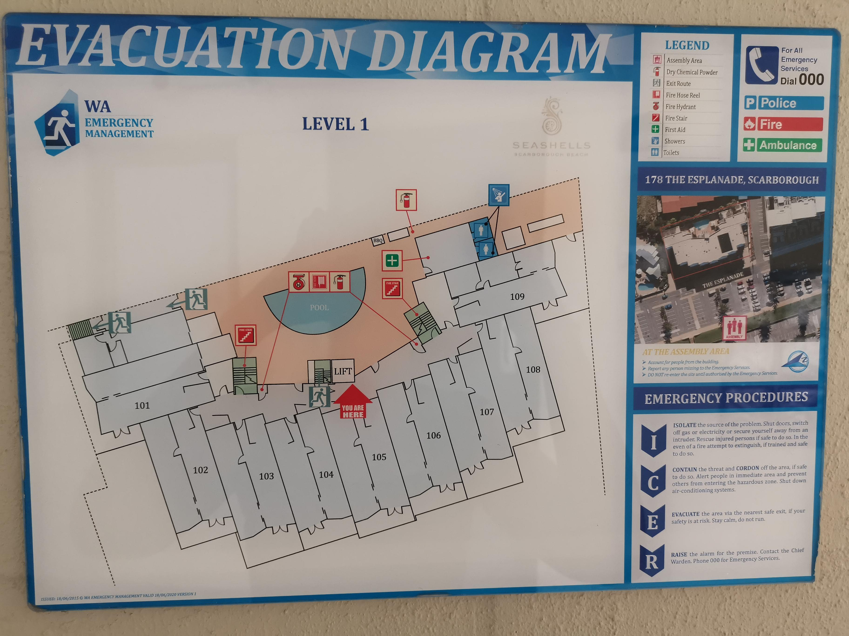
Evacuation Level 1 IMG_20240912_134413
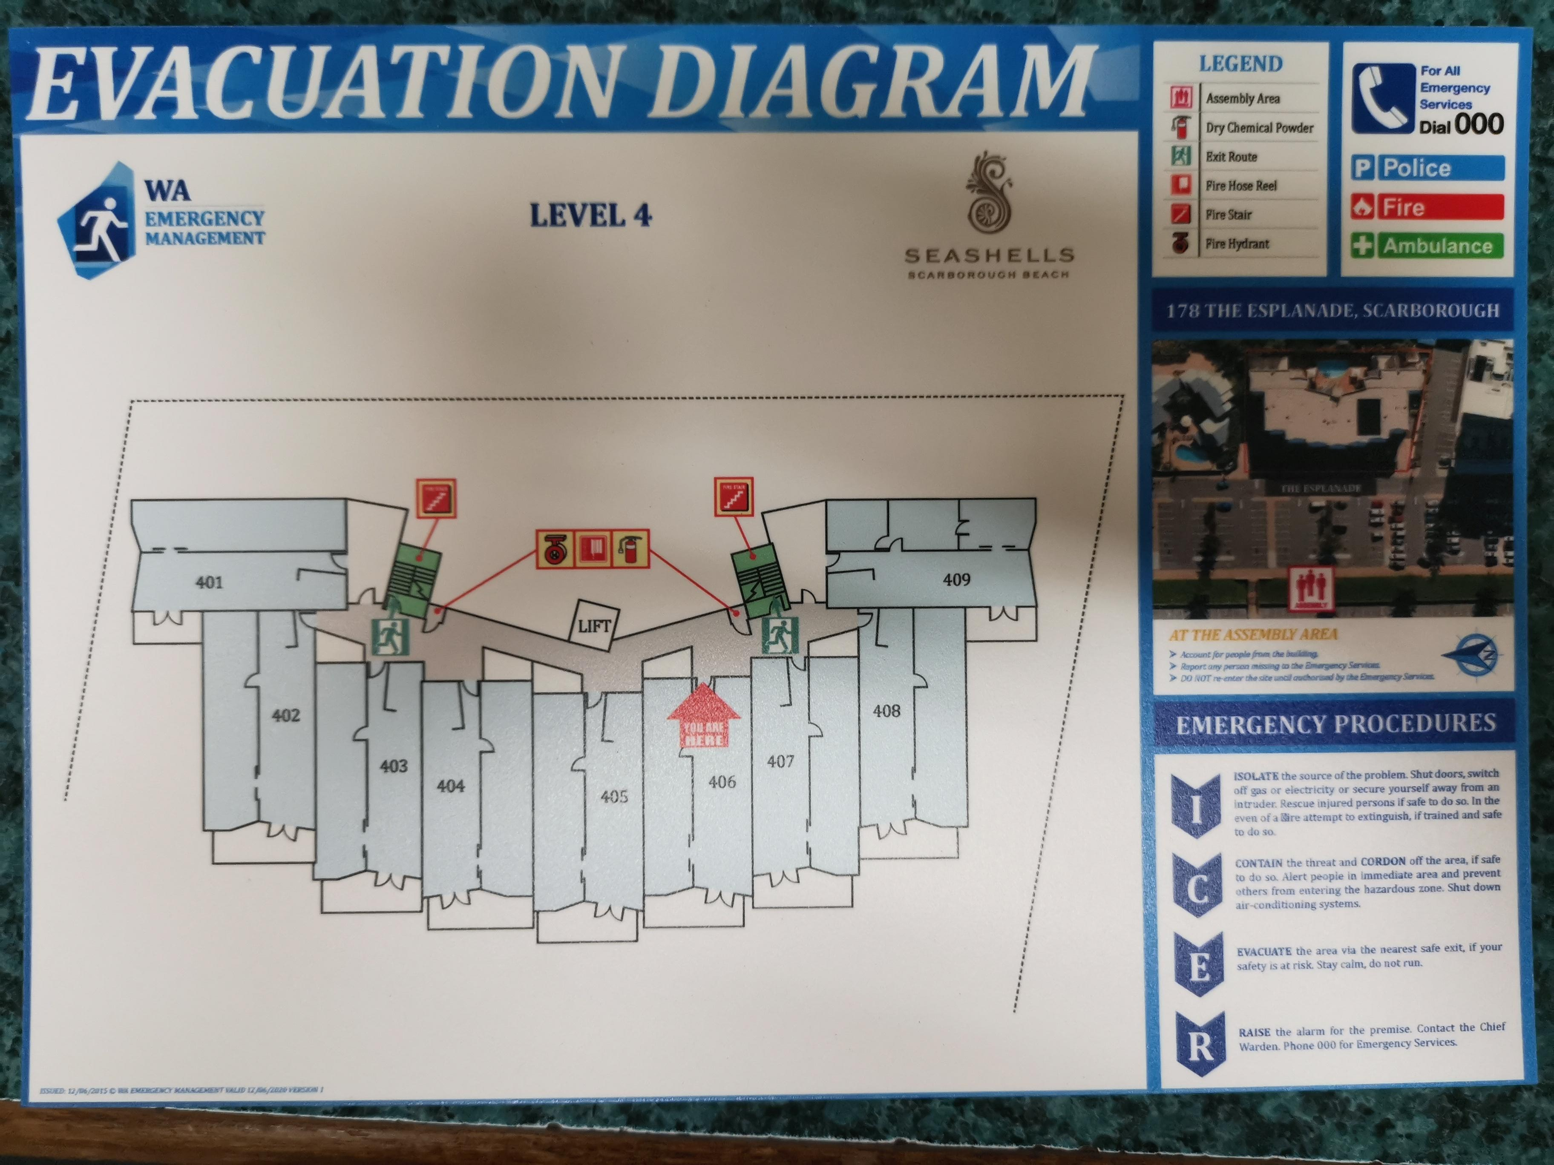
Evacuation Level 4 IMG_20240912_134751
- Guests with disabilities are noted in the guest log book for emergency and evacuation purposes

Communications
- Our business offers the following alternative communication methods
- Plain English

Not specified
- There is easy to read signage and information (e.g. menus and emergency information)

Other Information
- For bookings made onsite, the ticket booth/counter/box office is accessible for people using a wheelchair

Guide Dog and Service Animals
The business provides the following services for services animals:
Not specified

GENERAL

Pre-arrival, arrival and reception
The business has the following in place to support guests during pre-arrival, arrival and reception
- Booking information and websites are compatible with screen readers
- There is a reception/public entryway.
- Seating available at reception
- A clipboard to allow check-in/ticket purchase whilst seated
- A tablet with text to voice or pen and paper at reception to aid in communication
- Picture Board at reception to aid in communication
- Lighting in the reception area is even and glare free
- Large print information sheets and registration forms
- Information and maps are available in written form
- A familiarisation tour
- Keys are available for each guest
- Luggage assistance
- In addition, the following further information can assist guests:
Seating is available in Reception

Cognitive Impairment Support
- Documents are available in plain English for people with cognitive impairment (This may include instructions, guides, menus and general information)

Car Park and Access amenities
The business has the following Car Park and Access amenities
- A drop off zone
- Level or ramped access from the car park to the entrance
- The accessible entrance is clearly signed from the parking bay
- The public transport services available are:

Local map

External Paths
External paths of travel
- Surfaces are concrete, asphalt, smooth paving or hard packed fine gravel (max aggregate size 13mm)
- Pathways are wider than 900mm

Steps
Steps
- There are steps.
- Top and bottom steps are easily distinguished through colour contrast or the use of TGSIs (Tactile Ground Surface Indicators)
- All steps or staircases have enclosed risers
- The underside of all staircases are enclosed or protected to a height of at least 2 metres
- Handrails fitted to all open sets of steps
- Handrails extend 300mm beyond the top and bottom step
- Where steps are present are there three steps or less

Ramps
Ramps have the following amenities are in place
- There are ramps.
- All fixed ramps are 1:14 or less
- Hand rails are fitted

ACCOMMODATION

Bedrooms
The bedrooms have the following facilities/amenities in place
- There are 20 x 2 bedroom apartments rooms available to guests who use a wheelchair
  - Layout of room Image(s)
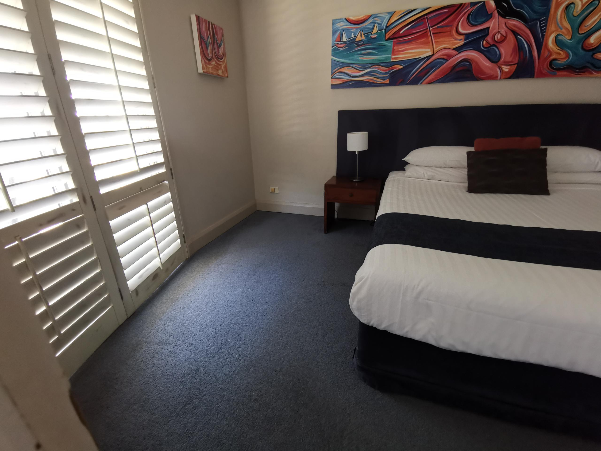
master
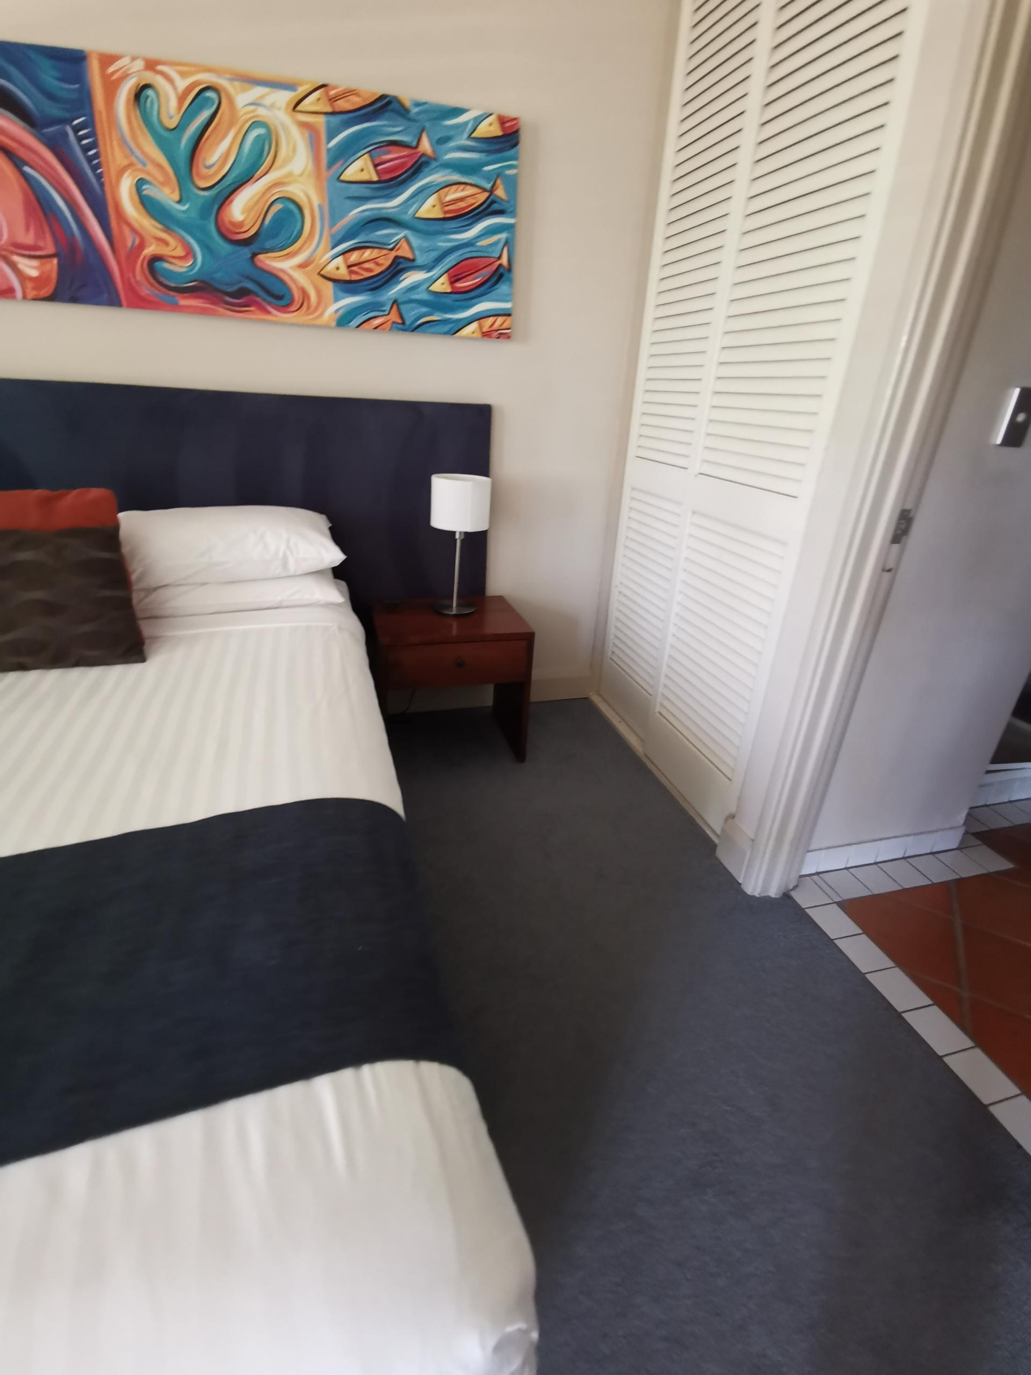
master1

Room Amenities
- In addition, the following further information can assist guests:
As noted on our registration records we will have a staff member attend to assist with safe evacuation
- Televisions are equipped with closed captioning capability
- Room phones have volume control
- Room phones have a visual ringing indicator
- There is contrast between the walls, skirtings, floor and furniture
- There is a clear path through the room
- Wardrobe handles are a contrasting colour to the doors and draws
- Housekeeping procedures instruct staff not to reposition furniture that has been moved
- Doors open fully against the adjoining wall
- There is a clear opening at least 850mm wide
- There luggage racks for at least two suitcases
- There at least one chair with rigid arms
- Wardrobe and drawer handles are easy to grip
- The bedside lamp switch is easy to reach from the bed
- There is at least 850mm clear space beside the bed

Bathrooms
The bathrooms have the following facilities/amenities in place
- All heating appliances and hot water pipes are protected or insulated
- All shower, bath and basin taps are clearly differentiated between hot and cold
- Fixtures and fittings have rounded edges
- The door is at least 850mm wide
- The width beside the toilet is Width is less - 250mm.
- There is a minimum of 1400mm of clear space in front of the toilet
- The toilet seat is a contrasting colour to the floor
- The toilet seat is 460mm above the floor
  - Bathroom Image(s)
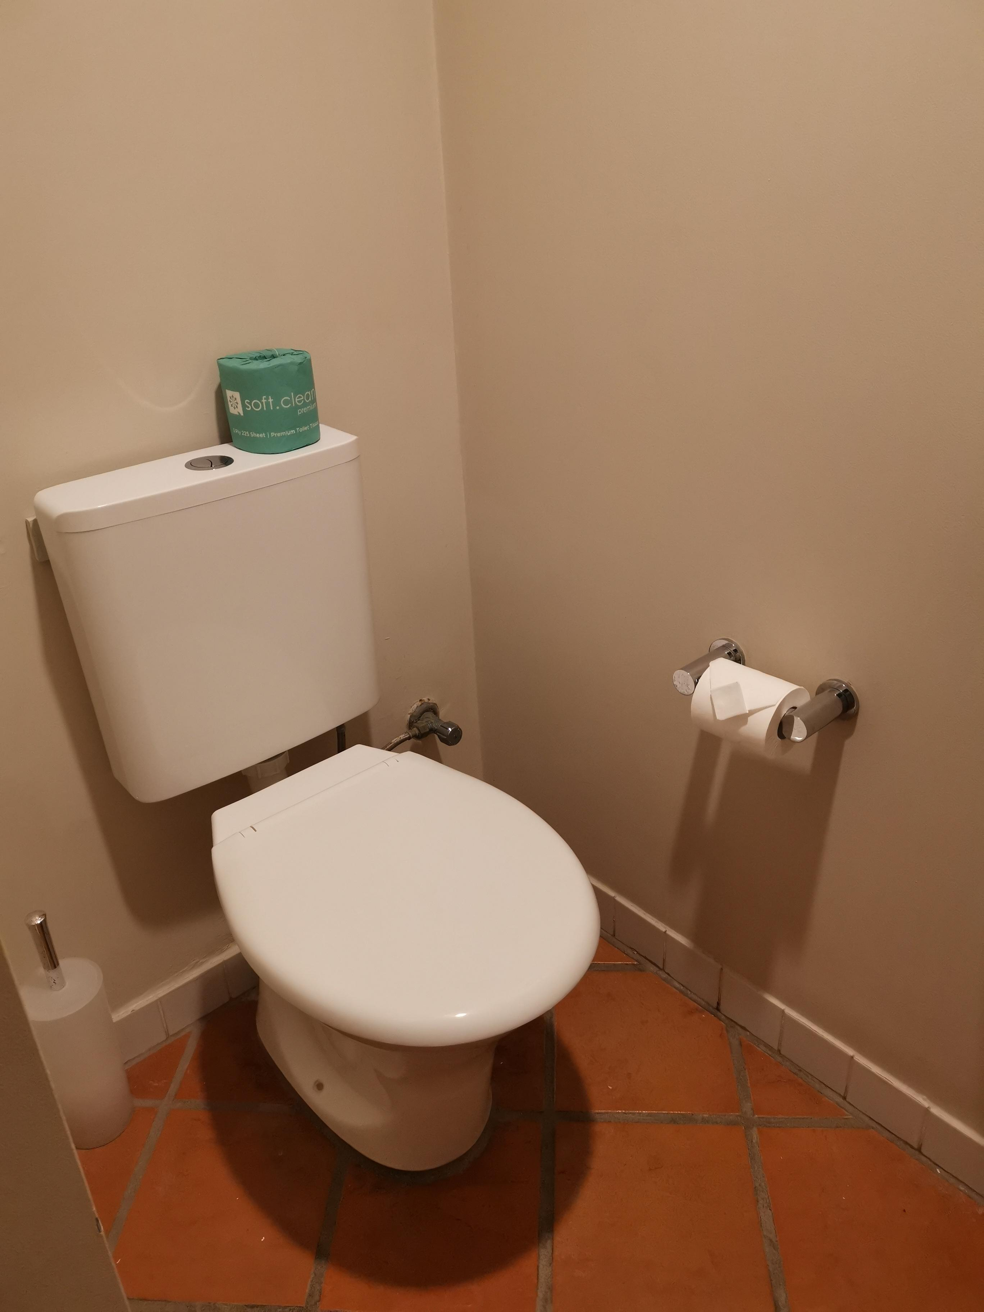
2nd toilet
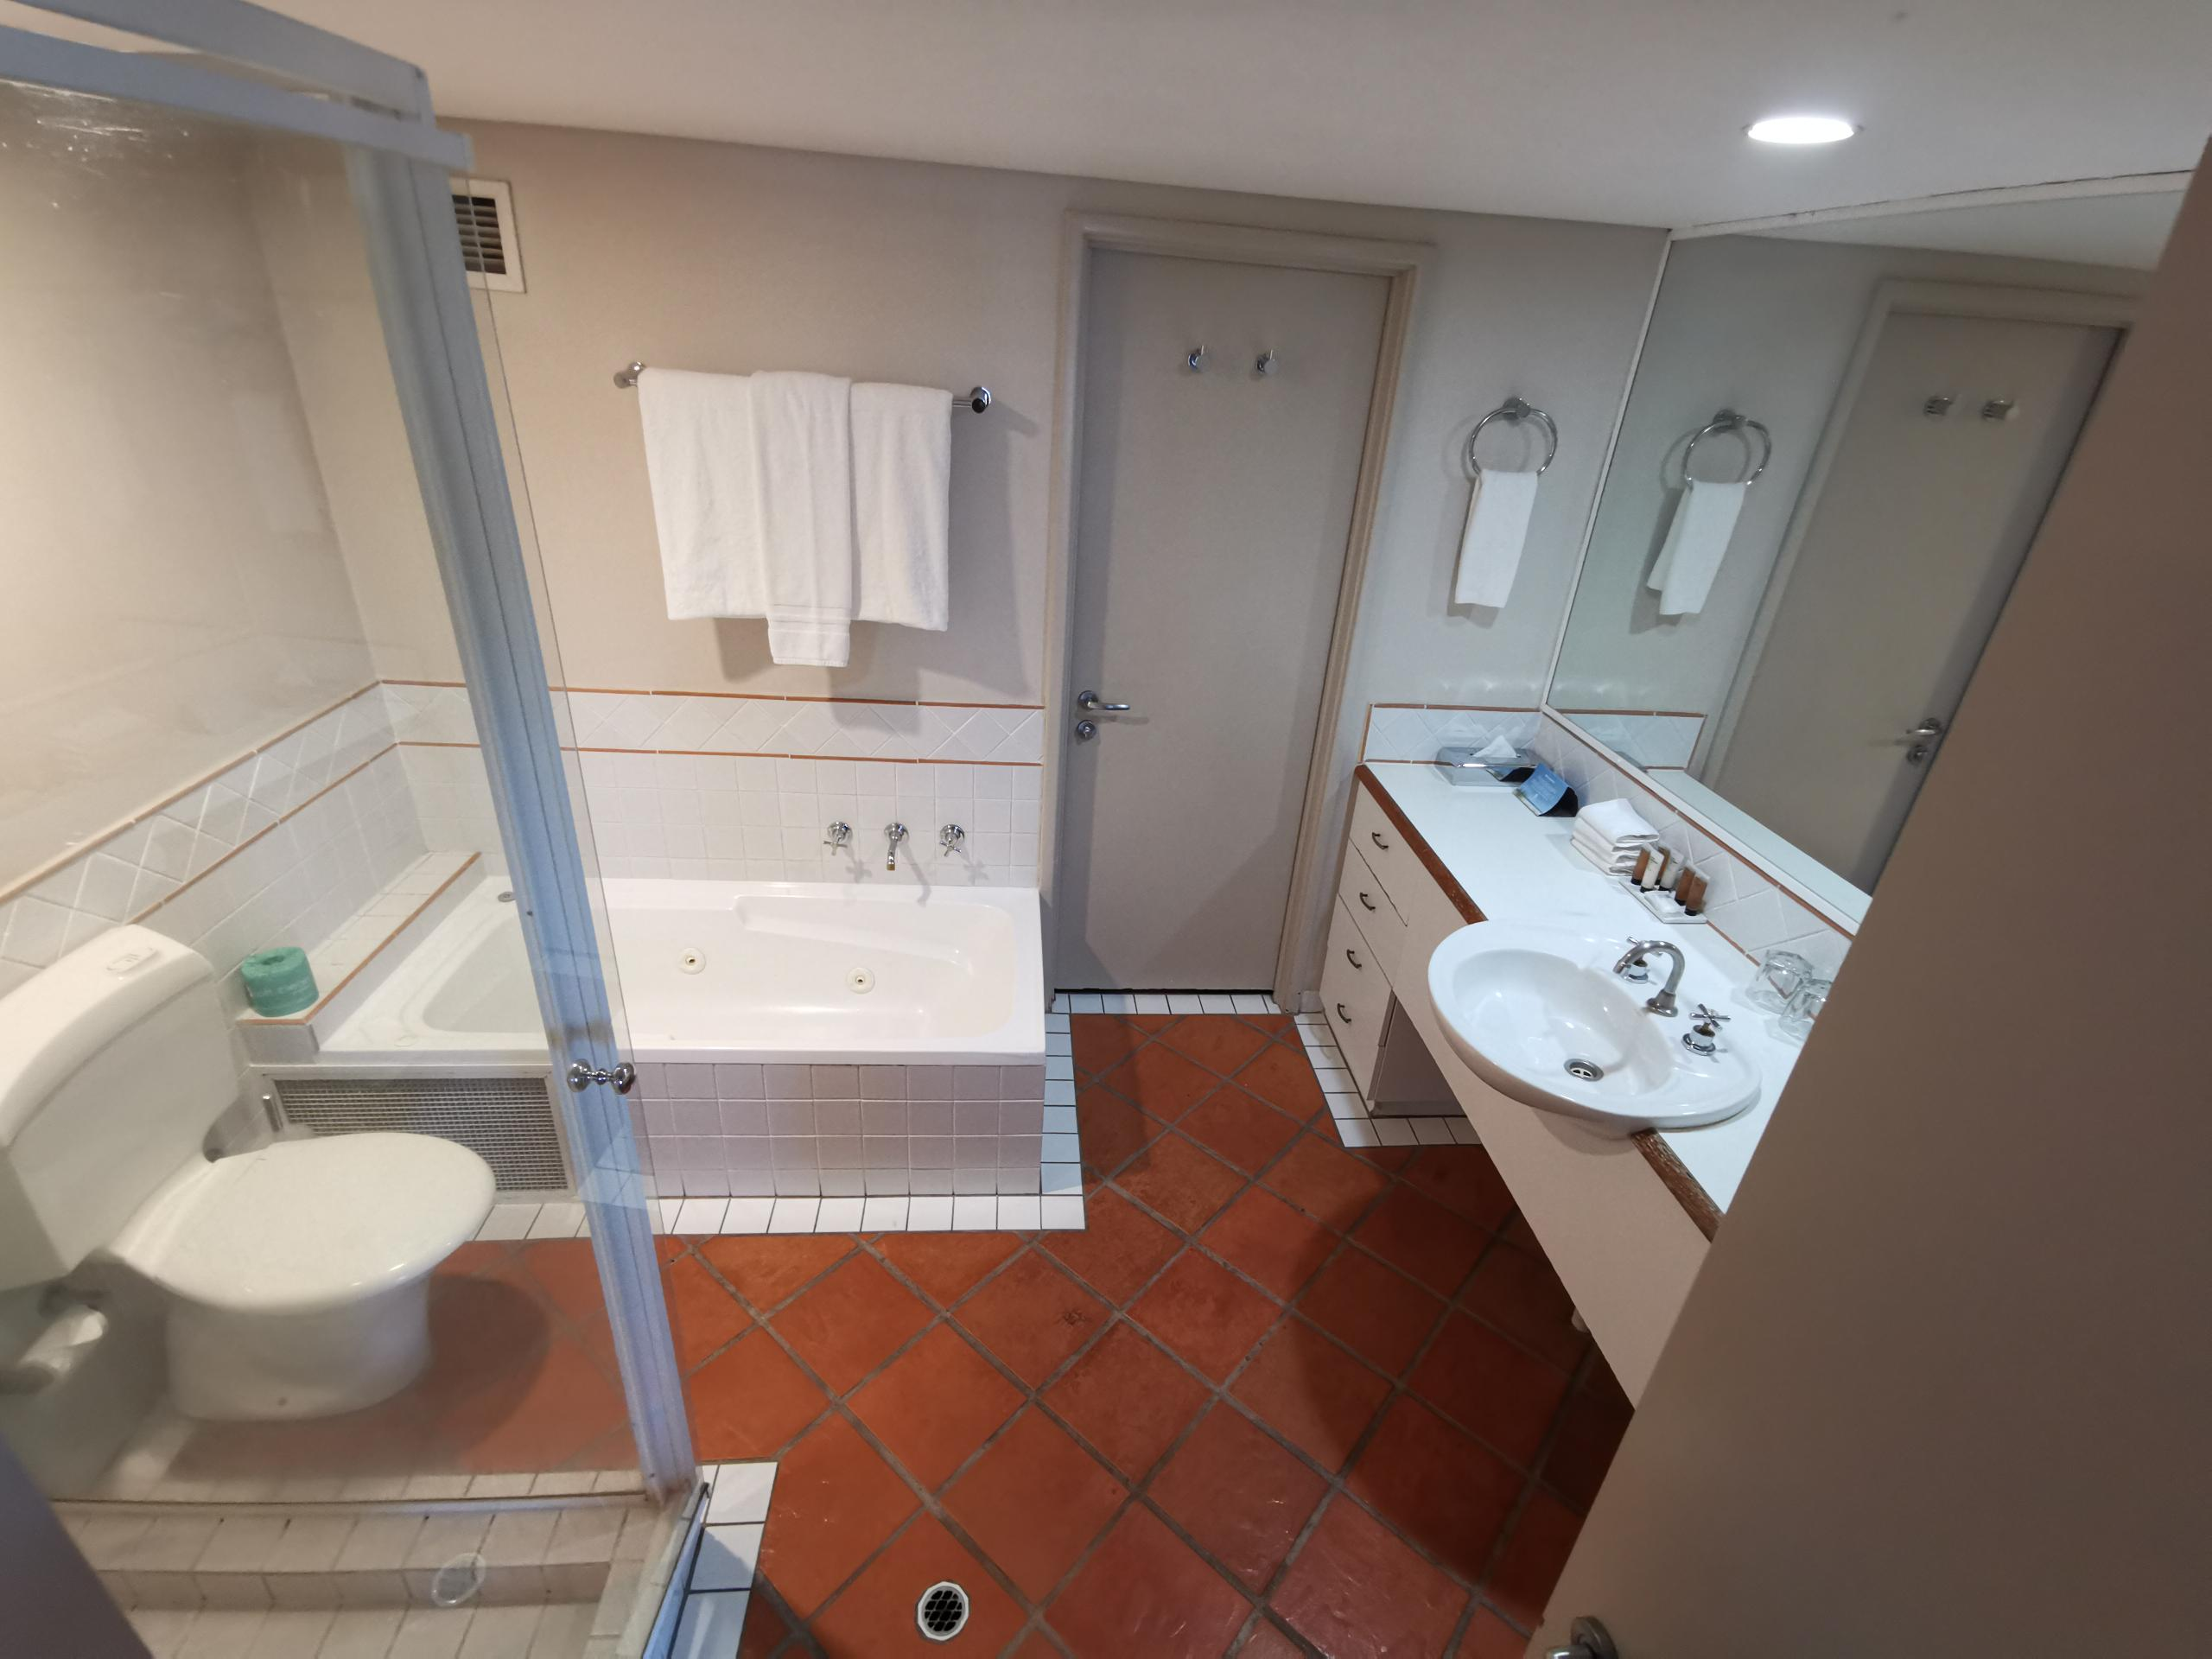
bathroom layout
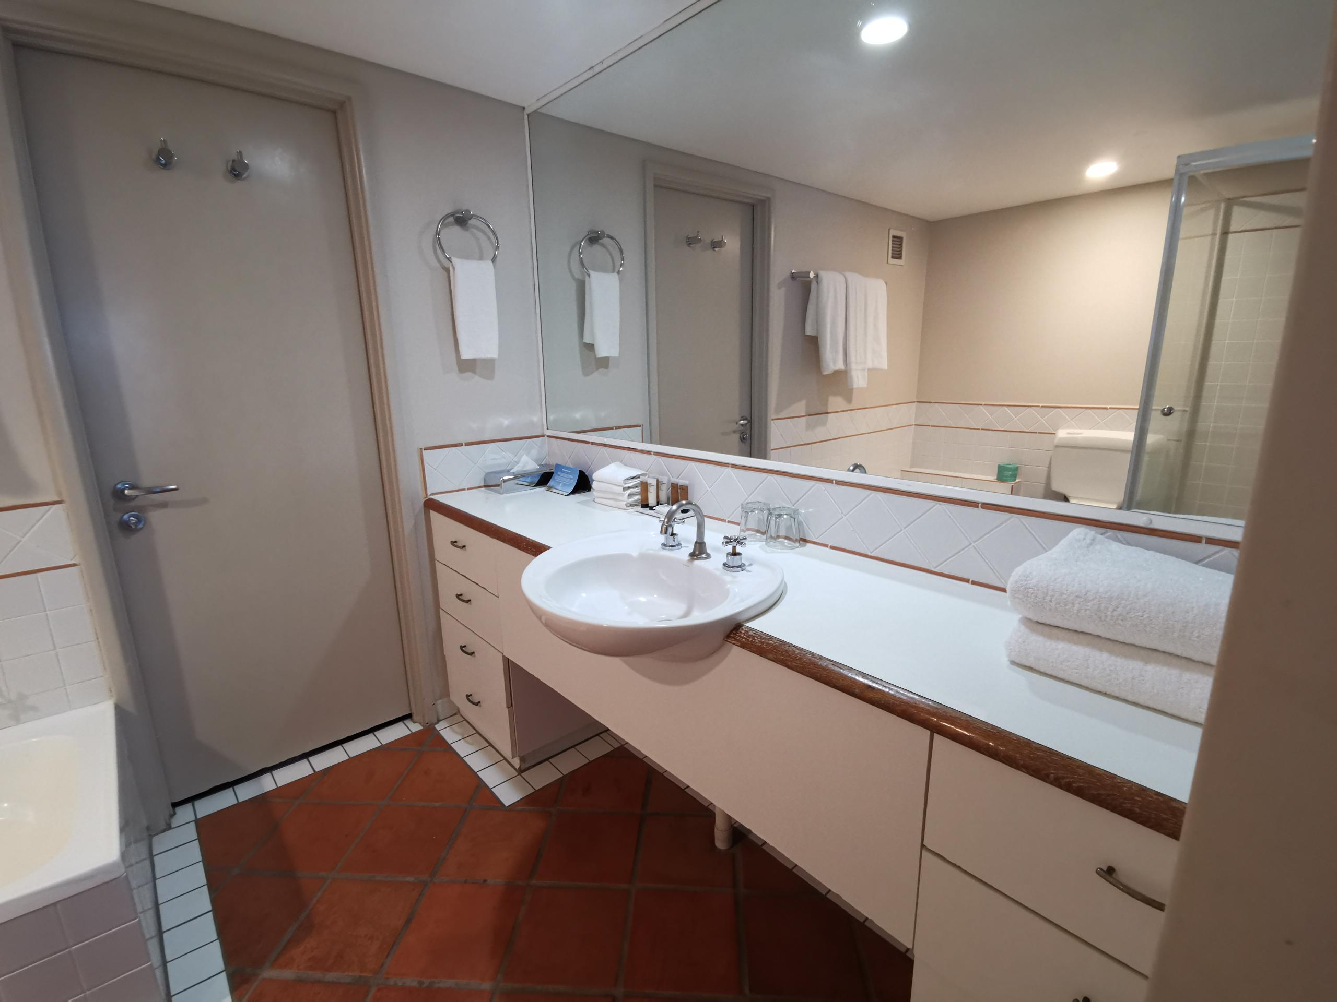
ensuite vanity

COMMON AREAS

Swimming pools, spas and waterparks
- The following swimming pools, spas and waterparks amenities are available
- The park map includes a step free route
  - Pool Access Image(s)
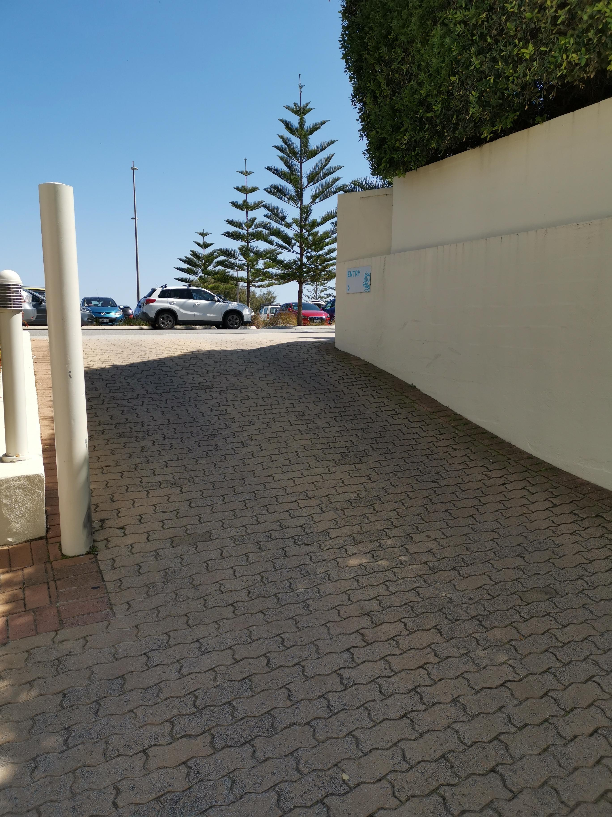
Driveway entry to reception level
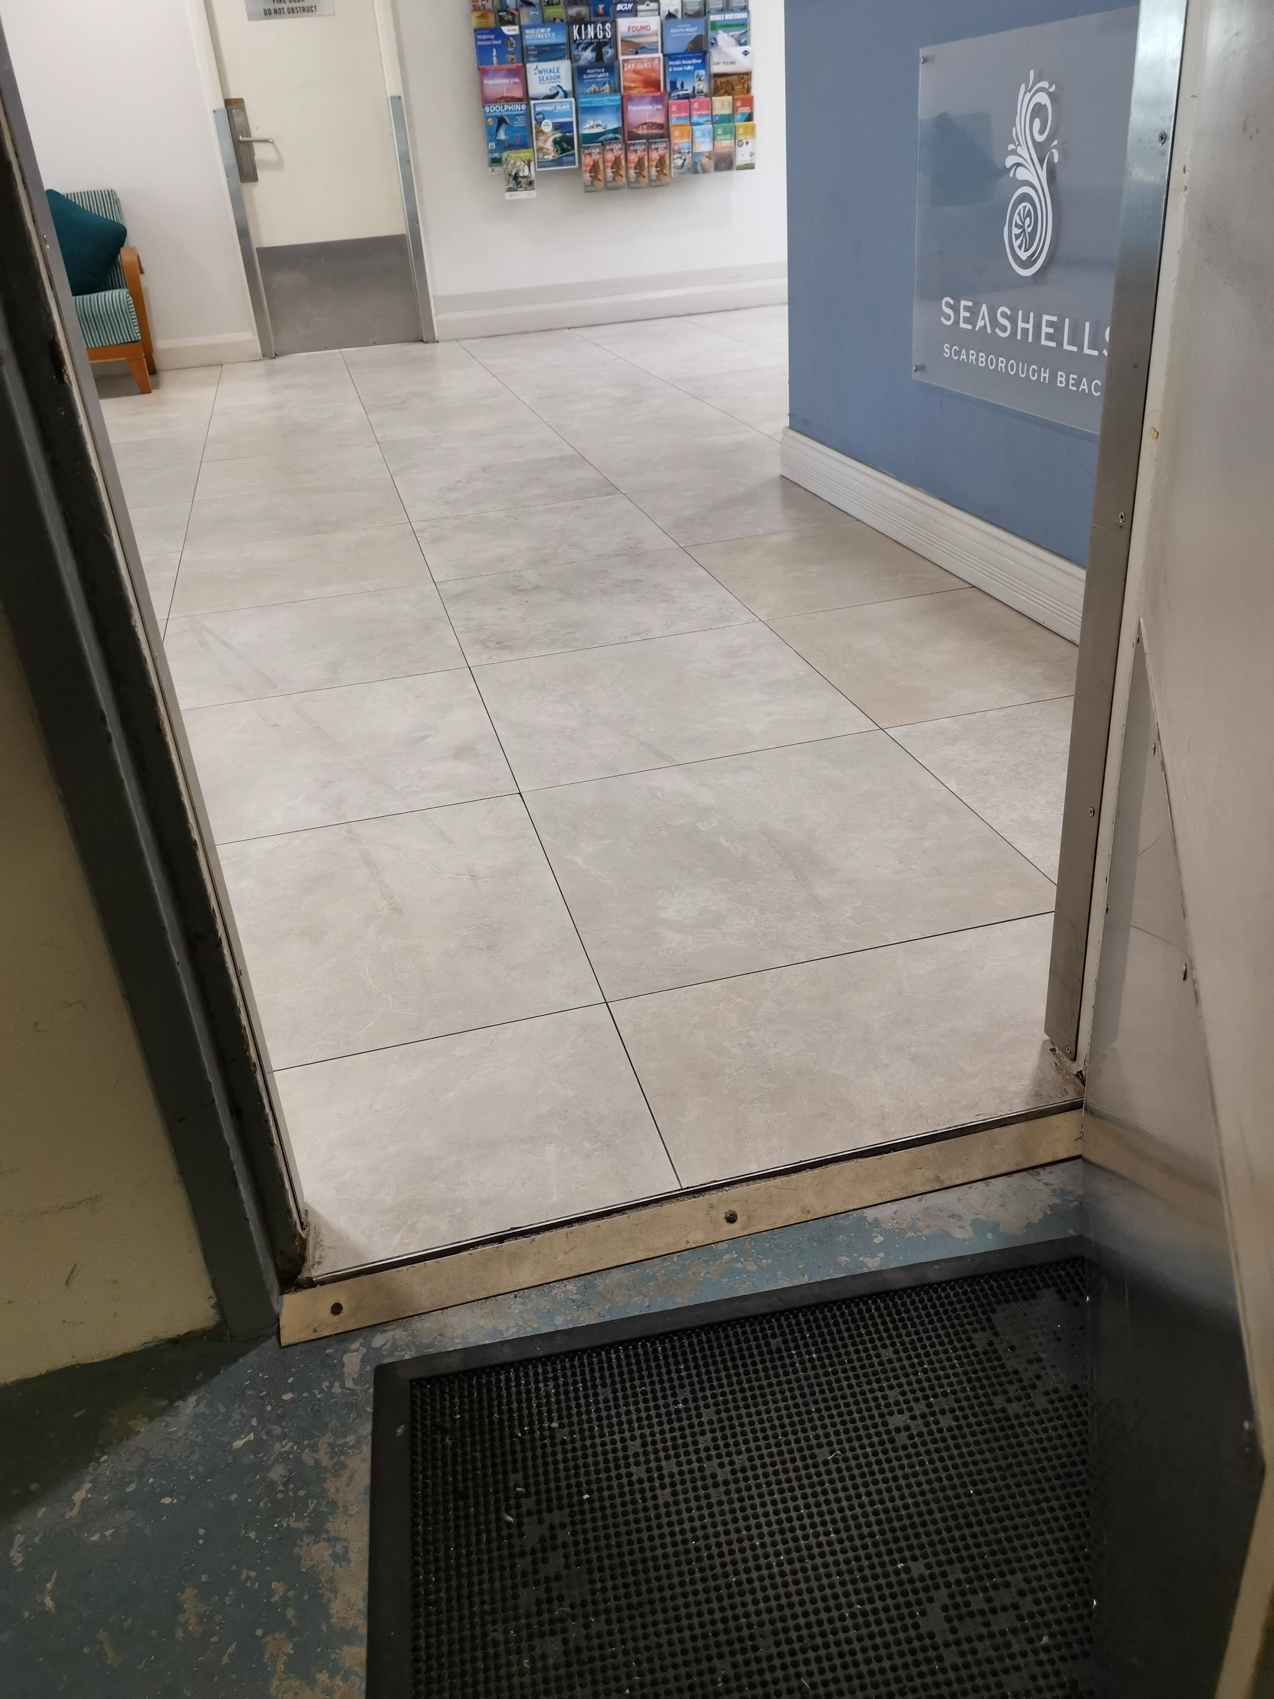
Entry from garage to lobby
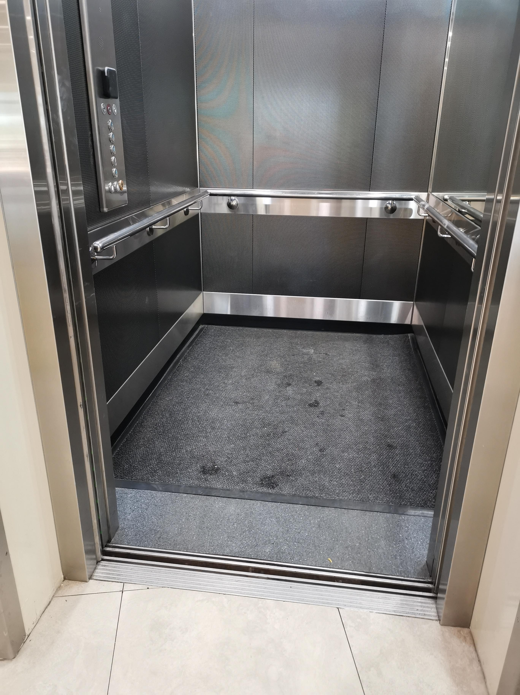
lift entry
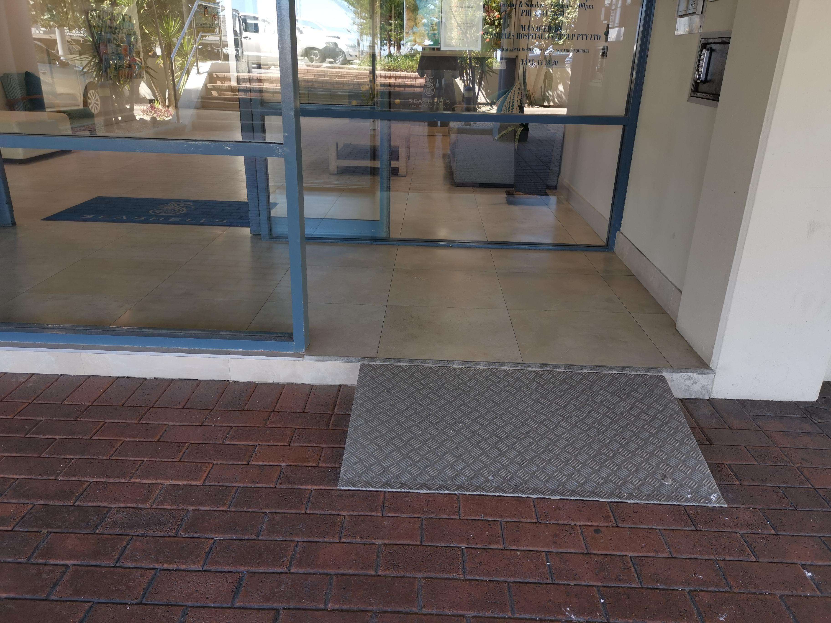
Seashells reception front entry
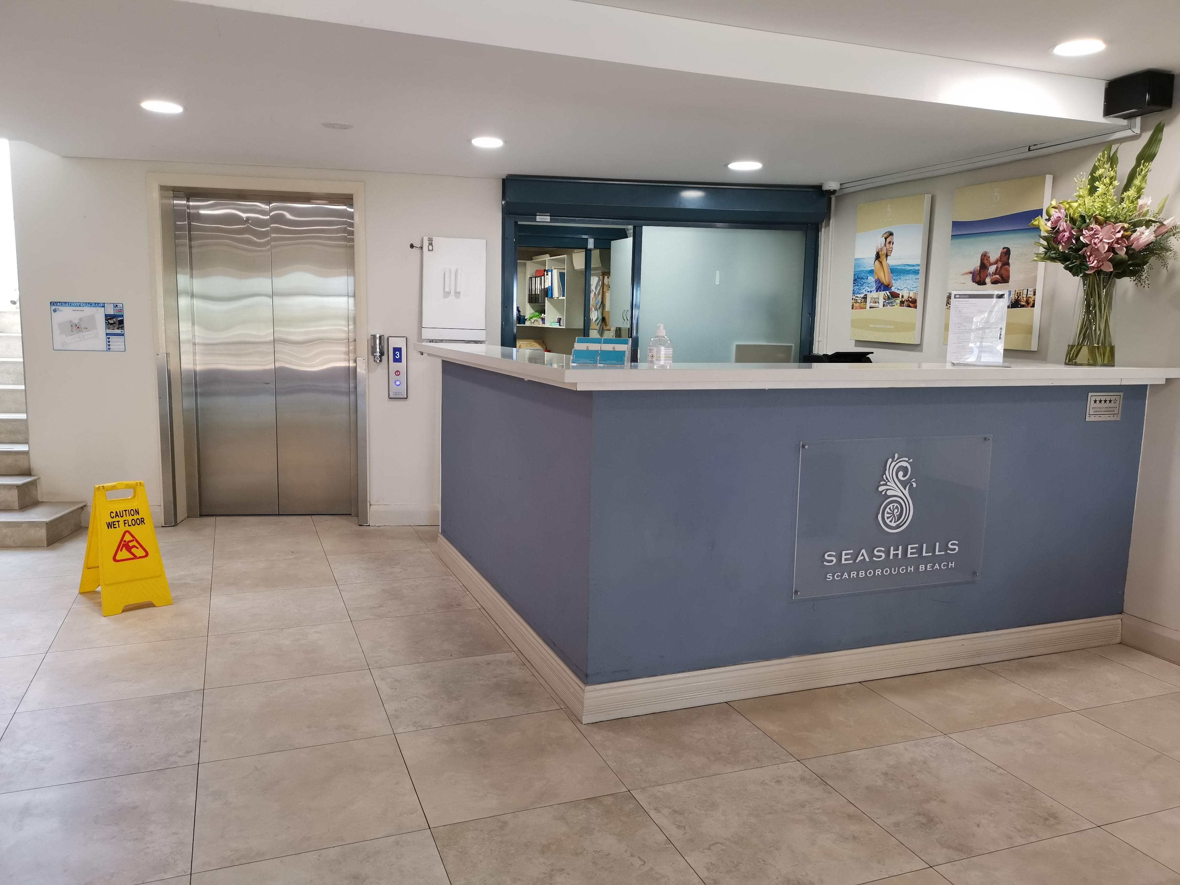
reception desk
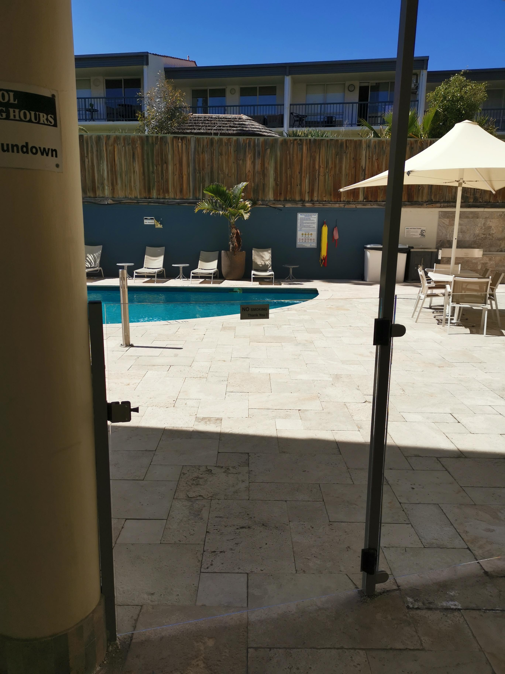
pool entry

Report Disclaimer
Please note that this business report, provided as a result of the use of the diagnostic assessment, is for information purposes only.
Australian Tourism Industry Council (ATIC) cannot guarantee the accuracy of respondent’s answers, or that they are fully representative of your business. Therefore, ATIC does not warrant or guarantee any particular outcome in respect of your businesses self-assessment.
This report is intended as guidance only for your business and should not be relied on for future marketing considerations. ATIC recommends that you seek your own independent advice as well as the results from the diagnostic.
Links to external web sites are inserted for convenience and do not constitute endorsement of material at those sites, or any associated organisation, product or service.
ATIC does not:
- Assume any legal liability for the accuracy, completeness, or usefulness of any information from this report or any links provided; or
- Accept responsibility for any loss associated directly or indirectly from the use of this report.

