ATIC Accessibility
To support the accessible community in making informed travel decisions for their individual needs

This report prepared for:
Business name: | Hanover Bay Apartments
Address: | 3 Festing Street
Town: | Albany
Contact for enquiries: | Jeanette De Landgrafft
Contact Number: | 0429 389062
Contact Email: | jeanette_de@westnet.com.au
Website: | https://hanoverbay.com.au/
Date: | 2026-10-09 09:28

ATIC Accessibility
The following pages provides travellers with information on the businesses facilities and amenities which aims to support the traveller to make an informed decision on whether the business is suitable for their individual needs.
OVERVIEW 4
Business Overview 4
Bookings 4
Communications 4
Guide Dog and Service Animals 4
GENERAL 6
Pre-arrival, arrival and reception 6
Cognitive Impairment Support 6
Car Park and Access amenities 6
Internal Spaces 6
External Paths 7
Steps 7
ACCOMMODATION 8
Bedrooms 8
Room Amenities 8
Bathrooms 9
COMMON AREAS 10
Report Disclaimer 12

OVERVIEW

Business Overview

The business has the following products/services available
- Accommodation

Our business caters for the following disability types:
- Limited mobility
- Wheelchairs or mobility scooters

Bookings

The business offers the following methods for bookings and enquiries:
- Phone
- Email
- Webportal

The accommodation is self-check in and there is an evacuation plan in the welcome file inside the accommodation.

Communications
- Our business offers the following alternative communication methods
- Plain English

no

Guide Dog and Service Animals
The business provides the following services for services animals:
A service animal is able to accompany its owner where required.

GENERAL

Pre-arrival, arrival and reception
The business has the following in place to support guests during pre-arrival, arrival and reception
- Booking information and websites are compatible with screen readers
- Information and maps are available in written form
- In addition, the following further information can assist guests:
Guests are provided with the code to their locked box to access their key and parking is right at the door so there is no waiting as they can come and go as they please in their own time.
- In addition, the following further information can assist guests:
As the guest is self-check in there is no reception or waiting area and they can access the key or lock it in the locked box if they are going to be away.

Cognitive Impairment Support
- Documents are available in plain English for people with cognitive impairment (This may include instructions, guides, menus and general information)

Car Park and Access amenities
The business has the following Car Park and Access amenities
- A drop off zone
- Designated disabled parking bays
- Level or ramped access from the car park to the entrance
- The accessible entrance is clearly signed from the parking bay
- In addition, the following further information can assist guests:
There are no quiet spaces or period of time as the apartments are all stand-alone apartments and set up in home style.

Internal Spaces
- Tableware/glassware contrast with the table surface or table cloth

External Paths
External paths of travel
- Surfaces are concrete, asphalt, smooth paving or hard packed fine gravel (max aggregate size 13mm)
- Pathways are wider than 900mm
- There 3 successive steps or less on any path or at any doorway

There are no steps on any of the paths at the apartments.
- In addition, the following further information can assist guests:
Each apartment has its own parking which is at ground level and adjacent to the apartment.

Steps
Steps
- There are steps.
- All steps or staircases have enclosed risers
- The underside of all staircases are enclosed or protected to a height of at least 2 metres
- Handrails fitted to all open sets of steps
- Handrails extend 300mm beyond the top and bottom step
- In addition, the following further information can assist guests:
The town houses have stairs but the cottage is a single level and has no stairs and is set up for people with limited mobility.
- In addition, the following further information can assist guests:
The accommodation is set up for couples in a home-style accommodation, no public areas. They use their private accommodation facilities.

ACCOMMODATION

Bedrooms
The bedrooms have the following facilities/amenities in place
- There are 1 kingbed room rooms available to guests who use a wheelchair
  - Layout of room Image(s)
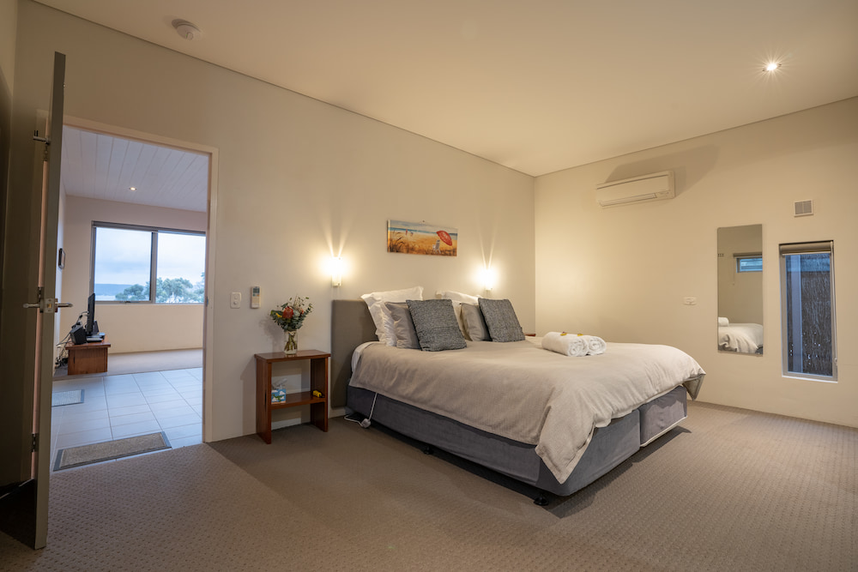
york cottage bedroom

Room Amenities

there is no wardrobe but there is a hanging rail and a bench
- There is contrast between the walls, skirtings, floor and furniture
- There is a clear path through the room
- Doors open fully against the adjoining wall
- There is a clear opening at least 850mm wide
- There luggage racks for at least two suitcases
- The bedside lamp switch is easy to reach from the bed
- There is at least 850mm clear space beside the bed
- The bed height is no higher than 680mm from the floor
- There is at least 130mm clearance under the bed
- Non-allergenic cleaning products are used
- In addition, the following further information can assist guests:
There are no wardrobes and the cleaning is only done after the guests have left so furniture is replaced for the next guests. There are no phones in the apartments as the guests always have their own which they also use as an alarm (phones and alarm clocks are things of the past!).

Bathrooms
The bathrooms have the following facilities/amenities in place
- All heating appliances and hot water pipes are protected or insulated
- All shower, bath and basin taps are clearly differentiated between hot and cold
- The hot water is thermostatically controlled to 41 degrees
- The door is at least 850mm wide
- There is a minimum of 850mm beside the toilet
- Handrails are fitted
- There is a minimum of 1400mm of clear space in front of the toilet
- The toilet seat is a contrasting colour to the floor
- The toilet seat is 460mm above the floor
- There is a portable shower head on flexible hose
  - Bathroom Image(s)
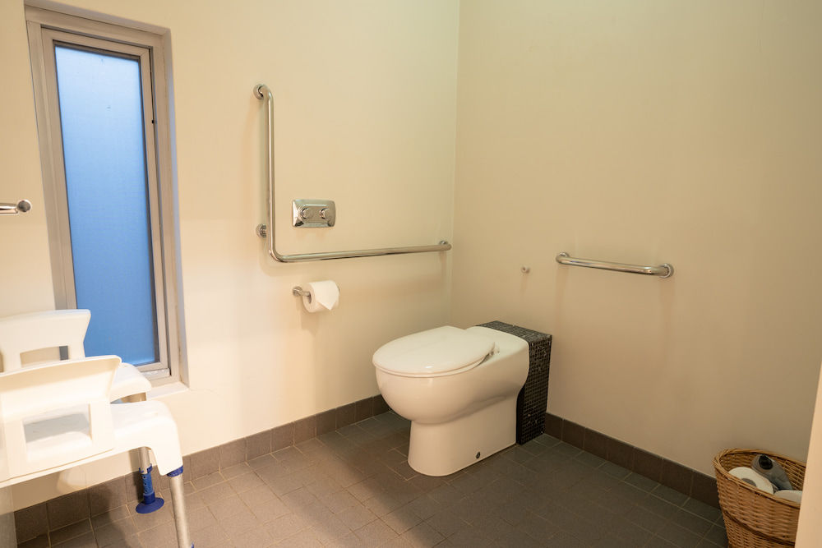
York-accessible-toilet
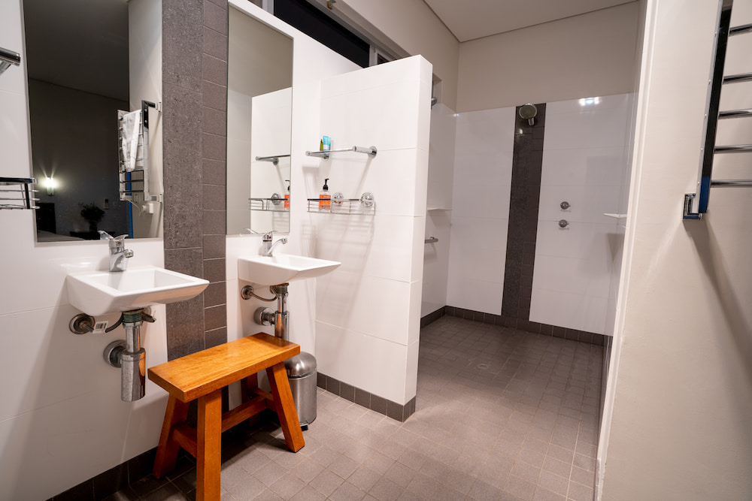
york-bathroom
- In addition, the following further information can assist guests:
The York cottage is set up for wheel chair access in the toilet and bathrooms and has a seat for the toilet and wheel in bathroom.

COMMON AREAS

Report Disclaimer
Please note that this business report, provided as a result of the use of the diagnostic assessment, is for information purposes only.
Australian Tourism Industry Council (ATIC) cannot guarantee the accuracy of respondent’s answers, or that they are fully representative of your business. Therefore, ATIC does not warrant or guarantee any particular outcome in respect of your businesses self-assessment.
This report is intended as guidance only for your business and should not be relied on for future marketing considerations. ATIC recommends that you seek your own independent advice as well as the results from the diagnostic.
Links to external web sites are inserted for convenience and do not constitute endorsement of material at those sites, or any associated organisation, product or service.
ATIC does not:
- Assume any legal liability for the accuracy, completeness, or usefulness of any information from this report or any links provided; or
- Accept responsibility for any loss associated directly or indirectly from the use of this report.

