ATIC Accessibility
To support the accessible community in making informed travel decisions for their individual needs

This report prepared for:
Business name: | Lucky Bean Cafe
Address: | Lucky Bay
Town: | ESPERANCE
Contact for enquiries: | Michelle Costolloe
Contact Number: | 0428936050
Contact Email: | costolloemichelle@gmail.com
Website: | www.kepakurl.com.au
Date: | 2026-10-18 01:42

ATIC Accessibility
The following pages provides travellers with information on the businesses facilities and amenities which aims to support the traveller to make an informed decision on whether the business is suitable for their individual needs.
OVERVIEW 3
Business Overview 3
Communications 3
Guide Dog and Service Animals 3
GENERAL 4
FOOD AND DRINK 5
Dining Spaces 5
Report Disclaimer 7

OVERVIEW

Business Overview

The business has the following products/services available
- Food and Drink

Our business caters for the following disability types:
- Food allergies or intolerances
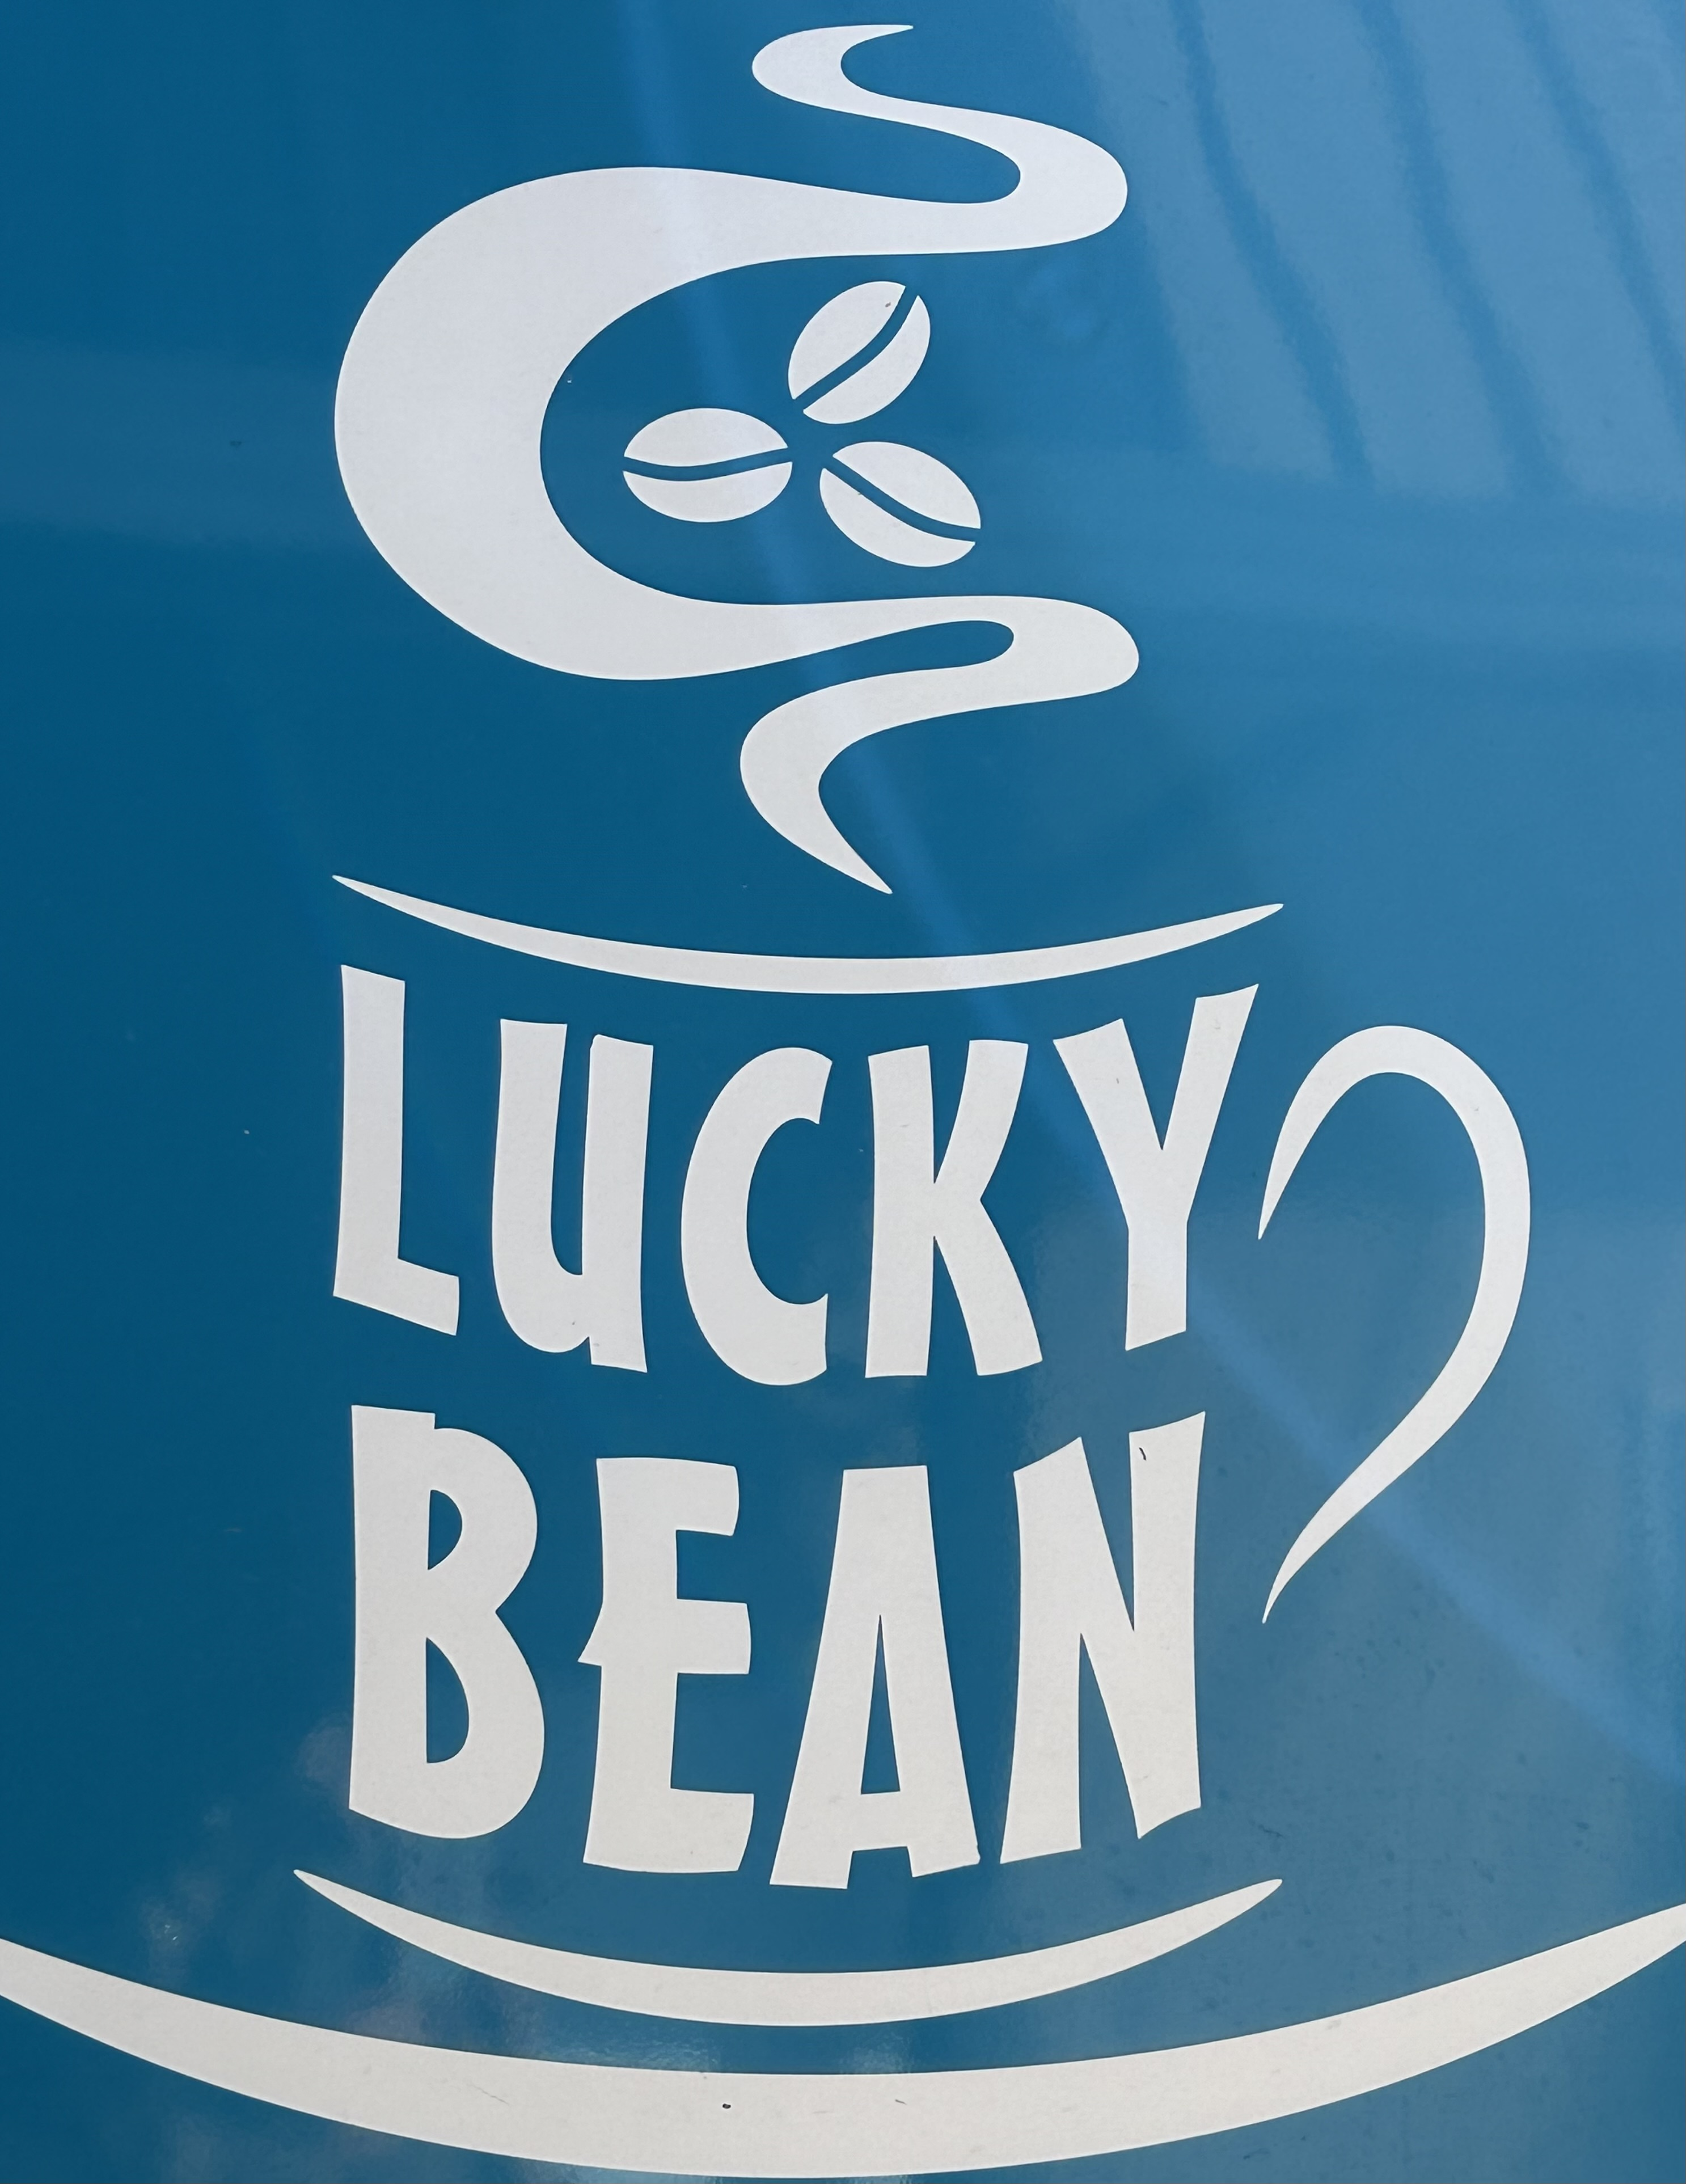

we are a mobile coffee van sat on the beach

Communications
- Our website meets WCAG 2.0 accessibility standards

Guide Dog and Service Animals
The business provides the following services for services animals:
if asked we would try our hardest to accomodate but being where we are it would be very hard to leave bowls and bedding outside on the beach

GENERAL
- In addition, the following further information can assist guests:
We do provide a few chairs to enjoy the scenery whilst you wait for your coffee
- In addition, the following further information can assist guests:
we do supply a few chairs for your comfort whilst you wait for your coffee
- In addition, the following further information can assist guests:
The national park has many areas for parking or can drive onto beach
The width of the smallest pathway is:
no pathways to van we are sat on the beach

Mobile coffee van parked on beach easily accessible from carpark or drive onto the beach and park

mobile Coffee van on the beach
- In addition, the following further information can assist guests:
We are a small mobile coffee van sat on the beautiful white sands of Lucky Bay
- In addition, the following further information can assist guests:
Hard compacted sand easy to walk on and it sqeaks
- In addition, the following further information can assist guests:
The National Park has toilets for visitors Disabled toilet available

FOOD AND DRINK

Dining Spaces
The dining spaces have the following facilities/amenities in place
- The doorway is at least 850mm wide
- There are large print menus
- There are Plain English menus
- There is an accessible toilet close by that is open during our business hours

Our business caters for the following dietary requirements
- Sugar free (diabetic)
- Lactose free (dairy free)
- In addition, the following further information can assist guests:
we use seperate jugs for our alterative milks

Report Disclaimer
Please note that this business report, provided as a result of the use of the diagnostic assessment, is for information purposes only.
Australian Tourism Industry Council (ATIC) cannot guarantee the accuracy of respondent’s answers, or that they are fully representative of your business. Therefore, ATIC does not warrant or guarantee any particular outcome in respect of your businesses self-assessment.
This report is intended as guidance only for your business and should not be relied on for future marketing considerations. ATIC recommends that you seek your own independent advice as well as the results from the diagnostic.
Links to external web sites are inserted for convenience and do not constitute endorsement of material at those sites, or any associated organisation, product or service.
ATIC does not:
- Assume any legal liability for the accuracy, completeness, or usefulness of any information from this report or any links provided; or
- Accept responsibility for any loss associated directly or indirectly from the use of this report.

