ATIC Accessibility
To support the accessible community in making informed travel decisions for their individual needs

This report prepared for:
Business name: | Dare Adventures
Address: | 43 Nanga rd
Town: | Dwellingup WA 6213
Contact for enquiries: | Clayton Fredericks
Contact Number: | (08) 9538 1314
Contact Email: | info@dareadventures.com.au
Website: | www.dareadventures.com.au
Date: | 2026-10-15 10:19

ATIC Accessibility
The following pages provides travellers with information on the businesses facilities and amenities which aims to support the traveller to make an informed decision on whether the business is suitable for their individual needs.
OVERVIEW 4
Business Overview 4
Bookings 4
Emergency Management 4
Other Information 5
Guide Dog and Service Animals 5
GENERAL 6
Pre-arrival, arrival and reception 6
Cognitive Impairment Support 6
Car Park and Access amenities 6
Entry 6
Internal Spaces 7
Public areas 7
Steps 7
Ramps 8
Public Toilets/Adult change facilities 8
ACCOMMODATION 9
Bedrooms 9
Room Amenities 9
Bathrooms 9
COMMON AREAS 10
ADVENTURE ACTIVITIES 11
Adventure activities 11
Report Disclaimer 13

OVERVIEW

Business Overview

The business has the following products/services available
- Accommodation
- Adventure

Our business caters for the following disability types:
- Blind or low vision
- Deaf or low hearing
- Limited mobility
- Wheelchairs or mobility scooters
- Food allergies or intolerances
- Cognitive or people on the Autism Spectrum
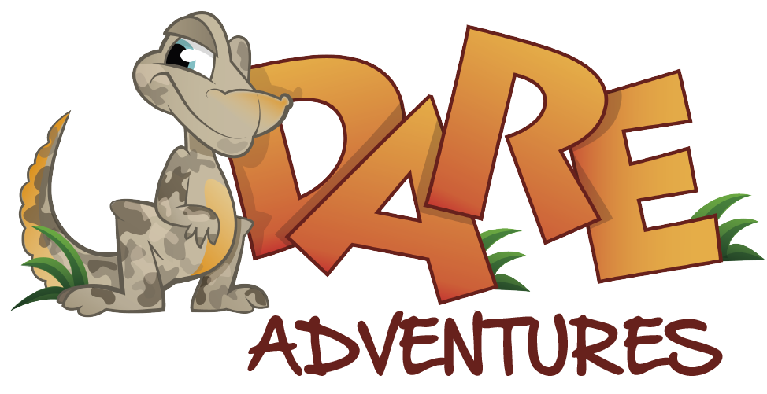

Bookings

The business offers the following methods for bookings and enquiries:
- Phone
- Email

Emergency Management
- Emergency and evacuation procedures are explained on arrival
- Exit signs are clear and easy to see
- Exit access is free and clear at all times
We ensure exit access is free and clear at all times by:
by keeping them clear
- Exits and access to exists are greater than 900mm
- Exit doors are able to be opened by all occupants
- The evacuation point is clearly marked by a sign
- In addition, the following further information can assist guests:
They are identified by the teachers during our briefing
- In addition, the following further information can assist guests:
They are assisted by the teachers

Other Information
- The business accepts the companion card

Guide Dog and Service Animals
The business provides the following services for services animals:
Not specified

GENERAL

Pre-arrival, arrival and reception
The business has the following in place to support guests during pre-arrival, arrival and reception
- Information and maps are available in written form
- A familiarisation tour
- In addition, the following further information can assist guests:
none

Cognitive Impairment Support
- Documents are available in plain English for people with cognitive impairment (This may include instructions, guides, menus and general information)
- A "social script" guide to your premises or attraction describing the sights, sounds and smells to aid parents/carers prepare visitors in advance
- A space for parents and children on the Autism Spectrum

Car Park and Access amenities
The business has the following Car Park and Access amenities
- A drop off zone
- Level or ramped access from the car park to the entrance

Entry
The business has the following amenities/systems in place for entry
- A drop off point close to the entrance
- A path of access to the building is clear of obstruction
- Self opening entry doors or fitted with a self closer
- Glass doors are fitted with a visual sighting strip
- Door handles are of a contrasting colour to the door
- Signage is written in a contrasting colour
- The entry door is a minimum of 850mm wide
- There a clear space of at least 1500mm x 1500mm in front of all doors.
- The entrance door mats have a thickness less than 13mm and a width of 7500mm or greater

Internal Spaces
- Clear and unobstructed routes through and between buildings
- Interior walls are matte or low sheen
- Floors, walls, counters and furniture are of contrasting colours
- Any protruding or overhanging obstructions are at least 2meters above the floor or are protected
- Tableware/glassware contrast with the table surface or table cloth
- Floor surfaces are hard or short pile carpet
- Seating is available for guests unable to stand for long periods
- All corridors greater than 900mm
- There is a quiet space for parents and children on the Autism Spectrum

Public areas
The public areas have the following amenities in place
- Seating
The width of the smallest pathway is:
no paths

no paths

no paths

Steps
Steps
- There are steps.
- Handrails fitted to all open sets of steps

Ramps
Ramps have the following amenities are in place
- There are ramps.
- Temporary ramps are available
- Temporary ramps are in place for the duration of the guests stay

Public Toilets/Adult change facilities
Public Toilets/Adult change facilities have the following amenities are in place
- There is an accessible toilet for public use
- The door is at least 850mm wide
- There is a minimum of 850mm beside the toilet
- Handrails are fitted
- The toilet seat is 460mm above the floor
- The toilet seat of a contrasting colour to the floor
- The toilet seat is460mm above the floor

ACCOMMODATION

Bedrooms
The bedrooms have the following facilities/amenities in place
- There are 0 rooms available to guests who use a wheelchair
- Bedroom furniture can be re-arranged on request

Room Amenities

we dont have them this is stupidity of the highest order!
- In addition, the following further information can assist guests:
teachers assist the children, weekend groups hire the facility as a whole we are not a hotel we have no staff onsite
- There is contrast between the walls, skirtings, floor and furniture
- There is a clear path through the room
- Doors open fully against the adjoining wall
- There is a clear opening at least 850mm wide

Bathrooms
The bathrooms have the following facilities/amenities in place
- All heating appliances and hot water pipes are protected or insulated
- All shower, bath and basin taps are clearly differentiated between hot and cold
- Fixtures and fittings have rounded edges
- The width of the door is we have 40 toilets and are a school camp with dormitories .
- The width beside the toilet is we have 40 toilets and are a school camp with dormitories .
- There is we have 40 toilets and are a school camp with dormitories mm of clear space in front of the toilet
- The toilet seat is a contrasting colour to the floor
- The actual height of the toilet seat is we have 40 toilets and are a school camp with dormitories .
- There is a portable shower head on flexible hose
- A door is fitted to the shower
- A door is fitted to the showers with an outward swing at minimum width of 900 mm

COMMON AREAS

ADVENTURE ACTIVITIES

Adventure activities
The adventure activities have the following facilities/amenities in place
- Our adventure activities cater for people with a disability
- In addition, the following further information can assist guests:
We cater to school camps and we also cater to education support centers. We commonly have children with ASD and children with mobility issues. We allow everyone regardless of ability to do our activities aslong as they can be completed safely and will modify activities to help students when required.
- In addition, the following further information can assist guests:
We cater to school camps and we also cater to education support centers. We commonly have children with ASD and children with mobility issues. We allow everyone regardless of ability to do our activities aslong as they can be completed safely and will modify activities to help students when required.
- In addition, the following further information can assist guests:
We cater to school camps and we also cater to education support centers. We commonly have children with ASD and children with mobility issues. We allow everyone regardless of ability to do our activities aslong as they can be completed safely and will modify activities to help students when required.

Report Disclaimer
Please note that this business report, provided as a result of the use of the diagnostic assessment, is for information purposes only.
Australian Tourism Industry Council (ATIC) cannot guarantee the accuracy of respondent’s answers, or that they are fully representative of your business. Therefore, ATIC does not warrant or guarantee any particular outcome in respect of your businesses self-assessment.
This report is intended as guidance only for your business and should not be relied on for future marketing considerations. ATIC recommends that you seek your own independent advice as well as the results from the diagnostic.
Links to external web sites are inserted for convenience and do not constitute endorsement of material at those sites, or any associated organisation, product or service.
ATIC does not:
- Assume any legal liability for the accuracy, completeness, or usefulness of any information from this report or any links provided; or
- Accept responsibility for any loss associated directly or indirectly from the use of this report.

