ATIC Accessibility
To support the accessible community in making informed travel decisions for their individual needs

This report prepared for:
Business name: | Wild Lot Distillery
Address: | 764 Brockman Highway
Town: | Karridale
Contact for enquiries: | Rebecca de Burgh
Contact Number: | 0418 381 333
Contact Email: | bec@wildlotdistillery.com.au
Website: | https://www.wildlotdistillery.com.au
Date: | 2026-10-26 22:46

ATIC Accessibility
The following pages provides travellers with information on the businesses facilities and amenities which aims to support the traveller to make an informed decision on whether the business is suitable for their individual needs.
OVERVIEW 4
Business Overview 4
Bookings 4
Emergency Management 5
Communications 5
Guide Dog and Service Animals 5
GENERAL 6
Cognitive Impairment Support 6
Car Park and Access amenities 6
Entry 7
Internal Spaces 7
Public areas 7
External Paths 8
Public Toilets/Adult change facilities 8
FOOD AND DRINK 9
Dining Spaces 9
Report Disclaimer 12

OVERVIEW

Business Overview

The business has the following products/services available
- Food and Drink

Our business caters for the following disability types:
- Blind or low vision
- Limited mobility
- Wheelchairs or mobility scooters
- Food allergies or intolerances
- Cognitive or people on the Autism Spectrum
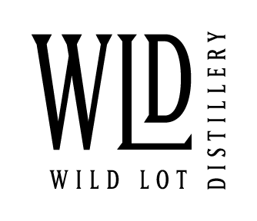

Bookings

The business offers the following methods for bookings and enquiries:
- Phone
- Email
- Staff have undergone disability awareness and training

Emergency Management
- The business has an emergency management and evacuation plan for guests with a disability

small venue, guests are greeted by the host upon arrival and any accessible needs discussed.

Communications
- An accessibility guide is available on the website

https://www.wildlotdistillery.com.au/access-inclusion/
- Our business offers the following alternative communication methods
- Plain English
- Magnifiers

We are currently investigating WCAG requirements and continually improving our website’s accessibility.
- There is easy to read signage and information (e.g. menus and emergency information)

Guide Dog and Service Animals
- The business provides a secure area with shade and water for service animals
- The business provides a toilet area for service animals
- Bowls, bedding, etc. are provided for service animals
The business provides the following services for services animals:
Accredited assistance animals are welcome throughout the venue. Fresh water is available and our spacious outdoor setting provides plenty of room for visitors travelling with assistance animals. Wild Lot is also a dog-friendly venue and welcomes well-behaved dogs on leads.

GENERAL
- In addition, the following further information can assist guests:
As a small family-run distillery, visitors are greeted personally and wait times are generally minimal. Seating is available throughout the venue, and guests are welcome to relax at their own pace. Where possible, we adapt the visitor experience to individual needs and encourage guests to contact us prior to their visit if they have specific requirements.

- In addition, the following further information can assist guests:
Our goal is simple: we want Wild Lot Distillery to be a destination worth the detour for everyone. If there’s anything we can do to make a persons visit more comfortable, accessible or enjoyable, we encourage them to get in touch before a visit or speak with our team on arrival. We welcome feedback and are committed to continually improving our visitor experience.

Cognitive Impairment Support
- Documents are available in plain English for people with cognitive impairment (This may include instructions, guides, menus and general information)
- Quiet periods or early opening times for people on the Autism Spectrum
- A space for parents and children on the Autism Spectrum

Car Park and Access amenities
The business has the following Car Park and Access amenities
- Designated disabled parking bays
- Level or ramped access from the car park to the entrance
- The accessible entrance is clearly signed from the parking bay
- In addition, the following further information can assist guests:
As a thoughtful, low-impact distillery, we believe accessibility is about more than physical access. It’s about creating a welcoming, relaxed and inclusive experience where every guest feels comfortable, respected and able to enjoy what our region has to offer. If there’s anything we can do to support your visit, we’d be delighted to hear from you before you arrive.

Entry
The business has the following amenities/systems in place for entry
- A drop off point close to the entrance
- A path of access to the building is slip resistance and even
- A path of access to the building is clear of obstruction
- Door jams/doors are of a contrasting colour to surrounding walls
- Door handles are of a contrasting colour to the door
- Signage is written in a contrasting colour
- The entry door is a minimum of 850mm wide
- The entrance sill is less than 13mm
- There a clear space of at least 1500mm x 1500mm in front of all doors.
- The entrance door mats have a thickness less than 13mm and a width of 7500mm or greater
- In addition, the following further information can assist guests:
The entry door will be "locked open" for all visitors to access at anytime.

Internal Spaces
- Clear and unobstructed routes through and between buildings
- Interior walls are matte or low sheen
- Floors, walls, counters and furniture are of contrasting colours
- Any protruding or overhanging obstructions are at least 2meters above the floor or are protected
- Menus are available in large print or Braille
- Floor surfaces are hard or short pile carpet
- Seating is available for guests unable to stand for long periods
- Accessible facilities are clearly signed and visible from all areas
- All corridors greater than 900mm
- There is a quiet space for parents and children on the Autism Spectrum

Public areas
The public areas have the following amenities in place
- Even lighting
- Seating
- In addition, the following further information can assist guests:
Most visitor experiences take place in well-lit indoor or outdoor areas with natural lighting. Small group interactions and a relaxed environment support face-to-face communication for guests who rely on lip reading. Staff are happy to move to a quieter or better-lit area where reasonably possible.

External Paths
External paths of travel
- Surfaces are concrete, asphalt, smooth paving or hard packed fine gravel (max aggregate size 13mm)
- Pathways are wider than 900mm

No steps in venue

Wild Lot Distillery provides ground-level access throughout the main visitor areas. While the venue includes compacted gravel and outdoor surfaces typical of a rural property, there are no stepped pathways requiring identification as non-wheelchair accessible.

Public Toilets/Adult change facilities
Public Toilets/Adult change facilities have the following amenities are in place
- There is an accessible toilet for public use
- The door is at least 850mm wide
- There is a minimum of 850mm beside the toilet
- Handrails are fitted
- The toilet seat is 460mm above the floor
- The toilet seat of a contrasting colour to the floor
- The toilet seat is460mm above the floor

FOOD AND DRINK

Dining Spaces
The dining spaces have the following facilities/amenities in place
- The entrance has level access
- The doorway is at least 850mm wide
- There is level access through the dining area
- Chairs are moveable to allow for wheelchairs to be seated at the tables
- All glass doors and full height windows have contrast markings
- There are areas of full lighting
- There are large print menus
- There are Plain English menus
- There is an accessible toilet

Our business caters for the following dietary requirements
- Sugar free (diabetic)
- Gluten free (celiac)
- Lactose free (dairy free)
- Low sodium
- Nut free
- Additive free
- Organic
- Vegetarian
- Vegan
- In addition, the following further information can assist guests:
Wild Lot Distillery follows safe food handling practices to minimise the risk of cross-contamination. Separate utensils and preparation areas are used where reasonably practicable, allergen information is available, and staff take reasonable care when preparing and serving food. Visitors with food allergies or dietary requirements are encouraged to advise staff before ordering so suitable options and precautions can be discussed. While every effort is made to prevent cross-contamination, food is prepared in a kitchen that handles common allergens.

- There is a sample menu available online
Sample menu is available here -
https://www.wildlotdistillery.com.au/menu/
  - Food and Beverage Image(s)
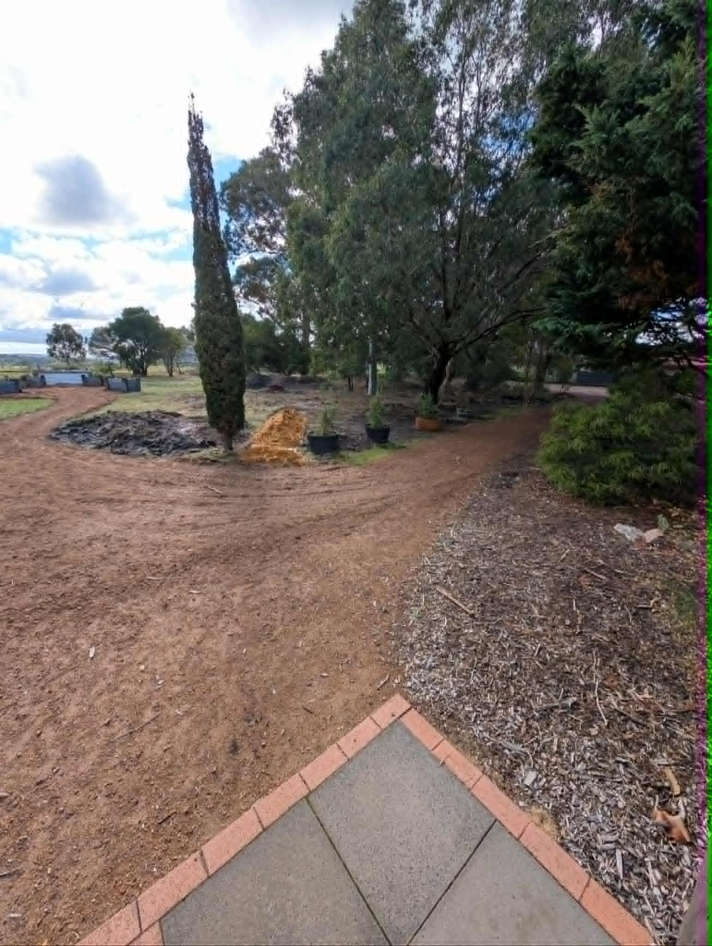
Unknown-30
- In addition, the following further information can assist guests:
Wild Lot Distillery was founded with a simple mission: to be a thoughtful, low-impact distillery. While that philosophy is often reflected in our environmental practices, it also shapes how we welcome people. We believe accessibility is not a checklist—it’s an attitude. It’s providing clear information before people arrive, creating a relaxed environment with no pressure to rush, adapting where reasonably possible, and ensuring every guest feels they belong. As a small regional business, we may not have the resources of larger attractions, but we believe thoughtful hospitality, genuine care and a commitment to continuous improvement can make a meaningful difference.

Report Disclaimer
Please note that this business report, provided as a result of the use of the diagnostic assessment, is for information purposes only.
Australian Tourism Industry Council (ATIC) cannot guarantee the accuracy of respondent’s answers, or that they are fully representative of your business. Therefore, ATIC does not warrant or guarantee any particular outcome in respect of your businesses self-assessment.
This report is intended as guidance only for your business and should not be relied on for future marketing considerations. ATIC recommends that you seek your own independent advice as well as the results from the diagnostic.
Links to external web sites are inserted for convenience and do not constitute endorsement of material at those sites, or any associated organisation, product or service.
ATIC does not:
- Assume any legal liability for the accuracy, completeness, or usefulness of any information from this report or any links provided; or
- Accept responsibility for any loss associated directly or indirectly from the use of this report.

