ATIC Accessibility
To support the accessible community in making informed travel decisions for their individual needs

This report prepared for:
Business name: | Albany Tours
Address: | 13 Chevalier St
Town: | Albany
Contact for enquiries: | Susan McCabe
Contact Number: | 0418 414 425
Contact Email: | susan@albanytourswa.com.au
Website: | www.albanytours.com.au
Date: | 2026-10-07 14:03

ATIC Accessibility
The following pages provides travellers with information on the businesses facilities and amenities which aims to support the traveller to make an informed decision on whether the business is suitable for their individual needs.
OVERVIEW 4
Business Overview 4
Bookings 4
Emergency Management 4
Communications 5
Guide Dog and Service Animals 5
GENERAL 6
Pre-arrival, arrival and reception 6
Car Park and Access amenities 6
Displays, exhibits, commentary and live performances 6
External Paths 7
Steps 7
TOUR OPERATORS 8
Tour/Transport Services 8
Route Planning 8
Guides 8
Report Disclaimer 12

OVERVIEW

Business Overview

The business has the following products/services available
- Tour/Transport

Our business caters for the following disability types:
- Blind or low vision
- Deaf or low hearing
- Food allergies or intolerances
- Cognitive or people on the Autism Spectrum
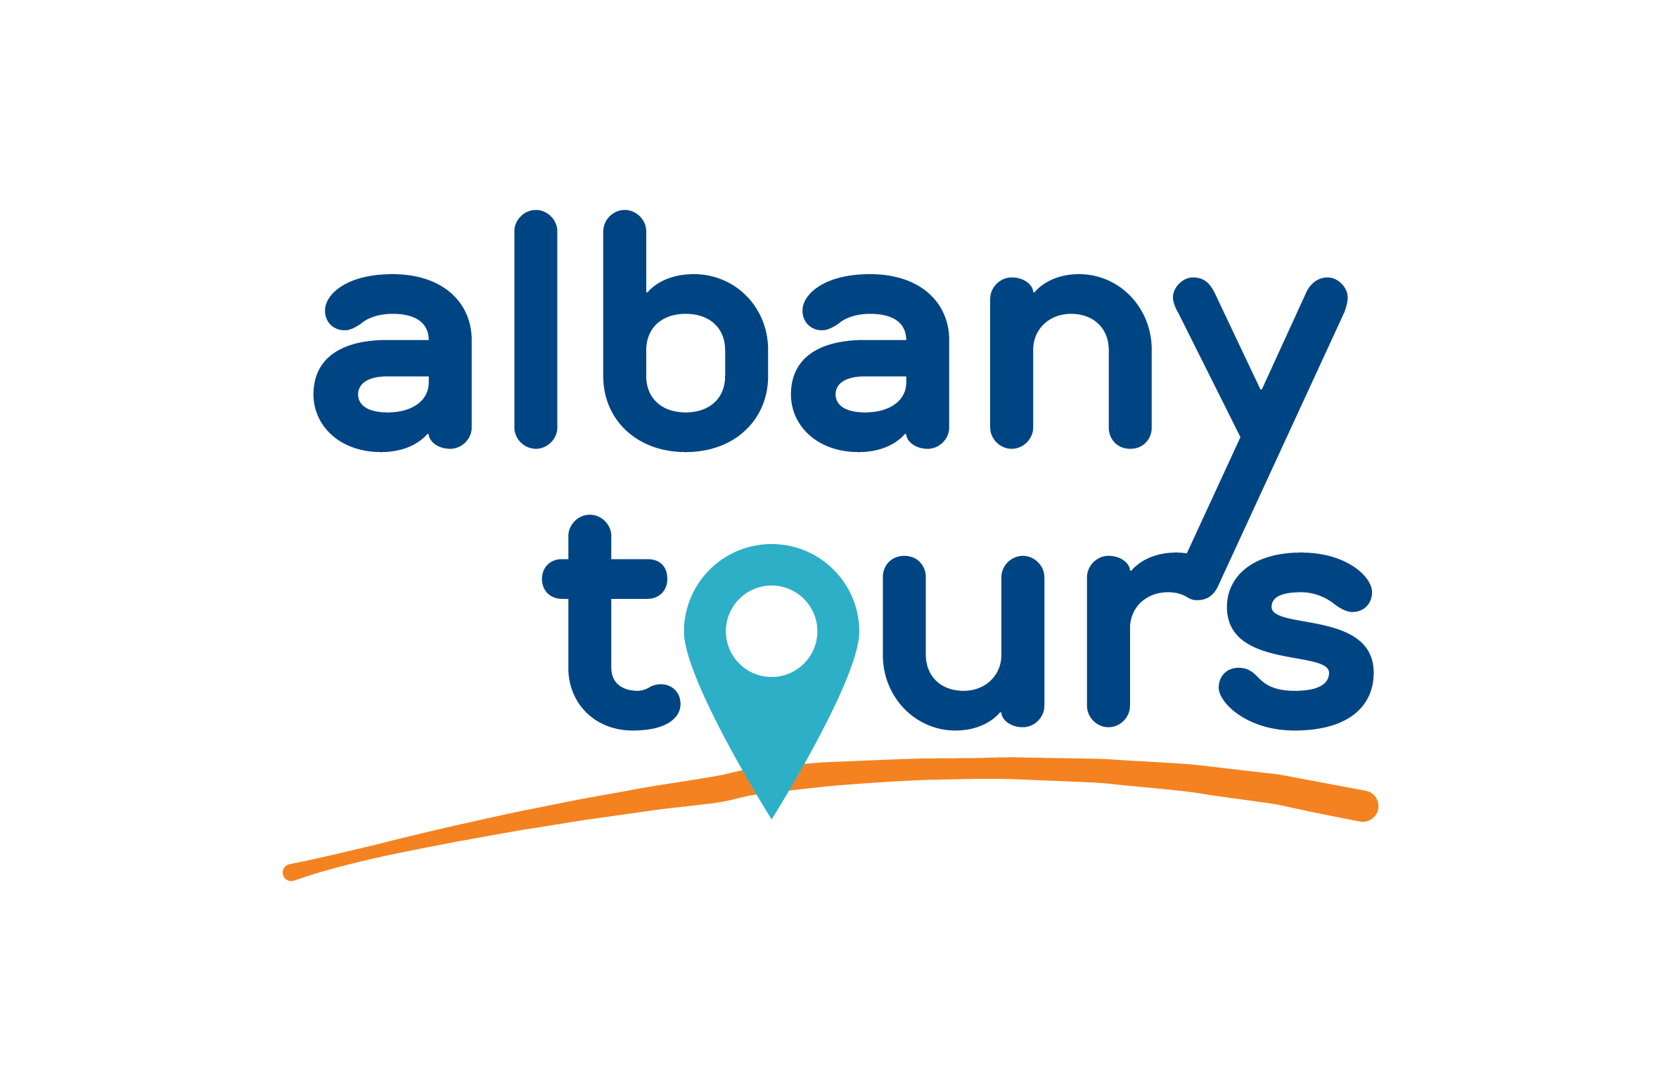

Bookings

The business offers the following methods for bookings and enquiries:
- Phone
- Email
- Webportal
- Our website supports Screen Readers
- Our forms have high contract boxes and submit boxes

Emergency Management
- Emergency and evacuation procedures are explained on arrival
- Guests with disabilities are noted in the guest log book for emergency and evacuation purposes

Communications
- Our website meets WCAG 2.0 accessibility standards
- Our business offers the following alternative communication methods
- Plain English

Not specified

Guide Dog and Service Animals
- The business provides a secure area with shade and water for service animals
- The business provides a toilet area for service animals
The business provides the following services for services animals:
Service animals are welcome to travel in vehicles and attend all sites visited

GENERAL

Pre-arrival, arrival and reception
The business has the following in place to support guests during pre-arrival, arrival and reception
- Booking information and websites are compatible with screen readers
- Information and maps are available in written form
- A familiarisation tour
- In addition, the following further information can assist guests:
Seating is available at the tour meeting point. Guests rest in the tour vehicle if they choose to opt out of walks.
- In addition, the following further information can assist guests:
We seek information about Special needs form our guests when they book. In the 24 hours prior to departure, we communicate with guests to check details recorded and respond to questions.

Car Park and Access amenities
The business has the following Car Park and Access amenities
- A drop off zone
- Designated disabled parking bays
- Level or ramped access from the car park to the entrance
- The accessible entrance is clearly signed from the parking bay
- Kerb ramps are in place where a pavement or walkway needs to be crossed
- In addition, the following further information can assist guests:
The standard pick up location is at the Albany Visitor Centre close to parking for those with disability and ramped access to the front of the building. Guests must be able to step into the vehicles independently. To assist we provision a mobile step that reduces the lift from ground to the floor level of the vehicle. This can be used at ll times entering and exiting the vehicle. We supervise all guests entry and exit from the vehicle providing advice for safety and secure footing.

Displays, exhibits, commentary and live performances
For displays, exhibits, commentary and live performances the following amenities are in place
- Seating
- In addition, the following further information can assist guests:
Commentary is provided as the vehicle is touring, out of the vehicle in the open air and inside venues. Voice amplification is provided in the vehicles. We encourage those who need to lip read to sit in view of the Tour Guide.

External Paths
External paths of travel
- Surfaces are concrete, asphalt, smooth paving or hard packed fine gravel (max aggregate size 13mm)
- Paths or slopes longer than 15 metres have resting places or seats
- Pathways are wider than 900mm
- There 3 successive steps or less on any path or at any doorway

We do not have capability to carry wheelchair reliant guests.
- Step free routes clearly signed

Steps
Steps
- There are steps.
- Top and bottom steps are easily distinguished through colour contrast or the use of TGSIs (Tactile Ground Surface Indicators)
- Handrails fitted to all open sets of steps
- In addition, the following further information can assist guests:
Sme of the venues on tours have enclosed risers, some do not. Please ask.

TOUR OPERATORS

Tour/Transport Services
The tour/transport services have the following facilities/amenities in place
- Buses/Coaches
- 0 vehicles have wheelchair lifts or ramps
- 0 vehicles have low floors with ramped entry
The maximum wheelchair capacity available in the fleet is:
0

Route Planning
- Route Planning
- The tour route includes stops with accessible toilet facilities
- Lunch stop venues are accessible
- Walking Tours
- Operated on a step free route
- Multi-paced to account for slower walkers
- Electronic voice augmentation

Guides

Guides have been trained in the following
- Use of clear/simple English
- Correct pronunciation for lip readers
  - Image(s)
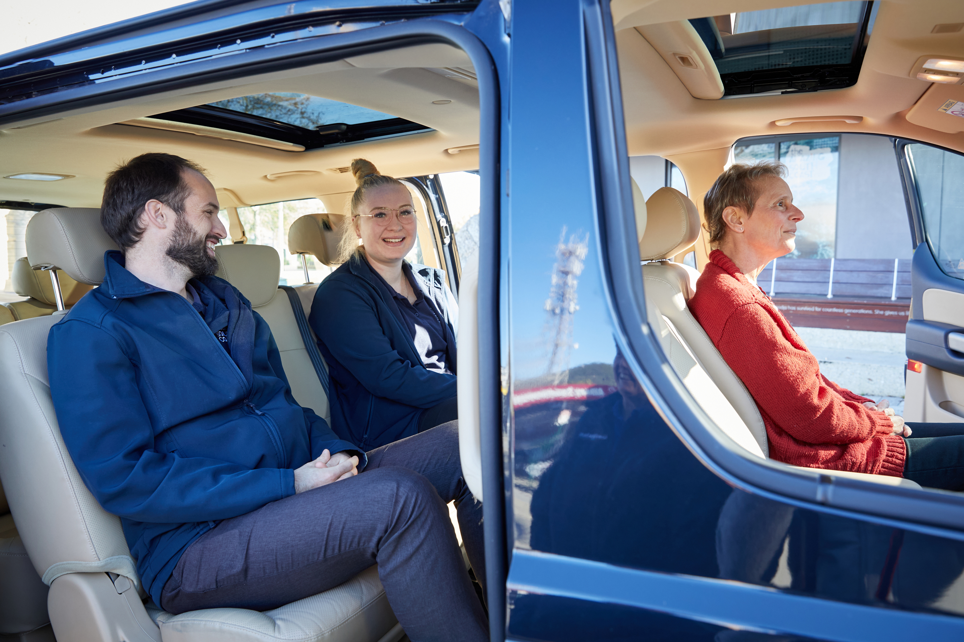
001_Customer middle seat iMax_Albany_BUSYBLUEBUSTOURS_SABINE ALBERS_Albany Western Australia
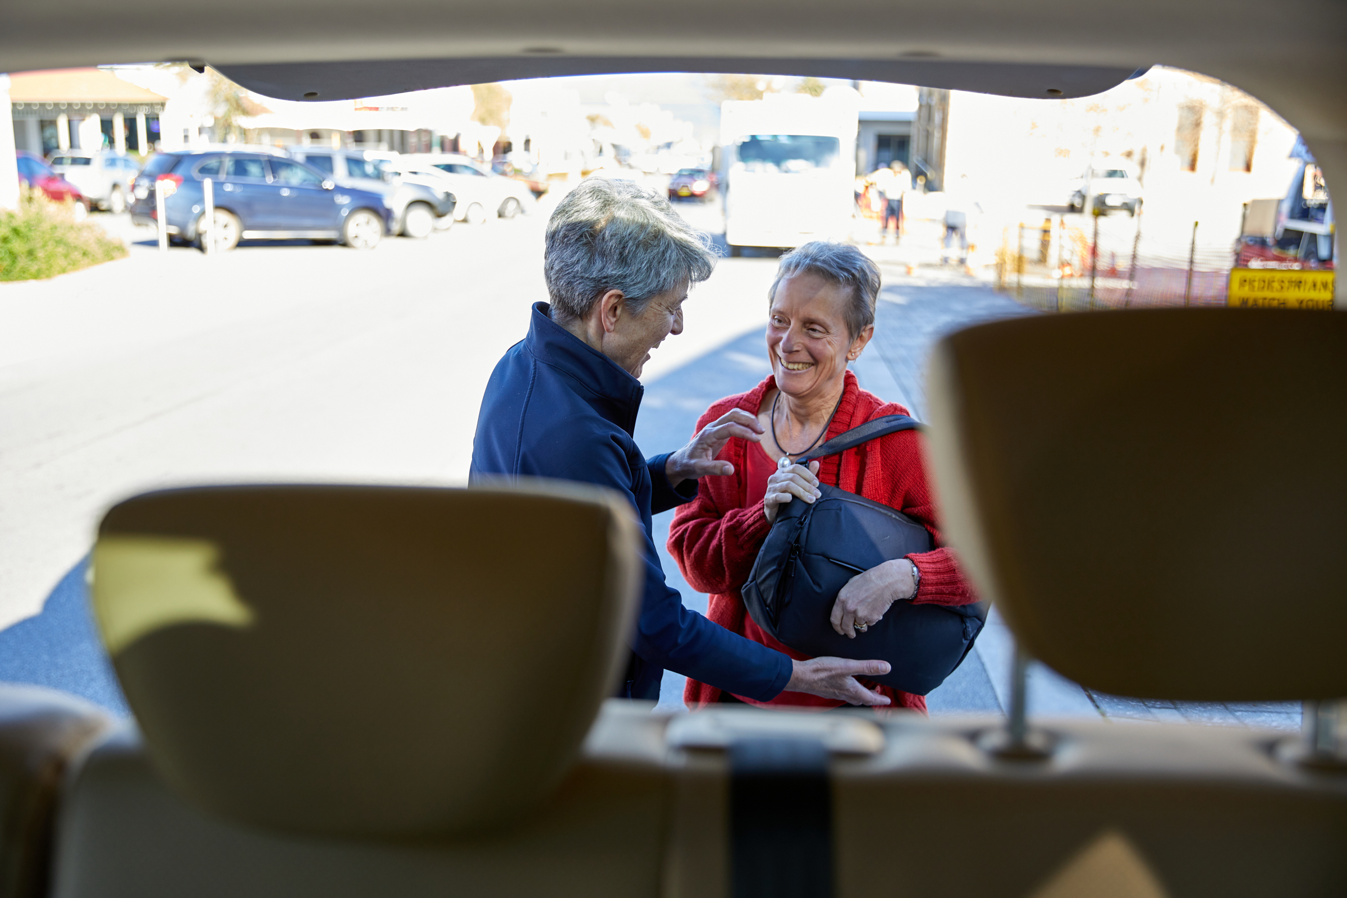
028_View to luggage area and guest_Albany_BUSYBLUEBUSTOURS_SABINE ALBERS_Albany Western Australia
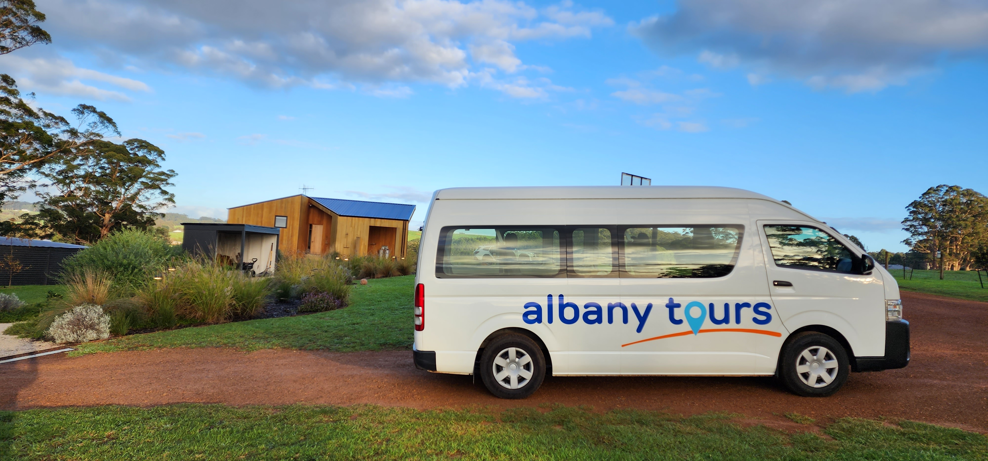
20230614_080719
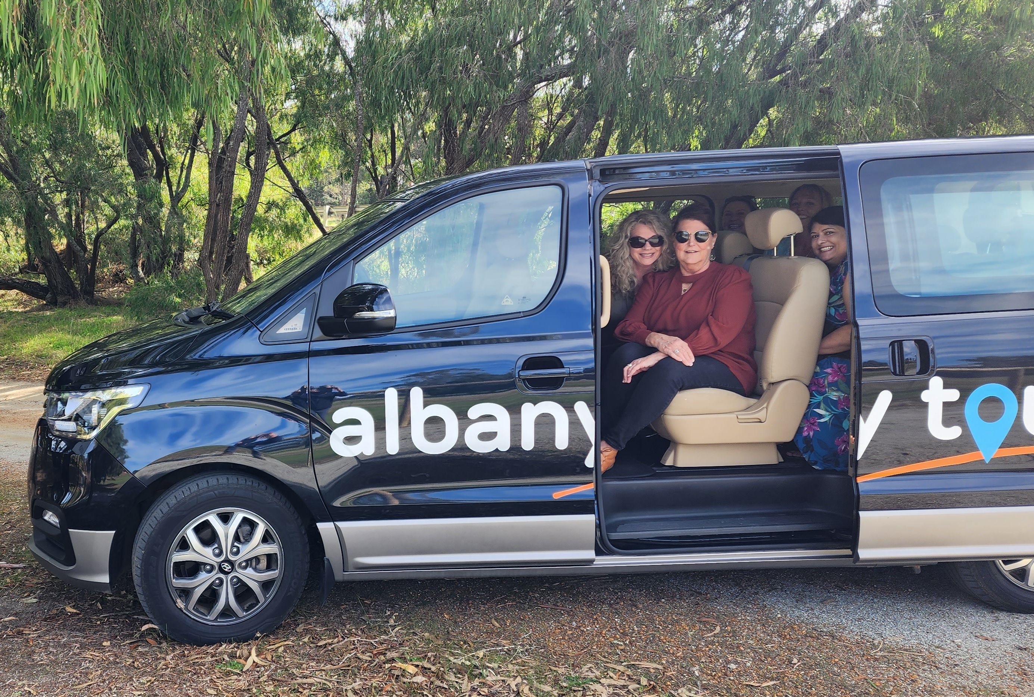
20230512_Albany Tours vehicle_BUSYBLUEBUSTOURS-Susan McCabe Albany Western Australia
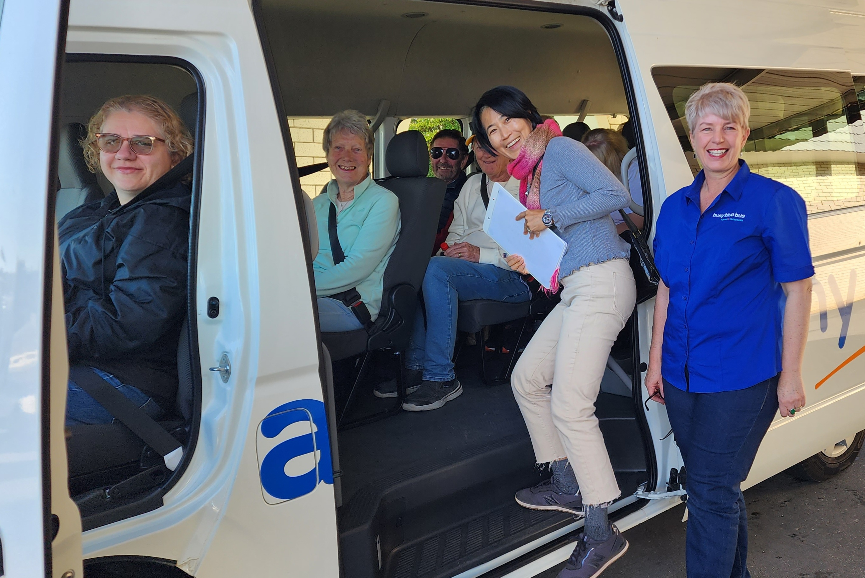
20230825_090216
- In addition, the following further information can assist guests:
Suppliers and websites

Businesswebsite

Albany Historical Societyhttps://www.historicalbany.com.au/Albany's Historic Whaling Stationhttps://discoverybay.com.au/ANZAC Centrehttps://www.nationalanzaccentre.com.au/Bartholemews Meaderyhttps://www.honeywine.com.au/Duckett's Millhttps://www.duckettsmillwines.com.au/Galafrey Wineshttps://www.galafreywines.com.au/Gilberts Wineshttps://www.gilbertwines.com.au/Ironwood Estatehttps://www.ironwoodestatewines.com.au/Kate's Placehttps://www.facebook.com/Katesplace42/Naturaliste Chartershttps://naturalistecharters.com.au/Plantagenet Wineshttps://plantagenetwines.com/The Lake House Denmarkhttps://www.lakehousedenmark.com.au/Three Anchorshttps://www.threeanchors.com.au/West Cape Howe Wineshttps://www.westcapehowewines.com.auWhaler's Galley Cafehttps://www.facebook.com/whalersgalleycafe/

Report Disclaimer
Please note that this business report, provided as a result of the use of the diagnostic assessment, is for information purposes only.
Australian Tourism Industry Council (ATIC) cannot guarantee the accuracy of respondent’s answers, or that they are fully representative of your business. Therefore, ATIC does not warrant or guarantee any particular outcome in respect of your businesses self-assessment.
This report is intended as guidance only for your business and should not be relied on for future marketing considerations. ATIC recommends that you seek your own independent advice as well as the results from the diagnostic.
Links to external web sites are inserted for convenience and do not constitute endorsement of material at those sites, or any associated organisation, product or service.
ATIC does not:
- Assume any legal liability for the accuracy, completeness, or usefulness of any information from this report or any links provided; or
- Accept responsibility for any loss associated directly or indirectly from the use of this report.

