ATIC Accessibility
To support the accessible community in making informed travel decisions for their individual needs

This report prepared for:
Business name: | Ventur Atlas
Address: | Broome
Town: | Broome
Contact for enquiries: | Natasha Marti
Contact Number: | (08) 6182 3050
Contact Email: | enquiries@venturatlas.com.au
Website: | https://www.venturatlas.com.au/
Date: | 2026-10-28 18:57

ATIC Accessibility
The following pages provides travellers with information on the businesses facilities and amenities which aims to support the traveller to make an informed decision on whether the business is suitable for their individual needs.
OVERVIEW 4
Business Overview 4
Bookings 4
Emergency Management 5
Communications 5
Guide Dog and Service Animals 5
GENERAL 6
Pre-arrival, arrival and reception 6
Car Park and Access amenities 6
Displays, exhibits, commentary and live performances 6
External Paths 6
Steps 7
TOUR OPERATORS 8
Tour/Transport Services 8
Route Planning 8
Guides 8
ADVENTURE ACTIVITIES 10
Adventure activities 10
Report Disclaimer 13

OVERVIEW

Business Overview

The business has the following products/services available
- Tour/Transport
- Adventure

Our business caters for the following disability types:
- Blind or low vision
- Deaf or low hearing
- Limited mobility
- Food allergies or intolerances
- Cognitive or people on the Autism Spectrum
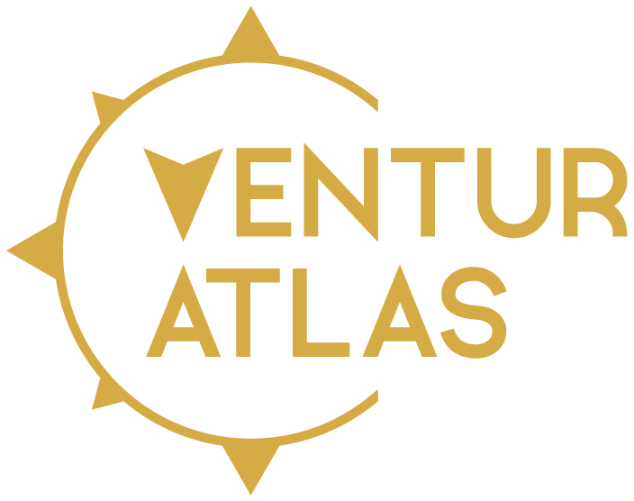

Bookings

The business offers the following methods for bookings and enquiries:
- Phone
- Email
- Webportal
- Our website supports Screen Readers
- Our forms have high contract boxes and submit boxes

Emergency Management
- Exit signs are clear and easy to see
- Exit access is free and clear at all times
We ensure exit access is free and clear at all times by:
Before any tour or event, our team conducts a visual inspection of all guest areas, entrances, and exits to confirm they are unobstructed and accessible. During tours, guides and support staff are trained to maintain clear pathways at all stops, camps, and accommodation sites, and to immediately remove or report any potential obstructions.
- Exits and access to exists are greater than 900mm
- Exit doors are able to be opened by all occupants
- The evacuation point is clearly marked by a sign
- In addition, the following further information can assist guests:
Pre-tour forms ask guests for all health requirements. Tour guide is briefed on these pre-tour.
- In addition, the following further information can assist guests:
Tour guides are first aid trained.
- Guests with disabilities are noted in the guest log book for emergency and evacuation purposes

Communications
- Our website meets WCAG 2.0 accessibility standards
- Our business offers the following alternative communication methods
- Plain English
- Magnifiers

Prompt phone & email communication available
- There is easy to read signage and information (e.g. menus and emergency information)

Guide Dog and Service Animals
- The business provides a secure area with shade and water for service animals
The business provides the following services for services animals:
We are happy to comply with the needs of service animals.

GENERAL

Pre-arrival, arrival and reception
The business has the following in place to support guests during pre-arrival, arrival and reception
- Booking information and websites are compatible with screen readers
- Information and maps are available in written form
- In addition, the following further information can assist guests:
Ventur Atlas ensures that guests with fatigue or other disabilities are supported and not disadvantaged by long wait times. We prioritise flexible scheduling, provide shaded rest areas, and offer seating during check-ins, briefings, and activities. Our staff are trained to recognise signs of fatigue and adjust the pace of experiences where possible. When needed, guests may rest in vehicles, air-conditioned areas, or accommodation facilities until departure or transfer times.

Car Park and Access amenities
The business has the following Car Park and Access amenities
- A drop off zone
- Designated disabled parking bays
- Level or ramped access from the car park to the entrance
- The accessible entrance is clearly signed from the parking bay

Displays, exhibits, commentary and live performances
For displays, exhibits, commentary and live performances the following amenities are in place
- Seating

External Paths
External paths of travel
- Pathways are wider than 900mm

We do not have a physical location

We do not have a physical location

Steps
Steps
- There are steps.
- Top and bottom steps are easily distinguished through colour contrast or the use of TGSIs (Tactile Ground Surface Indicators)
- All steps or staircases have enclosed risers
- The underside of all staircases are enclosed or protected to a height of at least 2 metres
- Handrails fitted to all open sets of steps
- Handrails extend 300mm beyond the top and bottom step
- Where steps are present are there three steps or less

TOUR OPERATORS

Tour/Transport Services
The tour/transport services have the following facilities/amenities in place
- Buses/Coaches
- 0 vehicles have wheelchair lifts or ramps
- 0 vehicles have low floors with ramped entry
The maximum wheelchair capacity available in the fleet is:
0

Route Planning
- Route Planning
- The tour route includes stops with accessible toilet facilities
- Lunch stop venues are accessible
- Overnight Stops
- For overnight stays, wheelchair accessible rooms are available
- The accommodation provider used for overnight stops has been independently verified as accessible, please contact us for further information
The total number of wheelchair passengers that can be catered for at overnight stops are:
Depends on accommodation provider availability
- Walking Tours
- Multi-paced to account for slower walkers

Guides

Guides have been trained in the following
- Use of clear/simple English
- Correct pronunciation for lip readers
- In addition, the following further information can assist guests:
Mount Hart Wilderness Lodge - https://www.mounthart.com.au/
Cygnet Bay Pearl Farm - https://www.cygnetbaypearlfarm.com.au/
Horizontal Falls Seaplane Adventures - https://horizontalfallsadventures.com.au/
Cable Beach Resort and Spa - https://www.cablebeachclub.com/

ADVENTURE ACTIVITIES

Adventure activities
The adventure activities have the following facilities/amenities in place
- Our adventure activities cater for people with a disability
- In addition, the following further information can assist guests:
Ventur Atlas works closely with a range of experienced third-party suppliers who operate accessible tourism experiences where possible. Many of our travel partners, including seaplane, helicopter, and 4WD tour operators, are able to accommodate guests with limited mobility, hearing, or vision impairments on a case-by-case basis.

While our itineraries are adventure-based, we strive to ensure that guests of all abilities can enjoy sightseeing, cultural experiences, scenic flights, wildlife viewing, and accessible accommodation options at key locations such as Broome, Cygnet Bay, and Mount Hart Wilderness Lodge.

Our team provides personalised pre-travel consultations to assess individual accessibility requirements and adapt itineraries where possible.

- In addition, the following further information can assist guests:
We utilise a range of supportive equipment and resources through our suppliers to assist guests with disabilities, including:

Step stools and handrails for safe vehicle and aircraft entry.

Ground crew or guide assistance for boarding aircraft and vehicles.

Accessible accommodation rooms and bathrooms at select partner lodges.

Communication assistance tools (written itineraries, visual aids, or staff briefings) to support guests with hearing or cognitive impairments.

Our team ensures suppliers are briefed on individual needs before departure to make the necessary arrangements in advance.

- In addition, the following further information can assist guests:
Due to the remote and rugged nature of the Kimberley region, some activities have limited accessibility. Terrain, aircraft design, and environmental conditions may restrict participation for guests with certain mobility impairments.

Activities not suitable for some people with disabilities include:

Remote hikes, gorge walks, and water-based activities that require uneven or unpaved access.

Helicopter or seaplane transfers that require stepping into confined cabins or over pontoons.

4WD off-road tours on rough terrain where accessible vehicles are not available.

Where an activity is not accessible, we can offer alternative sightseeing or cultural experiences to ensure an inclusive and enjoyable journey.

Report Disclaimer
Please note that this business report, provided as a result of the use of the diagnostic assessment, is for information purposes only.
Australian Tourism Industry Council (ATIC) cannot guarantee the accuracy of respondent’s answers, or that they are fully representative of your business. Therefore, ATIC does not warrant or guarantee any particular outcome in respect of your businesses self-assessment.
This report is intended as guidance only for your business and should not be relied on for future marketing considerations. ATIC recommends that you seek your own independent advice as well as the results from the diagnostic.
Links to external web sites are inserted for convenience and do not constitute endorsement of material at those sites, or any associated organisation, product or service.
ATIC does not:
- Assume any legal liability for the accuracy, completeness, or usefulness of any information from this report or any links provided; or
- Accept responsibility for any loss associated directly or indirectly from the use of this report.

