ATIC Accessibility
To support the accessible community in making informed travel decisions for their individual needs

This report prepared for:
Business name: | Cheela Plains Station Stay
Address: | Cheela Plains Station
Town: | PARABURDOO
Contact for enquiries: | Robin Pensini
Contact Number: | +61435633008
Contact Email: | reception@cheelaplains.com.au
Website: | https://www.cheelaplains.com.au/
Date: | 2026-11-08 03:07

ATIC Accessibility
The following pages provides travellers with information on the businesses facilities and amenities which aims to support the traveller to make an informed decision on whether the business is suitable for their individual needs.
OVERVIEW 4
Business Overview 4
Bookings 4
Emergency Management 4
Other Information 5
Guide Dog and Service Animals 5
GENERAL 6
Pre-arrival, arrival and reception 6
Cognitive Impairment Support 6
Car Park and Access amenities 6
Entry 6
Internal Spaces 7
Public areas 7
External Paths 7
Ramps 8
Public Toilets/Adult change facilities 8
ACCOMMODATION 9
Bedrooms 9
Room Amenities 9
Bathrooms 10
COMMON AREAS 11
Play Spaces 11
FOOD AND DRINK 12
Dining Spaces 12
ADVENTURE ACTIVITIES 16
Report Disclaimer 18

OVERVIEW

Business Overview

The business has the following products/services available
- Accommodation
- Food and Drink
- Adventure

Our business caters for the following disability types:
- Limited mobility
- Wheelchairs or mobility scooters
- Food allergies or intolerances
- Cognitive or people on the Autism Spectrum
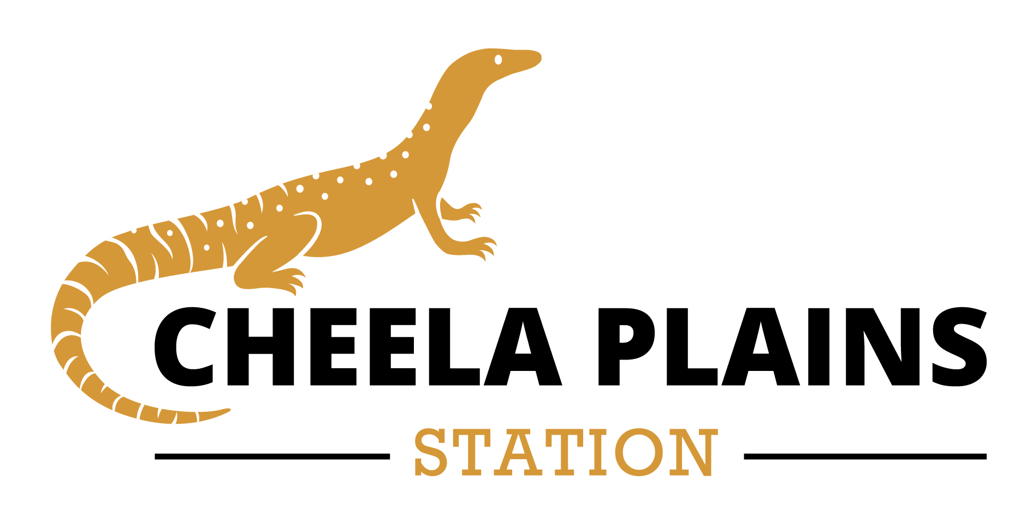

Bookings

The business offers the following methods for bookings and enquiries:
- Phone
- Email

Emergency Management
- The business has an emergency management and evacuation plan for guests with a disability

Other Information
- For bookings made onsite, the ticket booth/counter/box office is accessible for people using a wheelchair

Guide Dog and Service Animals
- The business provides a secure area with shade and water for service animals
- The business provides a toilet area for service animals
The business provides the following services for services animals:
Service dogs allowed are able to enter all indoor spaces

GENERAL

Pre-arrival, arrival and reception
The business has the following in place to support guests during pre-arrival, arrival and reception
- Booking information and websites are compatible with screen readers
- There is a reception/public entryway.
- Seating available at reception
- Lighting in the reception area is even and glare free
- Large print information sheets and registration forms
- Information and maps are available in written form
- Luggage assistance
- In addition, the following further information can assist guests:
Plenty of seating available in public areas
- In addition, the following further information can assist guests:
Plenty of seating available in public areas

Cognitive Impairment Support
- Documents are available in plain English for people with cognitive impairment (This may include instructions, guides, menus and general information)
- A space for parents and children on the Autism Spectrum

Car Park and Access amenities
The business has the following Car Park and Access amenities
- A drop off zone
- Level or ramped access from the car park to the entrance
- In addition, the following further information can assist guests:
No intercoms at the property.

Entry
The business has the following amenities/systems in place for entry
- A drop off point close to the entrance
- A path of access to the building is slip resistance and even
- A path of access to the building is clear of obstruction
- Glass doors are fitted with a visual sighting strip
- Door handles are of a contrasting colour to the door
- Signage is written in a contrasting colour
- The entry door is a minimum of 850mm wide
- The entrance sill is less than 13mm
- There a clear space of at least 1500mm x 1500mm in front of all doors.
- The entrance door mats have a thickness less than 13mm and a width of 7500mm or greater
- In addition, the following further information can assist guests:
Property is all one level.

Internal Spaces
- Clear and unobstructed routes through and between buildings
- Interior walls are matte or low sheen
- Tableware/glassware contrast with the table surface or table cloth
- Floor surfaces are hard or short pile carpet
- Seating is available for guests unable to stand for long periods
- All corridors greater than 900mm
- In addition, the following further information can assist guests:
No Specific area but lots of outdoor space

Public areas
The public areas have the following amenities in place
- Even lighting
- Seating
- In addition, the following further information can assist guests:
Lot of outdoor space with seating. Plenty of natural light.

External Paths
External paths of travel
- Pathways are wider than 900mm

No Steps at property, all one ground floor.

No steps at property.
- In addition, the following further information can assist guests:
All ground floor.
- In addition, the following further information can assist guests:
No steps at property.

Ramps
Ramps have the following amenities are in place
- There are ramps.
- Long ramps (more than 10m) are 1:20 or less
- In addition, the following further information can assist guests:
Ramp located for access to the accessible room for easy entry and another to gain entry to the dialed toilet.

Public Toilets/Adult change facilities
Public Toilets/Adult change facilities have the following amenities are in place
- There is an accessible toilet for public use
- The door is at least 850mm wide
- There is a minimum of 850mm beside the toilet
- Handrails are fitted
- The toilet seat is 460mm above the floor
- The toilet seat of a contrasting colour to the floor
- The toilet seat is460mm above the floor
- In addition, the following further information can assist guests:
Disabled toilet is located at the Emu Campground.

ACCOMMODATION

Bedrooms
The bedrooms have the following facilities/amenities in place
- There are 1 rooms available to guests who use a wheelchair
- Bedroom furniture can be re-arranged on request
  - Layout of room Image(s)
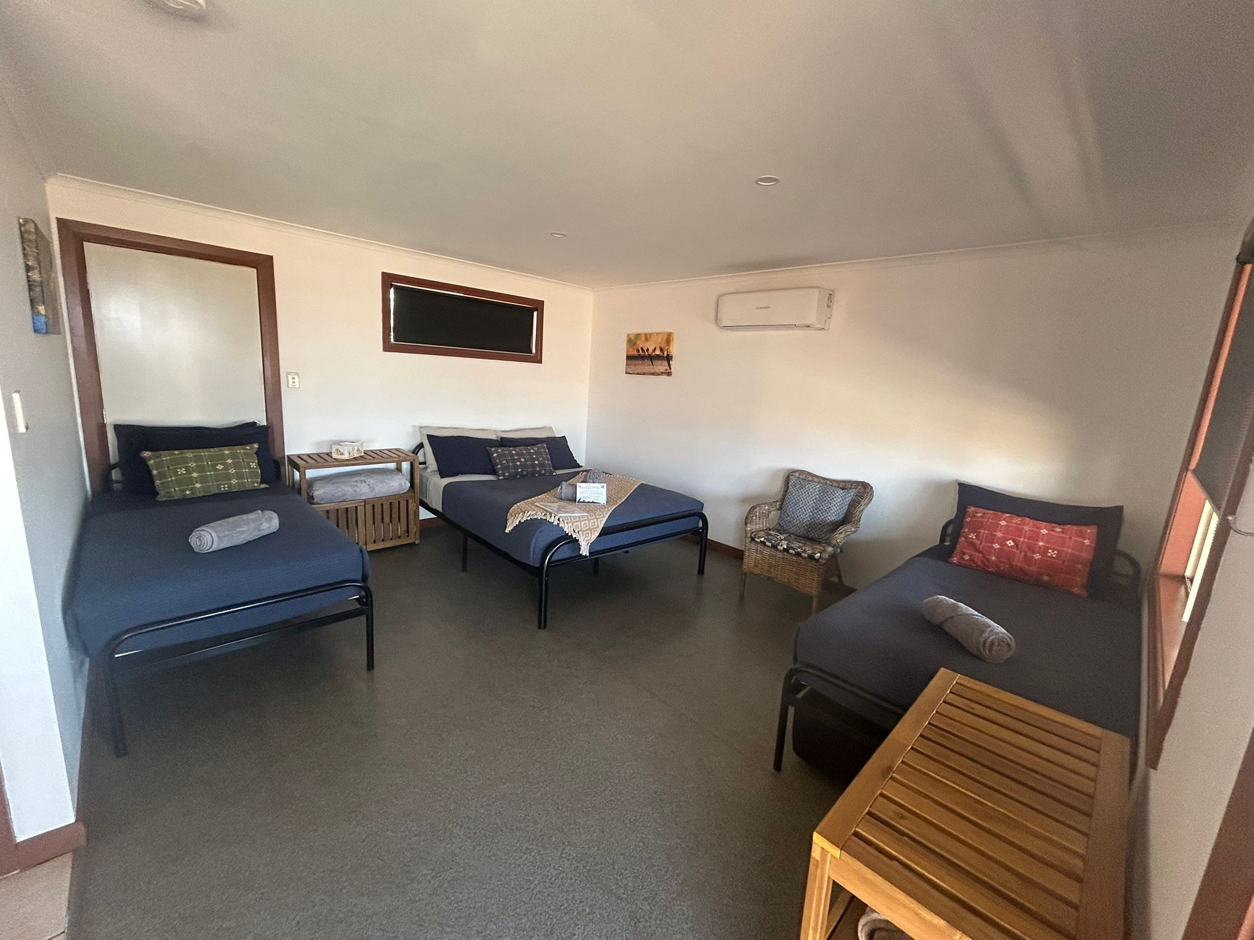
Dove 11

Room Amenities

No wardrobe in room.
- Televisions are equipped with closed captioning capability
- There is contrast between the walls, skirtings, floor and furniture
- There is a clear path through the room
- The edges of all furniture and fixtures are rounded
- Doors open fully against the adjoining wall
- There is a clear opening at least 850mm wide
- The bed height is no higher than 680mm from the floor
- There is at least 130mm clearance under the bed
- The business offers a range of non-allergenic bedding
- In addition, the following further information can assist guests:
Rooms are cleaned with White vinegar spray. No wardrobe or luggage racks.

Bathrooms
The bathrooms have the following facilities/amenities in place
- All heating appliances and hot water pipes are protected or insulated
- All shower, bath and basin taps are clearly differentiated between hot and cold
- Fixtures and fittings have rounded edges
- The door is at least 850mm wide
- There is a minimum of 850mm beside the toilet
- Handrails are fitted
- There is a minimum of 1400mm of clear space in front of the toilet
- The toilet seat is 460mm above the floor
- A range of non-allergenic toiletries are available
- There is a portable shower head on flexible hose
  - Bathroom Image(s)
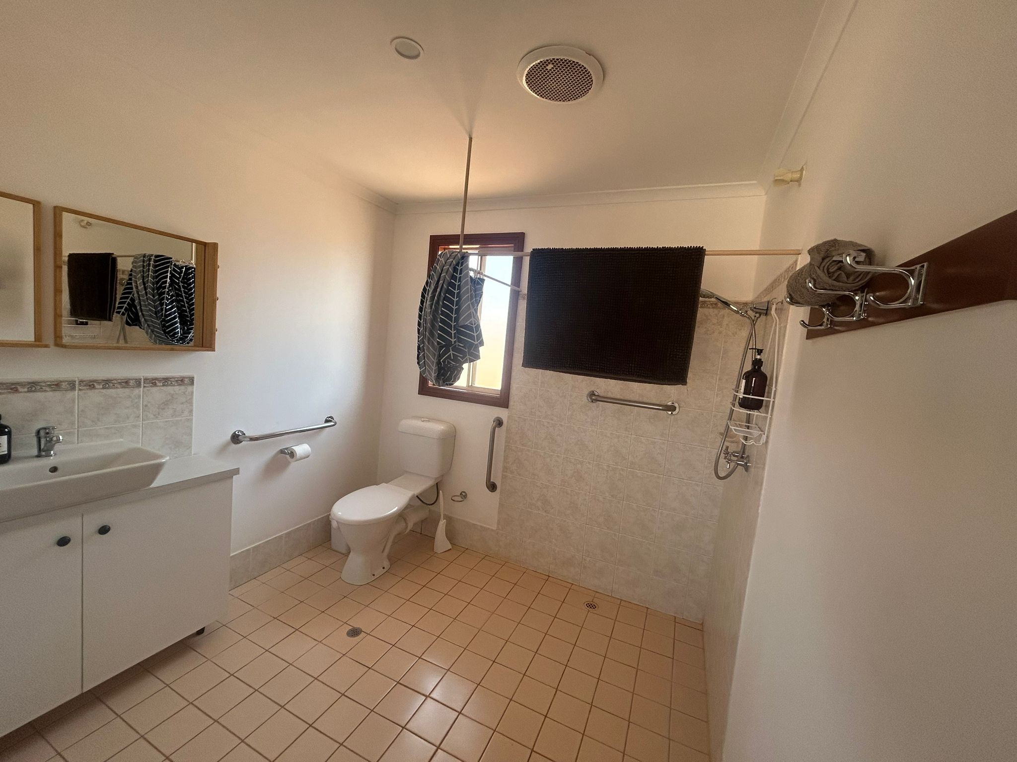
Dove 11 bathroom

COMMON AREAS

Play Spaces
- Level access is provided to play spaces
- Ramps provided are at least 25% of elevated sections of the play space
- Seating is provided in or around the play space
  - Image(s)
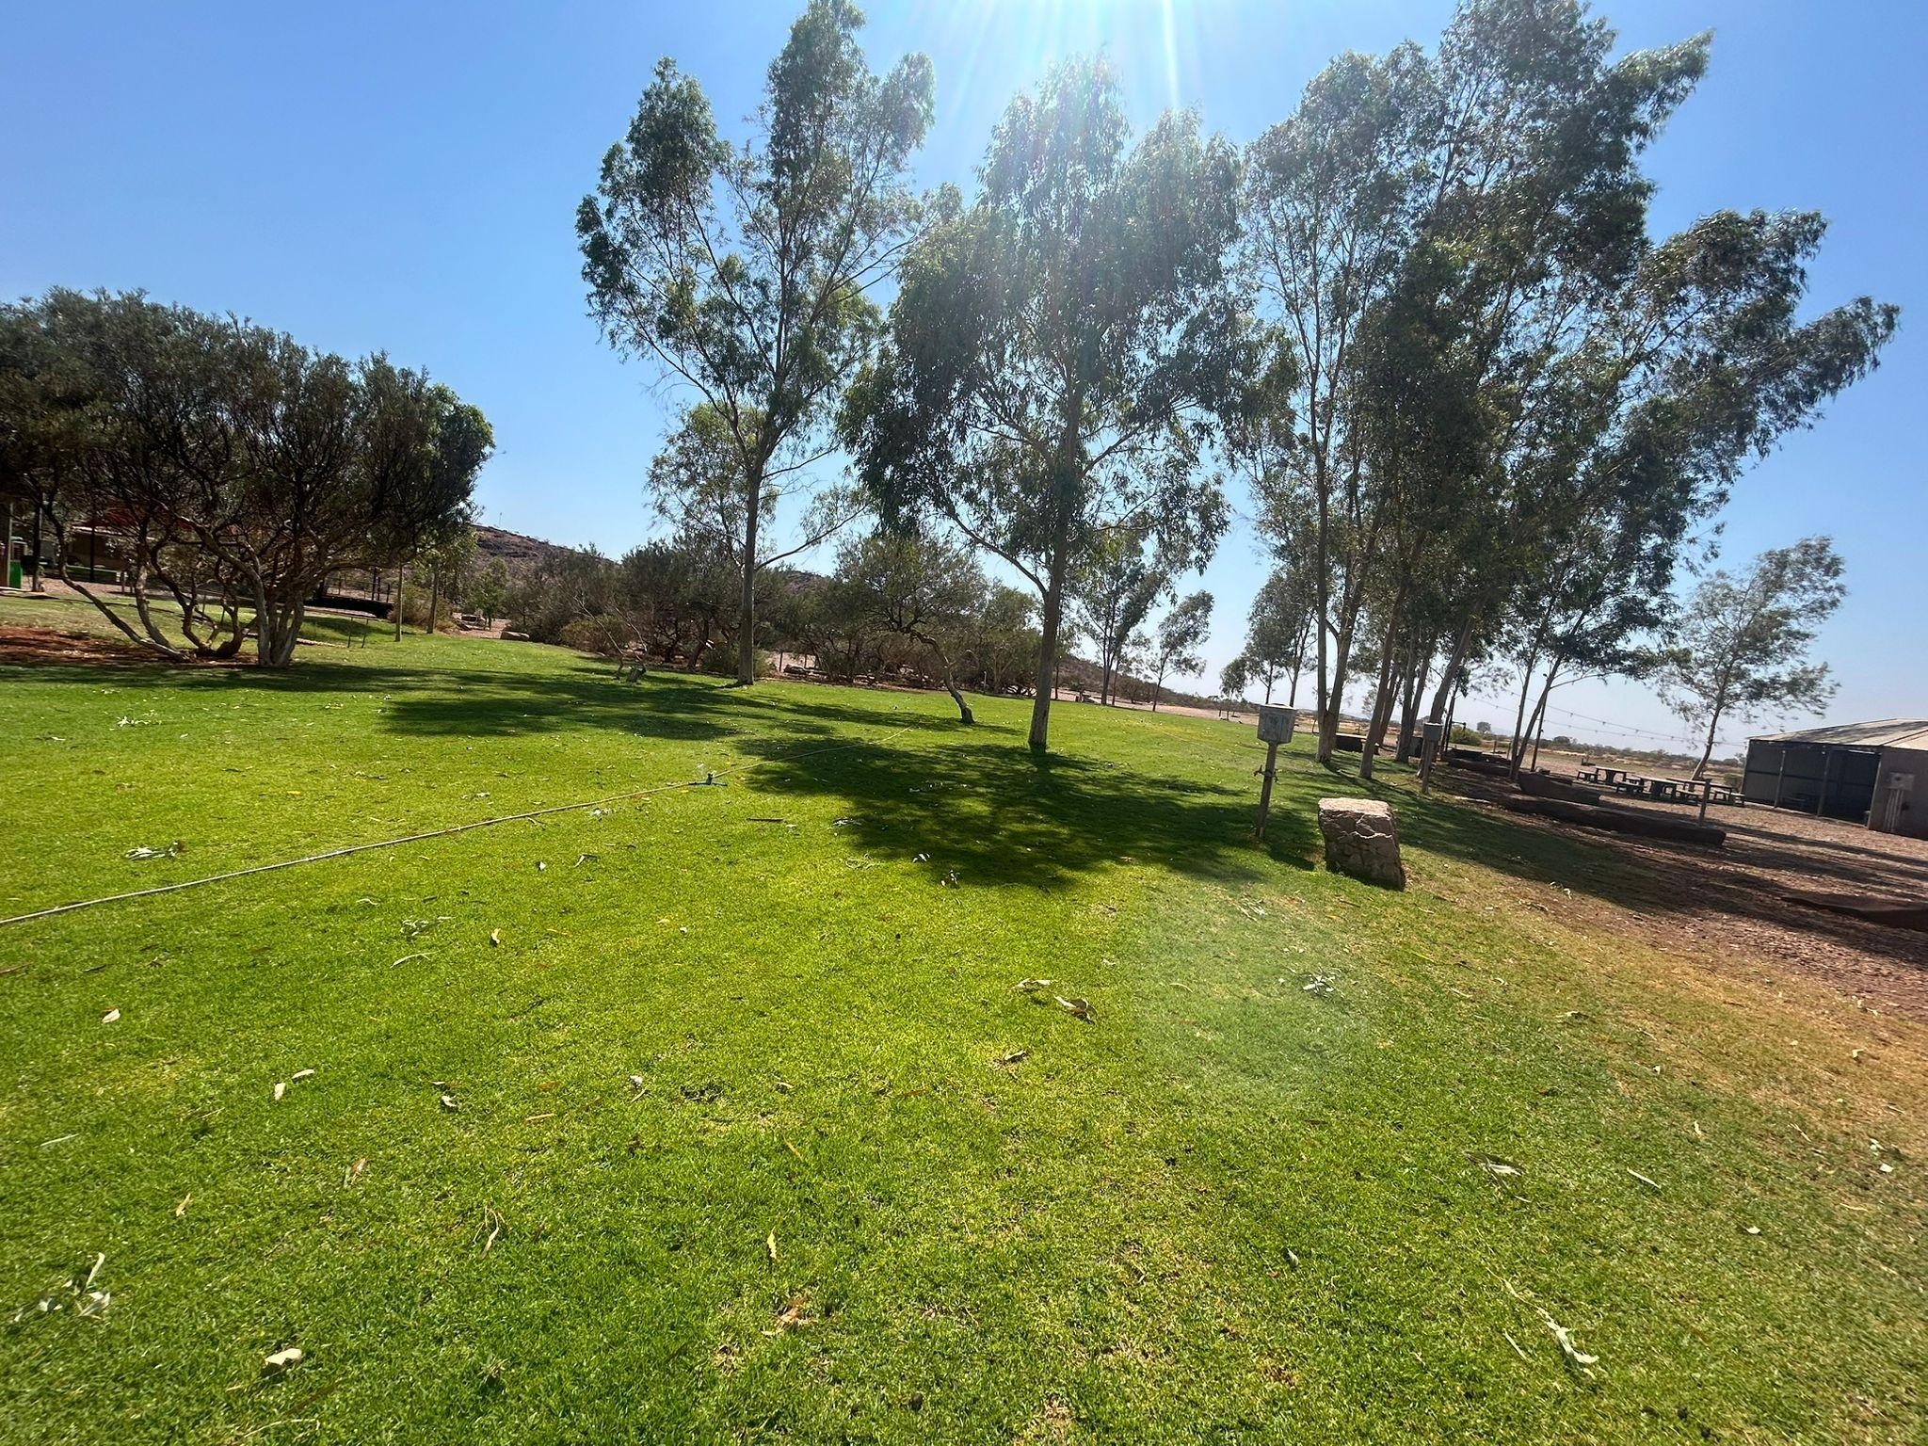
Oval
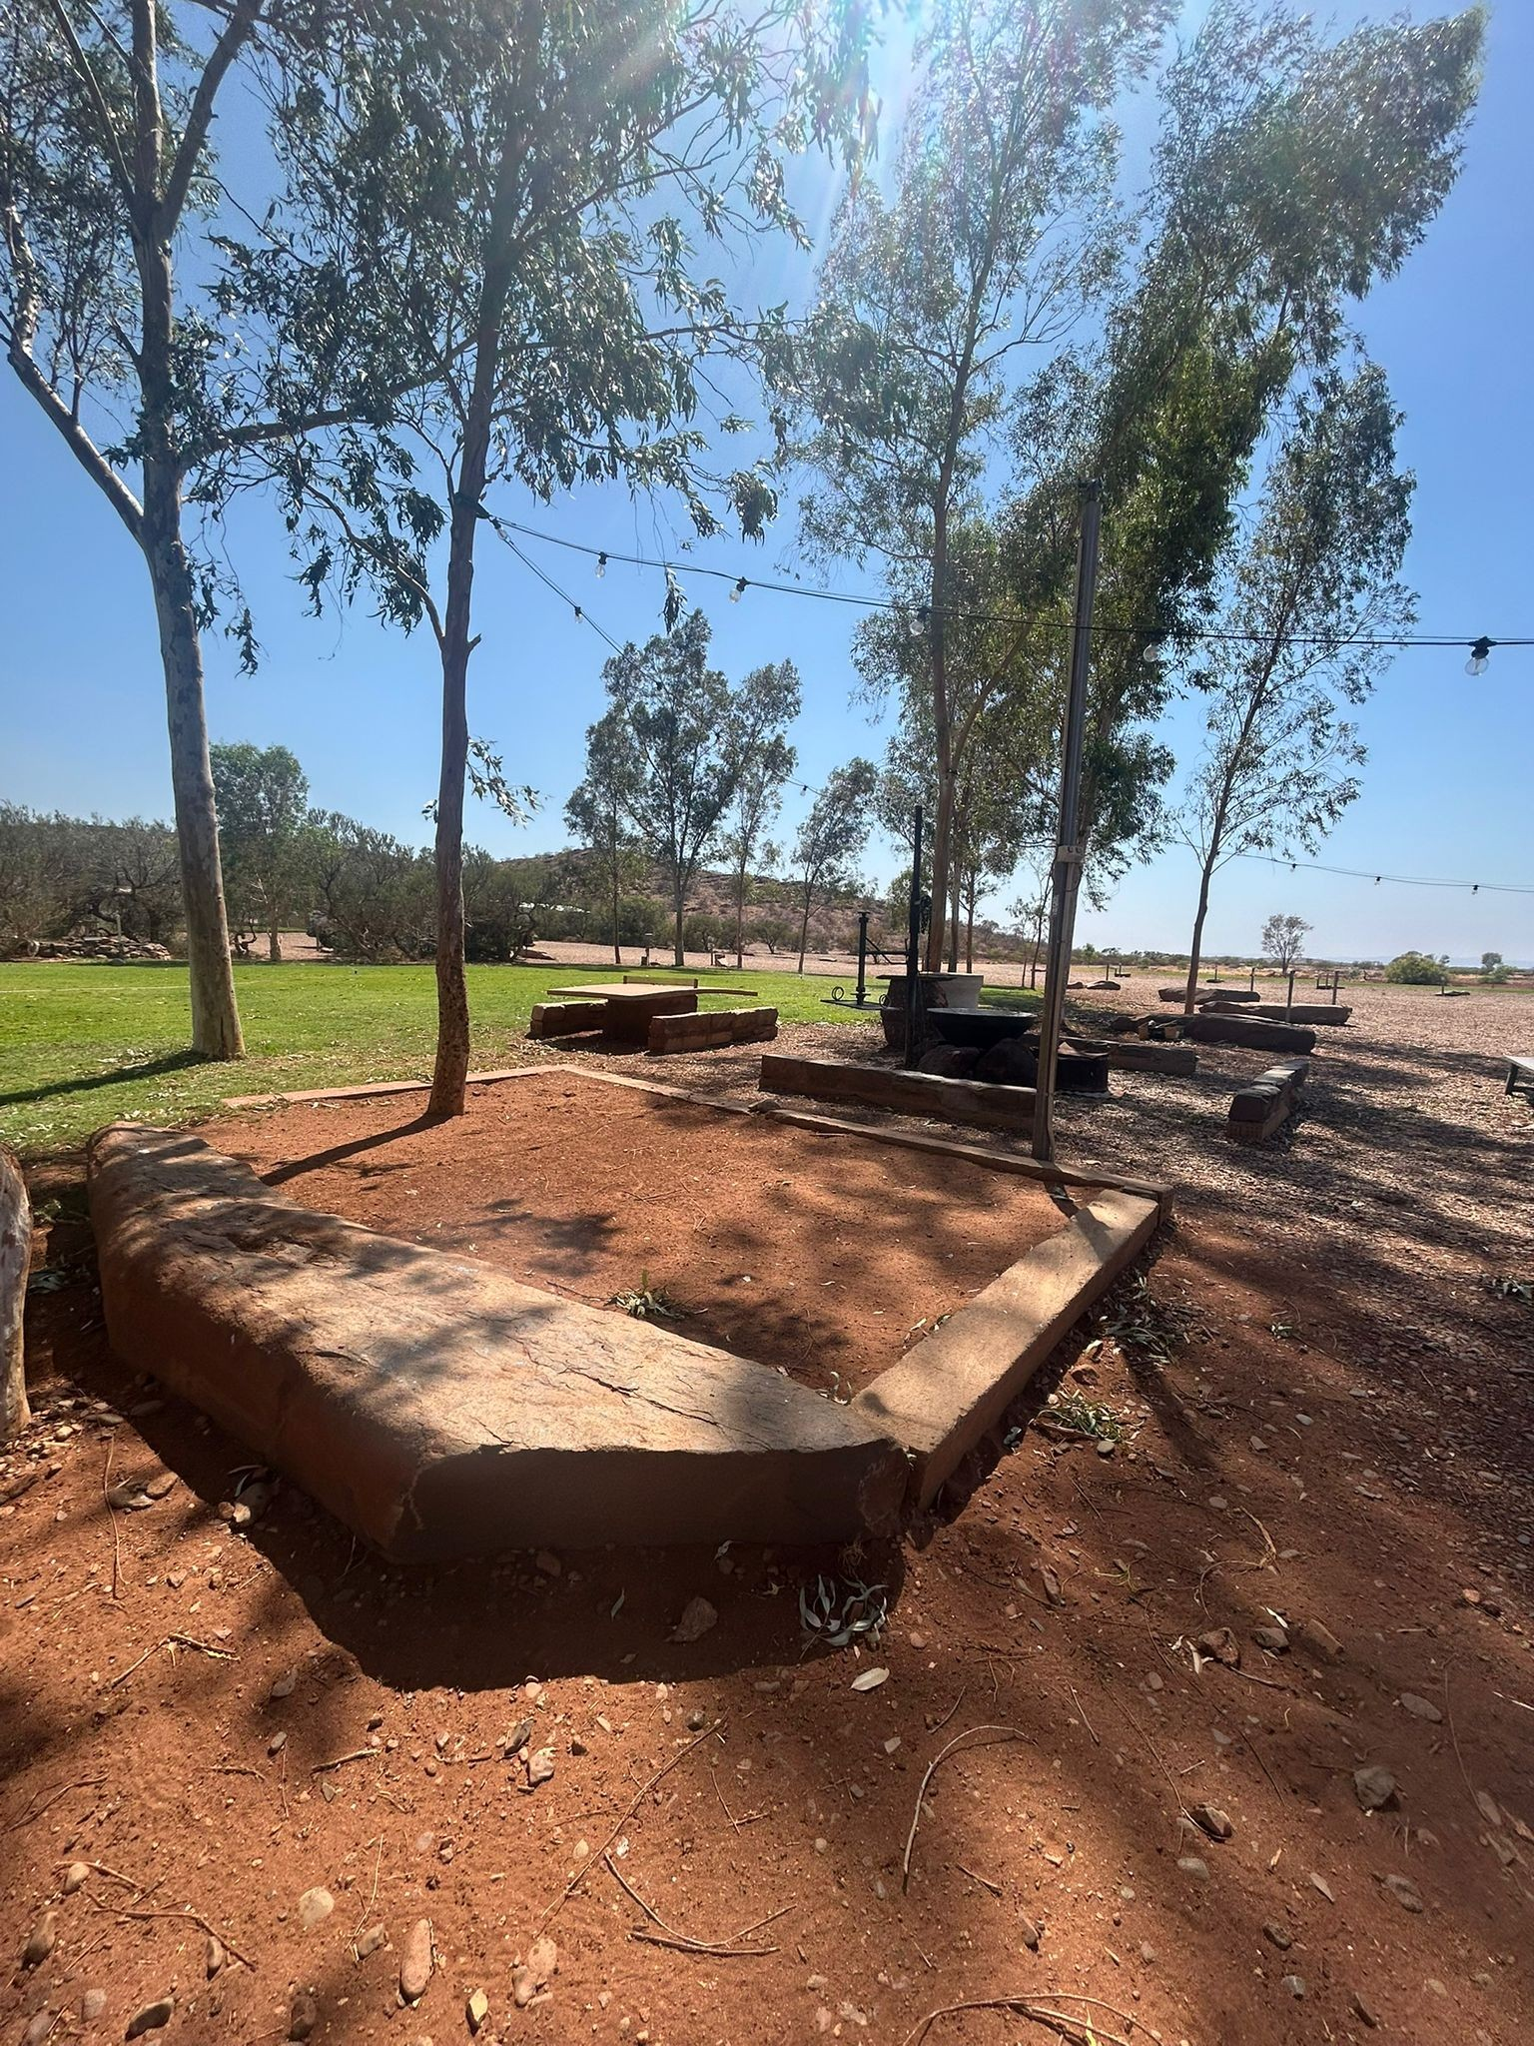
Sandpit

FOOD AND DRINK

Dining Spaces
The dining spaces have the following facilities/amenities in place
- The entrance has level access
- The doorway is at least 850mm wide
- Chairs are moveable to allow for wheelchairs to be seated at the tables
- All glass doors and full height windows have contrast markings
- There are areas of full lighting
- There are Plain English menus
- There is an accessible toilet

Our business caters for the following dietary requirements
- Gluten free (celiac)
- Lactose free (dairy free)
- Nut free
- Vegetarian
- Vegan
- Halal
- In addition, the following further information can assist guests:
Segregation of Food Types

Raw and cooked foods are stored separately at all times.

Colour-coded chopping boards, utensils, and containers are used for different food groups (e.g., raw meat, poultry, seafood, and ready-to-eat foods).

Cleaning and Sanitisation

All food preparation areas, equipment, and utensils are cleaned and sanitised before and after use.

Cleaning schedules are maintained and documented to ensure compliance with hygiene standards.

Personal Hygiene

Staff are trained in proper handwashing techniques and must wash hands between handling different food types.

Gloves and aprons are changed between tasks to prevent cross-contact.

Storage and Handling

Food items are stored in sealed, clearly labelled containers.

Refrigeration and dry storage areas are organised to prevent raw foods from coming into contact with ready-to-eat items.

Training and Monitoring

All food-handling staff complete regular food safety and hygiene training.

Supervisors conduct routine checks to ensure cross-contamination controls are followed.

Allergen Management

Allergen-containing ingredients are clearly identified and stored separately.

Equipment and surfaces are thoroughly cleaned before preparing allergen-free meals.

- There is a sample menu available online
Sample menu is available here -
https://www.cheelaplains.com.au/wp-content/uploads/2025/09/DINNER-MENU-Sept-15th-to-._.pdf
  - Food and Beverage Image(s)
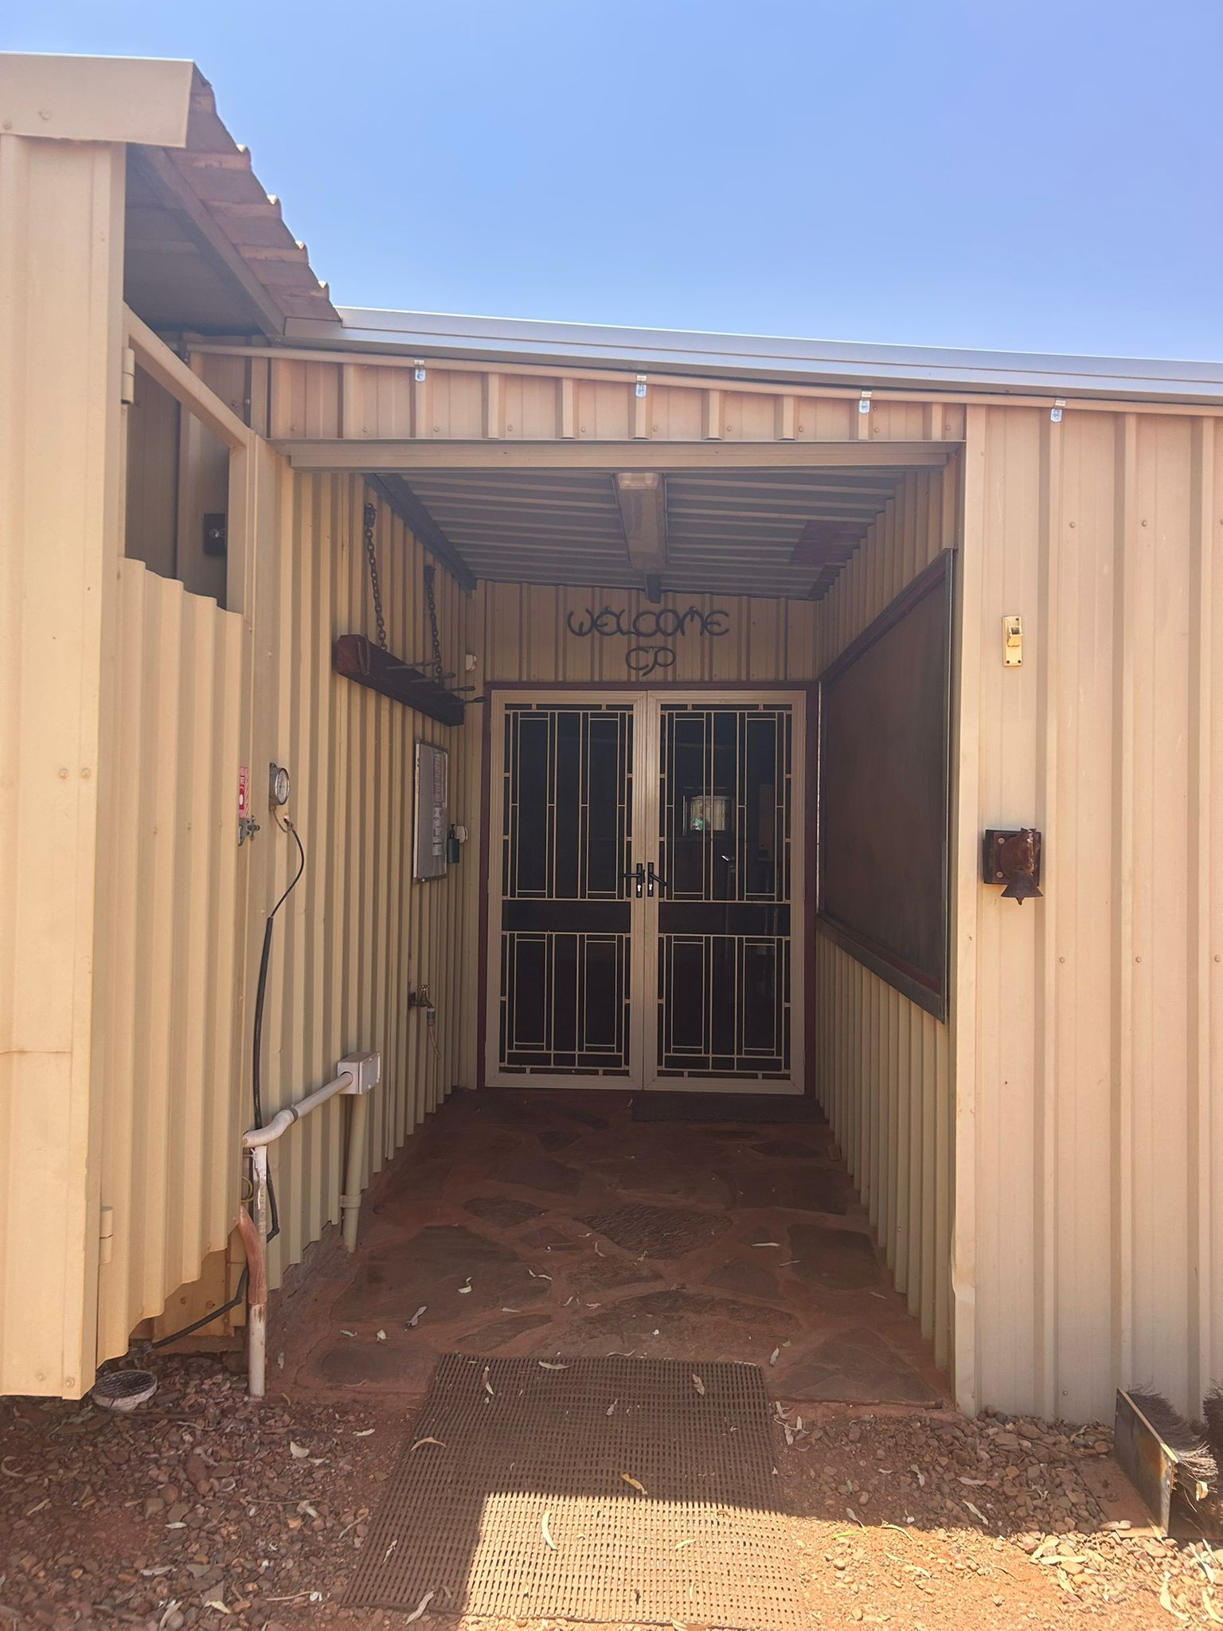
Cafe entrance
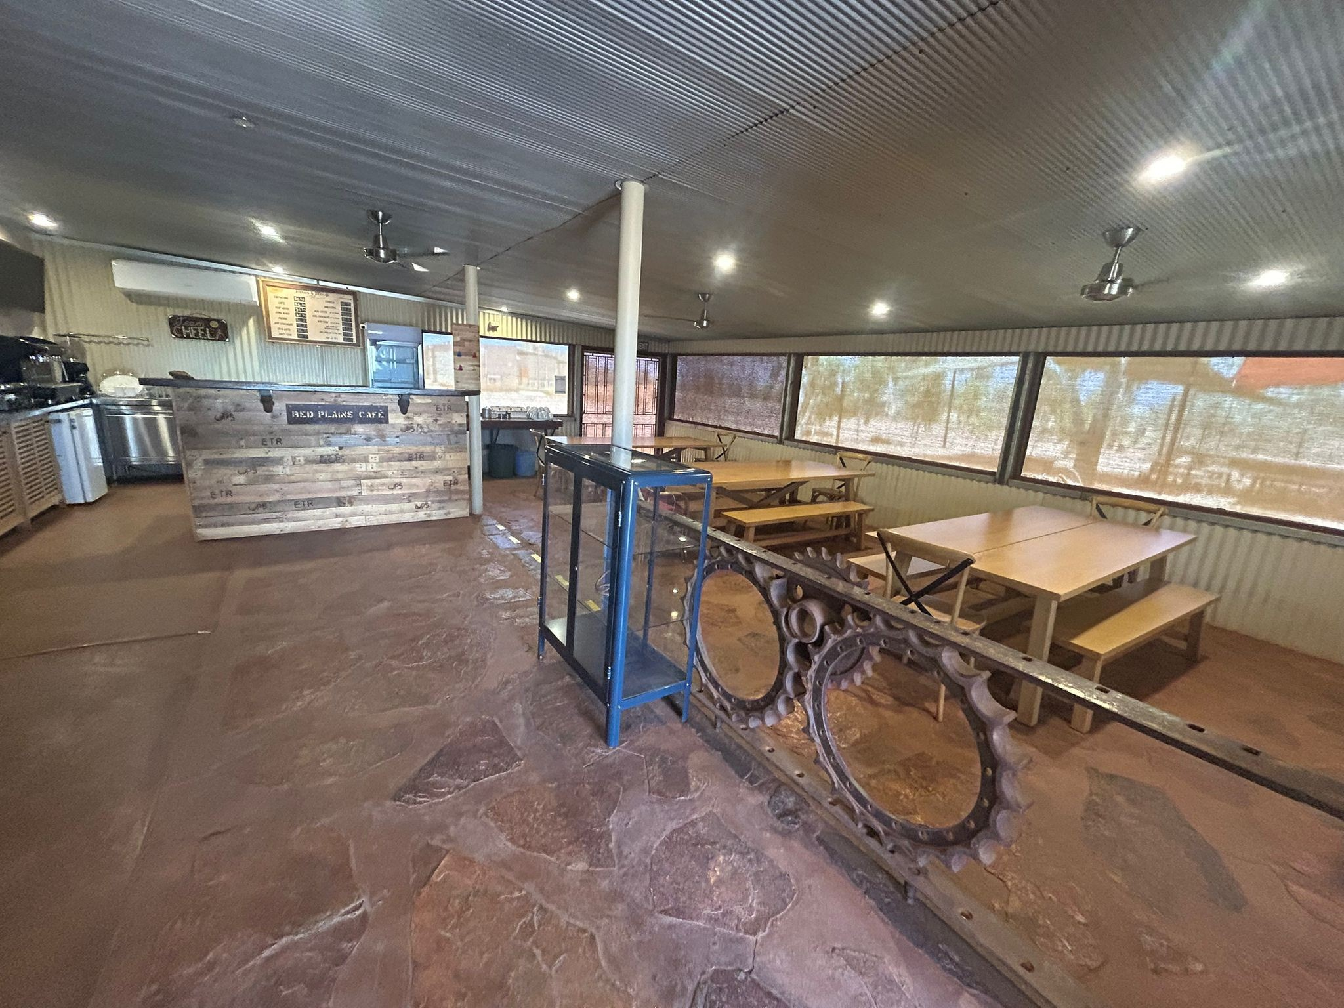
Cafe
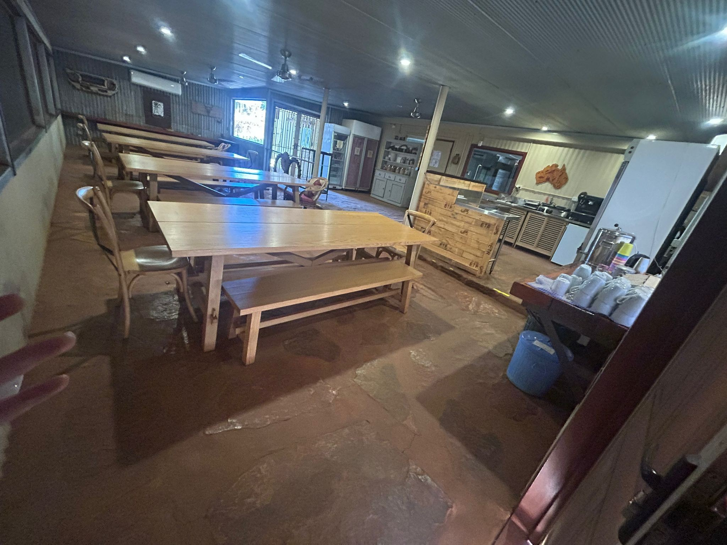
Cafe2
- In addition, the following further information can assist guests:
2 doors of entry.

ADVENTURE ACTIVITIES
- In addition, the following further information can assist guests:
No adventure activities offered at this point.

Report Disclaimer
Please note that this business report, provided as a result of the use of the diagnostic assessment, is for information purposes only.
Australian Tourism Industry Council (ATIC) cannot guarantee the accuracy of respondent’s answers, or that they are fully representative of your business. Therefore, ATIC does not warrant or guarantee any particular outcome in respect of your businesses self-assessment.
This report is intended as guidance only for your business and should not be relied on for future marketing considerations. ATIC recommends that you seek your own independent advice as well as the results from the diagnostic.
Links to external web sites are inserted for convenience and do not constitute endorsement of material at those sites, or any associated organisation, product or service.
ATIC does not:
- Assume any legal liability for the accuracy, completeness, or usefulness of any information from this report or any links provided; or
- Accept responsibility for any loss associated directly or indirectly from the use of this report.

