ATIC Accessibility
To support the accessible community in making informed travel decisions for their individual needs

This report prepared for:
Business name: | Codling Moth Tours and Experiences
Address: | 33 Greys Hill Road
Town: | Bridgetown
Contact for enquiries: | Chris Maher
Contact Number: | 0418 905 244
Contact Email: | info@codlingmoth.com.au
Website: | https://codlingmoth.com.au/
Date: | 2026-09-27 22:40

ATIC Accessibility
The following pages provides travellers with information on the businesses facilities and amenities which aims to support the traveller to make an informed decision on whether the business is suitable for their individual needs.
OVERVIEW 4
Business Overview 4
Bookings 6
Emergency Management 6
Communications 6
Other Information 7
Guide Dog and Service Animals 7
GENERAL 8
Pre-arrival, arrival and reception 8
Car Park and Access amenities 8
Displays, exhibits, commentary and live performances 8
External Paths 9
TOUR OPERATORS 10
Route Planning 10
Guides 10
FOOD AND DRINK 11
Dining Spaces 11
Report Disclaimer 13

OVERVIEW

Business Overview

The business has the following products/services available
- Tour/Transport
- Food and Drink

Our business caters for the following disability types:
- Blind or low vision
- Deaf or low hearing
- Limited mobility
- Wheelchairs or mobility scooters
- Food allergies or intolerances
- Cognitive or people on the Autism Spectrum
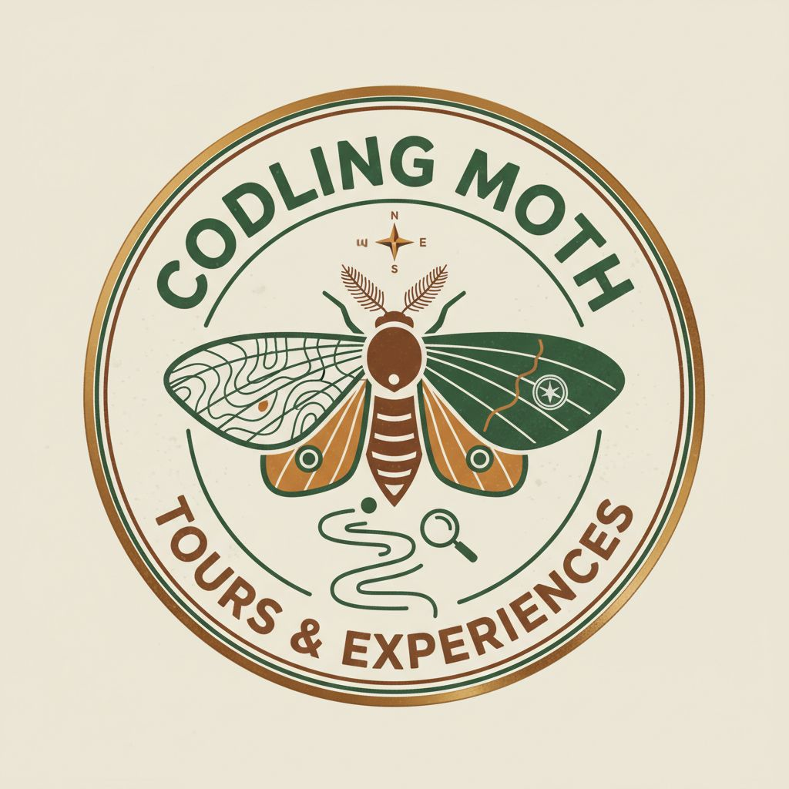

Bookings

The business offers the following methods for bookings and enquiries:
- Phone
- Email
- Webportal
- Our website supports Screen Readers
- Our forms have high contract boxes and submit boxes
- Staff have undergone disability awareness and training

Emergency Management
- Emergency and evacuation procedures are explained on arrival
- In addition, the following further information can assist guests:
Guests are asked to advise if they have any individual support needs at the time of booking a tour.
- In addition, the following further information can assist guests:
Guests are asked at tour booking what support requirements they have. If we have vulnerable guests on tour and second person comes on tour to assist with any requirements.
- Guests with disabilities are noted in the guest log book for emergency and evacuation purposes

Communications
- An accessibility guide is available on the website

https://codlingmoth.com.au/access-and-inclusion
- Our website meets WCAG 2.0 accessibility standards
- Our business offers the following alternative communication methods
- Plain English

Not specified
- There is easy to read signage and information (e.g. menus and emergency information)

Other Information
- The business accepts the companion card

Guide Dog and Service Animals
- The business provides a secure area with shade and water for service animals
The business provides the following services for services animals:
Service animals are welcomed on all our tours.

GENERAL

Pre-arrival, arrival and reception
The business has the following in place to support guests during pre-arrival, arrival and reception
- Booking information and websites are compatible with screen readers
- Information and maps are available in written form
- In addition, the following further information can assist guests:
There are no wait times on our tour
- In addition, the following further information can assist guests:
Guests are asks to advise of any support or dietary requirements they may have.

Car Park and Access amenities
The business has the following Car Park and Access amenities
- A drop off zone
- Designated disabled parking bays
- Level or ramped access from the car park to the entrance
- The accessible entrance is clearly signed from the parking bay
- In addition, the following further information can assist guests:
Our tours start at the Visitor Centre, which has reserved accessible parking

Displays, exhibits, commentary and live performances
For displays, exhibits, commentary and live performances the following amenities are in place
- Wheelchair accessible spaces/seating
- A written transcript where audio description is provided i.e. display commentary, tour commentary
- In addition, the following further information can assist guests:
N/A

External Paths
External paths of travel
- Surfaces are concrete, asphalt, smooth paving or hard packed fine gravel (max aggregate size 13mm)
- Pathways are wider than 900mm
- In addition, the following further information can assist guests:
N/A
- In addition, the following further information can assist guests:
N/A
- In addition, the following further information can assist guests:
N/A

TOUR OPERATORS

Route Planning
- Walking Tours
- Operated on a step free route
- Multi-paced to account for slower walkers

Guides

Guides have been trained in the following
- AUSLAN
- Use of clear/simple English
- Correct pronunciation for lip readers
- There is a audio description of surroundings
- In addition, the following further information can assist guests:
Wattleseed Bar Cafe https://www.wattleseedbarn.com.au/
Fallobst https://www.fallobst.au/
The Cidery https://www.thecidery.com.au/

FOOD AND DRINK

Dining Spaces
The dining spaces have the following facilities/amenities in place
- The entrance has level access
- The doorway is at least 850mm wide
- There is level access through the dining area
- Chairs are moveable to allow for wheelchairs to be seated at the tables
- All glass doors and full height windows have contrast markings
- There are areas of full lighting
- There are Plain English menus
- There is an accessible toilet

Our business caters for the following dietary requirements
- Sugar free (diabetic)
- Gluten free (celiac)
- Lactose free (dairy free)
- Low fat and fibre with no gastric content
- Low potassium
- Low sodium
- Nut free
- Additive free
- Organic
- Vegetarian
- Vegan
- Kosher
- Halal
- In addition, the following further information can assist guests:
We only use licensed food venues

Report Disclaimer
Please note that this business report, provided as a result of the use of the diagnostic assessment, is for information purposes only.
Australian Tourism Industry Council (ATIC) cannot guarantee the accuracy of respondent’s answers, or that they are fully representative of your business. Therefore, ATIC does not warrant or guarantee any particular outcome in respect of your businesses self-assessment.
This report is intended as guidance only for your business and should not be relied on for future marketing considerations. ATIC recommends that you seek your own independent advice as well as the results from the diagnostic.
Links to external web sites are inserted for convenience and do not constitute endorsement of material at those sites, or any associated organisation, product or service.
ATIC does not:
- Assume any legal liability for the accuracy, completeness, or usefulness of any information from this report or any links provided; or
- Accept responsibility for any loss associated directly or indirectly from the use of this report.

