ATIC Accessibility
To support the accessible community in making informed travel decisions for their individual needs

This report prepared for:
Business name: | Finlay's Kalbarri
Address: | 13 Magee Crs
Town: | Kalbarri
Contact for enquiries: | Melissa Finlay
Contact Number: | 08 9937 1253
Contact Email: | bookings@finlayskalbarri.com.au
Website: | www.finlayskalbarri.com.au
Date: | 2026-10-05 09:53

ATIC Accessibility
The following pages provides travellers with information on the businesses facilities and amenities which aims to support the traveller to make an informed decision on whether the business is suitable for their individual needs.
OVERVIEW 3
Business Overview 3
Bookings 3
Emergency Management 3
Guide Dog and Service Animals 4
GENERAL 5
Pre-arrival, arrival and reception 5
Cognitive Impairment Support 5
Car Park and Access amenities 5
External Paths 5
Steps 6
Public Toilets/Adult change facilities 6
FOOD AND DRINK 7
Dining Spaces 7
Report Disclaimer 11

OVERVIEW

Business Overview

The business has the following products/services available
- Food and Drink

Our business caters for the following disability types:
- Limited mobility
- Wheelchairs or mobility scooters
- Food allergies or intolerances
- Cognitive or people on the Autism Spectrum
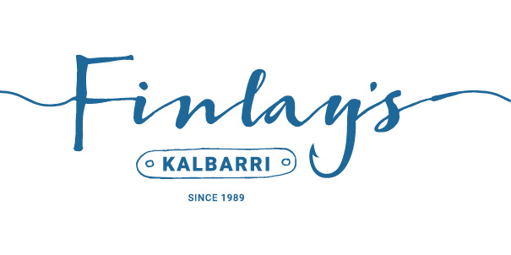

Bookings

The business offers the following methods for bookings and enquiries:
- Phone
- Email
- Webportal

Emergency Management
- The business has an emergency management and evacuation plan for guests with a disability

Guide Dog and Service Animals
- The business provides a secure area with shade and water for service animals
- Bowls, bedding, etc. are provided for service animals
The business provides the following services for services animals:
water is provided

GENERAL

Pre-arrival, arrival and reception
The business has the following in place to support guests during pre-arrival, arrival and reception
- There is a reception/public entryway.
- Seating available at reception

they don't have to fill anything in
- In addition, the following further information can assist guests:
People can order via their phone at tables so they don't have to get up and line up.

Cognitive Impairment Support
- Documents are available in plain English for people with cognitive impairment (This may include instructions, guides, menus and general information)

Car Park and Access amenities
The business has the following Car Park and Access amenities
- A drop off zone
- Level or ramped access from the car park to the entrance

External Paths
External paths of travel
- Surfaces are concrete, asphalt, smooth paving or hard packed fine gravel (max aggregate size 13mm)
- Pathways are wider than 900mm
- There 3 successive steps or less on any path or at any doorway

we don't have paths
- In addition, the following further information can assist guests:
There are no signs but they are clear to see

Steps
Steps
- There are steps.
- The underside of all staircases are enclosed or protected to a height of at least 2 metres
- In addition, the following further information can assist guests:
Guest can enter via the gate to avoid the steps

Public Toilets/Adult change facilities
Public Toilets/Adult change facilities have the following amenities are in place
- There is an accessible toilet for public use
- The door is at least 850mm wide
- There is a minimum of 850mm beside the toilet
- Handrails are fitted
- The toilet seat is460mm above the floor

FOOD AND DRINK

Dining Spaces
The dining spaces have the following facilities/amenities in place
- The entrance has level access
- The doorway is at least 850mm wide
- There is level access through the dining area
- Chairs are moveable to allow for wheelchairs to be seated at the tables
- All glass doors and full height windows have contrast markings
- There are areas of full lighting
- There are large print menus
- There are Plain English menus
- There is an accessible toilet

Our business caters for the following dietary requirements
- Sugar free (diabetic)
- Gluten free (celiac)
- Lactose free (dairy free)
- Nut free
- Vegetarian
- Vegan
- Halal
- In addition, the following further information can assist guests:
we use a separate fryer for our chips. Only chips are allowed to be cooked in it to ensure it is safe for celiacs to eat
Coloured chopping boards are used for different products
cleanliness and hygiene are essential

- There is a sample menu available online
Sample menu is available here -
https://finlayskalbarri.com.au/menu/
  - Food and Beverage Image(s)
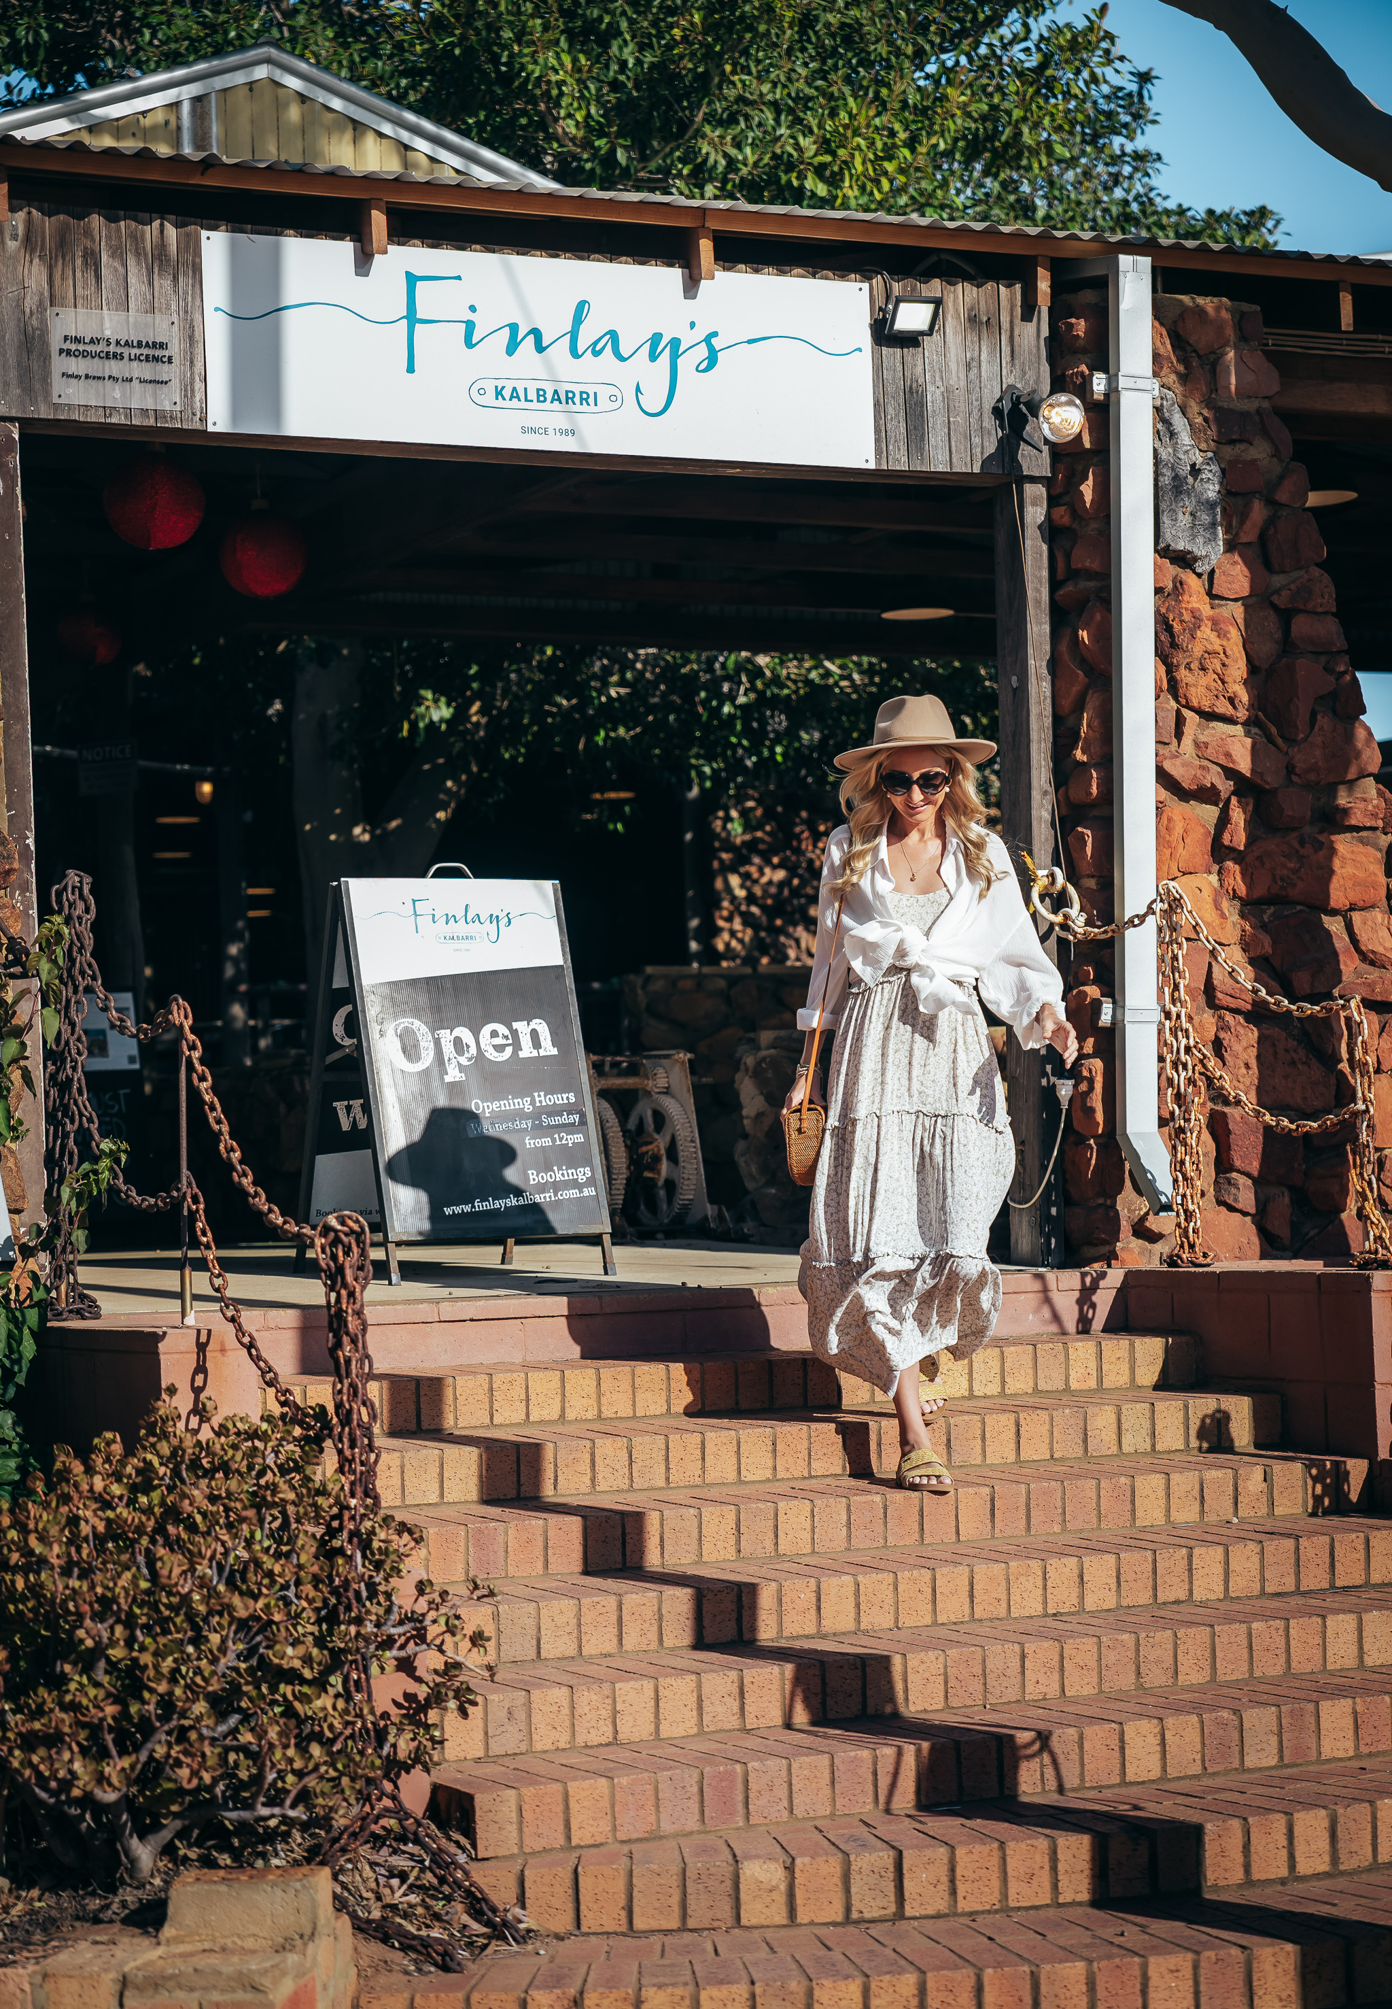
Cjmaddock_Finlays - Low Res_02
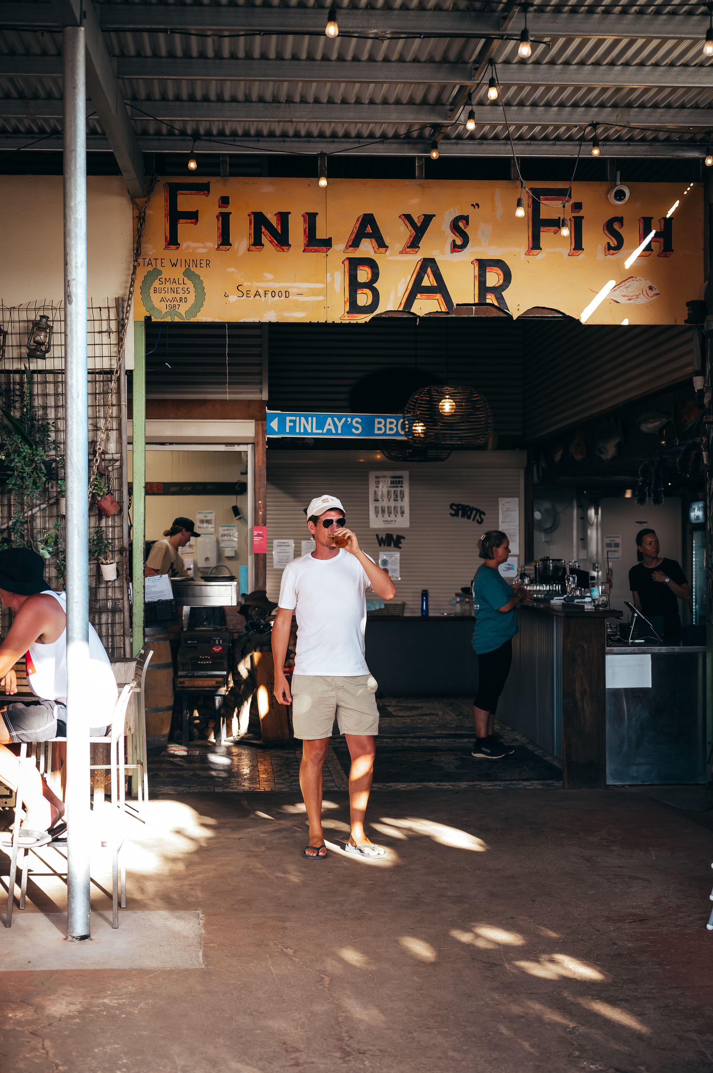
Cjmaddock_Finlays - Low Res_03
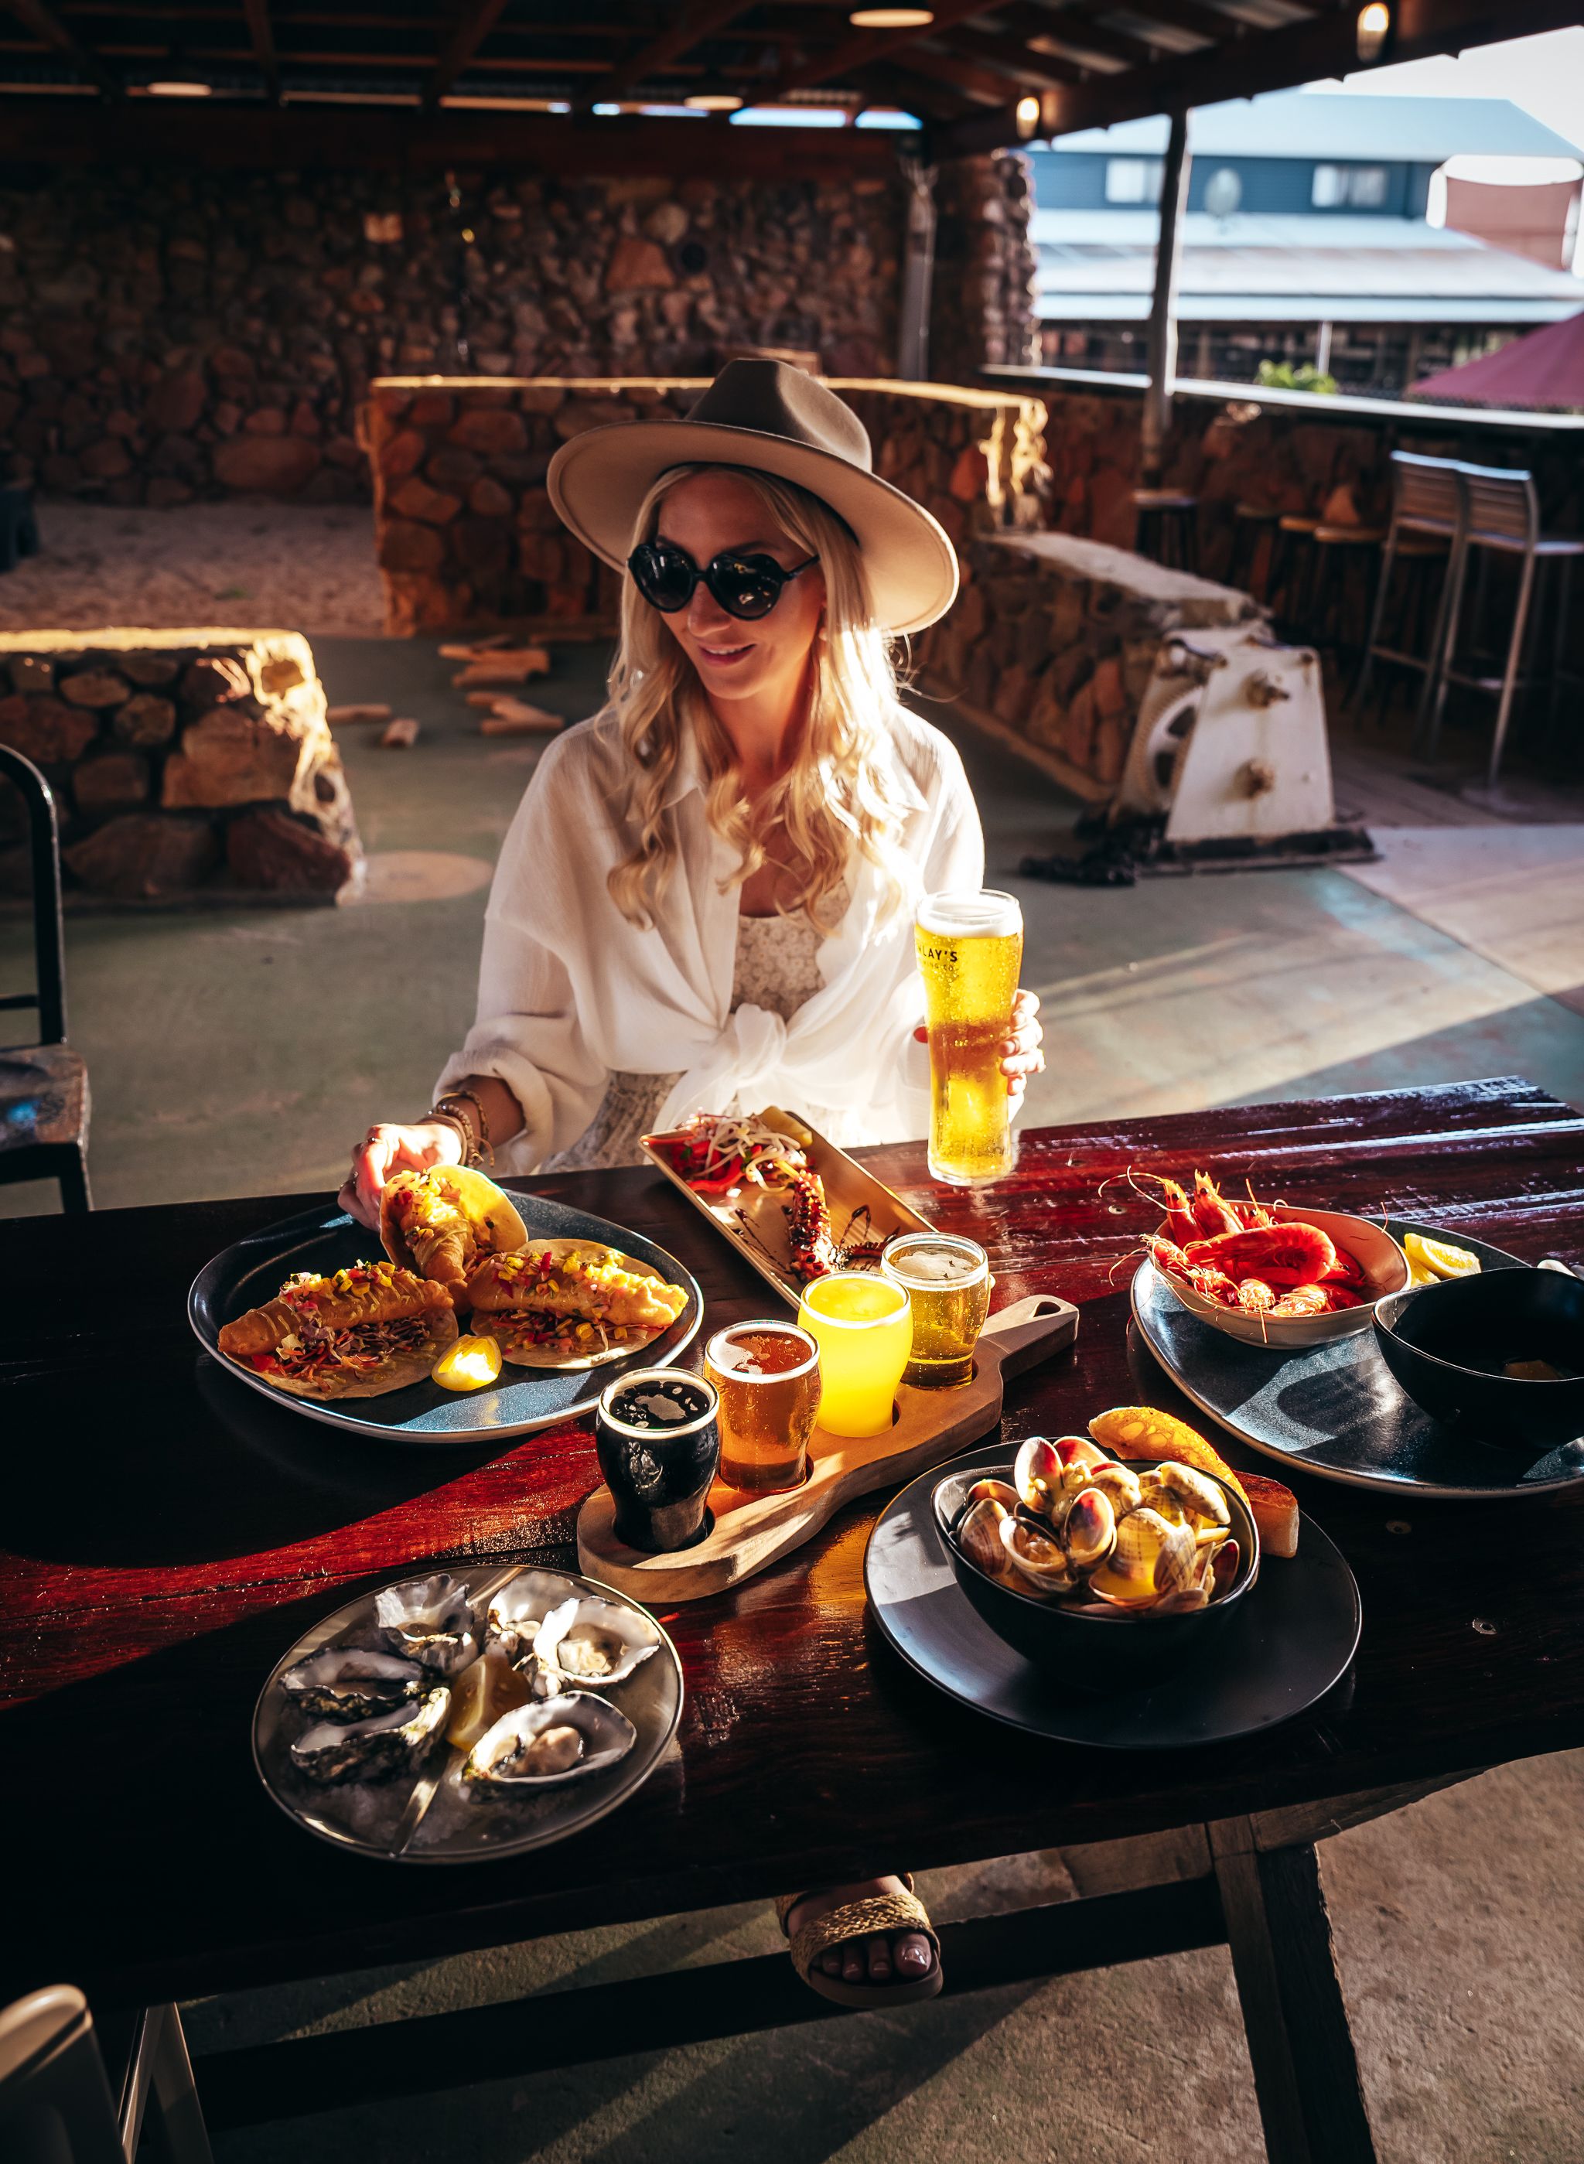
Cjmaddock_Finlays - Low Res_11
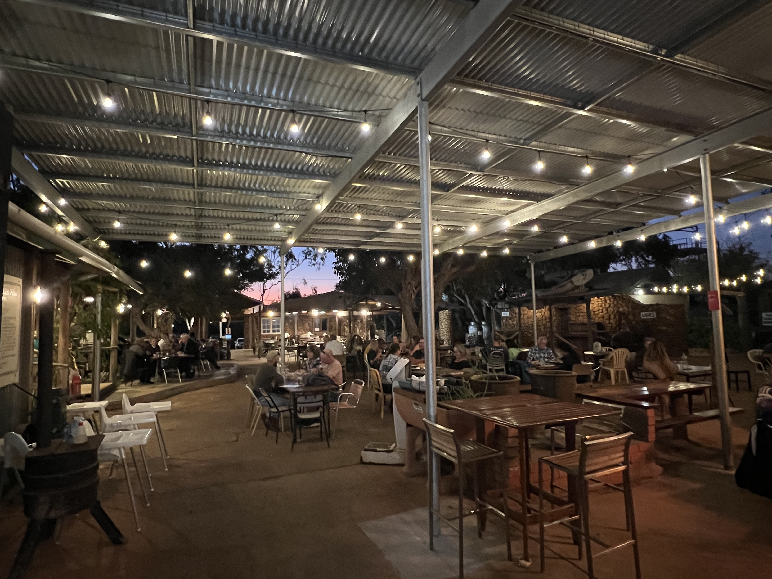
IMG_1819 copy
- In addition, the following further information can assist guests:
Finlay’s Kalbarri specialises in providing fresh locally caught seafood for over 30 years. With eucalyptus trees providing shade from the hot summer sun, campfires providing warmth in winter, dirt floors and the eclectic furniture, Finlay’s provides the perfect outdoor setting for a uniquely Australian dining experience.

Report Disclaimer
Please note that this business report, provided as a result of the use of the diagnostic assessment, is for information purposes only.
Australian Tourism Industry Council (ATIC) cannot guarantee the accuracy of respondent’s answers, or that they are fully representative of your business. Therefore, ATIC does not warrant or guarantee any particular outcome in respect of your businesses self-assessment.
This report is intended as guidance only for your business and should not be relied on for future marketing considerations. ATIC recommends that you seek your own independent advice as well as the results from the diagnostic.
Links to external web sites are inserted for convenience and do not constitute endorsement of material at those sites, or any associated organisation, product or service.
ATIC does not:
- Assume any legal liability for the accuracy, completeness, or usefulness of any information from this report or any links provided; or
- Accept responsibility for any loss associated directly or indirectly from the use of this report.

