ATIC Accessibility
To support the accessible community in making informed travel decisions for their individual needs

This report prepared for:
Business name: | Australian Stockman's Hall of Fame &Outback Heritage Centre
Address: | Landsborough Hwy
Town: | Longreach
Contact for enquiries: | Annette Mc Bride
Contact Number: | 07 4658 2166
Contact Email: | museum@stockmanshalloffame.com.au
Website: | www.stockmanshalloffame.com.au
Date: | 2026-09-23 22:23

ATIC Accessibility
The following pages provides travellers with information on the businesses facilities and amenities which aims to support the traveller to make an informed decision on whether the business is suitable for their individual needs.
OVERVIEW 4
Business Overview 4
Bookings 4
Emergency Management 4
Communications 5
Other Information 5
Guide Dog and Service Animals 5
GENERAL 7
Pre-arrival, arrival and reception 7
Cognitive Impairment Support 8
Car Park and Access amenities 8
Entry 9
Lifts 10
Internal Spaces 10
Public areas 11
Displays, exhibits, commentary and live performances 11
External Paths 12
Ramps 13
Public Toilets/Adult change facilities 14
ATTRACTIONS 15
COMMON AREAS 18
FOOD AND DRINK 19
Dining Spaces 19
Report Disclaimer 22

OVERVIEW

Business Overview

The business has the following products/services available
- Attraction
- Food and Drink

Our business caters for the following disability types:
- Blind or low vision
- Deaf or low hearing
- Limited mobility
- Wheelchairs or mobility scooters
- Food allergies or intolerances
- Cognitive or people on the Autism Spectrum

Bookings

The business offers the following methods for bookings and enquiries:
- Phone
- Email
- Webportal
- Our website supports Screen Readers
- Our forms have high contract boxes and submit boxes
- Staff have undergone disability awareness and training

Emergency Management
- The business has an emergency management and evacuation plan for guests with a disability
- Emergency and evacuation procedures are explained on arrival

Communications
- An accessibility guide is available on the website

www.stockmanshalloffame.com.au
- Our website meets WCAG 2.0 accessibility standards
- Our business offers the following alternative communication methods
- Plain English
- Braille Displays
- Magnifiers

Not specified
- There is easy to read signage and information (e.g. menus and emergency information)

Other Information
- For bookings made onsite, the ticket booth/counter/box office is accessible for people using a wheelchair
- The business accepts the companion card

Guide Dog and Service Animals
- The business provides a secure area with shade and water for service animals
- The business provides a toilet area for service animals
- Bowls, bedding, etc. are provided for service animals
The business provides the following services for services animals:
The Australian Stockman's Hall of Fame & Outback Heritage Centre welcomes accredited assistance animals and recognises the important role they play in enabling visitors to access and enjoy our experiences with confidence and independence. To ensure the comfort and wellbeing of both visitors and their assistance animals, the Hall of Fame provides: Fresh drinking water – Water bowls are available throughout the visitor precinct and can be refilled by staff at any time. Shaded rest areas – Landscaped gardens, covered walkways and seating areas provide comfortable places for assistance animals to rest during a visit. Indoor access – Assistance animals are welcome throughout the museum, galleries, cinema, café and retail areas, in accordance with Australian legislation. Outdoor experience access – Assistance animals are also welcome in the Live Outback Stockman's Show spectator areas. Staff will assist with seating where appropriate to provide adequate space and comfort. Staff assistance – Team members are trained to respectfully assist visitors travelling with assistance animals and can provide guidance around the site or identify suitable rest areas if required. Accessible pathways – Wide, sealed pathways throughout the precinct enable easy movement for visitors accompanied by assistance animals. Relief areas – Open grassed areas surrounding the precinct are available for assistance animals requiring a comfort break. Staff are happy to direct visitors to the most suitable locations. Cool environment – Air-conditioned galleries, the cinema and indoor facilities provide a comfortable environment during periods of extreme heat. Emergency support – In the event of an emergency, staff include assistance animals in evacuation procedures wherever possible and provide support to ensure both visitor and animal safety.

GENERAL

Pre-arrival, arrival and reception
The business has the following in place to support guests during pre-arrival, arrival and reception
- Booking information and websites are compatible with screen readers
- There is a reception/public entryway.
- Seating available at reception
- A lower counter at reception/ticket office
- A clipboard to allow check-in/ticket purchase whilst seated
- A tablet with text to voice or pen and paper at reception to aid in communication
- Picture Board at reception to aid in communication
- Hearing loop fitted to the reception area
- Lighting in the reception area is even and glare free
- Large print information sheets and registration forms
- Information and maps are available in written form
- A familiarisation tour
- In addition, the following further information can assist guests:
The Australian Stockman's Hall of Fame recognises that some visitors may experience fatigue due to disability, chronic illness, age or medical conditions. To ensure these visitors can enjoy the experience comfortably, a number of measures have been implemented to minimise waiting times and reduce physical exertion.
Visitors are encouraged to pre-book their experience, allowing arrival times to be managed and reducing queuing at reception. Timed entry to the museum and scheduled cinema sessions help spread visitor numbers throughout the day, avoiding unnecessary congestion.
Throughout the precinct, numerous shaded seating areas and rest points are available, allowing visitors to pause whenever required. Air-conditioned galleries, the cinema and café provide comfortable environments where guests can rest before continuing their visit.
For visitors requiring additional assistance, staff are available to personalise the experience. This may include providing a wheelchair, arranging direct access to the next activity, assisting with wayfinding, or adjusting the pace of the visit where operationally possible. Guests are encouraged to advise staff of any accessibility requirements on arrival so appropriate support can be provided.
The Live Outback Stockman's Show features tiered seating with accessible viewing areas, enabling visitors with limited stamina to be seated promptly before the performance commences. Staff are also happy to escort guests to seating if required.
The Hall's audio-guided museum allows visitors to explore at their own pace rather than following a fixed guided tour, enabling them to take breaks, revisit exhibits or shorten their visit according to their energy levels. Accessible amenities, drinking water stations and shaded outdoor spaces are located throughout the precinct to further support visitor comfort.
These initiatives ensure visitors experiencing fatigue are not disadvantaged by unnecessary waiting or prolonged standing, allowing them to participate fully while maintaining their comfort, independence and wellbeing.

- In addition, the following further information can assist guests:
The Australian Stockman's Hall of Fame &amp; Outback Heritage Centre is committed to providing an inclusive and welcoming experience for all visitors. If you have any accessibility requirements, we encourage you to contact us before your visit or speak with our friendly team on arrival so we can assist you.
To help make your visit as comfortable as possible, we offer:
Wheelchair-accessible parking, entrances, pathways and amenities.Complimentary wheelchairs available for visitor use (subject to availability).Hearing loop technology in designated areas.Personalised assistance and one-on-one support from staff when required.Assistance animals are welcome throughout the precinct, with water bowls, shaded rest areas and access to relief areas available.Accessible seating at the Live Outback Stockman's Show.Air-conditioned museum galleries, cinema, café and retail areas for visitor comfort.Numerous shaded seating areas and rest points throughout the grounds.Accessible toilets and baby change facilities.Drinking water stations located throughout the precinct.Flexible visit pacing, allowing guests to rest and explore at their own speed using the self-guided audio tour.Staff who are happy to provide directions, assistance with mobility, or information in a clear and respectful manner.

Cognitive Impairment Support
- Documents are available in plain English for people with cognitive impairment (This may include instructions, guides, menus and general information)
- Quiet periods or early opening times for people on the Autism Spectrum
- A space for parents and children on the Autism Spectrum

Car Park and Access amenities
The business has the following Car Park and Access amenities
- A drop off zone
- Designated disabled parking bays
- Level or ramped access from the car park to the entrance
- The accessible entrance is clearly signed from the parking bay
- Kerb ramps are in place where a pavement or walkway needs to be crossed
- In addition, the following further information can assist guests:
Longreach does not have a public bus, tram or suburban train network. As a result, there are no public transport stops servicing the Australian Stockman's Hall of Fame.
Visitors travelling to the Hall of Fame generally arrive by private vehicle, organised coach tour, taxi or airport transfer. If required, our staff are happy to assist guests by arranging a local taxi or providing information about transport options available within Longreach.
Guests requiring accessible transport are encouraged to contact us prior to their visit so we can discuss their needs and assist with coordinating suitable local transport where possible. Our team is committed to ensuring visitors can access the Hall of Fame safely and comfortably.

Entry
The business has the following amenities/systems in place for entry
- A drop off point close to the entrance
- A path of access to the building is slip resistance and even
- A path of access to the building is clear of obstruction
- Self opening entry doors or fitted with a self closer
- Glass doors are fitted with a visual sighting strip
- Door jams/doors are of a contrasting colour to surrounding walls
- Door handles are of a contrasting colour to the door
- Signage is written in a contrasting colour
- The entry door is a minimum of 850mm wide
- The entry door has self opening or a light opening pressure (for manual operations)
- The entrance sill is less than 13mm
- There a clear space of at least 1500mm x 1500mm in front of all doors.
- In addition, the following further information can assist guests:
The Australian Stockman's Hall of Fame uses signage designed with contrasting colours to maximise visibility and readability for all visitors, including people with low vision.
Directional, safety and facility signage throughout the precinct incorporates high-contrast text and backgrounds wherever possible to improve legibility under a range of lighting conditions. Signage is positioned to be easily visible and supports intuitive wayfinding between key visitor areas, including reception, galleries, the cinema, café, retail store, accessible amenities and the Live Outback Stockman's Show.
As part of the Hall's ongoing commitment to accessibility, signage is regularly reviewed and updated during maintenance and redevelopment projects to align with current accessibility and wayfinding best practices.

Lifts
- Premises has lifts
- In addition, the following further information can assist guests:
The lift is reserved for visitors who require step-free access, including people with disability, limited mobility, temporary injuries, or other accessibility needs.
This arrangement ensures that guests who rely on the lift for equitable access can move safely and comfortably throughout the facility. Staff are available to assist visitors requiring the lift and are happy to provide support throughout their visit if needed.

Internal Spaces
- Clear and unobstructed routes through and between buildings
- Interior walls are matte or low sheen
- Floors, walls, counters and furniture are of contrasting colours
- Tableware/glassware contrast with the table surface or table cloth
- Floor surfaces are hard or short pile carpet
- Seating is available for guests unable to stand for long periods
- Accessible facilities are clearly signed and visible from all areas
- All corridors greater than 900mm
- There is a quiet space for parents and children on the Autism Spectrum
- In addition, the following further information can assist guests:
The Australian Stockman's Hall of Fame has been designed to provide clear, wide and unobstructed routes throughout the visitor precinct, enabling guests of all abilities to move safely and independently between buildings and attractions.
Accessible pathways connect the reception, museum galleries, cinema, café, retail store, accessible amenities and the Live Outback Stockman's Show. Internal circulation spaces are wide enough to accommodate wheelchairs, mobility scooters, walking frames and prams, with level or ramped access provided wherever possible.
Walkways, entrances and exits are regularly inspected by staff to ensure they remain free from obstacles, trip hazards and temporary obstructions. Housekeeping and maintenance procedures include routine monitoring of public areas to maintain safe, accessible routes throughout the day.
Clear directional signage assists visitors in navigating the precinct, and staff are always available to provide guidance or personal assistance where required.
These measures ensure all guests can move comfortably and confidently throughout the Australian Stockman's Hall of Fame while enjoying a safe and inclusive visitor experience.

Public areas
The public areas have the following amenities in place
- Hearing loops
- Hearing loop symbols are displayed
- Even lighting
- Seating
- In addition, the following further information can assist guests:
The Australian Stockman's Hall of Fame provides hearing loop technology in designated public areas to support visitors who use compatible hearing aids and cochlear implants.
International hearing loop symbols are displayed in areas where the system is available, helping visitors easily identify accessible listening facilities. Staff are also able to advise guests on the locations and operation of the hearing loop upon arrival.

Displays, exhibits, commentary and live performances
For displays, exhibits, commentary and live performances the following amenities are in place
- Seating
- Wheelchair accessible spaces/seating
- A written transcript where audio description is provided i.e. display commentary, tour commentary
- In addition, the following further information can assist guests:
Hearing loop technology is not currently available for the Live Outback Stockman's Show.
The Australian Stockman's Hall of Fame recognises the importance of accessible communication and is actively investigating the installation of hearing loop technology for future live presentations as part of our ongoing commitment to improving accessibility and enhancing the visitor experience.
In the meantime, staff are happy to discuss individual accessibility requirements with guests prior to or on arrival and will provide reasonable assistance wherever possible to help ensure they can enjoy the experience.

External Paths
External paths of travel
- Surfaces are concrete, asphalt, smooth paving or hard packed fine gravel (max aggregate size 13mm)
- Paths or slopes longer than 15 metres have resting places or seats
- Pathways are wider than 900mm

No. The Australian Stockman's Hall of Fame's public visitor areas have been designed to provide step-free access. There are no successive steps on public pathways or at public doorways. Access throughout the precinct is provided via level pathways and compliant ramps, ensuring visitors using wheelchairs, mobility scooters, walking frames and prams can move safely and independently.

Not applicable. The Australian Stockman's Hall of Fame does not have steps within the public visitor areas. All primary visitor routes are step-free and accessible via level pathways or compliant ramps, allowing wheelchair users and other visitors with mobility requirements to access the museum, cinema, café, retail store, accessible amenities and the Live Outback Stockman's Show without encountering steps. As there are no stepped public pathways, there is no requirement to identify non-wheelchair-accessible routes.
- In addition, the following further information can assist guests:
Yes. The Australian Stockman's Hall of Fame has clearly identified step-free routes throughout the visitor precinct to ensure guests using wheelchairs, mobility scooters, walking aids, prams and other mobility devices can move safely and independently.
Accessible pathways connect the car park, reception, museum galleries, cinema, café, retail areas, accessible amenities and the Live Outback Stockman's Show. Directional signage assists visitors in locating accessible entrances and facilities, while staff are available to provide guidance or escort guests if required.
The pathways are wide, level and designed to minimise barriers, allowing visitors to navigate the precinct comfortably. Accessible routes are regularly inspected and maintained to ensure they remain safe, unobstructed and suitable for all visitors.
Guests who require additional assistance are encouraged to speak with staff on arrival, and personalised support is provided to ensure every visitor can access and enjoy the full Hall of Fame experience.

- In addition, the following further information can assist guests:
Visitors can move throughout the public precinct using accessible pathways without the need to negotiate steps. Wheelchairs are available for complimentary use (subject to availability), and staff are always happy to provide directions or personalised assistance to ensure every guest enjoys a safe, comfortable and inclusive visit.

Ramps
Ramps have the following amenities are in place
- There are ramps.
- All fixed ramps are 1:14 or less
- Hand rails are fitted
- Long ramps (more than 10m) are 1:20 or less
- Ramps have a raised edge of at least 100mm
- In addition, the following further information can assist guests:
Accessible ramps are integrated throughout the precinct and comply with accessibility standards. Combined with wide pathways and level access, they ensure visitors of all abilities can enjoy a seamless and inclusive experience. Staff are available to provide assistance whenever required.

Public Toilets/Adult change facilities
Public Toilets/Adult change facilities have the following amenities are in place
- There is an accessible toilet for public use
- The door is at least 850mm wide
- There is a minimum of 850mm beside the toilet
- Handrails are fitted
- The toilet seat is 460mm above the floor
- The toilet seat of a contrasting colour to the floor
- The toilet seat is460mm above the floor
- There is a registered changing places facility
- In addition, the following further information can assist guests:
Accessible (disabled) toilets are conveniently located within the Australian Stockman's Hall of Fame and are available throughout operating hours. The amenities are designed to provide safe, comfortable and independent access for visitors with disability, limited mobility and those requiring additional space.
The accessible toilets are located on the step-free accessible route, are clearly signed, and can be easily reached from the museum, cinema, café, retail areas and the Live Outback Stockman's Show. If assistance is required, our friendly staff are always available to help.

ATTRACTIONS
  - Image(s)
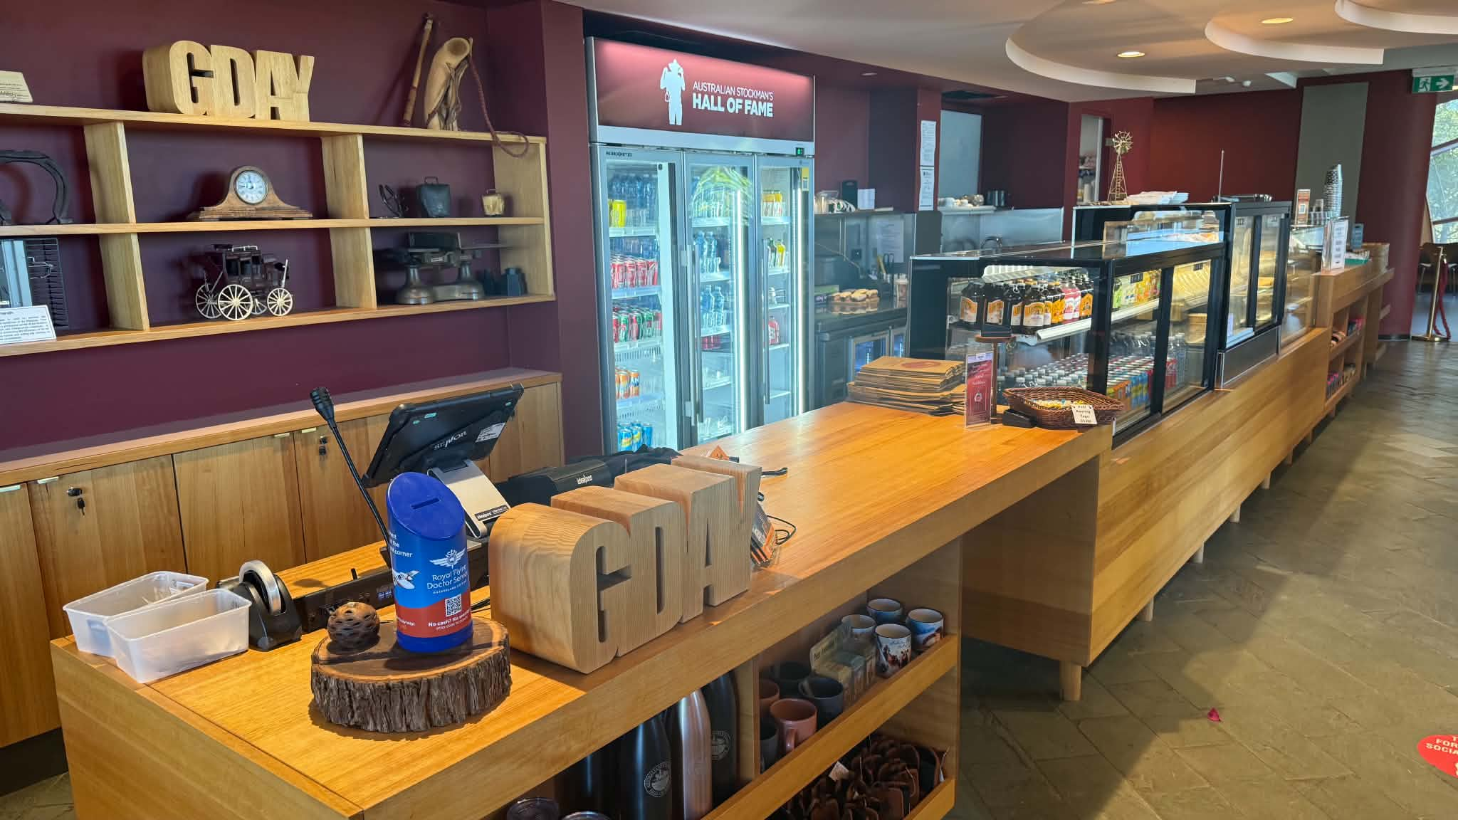
Cafe 1
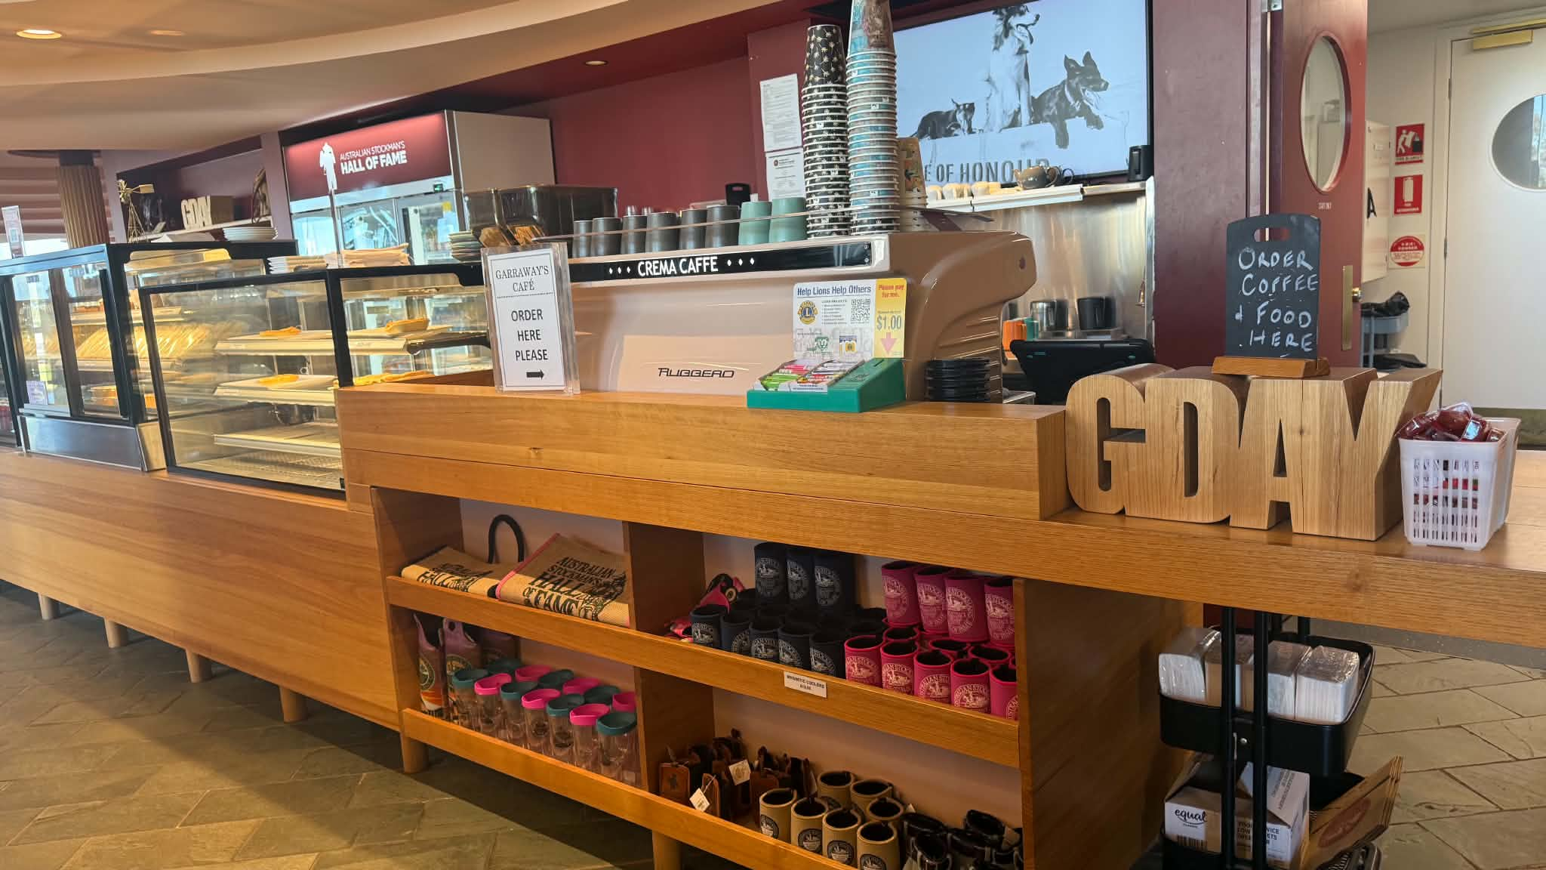
Cafe 2
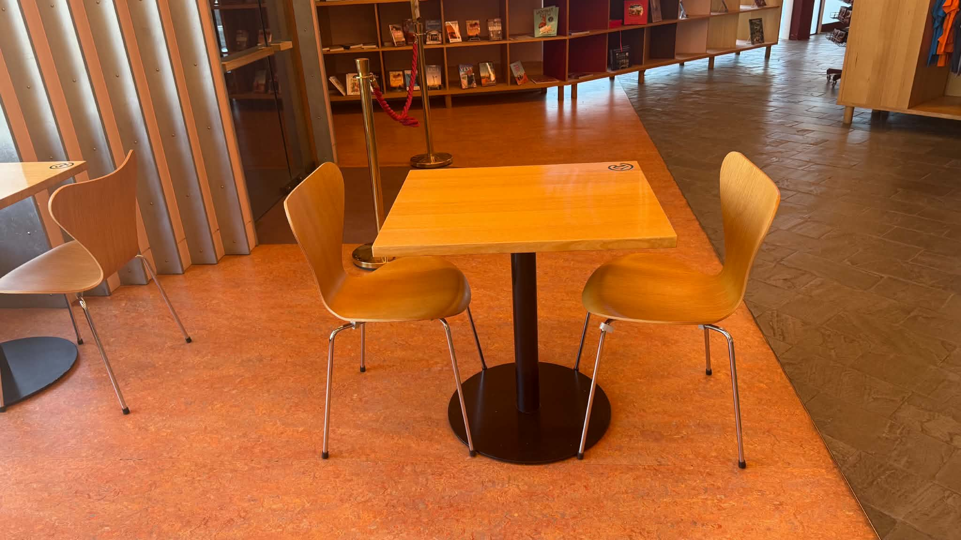
Cafe 3
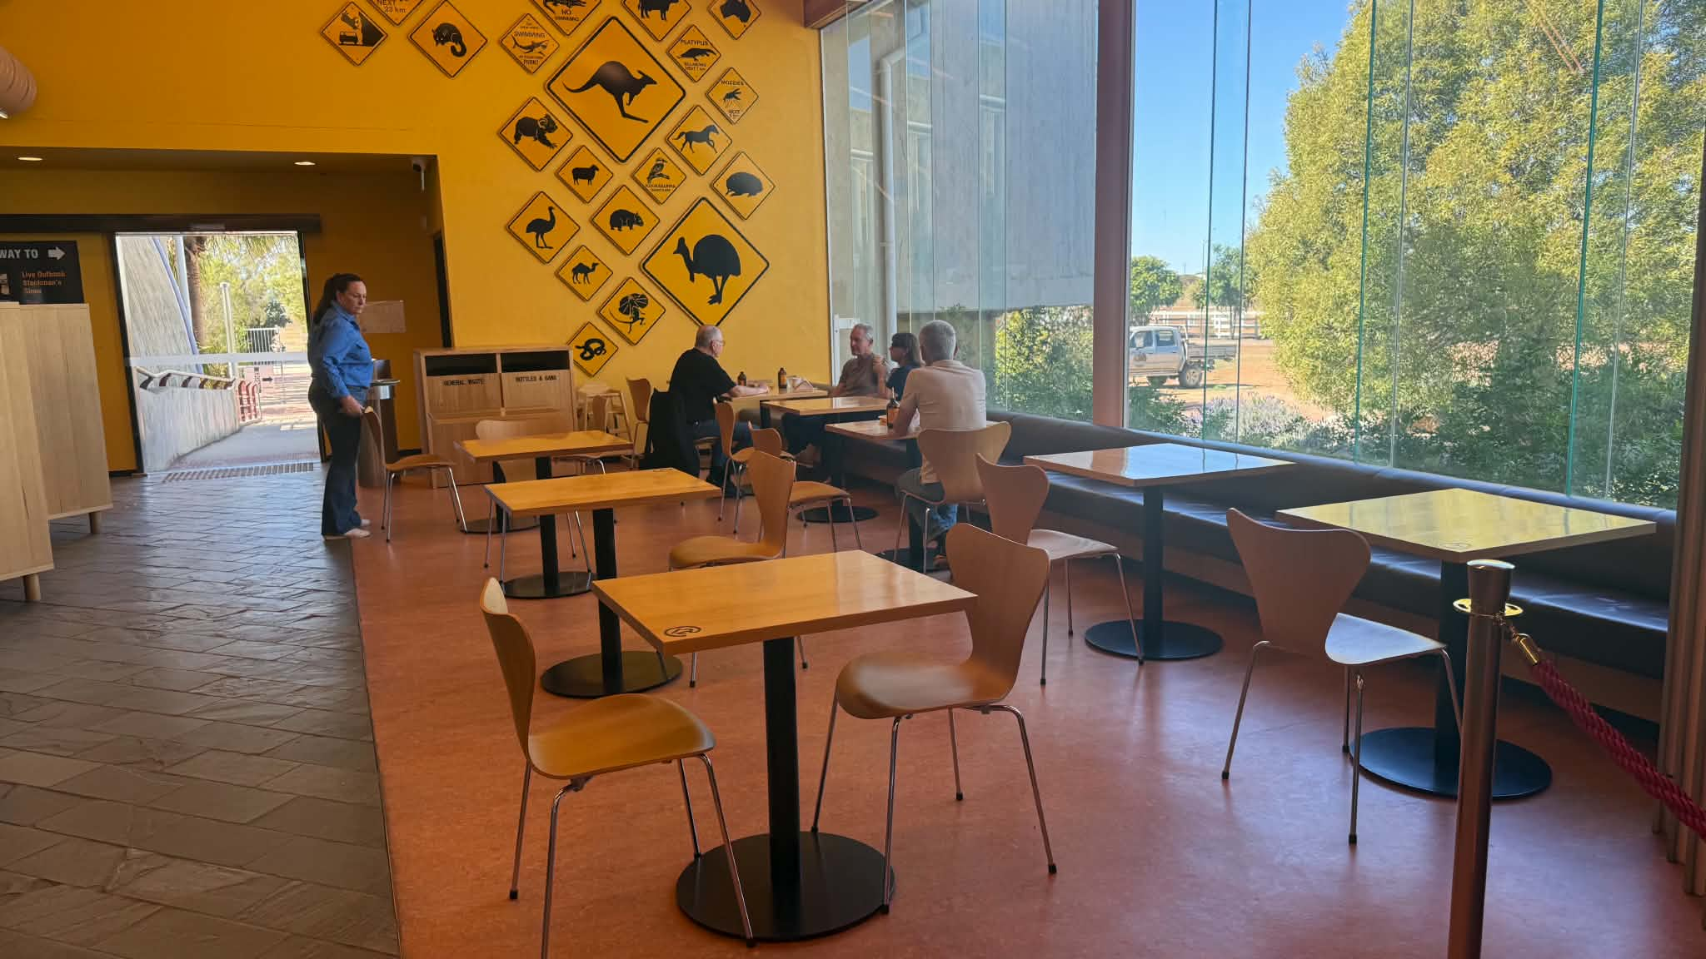
cafe 4
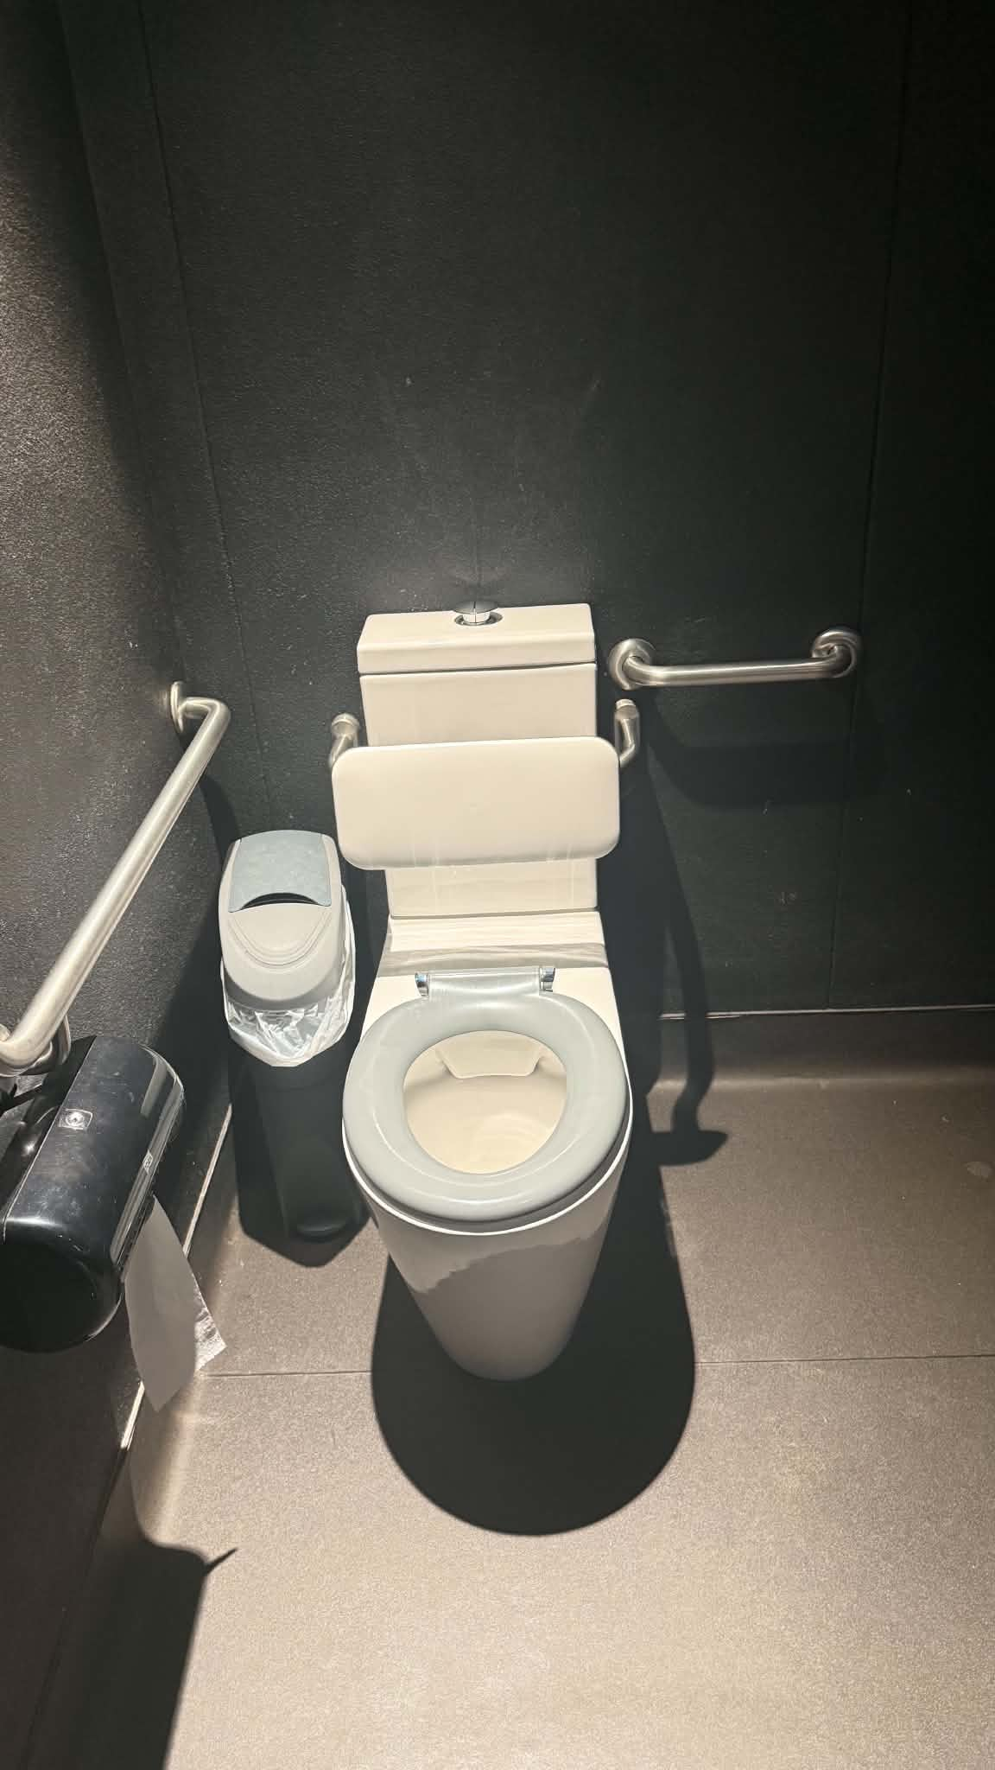
Disabled toilet
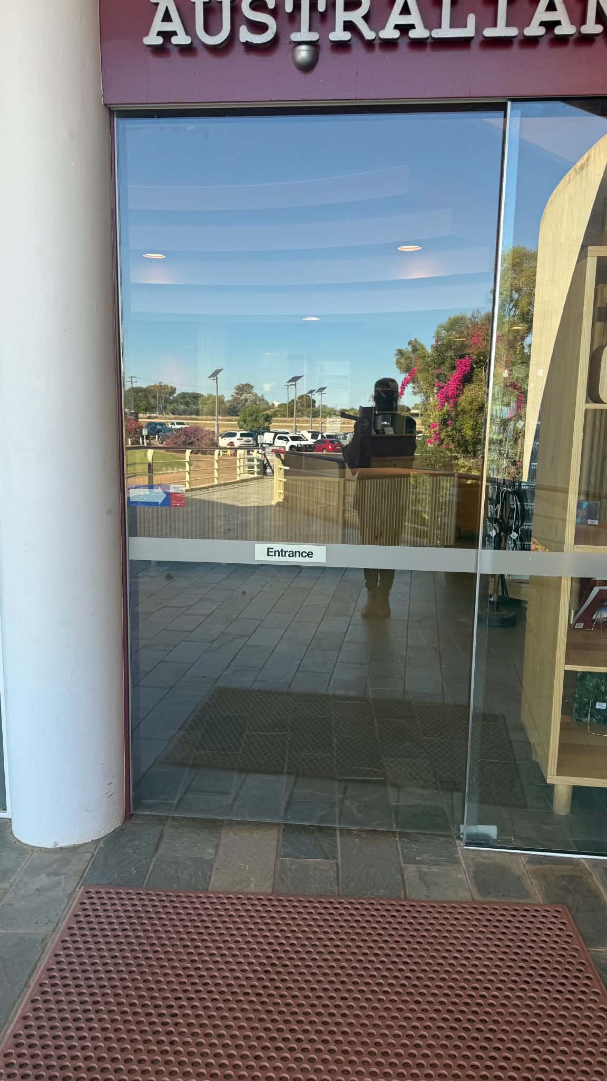
Entry
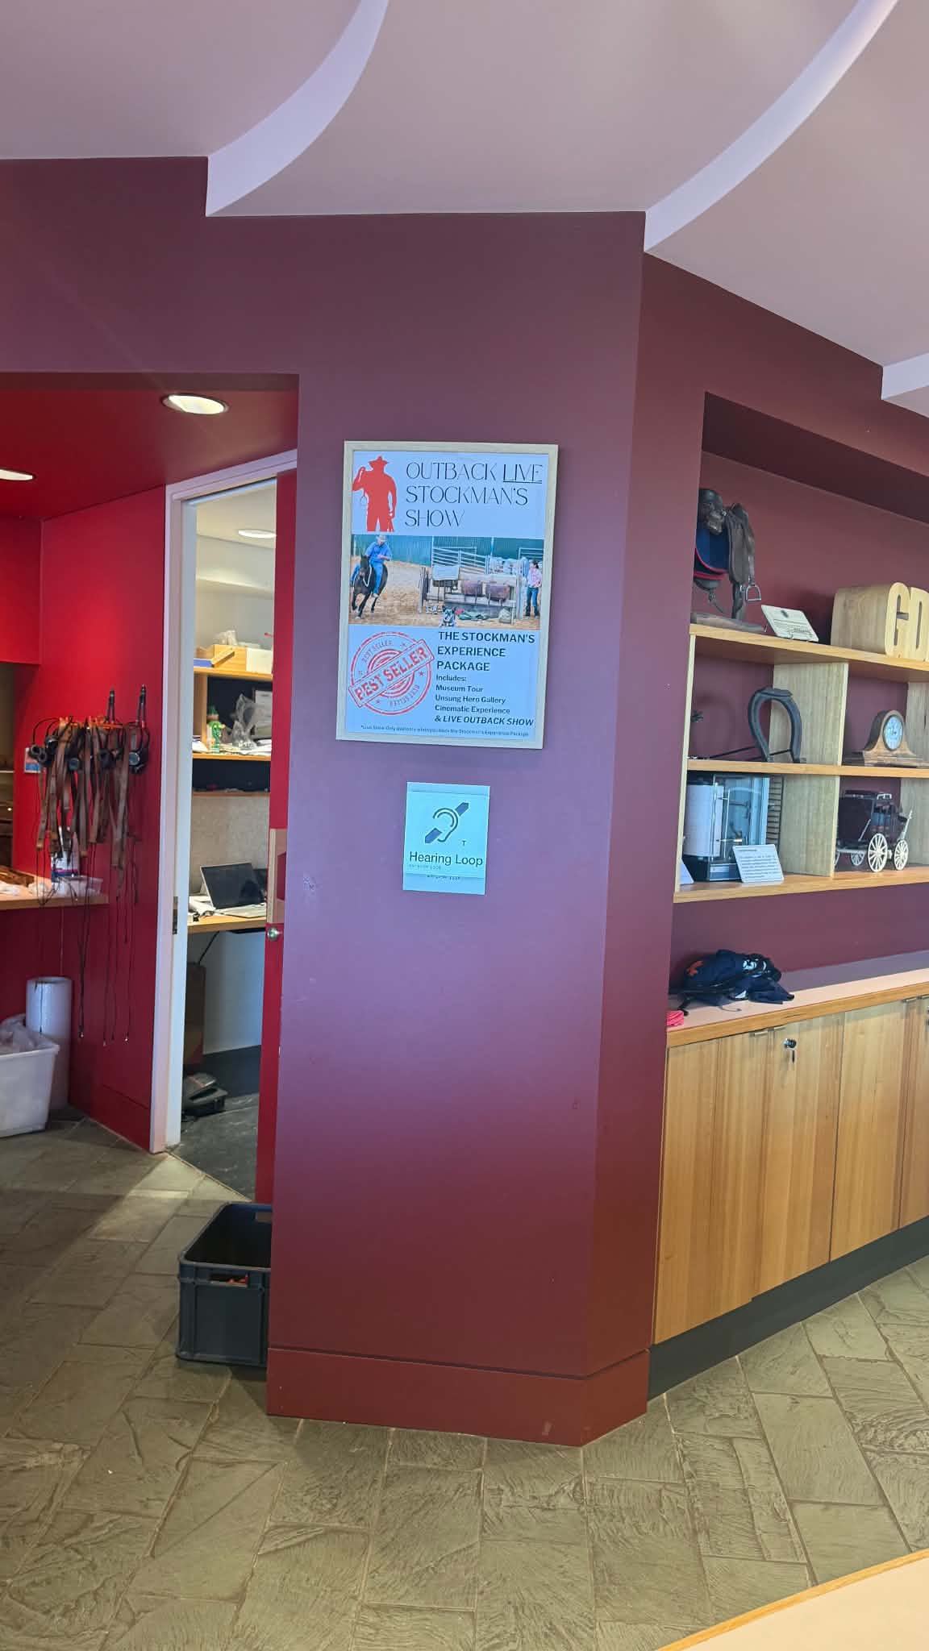
hearing loop
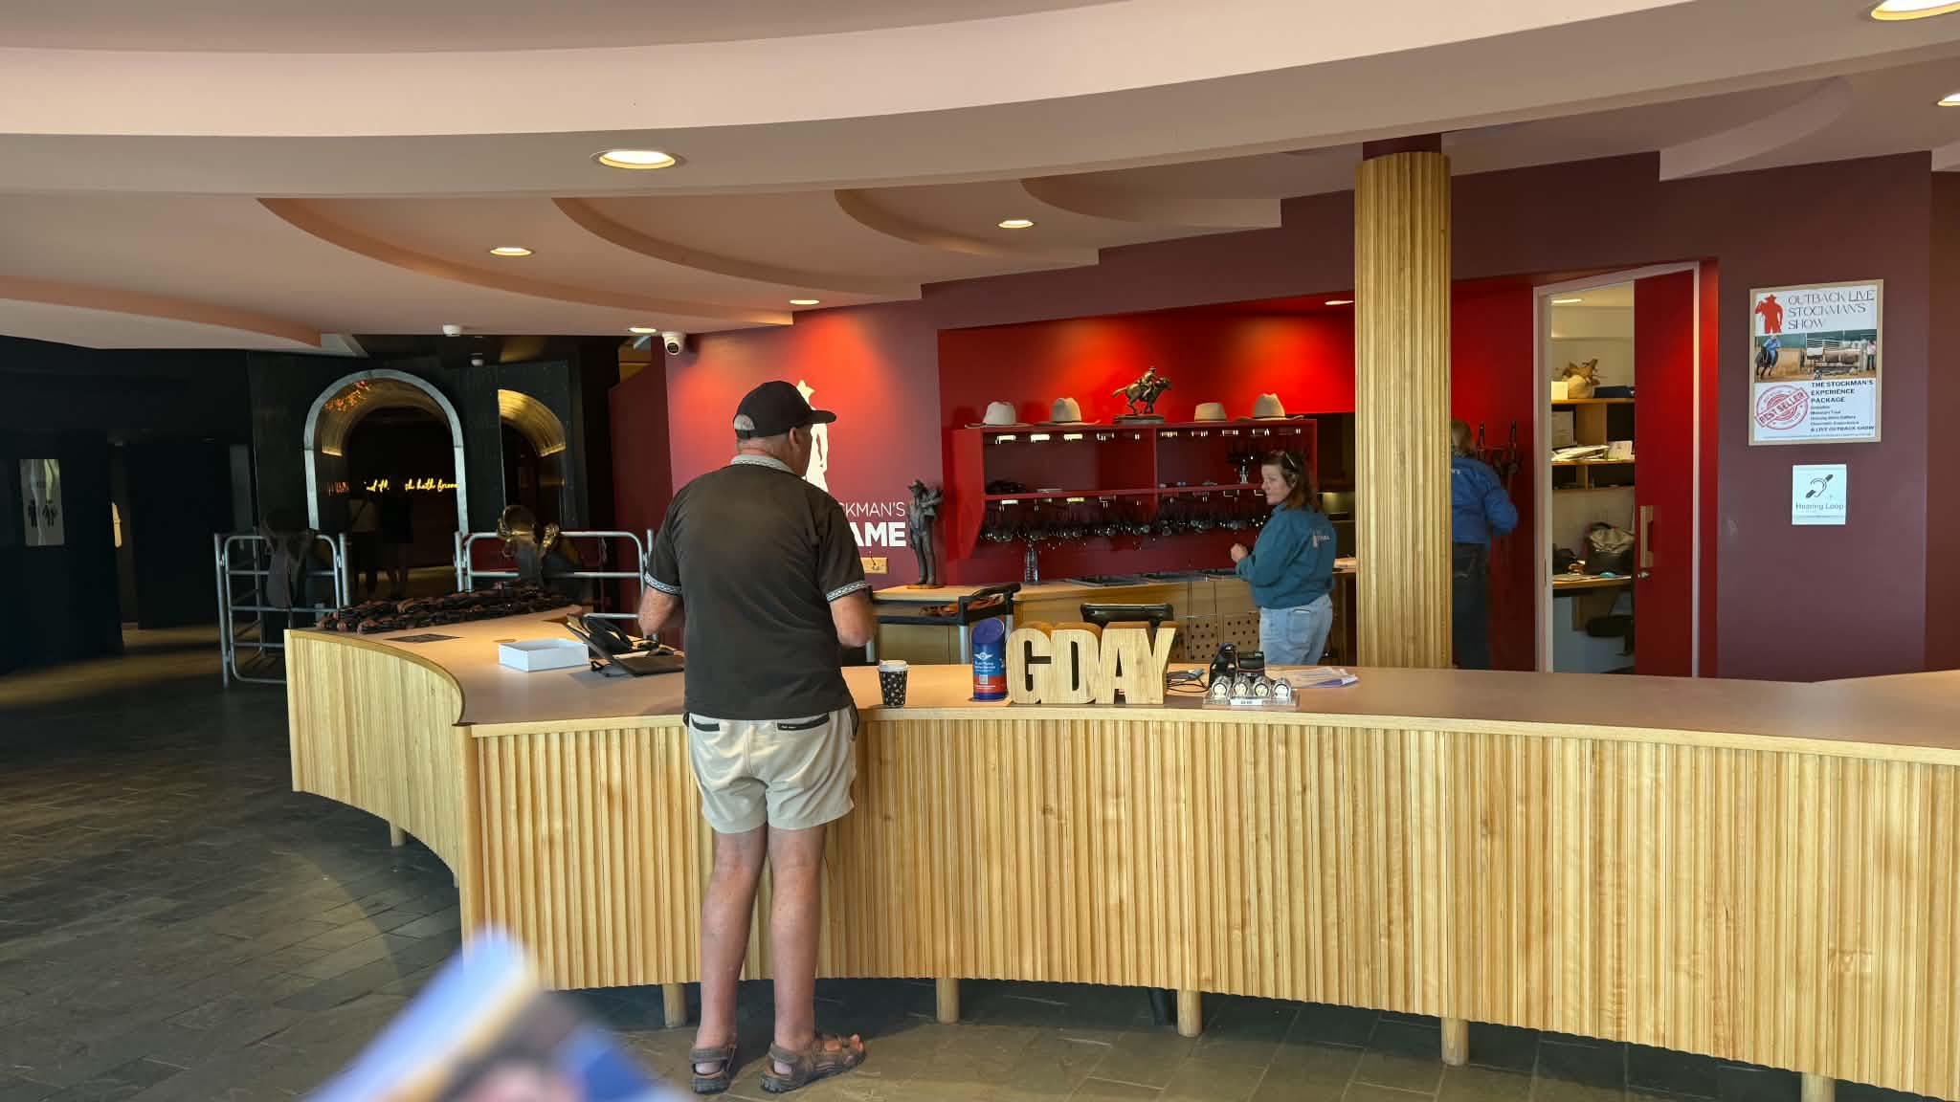
Reception
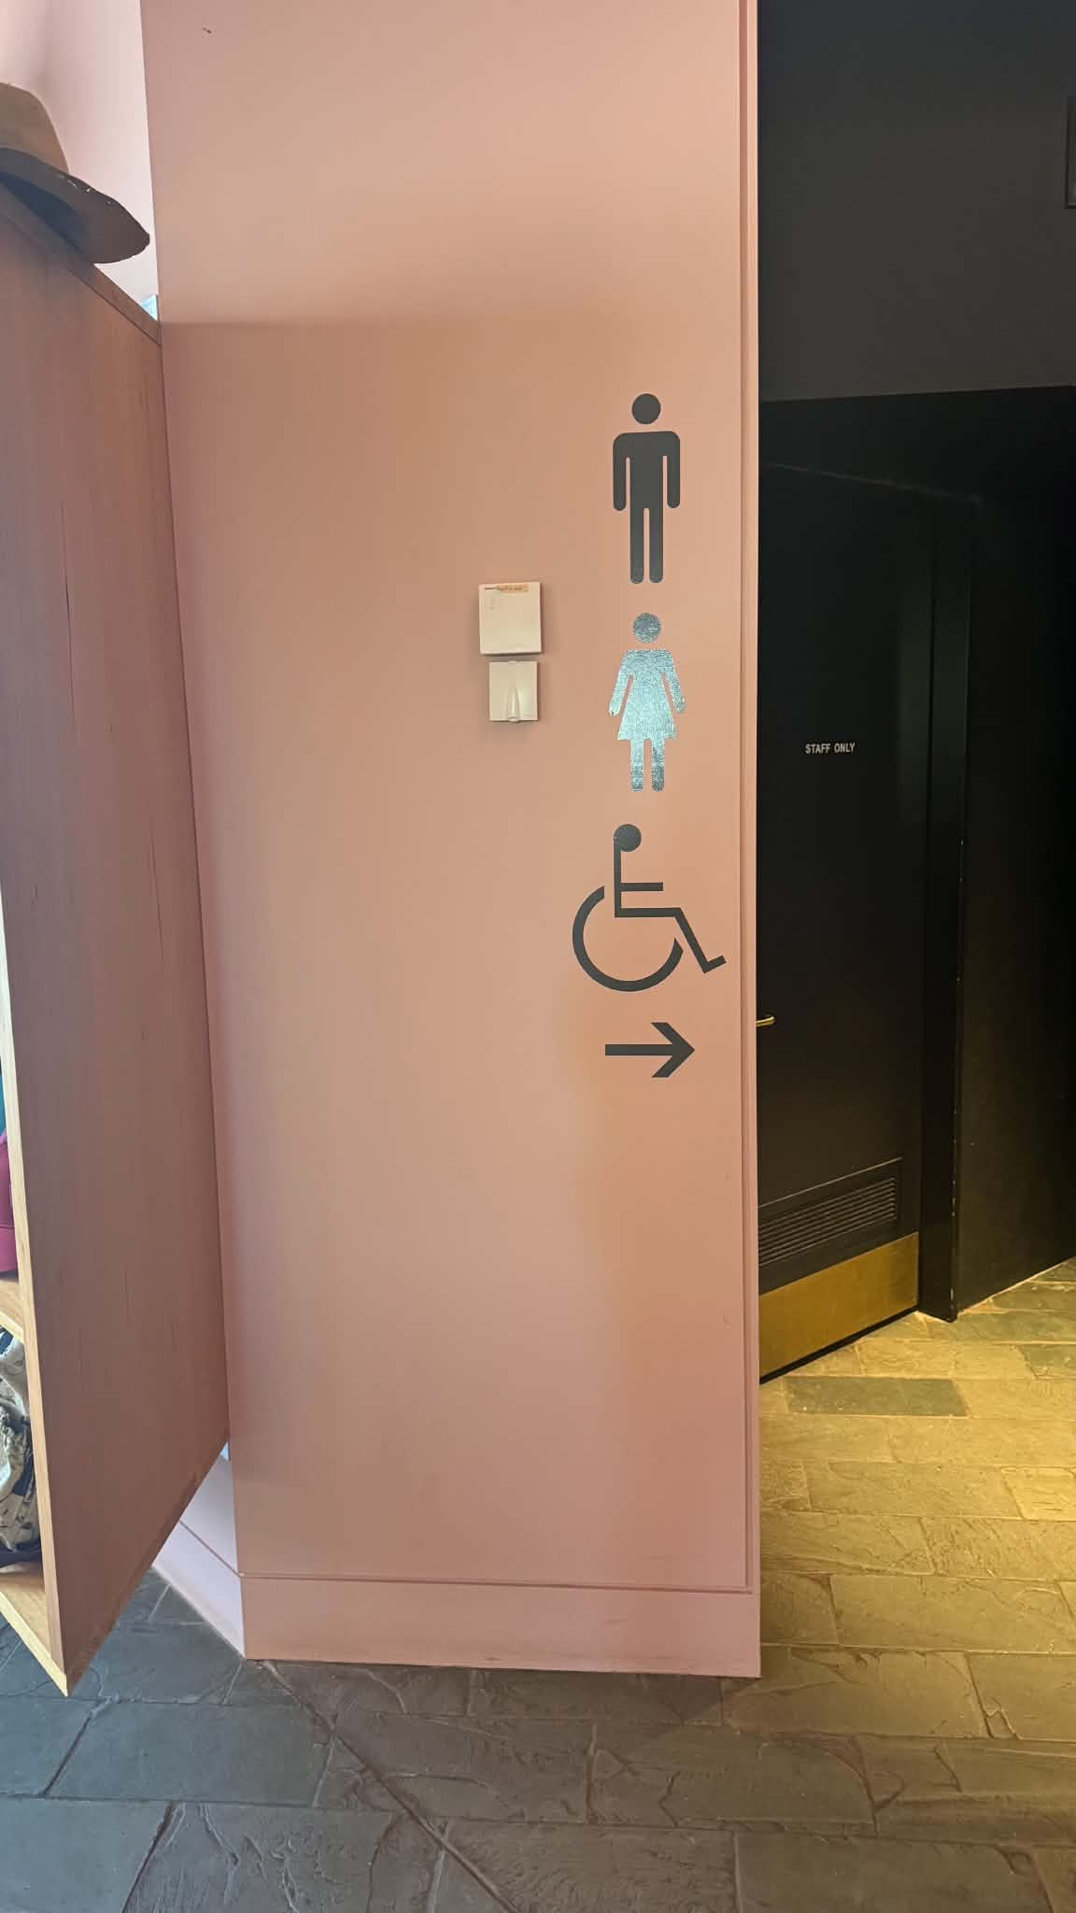
Signage

COMMON AREAS

FOOD AND DRINK

Dining Spaces
The dining spaces have the following facilities/amenities in place
- The entrance has level access
- The doorway is at least 850mm wide
- There is level access through the dining area
- Chairs are moveable to allow for wheelchairs to be seated at the tables
- Hearing loops are available
- All glass doors and full height windows have contrast markings
- There are areas of full lighting
- There is an accessible toilet

Our business caters for the following dietary requirements
- Sugar free (diabetic)
- Gluten free (celiac)
- Lactose free (dairy free)
- Nut free
- Vegetarian
- Vegan
- In addition, the following further information can assist guests:
The Australian Stockman's Hall of Fame is committed to providing a safe dining experience for all visitors, including those with food allergies, intolerances and dietary requirements. Our café follows established food safety procedures to minimise the risk of cross-contamination.
Our procedures include:
Staff receive food safety and allergen awareness training and understand the importance of preventing cross-contamination.Guests are encouraged to advise staff of any food allergies or dietary requirements when ordering.Allergen requests are clearly communicated between front-of-house and kitchen staff before food preparation begins.Separate utensils, chopping boards and preparation equipment are used where practical for allergen-sensitive meals.Preparation surfaces, equipment and utensils are thoroughly cleaned and sanitised before preparing meals for guests with dietary requirements.Disposable gloves are changed, and staff wash and sanitise their hands before handling allergen-sensitive foods.Ingredients are stored appropriately to reduce the risk of cross-contact between allergen and non-allergen products.Packaged products are checked for ingredient and allergen information before being served.Where possible, meals are prepared separately from other food items and identified before service.Staff communicate openly with guests regarding menu ingredients, potential allergens and any limitations of the kitchen.While every reasonable precaution is taken to minimise the risk of cross-contamination, the Hall of Fame advises guests that food is prepared in a commercial kitchen where common allergens, including gluten, dairy, eggs, peanuts, tree nuts, soy, sesame, seafood and wheat, are present. As such, we cannot guarantee that any menu item is completely free from trace allergens.
Our team is committed to working with each guest to provide suitable menu options wherever possible while maintaining the highest standards of food safety and customer care.
- In addition, the following further information can assist guests:
Our on-site café is wheelchair accessible and offers level access, accessible seating options and nearby accessible toilet facilities. Staff are happy to assist guests with seating, carrying food and beverages, or accommodating individual accessibility requirements wherever possible. Dietary requirements and food allergies can be discussed with café staff to help ensure a safe and enjoyable dining experience.

Report Disclaimer
Please note that this business report, provided as a result of the use of the diagnostic assessment, is for information purposes only.
Australian Tourism Industry Council (ATIC) cannot guarantee the accuracy of respondent’s answers, or that they are fully representative of your business. Therefore, ATIC does not warrant or guarantee any particular outcome in respect of your businesses self-assessment.
This report is intended as guidance only for your business and should not be relied on for future marketing considerations. ATIC recommends that you seek your own independent advice as well as the results from the diagnostic.
Links to external web sites are inserted for convenience and do not constitute endorsement of material at those sites, or any associated organisation, product or service.
ATIC does not:
- Assume any legal liability for the accuracy, completeness, or usefulness of any information from this report or any links provided; or
- Accept responsibility for any loss associated directly or indirectly from the use of this report.

