ATIC Accessibility
To support the accessible community in making informed travel decisions for their individual needs

This report prepared for:
Business name: | Sandalford Wines
Address: | 3210 West Swan Road
Town: | Caversham
Contact for enquiries: | Alyson Pollock
Contact Number: | (08) 9374 9374
Contact Email: | sandalford@sandalford.com
Website: | www.sandalford.com
Date: | 2026-10-31 00:12

ATIC Accessibility
The following pages provides travellers with information on the businesses facilities and amenities which aims to support the traveller to make an informed decision on whether the business is suitable for their individual needs.
OVERVIEW 4
Business Overview 4
Bookings 4
Emergency Management 5
Communications 5
Other Information 5
Guide Dog and Service Animals 5
GENERAL 6
Pre-arrival, arrival and reception 6
Car Park and Access amenities 6
Entry 6
Lifts 7
Internal Spaces 7
Public areas 7
Displays, exhibits, commentary and live performances 7
External Paths 7
Steps 8
Public Toilets/Adult change facilities 8
TOUR OPERATORS 9
Route Planning 9
Guides 9
COMMON AREAS 10
Play Spaces 10
Parks and gardens 10
FOOD AND DRINK 11
Dining Spaces 11
EVENTS 14
Events 14
Report Disclaimer 16

OVERVIEW

Business Overview

The business has the following products/services available
- Tour/Transport
- Food and Drink
- Event

Our business caters for the following disability types:
- Blind or low vision
- Limited mobility
- Wheelchairs or mobility scooters
- Food allergies or intolerances
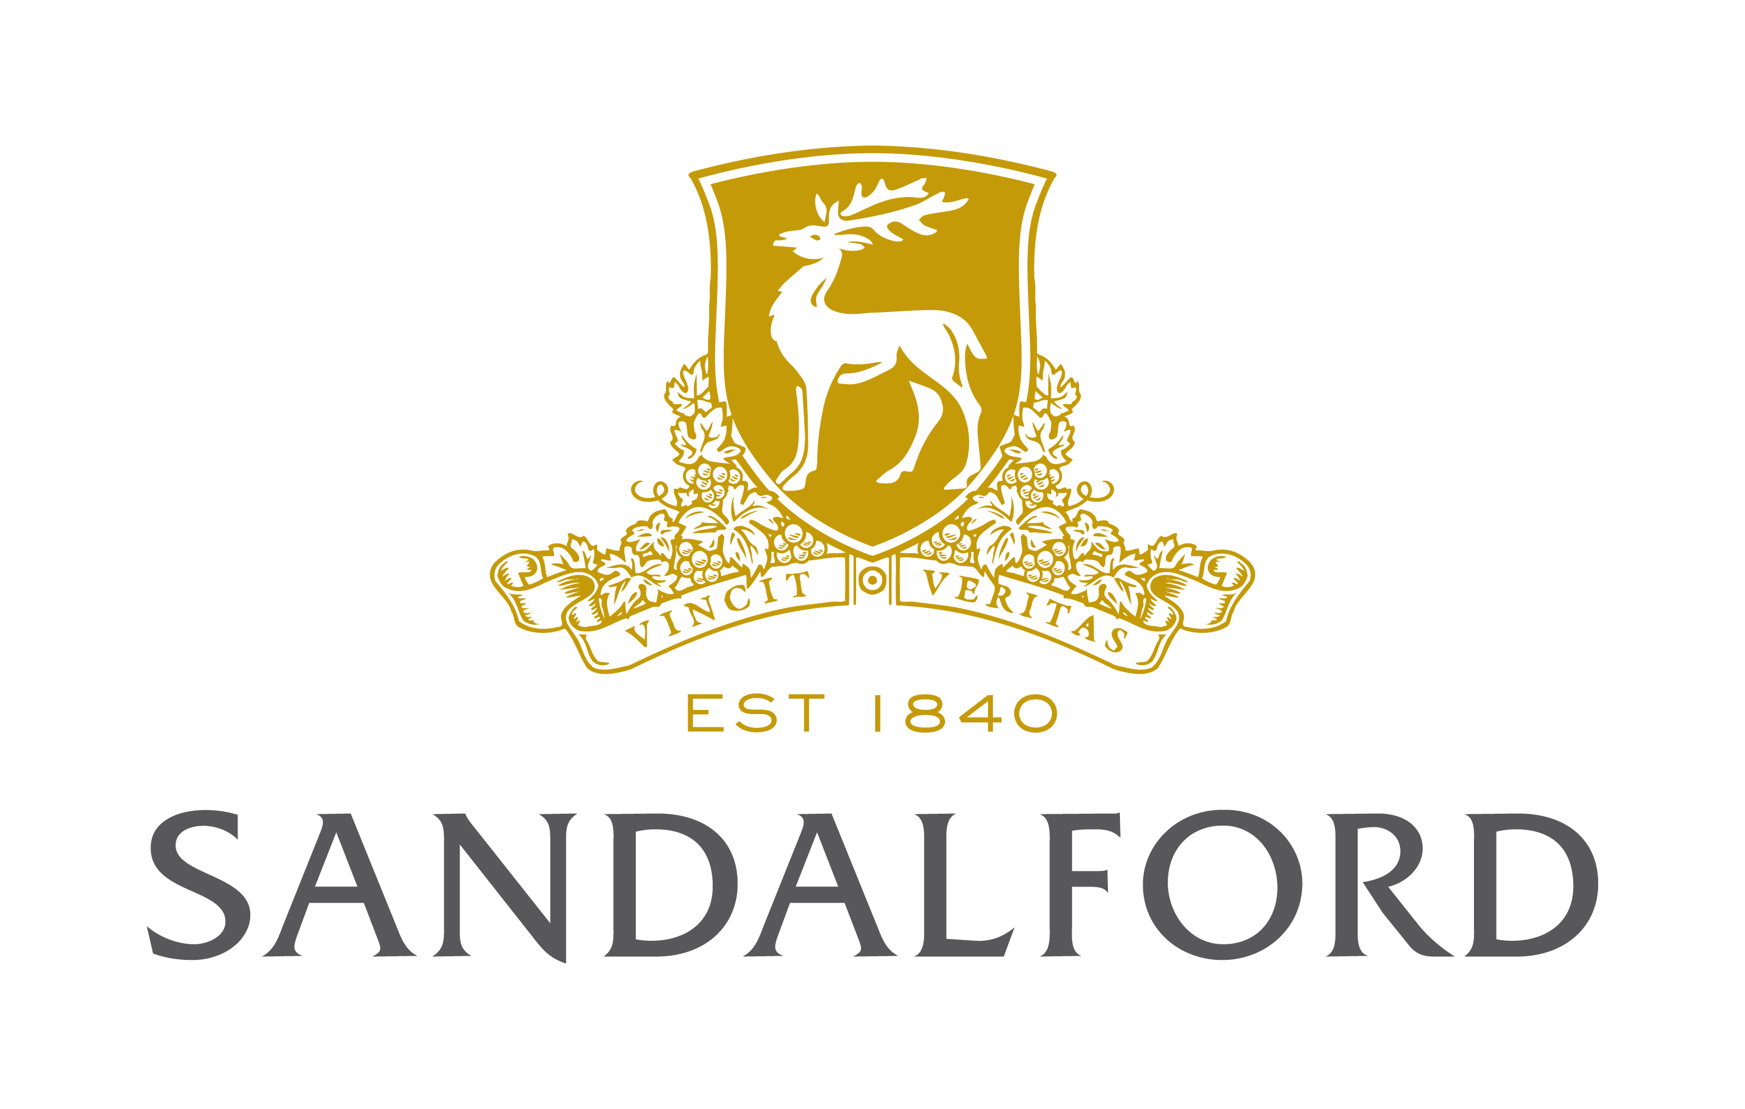

Bookings

The business offers the following methods for bookings and enquiries:
- Phone
- Email
- Webportal
- Our forms have high contract boxes and submit boxes

Emergency Management
- There are Audible device/s to alert occupants to evacuate with instructions on how to evacuate.
- There are visual device/s to alert occupants to evacuate.
- Exit signs are clear and easy to see
- Exits and access to exists are greater than 900mm
- Exit doors are able to be opened by all occupants
- Exits to the emergency evacuation point does not include stairways
- The evacuation point is clearly marked by a sign
- In addition, the following further information can assist guests:
We have evacuation marshalls in each departments to ensure all patrons are evacuated during an emergency, and the marshalls will identify guests requiring assistance.
- In addition, the following further information can assist guests:
We have evacuation marshalls in each departments to ensure all patrons are evacuated during an emergency, and the marshalls will identify guests requiring assistance.

Communications
- Our business offers the following alternative communication methods
- Plain English
- Braille Displays

Not specified
- There is easy to read signage and information (e.g. menus and emergency information)

Other Information
- For bookings made onsite, the ticket booth/counter/box office is accessible for people using a wheelchair
- The business accepts the companion card

Guide Dog and Service Animals
The business provides the following services for services animals:
We accept service animals.

GENERAL

Pre-arrival, arrival and reception
The business has the following in place to support guests during pre-arrival, arrival and reception
- There is a reception/public entryway.
- Seating available at reception
- Lighting in the reception area is even and glare free
- In addition, the following further information can assist guests:
We have disabled parking available and staff on hand to assist at all times.

Car Park and Access amenities
The business has the following Car Park and Access amenities
- A drop off zone
- Designated disabled parking bays
- Level or ramped access from the car park to the entrance
- The accessible entrance is clearly signed from the parking bay
- Kerb ramps are in place where a pavement or walkway needs to be crossed

Entry
The business has the following amenities/systems in place for entry
- A drop off point close to the entrance
- A path of access to the building is slip resistance and even
- A path of access to the building is clear of obstruction
- Self opening entry doors or fitted with a self closer
- Door jams/doors are of a contrasting colour to surrounding walls
- Door handles are of a contrasting colour to the door
- Signage is written in a contrasting colour
- The entry door is a minimum of 850mm wide
- The entry door has self opening or a light opening pressure (for manual operations)
- The entrance sill is less than 13mm
- There a clear space of at least 1500mm x 1500mm in front of all doors.
- The entrance door mats have a thickness less than 13mm and a width of 7500mm or greater

Lifts
- Premises has lifts

Internal Spaces
- Interior walls are matte or low sheen
- Floors, walls, counters and furniture are of contrasting colours
- Tableware/glassware contrast with the table surface or table cloth
- Floor surfaces are hard or short pile carpet
- Seating is available for guests unable to stand for long periods
- Accessible facilities are clearly signed and visible from all areas
- All corridors greater than 900mm

Public areas
The public areas have the following amenities in place
- Even lighting
- Seating

Displays, exhibits, commentary and live performances
For displays, exhibits, commentary and live performances the following amenities are in place
- Seating
- Wheelchair accessible spaces/seating

External Paths
External paths of travel
- Surfaces are concrete, asphalt, smooth paving or hard packed fine gravel (max aggregate size 13mm)
- Paths or slopes longer than 15 metres have resting places or seats
- Pathways are wider than 900mm
- Any paths having steps are clearly identified as non-wheelchair accessible

Steps
Steps
- There are steps.
- Top and bottom steps are easily distinguished through colour contrast or the use of TGSIs (Tactile Ground Surface Indicators)
- The underside of all staircases are enclosed or protected to a height of at least 2 metres
- Handrails fitted to all open sets of steps
- Handrails extend 300mm beyond the top and bottom step

Public Toilets/Adult change facilities
Public Toilets/Adult change facilities have the following amenities are in place
- There is an accessible toilet for public use
- The door is at least 850mm wide
- There is a minimum of 850mm beside the toilet
- Handrails are fitted
- The toilet seat is 460mm above the floor
- The toilet seat of a contrasting colour to the floor
- The toilet seat is460mm above the floor
- There is a registered changing places facility

TOUR OPERATORS

Route Planning
- Walking Tours
- Multi-paced to account for slower walkers

Guides

Guides have been trained in the following
- Use of clear/simple English
- Correct pronunciation for lip readers

COMMON AREAS

Play Spaces
- Level access is provided to play spaces
- There wheelchair accessible activities
- The space contain colour contrasting elements
- Seating is provided in or around the play space

Parks and gardens
- The following parks and gardens amenities are available
- Seats are provided at regular intervals
- Slip resistance surfaces are used.
  - Parks and Gardens Stair entry and exit Image(s)
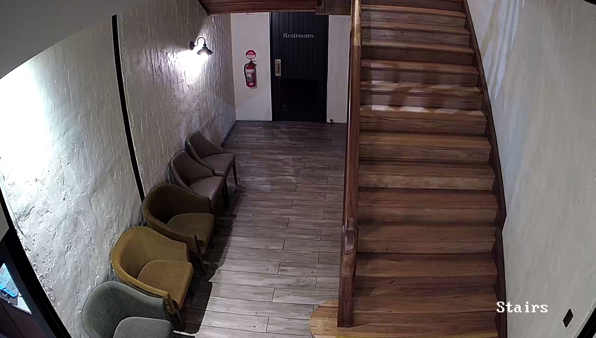
Stairs

FOOD AND DRINK

Dining Spaces
The dining spaces have the following facilities/amenities in place
- The entrance has level access
- The doorway is at least 850mm wide
- There is level access through the dining area
- Chairs are moveable to allow for wheelchairs to be seated at the tables
- There are areas of full lighting
- There are Plain English menus
- There is an accessible toilet

Our business caters for the following dietary requirements
- Sugar free (diabetic)
- Gluten free (celiac)
- Lactose free (dairy free)
- Low fat and fibre with no gastric content
- Low potassium
- Low sodium
- Nut free
- Additive free
- Organic
- Vegetarian
- Vegan
- Kosher
- Halal
- In addition, the following further information can assist guests:
To prevent cross-contamination of food products, raw and ready-to-eat foods are separated, staff wash hands and surfaces thoroughly, and use separate utensils and equipment.Proper storage, including storing raw foods on the bottom shelf of the refrigerator.
- There is a sample menu available online
Sample menu is available here -
https://www.sandalford.com/experience/the-restaurant-and-bar
  - Food and Beverage Image(s)
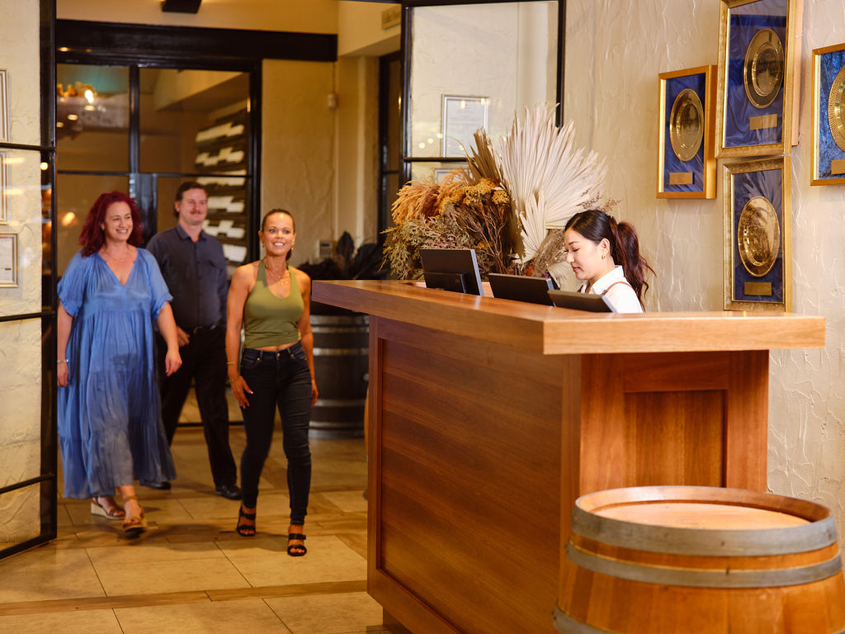
Service Counter
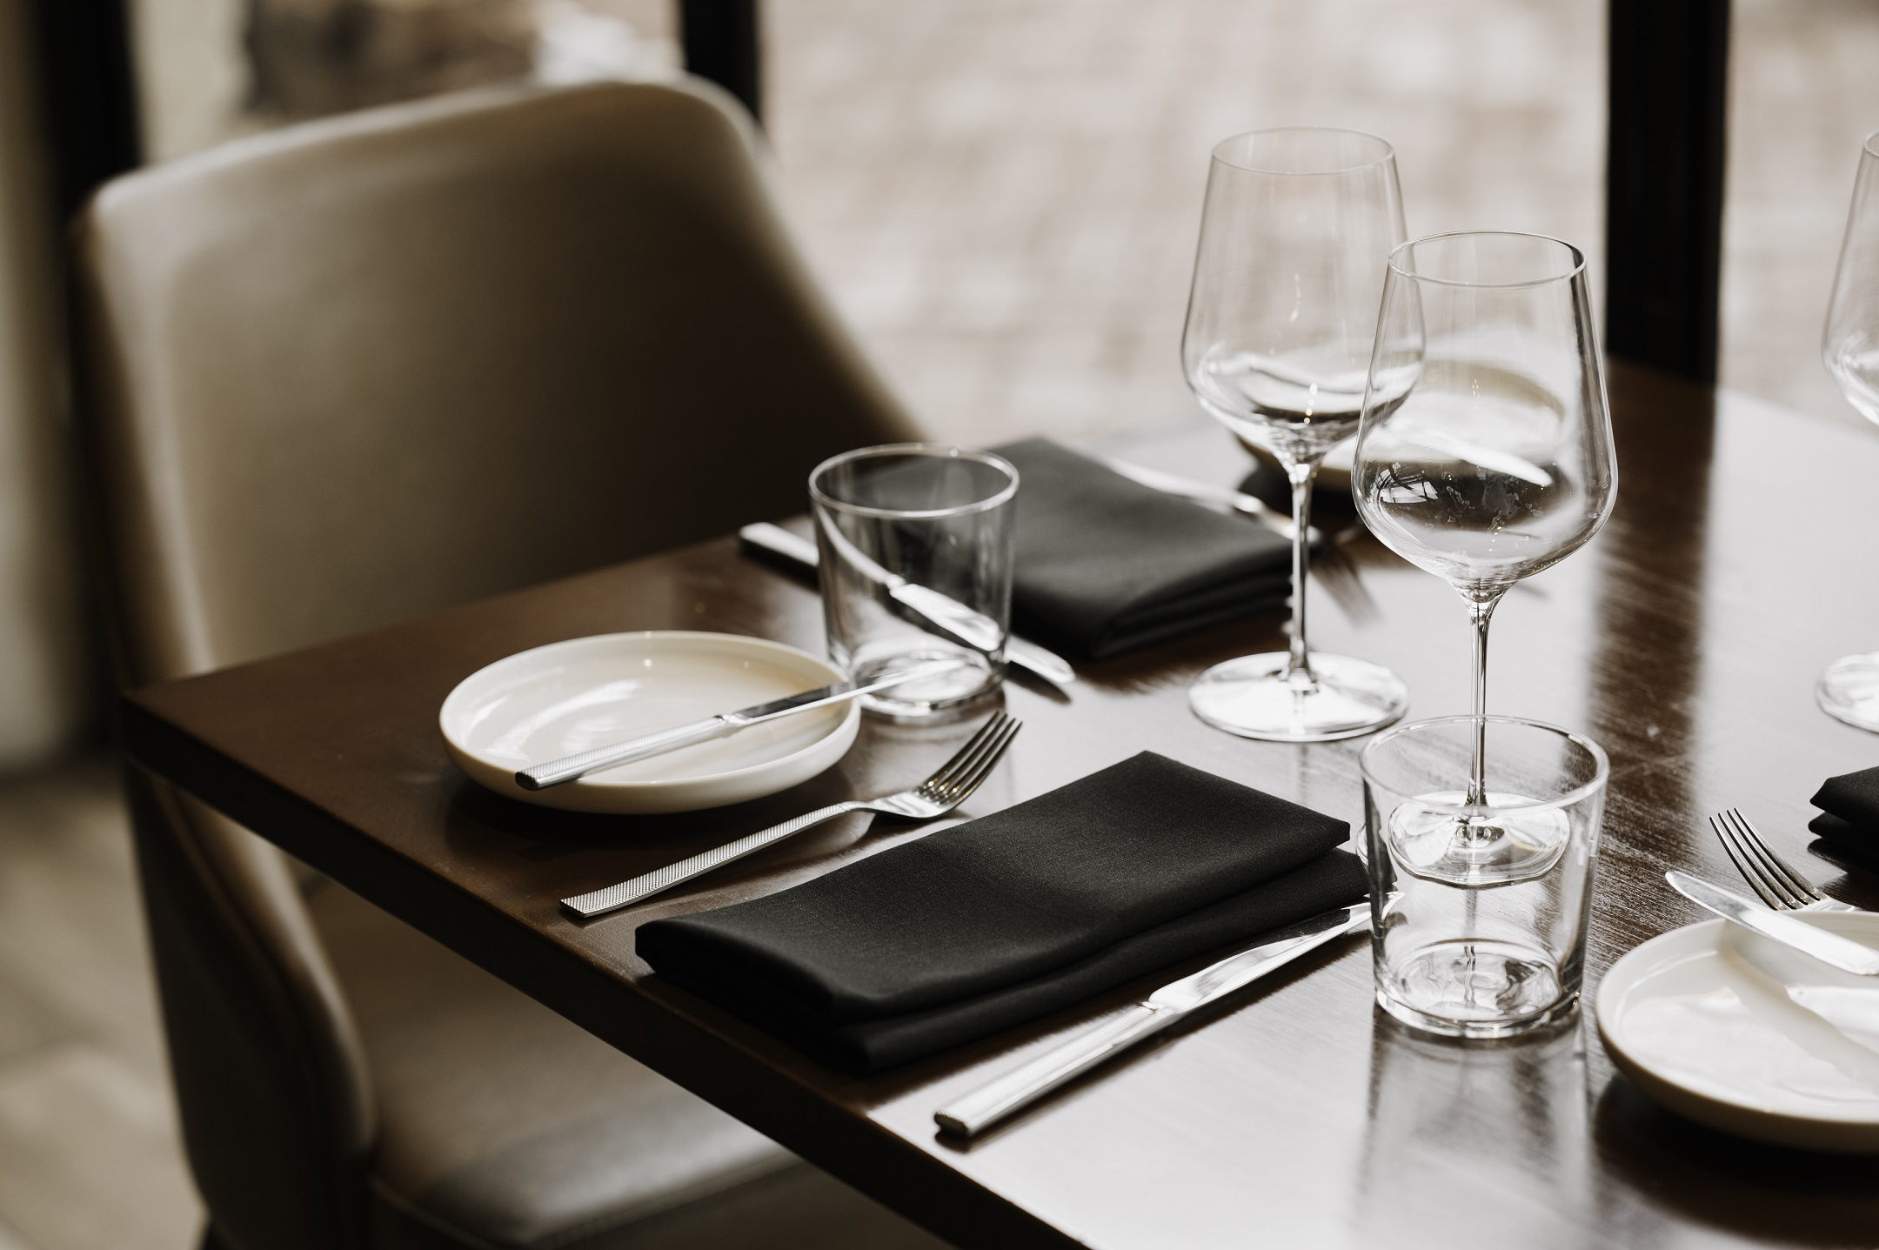
Table Layout
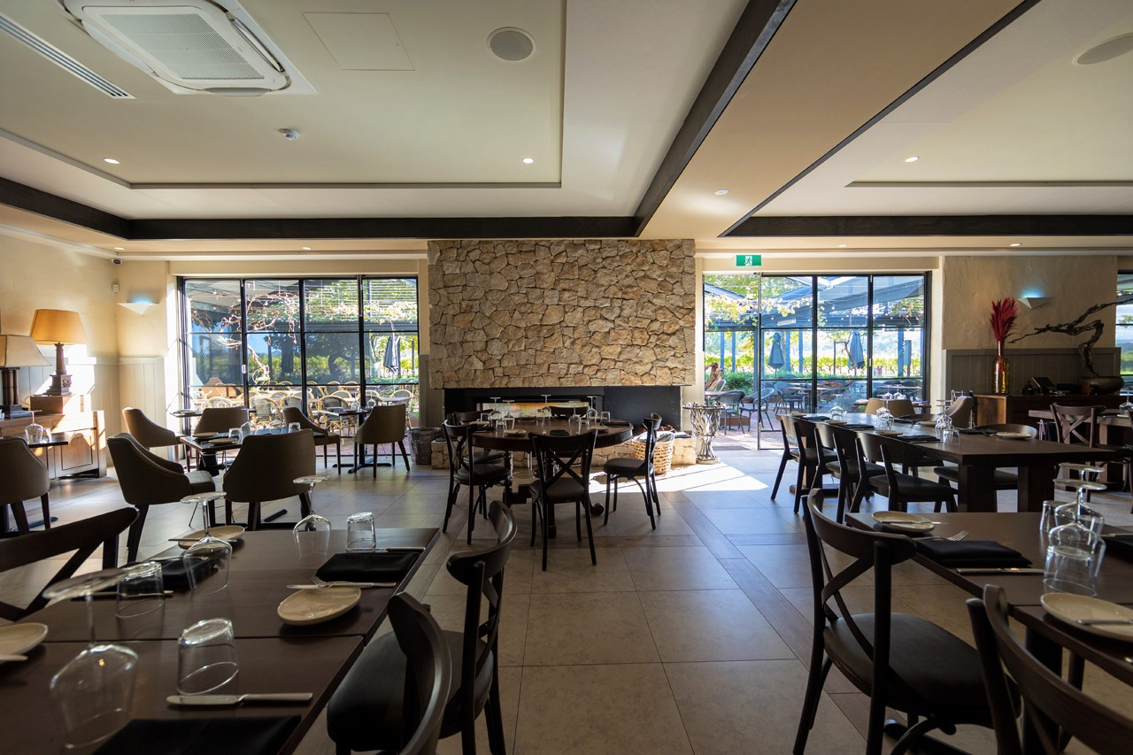
Table layout 2
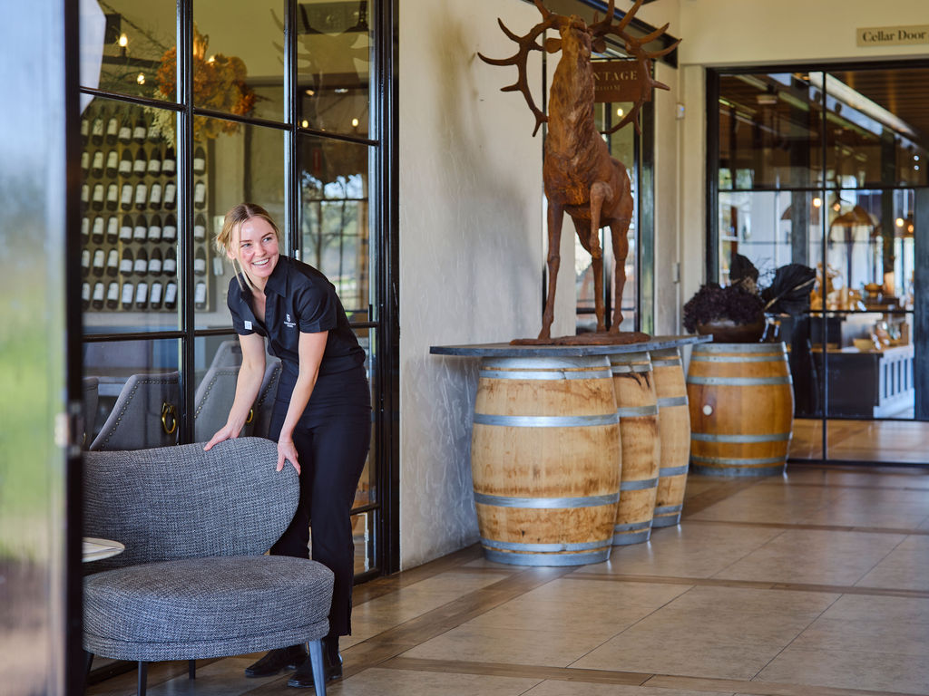
Entrance
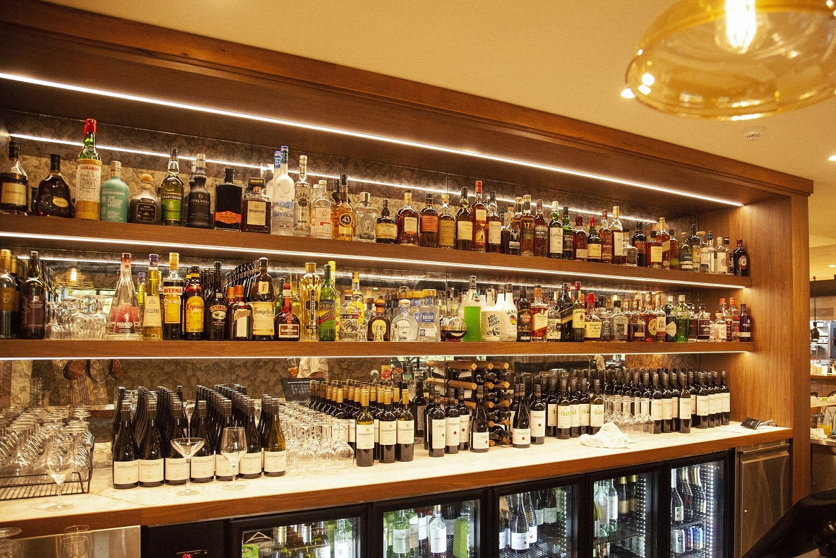
Bar

EVENTS

Events
Events have the following facilities/amenities in place
- There is step free access throughout the venue
- Reception, registration desks or ticket offices have a lower counter section
- All ancillary areas are step free e.g. breakout rooms, dining areas, outside areas and exhibition spaces
- Accessible toilets are available at the venue
- There is clear signage throughout the venue including accessible routes and accessible facilities
- Wheelchair designated seating is provided
- We cater for a range of seating and viewing options
- We cater for varying group sizes
- There is good circulation space with the number of people expected to allow people with a disability to move around freely
- The event is outdoors
- Portable accessible toilets are available
- Accessible car parking is available
- There are designated drop-off points
- The event includes the use of loud noises, fireworks or strobe lighting
- There is a warning included in the event information

Report Disclaimer
Please note that this business report, provided as a result of the use of the diagnostic assessment, is for information purposes only.
Australian Tourism Industry Council (ATIC) cannot guarantee the accuracy of respondent’s answers, or that they are fully representative of your business. Therefore, ATIC does not warrant or guarantee any particular outcome in respect of your businesses self-assessment.
This report is intended as guidance only for your business and should not be relied on for future marketing considerations. ATIC recommends that you seek your own independent advice as well as the results from the diagnostic.
Links to external web sites are inserted for convenience and do not constitute endorsement of material at those sites, or any associated organisation, product or service.
ATIC does not:
- Assume any legal liability for the accuracy, completeness, or usefulness of any information from this report or any links provided; or
- Accept responsibility for any loss associated directly or indirectly from the use of this report.

