ATIC Accessibility
To support the accessible community in making informed travel decisions for their individual needs

This report prepared for:
Business name: | Three Islands Whale Shark Dive
Address: | 7 Carpenter Street
Town: | Exmouth
Contact for enquiries: | Adam Moir
Contact Number: | 08 9949 1994
Contact Email: | info@whalesharkdive.com
Website: | www.whalesharkdive.com
Date: | 2026-10-01 09:03

ATIC Accessibility
The following pages provides travellers with information on the businesses facilities and amenities which aims to support the traveller to make an informed decision on whether the business is suitable for their individual needs.
OVERVIEW 4
Business Overview 4
Bookings 4
Emergency Management 4
Other Information 5
GENERAL 6
Pre-arrival, arrival and reception 6
Cognitive Impairment Support 6
Internal Spaces 6
External Paths 7
Public Toilets/Adult change facilities 7
TOUR OPERATORS 8
Tour/Transport Services 8
Route Planning 8
Guides 8
Report Disclaimer 10

OVERVIEW

Business Overview

The business has the following products/services available
- Tour/Transport

Our business caters for the following disability types:
- Deaf or low hearing
- Limited mobility
- Wheelchairs or mobility scooters
- Food allergies or intolerances
- Cognitive or people on the Autism Spectrum
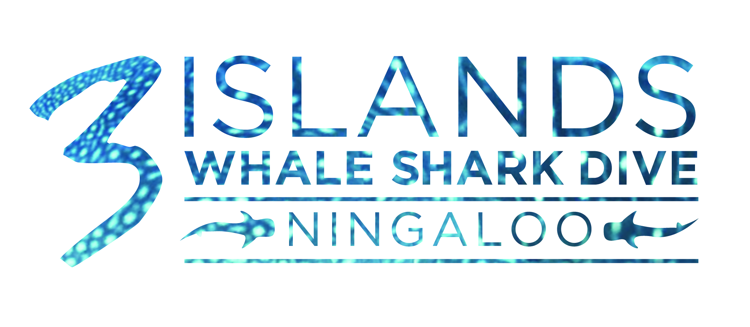

Bookings

The business offers the following methods for bookings and enquiries:
- Phone
- Email
- Webportal

Emergency Management
- Emergency and evacuation procedures are explained on arrival
- Exit signs are clear and easy to see
- Exits and access to exists are greater than 900mm
- Exit doors are able to be opened by all occupants
- In addition, the following further information can assist guests:
It is noted on our daily manifests
- In addition, the following further information can assist guests:
A guide will be nominated on the day to assist
- Guests with disabilities are noted in the guest log book for emergency and evacuation purposes

Other Information
- For bookings made onsite, the ticket booth/counter/box office is accessible for people using a wheelchair
- The business accepts the companion card
The business provides the following services for services animals:
We can not provide accessibility for dogs. It would not make sense for someone to do our tours swimming with whale sharks if they can't see

GENERAL

Pre-arrival, arrival and reception
The business has the following in place to support guests during pre-arrival, arrival and reception
- There is a reception/public entryway.
- Seating available at reception
- A lower counter at reception/ticket office
- A tablet with text to voice or pen and paper at reception to aid in communication
- Lighting in the reception area is even and glare free
- In addition, the following further information can assist guests:
Wait times are not an issue for us
- In addition, the following further information can assist guests:
Please contact our office and we would be happy to discuss any questions you may have

Cognitive Impairment Support
- Documents are available in plain English for people with cognitive impairment (This may include instructions, guides, menus and general information)
- Quiet periods or early opening times for people on the Autism Spectrum
- In addition, the following further information can assist guests:
The above questions are irrelevant. We pick all guests up from their accommodation.
- In addition, the following further information can assist guests:
The above is irrelevant. We will pick you up from your accommodation
- In addition, the following further information can assist guests:
There are no lifts on our boats

Internal Spaces
- Seating is available for guests unable to stand for long periods
- All corridors greater than 900mm
- In addition, the following further information can assist guests:
As our tour is on a boat there is limited space and no quiet space available
- In addition, the following further information can assist guests:
Please contact our office so we can assist you with making a decision on whether this tour is suitable.

External Paths
External paths of travel
- Pathways are wider than 900mm

We are on a boat, there are no paths
- In addition, the following further information can assist guests:
Please contact our office so we can assist you with making a decision on whether this tour is suitable.
- In addition, the following further information can assist guests:
Please contact our office so we can assist you with making a decision on whether this tour is suitable.

Public Toilets/Adult change facilities
Public Toilets/Adult change facilities have the following amenities are in place
- There is an accessible toilet for public use
- The door is We are on a boat so there is no disabled toilet wide
- There is N/A mm beside the toilet
- There is N/A mm of clear space in front of the toilet
- The height of the toilet seat is: Standard height.
- In addition, the following further information can assist guests:
Please contact our office so we can assist you with making a decision on whether this tour is suitable.

TOUR OPERATORS

Tour/Transport Services
The tour/transport services have the following facilities/amenities in place
- Buses/Coaches
- 0 vehicles have wheelchair lifts or ramps
- 0 vehicles have low floors with ramped entry
The maximum wheelchair capacity available in the fleet is:
2

Route Planning
- Route Planning
- The tour route includes stops with accessible toilet facilities
- Lunch stop venues are accessible
- Sightseeing and photo opportunity stops are step free

Guides
- Use of clear/simple English
- Correct pronunciation for lip readers
- Marine
- In addition, the following further information can assist guests:
You will need to be able to access a tender vessel via a boat ramp and be able to swim unassisted

Report Disclaimer
Please note that this business report, provided as a result of the use of the diagnostic assessment, is for information purposes only.
Australian Tourism Industry Council (ATIC) cannot guarantee the accuracy of respondent’s answers, or that they are fully representative of your business. Therefore, ATIC does not warrant or guarantee any particular outcome in respect of your businesses self-assessment.
This report is intended as guidance only for your business and should not be relied on for future marketing considerations. ATIC recommends that you seek your own independent advice as well as the results from the diagnostic.
Links to external web sites are inserted for convenience and do not constitute endorsement of material at those sites, or any associated organisation, product or service.
ATIC does not:
- Assume any legal liability for the accuracy, completeness, or usefulness of any information from this report or any links provided; or
- Accept responsibility for any loss associated directly or indirectly from the use of this report.

