ATIC Accessibility
To support the accessible community in making informed travel decisions for their individual needs

This report prepared for:
Business name: | Pirate Ship Mandurah
Address: | Eastern Foreshore Jetty, Opposite 9 Mandurah terrace
Town: | Mandurah
Contact for enquiries: | Ben Dougherty
Contact Number: | 08 9581 3349
Contact Email: | ben@pirateshipmandurah.com.au
Website: | https://pirateshipmandurah.com.au/
Date: | 2026-11-03 05:24

ATIC Accessibility
The following pages provides travellers with information on the businesses facilities and amenities which aims to support the traveller to make an informed decision on whether the business is suitable for their individual needs.
OVERVIEW 4
Business Overview 4
Bookings 4
Emergency Management 4
Communications 5
Guide Dog and Service Animals 5
GENERAL 6
Pre-arrival, arrival and reception 6
Car Park and Access amenities 6
Displays, exhibits, commentary and live performances 6
External Paths 7
Steps 7
TOUR OPERATORS 8
Guides 8
FOOD AND DRINK 10
Dining Spaces 10
Report Disclaimer 13

OVERVIEW

Business Overview

The business has the following products/services available
- Tour/Transport
- Food and Drink

Our business caters for the following disability types:
- Blind or low vision
- Deaf or low hearing
- Limited mobility
- Food allergies or intolerances
- Cognitive or people on the Autism Spectrum
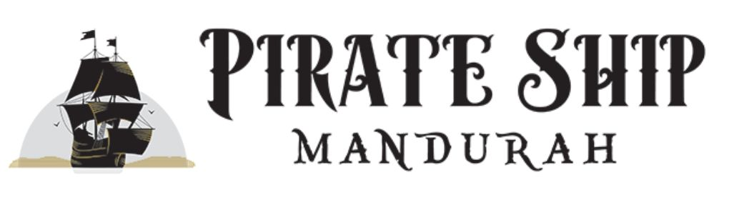

Bookings

The business offers the following methods for bookings and enquiries:
- Phone
- Email
- Webportal
- Our website supports Screen Readers
- Our forms have high contract boxes and submit boxes

Emergency Management
- Emergency and evacuation procedures are explained on arrival
- There are visual device/s to alert occupants to evacuate.
- Exit access is free and clear at all times
We ensure exit access is free and clear at all times by:
The gates are always clear to open, prams and walkers are folded up and stored towards the back of the boat.
- Exit doors are able to be opened by all occupants
- Exits to the emergency evacuation point does not include stairways
- In addition, the following further information can assist guests:
Customers can add notes at the time of booking. We also count and greet every passenger coming onto the boat the staff will be aware of any limitations of customers.
- In addition, the following further information can assist guests:
Someone will assist them getting a life jacket on if there was a serious emergency. If it is minor staff can accompany them off the boat the same as we do when they board.

Communications
- Our website meets WCAG 2.0 accessibility standards

Guide Dog and Service Animals
The business provides the following services for services animals:
Service dogs are welcome

GENERAL

Pre-arrival, arrival and reception
The business has the following in place to support guests during pre-arrival, arrival and reception
- Booking information and websites are compatible with screen readers
- Information and maps are available in written form
- A familiarisation tour
- In addition, the following further information can assist guests:
The boat is only at the jetty for 15 minutes for boarding between cruises. If they have a pre purchased ticket it doesn't take longer then 10-15 minutes to board every passenger.
- In addition, the following further information can assist guests:
We send out reminder emails before guests attend if they pre book they will have information on where we are located and how to find us. This information is also available on our website.

Car Park and Access amenities
The business has the following Car Park and Access amenities
- Level or ramped access from the car park to the entrance
- In addition, the following further information can assist guests:
There are two disabled parking bays on the foreshore close to the departure jetty and a loading area that could be used as a drop off spot.

Displays, exhibits, commentary and live performances
For displays, exhibits, commentary and live performances the following amenities are in place
- Seating
- In addition, the following further information can assist guests:
Crew talks live with a microphone and there are speakers located on the boat.

External Paths
External paths of travel
- Surfaces are concrete, asphalt, smooth paving or hard packed fine gravel (max aggregate size 13mm)
The width of the smallest pathway is:
600mm
- There 3 successive steps or less on any path or at any doorway

The steps we have are inside a toilet and the boat is not wheelchair accessible.
- In addition, the following further information can assist guests:
We have guests attend with walkers if they are able to take a few assisted steps to a seat we can them help them off and store the walker collapsed during the cruise.

Steps
Steps
- There are steps.
- Top and bottom steps are easily distinguished through colour contrast or the use of TGSIs (Tactile Ground Surface Indicators)
- All steps or staircases have enclosed risers
- The underside of all staircases are enclosed or protected to a height of at least 2 metres
- Where steps are present are there three steps or less
- In addition, the following further information can assist guests:
The entire boat is a flat deck where customers access apart from the toilet where you have to step down.

TOUR OPERATORS
- In addition, the following further information can assist guests:
The toilet has a 3 steps to get down.

Guides
- Use of clear/simple English
- Correct pronunciation for lip readers
- Marine
  - Image(s)
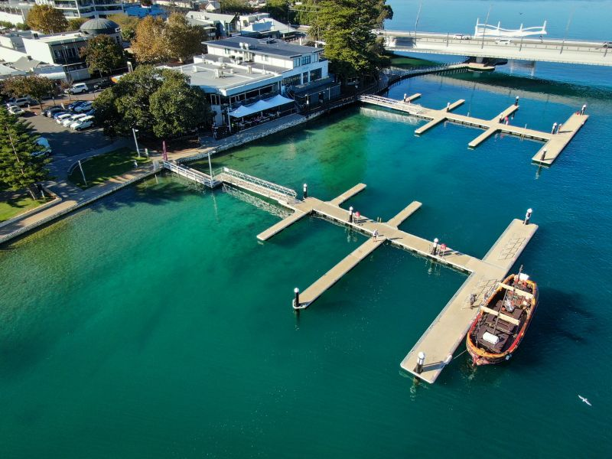
Arial view of jetty
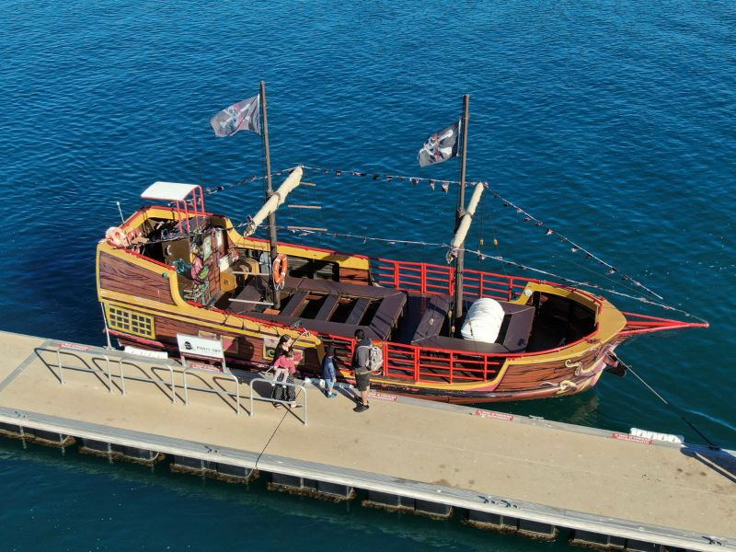
Ariel view of the seating
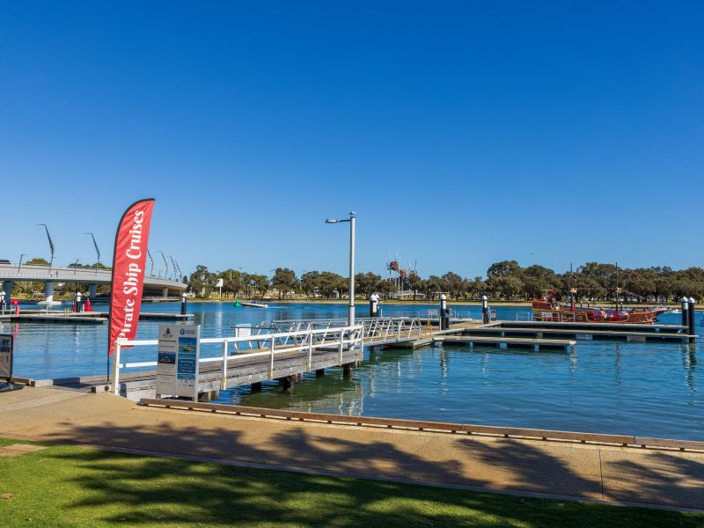
From the foreshore down the jetty ramp to boat
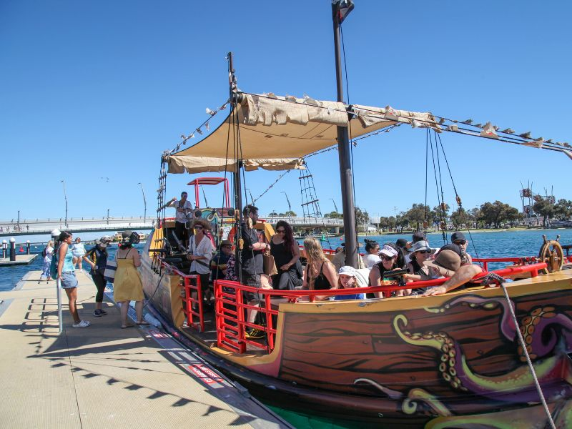
Step onto boat from jetty
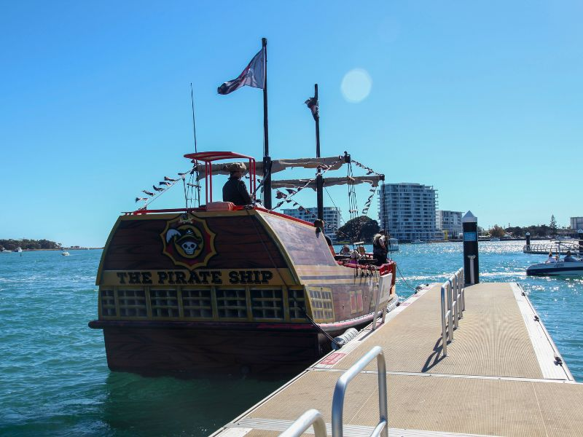
view of boat at jetty
- In addition, the following further information can assist guests:
We collect food only it is delivered straight to the boat and we hand it out in boxes to each customer.
- In addition, the following further information can assist guests:
It is a fish and chip lunch cruise we can request it to be gluten and celiac free but they say there can still be traces.

FOOD AND DRINK

Dining Spaces
The dining spaces have the following facilities/amenities in place
- The smallest doorway is 800mm but the pathway is only 600mm wide
- There is an accessible toilet close by that is open during our business hours

Our business caters for the following dietary requirements
- Gluten free (celiac)
- In addition, the following further information can assist guests:
The only cruise that includes food is the 90 minute scenic lunch cruise that operates once a day outside of school holidays. We can offer people a ticket that doesn't include the lunch option if they have specific dietary needs.
- There is a sample menu available online
Sample menu is available here -
https://pirateshipmandurah.com.au/boat-cruises/fish-chips-lunch-cruise
  - Food and Beverage Image(s)
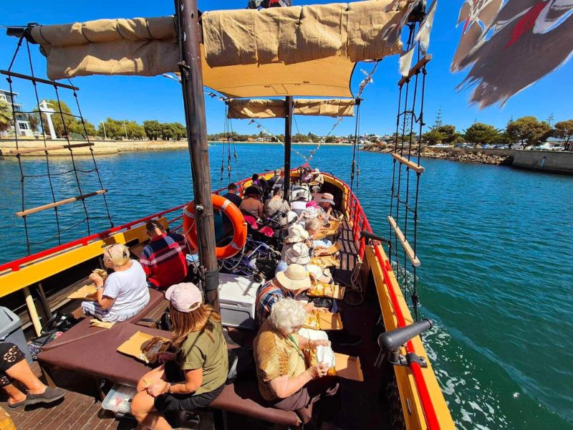
Bench style seating with food on lap or next to you on the seat
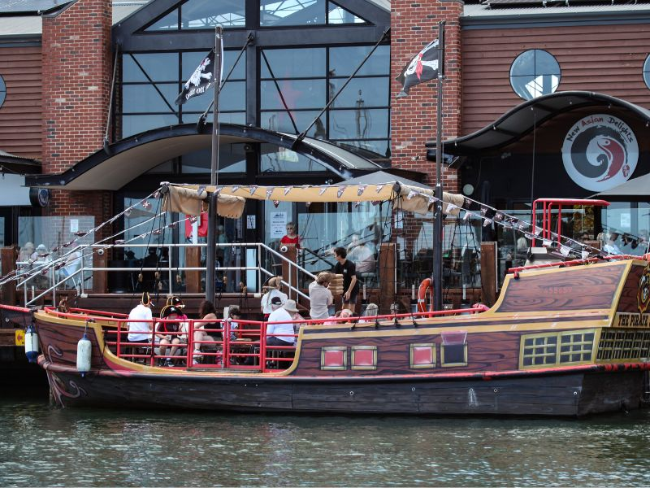
Collecting food from Sharky's in the marina
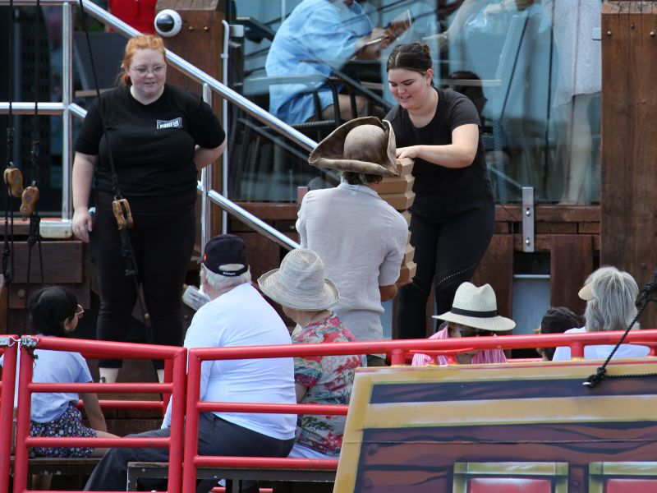
Collecting food which will then be passed out
- In addition, the following further information can assist guests:
Cruises that don't include food below
Our 45 Minute Pirate Cruise
1.5 Hour Sundowner Cruise
Christmas Lights cruise
Guests are welcome to brings snacks and drinks aboard

90 minute scenic lunch cruise departing 12pm midweek outside of school holidays includes battered fish and chips for adults and chicken nuggets and chips for kids. There is also a option to purchase a ticket with out food and bring your own lunch.

Report Disclaimer
Please note that this business report, provided as a result of the use of the diagnostic assessment, is for information purposes only.
Australian Tourism Industry Council (ATIC) cannot guarantee the accuracy of respondent’s answers, or that they are fully representative of your business. Therefore, ATIC does not warrant or guarantee any particular outcome in respect of your businesses self-assessment.
This report is intended as guidance only for your business and should not be relied on for future marketing considerations. ATIC recommends that you seek your own independent advice as well as the results from the diagnostic.
Links to external web sites are inserted for convenience and do not constitute endorsement of material at those sites, or any associated organisation, product or service.
ATIC does not:
- Assume any legal liability for the accuracy, completeness, or usefulness of any information from this report or any links provided; or
- Accept responsibility for any loss associated directly or indirectly from the use of this report.

