ATIC Accessibility
To support the accessible community in making informed travel decisions for their individual needs

This report prepared for:
Business name: | The Ellington Jazz Club
Address: | 193 Beaufort Street
Town: | Perth
Contact for enquiries: | Travis Simmons
Contact Number: | 0892281088
Contact Email: | info@ellingtonjazz.com.au
Website: | https://www.ellingtonjazz.com.au/
Date: | 2026-09-23 10:47

ATIC Accessibility
The following pages provides travellers with information on the businesses facilities and amenities which aims to support the traveller to make an informed decision on whether the business is suitable for their individual needs.
OVERVIEW 4
Business Overview 4
Bookings 5
Emergency Management 5
Communications 5
Other Information 6
Guide Dog and Service Animals 6
GENERAL 7
Pre-arrival, arrival and reception 7
Cognitive Impairment Support 7
Entry 7
Internal Spaces 7
Public areas 8
Displays, exhibits, commentary and live performances 8
External Paths 8
Public Toilets/Adult change facilities 8
ATTRACTIONS 10
COMMON AREAS 11
FOOD AND DRINK 12
Dining Spaces 12
EVENTS 15
Events 15
Report Disclaimer 17

OVERVIEW

Business Overview

The business has the following products/services available
- Attraction
- Food and Drink
- Event

Our business caters for the following disability types:
- Blind or low vision
- Deaf or low hearing
- Limited mobility
- Wheelchairs or mobility scooters
- Food allergies or intolerances
- Cognitive or people on the Autism Spectrum
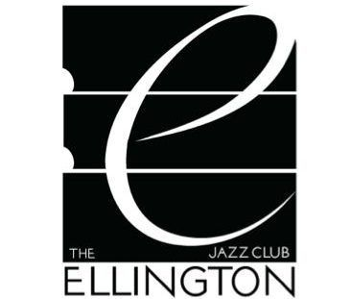

Bookings

The business offers the following methods for bookings and enquiries:
- Phone
- Email
- Webportal
- Our website supports Screen Readers

Emergency Management
- There are visual device/s to alert occupants to evacuate.
- Exit signs are clear and easy to see
- Exit access is free and clear at all times
We ensure exit access is free and clear at all times by:
Managed by Staff during shows, and constantly monitored
- Exits and access to exists are greater than 900mm
- Exit doors are able to be opened by all occupants
- Exits to the emergency evacuation point does not include stairways
- The evacuation point is clearly marked by a sign
- The evacuation point is clearly marked by a sign with raised letters or braille
- In addition, the following further information can assist guests:
By requesting guests share any accessibility requirements at the point of tiucket purchase
- In addition, the following further information can assist guests:
Staff will provide assistance as required

Communications
- Our business offers the following alternative communication methods
- Plain English

Not specified
- There is easy to read signage and information (e.g. menus and emergency information)

Other Information
- The business accepts the companion card

Guide Dog and Service Animals
- The business provides a secure area with shade and water for service animals
The business provides the following services for services animals:
Ourdoor courtyard available

GENERAL

Pre-arrival, arrival and reception
The business has the following in place to support guests during pre-arrival, arrival and reception
- Booking information and websites are compatible with screen readers
- In addition, the following further information can assist guests:
We seat a total of 96 guests, and process arrivals quickly and efficiently

Cognitive Impairment Support
- Documents are available in plain English for people with cognitive impairment (This may include instructions, guides, menus and general information)
- A space for parents and children on the Autism Spectrum
- In addition, the following further information can assist guests:
No carpark is available.

Entry
The business has the following amenities/systems in place for entry
- A drop off point close to the entrance
- A path of access to the building is slip resistance and even
- A path of access to the building is clear of obstruction
- Glass doors are fitted with a visual sighting strip
- Door jams/doors are of a contrasting colour to surrounding walls
- Door handles are of a contrasting colour to the door
- Signage is written in a contrasting colour
- The entry door is a minimum of 850mm wide
- The entry door has self opening or a light opening pressure (for manual operations)
- The entrance sill is less than 13mm

Internal Spaces
- Clear and unobstructed routes through and between buildings
- Interior walls are matte or low sheen
- Floors, walls, counters and furniture are of contrasting colours
- Any protruding or overhanging obstructions are at least 2meters above the floor or are protected
- Tableware/glassware contrast with the table surface or table cloth
- Floor surfaces are hard or short pile carpet
- Seating is available for guests unable to stand for long periods
- Accessible facilities are clearly signed and visible from all areas
- All corridors greater than 900mm
- There is a quiet space for parents and children on the Autism Spectrum

Public areas
The public areas have the following amenities in place
- Seating

Displays, exhibits, commentary and live performances
For displays, exhibits, commentary and live performances the following amenities are in place
- Seating
- Wheelchair accessible spaces/seating

External Paths
External paths of travel
- Surfaces are concrete, asphalt, smooth paving or hard packed fine gravel (max aggregate size 13mm)
- Pathways are wider than 900mm

No paths with steps

Public Toilets/Adult change facilities
Public Toilets/Adult change facilities have the following amenities are in place
- There is an accessible toilet for public use
- The door is at least 850mm wide
- There is a minimum of 850mm beside the toilet
- Handrails are fitted
- The toilet seat is 460mm above the floor
- The toilet seat of a contrasting colour to the floor
- The toilet seat is460mm above the floor

ATTRACTIONS

COMMON AREAS

FOOD AND DRINK

Dining Spaces
The dining spaces have the following facilities/amenities in place
- The entrance has level access
- The doorway is at least 850mm wide
- There is level access through the dining area
- Chairs are moveable to allow for wheelchairs to be seated at the tables
- All glass doors and full height windows have contrast markings
- There are Plain English menus
- There is an accessible toilet

Our business caters for the following dietary requirements
- Sugar free (diabetic)
- Gluten free (celiac)
- Lactose free (dairy free)
- Nut free
- Vegetarian
- Vegan
- Kosher
- Halal
- In addition, the following further information can assist guests:
All food is prepared in the same kitchen, but staff are trained in cross contamination procedures
- There is a sample menu available online
Sample menu is available here -
https://order.platform.hungryhungry.com/ellingtonjazzclub-menu/menu
  - Food and Beverage Image(s)
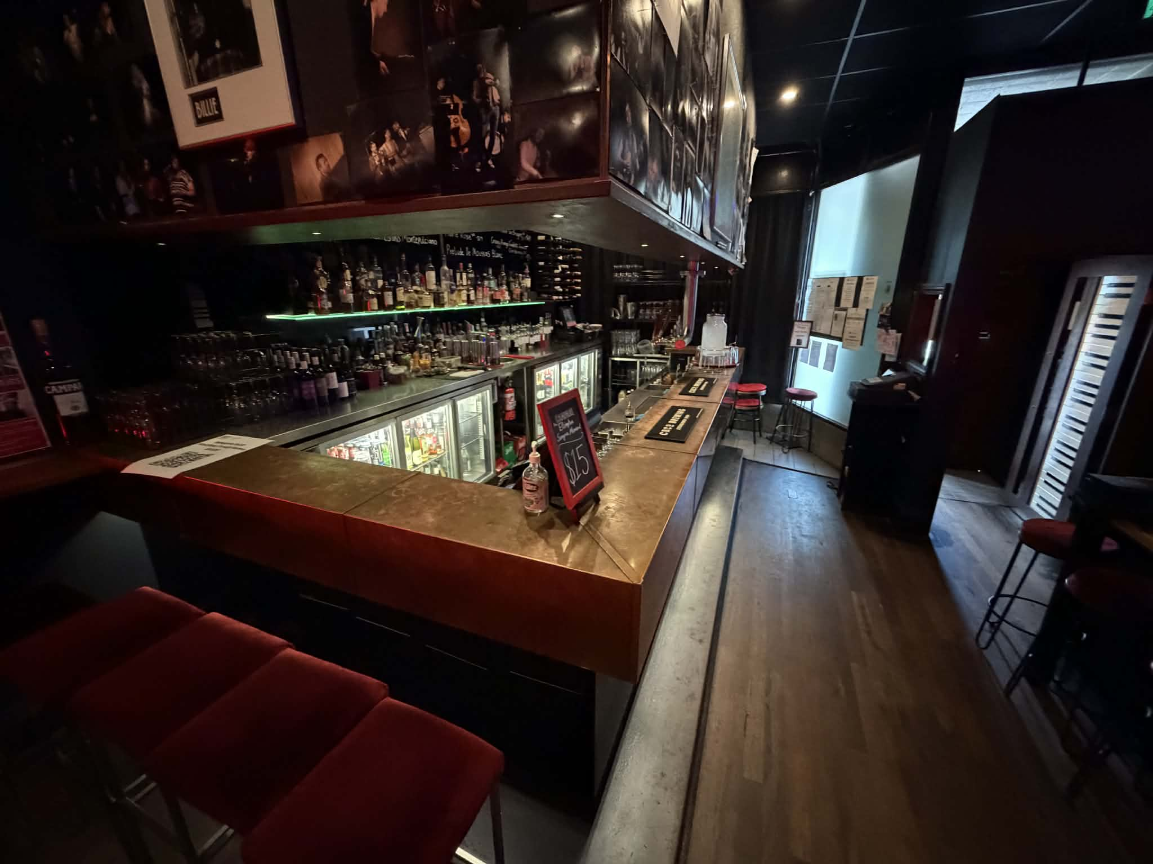
0dd47169-b822-407d-b479-a212360711c2
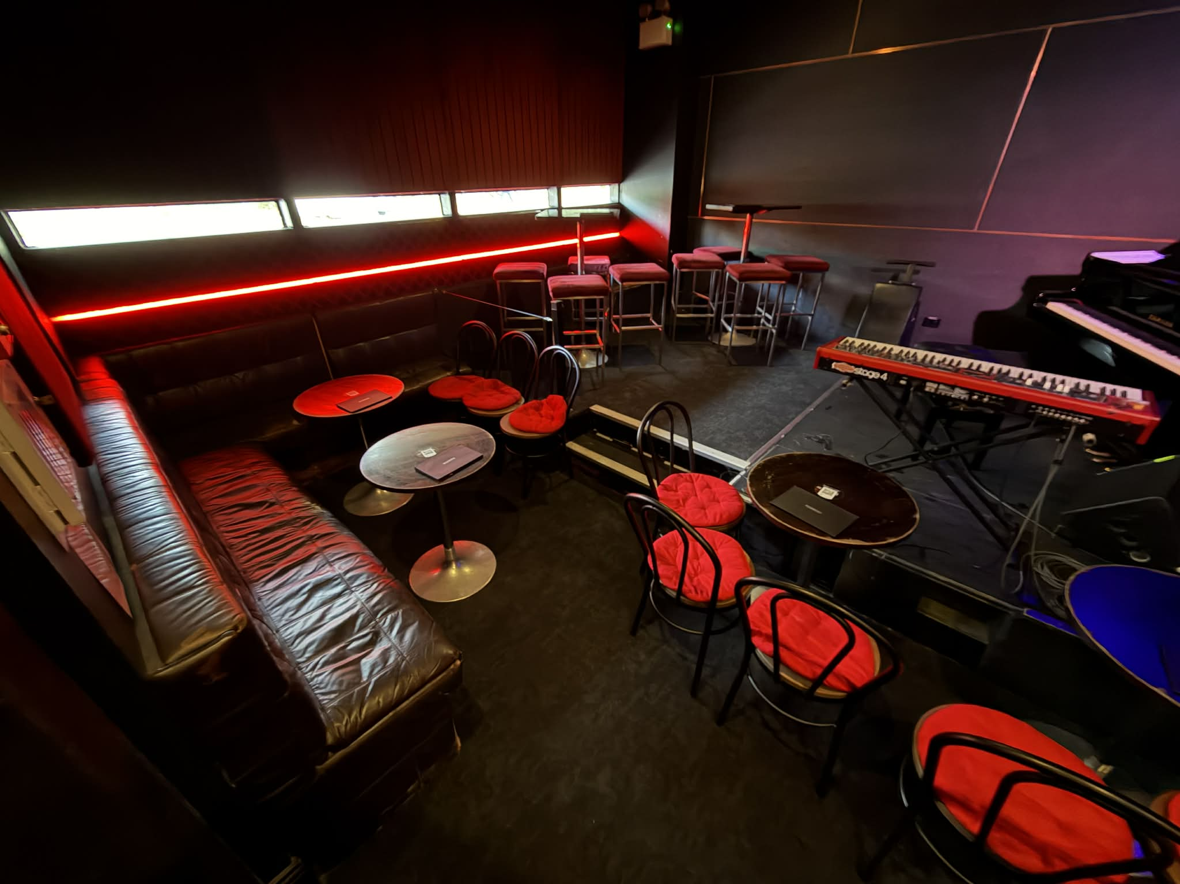
9c018305-1d87-44ea-bd74-691d1d8ea1ce
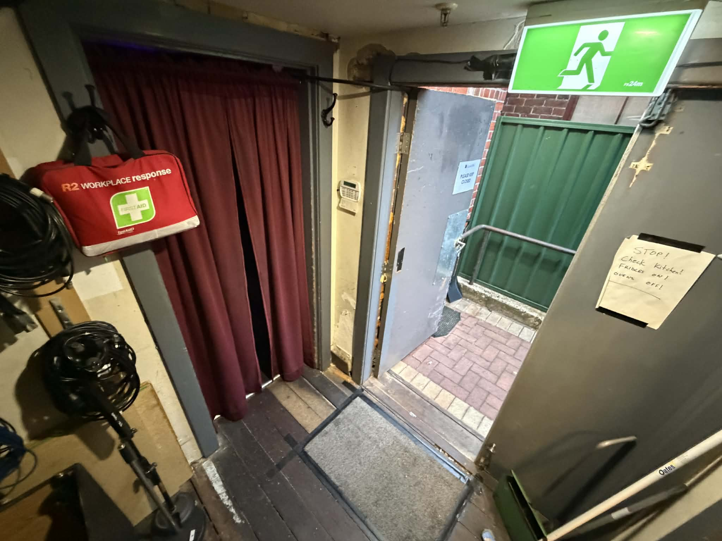
47e0412c-0de9-4f07-9ce2-43f4e0bc9049
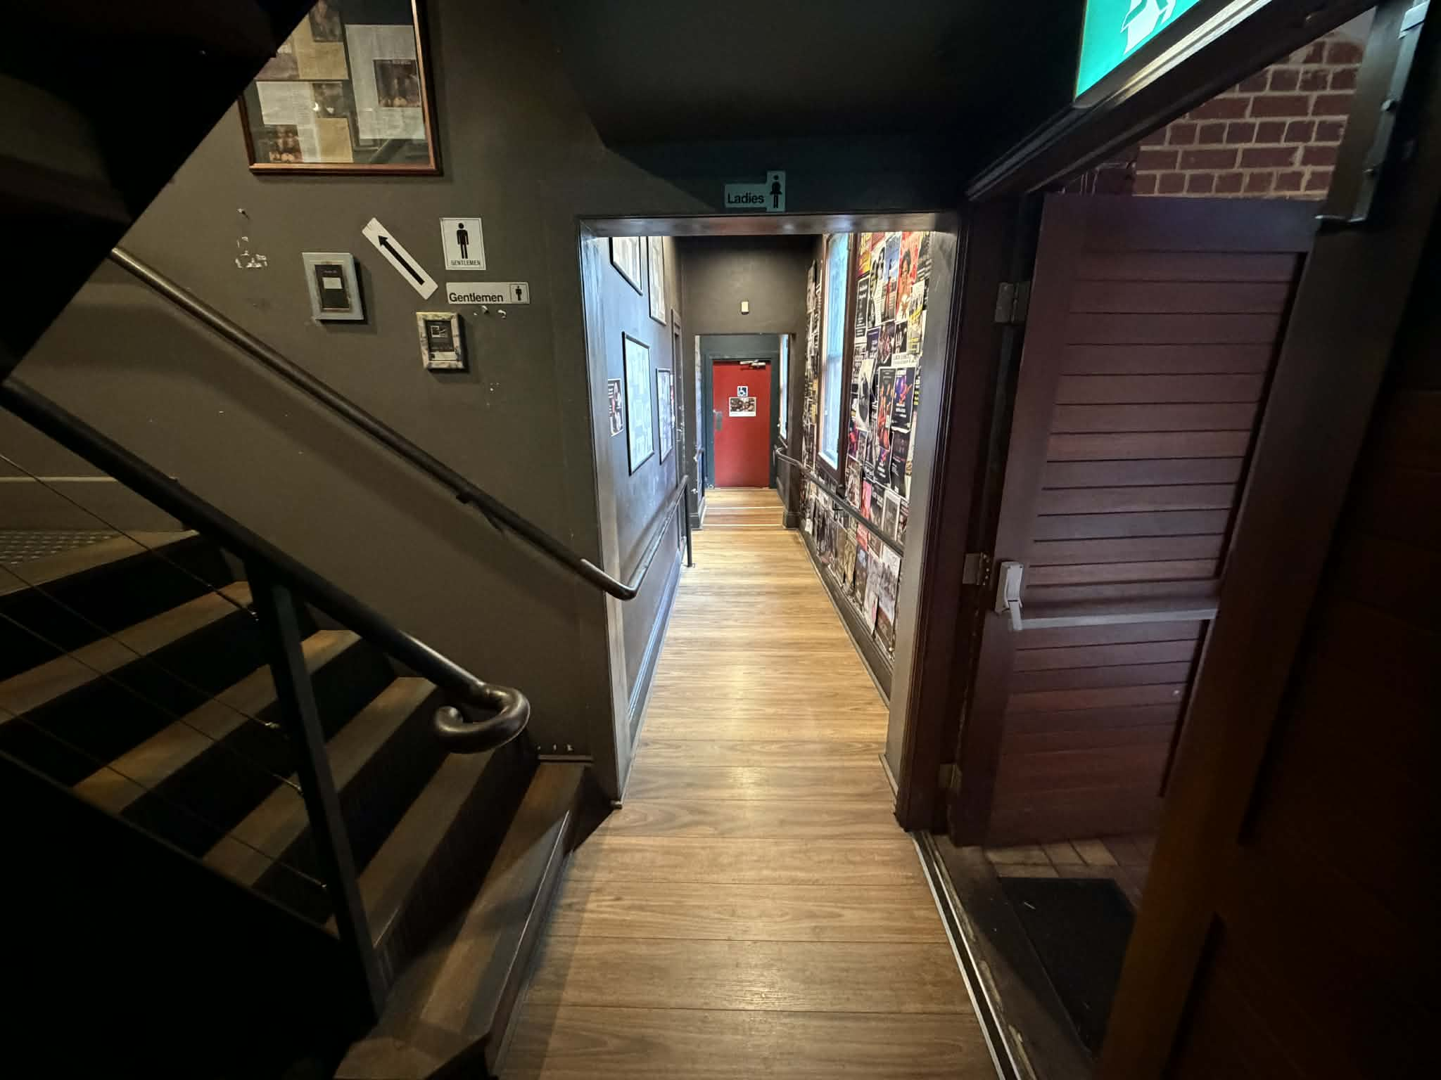
48c2dca9-07b3-4222-82df-2b035c8554f9

EVENTS

Events
Events have the following facilities/amenities in place
- There is step free access throughout the venue
- All ancillary areas are step free e.g. breakout rooms, dining areas, outside areas and exhibition spaces
- Accessible toilets are available at the venue
- There is clear signage throughout the venue including accessible routes and accessible facilities
- There is good circulation space with the number of people expected to allow people with a disability to move around freely
- There is accessible public transport to the venue

Report Disclaimer
Please note that this business report, provided as a result of the use of the diagnostic assessment, is for information purposes only.
Australian Tourism Industry Council (ATIC) cannot guarantee the accuracy of respondent’s answers, or that they are fully representative of your business. Therefore, ATIC does not warrant or guarantee any particular outcome in respect of your businesses self-assessment.
This report is intended as guidance only for your business and should not be relied on for future marketing considerations. ATIC recommends that you seek your own independent advice as well as the results from the diagnostic.
Links to external web sites are inserted for convenience and do not constitute endorsement of material at those sites, or any associated organisation, product or service.
ATIC does not:
- Assume any legal liability for the accuracy, completeness, or usefulness of any information from this report or any links provided; or
- Accept responsibility for any loss associated directly or indirectly from the use of this report.

