ATIC Accessibility
To support the accessible community in making informed travel decisions for their individual needs

This report prepared for:
Business name: | JF & YM Sharpe
Address: | William Bay Rd
Town: | William Bay
Contact for enquiries: | Yvonne Sharpe
Contact Number: | 0898409367
Contact Email: | jfymsharpe@gmail.com
Website: | https://www.jf-ym-sharpe.com.au
Date: | 2026-09-29 23:59

ATIC Accessibility
The following pages provides travellers with information on the businesses facilities and amenities which aims to support the traveller to make an informed decision on whether the business is suitable for their individual needs.
OVERVIEW 3
Business Overview 3
Bookings 3
Communications 3
Guide Dog and Service Animals 4
GENERAL 5
Cognitive Impairment Support 5
Car Park and Access amenities 5
External Paths 5
FOOD AND DRINK 7
Dining Spaces 7
Report Disclaimer 10

OVERVIEW

Business Overview

The business has the following products/services available
- Food and Drink

Our business caters for the following disability types:
- Blind or low vision
- Deaf or low hearing
- Limited mobility
- Wheelchairs or mobility scooters
- Food allergies or intolerances
- Cognitive or people on the Autism Spectrum
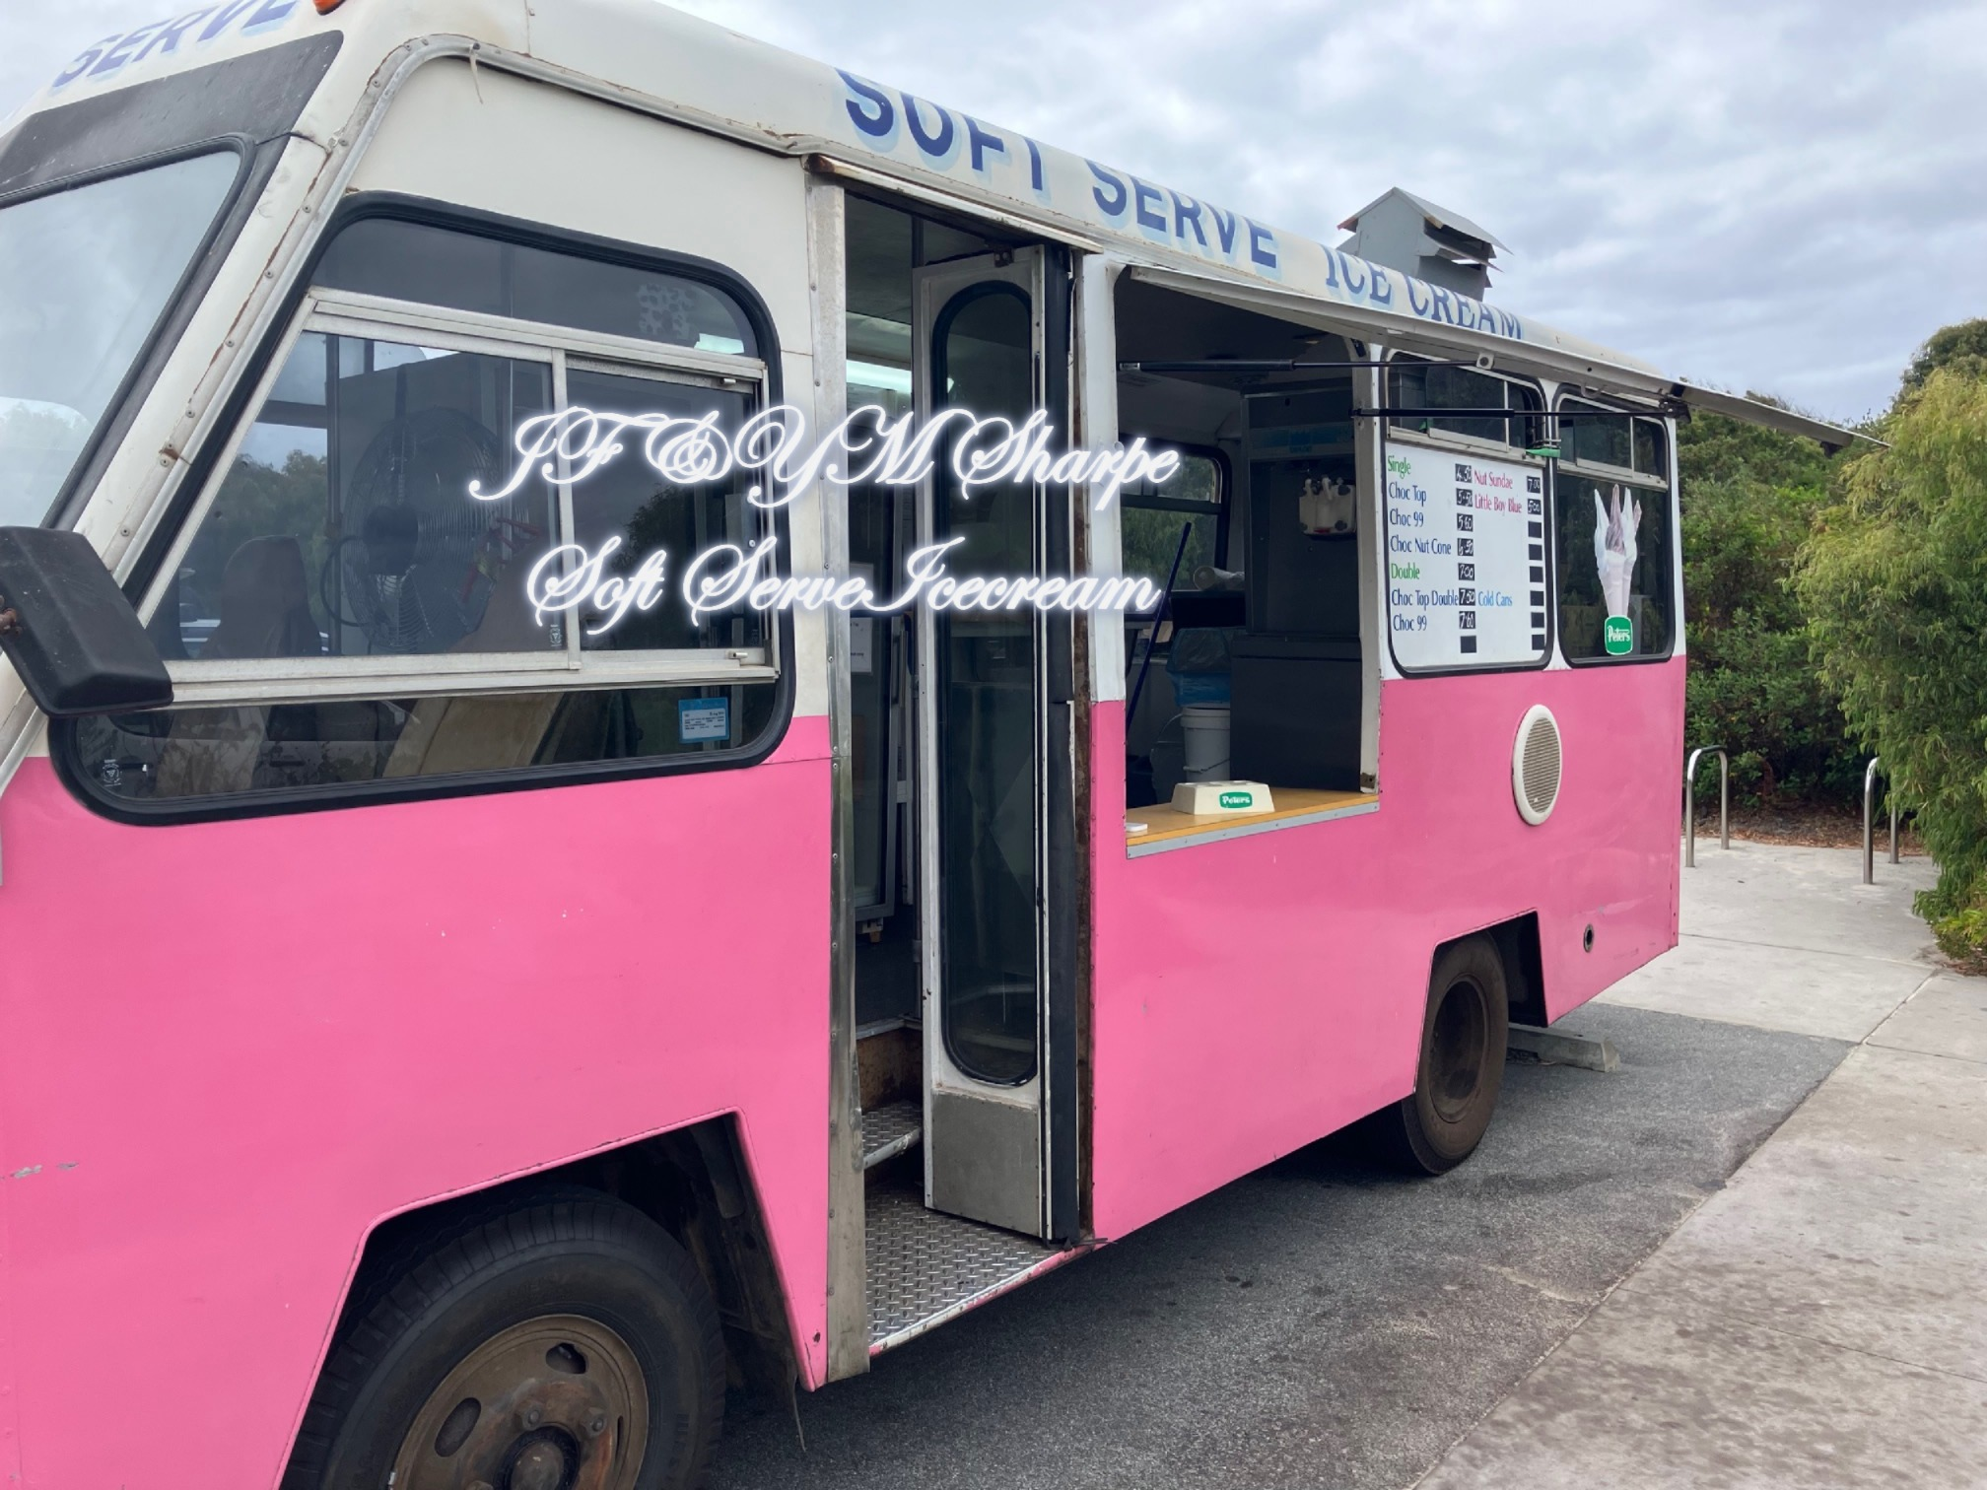

Bookings

The business offers the following methods for bookings and enquiries:
- Phone

Communications
- An accessibility guide is available on the website

https://www.jf-ym-sharpe.com.au
- Our website meets WCAG 2.0 accessibility standards
- Our business offers the following alternative communication methods
- Plain English

Printed Menu on outside and Pictured Menu Board on inner wall easily viewed from the outside
- There is easy to read signage and information (e.g. menus and emergency information)
- There is a Pictorial menu
  - Pictorial Menu Image(s)
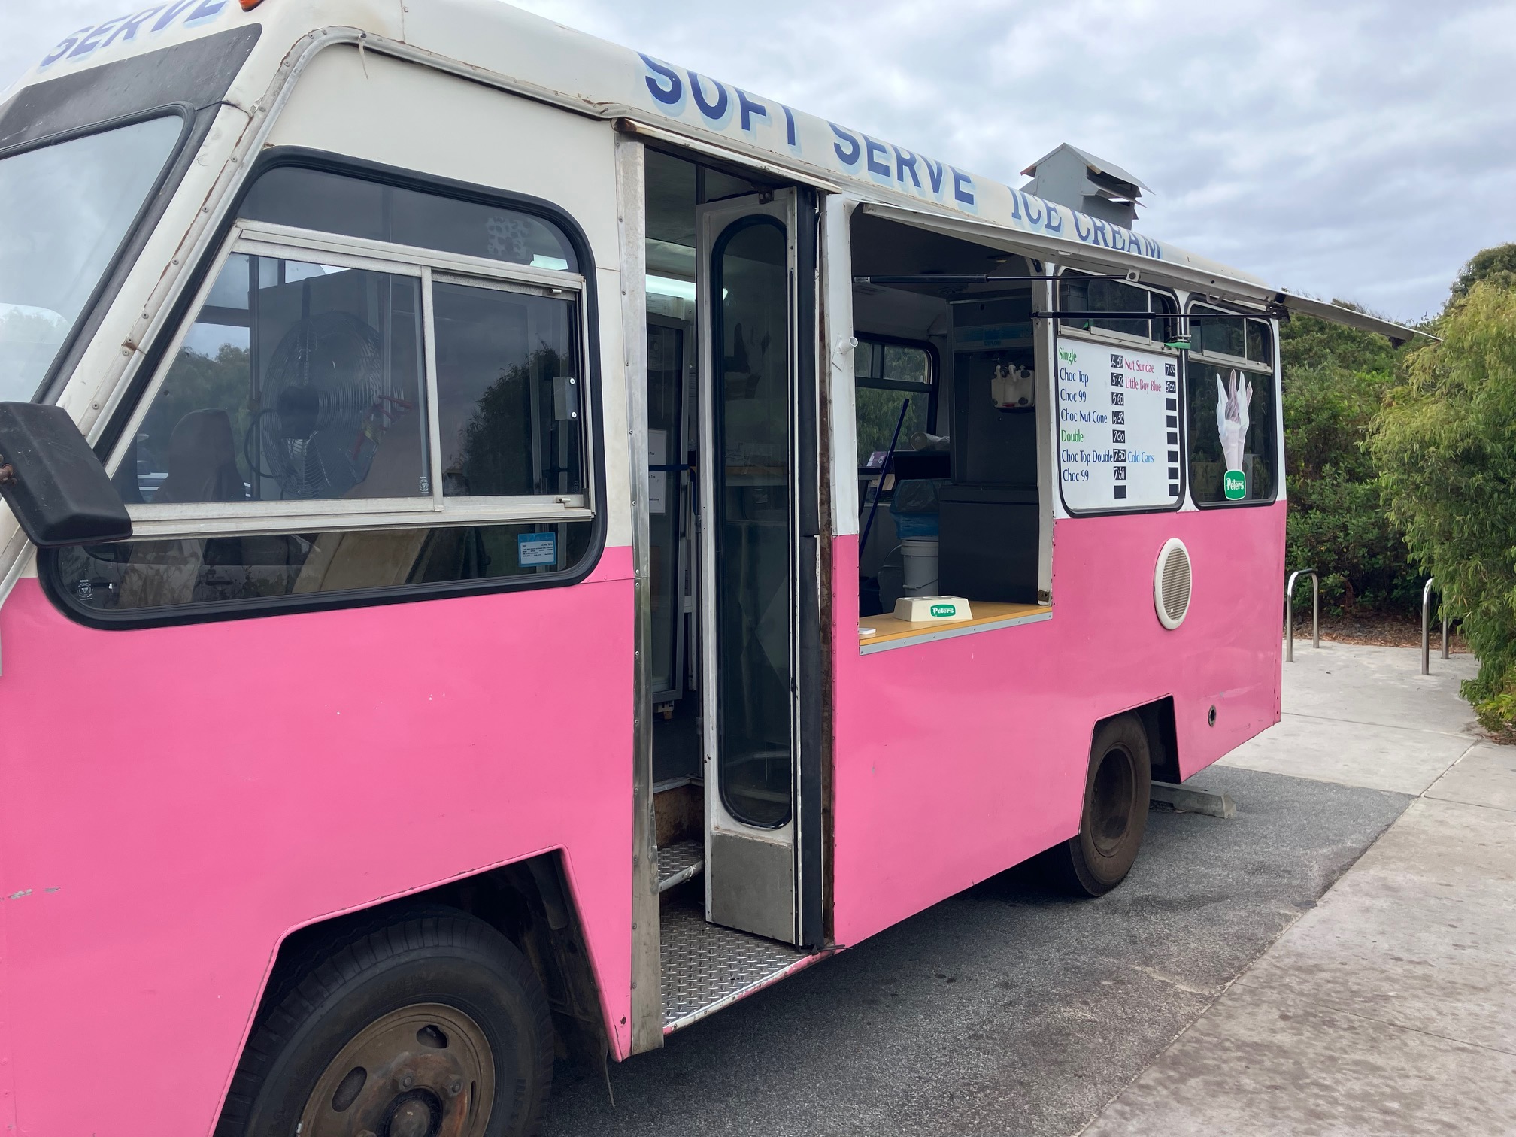
Ice cream Van

Guide Dog and Service Animals
The business provides the following services for services animals:
If service animals were in the Park we would be happy to provide water and assist with shade requirements

GENERAL
- In addition, the following further information can assist guests:
In our business and its location there are not long wait times. If this did occur, we would ask other customers to be patient while we attended to the needs of the person with the disability.

Cognitive Impairment Support
- Documents are available in plain English for people with cognitive impairment (This may include instructions, guides, menus and general information)
- A "social script" guide to your premises or attraction describing the sights, sounds and smells to aid parents/carers prepare visitors in advance
- The 'social script' is available in word and other editable formats

Car Park and Access amenities
The business has the following Car Park and Access amenities
- A drop off zone
- Designated disabled parking bays
- Level or ramped access from the car park to the entrance
- The accessible entrance is clearly signed from the parking bay
- Kerb ramps are in place where a pavement or walkway needs to be crossed
- In addition, the following further information can assist guests:
Additional information is in sign, and picture form that is provided by DBCA to inform Guests to the Park.

External Paths
External paths of travel
- Surfaces are concrete, asphalt, smooth paving or hard packed fine gravel (max aggregate size 13mm)
- Paths or slopes longer than 15 metres have resting places or seats
- Pathways are wider than 900mm

None in the Area where we trade

Not in the area where we trade. It is fully accessible.
- In addition, the following further information can assist guests:
What is on DBCA signage
- In addition, the following further information can assist guests:
No steps to gain access to around area where we trade.
- In addition, the following further information can assist guests:
The Park Toilets are accessible, and located close to our van.

FOOD AND DRINK

Dining Spaces
The dining spaces have the following facilities/amenities in place
- The entrance has level access
- The smallest doorway is 650mm wide
- All glass doors and full height windows have contrast markings
- There are areas of full lighting
- There are large print menus
- There are Plain English menus
- There is an accessible toilet close by that is open during our business hours

Our business caters for the following dietary requirements
- Gluten free (celiac)
- Low potassium
- Low sodium
- Nut free
- Vegetarian
- In addition, the following further information can assist guests:
We use very few food items, and all are kept in their separate lidded containers with own utensils.
- There is a sample menu available online
Sample menu is available here -
https://www.jf-ym-sharpe.com.au
  - Food and Beverage Image(s)
Ice cream Van
- In addition, the following further information can assist guests:
We only have one opening for customer contact.

Report Disclaimer
Please note that this business report, provided as a result of the use of the diagnostic assessment, is for information purposes only.
Australian Tourism Industry Council (ATIC) cannot guarantee the accuracy of respondent’s answers, or that they are fully representative of your business. Therefore, ATIC does not warrant or guarantee any particular outcome in respect of your businesses self-assessment.
This report is intended as guidance only for your business and should not be relied on for future marketing considerations. ATIC recommends that you seek your own independent advice as well as the results from the diagnostic.
Links to external web sites are inserted for convenience and do not constitute endorsement of material at those sites, or any associated organisation, product or service.
ATIC does not:
- Assume any legal liability for the accuracy, completeness, or usefulness of any information from this report or any links provided; or
- Accept responsibility for any loss associated directly or indirectly from the use of this report.

