ATIC Accessibility
To support the accessible community in making informed travel decisions for their individual needs

This report prepared for:
Business name: | Freycinet Resort
Address: | 1819, Coles Bay Road
Town: | Coles Bay
Contact for enquiries: | TOM YANG
Contact Number: | 03 6287 6345
Contact Email: | reservations@freycinet.com
Website: | www.freycinet.com
Date: | 2026-10-24 22:35

ATIC Accessibility
The following pages provides travellers with information on the businesses facilities and amenities which aims to support the traveller to make an informed decision on whether the business is suitable for their individual needs.
OVERVIEW 4
Business Overview 4
Bookings 4
Emergency Management 4
Communications 5
Other Information 5
Guide Dog and Service Animals 5
GENERAL 6
Pre-arrival, arrival and reception 6
Car Park and Access amenities 6
Internal Spaces 6
External Paths 7
Steps 7
Ramps 7
Public Toilets/Adult change facilities 7
ACCOMMODATION 9
Bedrooms 9
Room Amenities 9
Bathrooms 9
COMMON AREAS 11
FOOD AND DRINK 12
Dining Spaces 12
Report Disclaimer 18

OVERVIEW

Business Overview

The business has the following products/services available
- Accommodation
- Food and Drink

Our business caters for the following disability types:
- Wheelchairs or mobility scooters


Bookings

The business offers the following methods for bookings and enquiries:
- Phone
- Email
- Webportal

Emergency Management
- Emergency and evacuation procedures are explained on arrival
- Exit signs are clear and easy to see
- Exit access is free and clear at all times
We ensure exit access is free and clear at all times by:
Do daily visual checks (even quick walk-throughs) of all exit routes.
- Exits and access to exists are greater than 900mm
- Exit doors are able to be opened by all occupants
- Exits to the emergency evacuation point does not include stairways
- The evacuation point is clearly marked by a sign
- In addition, the following further information can assist guests:
In reservations or registration forms, include an optional question like:“Do you have any accessibility needs or require assistance in an emergency?”
- In addition, the following further information can assist guests:
Use the Buddy System — pair the guest with a trained staff member.
- Guests with disabilities are noted in the guest log book for emergency and evacuation purposes

Communications
- Our website meets WCAG 2.0 accessibility standards
- Our business offers the following alternative communication methods
- Plain English

Yes. We also accept enquiries and booking requests via telephone and email, so guests can choose the method that’s most convenient for them.
- There is easy to read signage and information (e.g. menus and emergency information)

Other Information
- For bookings made onsite, the ticket booth/counter/box office is accessible for people using a wheelchair

Guide Dog and Service Animals
- The business provides a secure area with shade and water for service animals
- The business provides a toilet area for service animals
The business provides the following services for services animals:
We welcome service animals in all areas of our premises that are open to customers. Our team is trained to accommodate guests accompanied by service animals and to provide any reasonable assistance needed. E.g. Assistance with entry and exit if required; Provision of water for the animal upon request.

GENERAL

Pre-arrival, arrival and reception
The business has the following in place to support guests during pre-arrival, arrival and reception
- There is a reception/public entryway.
- Seating available at reception
- A tablet with text to voice or pen and paper at reception to aid in communication
- Picture Board at reception to aid in communication
- Large print information sheets and registration forms
- Information and maps are available in written form
- A step free map/guide
- A familiarisation tour
- Luggage assistance
- In addition, the following further information can assist guests:
1. Priority Access / Reduced Wait Times
Offer faster appointment check-ins for individuals with disabilities, reducing time spent waiting at reception.

2. To accommodate guests who is disability, we offer the option to wait in our comfortable lounge area during the check-in process. This allows guests to sit and rest in a safe, accessible environment rather than standing in line, ensuring they are not disadvantaged by longer wait times. Staff are trained to proactively offer this option and will notify guests when it is their turn to proceed.

Car Park and Access amenities
The business has the following Car Park and Access amenities
- A drop off zone
- Level or ramped access from the car park to the entrance
- The accessible entrance is clearly signed from the parking bay

Internal Spaces
- Tableware/glassware contrast with the table surface or table cloth

External Paths
External paths of travel
- Surfaces are concrete, asphalt, smooth paving or hard packed fine gravel (max aggregate size 13mm)
- Pathways are wider than 900mm
- There 3 successive steps or less on any path or at any doorway

Steps
Steps
- There are steps.
- The underside of all staircases are enclosed or protected to a height of at least 2 metres
- Where steps are present are there three steps or less
- In addition, the following further information can assist guests:
All buildings on the premises are single-story structures located at ground level. If steps are present, we have alternative route with ramp for access. (This is for our main building and accessible cabin(s).

Ramps
Ramps have the following amenities are in place
- There are ramps.
- All fixed ramps are 1:14 or less
- Long ramps (more than 10m) are 1:20 or less

Public Toilets/Adult change facilities
Public Toilets/Adult change facilities have the following amenities are in place
- There is an accessible toilet for public use
- The door is at least 850mm wide
- There is a minimum of 850mm beside the toilet
- Handrails are fitted
- The toilet seat is 460mm above the floor
- The toilet seat of a contrasting colour to the floor
- The toilet seat is460mm above the floor
- In addition, the following further information can assist guests:
We have anaccessible toiletin the main building which has ramp access.

ACCOMMODATION

Bedrooms
The bedrooms have the following facilities/amenities in place
- There are 1 rooms available to guests who use a wheelchair
- Bedroom furniture can be re-arranged on request
  - Layout of room Image(s)
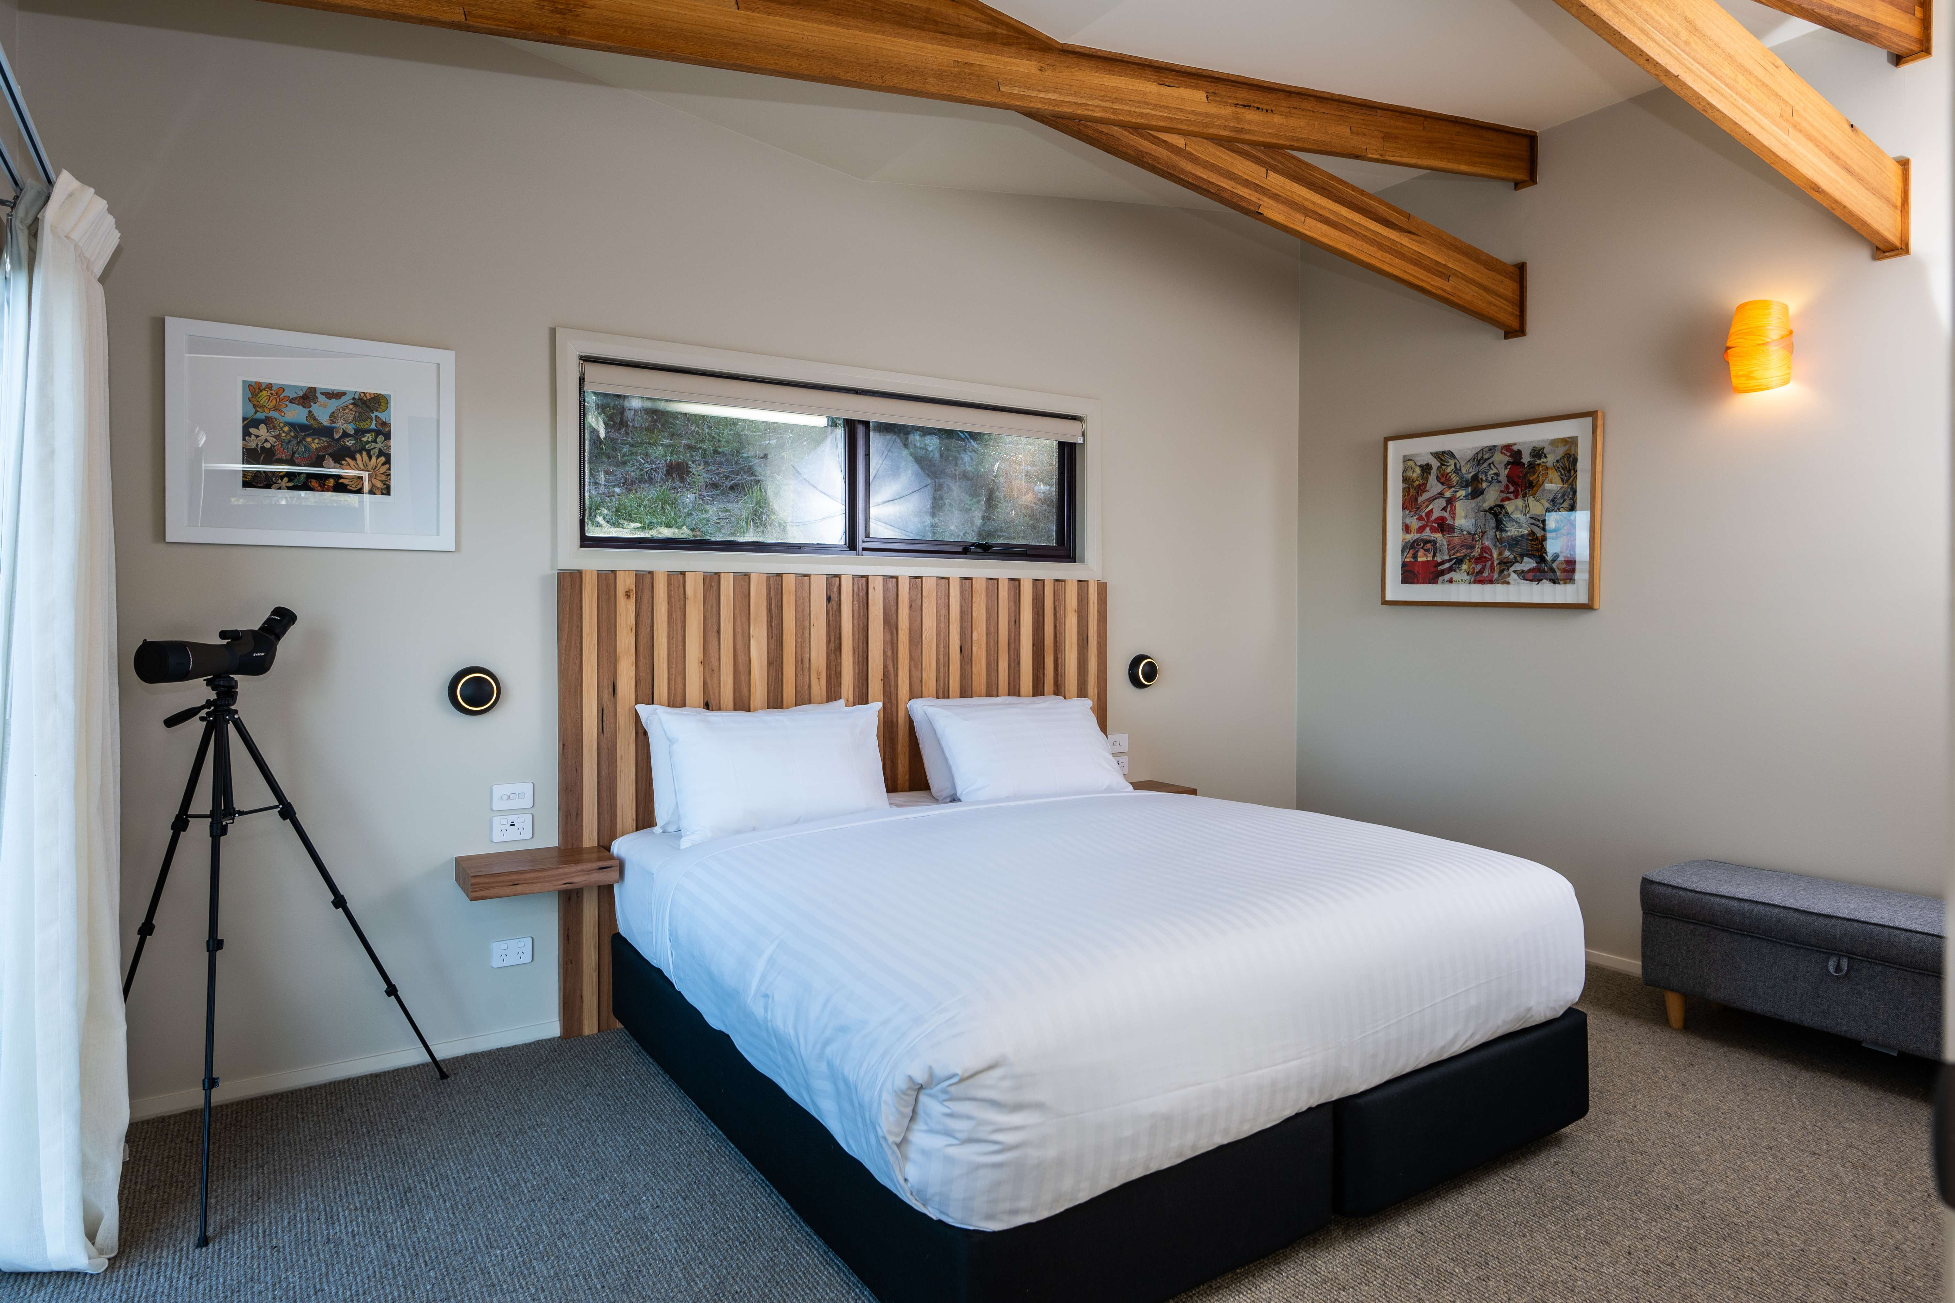
Retreat (Bed & Wall Space)

Room Amenities
- Televisions are equipped with closed captioning capability
- There is a clear path through the room
- Housekeeping procedures instruct staff not to reposition furniture that has been moved
- Doors open fully against the adjoining wall
- There is a clear opening at least 850mm wide
- There luggage racks for at least two suitcases
- There at least one chair with rigid arms
- Wardrobe and drawer handles are easy to grip
- The bedside lamp switch is easy to reach from the bed
- There is at least 850mm clear space beside the bed
- The bed height is no higher than 680mm from the floor

Bathrooms
The bathrooms have the following facilities/amenities in place
- All heating appliances and hot water pipes are protected or insulated
- The door is at least 850mm wide
- The width beside the toilet is 400mm.
- There is 850mm mm of clear space in front of the toilet
- The toilet seat is a contrasting colour to the floor
- The toilet seat is 460mm above the floor
- There is a portable shower head on flexible hose
- A door is fitted to the shower
  - Bathroom Image(s)
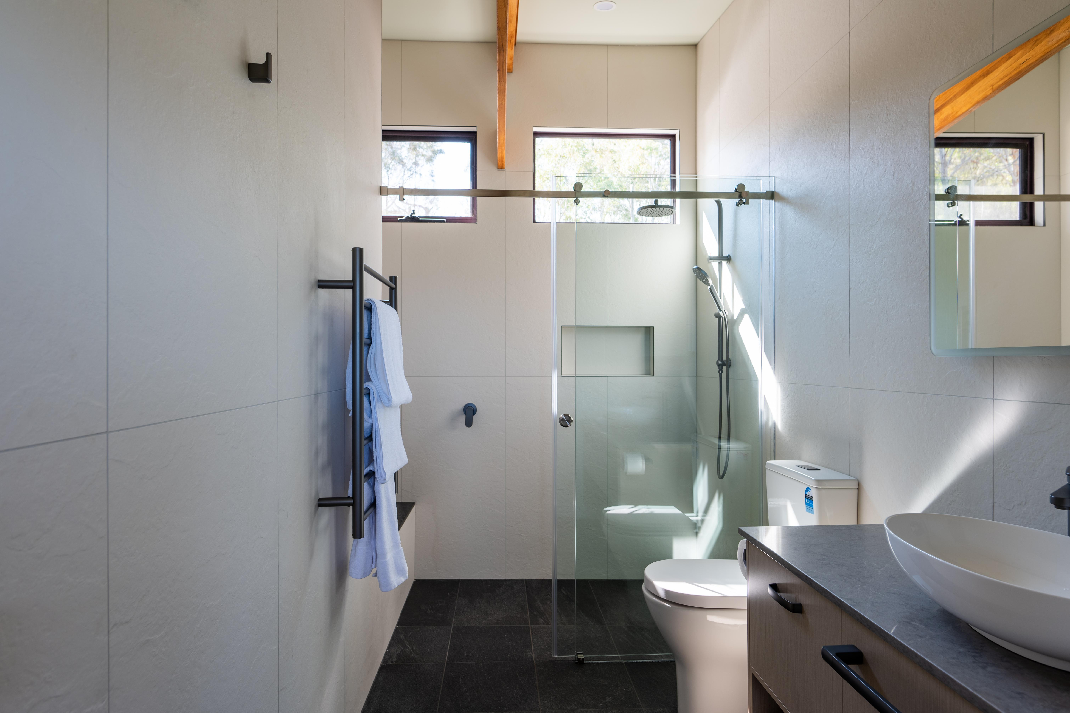
Retreat (Bathroom)_01
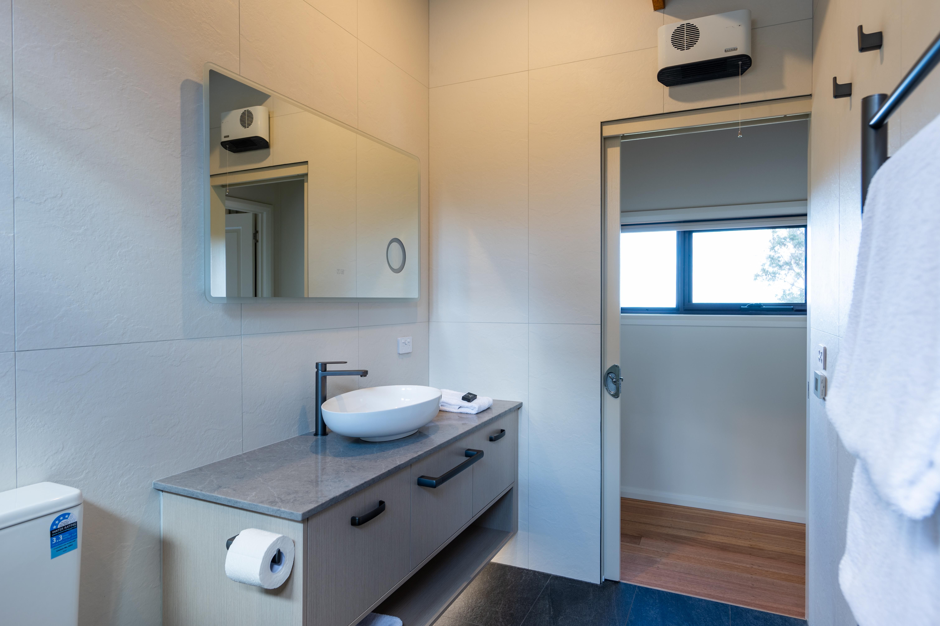
Retreat (Bathroom)_02
- In addition, the following further information can assist guests:
For ease of access, the bathroom, shower, and bedroom are each fitted with sliding doors.

COMMON AREAS

FOOD AND DRINK

Dining Spaces
The dining spaces have the following facilities/amenities in place
- The entrance has level access
- The doorway is at least 850mm wide
- There is level access through the dining area
- Chairs are moveable to allow for wheelchairs to be seated at the tables
- All glass doors and full height windows have contrast markings
- There are areas of full lighting
- There is an accessible toilet

Our business caters for the following dietary requirements
- Gluten free (celiac)
- Low sodium
- Nut free
- Vegetarian
- In addition, the following further information can assist guests:
1. General Food Safety PrinciplesAlways follow Good Hygiene Practices (GHP) and Hazard Analysis and Critical Control Points (HACCP) guidelines.

Wash hands thoroughly with warm water and antibacterial soap:

Before starting work.

After handling raw meat, seafood, or eggs.

After touching rubbish bins, cleaning chemicals, or non-food contact surfaces.

Avoid touching face, hair, or clothing during food preparation.

2. Food Storage PracticesStore raw and ready-to-eat foods separately:

Raw meats on the lowest shelves of refrigerators to prevent drips.

Ready-to-eat and cooked foods on higher shelves.

Use sealed, clearly labeled containers for all stored food.

Apply First-In, First-Out (FIFO) rotation for stock to minimize spoilage risk.

3. Preparation Area ControlDesignate separate preparation zones for:

Raw meat, poultry, and seafood.

Vegetables and fruits.

Ready-to-eat items (sandwiches, salads, baked goods).

Use color-coded cutting boards:

Red = Raw meat

Blue = Raw fish

Yellow = Raw poultry

Green = Vegetables &amp; fruits

White = Dairy &amp; bakery items

Keep knives and utensils for each zone separate and sanitized.

4. Equipment &amp; Utensil CleaningWash, rinse, and sanitize all food-contact surfaces after each task.

Never reuse unwashed cutting boards or utensils between raw and ready-to-eat foods.

Small equipment (blenders, slicers) must be disassembled, cleaned, and sanitized between uses.

5. Temperature ControlsKeep cold food at ≤5°C and hot food at ≥60°C

Use separate thermometers for raw and cooked foods, or sanitize between uses.

Chill cooked food quickly if not serving immediately (within 2 hours to below 5°C).

6. Waste &amp; Cleaning ControlEmpty rubbish bins regularly and keep lids closed.

Never store waste near food preparation or storage areas.

Use separate cleaning cloths for food contact surfaces vs. floors/equipment.

Keep mops, brooms, and cleaning chemicals stored away from food prep zones.

7. Staff Training &amp; MonitoringTrain all kitchen staff on cross-contamination risks and safe food handling.

Conduct regular refresher courses and practical demonstrations.

Supervisors must monitor workstations and correct unsafe practices immediately.

Keep records of cleaning schedules, fridge/freezer temperature checks, and staff training.

- There is a sample menu available online
Sample menu is available here -
https://www.freycinet.com/wp-content/uploads/2024/11/MPL_Menu-Omakase_7Shabu-Shabu_V2.2_Nov-2024.pdf
  - Food and Beverage Image(s)
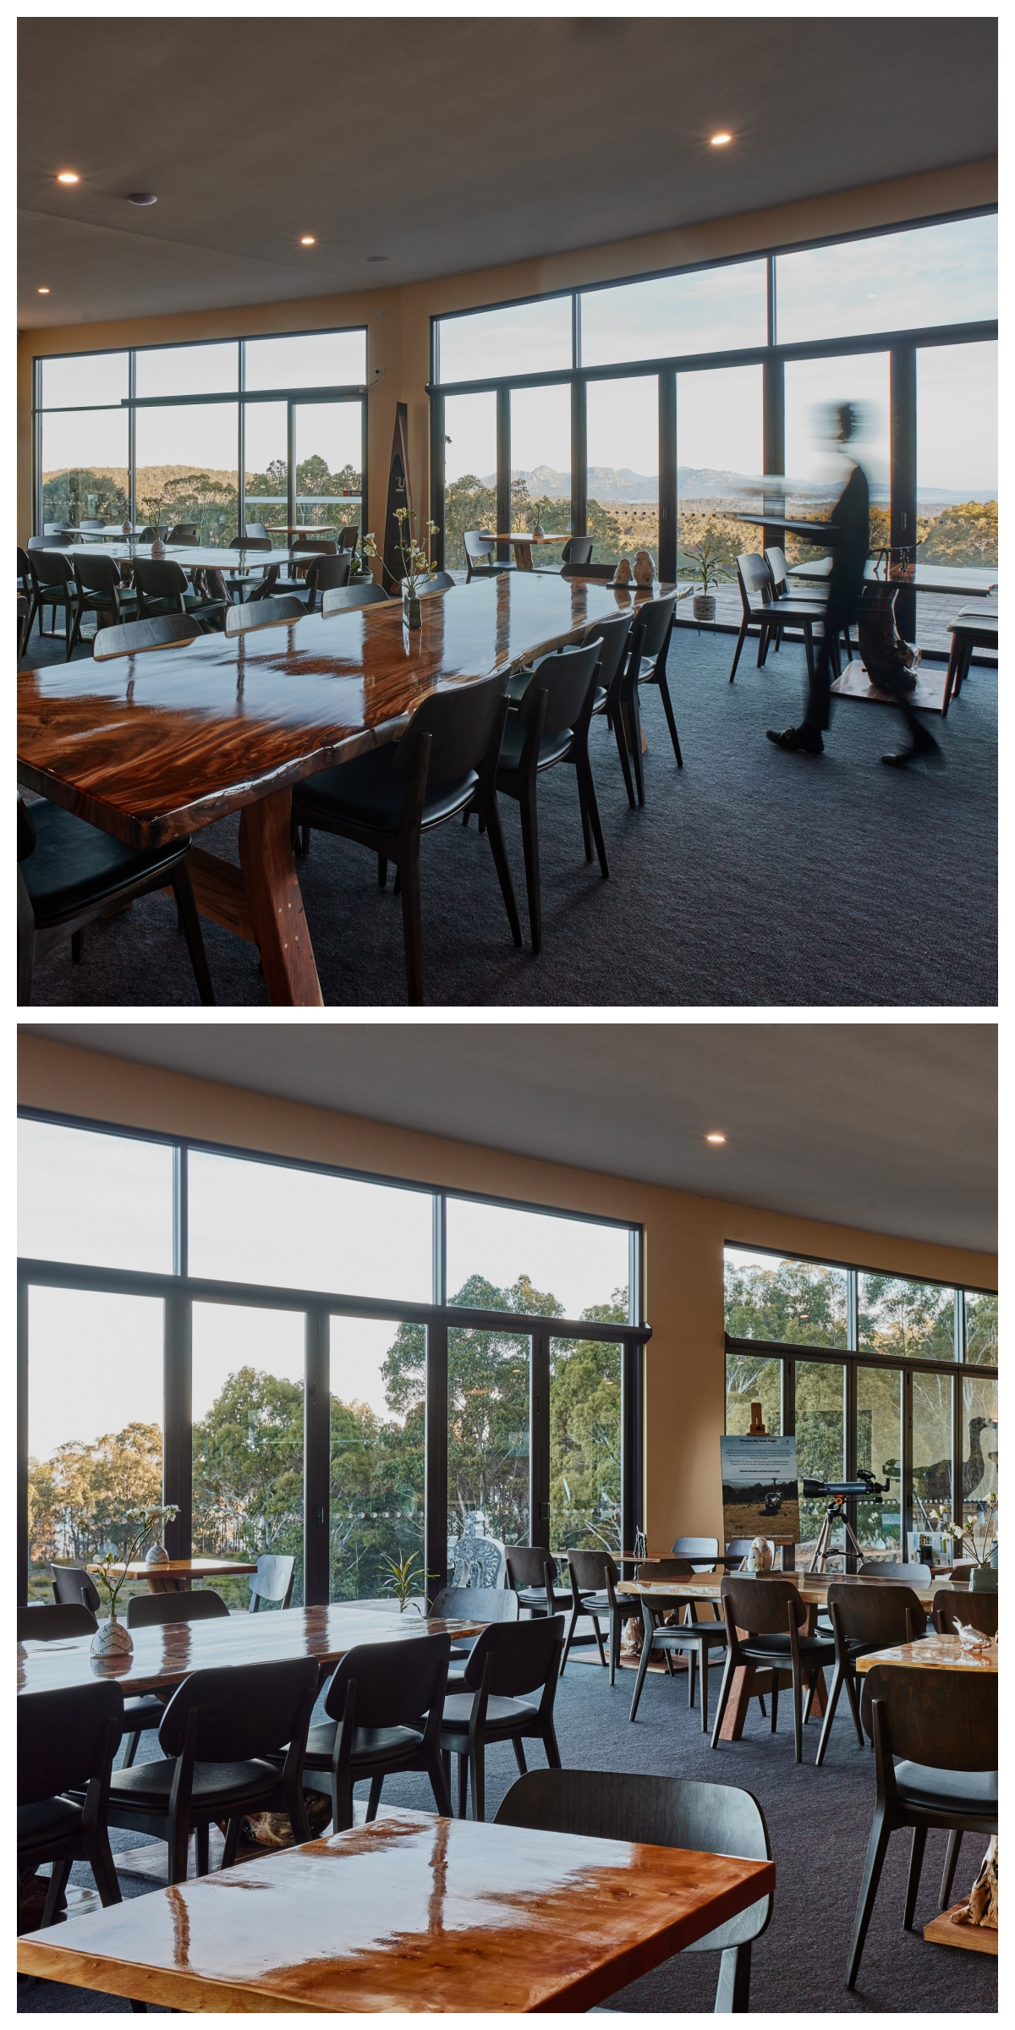
Tables allow for wheelchairs
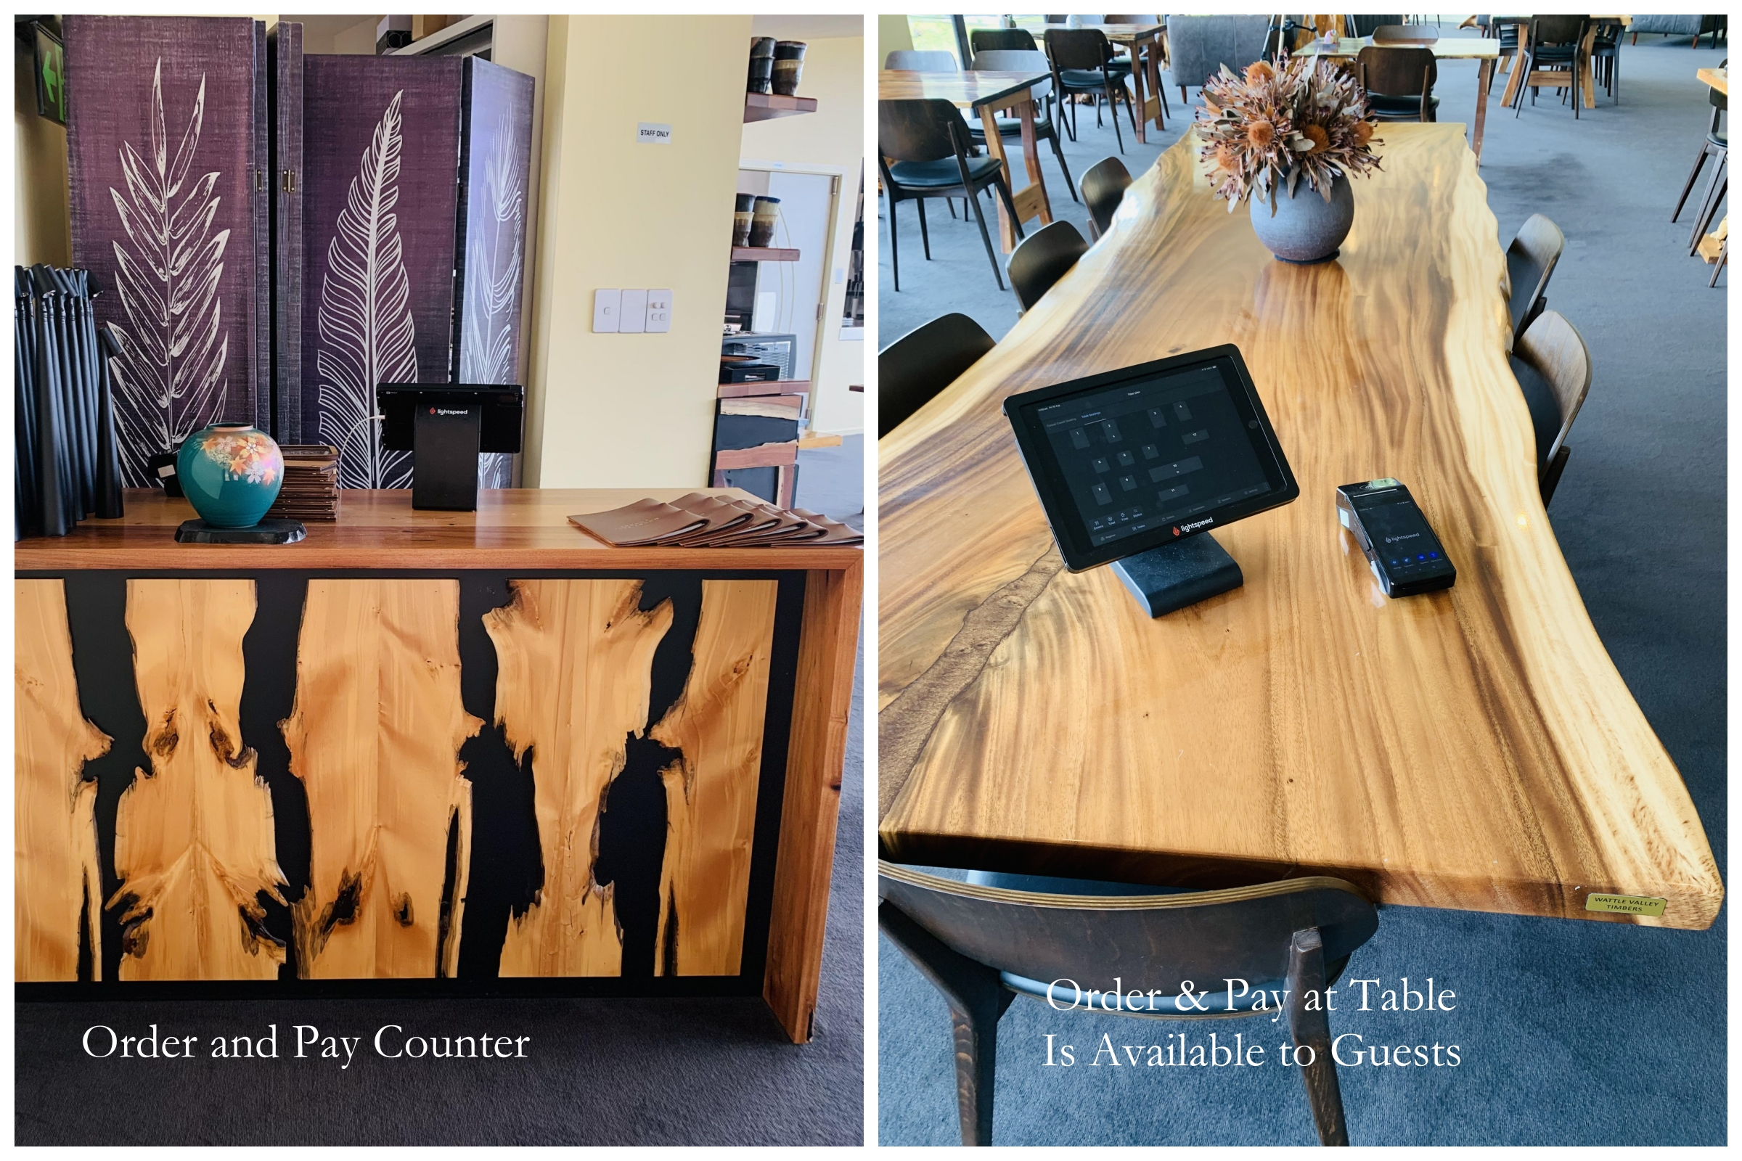
Order and pay
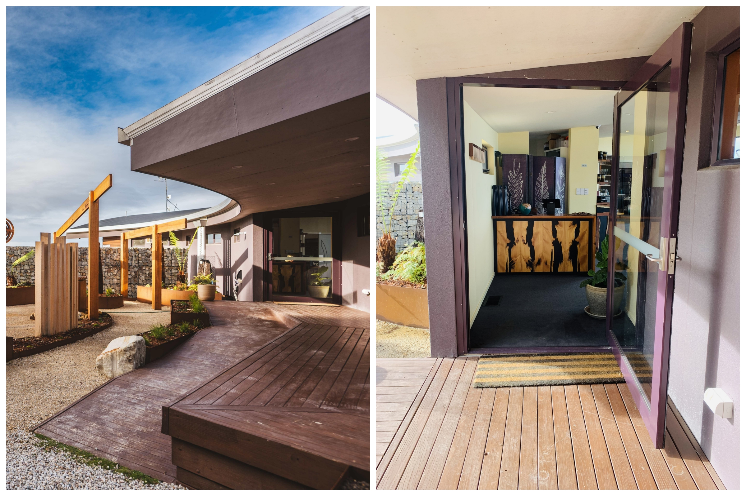
Entry & Door

Report Disclaimer
Please note that this business report, provided as a result of the use of the diagnostic assessment, is for information purposes only.
Australian Tourism Industry Council (ATIC) cannot guarantee the accuracy of respondent’s answers, or that they are fully representative of your business. Therefore, ATIC does not warrant or guarantee any particular outcome in respect of your businesses self-assessment.
This report is intended as guidance only for your business and should not be relied on for future marketing considerations. ATIC recommends that you seek your own independent advice as well as the results from the diagnostic.
Links to external web sites are inserted for convenience and do not constitute endorsement of material at those sites, or any associated organisation, product or service.
ATIC does not:
- Assume any legal liability for the accuracy, completeness, or usefulness of any information from this report or any links provided; or
- Accept responsibility for any loss associated directly or indirectly from the use of this report.

