ATIC Accessibility
To support the accessible community in making informed travel decisions for their individual needs

This report prepared for:
Business name: | Epic Ocean Adventures Noosa
Address: | 60 Noosa Drive
Town: | Noosa Heads
Contact for enquiries: | Tyron van Santen
Contact Number: | +61753728066
Contact Email: | noosa@epicoceanadventures.com.au
Website: | https://www.epicoceanadventures.com.au
Date: | 2026-10-22 15:48

ATIC Accessibility
The following pages provides travellers with information on the businesses facilities and amenities which aims to support the traveller to make an informed decision on whether the business is suitable for their individual needs.
OVERVIEW 3
Business Overview 3
Bookings 3
Emergency Management 4
Guide Dog and Service Animals 4
GENERAL 5
Pre-arrival, arrival and reception 5
Car Park and Access amenities 5
TOUR OPERATORS 6
Tour/Transport Services 6
Route Planning 6
Guides 6
ADVENTURE ACTIVITIES 7
Adventure activities 7
Report Disclaimer 9

OVERVIEW

Business Overview

The business has the following products/services available
- Tour/Transport
- Adventure

Our business caters for the following disability types:
- Limited mobility
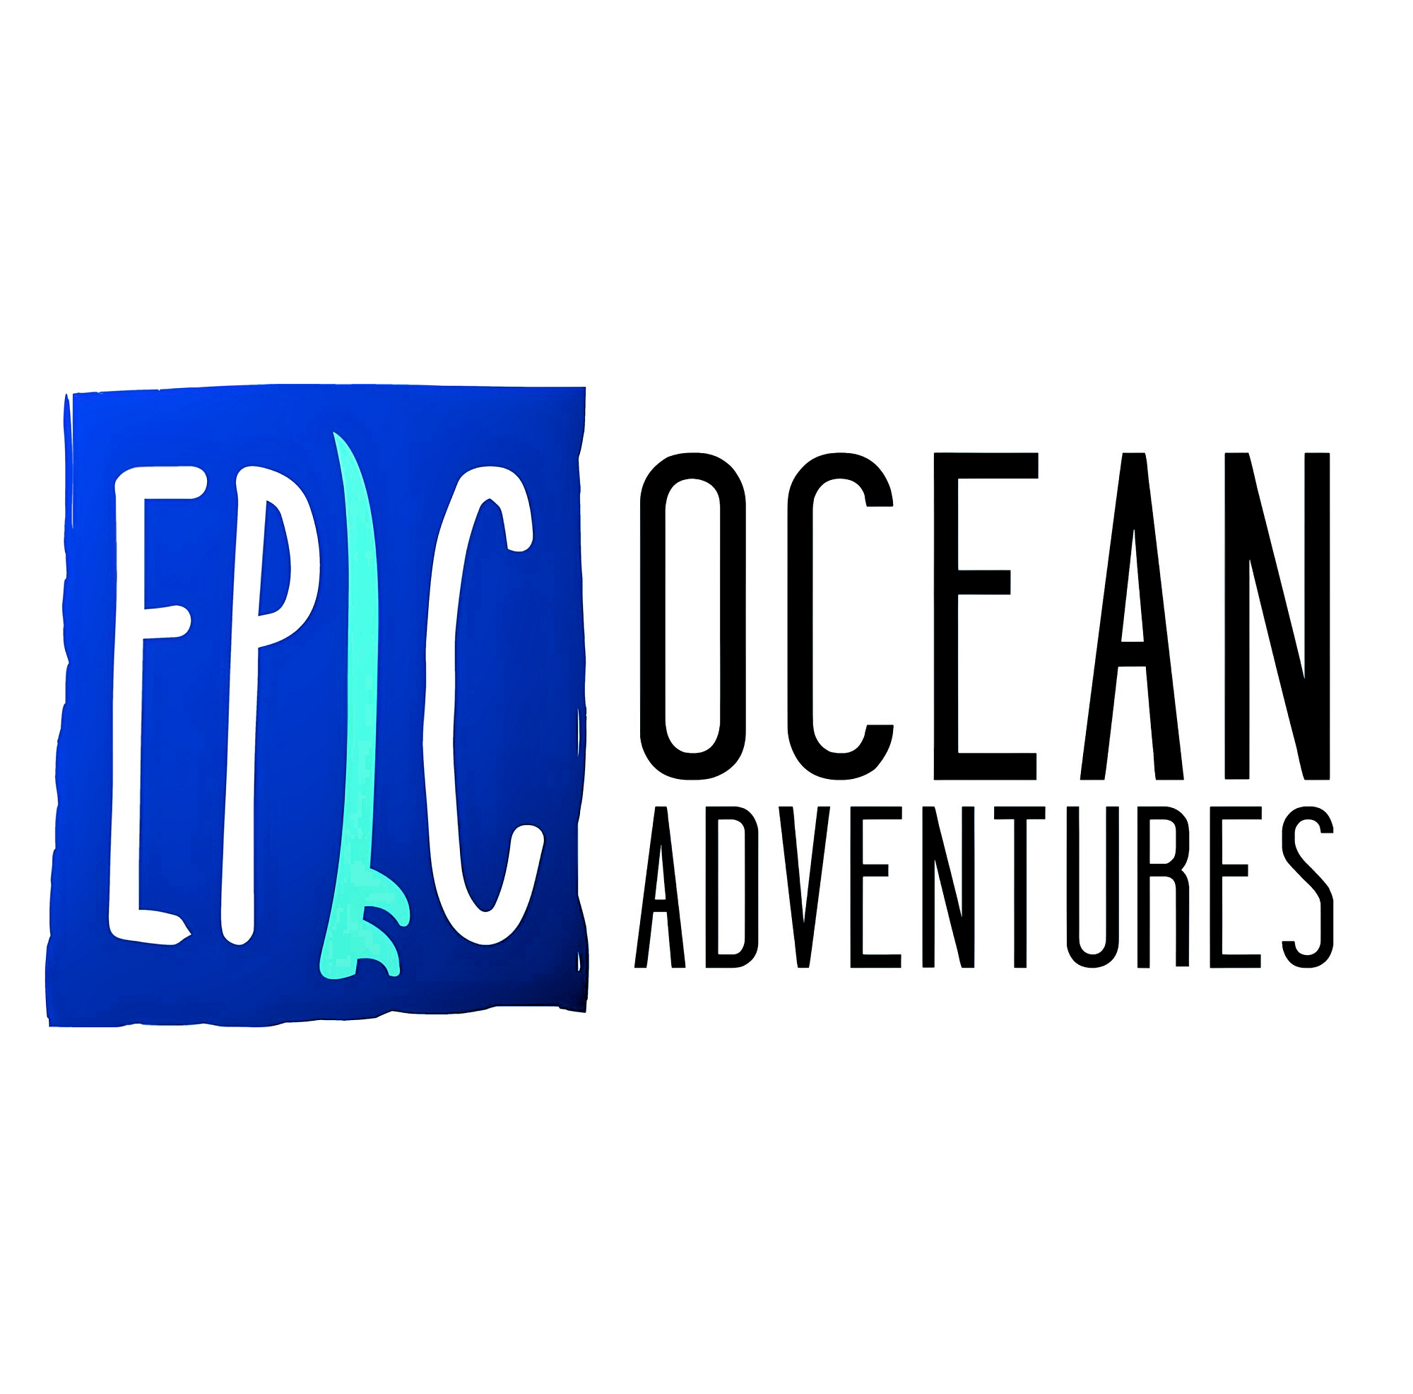

Bookings

The business offers the following methods for bookings and enquiries:
- Phone
- Email
- Webportal
- Our forms have high contract boxes and submit boxes

Emergency Management
- Exit signs are clear and easy to see
- Exit access is free and clear at all times
We ensure exit access is free and clear at all times by:
Vehicle exits are clear as required by law
- Exit doors are able to be opened by all occupants
- Exits to the emergency evacuation point does not include stairways
- In addition, the following further information can assist guests:
participation decleration, rezdy booking notes prior to tour day
- In addition, the following further information can assist guests:
Those requiring assistance are attended to first by guides
- Guests with disabilities are noted in the guest log book for emergency and evacuation purposes

Guide Dog and Service Animals
The business provides the following services for services animals:
Not specified

GENERAL

Pre-arrival, arrival and reception
The business has the following in place to support guests during pre-arrival, arrival and reception
- Information and maps are available in written form
- In addition, the following further information can assist guests:
seating, clear communication on duration times and itinerary,

Car Park and Access amenities
The business has the following Car Park and Access amenities
- A drop off zone
- Designated disabled parking bays
- Level or ramped access from the car park to the entrance
The width of the smallest pathway is:
n/a

TOUR OPERATORS

Tour/Transport Services
The tour/transport services have the following facilities/amenities in place
- Buses/Coaches
- none vehicles have wheelchair lifts or ramps
- none vehicles have low floors with ramped entry
The maximum wheelchair capacity available in the fleet is:
none

Route Planning
- Route Planning
- In addition, the following further information can assist guests:
due to the wild National Park environment in which we operate we find it challenging to offer accessible options during this time.

Guides
- Use of clear/simple English
- Marine
- Accessibility is tide dependent

ADVENTURE ACTIVITIES

Adventure activities
The adventure activities have the following facilities/amenities in place
- Our adventure activities cater for people with a disability
- In addition, the following further information can assist guests:
kayaking, surfing.
- In addition, the following further information can assist guests:
bus handrails.

- In addition, the following further information can assist guests:
Depending on the disability we need to be mindful of the physical nature of the tours and activities we operate in regards to disabilities and suitability

Report Disclaimer
Please note that this business report, provided as a result of the use of the diagnostic assessment, is for information purposes only.
Australian Tourism Industry Council (ATIC) cannot guarantee the accuracy of respondent’s answers, or that they are fully representative of your business. Therefore, ATIC does not warrant or guarantee any particular outcome in respect of your businesses self-assessment.
This report is intended as guidance only for your business and should not be relied on for future marketing considerations. ATIC recommends that you seek your own independent advice as well as the results from the diagnostic.
Links to external web sites are inserted for convenience and do not constitute endorsement of material at those sites, or any associated organisation, product or service.
ATIC does not:
- Assume any legal liability for the accuracy, completeness, or usefulness of any information from this report or any links provided; or
- Accept responsibility for any loss associated directly or indirectly from the use of this report.

