ATIC Accessibility
To support the accessible community in making informed travel decisions for their individual needs

This report prepared for:
Business name: | Hamelin Bay Holiday Park
Address: | Hamelin Bay Rd West
Town: | Hamelin Bay
Contact for enquiries: | Melissa Lay
Contact Number: | 08 97585540
Contact Email: | bookings@hamelinbayholidaypark.com.au
Website: | https://www.hamelinbayholidaypark.com.au
Date: | 2026-10-23 08:53

ATIC Accessibility
The following pages provides travellers with information on the businesses facilities and amenities which aims to support the traveller to make an informed decision on whether the business is suitable for their individual needs.
OVERVIEW 4
Business Overview 4
Bookings 4
Emergency Management 4
Other Information 5
GENERAL 6
Pre-arrival, arrival and reception 6
Car Park and Access amenities 6
Entry 6
Internal Spaces 6
Public areas 7
External Paths 7
Steps 7
Ramps 7
Public Toilets/Adult change facilities 8
ACCOMMODATION 9
Bedrooms 9
Room Amenities 9
Bathrooms 9
ATTRACTIONS 11
COMMON AREAS 12
Play Spaces 12
FOOD AND DRINK 13
Dining Spaces 13
Report Disclaimer 17

OVERVIEW

Business Overview

The business has the following products/services available
- Accommodation
- Food and Drink

Our business caters for the following disability types:
- Blind or low vision
- Limited mobility
- Wheelchairs or mobility scooters


Bookings

The business offers the following methods for bookings and enquiries:
- Phone
- Email
- Webportal

Emergency Management
- There are Audible device/s to alert occupants to evacuate with instructions on how to evacuate.
- Exit signs are clear and easy to see
- Exit access is free and clear at all times
We ensure exit access is free and clear at all times by:
The exit and entrance to the holiday park is via a road that is always open
- Exits and access to exists are greater than 900mm
- Exit doors are able to be opened by all occupants
- Exits to the emergency evacuation point does not include stairways
- The evacuation point is clearly marked by a sign
- In addition, the following further information can assist guests:
Notes on our guests inhouse report
- In addition, the following further information can assist guests:
Our staff are available 24hours per day, 7 days per week to assist our guests with urgent matters
- Guests with disabilities are noted in the guest log book for emergency and evacuation purposes

Other Information
- For bookings made onsite, the ticket booth/counter/box office is accessible for people using a wheelchair
- The business accepts the companion card
The business provides the following services for services animals:
Service animals stay with their owners either in onsite accommodation or on a caravan camping site. They are taken care of by their owners.

GENERAL

Pre-arrival, arrival and reception
The business has the following in place to support guests during pre-arrival, arrival and reception
- Booking information and websites are compatible with screen readers
- There is a reception/public entryway.
- Seating available at reception
- Lighting in the reception area is even and glare free
- Information and maps are available in written form
- A step free map/guide
- In addition, the following further information can assist guests:
None

Car Park and Access amenities
The business has the following Car Park and Access amenities
- A drop off zone
- Level or ramped access from the car park to the entrance
- The accessible entrance is clearly signed from the parking bay

Entry
The business has the following amenities/systems in place for entry
- A drop off point close to the entrance
- A path of access to the building is slip resistance and even
- A path of access to the building is clear of obstruction
- Door handles are of a contrasting colour to the door
- Signage is written in a contrasting colour
- The entry door is a minimum of 850mm wide
- The entrance door mats have a thickness less than 13mm and a width of 7500mm or greater

Internal Spaces
- Interior walls are matte or low sheen
- Floors, walls, counters and furniture are of contrasting colours
- Any protruding or overhanging obstructions are at least 2meters above the floor or are protected
- Floor surfaces are hard or short pile carpet
- Seating is available for guests unable to stand for long periods
- Accessible facilities are clearly signed and visible from all areas
- All corridors greater than 900mm

Public areas
The public areas have the following amenities in place
- Seating

External Paths
External paths of travel
- Pathways are wider than 900mm
- There 3 successive steps or less on any path or at any doorway

Steps
Steps
- There are steps.
- Handrails fitted to all open sets of steps
- Handrails extend 300mm beyond the top and bottom step

Ramps
Ramps have the following amenities are in place
- There are ramps.
- All fixed ramps are 1:14 or less
- Hand rails are fitted
- Long ramps (more than 10m) are 1:20 or less
- Ramps have a raised edge of at least 100mm

Public Toilets/Adult change facilities
Public Toilets/Adult change facilities have the following amenities are in place
- There is an accessible toilet for public use
- The door is at least 850mm wide
- There is a minimum of 850mm beside the toilet
- Handrails are fitted
- The toilet seat is 460mm above the floor
- The toilet seat of a contrasting colour to the floor
- The toilet seat is460mm above the floor
- There is a registered changing places facility
- In addition, the following further information can assist guests:
The closest 'changing place' is in Margaret River at the Recreation Centre, 38kms away from Hamelin Bay

ACCOMMODATION

Bedrooms
The bedrooms have the following facilities/amenities in place
- There are 1 cottage and 2 accessible public bathrooms rooms available to guests who use a wheelchair

Room Amenities
- Visual alarm is fitted to the room
- Televisions are equipped with closed captioning capability
- There is a clear path through the room
- The edges of all furniture and fixtures are rounded
- Wardrobe handles are a contrasting colour to the doors and draws
- Housekeeping procedures instruct staff not to reposition furniture that has been moved
- Doors open fully against the adjoining wall
- There is a clear opening at least 850mm wide
- There luggage racks for at least two suitcases
- There at least one chair with rigid arms
- Wardrobe and drawer handles are easy to grip
- The bedside lamp switch is easy to reach from the bed
- There is at least 850mm clear space beside the bed
- The bed height is no higher than 680mm from the floor
- Non-allergenic cleaning products are used

Bathrooms
The bathrooms have the following facilities/amenities in place
- All heating appliances and hot water pipes are protected or insulated
- All shower, bath and basin taps are clearly differentiated between hot and cold
- Fixtures and fittings have rounded edges
- The hot water is thermostatically controlled to 41 degrees
- The door is at least 850mm wide
- There is a minimum of 850mm beside the toilet
- Handrails are fitted
- There is a minimum of 1400mm of clear space in front of the toilet
- The toilet seat is a contrasting colour to the floor
- The actual height of the toilet seat is 420mm.
- There is a roll-in shower with fold down fixed seat or a shower chair
- There is a portable shower head on flexible hose
- A door is fitted to the shower
- A door is fitted to the showers with an outward swing at minimum width of 900 mm

ATTRACTIONS

https://hamelinbayholidaypark.com.au/

COMMON AREAS

Play Spaces
- The space contain colour contrasting elements
  - Image(s)
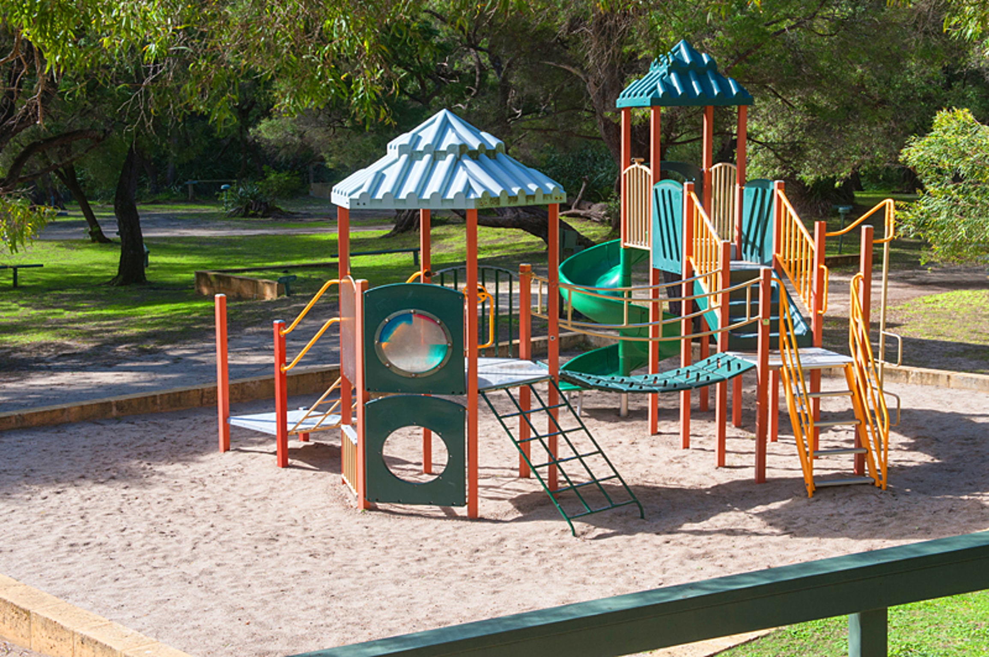
playground

FOOD AND DRINK

Dining Spaces
The dining spaces have the following facilities/amenities in place
- The smallest doorway is 800mm wide
- All glass doors and full height windows have contrast markings
- There are areas of full lighting
- There is an accessible toilet

Our business caters for the following dietary requirements
- Gluten free (celiac)
- Vegetarian
- In addition, the following further information can assist guests:
We have a small kiosk onsite - all of our food is delivered packaged and sold to the customer packaged.
  - Food and Beverage Image(s)
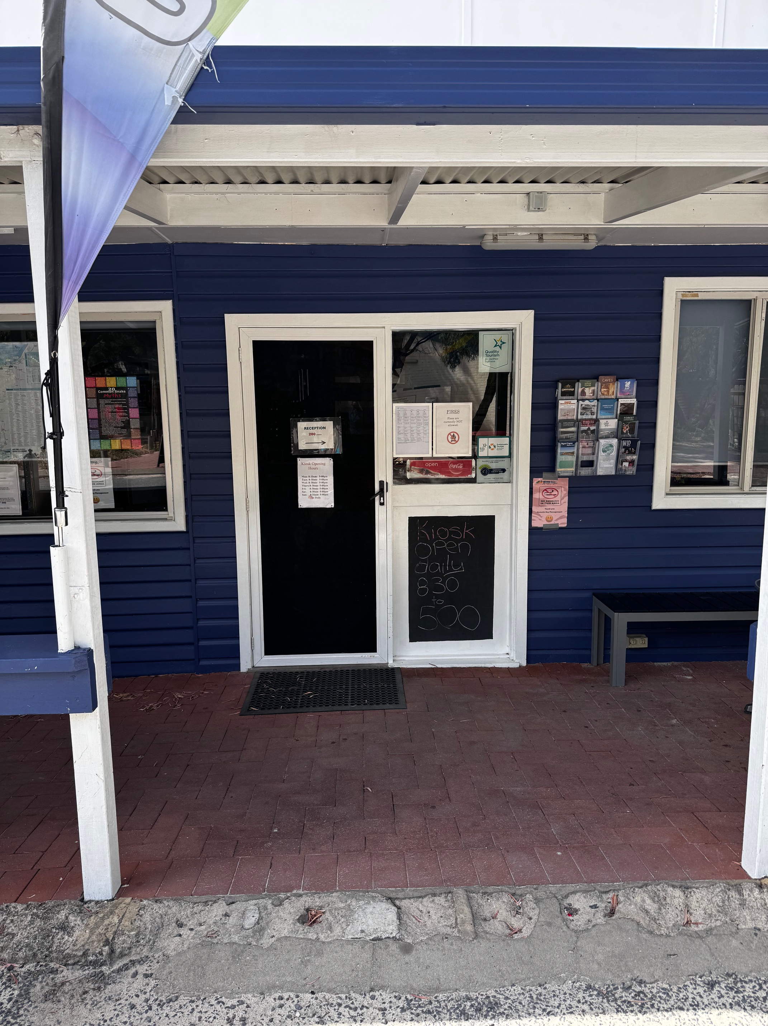
IMG_4714
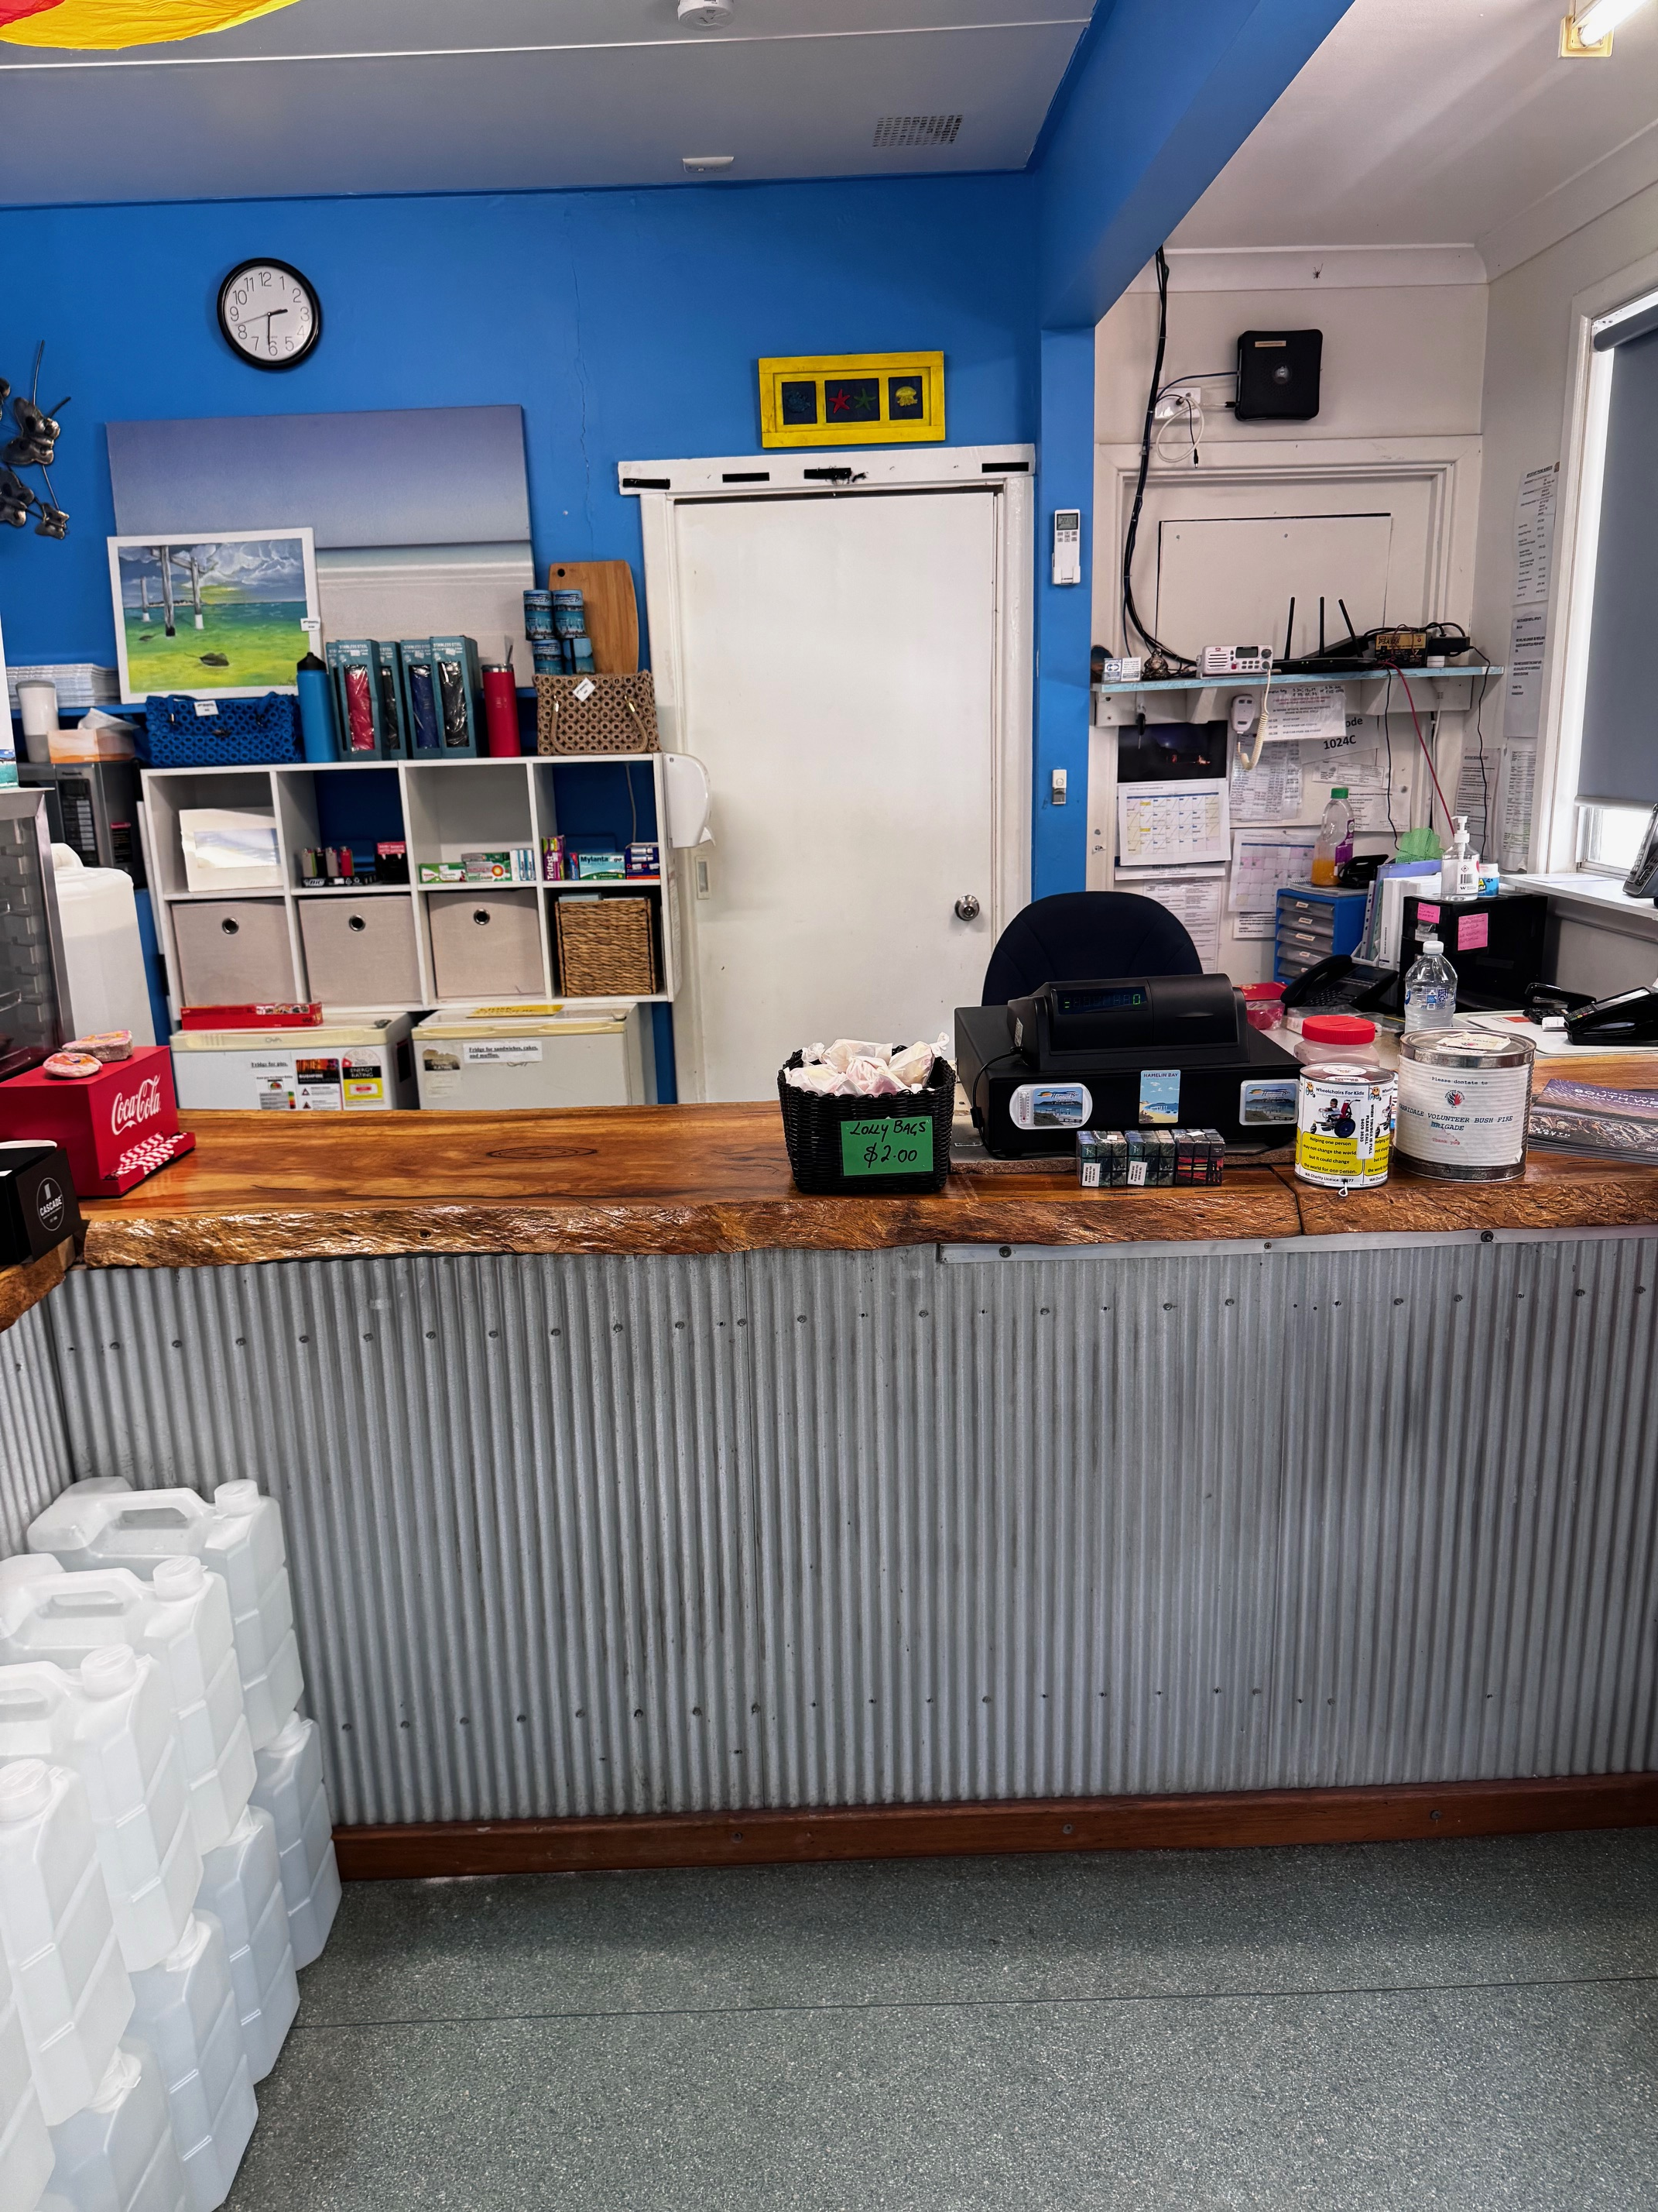
IMG_4716
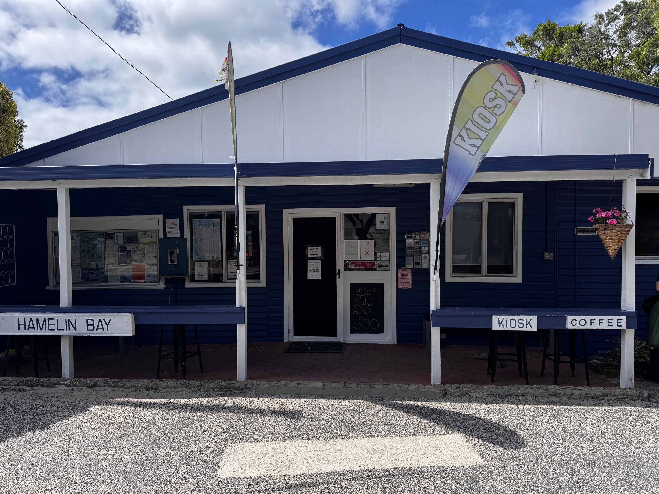
IMG_4713
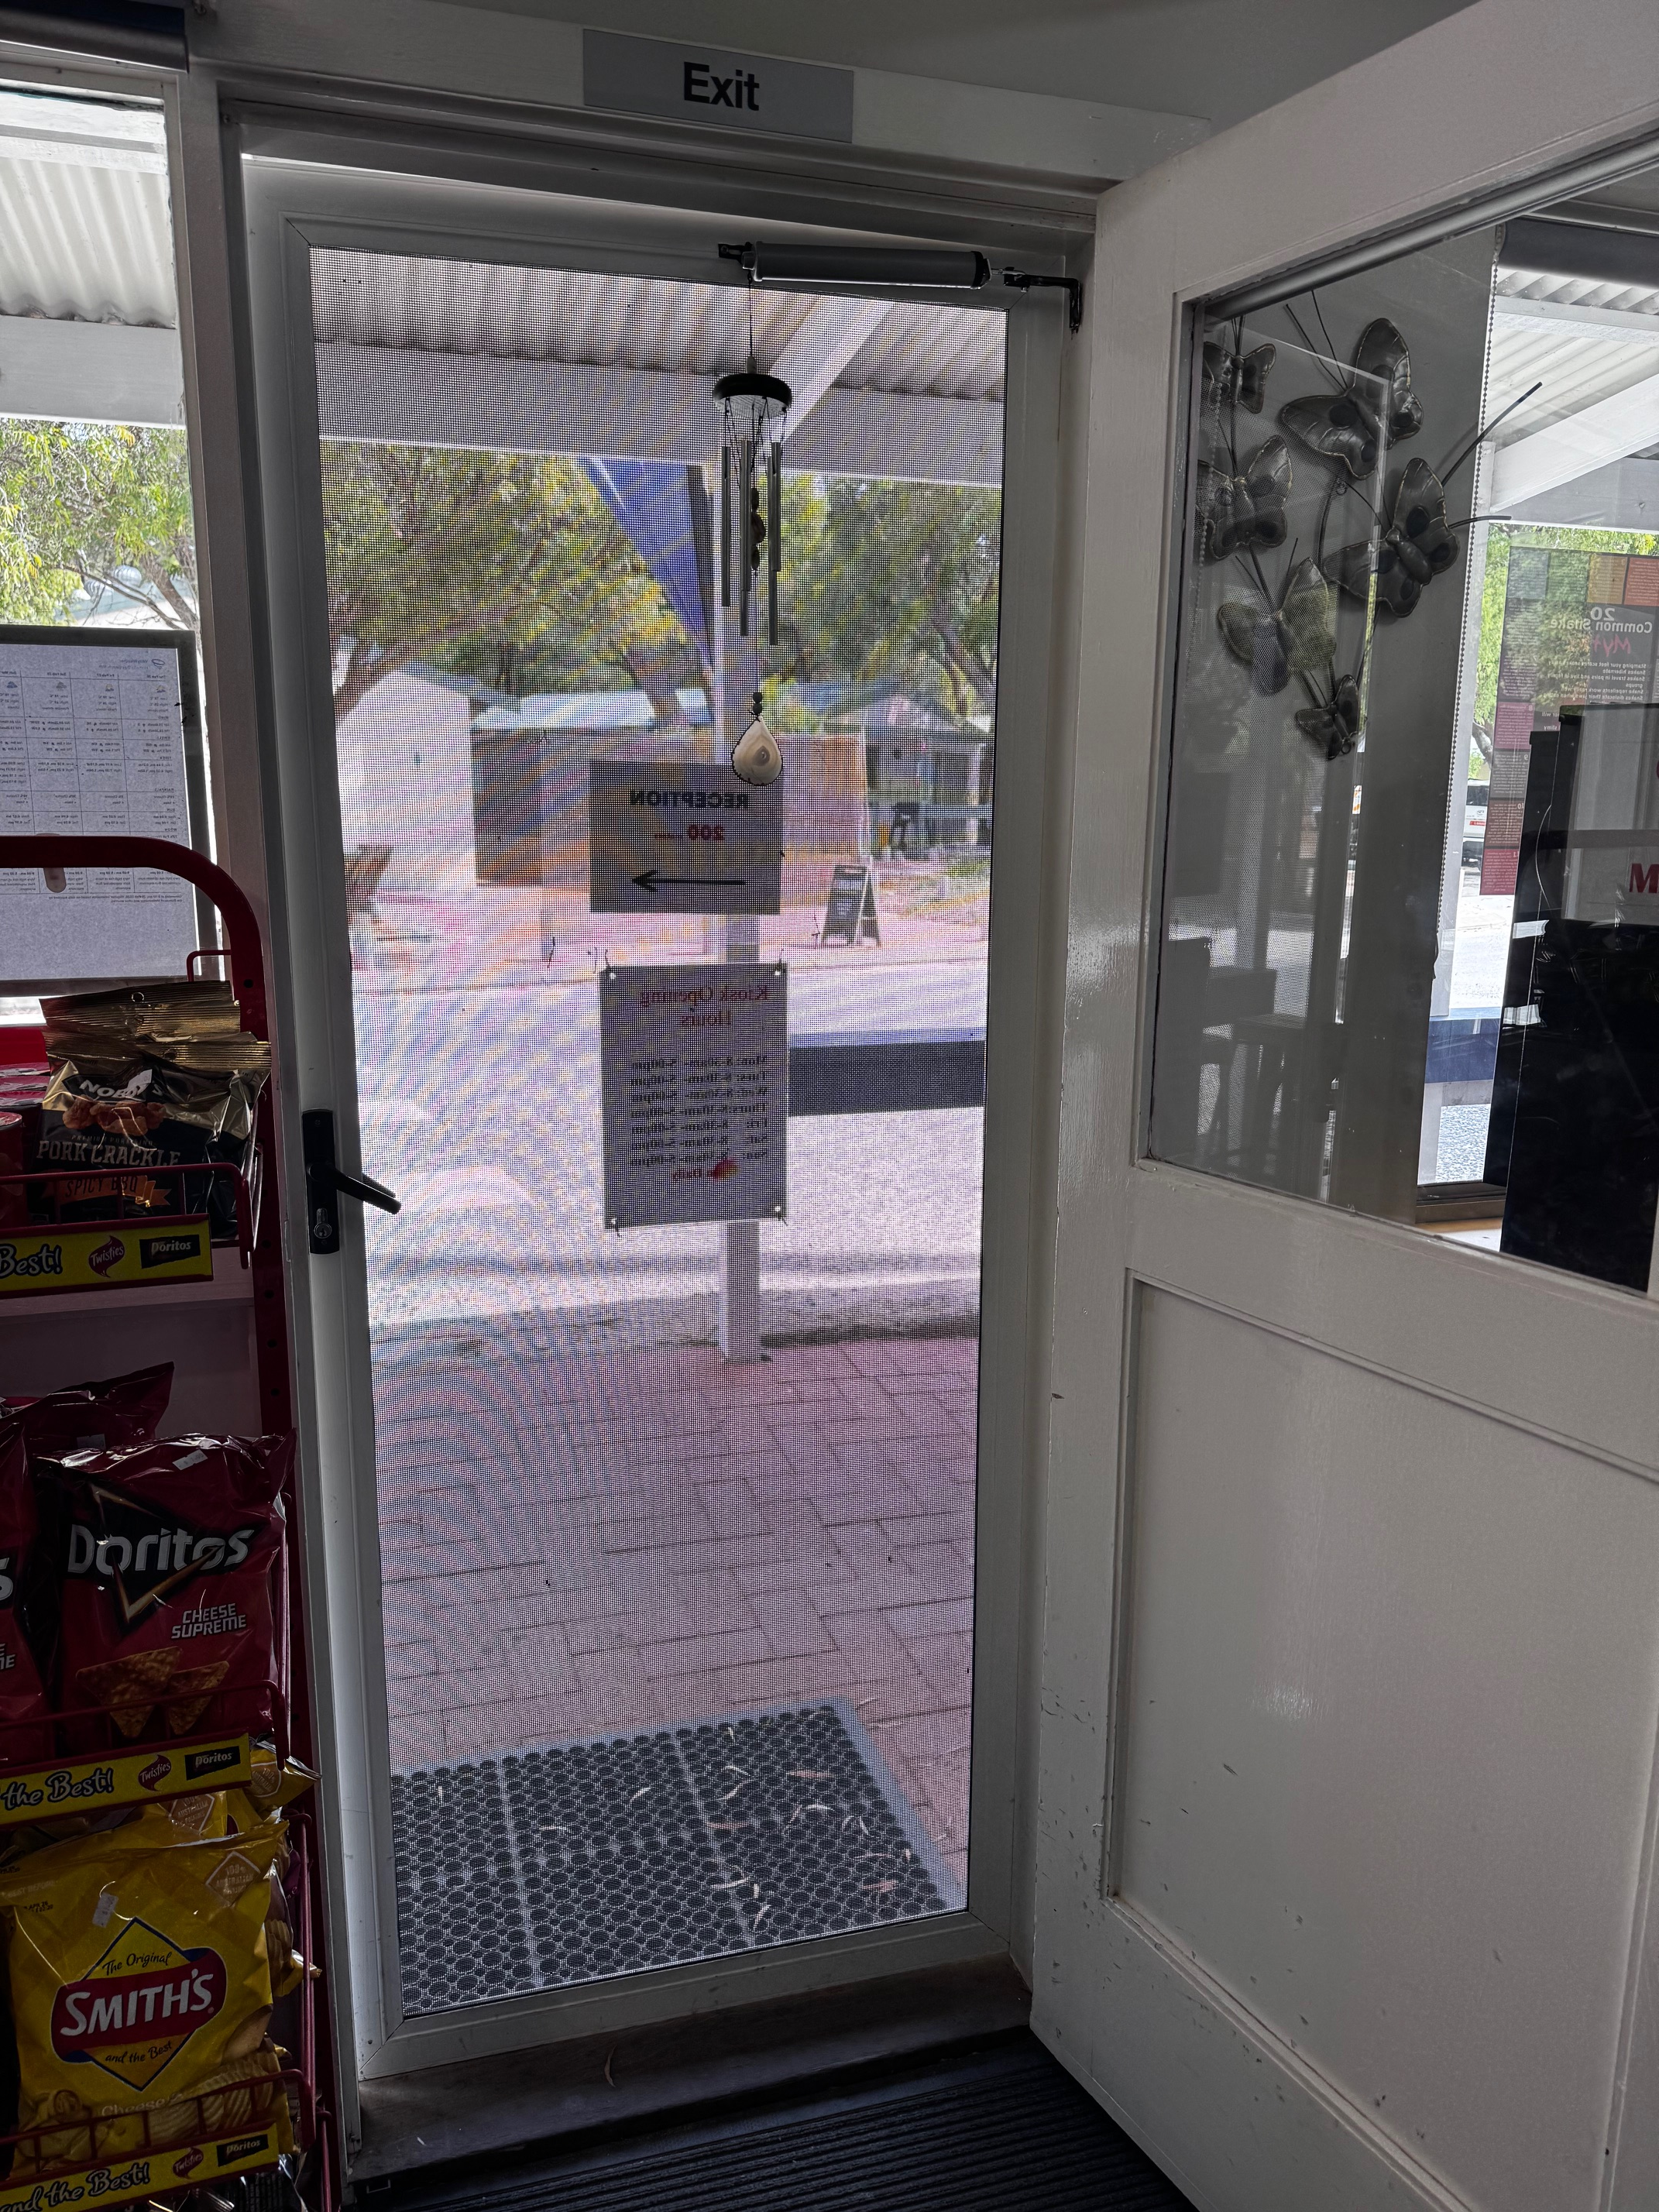
IMG_4717
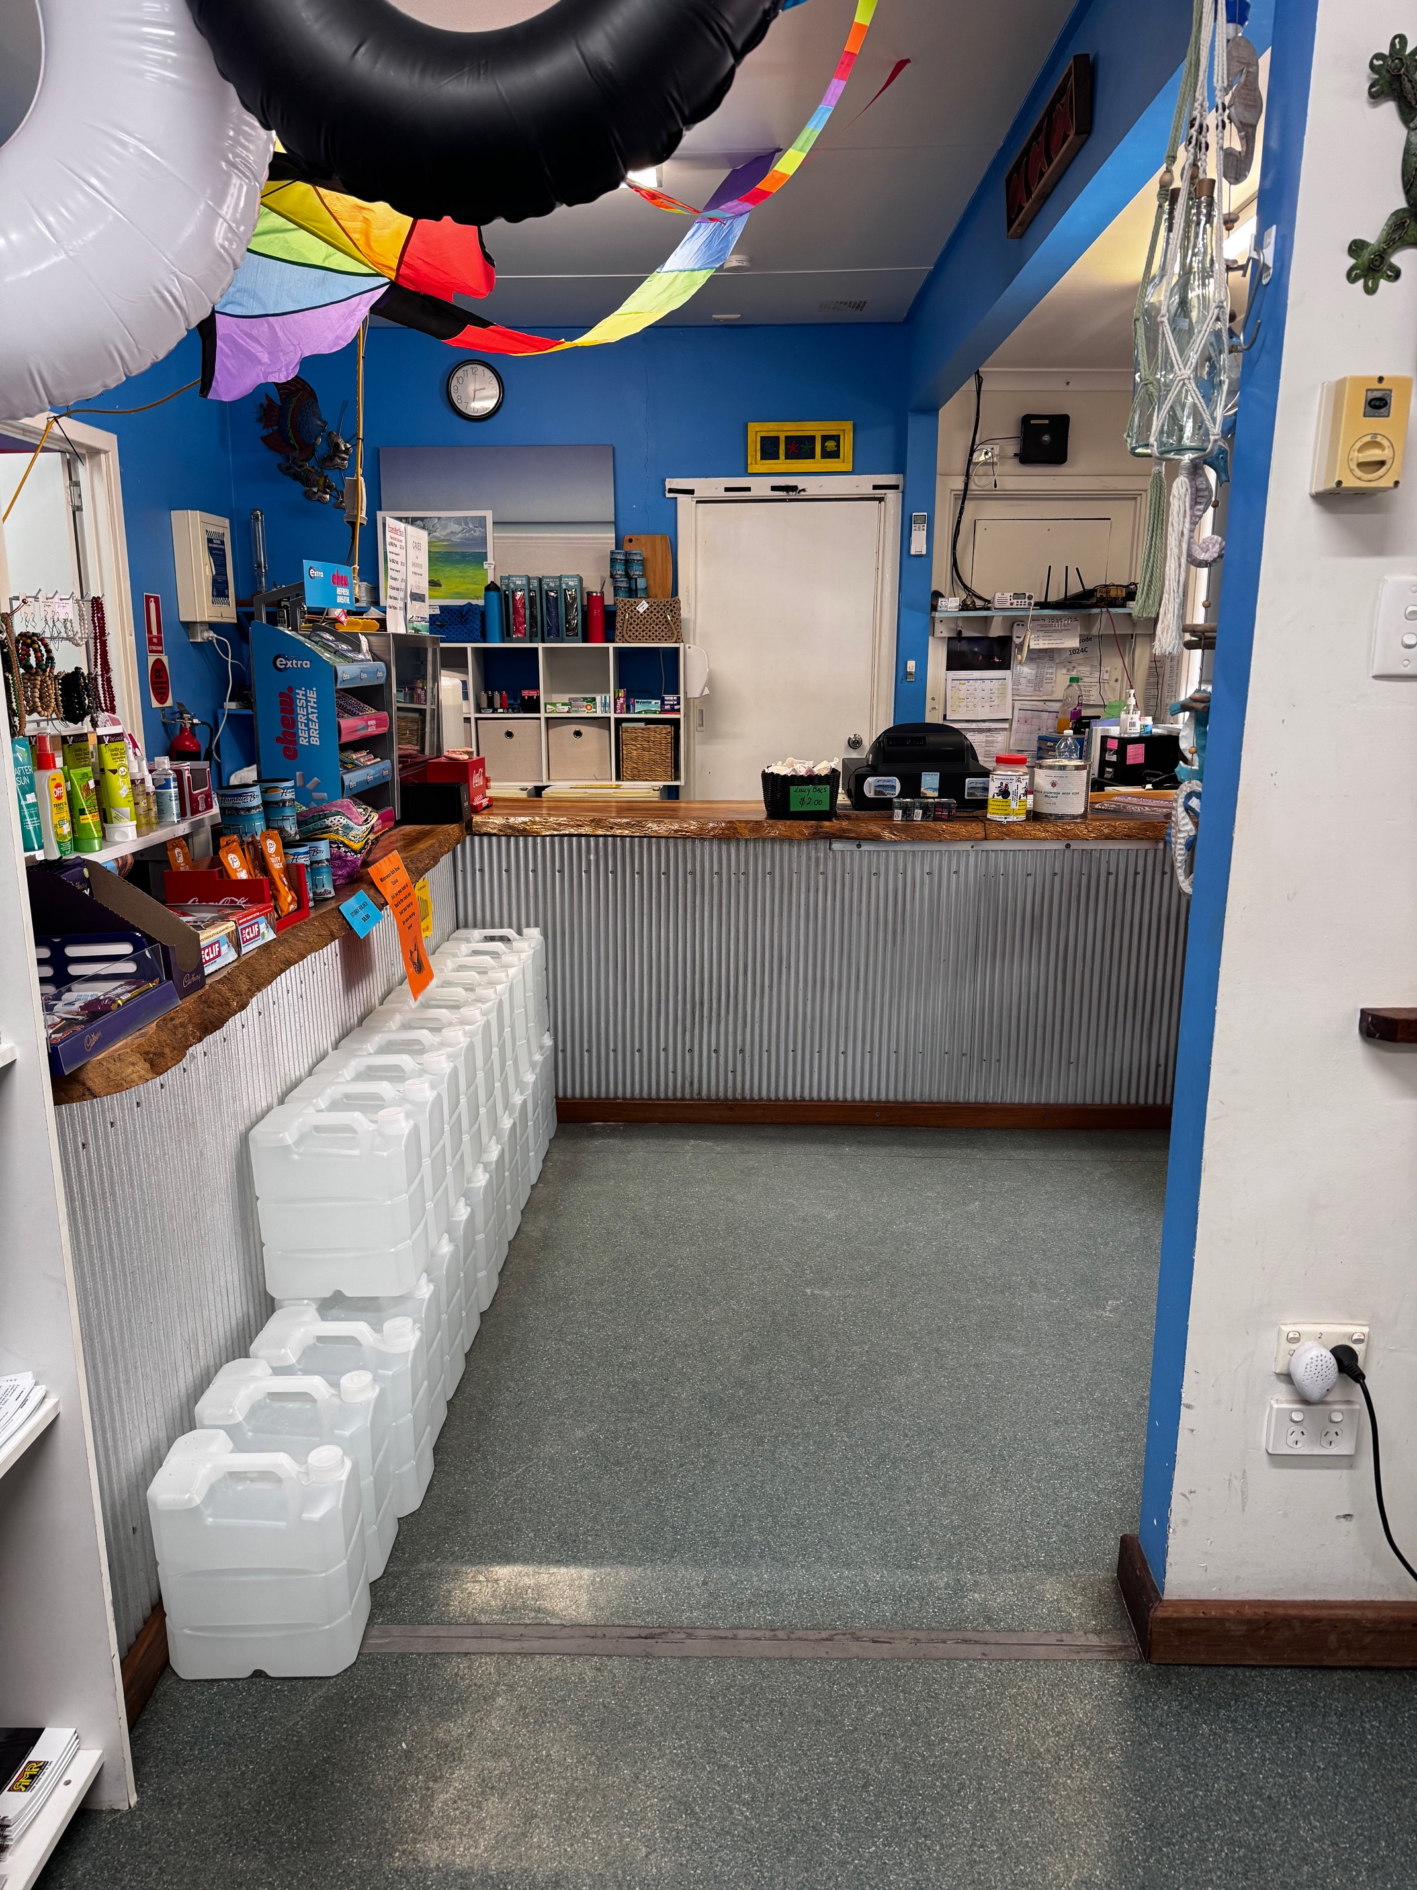
IMG_4718
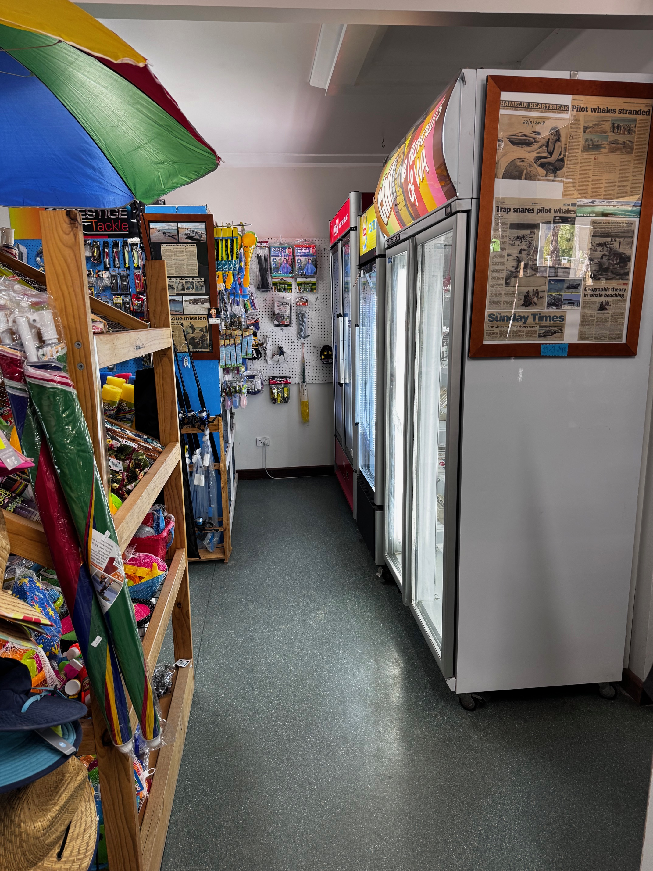
IMG_4719
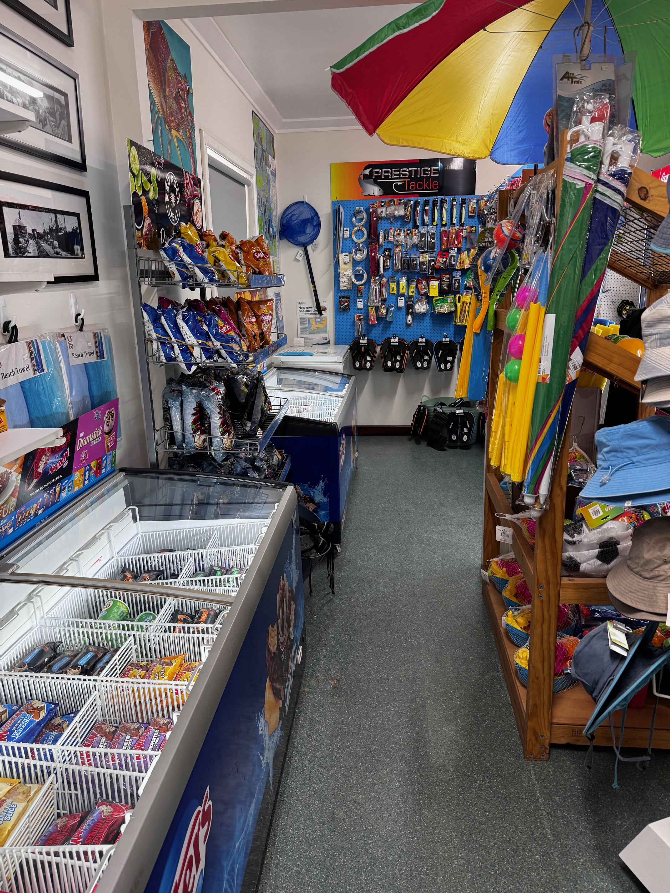
IMG_4720

Report Disclaimer
Please note that this business report, provided as a result of the use of the diagnostic assessment, is for information purposes only.
Australian Tourism Industry Council (ATIC) cannot guarantee the accuracy of respondent’s answers, or that they are fully representative of your business. Therefore, ATIC does not warrant or guarantee any particular outcome in respect of your businesses self-assessment.
This report is intended as guidance only for your business and should not be relied on for future marketing considerations. ATIC recommends that you seek your own independent advice as well as the results from the diagnostic.
Links to external web sites are inserted for convenience and do not constitute endorsement of material at those sites, or any associated organisation, product or service.
ATIC does not:
- Assume any legal liability for the accuracy, completeness, or usefulness of any information from this report or any links provided; or
- Accept responsibility for any loss associated directly or indirectly from the use of this report.

