ATIC Accessibility
To support the accessible community in making informed travel decisions for their individual needs

This report prepared for:
Business name: | Ningaloo Reef Dive
Address: | Shop 8 Coral Bay Arcade
Town: | Coral Bay
Contact for enquiries: | Vikki Hoff
Contact Number: | 0461289998
Contact Email: | info@ningalooreefdive.com
Website: | www.ningalooreefdive.com
Date: | 2026-10-25 03:57

ATIC Accessibility
The following pages provides travellers with information on the businesses facilities and amenities which aims to support the traveller to make an informed decision on whether the business is suitable for their individual needs.
OVERVIEW 4
Business Overview 4
Bookings 4
Emergency Management 5
Communications 5
Other Information 6
Guide Dog and Service Animals 6
GENERAL 7
Pre-arrival, arrival and reception 7
Cognitive Impairment Support 7
Car Park and Access amenities 7
Entry 8
Internal Spaces 8
Public areas 8
Displays, exhibits, commentary and live performances 9
External Paths 9
Public Toilets/Adult change facilities 9
TOUR OPERATORS 10
Tour/Transport Services 10
Route Planning 10
Guides 11
ATTRACTIONS 15
COMMON AREAS 17
ADVENTURE ACTIVITIES 18
Adventure activities 18
Report Disclaimer 23

OVERVIEW

Business Overview

The business has the following products/services available
- Tour/Transport
- Attraction
- Adventure

Our business caters for the following disability types:
- Blind or low vision
- Deaf or low hearing
- Limited mobility
- Wheelchairs or mobility scooters
- Food allergies or intolerances
- Cognitive or people on the Autism Spectrum
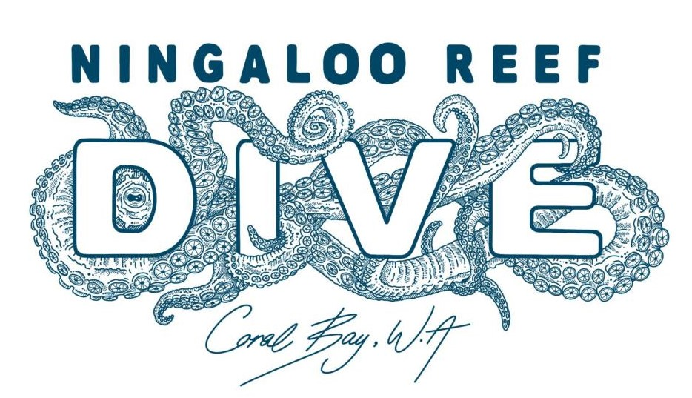

Bookings

The business offers the following methods for bookings and enquiries:
- Phone
- Email
- Webportal
- Our forms have high contract boxes and submit boxes

Emergency Management
- The business has an emergency management and evacuation plan for guests with a disability
- Emergency and evacuation procedures are explained on arrival
- Guests with disabilities are noted in the guest log book for emergency and evacuation purposes

Communications
- An accessibility guide is available on the website

https://www.ningalooreefdive.com
- Our website meets WCAG 2.0 accessibility standards
- Our business offers the following alternative communication methods
- Plain English
- Magnifiers

Not specified
- There is easy to read signage and information (e.g. menus and emergency information)
- There are Picture boards
  - Picture Boards Image(s)
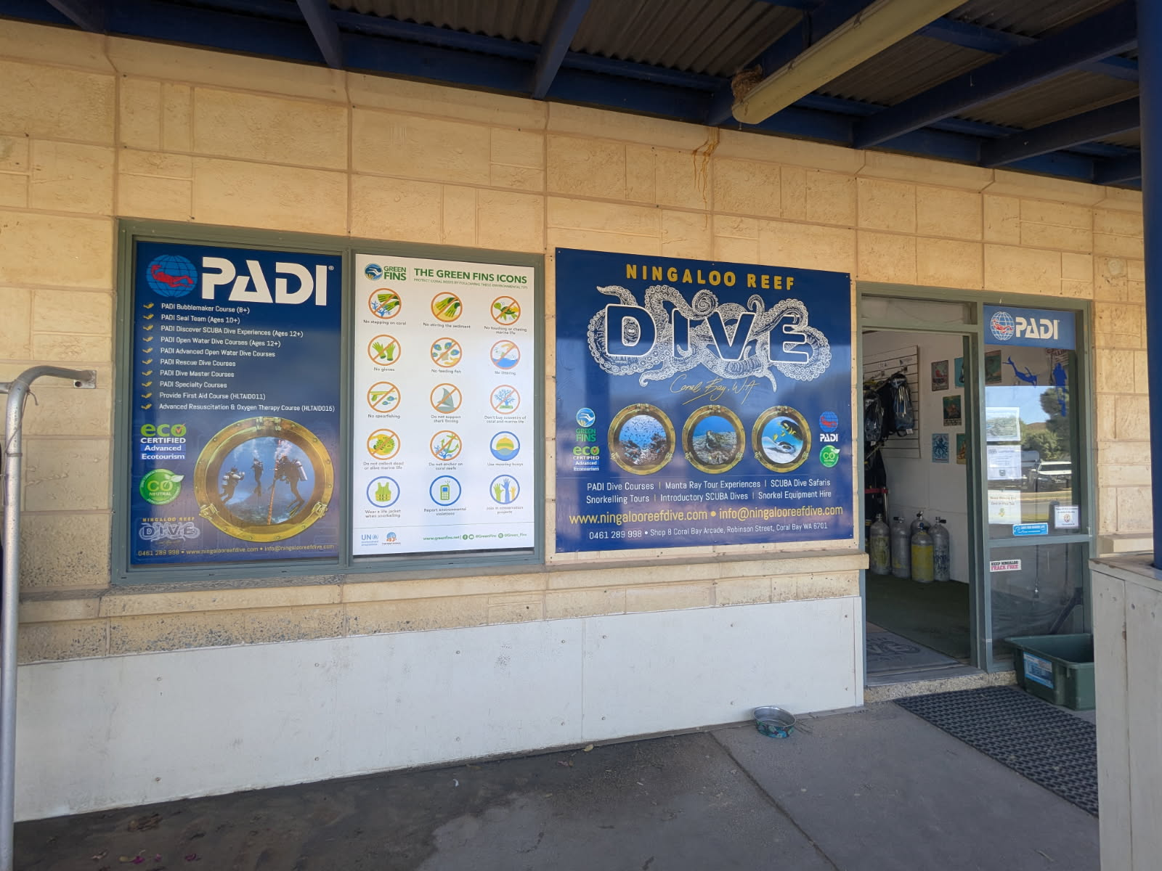
Signage.JPG

Other Information
- For bookings made onsite, the ticket booth/counter/box office is accessible for people using a wheelchair
- The business accepts the companion card

Guide Dog and Service Animals
- The business provides a secure area with shade and water for service animals
- The business provides a toilet area for service animals
The business provides the following services for services animals:
Due to the nature of our tours, service animals are welcomed aboard the vessel but are not permitted in the water and a carer or other support is required to be responsible for the service animal if their control person is participating in an in-water activity.

GENERAL

Pre-arrival, arrival and reception
The business has the following in place to support guests during pre-arrival, arrival and reception
- Booking information and websites are compatible with screen readers
- There is a reception/public entryway.
- Seating available at reception
- A lower counter at reception/ticket office
- A clipboard to allow check-in/ticket purchase whilst seated
- A tablet with text to voice or pen and paper at reception to aid in communication
- Picture Board at reception to aid in communication
- Lighting in the reception area is even and glare free
- Large print information sheets and registration forms
- Information and maps are available in written form
- A step free map/guide
- A familiarisation tour
- In addition, the following further information can assist guests:
We have a set check in time and to avoid delays our guests can complete their pre-tour forms online. We have a range of seating that guests can use while waiting for gear and trying on equipment.

Cognitive Impairment Support
- Documents are available in plain English for people with cognitive impairment (This may include instructions, guides, menus and general information)
- Quiet periods or early opening times for people on the Autism Spectrum
- A space for parents and children on the Autism Spectrum
- Access has alternative procedures and clear written instructions with universal access symbols

Car Park and Access amenities
The business has the following Car Park and Access amenities
- A drop off zone
- Designated disabled parking bays
- Level or ramped access from the car park to the entrance
- In addition, the following further information can assist guests:
Not necessary as the shop is located directly across from the parking bays.

Entry
The business has the following amenities/systems in place for entry
- A drop off point close to the entrance
- A path of access to the building is slip resistance and even
- A path of access to the building is clear of obstruction
- Glass doors are fitted with a visual sighting strip
- Door jams/doors are of a contrasting colour to surrounding walls
- Door handles are of a contrasting colour to the door
- Signage is written in a contrasting colour
- The entry door is a minimum of 850mm wide
- The entrance sill is less than 13mm
- There a clear space of at least 1500mm x 1500mm in front of all doors.

Internal Spaces
- Clear and unobstructed routes through and between buildings
- Interior walls are matte or low sheen
- Floors, walls, counters and furniture are of contrasting colours
- Any protruding or overhanging obstructions are at least 2meters above the floor or are protected
- Floor surfaces are hard or short pile carpet
- Seating is available for guests unable to stand for long periods
- Accessible facilities are clearly signed and visible from all areas
- All corridors greater than 900mm
- There is a quiet space for parents and children on the Autism Spectrum

Public areas
The public areas have the following amenities in place
- Display units, Televisions, Video displays etc. are open captioned
- Even lighting
- Seating

Displays, exhibits, commentary and live performances
For displays, exhibits, commentary and live performances the following amenities are in place
- Seating
- Wheelchair accessible spaces/seating
- A written transcript where audio description is provided i.e. display commentary, tour commentary

External Paths
External paths of travel
- Surfaces are concrete, asphalt, smooth paving or hard packed fine gravel (max aggregate size 13mm)
- Paths or slopes longer than 15 metres have resting places or seats
- Pathways are wider than 900mm

All pathways leading to the business are wheelchair accessible

Public Toilets/Adult change facilities
Public Toilets/Adult change facilities have the following amenities are in place
- There is an accessible toilet for public use
- The door is at least 850mm wide
- There is a minimum of 850mm beside the toilet
- Handrails are fitted
- The toilet seat is 460mm above the floor
- The toilet seat of a contrasting colour to the floor
- The toilet seat is460mm above the floor

TOUR OPERATORS

Tour/Transport Services
The tour/transport services have the following facilities/amenities in place
- Buses/Coaches
- 0 vehicles have wheelchair lifts or ramps
- 0 vehicles have low floors with ramped entry
The maximum wheelchair capacity available in the fleet is:
2
- Commentary is available in written format
- Audio visual displays are sub titles

Route Planning
- Route Planning
- The tour route includes stops with accessible toilet facilities
- There is an accessible toilet on-board for public use
- The door is at least 850mm wide
- There is a minimum of 850mm beside the toilet
- The toilet seat is 460mm above the floor
- The toilet seat of a contrasting colour to the floor
- The toilet seat is 460mm above the floor
  - Accessible Toilet Image(s)
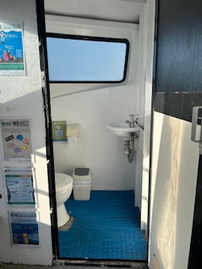
Toilet 1
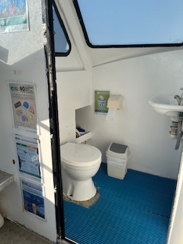
Toilet 2
- In addition, the following further information can assist guests:
Some areas of the vessel may require additional assistance from a carer or crew member. We encourage our guests to contact us prior to making their booking so that we can determined their needs and that we can meet them whilst maintaining their level of comfortability.
- Lunch stop venues are accessible
- Sightseeing and photo opportunity stops are step free

Guides
- AUSLAN
- Use of clear/simple English
- Correct pronunciation for lip readers
- There is a audio description of surroundings
- Marine
- Marine craft are wheelchair accessible
- Length (cm) 110.
- Width (cm) 70.
- Height (cm) 100.
- Weight (kg) 30.
- Accessibility is tide dependent
  - Image(s)
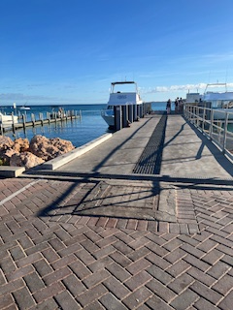
The Jetty
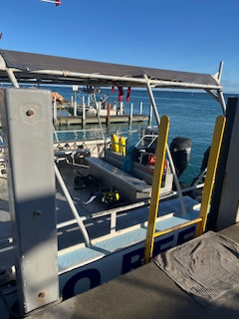
Jetty to Boat
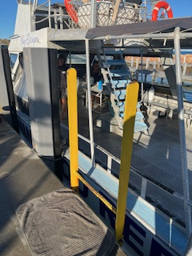
Jetty to Boat 2
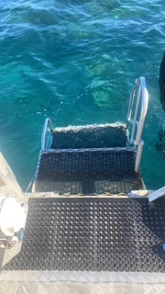
Boat Ladder 1.JPG
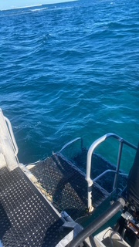
Boat Ladder 2.JPG
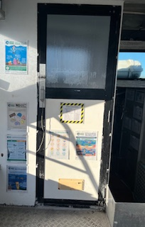
Signage 1
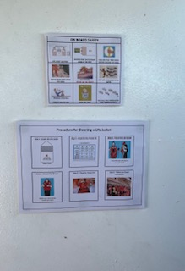
Signage 2
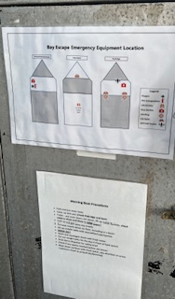
Signage 3
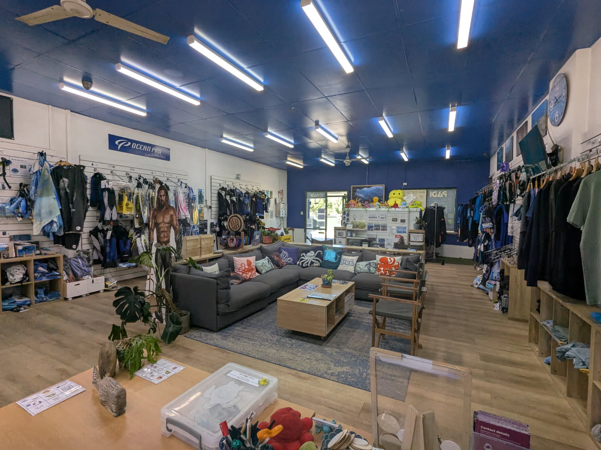
Shop 1.JPG
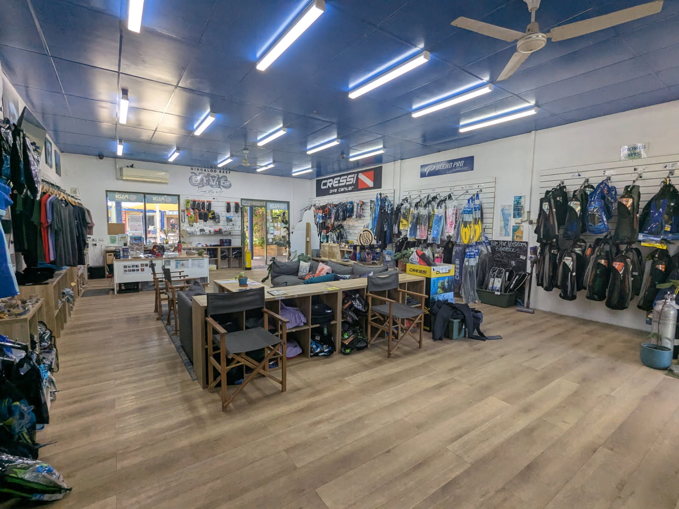
Shop 2.JPG
- In addition, the following further information can assist guests:
We are able to provide specialised transport if required through another company in Coral Bay.
We would need to organise this option when guests are making their booking should they not have their own transportation that meets their transportation requirements.

ATTRACTIONS
- In addition, the following further information can assist guests:
We don't have any limitations for service animals except for in-water interactions whereby the animals must remain on the vessel and be cared for by their owner or carer.
  - Image(s)
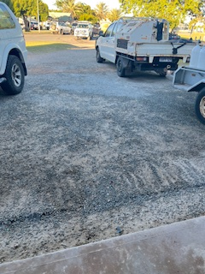
Shop Driveway Entrance
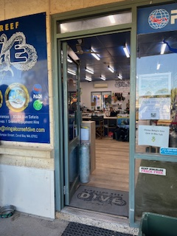
Shop Entrance 1
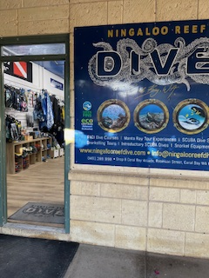
Shop Entrance 2
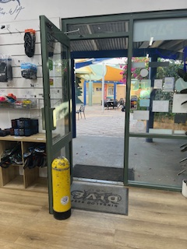
Shop Exit to Arcade
The Jetty
Toilet 2
Shop 1.JPG
Shop 2.JPG

COMMON AREAS

ADVENTURE ACTIVITIES

Adventure activities
The adventure activities have the following facilities/amenities in place
- Our adventure activities cater for people with a disability
- In addition, the following further information can assist guests:
Our guests can enjoy a range of in-water and out-of-water experiences. In water experiences can include diving, snorkelling, and manta ray interaction snorkelling. Our boat ladders lower into the water making it suitable for anyone with accessibility needs. On board, there is plenty of deck space (with shade) for our guests to observe a variety of marine life.
- In addition, the following further information can assist guests:
Accessibility Management Tourism Strategy

Purpose of this Strategy
To provide equal opportunities for all levels of accessibility for the tourism market.
Ningaloo Reef Dive will continue to make thoughtful adjustments to enhance accessibility across our tours, ensuring that individuals with diverse abilities can continue to enjoy the unique experiences on the Ningaloo Reef.
Strategies
1. Accessible Facilities and Equipment
Onboard Accessibility:
Ensure our vessel is accessible with features like sturdy, non-slip ramps, wide aisles, and handrails. Guests requiring assistance are advised when booking as to the layout of our vessel and photos of the vessel are provided upon request.
Adaptive Snorkelling and Diving Gear:
We offer adaptive equipment such as flotation devices, specialized masks, or equipment tailored for individuals with limited mobility. We provide wetsuits and buoyancy aids for varying body types to accommodate everyone comfortably.
Accessible Transportation:
We are partnered with accessible transportation providers for easier travel to and from Coral Bay, especially for clients arriving from Perth or Learmonth airports.
2. Staff Training on Accessibility Awareness
Inclusive Training Programs:
Our crew are trained on how to assist guests with disabilities in a respectful, empathetic manner, and educate them about different needs related to mobility, sensory, or cognitive disabilities. This includes training on assisting with adaptive gear, handling unexpected situations, and using inclusive language.
First Aid and Emergency Procedures:
Staff are trained in basic communication methods for guests with hearing impairments and know how to address specific emergency scenarios involving individuals with disabilities.
We have interpretive material available to guests with hearing impairments or language barriers for guests.
3. Accessible Experiences
Adaptive SCUBA Diving Courses:
Partnered with PADI’s and offer additional training for crew to complete the PADI Adaptive Techniques Specialty course to provide inclusive dive training that can accommodate a range of abilities. We also offer adaptive diving experiences enables people with physical disabilities to safely experience SCUBA.
Guided Snorkelling with Trained Guides:
We provide guided snorkelling and diving experiences with crew specifically trained to support guests who may need extra assistance.
Crew are trained to assist guests with visibility challenges; help maintain buoyancy or accompany guests with limited mobility.
4. Accessible Booking and Communication
Accessible Website:
The Ningaloo Reef Dive website is aimed to being optimised for accessibility with features like screen-reader compatibility, high-contrast options, and accessible booking forms. We have included descriptions of accessibility options on the website, so potential clients know what to expect.
We commit to reviewing this regularly with guidance from our partners to improve our website to meet these requirements.
Clear Communication Channels:
We have a dedicated crew member for accessible inquiries, where potential guests can discuss specific needs and accommodations directly with a trained member who can offer guidance and reassurance.
5. Inclusive Marketing and Partnerships
Feature Accessible Tourism in Marketing:
We are working towards highlighting accessibility options in social media, promotional materials, and on the website.
We plan to share future testimonials or stories from clients with disabilities who enjoyed their experience, which can help foster an inclusive image and reassure potential guests.
Partner with Accessible Tourism Organisations:
We aim to continue to collaborate with organisations focused on accessible tourism, both locally and internationally, to increase awareness and promote the business within the accessible tourism community.
We aim to partner with local disability organisations and request their assistance to identify needs and improve offerings.
6. Feedback and Continuous Improvement
Guest Feedback for Accessibility Improvements:
Collect feedback from guests on accessibility features and any areas for improvement.
This input can help refine our services and ensure the offerings evolve to meet diverse needs. We have made improvements in the past from customer feedback and needs and are committed to seeking these out in the future to ensure that we are meeting the needs of all our customers.
Ongoing Accessibility Audits:
We will continue to periodically review and assess all facilities, equipment, and protocols to ensure they remain accessible and compliant with evolving standards in Accessible Tourism.
Our commitment to reviewing these strategies regularly and from our customer feedback, Ningaloo Reef Dive can become a leader in accessible tourism, providing meaningful, safe, and enjoyable experiences for individuals of all abilities. This inclusive approach not only benefits the business but also reinforces a commitment to equality and sustainability in the tourism industry.
- In addition, the following further information can assist guests:
There isn't much that our guests with a disability can't enjoy on our vessel. The main limitations would include access to the bow of the boat and the observation deck upstairs. Having a large open main deck still allows our guests to observe a variety of marine animals from there.
We encourage anyone with special needs to email us directly to discuss how we can accommodate them on our tour. They are made aware that our crew will need to assist them on and off the vessel by lifting them and we ensure that they are comfortable with this prior to them making a booking with us. We have photos available to send them for them to make their own assessment that they will be comfortable with.
- In addition, the following further information can assist guests:
Due to the railing on the vessel, it will be necessary for our crew to lift a person from their wheelchair on to the boat and placed back in their wheelchair. This is done with a minimum of three crew to assist and ensure the comfortability of the guest.
It is strongly encouraged through our website that anyone with additional needs contact us prior to making their booking to help them make an informed decision about participating in our tours.

Report Disclaimer
Please note that this business report, provided as a result of the use of the diagnostic assessment, is for information purposes only.
Australian Tourism Industry Council (ATIC) cannot guarantee the accuracy of respondent’s answers, or that they are fully representative of your business. Therefore, ATIC does not warrant or guarantee any particular outcome in respect of your businesses self-assessment.
This report is intended as guidance only for your business and should not be relied on for future marketing considerations. ATIC recommends that you seek your own independent advice as well as the results from the diagnostic.
Links to external web sites are inserted for convenience and do not constitute endorsement of material at those sites, or any associated organisation, product or service.
ATIC does not:
- Assume any legal liability for the accuracy, completeness, or usefulness of any information from this report or any links provided; or
- Accept responsibility for any loss associated directly or indirectly from the use of this report.

