ATIC Accessibility
To support the accessible community in making informed travel decisions for their individual needs

This report prepared for:
Business name: | Broome Bird Observatory
Address: | Broome Bird Observatory
Town: | Broome
Contact for enquiries: | Jamie Van Jones
Contact Number: | 0891935600
Contact Email: | broome@birdlife.org.au
Website: | broomebirdobservatory.com
Date: | 2026-11-03 21:54

ATIC Accessibility
The following pages provides travellers with information on the businesses facilities and amenities which aims to support the traveller to make an informed decision on whether the business is suitable for their individual needs.
OVERVIEW 4
Business Overview 4
Bookings 4
Emergency Management 5
Communications 5
Other Information 6
Guide Dog and Service Animals 6
GENERAL 7
Pre-arrival, arrival and reception 7
Cognitive Impairment Support 7
Car Park and Access amenities 8
Entry 8
Internal Spaces 8
Public areas 8
Displays, exhibits, commentary and live performances 9
External Paths 9
Steps 9
Ramps 9
TOUR OPERATORS 10
Route Planning 10
Guides 10
ACCOMMODATION 15
Room Amenities 15
Bathrooms 15
ATTRACTIONS 20
COMMON AREAS 33
Report Disclaimer 35

OVERVIEW

Business Overview

The business has the following products/services available
- Tour/Transport
- Accommodation
- Attraction

Our business caters for the following disability types:
- Blind or low vision
- Deaf or low hearing
- Limited mobility
- Wheelchairs or mobility scooters
- Food allergies or intolerances
- Cognitive or people on the Autism Spectrum
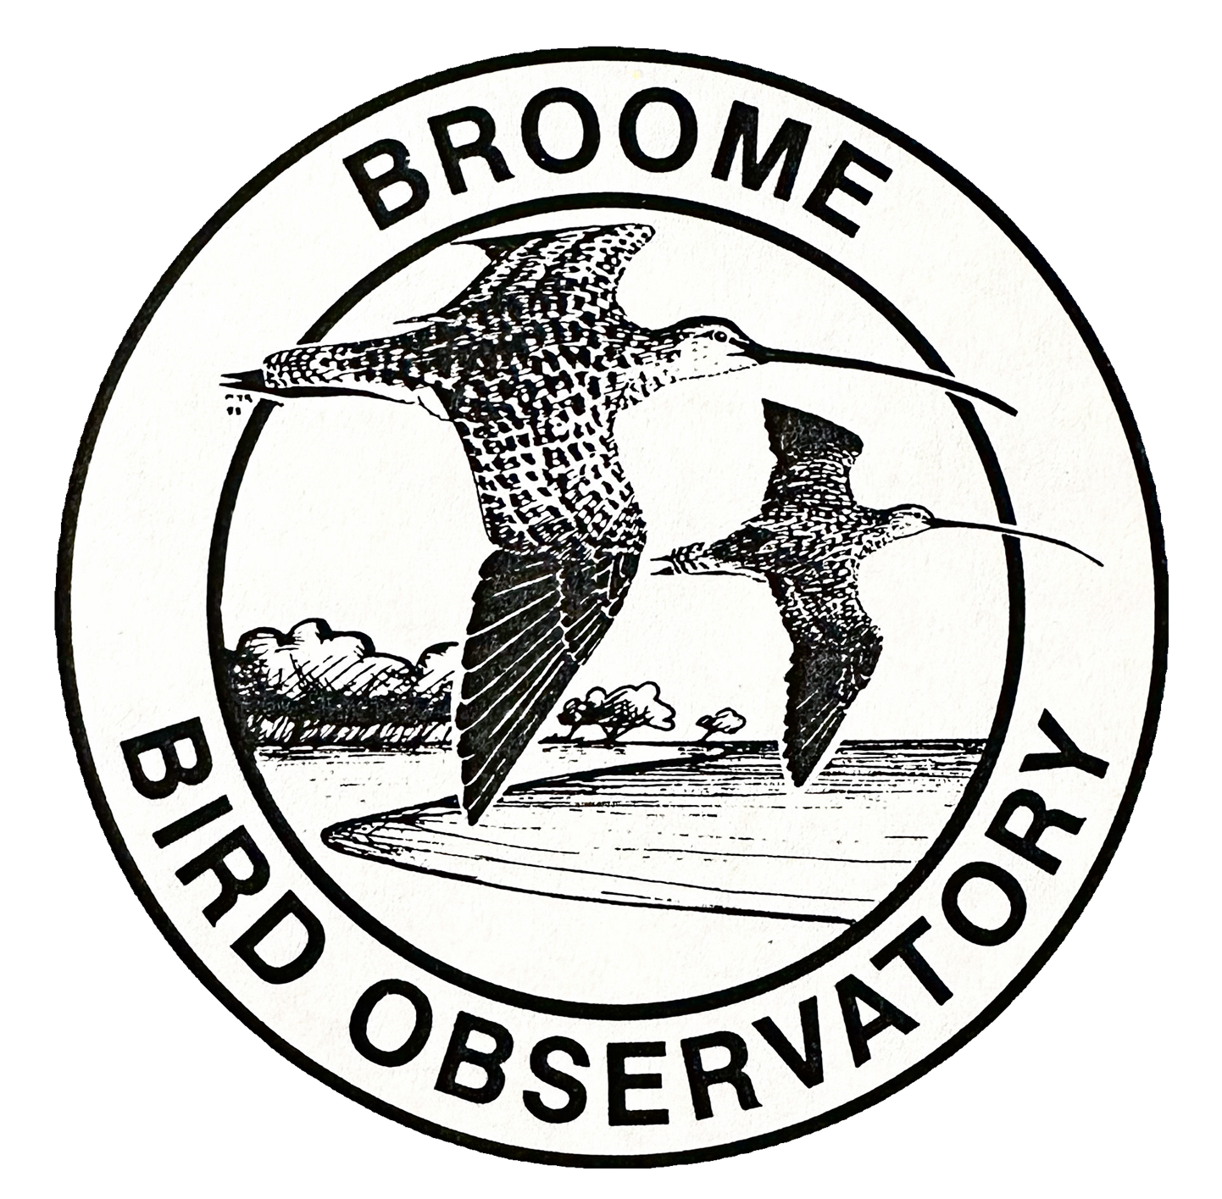

Bookings

The business offers the following methods for bookings and enquiries:
- Phone
- Email
- Webportal
- Our website supports Screen Readers
- Our forms have high contract boxes and submit boxes

Emergency Management
- Emergency and evacuation procedures are explained on arrival
- There are visual device/s to alert occupants to evacuate.
- Exit signs are clear and easy to see
- Exit access is free and clear at all times
We ensure exit access is free and clear at all times by:
The areas in front, behind and to the sides remain clear, by not putting anything in-front of them, and providing areas for people to wait to avoid congregation / blocking of these exits.
- Exits and access to exists are greater than 900mm
- Exits to the emergency evacuation point does not include stairways
- The evacuation point is clearly marked by a sign
- In addition, the following further information can assist guests:
At the time of booking for when guests come and stay / participate on a tour we have an optional box where they can disclose any medical concerns and if anything might need to be adjusted on the tour. This allows us to have records at hand of who may need extra assistance during and emergency and those that may be more at risk when evacuating to the evacuation point.
- In addition, the following further information can assist guests:
We are close enough to the town of Broome that ambulance and other emergency services are able to make it out to us. We also have the ability to get a helicopter out here should we need it.
- Guests with disabilities are noted in the guest log book for emergency and evacuation purposes

Communications
- Our business offers the following alternative communication methods
- Plain English

Not specified
- There is easy to read signage and information (e.g. menus and emergency information)

Other Information
- For bookings made onsite, the ticket booth/counter/box office is accessible for people using a wheelchair
- The business accepts the companion card

Guide Dog and Service Animals
- The business provides a toilet area for service animals
The business provides the following services for services animals:
We can offer shade, water and a rest area for service animals.

GENERAL

Pre-arrival, arrival and reception
The business has the following in place to support guests during pre-arrival, arrival and reception
- Booking information and websites are compatible with screen readers
- There is a reception/public entryway.
- Seating available at reception
- A clipboard to allow check-in/ticket purchase whilst seated
- A tablet with text to voice or pen and paper at reception to aid in communication
- Lighting in the reception area is even and glare free
- Large print information sheets and registration forms
- Information and maps are available in written form
- A familiarisation tour
- Luggage assistance
- In addition, the following further information can assist guests:
At Broome Bird Observatory, we arrange all drop-off and pickup times individually and organise schedules from designated pickup locations in advance. This allows guests who may experience fatigue to plan their travel with minimal stress and avoid unnecessary waiting. Our small group tours are designed to reduce waiting times further and provide a more personalised experience.

We also offer a range of accommodation options that allow for privacy and quiet rest. Additionally, our Shadehouse area provides a comfortable and shaded space where guests can relax and unwind at their own pace. These measures help ensure that all visitors, including those with fatigue-related disabilities, can enjoy their time with us comfortably.

Cognitive Impairment Support
- Documents are available in plain English for people with cognitive impairment (This may include instructions, guides, menus and general information)

Car Park and Access amenities
The business has the following Car Park and Access amenities
- A drop off zone
- Designated disabled parking bays
- Level or ramped access from the car park to the entrance
- The accessible entrance is clearly signed from the parking bay

Entry
The business has the following amenities/systems in place for entry
- A drop off point close to the entrance
- A path of access to the building is slip resistance and even
- A path of access to the building is clear of obstruction
- Glass doors are fitted with a visual sighting strip
- Door jams/doors are of a contrasting colour to surrounding walls
- Signage is written in a contrasting colour
- The entry door is a minimum of 850mm wide
- The entrance sill is less than 13mm
- The entrance door mats have a thickness less than 13mm and a width of 7500mm or greater

Internal Spaces
- Interior walls are matte or low sheen
- Floors, walls, counters and furniture are of contrasting colours
- Tableware/glassware contrast with the table surface or table cloth
- Floor surfaces are hard or short pile carpet
- Seating is available for guests unable to stand for long periods
- All corridors greater than 900mm

Public areas
The public areas have the following amenities in place
- Display units, Televisions, Video displays etc. are open captioned
- Even lighting
- Seating

Displays, exhibits, commentary and live performances
For displays, exhibits, commentary and live performances the following amenities are in place
- Seating
- Wheelchair accessible spaces/seating

External Paths
External paths of travel
- Paths or slopes longer than 15 metres have resting places or seats
- Pathways are wider than 900mm
- There 3 successive steps or less on any path or at any doorway
- Any paths having steps are clearly identified as non-wheelchair accessible
- In addition, the following further information can assist guests:
Most of the paths around the BBO are loose gravel or pindan soil. The entrance to the Discovery Center / Shop is accessible via wheelchair.

Steps
Steps
- There are steps.
- Top and bottom steps are easily distinguished through colour contrast or the use of TGSIs (Tactile Ground Surface Indicators)
- All steps or staircases have enclosed risers
- The underside of all staircases are enclosed or protected to a height of at least 2 metres
- Where steps are present are there three steps or less

Ramps
Ramps have the following amenities are in place
- There are ramps.
- All fixed ramps are 1:14 or less
- Hand rails are fitted
- In addition, the following further information can assist guests:
The entrance to the Discovery Center / Shop is has a ramp located next to the designated disabled parking bay, and is accessible via wheelchair.

TOUR OPERATORS

Route Planning
- Route Planning
- Lunch stop venues are accessible
- Sightseeing and photo opportunity stops are step free
- Walking Tours
- Operated on a step free route
- Multi-paced to account for slower walkers
- Hearing aid compatible

Guides

Guides have been trained in the following
- Use of clear/simple English
- Correct pronunciation for lip readers
  - Image(s)
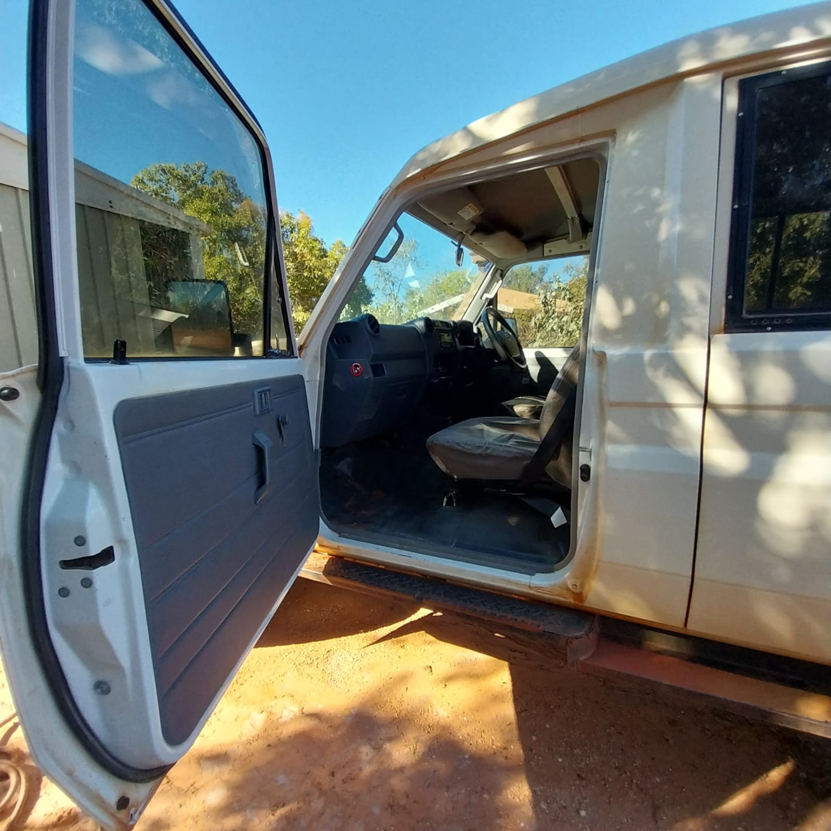
Carrearentry
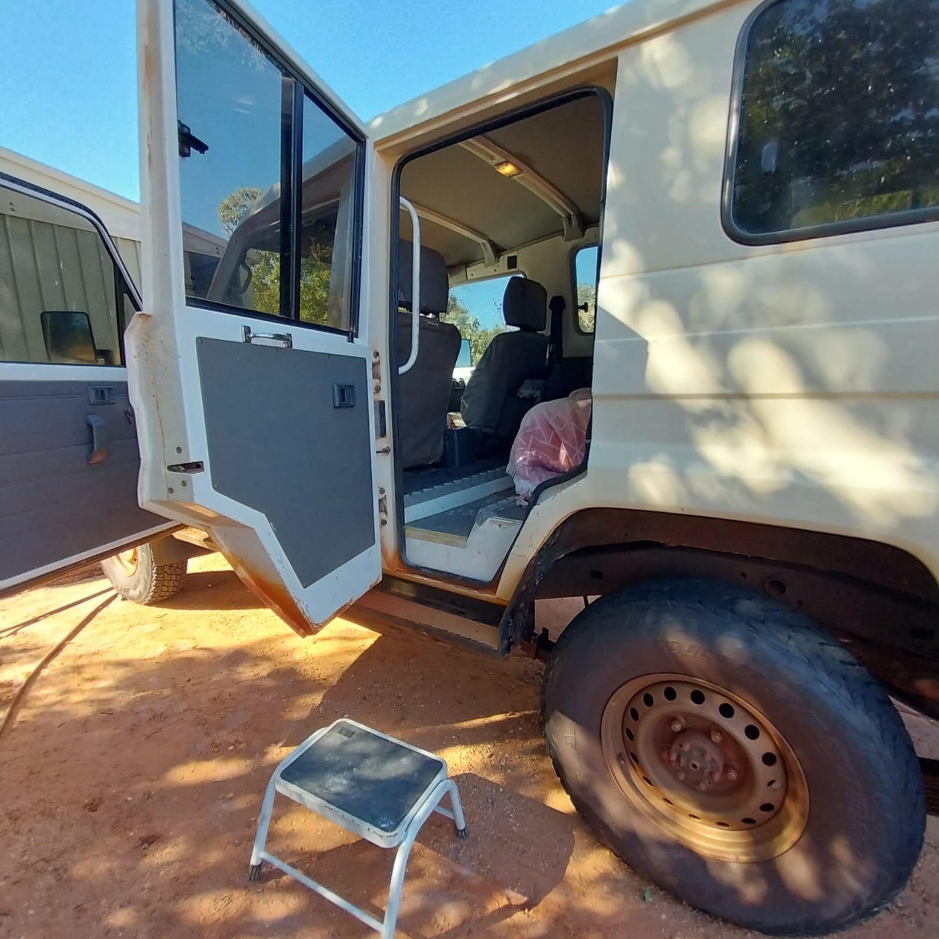
Carfrontdoor
- In addition, the following further information can assist guests:
There is a picnic area that is accessible from the discovery centre, with a short distance over gravel. It is on the Coastal Tour where all stops are not accessible for wheelchairs.

ACCOMMODATION

Room Amenities
- Lower hanging rails are in wardrobes
- Visual alarm is fitted to the room
- There is contrast between the walls, skirtings, floor and furniture
- There is a clear path through the room
- Doors open fully against the adjoining wall
- Openings are a minimum of 810mm wide
- There luggage racks for at least two suitcases
- There at least one chair with rigid arms
- Wardrobe and drawer handles are easy to grip
- There is at least 850mm clear space beside the bed
- The bed height is no higher than 680mm from the floor
- There is at least 130mm clearance under the bed
- In addition, the following further information can assist guests:
The double room has above 850mm clearance besides the bed.

Bathrooms
The bathrooms have the following facilities/amenities in place
- All heating appliances and hot water pipes are protected or insulated
- All shower, bath and basin taps are clearly differentiated between hot and cold
- Fixtures and fittings have rounded edges
- The hot water is thermostatically controlled to 41 degrees
- The width of the door is 810mm.
- The width beside the toilet is N/A.
- There is 1080 mm of clear space in front of the toilet
- The toilet seat is a contrasting colour to the floor
- The toilet seat is 460mm above the floor
- A door is fitted to the shower
  - Bathroom Image(s)
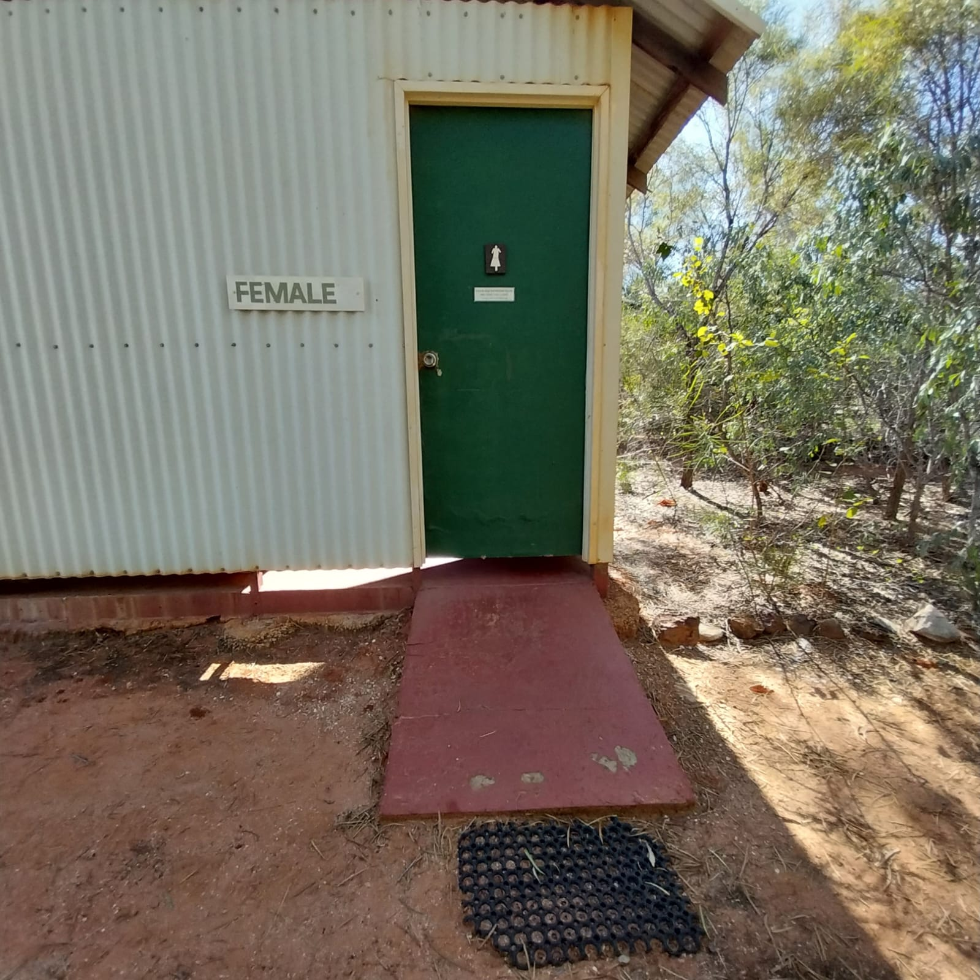
Toilet&Showerlayout
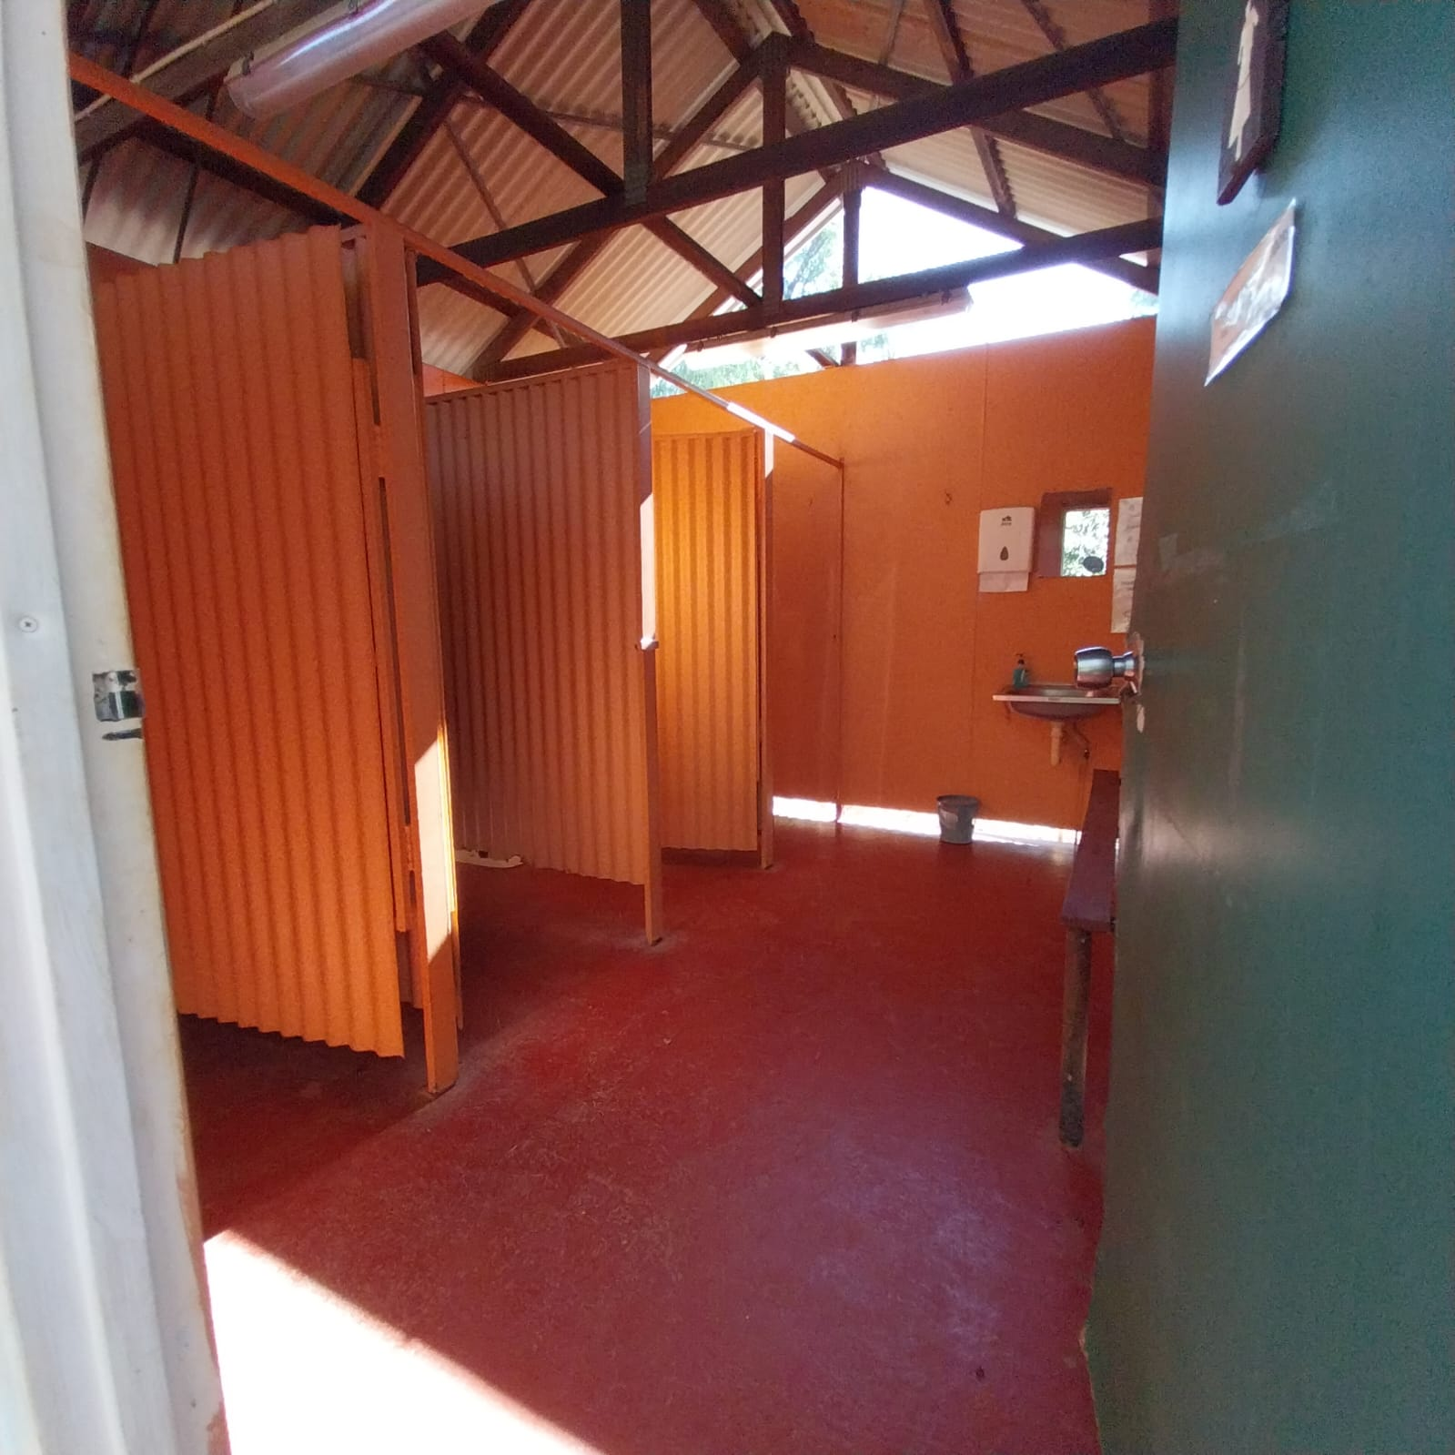
Toilet&Showerentry

ATTRACTIONS
  - Image(s)
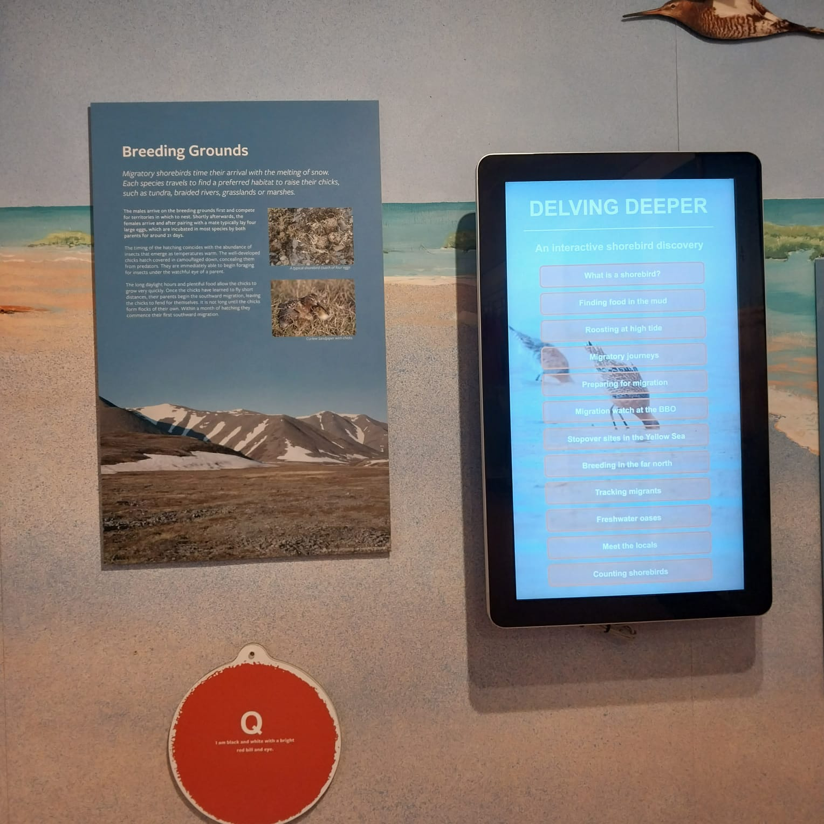
Discoverycenterinfo
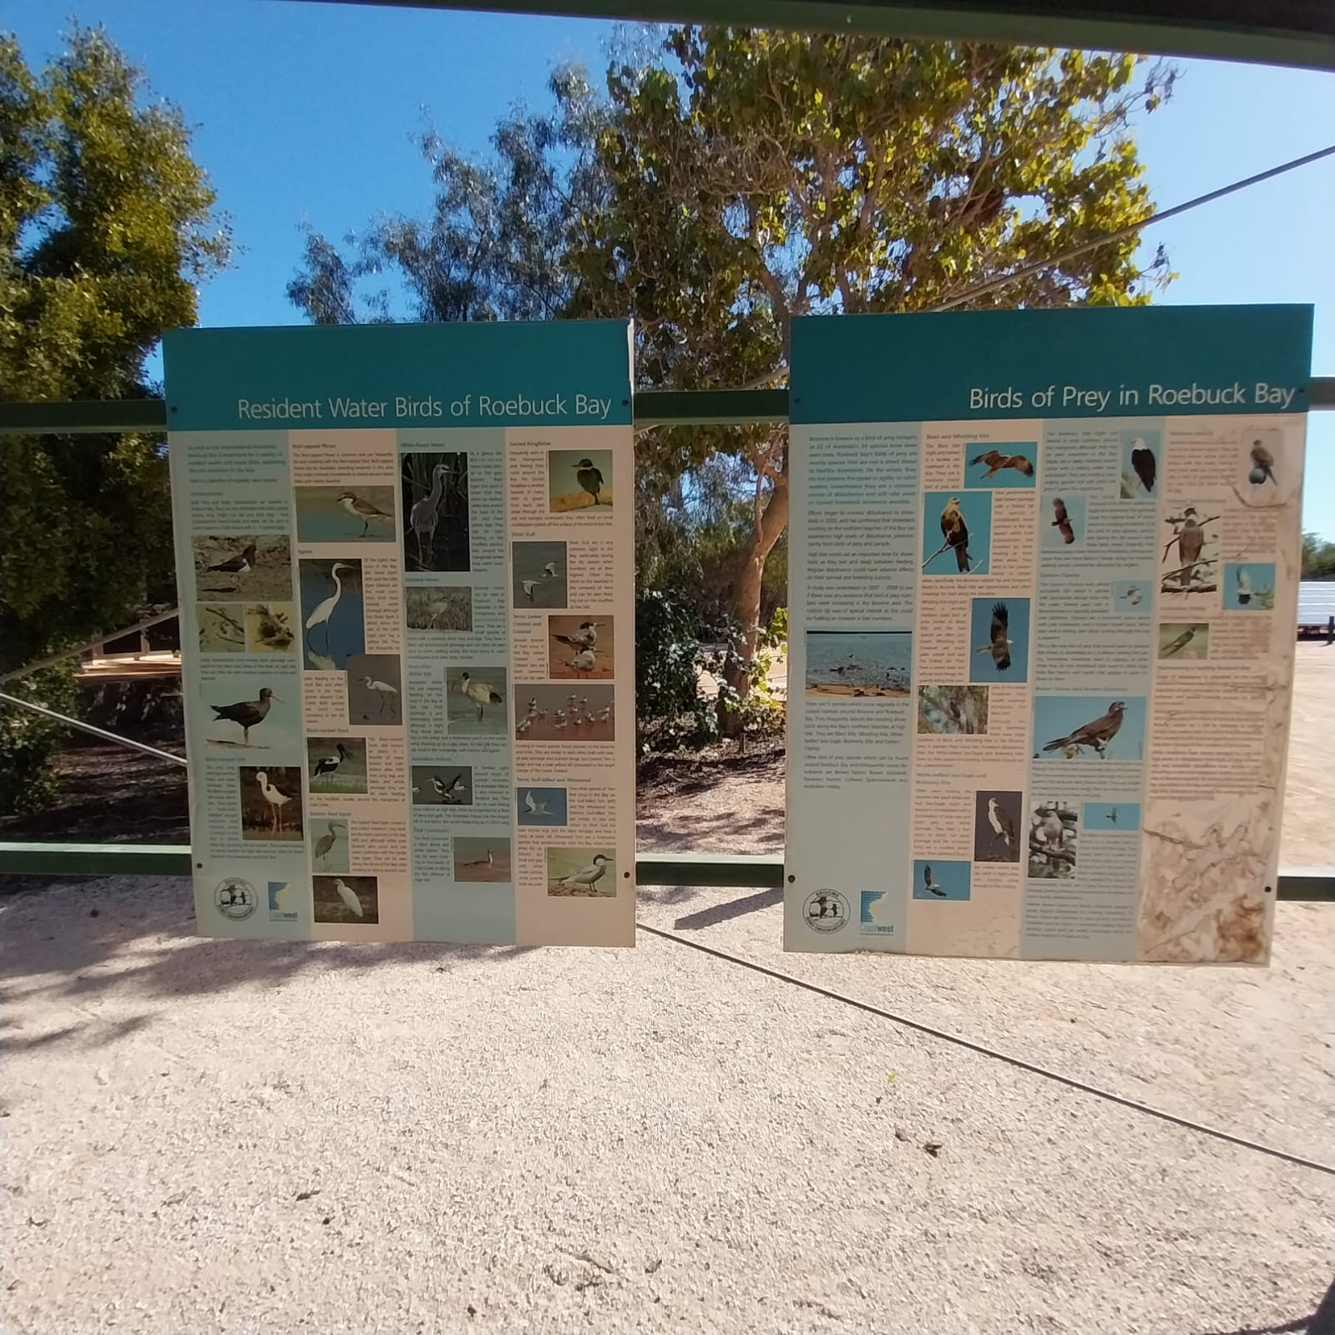
Interperativesignspicnicarea
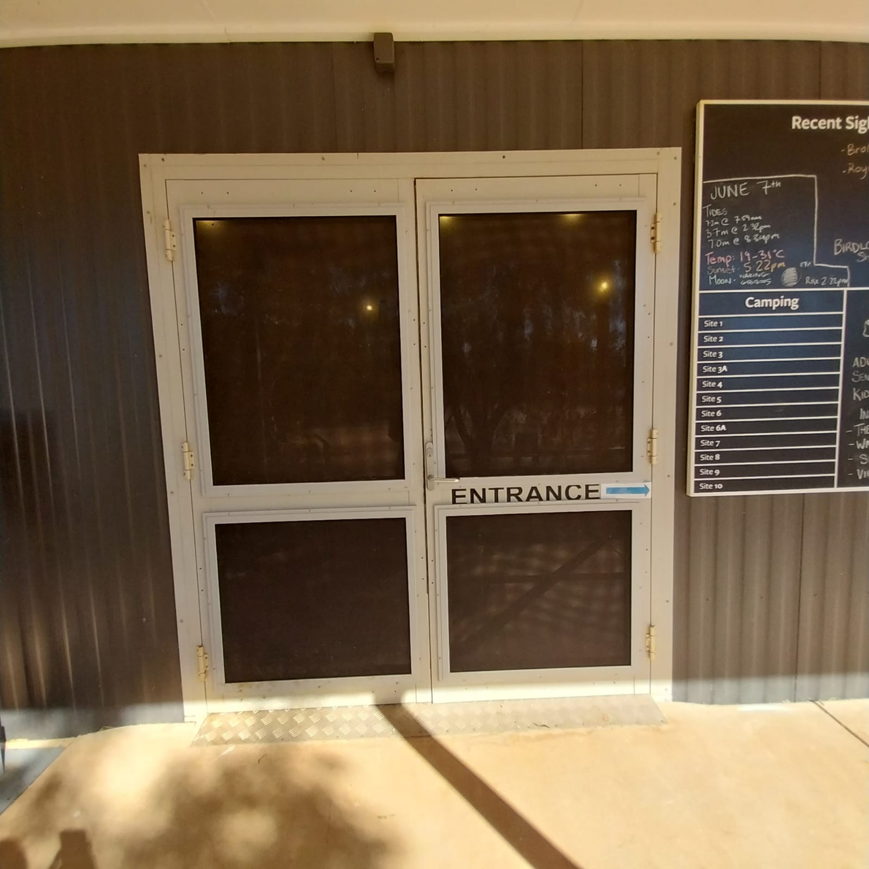
Discocenterallabilityaccess
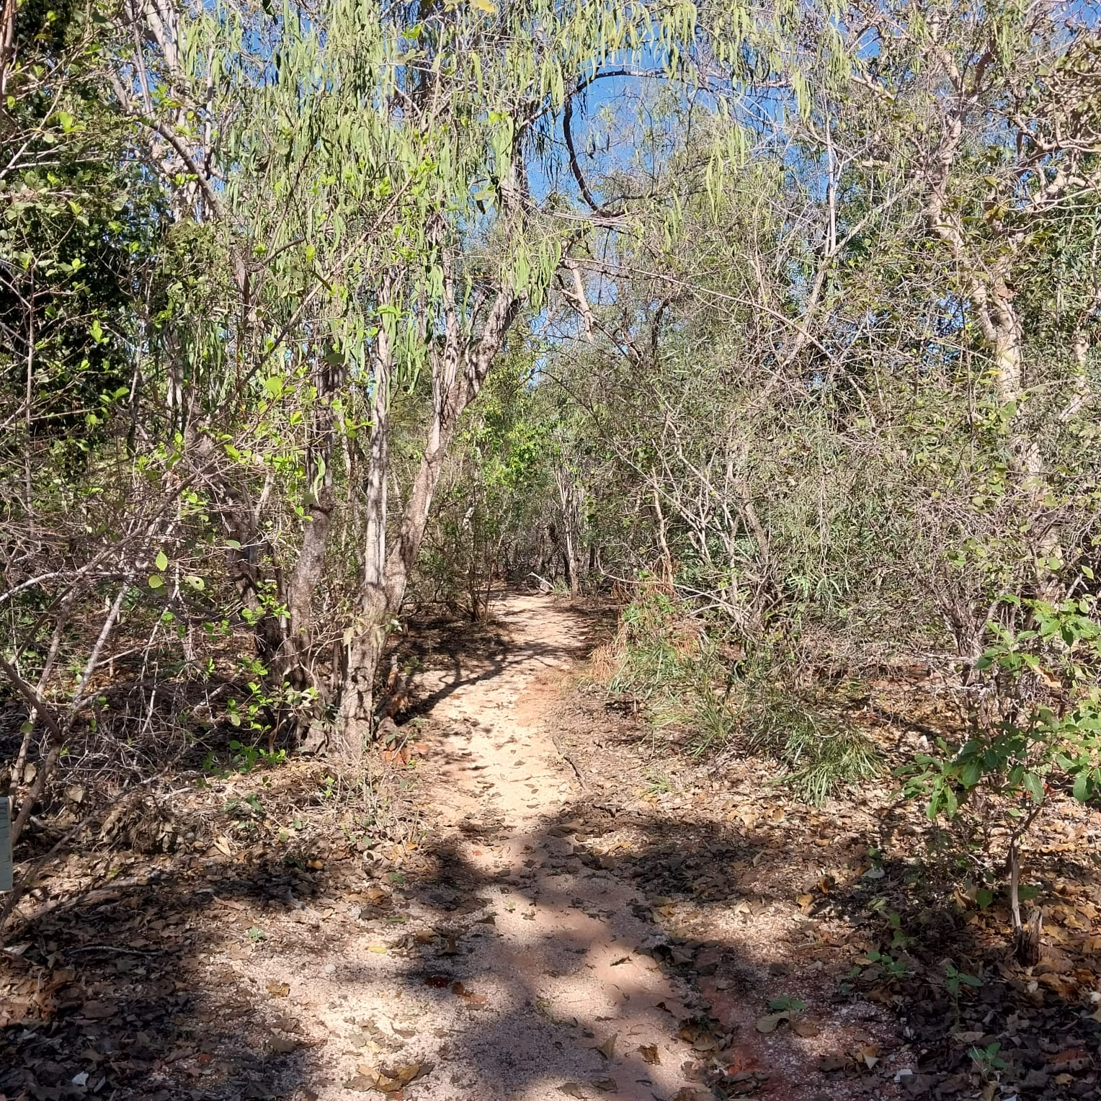
Walkingpath
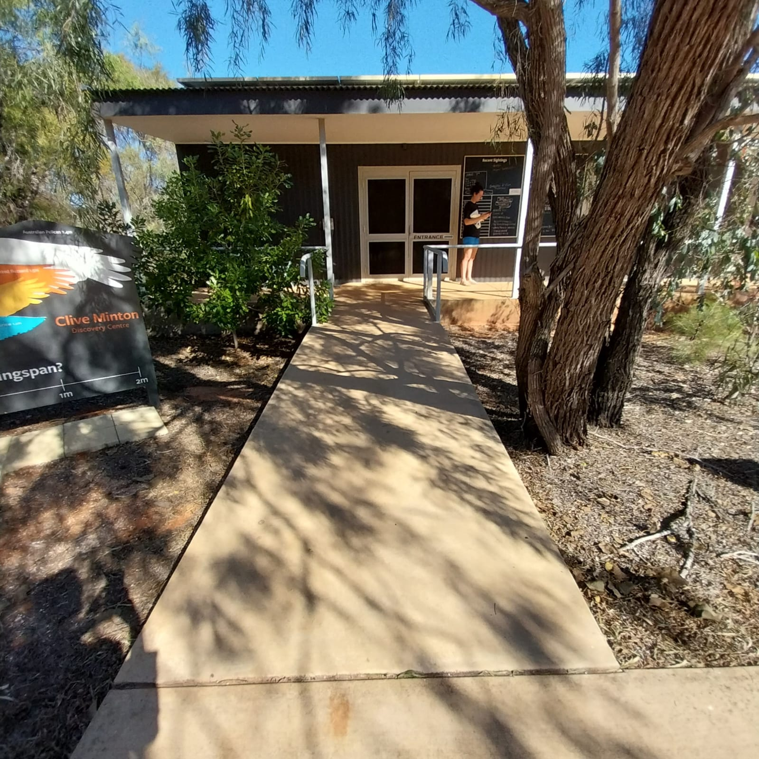
Discocenterrampentry
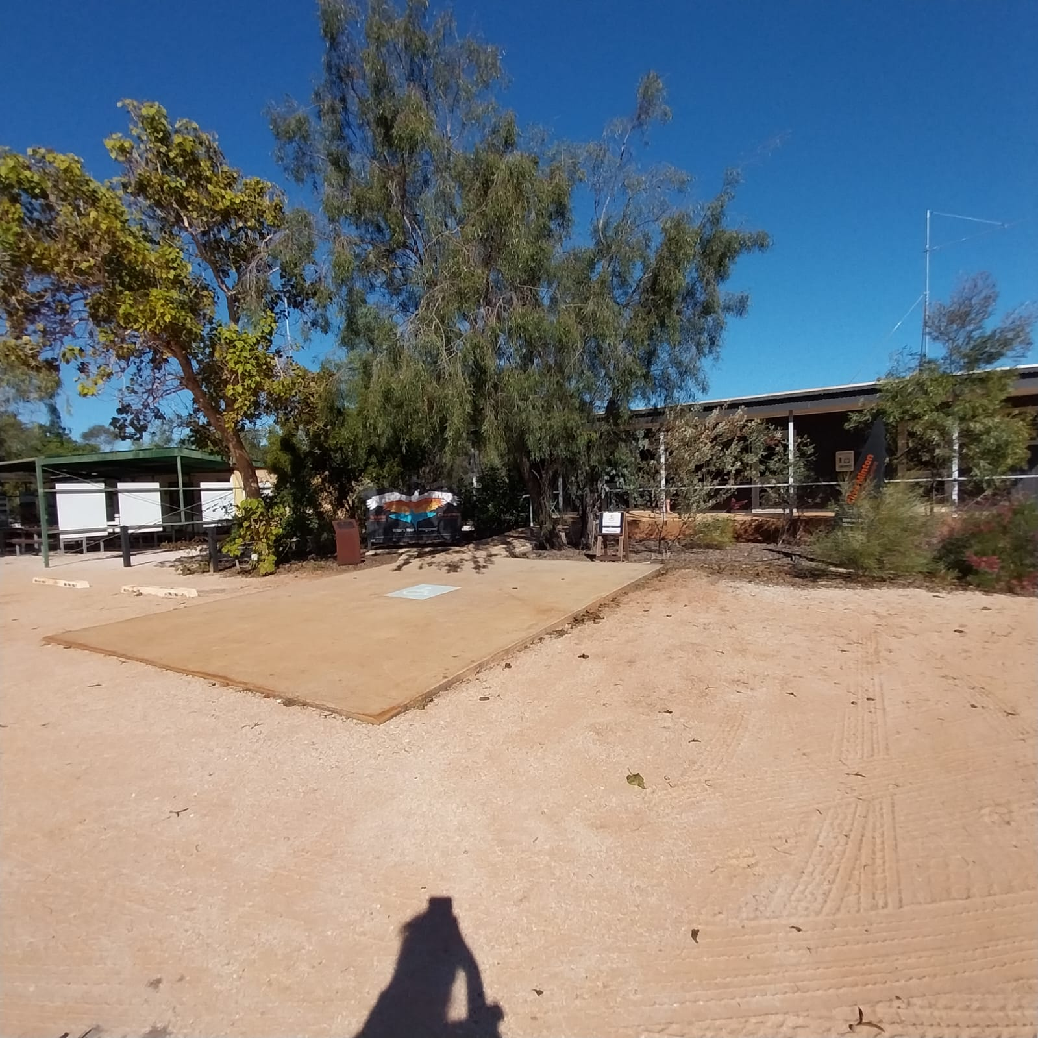
Disabledparkingbay

COMMON AREAS

Report Disclaimer
Please note that this business report, provided as a result of the use of the diagnostic assessment, is for information purposes only.
Australian Tourism Industry Council (ATIC) cannot guarantee the accuracy of respondent’s answers, or that they are fully representative of your business. Therefore, ATIC does not warrant or guarantee any particular outcome in respect of your businesses self-assessment.
This report is intended as guidance only for your business and should not be relied on for future marketing considerations. ATIC recommends that you seek your own independent advice as well as the results from the diagnostic.
Links to external web sites are inserted for convenience and do not constitute endorsement of material at those sites, or any associated organisation, product or service.
ATIC does not:
- Assume any legal liability for the accuracy, completeness, or usefulness of any information from this report or any links provided; or
- Accept responsibility for any loss associated directly or indirectly from the use of this report.

