ATIC Accessibility
To support the accessible community in making informed travel decisions for their individual needs

This report prepared for:
Business name: | Liberty Balloon Flights - WA
Address: | Unit 1
Town: | North Shore
Contact for enquiries: | Nick BRAU
Contact Number: | 0400694299
Contact Email: | info@libertyballoonflights.com.au
Website: | https://libertyballoonflights.com.au
Date: | 2026-10-17 03:52

ATIC Accessibility
The following pages provides travellers with information on the businesses facilities and amenities which aims to support the traveller to make an informed decision on whether the business is suitable for their individual needs.
OVERVIEW 4
Business Overview 4
Bookings 6
Emergency Management 6
Communications 6
Other Information 7
Guide Dog and Service Animals 7
GENERAL 8
Pre-arrival, arrival and reception 8
Cognitive Impairment Support 8
Car Park and Access amenities 8
Displays, exhibits, commentary and live performances 9
External Paths 9
Steps 9
Public Toilets/Adult change facilities 9
TOUR OPERATORS 11
Tour/Transport Services 11
Route Planning 11
Guides 11
COMMON AREAS 12
ADVENTURE ACTIVITIES 13
Adventure activities 13
Report Disclaimer 16

OVERVIEW

Business Overview

The business has the following products/services available
- Tour/Transport
- Adventure

Our business caters for the following disability types:
- Blind or low vision
- Deaf or low hearing
- Limited mobility
- Food allergies or intolerances
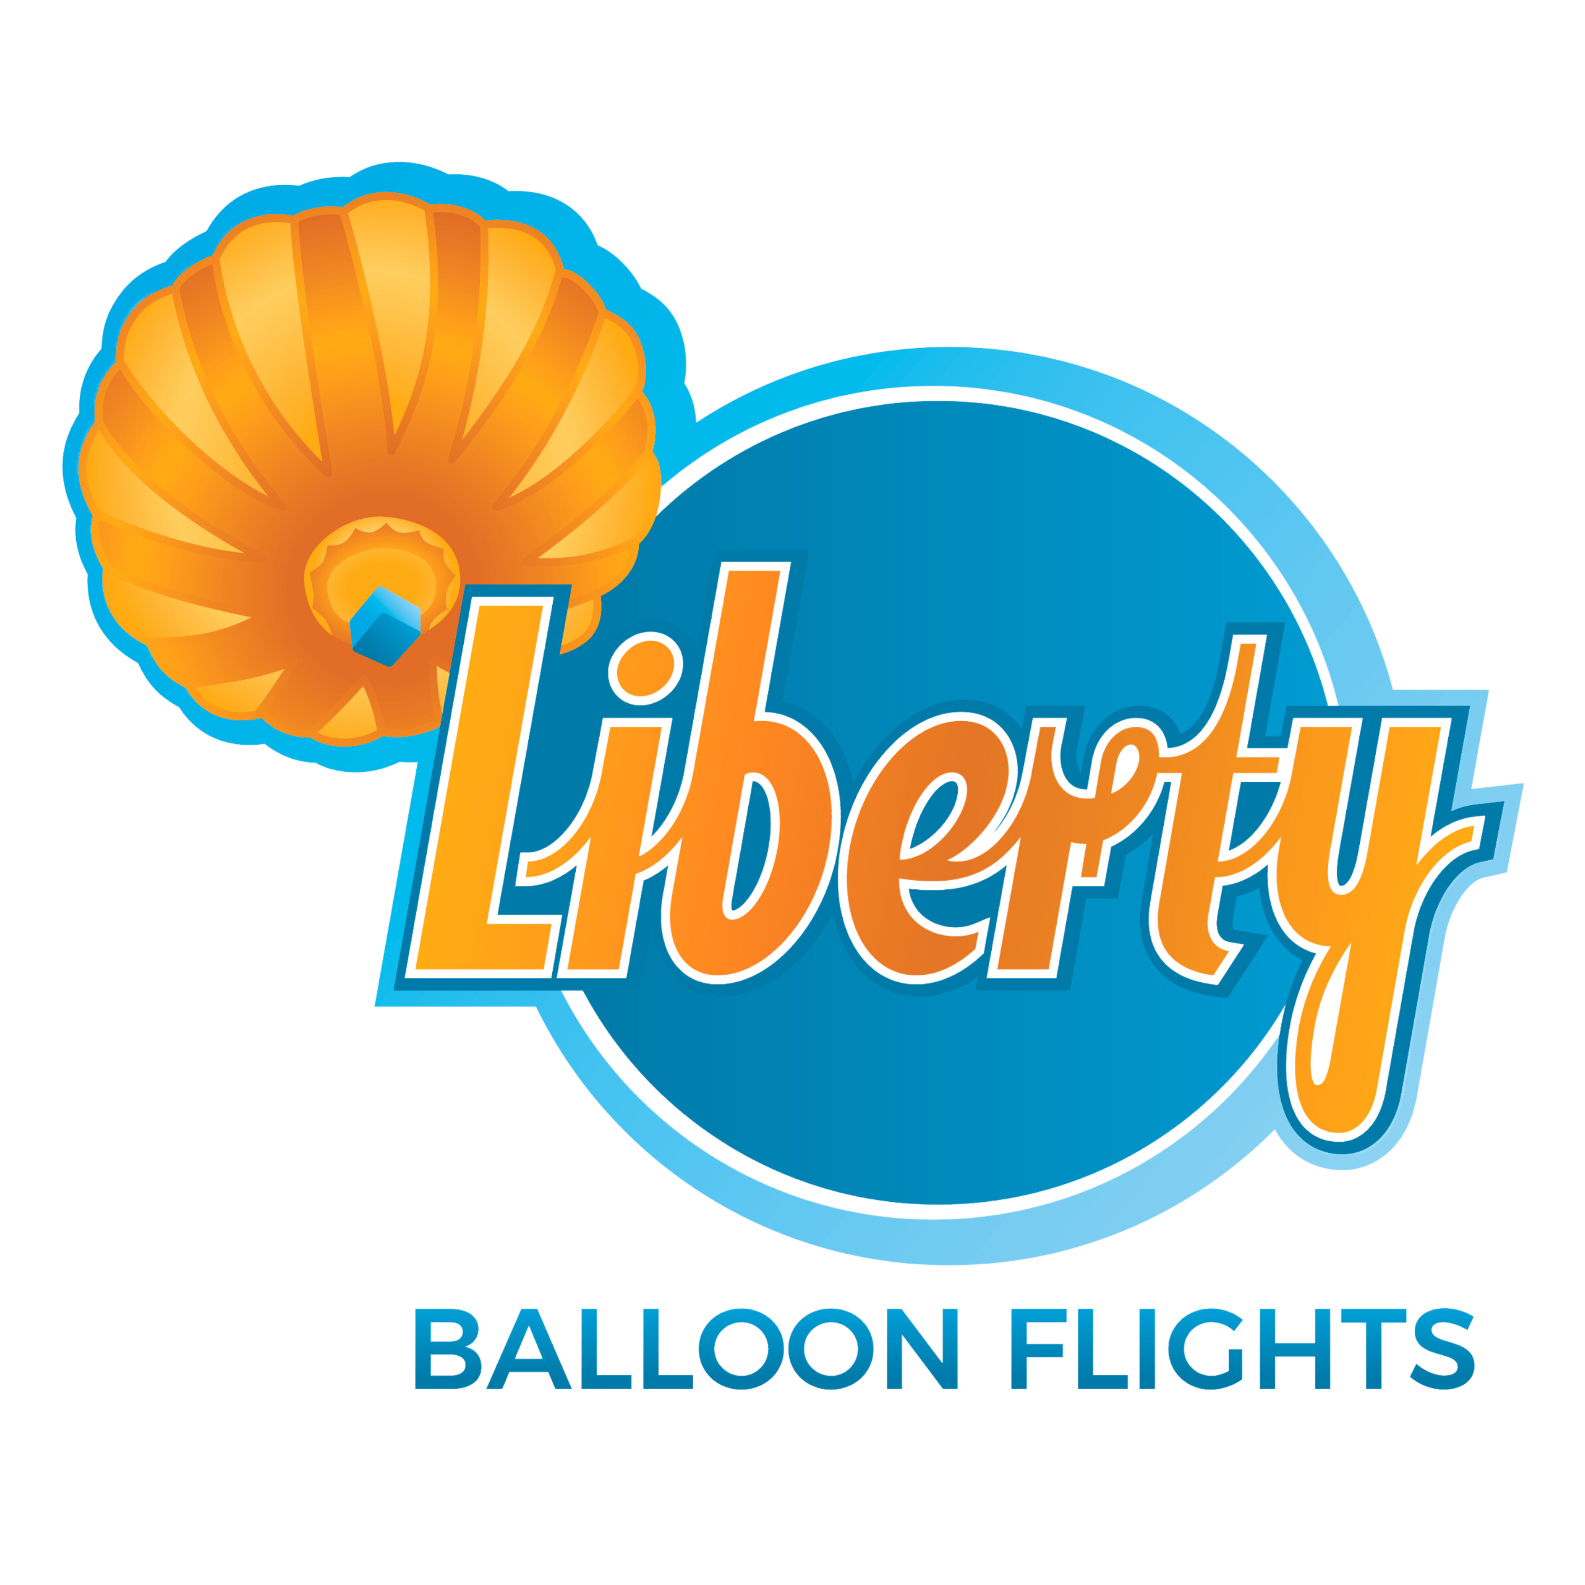

Bookings

The business offers the following methods for bookings and enquiries:
- Phone
- Email
- Webportal

Emergency Management
- Emergency and evacuation procedures are explained on arrival
- Exit access is free and clear at all times
We ensure exit access is free and clear at all times by:
Visibly checked as part of customer care.
- Exits and access to exists are greater than 900mm
- Exit doors are able to be opened by all occupants
- Exits that include stairways have emergency stair travel devices available.
- Exits including stairwells, have bright edges used on the steps.
- In addition, the following further information can assist guests:
Speak to them prior to booking and note clearly on manifest that is seen by pilots and crew, so they are able to be identified during check in process.
- In addition, the following further information can assist guests:
The procedure for assisting guests who need assisted rescue is: Reassure, check and monitor guest, confirm safe landing zone with crew access for support vehicles, assist guest into proper landing position and notify ground crew of expected assistance needs including contacting emergency services if needed, use equipment (steps, extra crew) to disembark guest, provide first aid if needed.
- Guests with disabilities are noted in the guest log book for emergency and evacuation purposes

Communications
- An accessibility guide is available on the website

https://accreditation.qualitytourismaustralia.com/report/AccessReportPublicHtml2/860c68f0-71b6-47f3-bf8f-966cb7a1c258
- Our business offers the following alternative communication methods
- Plain English

Not specified
- There is easy to read signage and information (e.g. menus and emergency information)

Other Information
- For bookings made onsite, the ticket booth/counter/box office is accessible for people using a wheelchair

Guide Dog and Service Animals
The business provides the following services for services animals:
We are not a business that is able to cater for service animals at this time. We are exploring lots of accessibility options at present however.

GENERAL

Pre-arrival, arrival and reception
The business has the following in place to support guests during pre-arrival, arrival and reception
- Booking information and websites are compatible with screen readers
- There is a reception/public entryway.
- Seating available at reception
- A tablet with text to voice or pen and paper at reception to aid in communication

We meet our passengers in Dome, Northam very early in the morning. Check in is done online prior and then verbally on arrival. Pilots provide a verbal brief. We gather information about individual passenger needs prior to meeting and cater specifically as/where necessary.
- Information and maps are available in written form
- In addition, the following further information can assist guests:
We have seating in meeting venue and passengers are welcome to be seated in transit vehicles or on a step during set up and/or pack away of balloon.

Cognitive Impairment Support
- A "social script" guide to your premises or attraction describing the sights, sounds and smells to aid parents/carers prepare visitors in advance
- The 'social script' is available in word and other editable formats
- Access has alternative procedures and clear written instructions with universal access symbols

Car Park and Access amenities
The business has the following Car Park and Access amenities
- Designated disabled parking bays
- Level or ramped access from the car park to the entrance
- The accessible entrance is clearly signed from the parking bay
- The public transport services available are:

We offer a transfer service from Perth and also details for train.
- Kerb ramps are in place where a pavement or walkway needs to be crossed

Displays, exhibits, commentary and live performances
For displays, exhibits, commentary and live performances the following amenities are in place
- Seating
- Wheelchair accessible spaces/seating

External Paths
External paths of travel
- Surfaces are concrete, asphalt, smooth paving or hard packed fine gravel (max aggregate size 13mm)
- Pathways are wider than 900mm

We are working outdoors for most of the time.

We meet at Dome, Northam where some of this is applicable but experience is from different locations, often uneven paddocks.

Steps
Steps
- There are steps.
- Where steps are present are there three steps or less

Public Toilets/Adult change facilities
Public Toilets/Adult change facilities have the following amenities are in place
- There is an accessible toilet for public use
- The door is at least 850mm wide
- There is a minimum of 850mm beside the toilet
- Handrails are fitted
- The toilet seat is 460mm above the floor
- There is Unsure sorry. Part of Dome Northam where we meet our passengers. No facilities again before returning for breakfast. mm of clear space in front of the toilet
- The toilet seat of a contrasting colour to the floor
- The toilet seat is460mm above the floor
- In addition, the following further information can assist guests:
We have toilets at the meeting place and when we return for breakfast. There are no toilet facilities during ballooning experience itself.

TOUR OPERATORS

Tour/Transport Services
The tour/transport services have the following facilities/amenities in place
- Buses/Coaches
- None at present vehicles have wheelchair lifts or ramps
- None at present vehicles have low floors with ramped entry
The maximum wheelchair capacity available in the fleet is:
None at present although we have had plans drawn up and are actively exploring options.
- Commentary is available in written format

Route Planning
- Route Planning
- The tour route includes stops with accessible toilet facilities

Guides
- Use of clear/simple English
- Correct pronunciation for lip readers
- There is a audio description of surroundings

COMMON AREAS

ADVENTURE ACTIVITIES

Adventure activities
The adventure activities have the following facilities/amenities in place
- Our adventure activities cater for people with a disability
- In addition, the following further information can assist guests:
Hot air ballooning is more 'soft adventure' and once in the air a very gentle experience. We can cater for people who are vision or hearing impaired and generally situate these people next to our pilot to ensure they benefit through using other senses...listening to stories, descriptions of the experience, feeling the warmth of burners above etc. We cater for older people and children over the age of 6.
We listen to individual needs and best cater if/when it is safe to do so and in the best interest of all involved in the experience.

The equipment utilised to make the activities available are:
We use steps and experienced staff and ensure communication is clear prior, during and following experience.

- In addition, the following further information can assist guests:
We use steps and experienced staff and ensure communication is clear prior, during and following experience.

- In addition, the following further information can assist guests:
Due to the nature of ballooning and the sometimes rough and uneven terrain we launch and land from, the need to climb in and out of the basket and sometimes a bit of a bump on landing hot air ballooning is not for everyone. Some people will also not like being confined in a basket with other people for up to an hour or more in the air. It is best to talk through needs with one of our staff to see what might be possible.

Report Disclaimer
Please note that this business report, provided as a result of the use of the diagnostic assessment, is for information purposes only.
Australian Tourism Industry Council (ATIC) cannot guarantee the accuracy of respondent’s answers, or that they are fully representative of your business. Therefore, ATIC does not warrant or guarantee any particular outcome in respect of your businesses self-assessment.
This report is intended as guidance only for your business and should not be relied on for future marketing considerations. ATIC recommends that you seek your own independent advice as well as the results from the diagnostic.
Links to external web sites are inserted for convenience and do not constitute endorsement of material at those sites, or any associated organisation, product or service.
ATIC does not:
- Assume any legal liability for the accuracy, completeness, or usefulness of any information from this report or any links provided; or
- Accept responsibility for any loss associated directly or indirectly from the use of this report.

