ATIC Accessibility
To support the accessible community in making informed travel decisions for their individual needs

This report prepared for:
Business name: | Cape2Camp
Address: | 3 Walkington Avenue
Town: | Margaret River
Contact for enquiries: | Anne Nordgard
Contact Number: | 0426441503
Contact Email: | cape2camp@gmail.com
Website: | www.cape2camp.com
Date: | 2026-09-09 21:28

ATIC Accessibility
The following pages provides travellers with information on the businesses facilities and amenities which aims to support the traveller to make an informed decision on whether the business is suitable for their individual needs.
OVERVIEW 4
Business Overview 4
Bookings 4
Emergency Management 5
Communications 6
Guide Dog and Service Animals 7
GENERAL 8
Pre-arrival, arrival and reception 8
Car Park and Access amenities 9
Public Toilets/Adult change facilities 11
TOUR OPERATORS 12
Route Planning 12
ACCOMMODATION 13
Room Amenities 13
COMMON AREAS 15
FOOD AND DRINK 16
Dining Spaces 16
ADVENTURE ACTIVITIES 18
Report Disclaimer 20

OVERVIEW

Business Overview

The business has the following products/services available
- Tour/Transport
- Accommodation
- Food and Drink
- Adventure

Our business caters for the following disability types:
- Food allergies or intolerances


Bookings

The business offers the following methods for bookings and enquiries:
- Phone
- Email
- Webportal
- Our website supports Screen Readers

Emergency Management
- Emergency and evacuation procedures are explained on arrival
- In addition, the following further information can assist guests:
Cape2Camp identifies guests who may need additional assistance in an emergency through several proactive measures: Pre-trip Communication: During the booking process and through pre-hike communication, guests are encouraged to disclose any medical conditions, disabilities, or special needs that may require additional support. This information is gathered through booking forms and communication via WhatsApp or email. Direct Communication with Guests: Cape2Camp staff engages directly with guests before their hike to confirm any specific requirements, including mobility issues, medical needs, or any other conditions that might require attention in an emergency. Hike Briefings: On the first day of the hike, a thorough briefing is given, where guests are asked to inform staff about any concerns or special requirements for the hike, including emergency assistance. This ensures that all hikers are accounted for, and any necessary adjustments can be made to the hiking itinerary or support plans. 24/7 Phone Support Service: Cape2Camp offers 24/7 phone support, ensuring that guests can contact staff at any time during their hike. This service is available for any emergency or additional support needs, providing peace of mind for hikers who may require assistance while on the trail. These steps ensure that Cape2Camp is prepared to provide the necessary support for any guests who may need additional assistance during an emergency situation
- In addition, the following further information can assist guests:
Procedure for Assisting Guests Who Need Assisted Rescue In the event that a guest requires an assisted rescue, Cape2Camp follows a clear and structured procedure to ensure prompt and effective support. The steps are as follows: Immediate Contact via 24/7 Phone Support: If a guest requires assistance, they can contact Cape2Camp’s 24/7 phone support service. Our staff will immediately assess the situation, gather critical information (such as the guest’s location, nature of the emergency, and any medical conditions), and prioritize the response. Assess the Situation: The Cape2Camp team will evaluate whether the situation requires evacuation or other forms of assistance based on the guest's condition, location, and the severity of the emergency. Staff will maintain communication with the guest to keep them calm and informed while assistance is being arranged. Coordinate with Emergency Services: If necessary, Cape2Camp will contact local emergency services (such as paramedics or search and rescue teams) to provide further assistance. In remote or difficult-to-access locations, the Cape2Camp team will assist in facilitating the transfer of the guest to a safer location for pick-up. Encouraging Support from Fellow Hikers: In emergency situations, Cape2Camp encourages hikers within the same group to assist, provided it is safe to do so. Fellow hikers can help with basic first aid, provide comfort, or assist in transporting the affected guest to a safer location if needed. This cooperative effort can help in less severe cases and ensure immediate support while awaiting further assistance. The safety of all hikers is the top priority, and Cape2Camp will provide guidance on how to safely manage the situation. Provide Support and Assistance: If the situation involves non-urgent assistance, the Cape2Camp team will provide support until emergency services arrive or the guest is safely relocated. Whether it’s offering first aid or facilitating transportation, our team is trained to handle various emergency situations. Evacuation Plan: If the guest requires evacuation, the Cape2Camp team will arrange for safe and efficient transportation, either to the nearest trailhead or directly to the hospital, depending on the severity of the situation. Emergency contact details will be updated, and the guest's safety is prioritized throughout the evacuation process. By maintaining 24/7 support, coordinating with emergency services, and encouraging assistance from fellow hikers, Cape2Camp ensures that all guests receive the appropriate care and support quickly and efficiently in the event of an emergency or rescue situation.
- Guests with disabilities are noted in the guest log book for emergency and evacuation purposes

Communications
- An accessibility guide is available on the website

Not specified
- Our business offers the following alternative communication methods
- Plain English

Not specified
- There is easy to read signage and information (e.g. menus and emergency information)
- There is a Pictorial menu
  - Pictorial Menu Image(s)
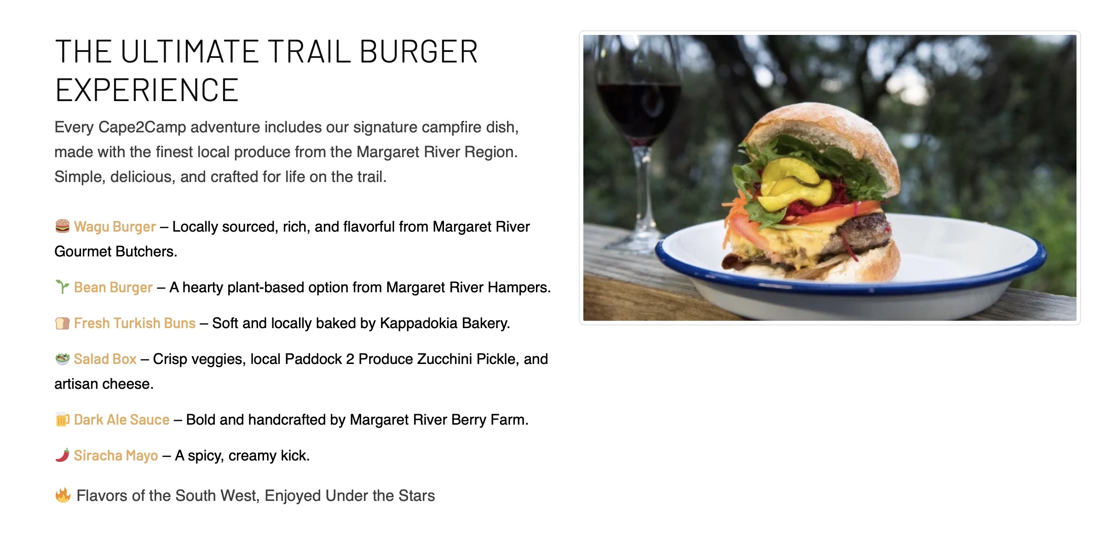
Image 7-5-2025 at 1.26 pm
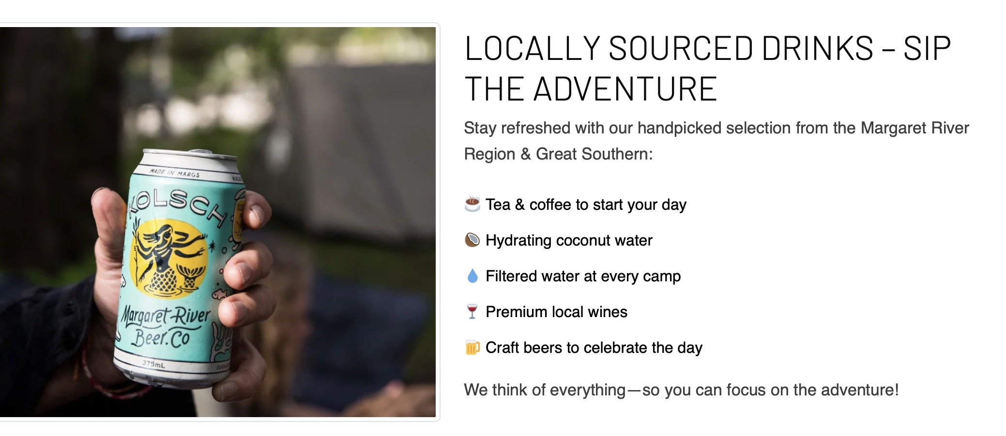
Image 7-5-2025 at 1.26 pm

Guide Dog and Service Animals
The business provides the following services for services animals:
Cape2Camp offers a unique self-guided and fully catered hiking experience along the Cape to Cape Track in Western Australia. While the company provides comprehensive services for human guests, including comfortable tented accommodations, meals, and hand-luggage transfers, it does not currently offer specific accommodations or services tailored for service animals

GENERAL

Pre-arrival, arrival and reception
The business has the following in place to support guests during pre-arrival, arrival and reception
- Luggage assistance
- In addition, the following further information can assist guests:

Assistance with Luggage:
Cape2Camp does not provide traditional accommodation services, as the business focuses on outdoor, self-guided hiking experiences. However, guests are assisted with luggage through luggage transfer services along the Cape to Cape Track. This allows guests to hike with only a day pack, while their main luggage is transferred between campsites, reducing the physical load and making the hiking experience more comfortable. This service ensures that guests don’t have to worry about carrying heavy luggage on the trail, which can be especially beneficial for those with mobility challenges or other physical limitations.

Accommodations for Fatigue-Related Disabilities:
Cape2Camp recognizes that some guests may experience fatigue related to their disability and takes steps to ensure they are not disadvantaged by long wait times during the hiking experience. Here are the accommodations made:

Flexible Itinerary: Cape2Camp allows for flexibility in the hiking schedule, ensuring that guests can take their time to rest when needed. The trail is designed to be self-paced, with guests having the ability to adjust their hiking pace based on their personal needs.

Regular Rest Points: Along the Cape to Cape Track, there are multiple natural rest points, such as beaches, forested areas, and campgrounds, where guests can stop to rest and recover. These spots are often strategically located to allow for breaks when fatigue sets in.

Support from Staff: Guests can access 24/7 phone support from the Cape2Camp team, who can assist with any issues related to fatigue or other concerns. If a guest is feeling fatigued or in need of additional support, the team can arrange alternative transport options to the next campsite or assist with adjustments to the itinerary.

Transport Options: In case a guest needs assistance with reducing physical strain, Cape2Camp offers transport options between some sections of the trail. This ensures that guests can bypass particularly challenging parts of the hike if fatigue or other disability-related issues arise.

These accommodations ensure that guests with fatigue-related disabilities are supported throughout their experience, with adjustments made to avoid long wait times or undue physical strain.

- In addition, the following further information can assist guests:
Cape2Camp does not offer traditional accommodation services, as it operates in outdoor environments along hiking trails. However, luggage assistance is provided as part of the hiking experience.

Cape2Camp offers luggage transfers for guests along the Cape to Cape Track. Guests are required to pack only a day pack for the hike, while their main luggage is transferred between campsites, allowing them to hike without the burden of carrying heavy gear. This service ensures a comfortable and convenient experience for guests, letting them focus on enjoying the trail without worrying about carrying their belongings.

This form of luggage support is specifically tailored for the hiking experience and is provided as part of the all-inclusive service, which includes accommodation, meals, and logistical support along the track

Car Park and Access amenities
The business has the following Car Park and Access amenities
- A drop off zone
- In addition, the following further information can assist guests:
Cape2Camp primarily operates in outdoor environments and does not have a traditional car park or building entrance with an intercom system. The starting points for hikes are generally located at trailheads or outdoor locations, not in facilities with infrastructure such as car parks or intercoms.
The width of the smallest pathway is:
Cape2Camp operates in natural outdoor environments along hiking trails, rather than in built or urban areas with standardized pathways. The Cape to Cape Track consists of a variety of natural surfaces, including dirt paths, sandy beaches, and forest trails, which vary in width and terrain. While some sections of the trail may have narrower paths, the majority of the Cape to Cape Track is designed for hikers and is not typically constrained by the specific width standards for accessibility that apply to paved pathways in urban settings.
- In addition, the following further information can assist guests:
The Cape to Cape Track is primarily a natural hiking trail, and there are no built structures or designated step-free routes like those you might find in urban areas or buildings. The trail consists of diverse terrain, including beaches, forest paths, and rocky sections, which are not typically designed with step-free access in mind.
- In addition, the following further information can assist guests:

Natural Terrain: The Cape to Cape Track offers a mix of gentle and more challenging sections, with natural obstacles such as rocks, sand, and uneven ground. There are no artificial steps, but hikers may encounter inclines or declines, particularly in forested or coastal sections.

Trail Conditions: Some areas of the trail may include small rock steps or uneven surfaces, especially in forested or cliff-side areas. However, these natural features are part of the adventure and are manageable with the right gear, like sturdy hiking boots.

Preparation for Varied Terrain: We recommend guests come prepared for the diverse trail conditions by bringing appropriate footwear and ensuring they are comfortable with navigating uneven surfaces. Cape2Camp provides maps and navigation tools to help guests stay informed about the trail’s conditions and plan accordingly.

If guests have specific concerns regarding mobility or the trail’s accessibility, Cape2Camp encourages them to reach out prior to booking so we can provide advice and make any necessary adjustments to ensure an enjoyable experience.

Public Toilets/Adult change facilities
Public Toilets/Adult change facilities have the following amenities are in place
- There is an accessible toilet for public use
- The door is Since the hiking experience is set in natural environments, guests stay in tented accommodation or at campgrounds, and there are no conventional doors involved. Tented accommodations typically use tent flaps or zippered entrances, which provide easy access for hikers and do not adhere to traditional door measurements. wide
- There is Since the hiking experience is set in natural environments, guests stay in tented accommodation or at campgrounds, and there are no conventional doors involved. Tented accommodations typically use tent flaps or zippered entrances, which provide easy access for hikers and do not adhere to traditional door measurements. mm beside the toilet
- There is Since the hiking experience is set in natural environments, guests stay in tented accommodation or at campgrounds, and there are no conventional doors involved. Tented accommodations typically use tent flaps or zippered entrances, which provide easy access for hikers and do not adhere to traditional door measurements. mm of clear space in front of the toilet
- The height of the toilet seat is: Since the hiking experience is set in natural environments, guests stay in tented accommodation or at campgrounds, and there are no conventional doors involved. Tented accommodations typically use tent flaps or zippered entrances, which provide easy access for hikers and do not adhere to traditional door measurements..
- In addition, the following further information can assist guests:
Since the hiking experience is set in natural environments, guests stay in tented accommodation or at campgrounds, and there are no conventional doors involved. Tented accommodations typically use tent flaps or zippered entrances, which provide easy access for hikers and do not adhere to traditional door measurements.

TOUR OPERATORS

Route Planning
- In addition, the following further information can assist guests:
Cape2Camp does not operate buses, coaches, or boats as part of our service. Our business focuses onself-guided hiking experiencesalong the Cape to Cape Track, where guests navigate the trail on foot. We provide logistical support such asluggage transfers, campsite bookings, andmeal provisionsto make the hiking experience as seamless as possible.
- Overnight Stops
The total number of wheelchair passengers that can be catered for at overnight stops are:
Nil
- In addition, the following further information can assist guests:
Cape2Camp’s hiking route, theCape to Cape Track, does not include stops at attractions, accommodation, food and beverage, or retail spaces operated by third-party businesses. The experience is primarily focused on hiking through the natural environment, with all meals, accommodation, and logistical services provided by Cape2Camp along the trail.

ACCOMMODATION

Room Amenities

Cape2Camp provides tented accommodations along the Cape to Cape Track, rather than traditional hotel rooms or buildings with wardrobes and hanging rails.
- Openings are a minimum of Cape2Camp operates in outdoor, tented accommodations along the Cape to Cape Track, rather than in traditional buildings or rooms with doors or structured openings. wide
- Non-allergenic cleaning products are used
- In addition, the following further information can assist guests:
Cape2Camp usesbiodegradable, eco-friendly cleaning productsfor cleaning the tents and other camp facilities. These products are chosen to ensure they are safe for the environment and for guests with sensitivities.
- The width of the door is Cape2Camp provides tented accommodations along the Cape to Cape Track rather than traditional buildings or rooms with conventional doors. The entrances to the tents are typically zippered flaps, which allow easy access in and out of the tent..
- The width beside the toilet is at the Cape2Camp campsites along the Cape to Cape Track, the toilet facilities are basic drop toilets or composting toilets. These are eco-friendly, simple outdoor facilities designed to serve hikers along the trail. They are functional and ensure that guests have access to essential services during their hike, but they are not equipped with the same accessibility features as indoor restrooms in buildings or hotels.
- There is at the Cape2Camp campsites along the Cape to Cape Track, the toilet facilities are basic drop toilets or composting toilets. These are eco-friendly, simple outdoor facilities designed to serve hikers along the trail. They are functional and ensure that guests have access to essential services during their hike, but they are not equipped with the same accessibility features as indoor restrooms in buildings or hotels mm of clear space in front of the toilet
- The actual height of the toilet seat is at the Cape2Camp campsites along the Cape to Cape Track, the toilet facilities are basic drop toilets or composting toilets. These are eco-friendly, simple outdoor facilities designed to serve hikers along the trail. They are functional and ensure that guests have access to essential services during their hike, but they are not equipped with the same accessibility features as indoor restrooms in buildings or hotels.
- In addition, the following further information can assist guests:
at the Cape2Camp campsites along the Cape to Cape Track, the toilet facilities arebasic drop toiletsorcomposting toilets. These are eco-friendly, simple outdoor facilities designed to serve hikers along the trail. They are functional and ensure that guests have access to essential services during their hike, but they are not equipped with the same accessibility features as indoor restrooms in buildings or hotels.

COMMON AREAS

FOOD AND DRINK

Dining Spaces
The dining spaces have the following facilities/amenities in place
- The smallest doorway is Cape2Camp operates in outdoor environments, with dining spaces provided as part of the campsites during the hiking experience, rather than in traditional buildings or structures with specific doorways. The dining areas at the campsites are typically set up in outdoor or tented areas where guests gather for meals wide

Our business caters for the following dietary requirements
- Gluten free (celiac)
- Nut free
- Vegetarian
- In addition, the following further information can assist guests:
At Cape2Camp, we prioritize food safety to ensure the well-being of our guests, particularly those with dietary restrictions or allergies.

Registered Caterers:We work with registered, certified caterers who follow food safety standards to ensure safe food preparation and transport.

Allergen Awareness:Special dietary requirements are communicated to our caterers in advance, and care is taken to prevent cross-contact between allergens.

Separation of Food Products:Raw and ready-to-eat foods are kept separate during preparation and transport to avoid contamination.

Cleanliness and Hygiene:All cooking and serving equipment is thoroughly cleaned, and strict hand hygiene is followed by staff.

Food Stored in Refrigeration:At the campsites, all food is stored in refrigeration to ensure freshness and prevent contamination.

If you have specific dietary needs or allergies, please inform us at booking, and we will ensure your meals meet your requirements.

Guests are encouraged to bring their own snacks or special ingredients for the hike.

By following these procedures, Cape2Camp ensures that guests can enjoy safe, clean meals throughout their adventure.

- In addition, the following further information can assist guests:

All Meals Included: Cape2Camp provides all meals during the hike, ensuring guests are well-nourished throughout their adventure.

Dietary Preferences: Vegetarian, vegan, and gluten-free options are available upon request.

Beverages: A selection of beverages, including water, coconut water, juice, tea, coffee, and local wines and beers, are provided.

Sustainable Practices: Cape2Camp prioritizes low-impact camping and supports local produce, aligning with their commitment to sustainability.

ADVENTURE ACTIVITIES
- In addition, the following further information can assist guests:
Cape2Camp is committed to providing an inclusive and accessible hiking experience, though the nature of the self-guided hiking adventure along the Cape to Cape Track may present certain challenges for individuals with mobility impairments or other disabilities.

While the Cape to Cape Track is a rugged, outdoor trail, Cape2Camp strives to offer an enjoyable experience for guests with disabilities. We encourage guests with specific accessibility needs to contact us prior to booking so that we can discuss the best options and make any necessary adjustments.

Trail Support: We provide support through 24/7 phone assistance, ensuring guests can contact us at any time if they need help navigating the trail or managing any challenges they encounter.

Customised Arrangements: Depending on the guest's specific needs, we can offer guidance on which sections of the track may be more accessible, or suggest alternative routes or accommodations where applicable.

Report Disclaimer
Please note that this business report, provided as a result of the use of the diagnostic assessment, is for information purposes only.
Australian Tourism Industry Council (ATIC) cannot guarantee the accuracy of respondent’s answers, or that they are fully representative of your business. Therefore, ATIC does not warrant or guarantee any particular outcome in respect of your businesses self-assessment.
This report is intended as guidance only for your business and should not be relied on for future marketing considerations. ATIC recommends that you seek your own independent advice as well as the results from the diagnostic.
Links to external web sites are inserted for convenience and do not constitute endorsement of material at those sites, or any associated organisation, product or service.
ATIC does not:
- Assume any legal liability for the accuracy, completeness, or usefulness of any information from this report or any links provided; or
- Accept responsibility for any loss associated directly or indirectly from the use of this report.

