ATIC Accessibility
To support the accessible community in making informed travel decisions for their individual needs

This report prepared for:
Business name: | Hotel Ernest Bendigo
Address: | 10 - 12 View Street
Town: | Bendigo
Contact for enquiries: | Martin Shew
Contact Number: | 0447 242 987
Contact Email: | hello@hotelbendigo.com.au
Website: | https://www.hotelbendigo.com.au/
Date: | 2026-09-21 10:48

ATIC Accessibility
The following pages provides travellers with information on the businesses facilities and amenities which aims to support the traveller to make an informed decision on whether the business is suitable for their individual needs.
OVERVIEW 4
Business Overview 4
Bookings 4
Emergency Management 4
Communications 5
Other Information 5
Guide Dog and Service Animals 5
GENERAL 7
Pre-arrival, arrival and reception 7
Cognitive Impairment Support 7
Car Park and Access amenities 7
Internal Spaces 8
External Paths 8
Public Toilets/Adult change facilities 8
ACCOMMODATION 10
Bedrooms 10
Room Amenities 11
Bathrooms 12
COMMON AREAS 14
FOOD AND DRINK 15
Dining Spaces 15
Report Disclaimer 18

OVERVIEW

Business Overview

The business has the following products/services available
- Accommodation
- Food and Drink

Our business caters for the following disability types:
- Blind or low vision
- Deaf or low hearing
- Limited mobility
- Wheelchairs or mobility scooters
- Food allergies or intolerances


Bookings

The business offers the following methods for bookings and enquiries:
- Phone
- Email
- Webportal
- Our website supports Screen Readers

Emergency Management
- The business has an emergency management and evacuation plan for guests with a disability
- Emergency and evacuation procedures are explained on arrival
- Guests with disabilities are noted in the guest log book for emergency and evacuation purposes

Communications
- An accessibility guide is available on the website

https://hotelbendigo.com.au/accessibility
- Our website meets WCAG 2.0 accessibility standards
- Our business offers the following alternative communication methods
- Plain English
- Magnifiers

Nothing to add
- There is easy to read signage and information (e.g. menus and emergency information)

Other Information
- For bookings made onsite, the ticket booth/counter/box office is accessible for people using a wheelchair

Guide Dog and Service Animals
- The business provides a secure area with shade and water for service animals
- The business provides a toilet area for service animals
- Bowls, bedding, etc. are provided for service animals
The business provides the following services for services animals:
Service Animal Accommodations at Hotel Ernest: At Hotel Ernest we warmly welcome guests accompanied by service animals and are committed to providing a comfortable and accessible environment for both you and your animal companion. Our services and accommodations for guests with service animals include: No Additional Fees: Service animals are welcome at no extra charge. Accessible Rooms: We offer accessible guest rooms designed to provide ample space and comfort for guests and their service animals. Water Bowls and Mats: Complimentary water bowls and mats are available upon request to ensure your service animal’s comfort during your stay. Relief Areas: Designated outdoor areas are available for service animal relief, and our staff can provide directions or escort you to these locations. Welcome Amenities: Upon arrival, service animals receive a welcome treat and information about nearby pet supply stores and veterinary services. Housekeeping Coordination: Our housekeeping team will coordinate with you to arrange cleaning times that are convenient and comfortable for your service animal. Emergency Support: Information about local veterinarians and 24-hour animal emergency services is available at the front desk. Staff Training: Our staff are trained to interact appropriately with service animals and to respect their role in assisting our guests. If you have any specific needs or requests for your service animal, please let us know before or during your stay. We are dedicated to ensuring a welcoming and supportive experience for all our guests.

GENERAL

Pre-arrival, arrival and reception
The business has the following in place to support guests during pre-arrival, arrival and reception
- Booking information and websites are compatible with screen readers
- There is a reception/public entryway.
- Seating available at reception
- A clipboard to allow check-in/ticket purchase whilst seated
- A tablet with text to voice or pen and paper at reception to aid in communication
- Lighting in the reception area is even and glare free
- Information and maps are available in written form
- A step free map/guide
- A familiarisation tour
- Keys are available for each guest
- Luggage assistance
- In addition, the following further information can assist guests:
As a boutique property of only 10 suites it is highly likely that all guests will be arriving at the same time. People with a disability are prioritised and other guests understand this. We sent a pre-arrival text message to all guests the day before asking for arrival time. This ensures that the guest experience manager has a detailed run sheet and is able to anticipate and plan for any potential guest overlaps.
- In addition, the following further information can assist guests:
We have a "quiet" room as part of the hotel reception which is separate from lounge bar, if a person needs solitude and peace. The bar area is not in operation until after 5.30pm and by this time a majority of guests have checked in.

Cognitive Impairment Support
- Documents are available in plain English for people with cognitive impairment (This may include instructions, guides, menus and general information)
- Quiet periods or early opening times for people on the Autism Spectrum

Car Park and Access amenities
The business has the following Car Park and Access amenities
- A drop off zone
- Level or ramped access from the car park to the entrance
- The public transport services available are:

This information is provided at reception upon request at arrival
- In addition, the following further information can assist guests:
Bendigo Ernest Hotel, built c. 1864 during the gold rush period. Designed by architect Alfred Smith from Melbourne, it was first owned by the Commercial Banking Company of Sydney, and is the oldest surviving bank building in Bendigo. It sits adjacent to Rosalind Park, a late 19th century recreation reserve with heritage trees, a fernery, conservatory building, rose gardens, and heritage sculptures. The building’s decorated facade with pedimented windows faces Pall Mall, Alexandra Fountain and View Street - built in a prominent position to oversee the town. There are three entry points - two of these are accessible.

Internal Spaces
- Tableware/glassware contrast with the table surface or table cloth

External Paths
External paths of travel
- Surfaces are concrete, asphalt, smooth paving or hard packed fine gravel (max aggregate size 13mm)
- Paths or slopes longer than 15 metres have resting places or seats
- Pathways are wider than 900mm
- There 3 successive steps or less on any path or at any doorway
- Any paths having steps are clearly identified as non-wheelchair accessible
- Step free routes clearly signed

Public Toilets/Adult change facilities
Public Toilets/Adult change facilities have the following amenities are in place
- There is an accessible toilet for public use
- The door is at least 850mm wide
- There is a minimum of 850mm beside the toilet
- Handrails are fitted
- The toilet seat is 460mm above the floor
- The toilet seat of a contrasting colour to the floor
- The toilet seat is460mm above the floor
- In addition, the following further information can assist guests:
Guests can call us on 0447 242 987 on arrival and we will be able to greet them in the car park. Our guest experience manager can also help with luggage and direct guests for personalised tour of the suite, detailing amenities and important information.

ACCOMMODATION

Bedrooms
The bedrooms have the following facilities/amenities in place
- There are 1 rooms available to guests who use a wheelchair
- Bedroom furniture can be re-arranged on request
  - Layout of room Image(s)
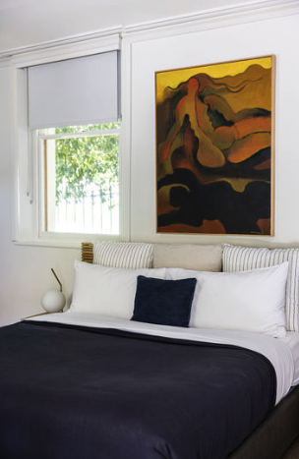
Accessible bedroom 1
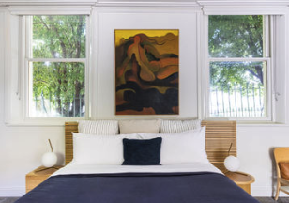
Accessible bedroom 2
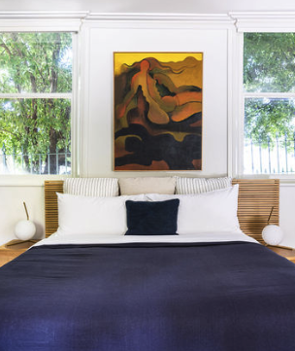
Accessible bedroom 3

Room Amenities

We have a set of drawers they can access
- In addition, the following further information can assist guests:
The accessible suite is separate from the main hotel building. It has direct access to the courtyard which is the rear evacuation point.
- Televisions are equipped with closed captioning capability
- There is contrast between the walls, skirtings, floor and furniture
- There is a clear path through the room
- The edges of all furniture and fixtures are rounded
- Housekeeping procedures instruct staff not to reposition furniture that has been moved
- Doors open fully against the adjoining wall
- There is a clear opening at least 850mm wide
- There luggage racks for at least two suitcases
- There at least one chair with rigid arms
- Wardrobe and drawer handles are easy to grip
- The bedside lamp switch is easy to reach from the bed
- There is at least 850mm clear space beside the bed
- The bed height is no higher than 680mm from the floor
- There is at least 130mm clearance under the bed
- The business offers a range of non-allergenic bedding
- Non-allergenic cleaning products are used

Bathrooms
The bathrooms have the following facilities/amenities in place
- All heating appliances and hot water pipes are protected or insulated
- All shower, bath and basin taps are clearly differentiated between hot and cold
- Fixtures and fittings have rounded edges
- The hot water is thermostatically controlled to 41 degrees
- The door is at least 850mm wide
- There is a minimum of 850mm beside the toilet
- Handrails are fitted
- There is a minimum of 1400mm of clear space in front of the toilet
- The toilet seat is a contrasting colour to the floor
- The toilet seat is 460mm above the floor
- A range of non-allergenic toiletries are available
- There is a roll-in shower with fold down fixed seat or a shower chair
- There is a portable shower head on flexible hose
  - Bathroom Image(s)
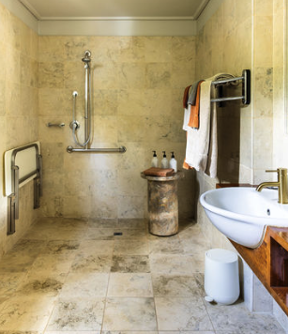
Accessible bathroom 2
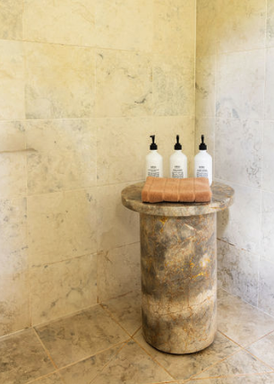
Accessible bathroom 1

COMMON AREAS

FOOD AND DRINK

Dining Spaces
The dining spaces have the following facilities/amenities in place
- The entrance has level access
- The doorway is at least 850mm wide
- There is level access through the dining area
- Chairs are moveable to allow for wheelchairs to be seated at the tables
- All glass doors and full height windows have contrast markings
- There are areas of full lighting
- There are Plain English menus
- There is an accessible toilet

Our business caters for the following dietary requirements
- Sugar free (diabetic)
- Gluten free (celiac)
- Lactose free (dairy free)
- Low fat and fibre with no gastric content
- Low potassium
- Low sodium
- Additive free
- Organic
- Vegetarian
- Kosher
- Halal
- In addition, the following further information can assist guests:
Procedures to Avoid Cross-Contamination of Food Products

Separation of Raw &amp; Ready-to-Eat Foods
Raw meats, poultry, and seafood are stored on the lowest shelves in dedicated containers, always below ready-to-eat itemsSeparate refrigeration units (or clearly designated zones) are used for raw proteins and cooked/ready-to-eat productsRaw and cooked foods are never transported on the same tray or trolley without thorough sanitisation between usesColour-Coded Equipment
Colour-coded chopping boards and utensils are used to prevent cross-contact (e.g. red for raw meat, green for vegetables, blue for seafood, yellow for cooked meats, white for dairy/bread)Staff are trained to never use equipment across categories without washing and sanitising firstHandwashing &amp; Glove Use
Staff wash hands thoroughly between handling different food types, after touching raw proteins, and after any non-food contact (bins, phones, doors)Single-use gloves are changed between tasks and are never considered a substitute for handwashingAllergen Management
Allergen-free meals are prepared in a dedicated area or on sanitised surfaces with clean equipmentAllergen information is clearly labelled on storage containers and communicated to front-of-house staffSeparate utensils and oil are used for allergen-specific cooking (e.g. gluten-free fryer)Cleaning &amp; Sanitisation
All food contact surfaces are cleaned and sanitised between tasks using food-safe sanitiserCleaning schedules are documented and verified by the duty manager each shiftStaff Training
All kitchen staff complete food safety training (including cross-contamination and allergen awareness) at induction and annually thereafterRefresher training is provided whenever menu changes introduce new allergens or processesReceiving &amp; Storage
Deliveries are inspected on arrival and separated immediately into appropriate storage areasPackaging from raw products is disposed of before entering prep areas
- There is a sample menu available online
Sample menu is available here -
https://terraebendigo.com.au/wp-content/uploads/2026/02/Menu_web.pdf

Report Disclaimer
Please note that this business report, provided as a result of the use of the diagnostic assessment, is for information purposes only.
Australian Tourism Industry Council (ATIC) cannot guarantee the accuracy of respondent’s answers, or that they are fully representative of your business. Therefore, ATIC does not warrant or guarantee any particular outcome in respect of your businesses self-assessment.
This report is intended as guidance only for your business and should not be relied on for future marketing considerations. ATIC recommends that you seek your own independent advice as well as the results from the diagnostic.
Links to external web sites are inserted for convenience and do not constitute endorsement of material at those sites, or any associated organisation, product or service.
ATIC does not:
- Assume any legal liability for the accuracy, completeness, or usefulness of any information from this report or any links provided; or
- Accept responsibility for any loss associated directly or indirectly from the use of this report.

