ATIC Accessibility
To support the accessible community in making informed travel decisions for their individual needs

This report prepared for:
Business name: | Lethal Adventures Pty Ltd
Address: | 26, Middleton way
Town: | Nickol
Contact for enquiries: | Leith Rowe
Contact Number: | 0418906963
Contact Email: | leith@lethaladventures.au
Website: | Lethaladventures.au
Date: | 2026-10-12 10:55

ATIC Accessibility
The following pages provides travellers with information on the businesses facilities and amenities which aims to support the traveller to make an informed decision on whether the business is suitable for their individual needs.
OVERVIEW 3
Business Overview 3
Bookings 3
Emergency Management 3
Guide Dog and Service Animals 4
GENERAL 5
Pre-arrival, arrival and reception 5
Cognitive Impairment Support 5
Car Park and Access amenities 5
Displays, exhibits, commentary and live performances 5
External Paths 6
TOUR OPERATORS 7
Guides 7
ADVENTURE ACTIVITIES 9
Report Disclaimer 11

OVERVIEW

Business Overview

The business has the following products/services available
- Tour/Transport
- Adventure
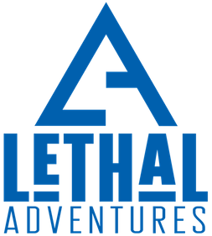

Bookings

The business offers the following methods for bookings and enquiries:
- Phone
- Email
- Webportal

Emergency Management
- Emergency and evacuation procedures are explained on arrival
- Guests with disabilities are noted in the guest log book for emergency and evacuation purposes

Guide Dog and Service Animals
The business provides the following services for services animals:
Not specified

GENERAL

Pre-arrival, arrival and reception
The business has the following in place to support guests during pre-arrival, arrival and reception
- Booking information and websites are compatible with screen readers
- Information and maps are available in written form
- A familiarisation tour
- In addition, the following further information can assist guests:
Our tours are small groups or up to 12. We do a 30 minute safety induction and as this is an adventure experience it would be difficult to ensure this.

Cognitive Impairment Support
- Documents are available in plain English for people with cognitive impairment (This may include instructions, guides, menus and general information)

Car Park and Access amenities
The business has the following Car Park and Access amenities
- A drop off zone
- In addition, the following further information can assist guests:
We usually leave from a beach or boat ramp depending on the vessel. Parking is on the beach for beach launching and would not be suited for the majority of accessible visitors unfortunately.

Displays, exhibits, commentary and live performances
For displays, exhibits, commentary and live performances the following amenities are in place
- Seating
- In addition, the following further information can assist guests:
if we were too have hiring impaired guests we could create a written script and will look at doing this to add to our tool kit.

External Paths
External paths of travel
The width of the smallest pathway is:
We are on the beach - drive onto beach to launch and park.

beach
- Step free routes clearly signed
- In addition, the following further information can assist guests:
As we launch from the beach there are no signs as such but is very clear where you go as you can only go to the beach.
- In addition, the following further information can assist guests:
No traditional steps, however the ski and boat you have to step on and put one leg over the other side of your seat so need good mobility

TOUR OPERATORS
- In addition, the following further information can assist guests:
Guests only disembark from their own vehicles at the start point of our jetski and boat tour

Guides
- Use of clear/simple English
- Correct pronunciation for lip readers
- Marine
- Accessibility is tide dependent
  - Image(s)
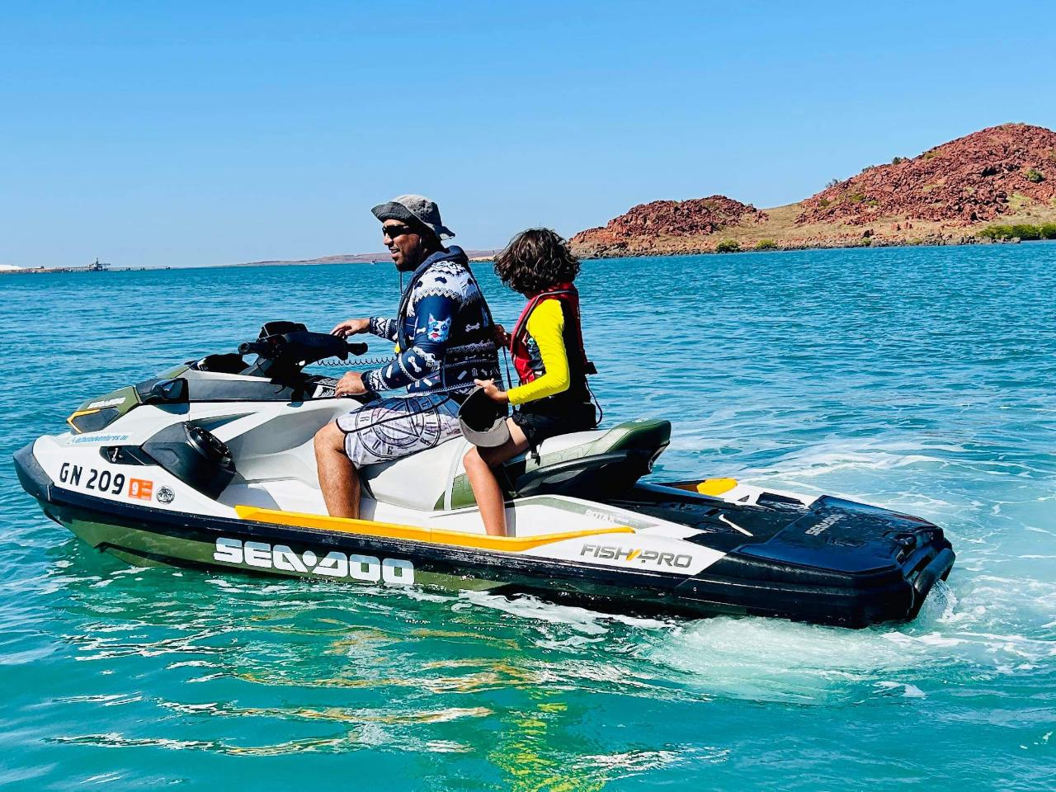
IMG_0371_lg.JPG
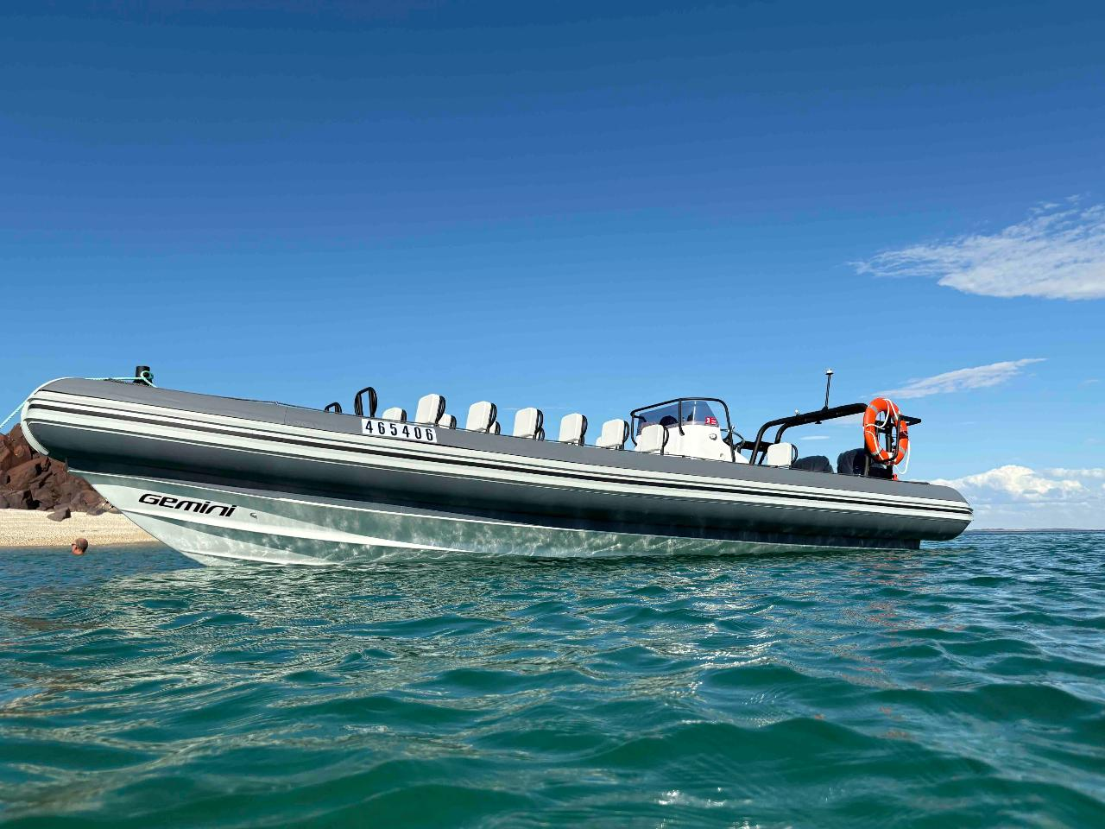
IMG_0014_lg
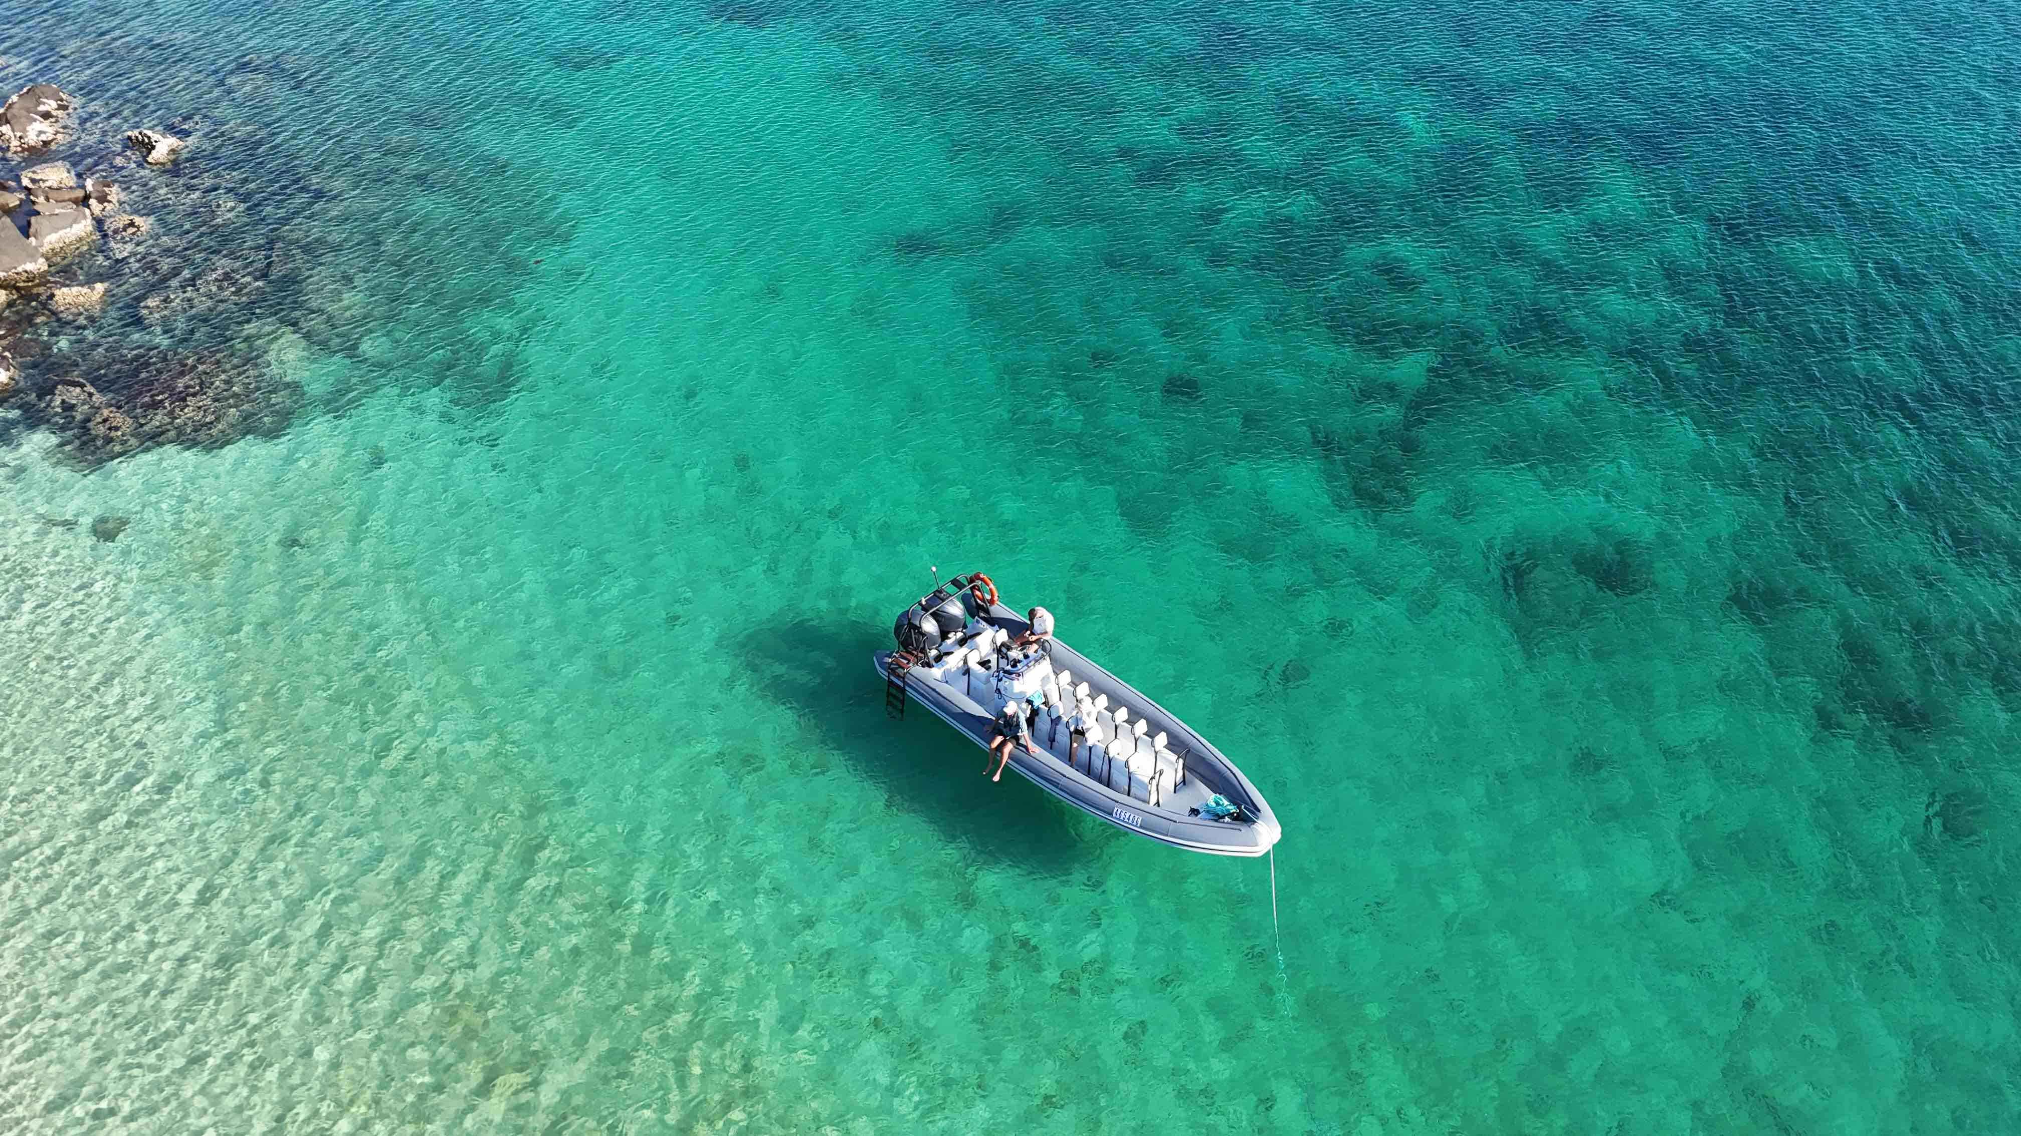
dji_fly_20250423_153836_0526_1745407503494_photo__1_

ADVENTURE ACTIVITIES
- In addition, the following further information can assist guests:
At this stage as an owner operator of marine craft I do not have the capacity. As I grow my business and get more staff this is something I will offer when I have some capacity. Private charters for the vessel are also welcomed to enquire and we will always make sure we seek some additional assistance for special requested bookings.

Report Disclaimer
Please note that this business report, provided as a result of the use of the diagnostic assessment, is for information purposes only.
Australian Tourism Industry Council (ATIC) cannot guarantee the accuracy of respondent’s answers, or that they are fully representative of your business. Therefore, ATIC does not warrant or guarantee any particular outcome in respect of your businesses self-assessment.
This report is intended as guidance only for your business and should not be relied on for future marketing considerations. ATIC recommends that you seek your own independent advice as well as the results from the diagnostic.
Links to external web sites are inserted for convenience and do not constitute endorsement of material at those sites, or any associated organisation, product or service.
ATIC does not:
- Assume any legal liability for the accuracy, completeness, or usefulness of any information from this report or any links provided; or
- Accept responsibility for any loss associated directly or indirectly from the use of this report.

