ATIC Accessibility
To support the accessible community in making informed travel decisions for their individual needs

This report prepared for:
Business name: | Stay Tasmania Pty Ltd trading as Swansea Beach Chalets
Address: | 27 Shaw Street
Town: | Swansea
Contact for enquiries: | Lisa Deegan Brown
Contact Number: | +61 3 62578177
Contact Email: | info@swanseachalets.com.au
Website:
Date: | 2026-10-19 09:29

ATIC Accessibility
The following pages provides travellers with information on the businesses facilities and amenities which aims to support the traveller to make an informed decision on whether the business is suitable for their individual needs.
OVERVIEW 4
Business Overview 4
Bookings 4
Emergency Management 5
GENERAL 6
Pre-arrival, arrival and reception 6
Cognitive Impairment Support 6
Car Park and Access amenities 6
External Paths 6
Steps 7
Ramps 7
Public Toilets/Adult change facilities 7
ACCOMMODATION 8
Bedrooms 8
Room Amenities 8
Bathrooms 9
COMMON AREAS 12
Report Disclaimer 14

OVERVIEW

Business Overview

The business has the following products/services available
- Accommodation

Our business caters for the following disability types:
- Deaf or low hearing
- Limited mobility
- Wheelchairs or mobility scooters
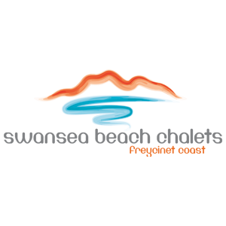

Bookings

The business offers the following methods for bookings and enquiries:
- Phone
- Email
- Webportal

Emergency Management
- The business has an emergency management and evacuation plan for guests with a disability
The business provides the following services for services animals:
Not specified

GENERAL

Pre-arrival, arrival and reception
The business has the following in place to support guests during pre-arrival, arrival and reception
- There is a reception/public entryway.
- Seating available at reception
- A lower counter at reception/ticket office
- A clipboard to allow check-in/ticket purchase whilst seated
- Information and maps are available in written form
- Keys are available for each guest
- Luggage assistance
- In addition, the following further information can assist guests:
Guests who identify with fatigue as a concern are offered priority arrival information, also ensuring other guests who arrived prior at not put at a diadvantage.

Cognitive Impairment Support
- A space for parents and children on the Autism Spectrum

Car Park and Access amenities
The business has the following Car Park and Access amenities
- A drop off zone
- Designated disabled parking bays
- Level or ramped access from the car park to the entrance
- The accessible entrance is clearly signed from the parking bay
- Kerb ramps are in place where a pavement or walkway needs to be crossed

External Paths
External paths of travel
- Surfaces are concrete, asphalt, smooth paving or hard packed fine gravel (max aggregate size 13mm)
- Pathways are wider than 900mm
- Any paths having steps are clearly identified as non-wheelchair accessible
- Step free routes clearly signed

Steps
Steps
- There are steps.
- Top and bottom steps are easily distinguished through colour contrast or the use of TGSIs (Tactile Ground Surface Indicators)
- The underside of all staircases are enclosed or protected to a height of at least 2 metres

Ramps
Ramps have the following amenities are in place
- There are ramps.
- All fixed ramps are 1:14 or less
- Hand rails are fitted
- Ramps have a raised edge of at least 100mm

Public Toilets/Adult change facilities
Public Toilets/Adult change facilities have the following amenities are in place
- There is an accessible toilet for public use
- The door is at least 850mm wide
- There is a minimum of 850mm beside the toilet
- Handrails are fitted
- The toilet seat is 460mm above the floor
- The toilet seat is460mm above the floor

ACCOMMODATION

Bedrooms
The bedrooms have the following facilities/amenities in place
- There are 2 rooms available to guests who use a wheelchair
- Bedroom furniture can be re-arranged on request
  - Layout of room Image(s)
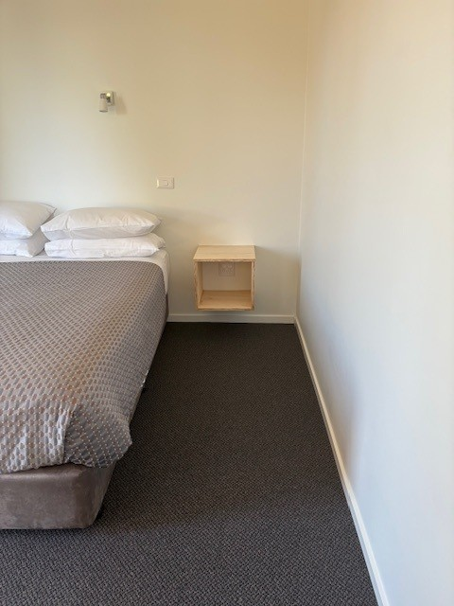
bedroom
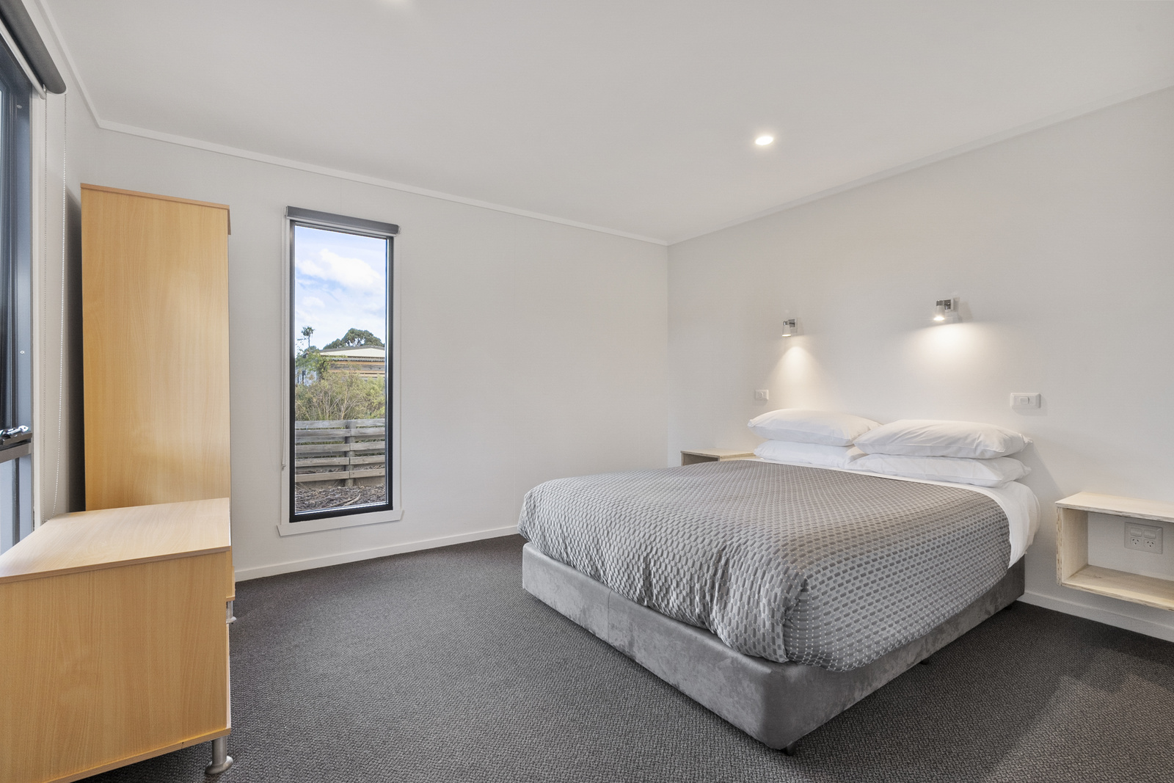
bedroom

Room Amenities
- Lower hanging rails are in wardrobes
- In addition, the following further information can assist guests:
Staff members are assigned to personally notify and guide these guests to safety using visual signals and written instructions if needed.

Emergency evacuation plans with visual aids are clearly displayed in guest rooms and throughout the property.

- Televisions are equipped with closed captioning capability
- There is contrast between the walls, skirtings, floor and furniture
- There is a clear path through the room
- The edges of all furniture and fixtures are rounded
- Wardrobe handles are a contrasting colour to the doors and draws
- Housekeeping procedures instruct staff not to reposition furniture that has been moved
- Doors open fully against the adjoining wall
- There is a clear opening at least 850mm wide
- There at least one chair with rigid arms
- Wardrobe and drawer handles are easy to grip
- The bedside lamp switch is easy to reach from the bed
- There is at least 850mm clear space beside the bed
- The bed height is no higher than 680mm from the floor
- There is at least 130mm clearance under the bed
- Non-allergenic cleaning products are used

Bathrooms
The bathrooms have the following facilities/amenities in place
- All heating appliances and hot water pipes are protected or insulated
- All shower, bath and basin taps are clearly differentiated between hot and cold
- Fixtures and fittings have rounded edges
- The hot water is thermostatically controlled to 41 degrees
- The door is at least 850mm wide
- There is a minimum of 850mm beside the toilet
- Handrails are fitted
- There is a minimum of 1400mm of clear space in front of the toilet
- The toilet seat is a contrasting colour to the floor
- The toilet seat is 460mm above the floor
- A range of non-allergenic toiletries are available
- There is a roll-in shower with fold down fixed seat or a shower chair
- There is a portable shower head on flexible hose
  - Bathroom Image(s)
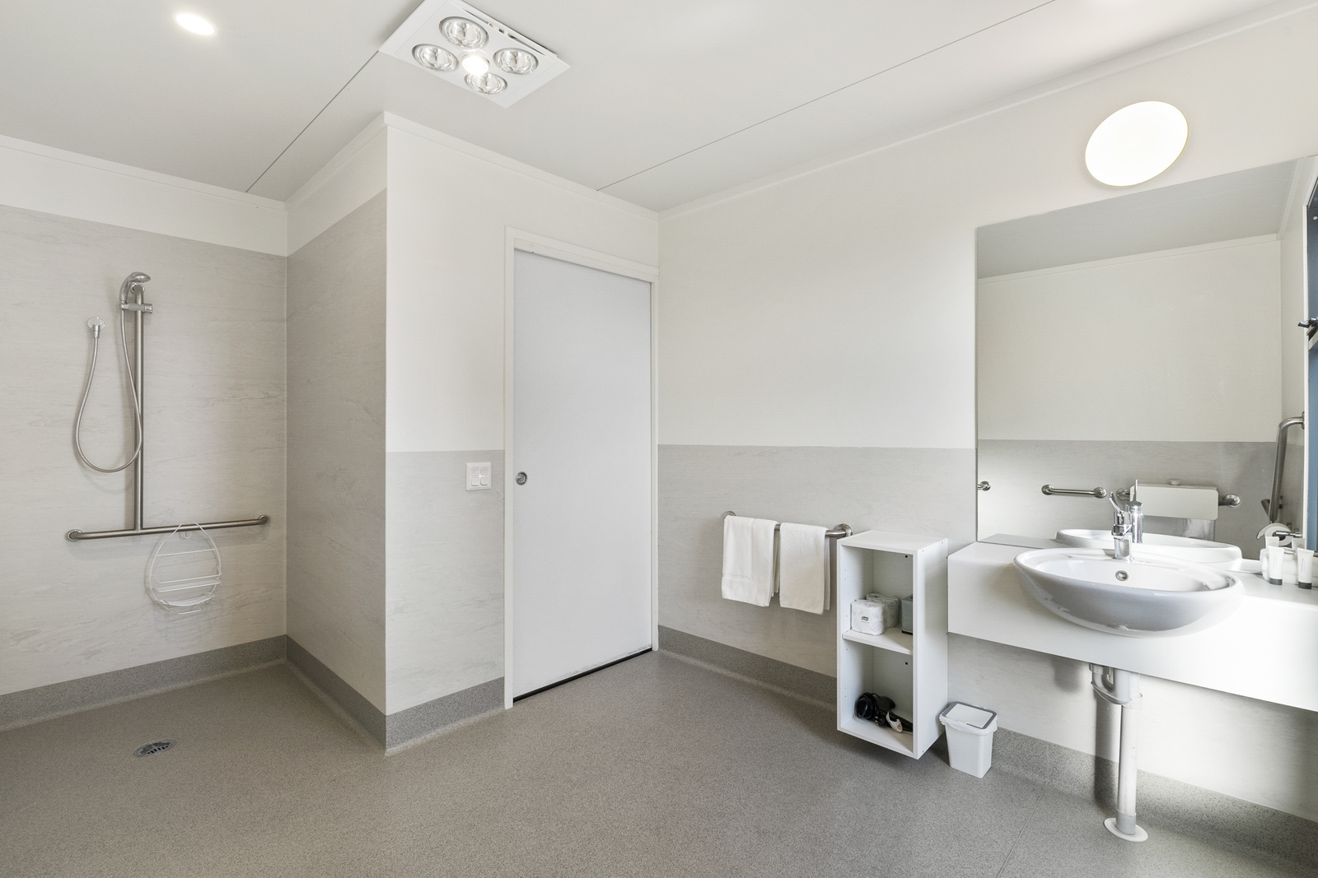
bathroom
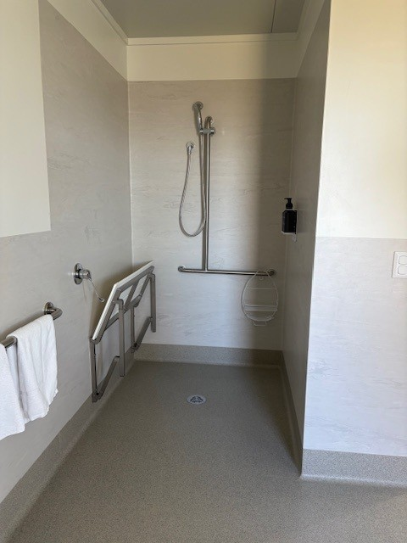
bathroom 1
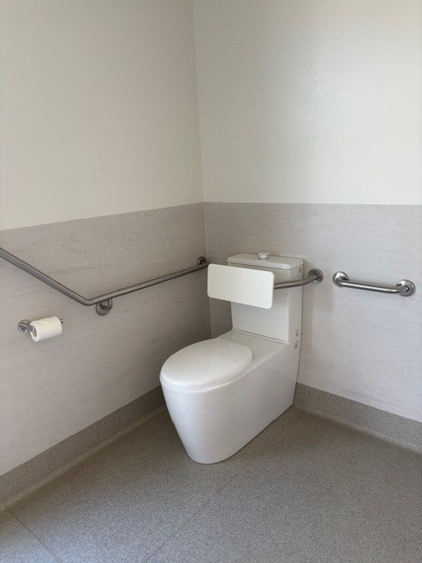
bathroom 2
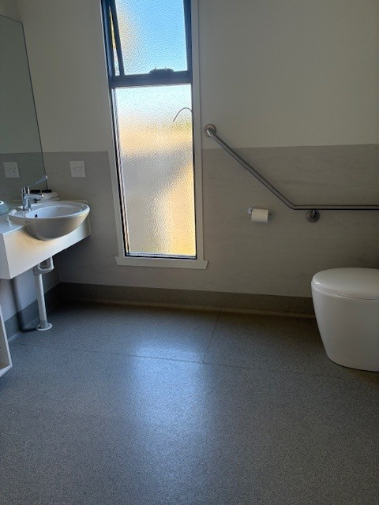
bathroom 3

COMMON AREAS

Report Disclaimer
Please note that this business report, provided as a result of the use of the diagnostic assessment, is for information purposes only.
Australian Tourism Industry Council (ATIC) cannot guarantee the accuracy of respondent’s answers, or that they are fully representative of your business. Therefore, ATIC does not warrant or guarantee any particular outcome in respect of your businesses self-assessment.
This report is intended as guidance only for your business and should not be relied on for future marketing considerations. ATIC recommends that you seek your own independent advice as well as the results from the diagnostic.
Links to external web sites are inserted for convenience and do not constitute endorsement of material at those sites, or any associated organisation, product or service.
ATIC does not:
- Assume any legal liability for the accuracy, completeness, or usefulness of any information from this report or any links provided; or
- Accept responsibility for any loss associated directly or indirectly from the use of this report.

