ATIC Accessibility
To support the accessible community in making informed travel decisions for their individual needs

This report prepared for:
Business name: | Dive Traveller's
Address: | 10 Relic BVD
Town: | Aveley
Contact for enquiries: | Yasuhiro Taniguchi
Contact Number: | 0401905749
Contact Email: | info@perthscuba-dive.com
Website: | https://en.perthscuba-dive.com
Date: | 2026-09-21 02:46

ATIC Accessibility
The following pages provides travellers with information on the businesses facilities and amenities which aims to support the traveller to make an informed decision on whether the business is suitable for their individual needs.
OVERVIEW 4
Business Overview 4
Bookings 4
Emergency Management 5
Communications 5
Guide Dog and Service Animals 5
GENERAL 6
Pre-arrival, arrival and reception 6
Cognitive Impairment Support 6
Car Park and Access amenities 6
External Paths 6
Public Toilets/Adult change facilities 7
TOUR OPERATORS 8
Tour/Transport Services 8
Route Planning 8
Guides 8
Report Disclaimer 11

OVERVIEW

Business Overview

The business has the following products/services available
- Tour/Transport

Our business caters for the following disability types:
- Deaf or low hearing
- Food allergies or intolerances
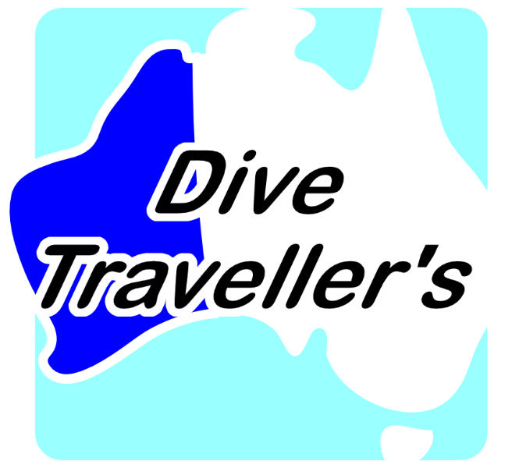

Bookings

The business offers the following methods for bookings and enquiries:
- Phone
- Email
- Webportal
- Our website supports Screen Readers
- Our forms have high contract boxes and submit boxes
- Staff have undergone disability awareness and training

Emergency Management
- The business has an emergency management and evacuation plan for guests with a disability
- Emergency and evacuation procedures are explained on arrival
- Guests with disabilities are noted in the guest log book for emergency and evacuation purposes

Communications
- An accessibility guide is available on the website

en.perthscuba-dive.com
- Our website meets WCAG 2.0 accessibility standards
- Our business offers the following alternative communication methods
- Plain English
- Magnifiers

Not specified
- There is easy to read signage and information (e.g. menus and emergency information)

Board for writing letters underwater

Guide Dog and Service Animals
- The business provides a secure area with shade and water for service animals
- The business provides a toilet area for service animals
- Bowls, bedding, etc. are provided for service animals
The business provides the following services for services animals:
Staff to be assigned to look after assistance animals during diving.

GENERAL

Pre-arrival, arrival and reception
The business has the following in place to support guests during pre-arrival, arrival and reception
- Booking information and websites are compatible with screen readers
- Information and maps are available in written form
- In addition, the following further information can assist guests:
When participating in diving tours, as forms are completed individually beforehand, there is no waiting time.

Cognitive Impairment Support
- Documents are available in plain English for people with cognitive impairment (This may include instructions, guides, menus and general information)
- A "social script" guide to your premises or attraction describing the sights, sounds and smells to aid parents/carers prepare visitors in advance
- The 'social script' is available in word and other editable formats
- Quiet periods or early opening times for people on the Autism Spectrum
- A space for parents and children on the Autism Spectrum

Car Park and Access amenities
The business has the following Car Park and Access amenities
- A drop off zone
- Level or ramped access from the car park to the entrance
- The public transport services available are:

We will provide a pick-up and drop-off service from the closest train stations, as well as from the closest bus or tram stops.
- Kerb ramps are in place where a pavement or walkway needs to be crossed

External Paths
External paths of travel
- Surfaces are concrete, asphalt, smooth paving or hard packed fine gravel (max aggregate size 13mm)
- Paths or slopes longer than 15 metres have resting places or seats
- Pathways are wider than 900mm
- In addition, the following further information can assist guests:
At some scuba diving sites, there may be steps.

Public Toilets/Adult change facilities
Public Toilets/Adult change facilities have the following amenities are in place
- There is an accessible toilet for public use
- The door is at least 850mm wide
- There is a minimum of 850mm beside the toilet
- Handrails are fitted
- The toilet seat is 460mm above the floor
- The toilet seat of a contrasting colour to the floor
- The toilet seat is460mm above the floor
- A facility with an adult change table

TOUR OPERATORS

Tour/Transport Services
The tour/transport services have the following facilities/amenities in place
- Buses/Coaches
- 0 vehicles have wheelchair lifts or ramps
- 0 vehicles have low floors with ramped entry
The maximum wheelchair capacity available in the fleet is:
0
- Commentary is available in written format

Route Planning
- Route Planning
- The tour route includes stops with accessible toilet facilities
- Lunch stop venues are accessible
- Sightseeing and photo opportunity stops are step free
- Overnight Stops
- For overnight stays, wheelchair accessible rooms are available
- The accommodation provider used for overnight stops has been independently verified as accessible, please contact us for further information
The total number of wheelchair passengers that can be catered for at overnight stops are:
0
- Walking Tours
- Operated on a step free route
- Multi-paced to account for slower walkers

Guides

Guides have been trained in the following
- Use of clear/simple English
- Correct pronunciation for lip readers
- There is a audio description of surroundings
- Marine
- Accessibility is tide dependent
  - Image(s)
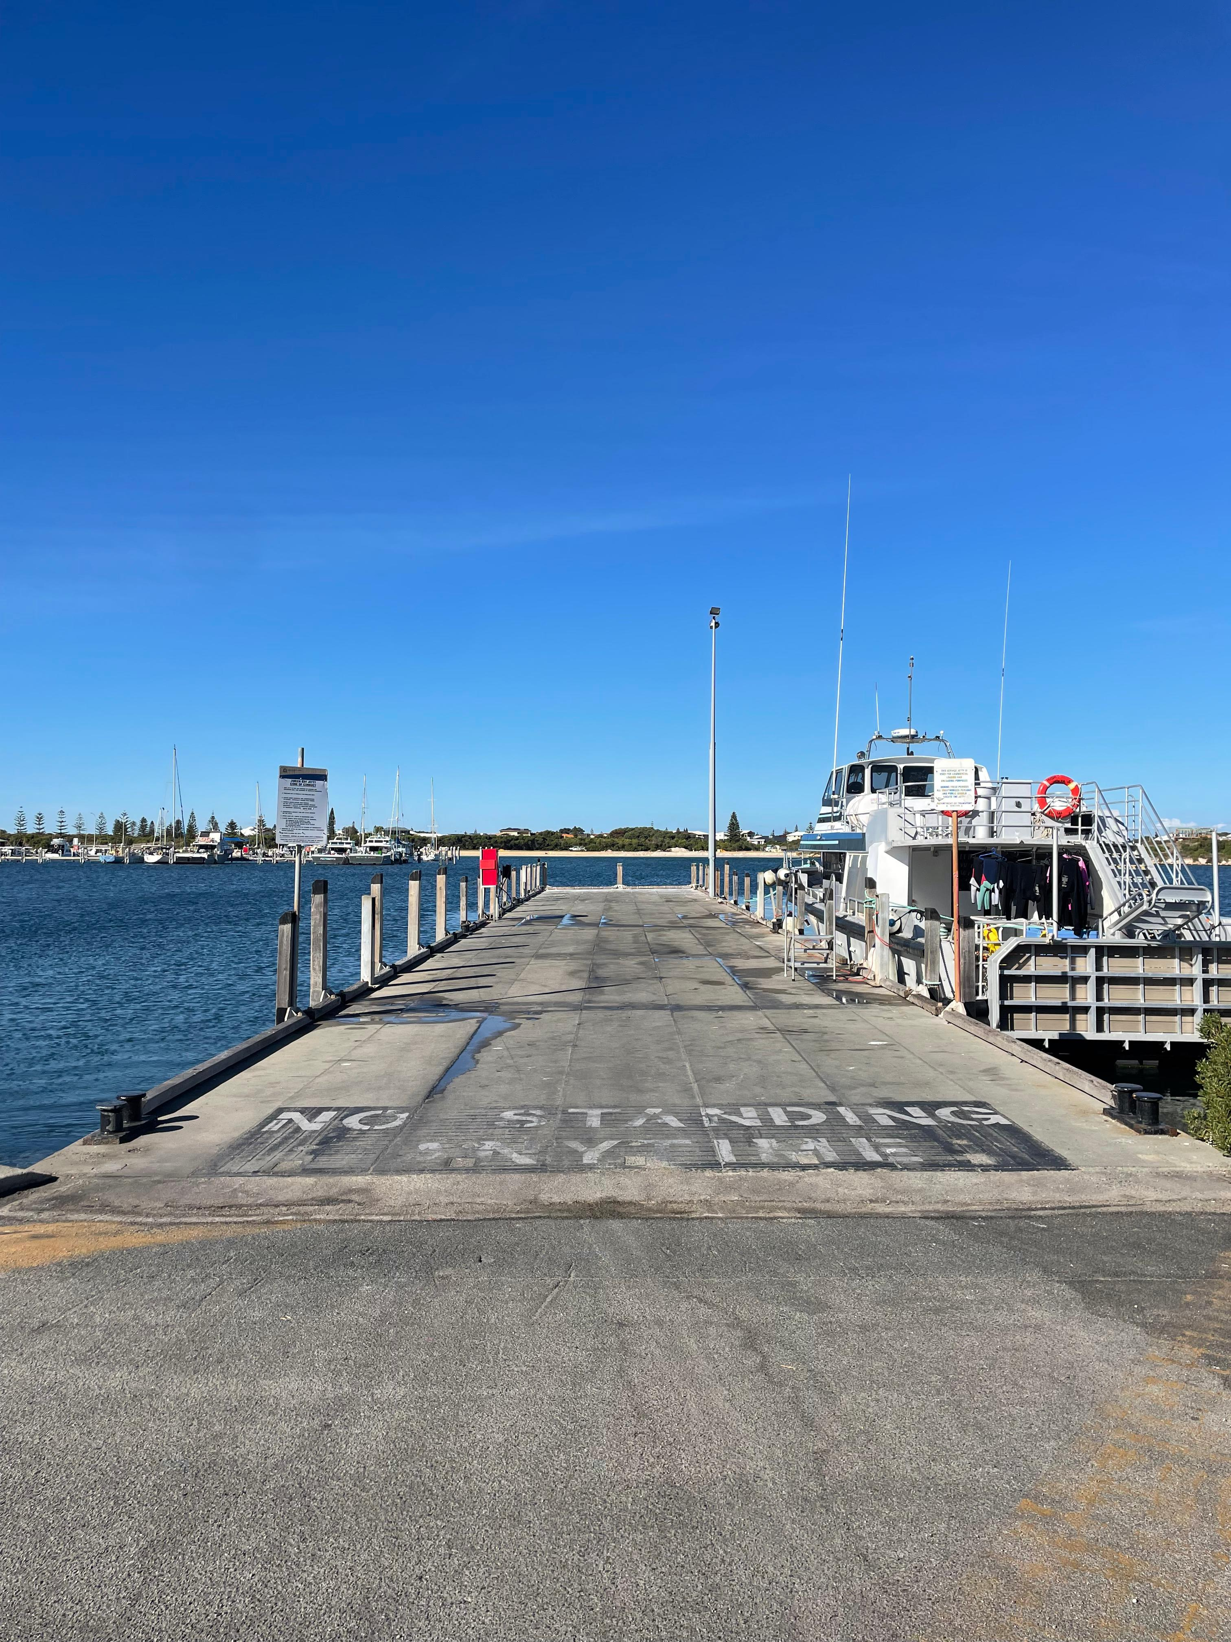
Jurien Bay Jetty
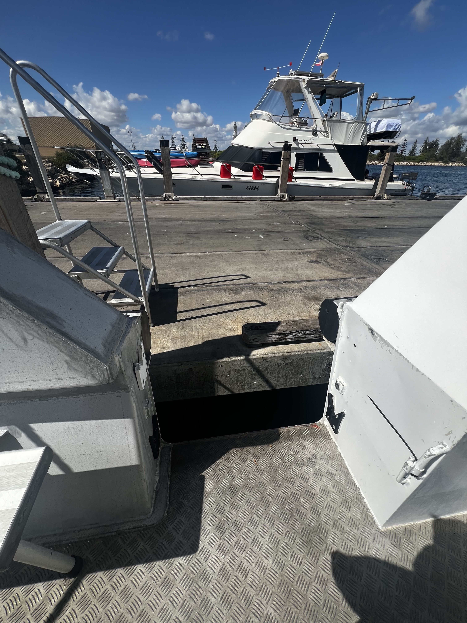
Jurien Bay Boarding area
- In addition, the following further information can assist guests:
・Pinnacles Desert：https://exploreparks.dbca.wa.gov.au/site/pinnacles-desert-lookout-and-drive
・Lobster Shack：https://www.lobstershack.com.au

Report Disclaimer
Please note that this business report, provided as a result of the use of the diagnostic assessment, is for information purposes only.
Australian Tourism Industry Council (ATIC) cannot guarantee the accuracy of respondent’s answers, or that they are fully representative of your business. Therefore, ATIC does not warrant or guarantee any particular outcome in respect of your businesses self-assessment.
This report is intended as guidance only for your business and should not be relied on for future marketing considerations. ATIC recommends that you seek your own independent advice as well as the results from the diagnostic.
Links to external web sites are inserted for convenience and do not constitute endorsement of material at those sites, or any associated organisation, product or service.
ATIC does not:
- Assume any legal liability for the accuracy, completeness, or usefulness of any information from this report or any links provided; or
- Accept responsibility for any loss associated directly or indirectly from the use of this report.

