ATIC Accessibility
To support the accessible community in making informed travel decisions for their individual needs

This report prepared for:
Business name: | Gourmet Camp Oven Experience
Address: | 12 Carbeen ST
Town: | KUNUNURRA, WA 6743
Contact for enquiries: | Josh Melville
Contact Number: | 0457570132
Contact Email: | info@gourmetcampovenexperience.com.au
Website: | https://www.gourmetcampovenexperience.com.au/
Date: | 2026-08-25 12:37

ATIC Accessibility
The following pages provides travellers with information on the businesses facilities and amenities which aims to support the traveller to make an informed decision on whether the business is suitable for their individual needs.
OVERVIEW 4
Business Overview 4
Bookings 6
Emergency Management 6
Communications 6
Guide Dog and Service Animals 7
GENERAL 8
Pre-arrival, arrival and reception 8
Cognitive Impairment Support 8
Car Park and Access amenities 8
Internal Spaces 9
Displays, exhibits, commentary and live performances 9
External Paths 9
Public Toilets/Adult change facilities 9
TOUR OPERATORS 11
Tour/Transport Services 11
Guides 11
FOOD AND DRINK 13
Dining Spaces 13
Report Disclaimer 16

OVERVIEW

Business Overview

The business has the following products/services available
- Tour/Transport
- Food and Drink

Our business caters for the following disability types:
- Blind or low vision
- Deaf or low hearing
- Limited mobility
- Wheelchairs or mobility scooters
- Food allergies or intolerances
- Cognitive or people on the Autism Spectrum


Bookings

The business offers the following methods for bookings and enquiries:
- Phone
- Email
- Webportal
- Our forms have high contract boxes and submit boxes
- Staff have undergone disability awareness and training

Emergency Management
- The business has an emergency management and evacuation plan for guests with a disability
- Emergency and evacuation procedures are explained on arrival
- Guests with disabilities are noted in the guest log book for emergency and evacuation purposes

Communications
- An accessibility guide is available on the website

https://www.gourmetcampovenexperience.com.au/faq-s
- Our website meets WCAG 2.0 accessibility standards
- Our business offers the following alternative communication methods
- Plain English

Not specified
- There is easy to read signage and information (e.g. menus and emergency information)
- There is a Pictorial menu
  - Pictorial Menu Image(s)
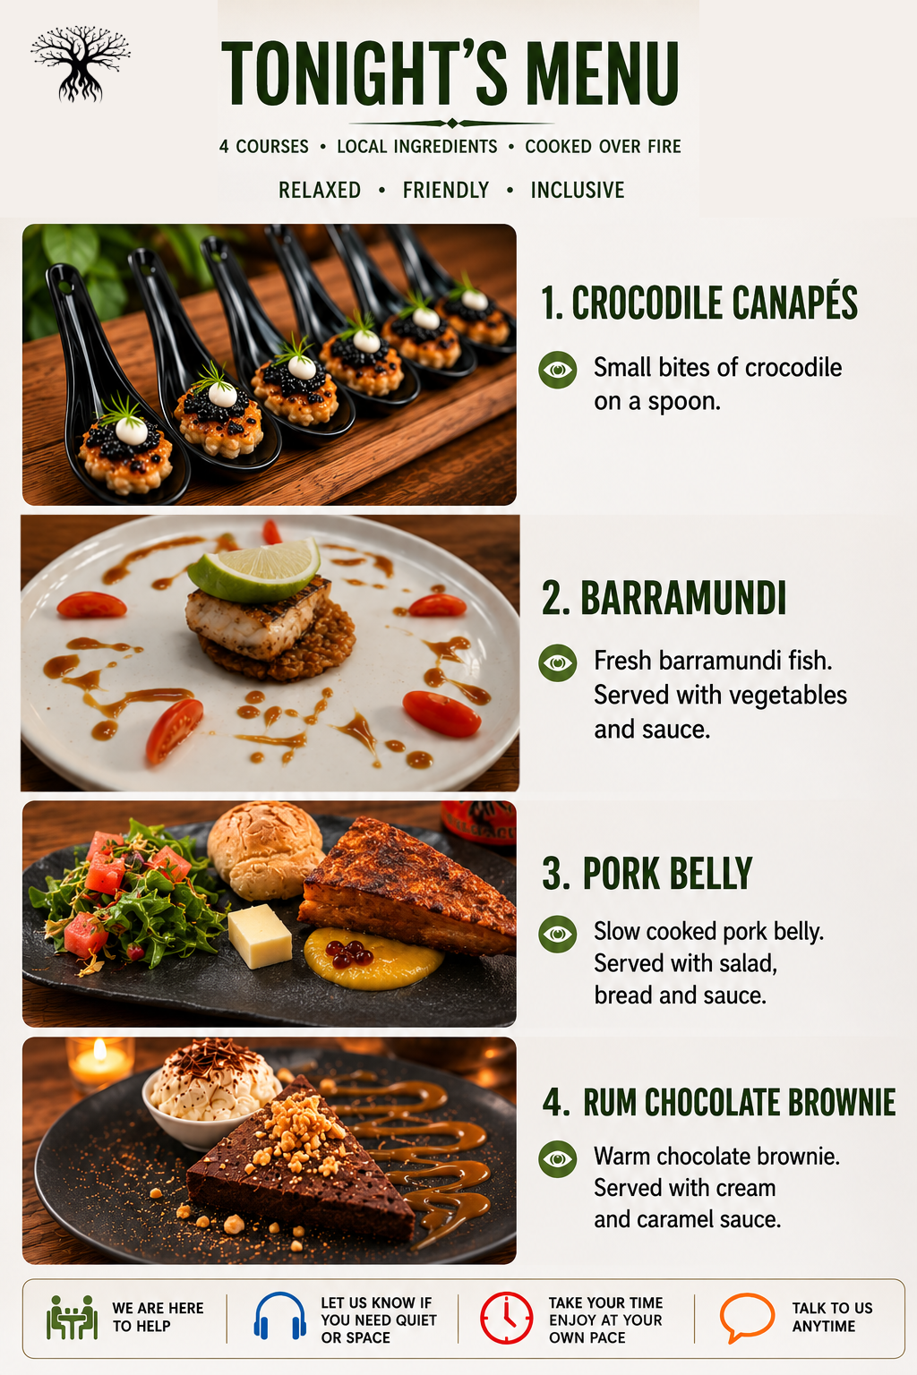
Pictoral Menu

We have our evening's dialogue and menus printed in 8 different languages.

Guide Dog and Service Animals
- The business provides a secure area with shade and water for service animals
- The business provides a toilet area for service animals
- Bowls, bedding, etc. are provided for service animals
The business provides the following services for services animals:
water bowl, shade, toilet area.

GENERAL

Pre-arrival, arrival and reception
The business has the following in place to support guests during pre-arrival, arrival and reception
- Booking information and websites are compatible with screen readers
- Information and maps are available in written form
- A familiarisation tour
- In addition, the following further information can assist guests:
We have seats ready on arrival for guests that might not be able to join us for the few minute tour where we show what is cooking over the fire.&nbsp;

Cognitive Impairment Support
- Documents are available in plain English for people with cognitive impairment (This may include instructions, guides, menus and general information)
- A "social script" guide to your premises or attraction describing the sights, sounds and smells to aid parents/carers prepare visitors in advance
- The 'social script' is available in word and other editable formats
- A space for parents and children on the Autism Spectrum

Car Park and Access amenities
The business has the following Car Park and Access amenities
- A drop off zone
- Designated disabled parking bays
- Level or ramped access from the car park to the entrance
- The accessible entrance is clearly signed from the parking bay
- In addition, the following further information can assist guests:
We chauffer guests to the dining spot, guests with disabilities, ie a wheelchair, we have both a bus and a low to ground vehicle to get them out to the spot, alternatively the can follow us in their own vehicle to the spot where compacted dirt is there for them to be able to navigate the dining area comfortably.&nbsp;

Internal Spaces
- Menus are available in large print or Braille
- Tableware/glassware contrast with the table surface or table cloth

Displays, exhibits, commentary and live performances
For displays, exhibits, commentary and live performances the following amenities are in place
- Seating
- Wheelchair accessible spaces/seating
- A written transcript where audio description is provided i.e. display commentary, tour commentary

External Paths
External paths of travel
- Surfaces are concrete, asphalt, smooth paving or hard packed fine gravel (max aggregate size 13mm)
- Pathways are wider than 900mm

no steps and no doorway

no steps
- Step free routes clearly signed

Public Toilets/Adult change facilities
Public Toilets/Adult change facilities have the following amenities are in place
- There is an accessible toilet for public use
- The door is at least 850mm wide
- There is a minimum of 850mm beside the toilet
- Handrails are fitted
- The toilet seat is 460mm above the floor
- There is 10 metres. It doesnt have a front door and is called the loo with a view. mm of clear space in front of the toilet
- The toilet seat of a contrasting colour to the floor
- The toilet seat is460mm above the floor

TOUR OPERATORS

Tour/Transport Services
The tour/transport services have the following facilities/amenities in place
- Buses/Coaches
- 0 vehicles have wheelchair lifts or ramps
- 1 vehicles have low floors with ramped entry
The maximum wheelchair capacity available in the fleet is:
27
- Commentary is available in written format

Guides
- Use of clear/simple English
- Correct pronunciation for lip readers
  - Image(s)
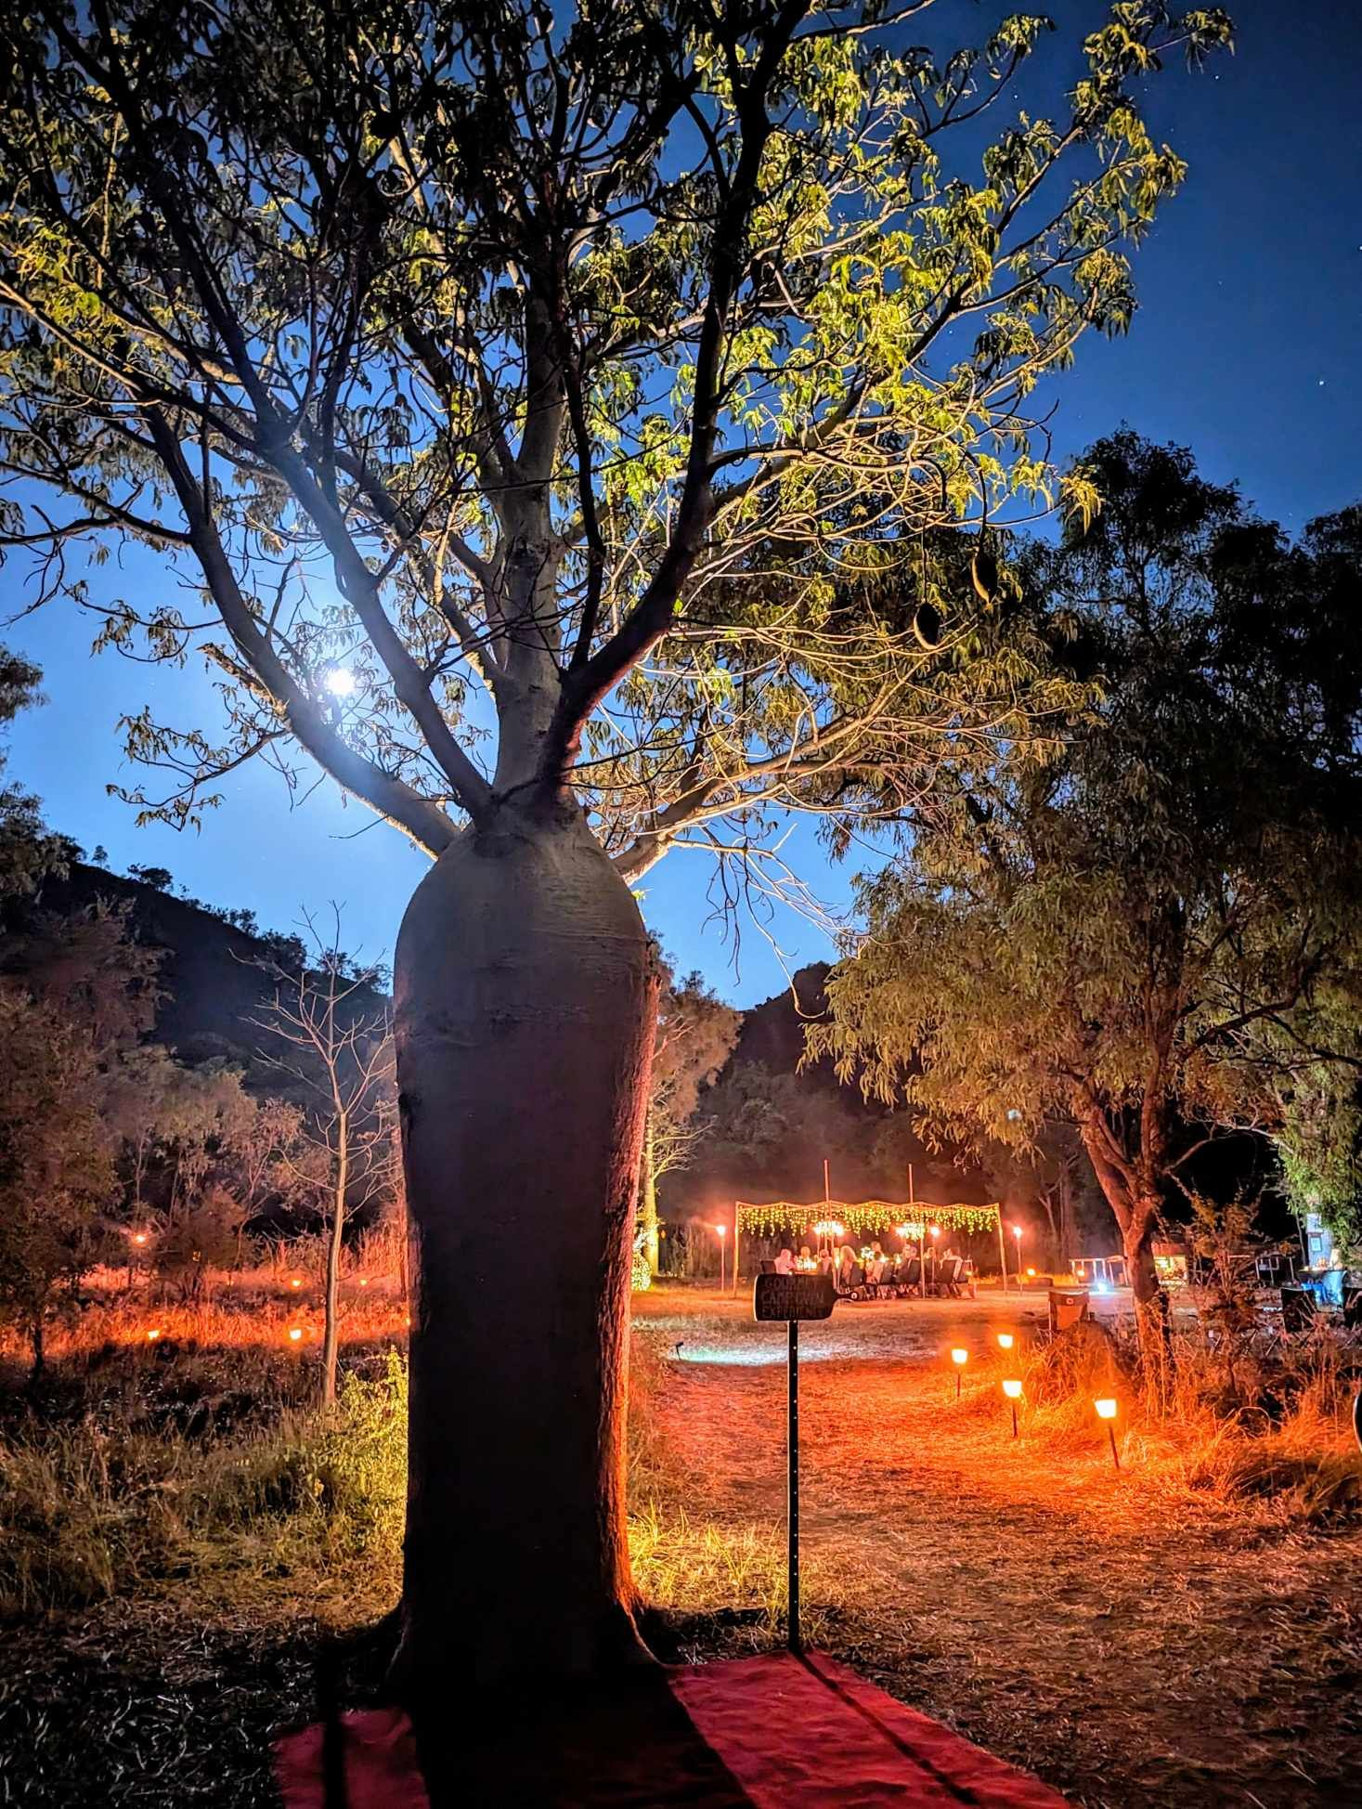
448116836_453422400745599_6516076531103722762_n
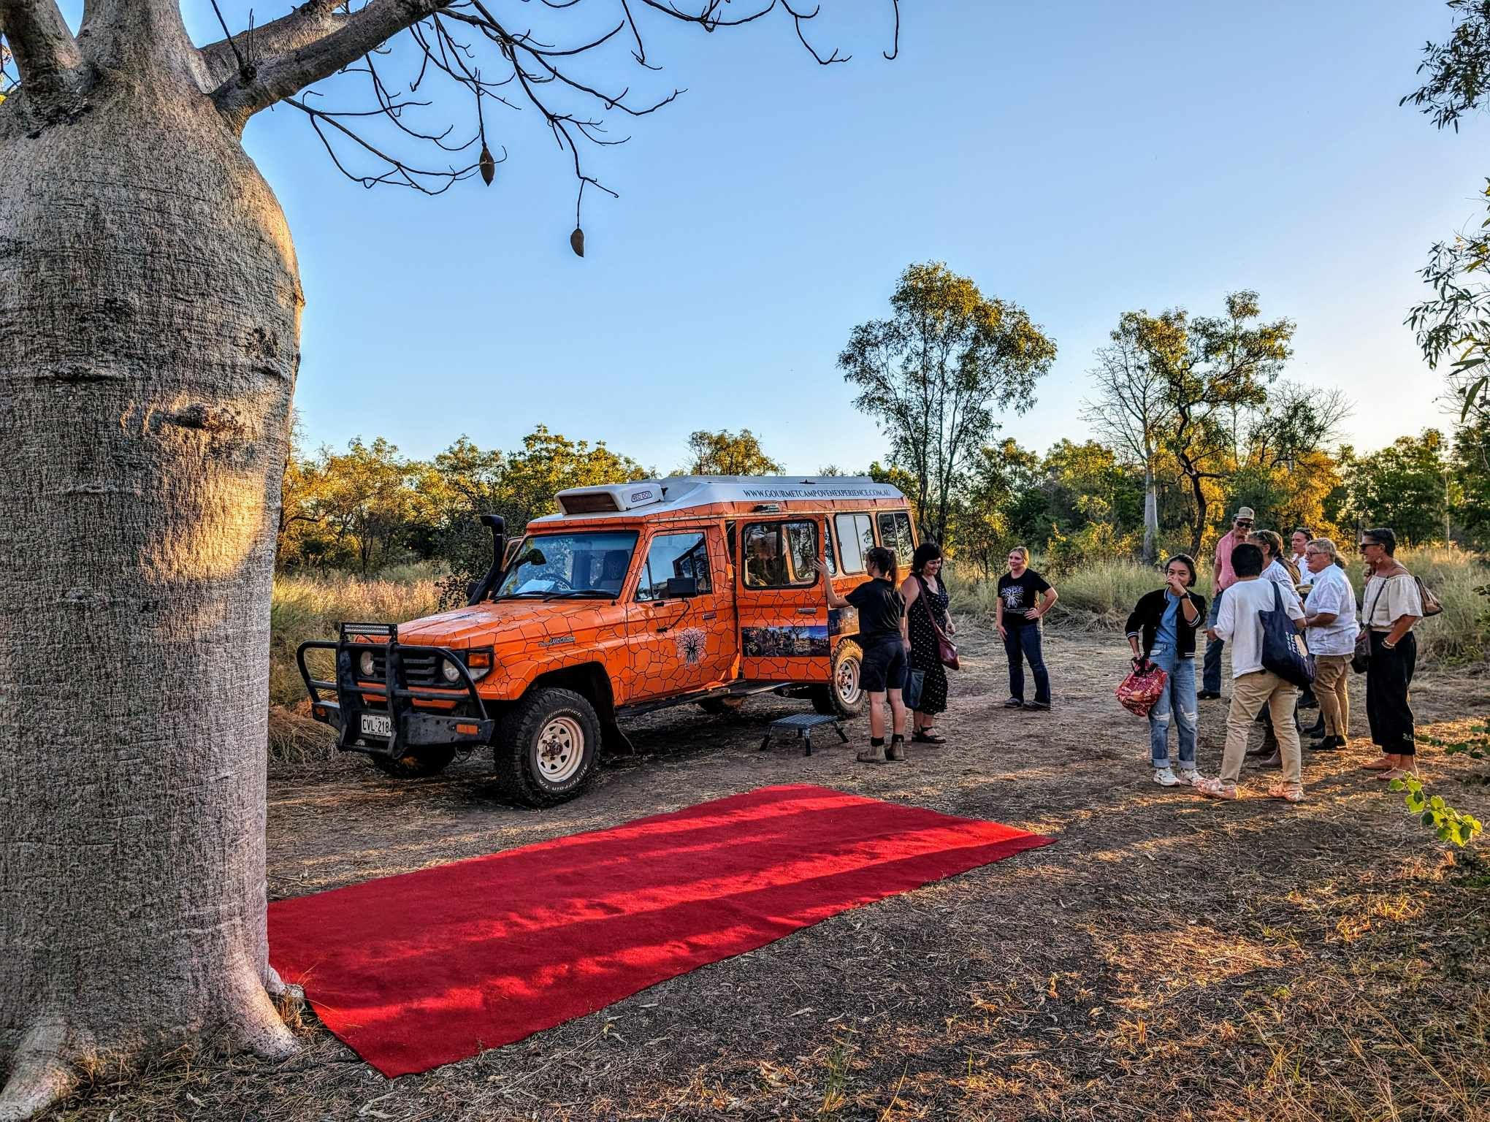
448120449_1157724255430796_3635449613999482861_n
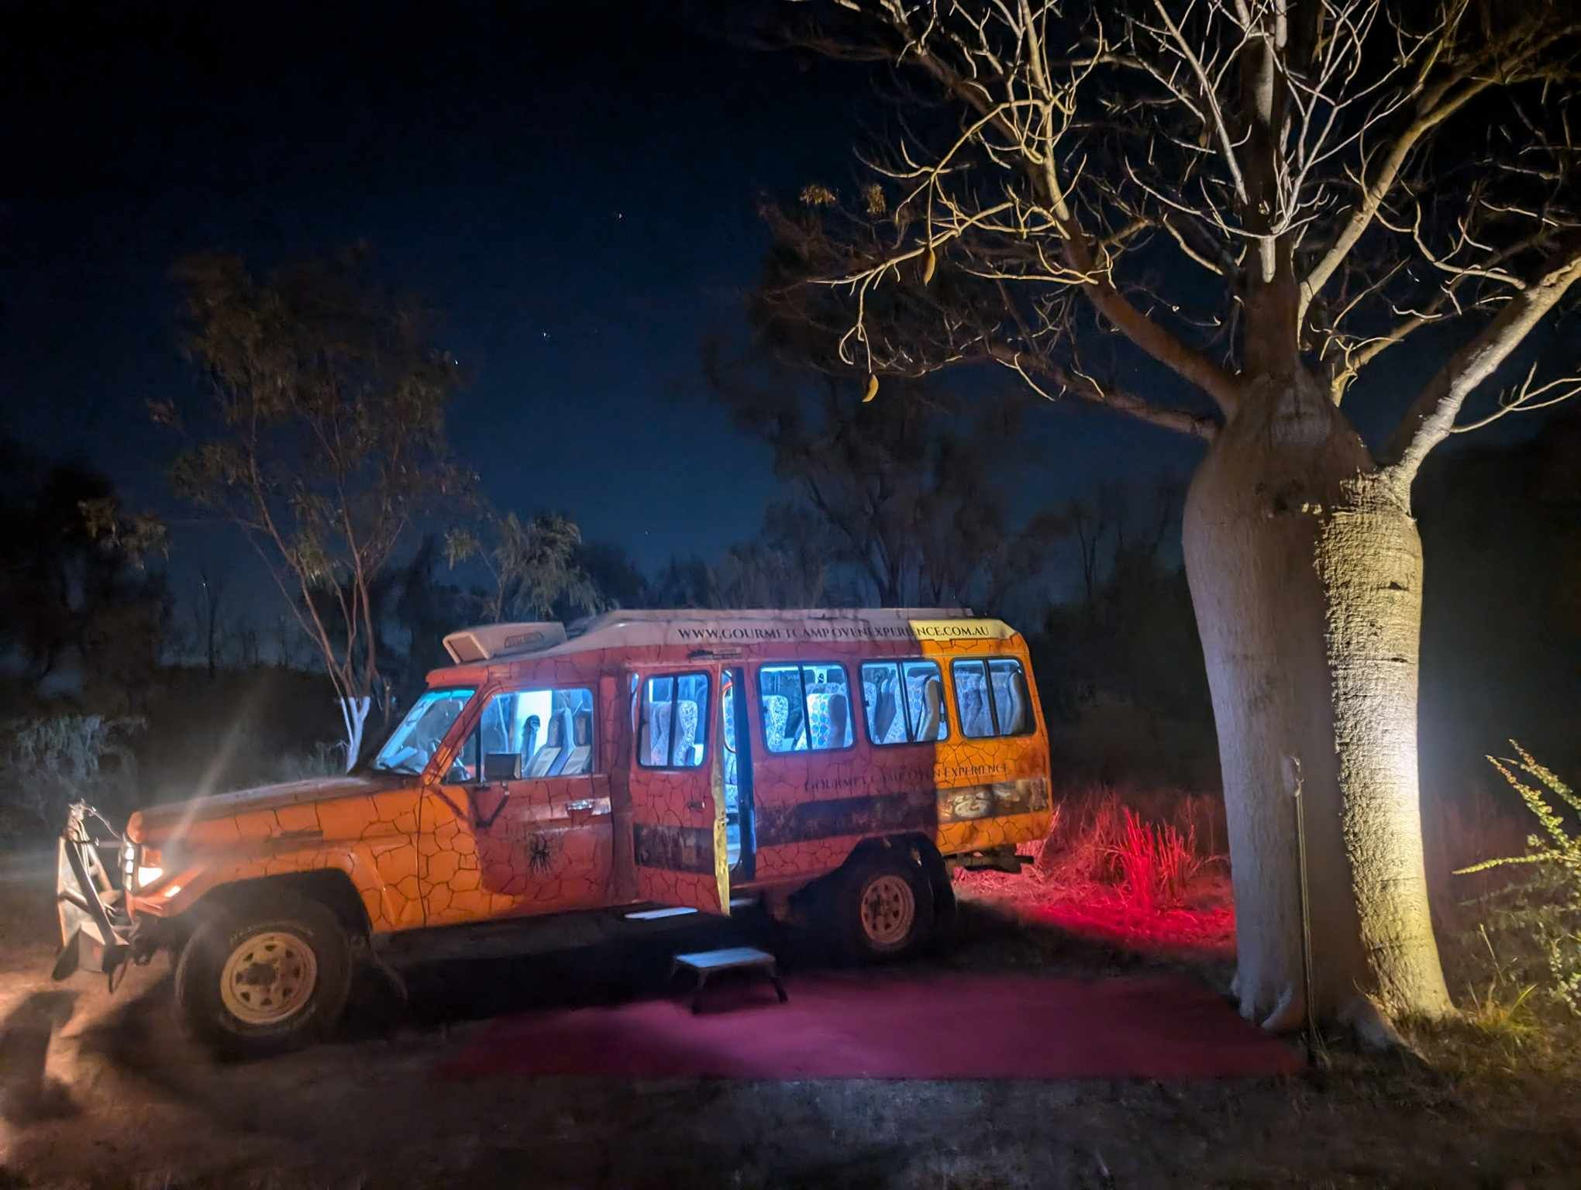
447783991_990698629435391_2196205826480435022_n

FOOD AND DRINK

Dining Spaces
The dining spaces have the following facilities/amenities in place
- The entrance has level access
- The doorway is at least 850mm wide
- There is level access through the dining area
- Chairs are moveable to allow for wheelchairs to be seated at the tables
- There are areas of full lighting
- There are large print menus
- There are Plain English menus
- There is an accessible toilet

Our business caters for the following dietary requirements
- Sugar free (diabetic)
- Gluten free (celiac)
- Lactose free (dairy free)
- Low potassium
- Low sodium
- Nut free
- Additive free
- Vegetarian
- Vegan
- Kosher
- Halal
- In addition, the following further information can assist guests:
We have a commercial kitchen where all the food is prepared to take to the dining location. All surfaces are stainless steel ie easy to clean. We have a range of coloured chopping boards that are only used for specific types of food. When putting food into the fridge to take to the dining location they are all housed in separate containers. We have different grills / hotplates / camp ovens to cook different types of food and to cater for allergies.&nbsp;
- There is a sample menu available online
Sample menu is available here -
https://www.gourmetcampovenexperience.com.au/our-experience
  - Food and Beverage Image(s)
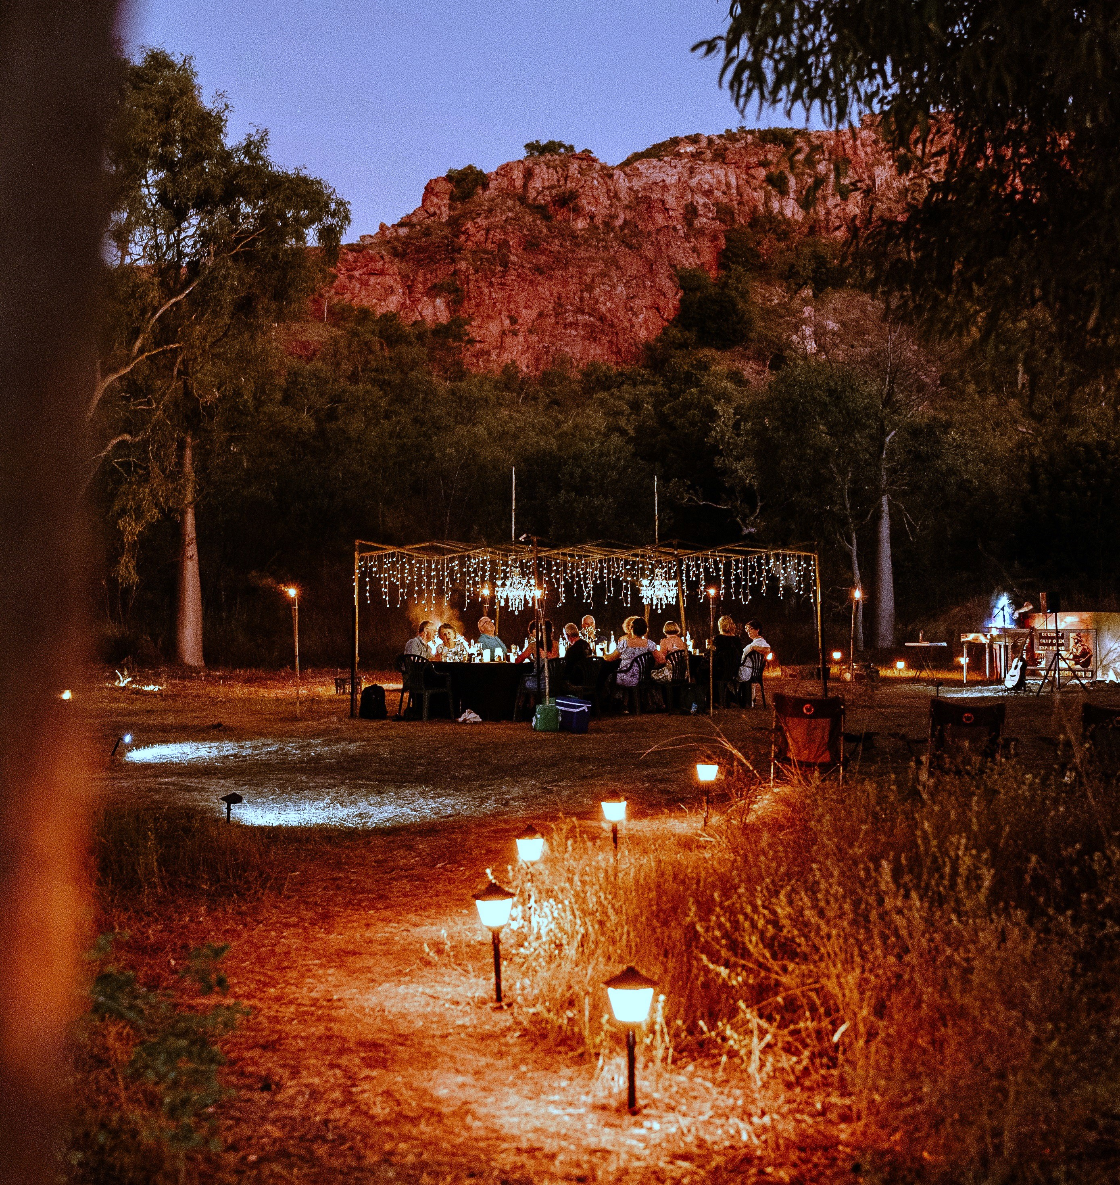
KunanurraCampovenExperience-222

Report Disclaimer
Please note that this business report, provided as a result of the use of the diagnostic assessment, is for information purposes only.
Australian Tourism Industry Council (ATIC) cannot guarantee the accuracy of respondent’s answers, or that they are fully representative of your business. Therefore, ATIC does not warrant or guarantee any particular outcome in respect of your businesses self-assessment.
This report is intended as guidance only for your business and should not be relied on for future marketing considerations. ATIC recommends that you seek your own independent advice as well as the results from the diagnostic.
Links to external web sites are inserted for convenience and do not constitute endorsement of material at those sites, or any associated organisation, product or service.
ATIC does not:
- Assume any legal liability for the accuracy, completeness, or usefulness of any information from this report or any links provided; or
- Accept responsibility for any loss associated directly or indirectly from the use of this report.

