ATIC Accessibility
To support the accessible community in making informed travel decisions for their individual needs

This report prepared for:
Business name: | Boston Bay Diner
Address: | 49 Tasman Terrace
Town: | Port Lincoln
Contact for enquiries: | Ron Chirgwin
Contact Number: | (08)86834635
Contact Email: | contact@bostonbaydiner.com.au
Website: | https://www.bostonbaydiner.com.au/
Date: | 2026-10-25 03:34

ATIC Accessibility
The following pages provides travellers with information on the businesses facilities and amenities which aims to support the traveller to make an informed decision on whether the business is suitable for their individual needs.
OVERVIEW 4
Business Overview 4
Bookings 4
Emergency Management 4
Communications 5
Other Information 5
Guide Dog and Service Animals 5
GENERAL 6
Pre-arrival, arrival and reception 6
Cognitive Impairment Support 6
Car Park and Access amenities 6
Entry 6
Internal Spaces 7
Public areas 7
External Paths 8
Public Toilets/Adult change facilities 8
FOOD AND DRINK 9
Dining Spaces 9
Report Disclaimer 12

OVERVIEW

Business Overview

The business has the following products/services available
- Food and Drink

Our business caters for the following disability types:
- Limited mobility
- Wheelchairs or mobility scooters
- Food allergies or intolerances
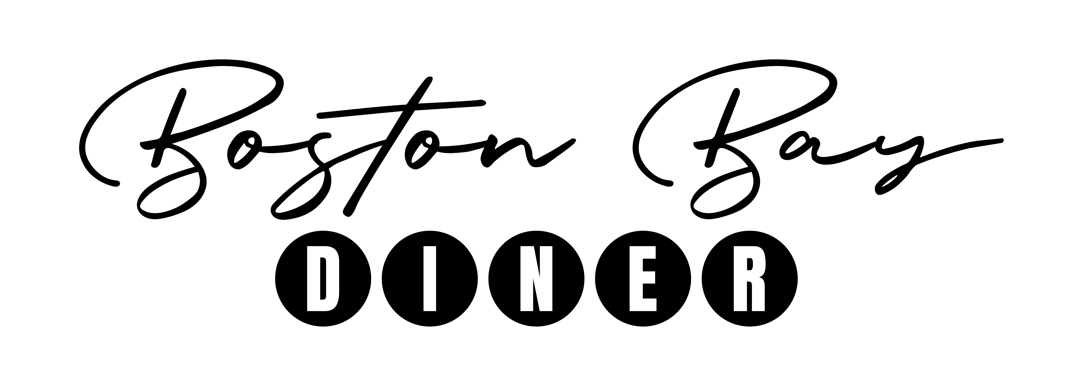

Bookings

The business offers the following methods for bookings and enquiries:
- Phone
- Email
- Webportal
- Our website supports Screen Readers
- Our forms have high contract boxes and submit boxes

Emergency Management
- The business has an emergency management and evacuation plan for guests with a disability

Communications
- An accessibility guide is available on the website

https://www.bostonbaydiner.com.au/accessibility/
- Our website meets WCAG 2.0 accessibility standards

Other Information
- For bookings made onsite, the ticket booth/counter/box office is accessible for people using a wheelchair

Guide Dog and Service Animals
- The business provides a secure area with shade and water for service animals
- Bowls, bedding, etc. are provided for service animals
The business provides the following services for services animals:
Not specified

GENERAL

Pre-arrival, arrival and reception
The business has the following in place to support guests during pre-arrival, arrival and reception
- Booking information and websites are compatible with screen readers
- In addition, the following further information can assist guests:
We have table ordering or counter ordering.
- In addition, the following further information can assist guests:
We have a full suite of information on our website as well as in the cafe to help people plain for their dining experience with us. Our staff are friendly and will help.

Cognitive Impairment Support
- Documents are available in plain English for people with cognitive impairment (This may include instructions, guides, menus and general information)

Car Park and Access amenities
The business has the following Car Park and Access amenities
- Designated disabled parking bays
- The accessible entrance is clearly signed from the parking bay
- Kerb ramps are in place where a pavement or walkway needs to be crossed
- In addition, the following further information can assist guests:
There is no carpark on-site just the public foreshore parking in Port Lincoln.

Entry
The business has the following amenities/systems in place for entry
- A path of access to the building is slip resistance and even
- A path of access to the building is clear of obstruction
- Self opening entry doors or fitted with a self closer
- Glass doors are fitted with a visual sighting strip
- Door jams/doors are of a contrasting colour to surrounding walls
- Door handles are of a contrasting colour to the door
- Signage is written in a contrasting colour
- Signage is written in a Sans Serif font and use upper and lower case letters
- The entry door is a minimum of 850mm wide
- The entry door has self opening or a light opening pressure (for manual operations)
- The entrance sill is less than 13mm
- There a clear space of at least 1500mm x 1500mm in front of all doors.
- The entrance door mats have a thickness less than 13mm and a width of 7500mm or greater
- In addition, the following further information can assist guests:
There are no doors to the entry as it's an open cafe. See image.
- In addition, the following further information can assist guests:
There is no lift as its a ground floor cafe.

Internal Spaces
- Clear and unobstructed routes through and between buildings
- Interior walls are matte or low sheen
- Floors, walls, counters and furniture are of contrasting colours
- Any protruding or overhanging obstructions are at least 2meters above the floor or are protected
- Tableware/glassware contrast with the table surface or table cloth
- Floor surfaces are hard or short pile carpet
- Seating is available for guests unable to stand for long periods
- Accessible facilities are clearly signed and visible from all areas
- All corridors greater than 900mm
- In addition, the following further information can assist guests:
It's a small cafe but we do offer a small kids play space.

Public areas
The public areas have the following amenities in place
- Display units, Televisions, Video displays etc. are open captioned
- Seating
- In addition, the following further information can assist guests:
This is an open cafe that overlooks the foreshore in Port Lincoln. There is limited space but we do have people of all walks of life visit us.

External Paths
External paths of travel
- Surfaces are concrete, asphalt, smooth paving or hard packed fine gravel (max aggregate size 13mm)
- Pathways are wider than 900mm

There are no steps to the entrance

There are no steps
- In addition, the following further information can assist guests:
This is a ground floor cafe on the foreshore in Port Lincoln.
- In addition, the following further information can assist guests:
Entry way is easily accessible.

Public Toilets/Adult change facilities
Public Toilets/Adult change facilities have the following amenities are in place
- There is an accessible toilet for public use
- The door is at least 850mm wide
- There is 750mm mm beside the toilet
- There is Toilet is not wheelchair accessible but there are public accessible toilet across the road. mm of clear space in front of the toilet
- The toilet seat is460mm above the floor
- There is a registered changing places facility
- There is a 'Changing Place' within Full size change table available of our business
- In addition, the following further information can assist guests:
If you have accessibility issues please contact us before visiting so we can identify the most suitable available table.

FOOD AND DRINK

Dining Spaces
The dining spaces have the following facilities/amenities in place
- The entrance has level access
- The doorway is at least 850mm wide
- There is level access through the dining area
- Chairs are moveable to allow for wheelchairs to be seated at the tables
- All glass doors and full height windows have contrast markings
- There are areas of full lighting
- There are large print menus
- There are Plain English menus
- There is an accessible toilet close by that is open during our business hours

Our business caters for the following dietary requirements
- Sugar free (diabetic)
- Gluten free (celiac)
- Lactose free (dairy free)
- Low fat and fibre with no gastric content
- Low potassium
- Low sodium
- Nut free
- Additive free
- Vegetarian
- Vegan
- In addition, the following further information can assist guests:
Food Safety Standard Operating Procedures: Cross-Contamination Prevention1. Personal Hygiene and HandwashingMandatory Handwashing: Staff must wash hands in designated hand-washing sinks before handling food, after touching raw ingredients, after cleaning, and after using the restroom. [1, 2]Handwash Station Setup: All handwashing basins are permanently stocked with liquid soap, warm running water, and single-use paper towels.Glove Usage: Gloves are changed between tasks, after touching faces/clothing, and at least every hour during continuous tasks. Handwashing is mandatory before putting on new gloves.2. Colour-Coded Equipment and SegregationColour-Coded Chopping Boards: We use a strict colour system to keep food groups separate:Red: Raw meatYellow: Raw poultryBlue: Raw seafoodGreen: Fruits and vegetablesWhite: Dairy and bakeryBrown: Cooked meatsDedicated Utensils: Separate knives, tongs, and preparation utensils are allocated to raw and ready-to-eat (RTE) stations.3. Storage ManagementCoolroom Organisation: Food is stored using the "top-down" rule to prevent drips. RTE foods and baked goods sit on the top shelves, followed by washed produce, with raw meats and poultry secured on the lowest shelves.Sealed Containers: All stored food is kept in clean, food-grade, covered containers and clearly labelled with the item name, preparation date, and use-by date.Chemical Storage: All cleaning chemicals and pest control items are stored in a designated cupboard completely separate from food storage and preparation areas.4. Cleaning and Sanitising ProtocolsTwo-Step Clean: Food contact surfaces undergo a two-step process: cleaning with detergent to remove visible dirt, followed by applying a food-safe chemical sanitiser.High-Touch Clean: Benches, slicers, and touchpoints are sanitised between batches, after handling raw products, and at scheduled intervals throughout the day.Commercial Dishwashing: All crockery, cutlery, and kitchen utensils are washed in a commercial dishwasher operating at high temperatures (above 80°C) to ensure heat sanitisation.5. Allergen ControlAllergen Segregation: We use designated, cleaned areas and separate utensils to prepare allergen-free orders (e.g., gluten-free or dairy-free).Staff Training: Team members are trained to check labels, identify the 11 major allergens, and communicate customer dietary requirements directly to the kitchen hand.

- There is a sample menu available online
Sample menu is available here -
https://www.bostonbaydiner.com.au/menu
  - Food and Beverage Image(s)
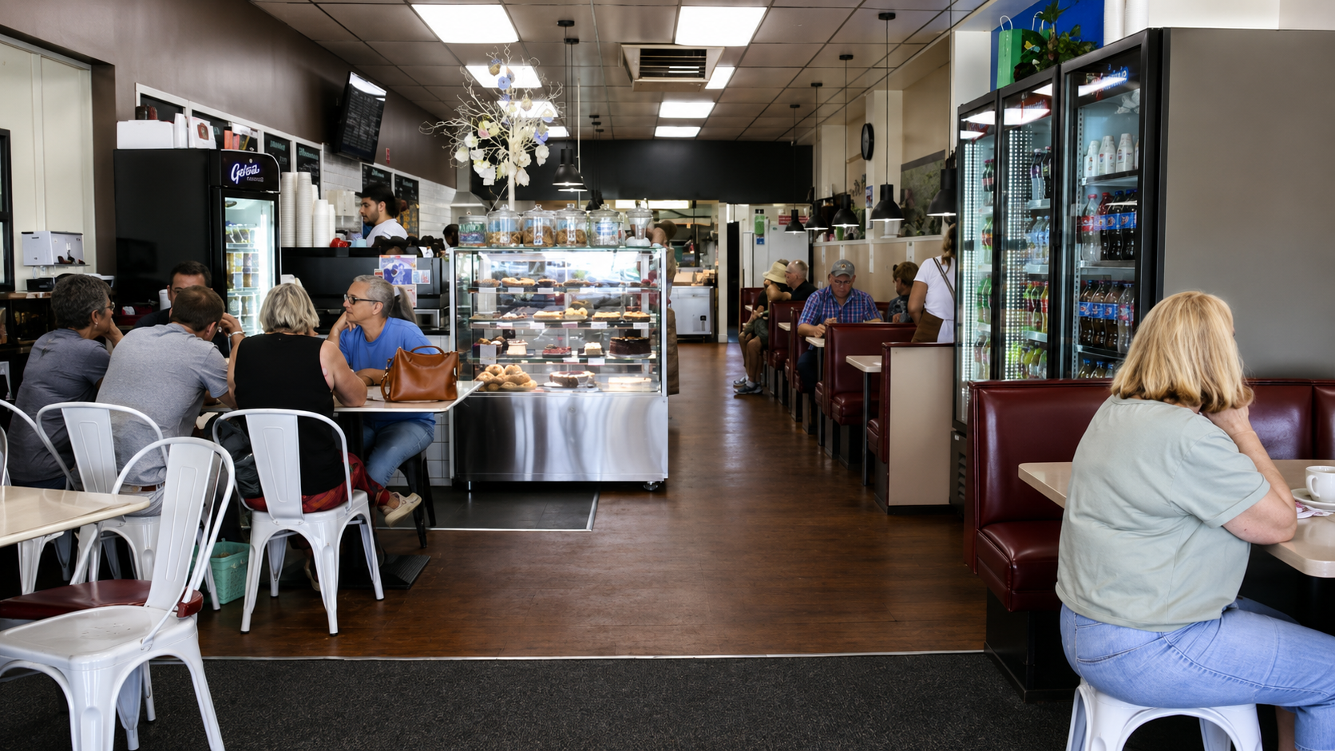
Entrance Boston Bay Diner

Report Disclaimer
Please note that this business report, provided as a result of the use of the diagnostic assessment, is for information purposes only.
Australian Tourism Industry Council (ATIC) cannot guarantee the accuracy of respondent’s answers, or that they are fully representative of your business. Therefore, ATIC does not warrant or guarantee any particular outcome in respect of your businesses self-assessment.
This report is intended as guidance only for your business and should not be relied on for future marketing considerations. ATIC recommends that you seek your own independent advice as well as the results from the diagnostic.
Links to external web sites are inserted for convenience and do not constitute endorsement of material at those sites, or any associated organisation, product or service.
ATIC does not:
- Assume any legal liability for the accuracy, completeness, or usefulness of any information from this report or any links provided; or
- Accept responsibility for any loss associated directly or indirectly from the use of this report.

