ATIC Accessibility
To support the accessible community in making informed travel decisions for their individual needs

This report prepared for:
Business name: | Kokoda Park
Address: | 213 Mulgowie Road
Town: | Thornton
Contact for enquiries: | Anna Maitala
Contact Number: | 07 5539 4141
Contact Email: | admin@kokodaoutdoor.com
Website: | www.kokodaoutdoor.com
Date: | 2026-10-18 03:21

ATIC Accessibility
The following pages provides travellers with information on the businesses facilities and amenities which aims to support the traveller to make an informed decision on whether the business is suitable for their individual needs.
OVERVIEW 4
Business Overview 4
Bookings 4
Emergency Management 4
Guide Dog and Service Animals 5
GENERAL 6
Pre-arrival, arrival and reception 6
Cognitive Impairment Support 6
Car Park and Access amenities 6
Internal Spaces 6
External Paths 7
Ramps 7
ACCOMMODATION 8
Bedrooms 8
Room Amenities 8
Bathrooms 8
COMMON AREAS 10
Swimming pools, spas and waterparks 10
FOOD AND DRINK 12
Dining Spaces 12
ADVENTURE ACTIVITIES 15
Report Disclaimer 18

OVERVIEW

Business Overview

The business has the following products/services available
- Accommodation
- Food and Drink
- Adventure

Our business caters for the following disability types:
- Blind or low vision
- Deaf or low hearing
- Food allergies or intolerances
- Cognitive or people on the Autism Spectrum
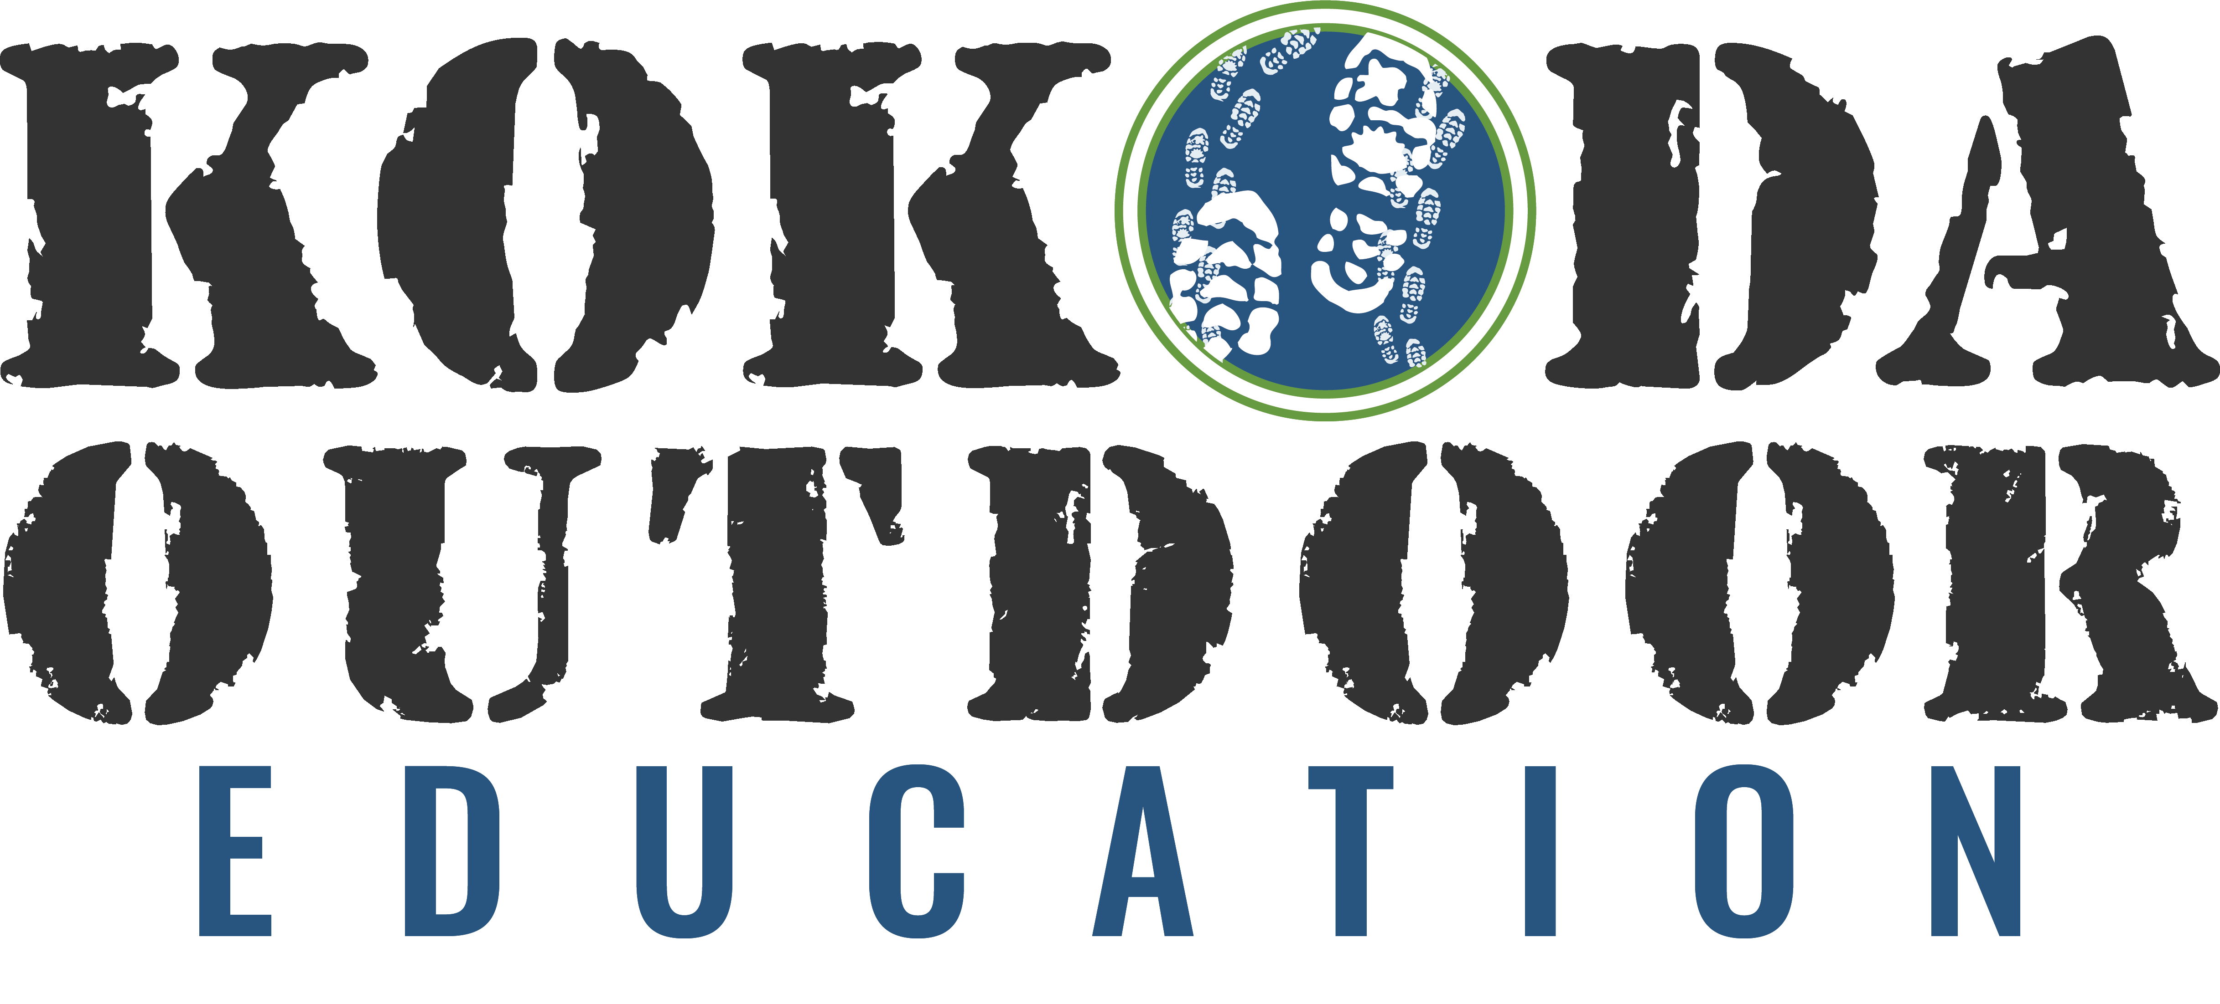

Bookings

The business offers the following methods for bookings and enquiries:
- Phone
- Email
- Webportal

Emergency Management
- Emergency and evacuation procedures are explained on arrival
- Exit signs are clear and easy to see
- Exit access is free and clear at all times
We ensure exit access is free and clear at all times by:
Regularly checked by staff and onsite maintenance supervisor.
- Exits and access to exists are greater than 900mm
- Exit doors are able to be opened by all occupants
- Exits to the emergency evacuation point does not include stairways
- The evacuation point is clearly marked by a sign
- In addition, the following further information can assist guests:
Guest Self-Identification: During the booking process, guests are encouraged to notify Kokoda Park staff of any special needs, including mobility issues, medical conditions, or other factors that may require additional assistance during an emergency. This information is handled confidentially and shared only with staff responsible for safety and emergency management. Customized Communication: Guests who disclose additional needs receive personalised communication outlining safety measures and the assistance available during their visit.
- In addition, the following further information can assist guests:
Upon identifying the need for an assisted rescue, staff immediately activate the park’s emergency response plan and notify the designated emergency coordinator or team leader. Emergency services (e.g., paramedics, fire rescue) are contacted if required.
- Guests with disabilities are noted in the guest log book for emergency and evacuation purposes

Guide Dog and Service Animals
- The business provides a secure area with shade and water for service animals
- The business provides a toilet area for service animals
- Bowls, bedding, etc. are provided for service animals
The business provides the following services for services animals:
Not specified

GENERAL

Pre-arrival, arrival and reception
The business has the following in place to support guests during pre-arrival, arrival and reception
- Booking information and websites are compatible with screen readers
- There is a reception/public entryway.
- Seating available at reception
- A clipboard to allow check-in/ticket purchase whilst seated
- Lighting in the reception area is even and glare free
- Information and maps are available in written form
- A familiarisation tour
- Advertising material, web sites and social media contain information relating to phone numbers available for non-voice communication e: Text, SMS, email and fax
- Luggage assistance
- In addition, the following further information can assist guests:
Staff are made aware of guests requiring priority assistance and can provide personalised support, such as guiding them to seating areas or expediting their access to programs and activities.

Cognitive Impairment Support
- Documents are available in plain English for people with cognitive impairment (This may include instructions, guides, menus and general information)

Car Park and Access amenities
The business has the following Car Park and Access amenities
- A drop off zone
- The accessible entrance is clearly signed from the parking bay
- Kerb ramps are in place where a pavement or walkway needs to be crossed

Internal Spaces
- Tableware/glassware contrast with the table surface or table cloth

External Paths
External paths of travel
- Surfaces are concrete, asphalt, smooth paving or hard packed fine gravel (max aggregate size 13mm)
- Pathways are wider than 900mm

Ramps
Ramps have the following amenities are in place
- There are ramps.
- All fixed ramps are 1:14 or less
- Hand rails are fitted
- Long ramps (more than 10m) are 1:20 or less
- Ramps have a raised edge of at least 100mm

ACCOMMODATION

Bedrooms
The bedrooms have the following facilities/amenities in place
- There are 10 rooms available to guests who use a wheelchair
- Bedroom furniture can be re-arranged on request

Room Amenities

There are no wardrobes in the dormitory rooms.
- In addition, the following further information can assist guests:
Please refer to our Emergency Evacuation Manual.
- There is contrast between the walls, skirtings, floor and furniture
- There is a clear path through the room
- Wardrobe handles are a contrasting colour to the doors and draws
- Housekeeping procedures instruct staff not to reposition furniture that has been moved
- There is a clear opening at least 850mm wide
- There is at least 850mm clear space beside the bed
- There is at least 130mm clearance under the bed
- Non-allergenic cleaning products are used

Bathrooms
The bathrooms have the following facilities/amenities in place
- All heating appliances and hot water pipes are protected or insulated
- All shower, bath and basin taps are clearly differentiated between hot and cold
- Fixtures and fittings have rounded edges
- The hot water is thermostatically controlled to 41 degrees
- The door is at least 850mm wide
- There is a minimum of 850mm beside the toilet
- There is a minimum of 1400mm of clear space in front of the toilet
- The toilet seat is a contrasting colour to the floor
- The toilet seat is 460mm above the floor
- A door is fitted to the shower
- A door is fitted to the showers with an outward swing at minimum width of 900 mm
  - Bathroom Image(s)
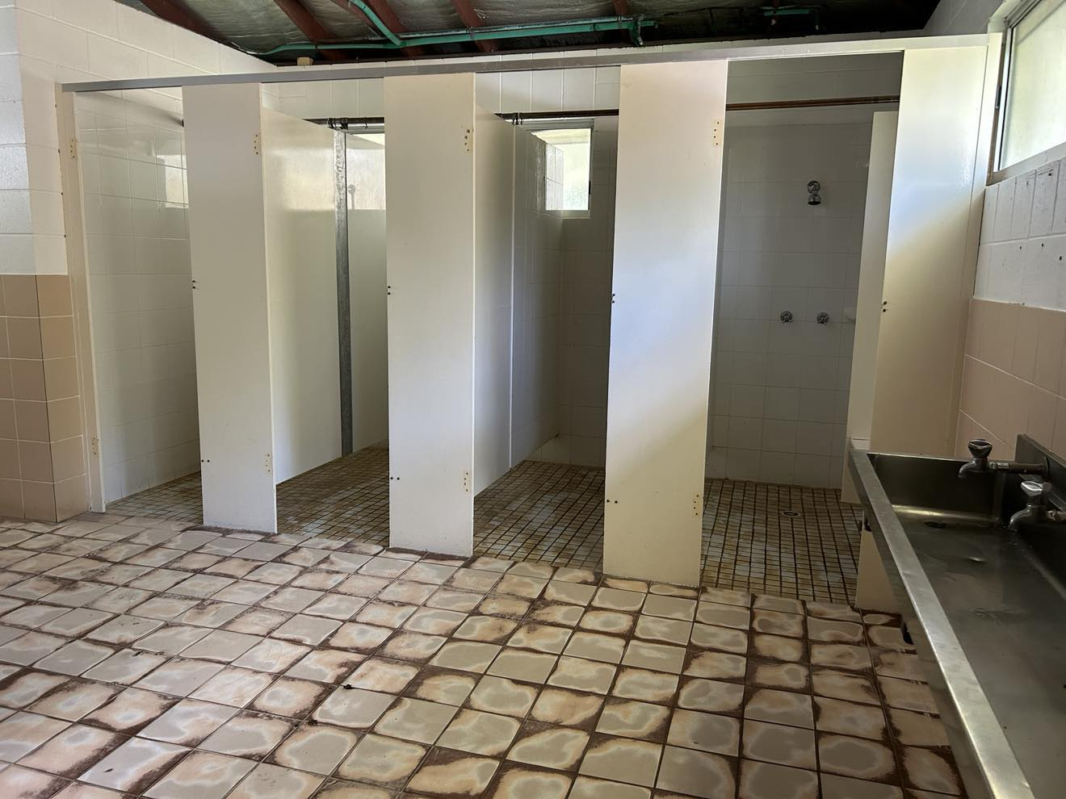
462640438_8802445396504174_3282783965994343366_n
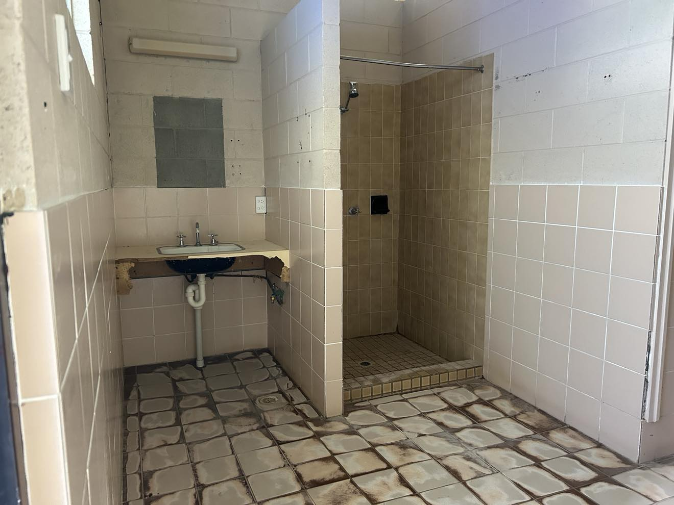
462567223_612286761473546_8205656250175494125_n
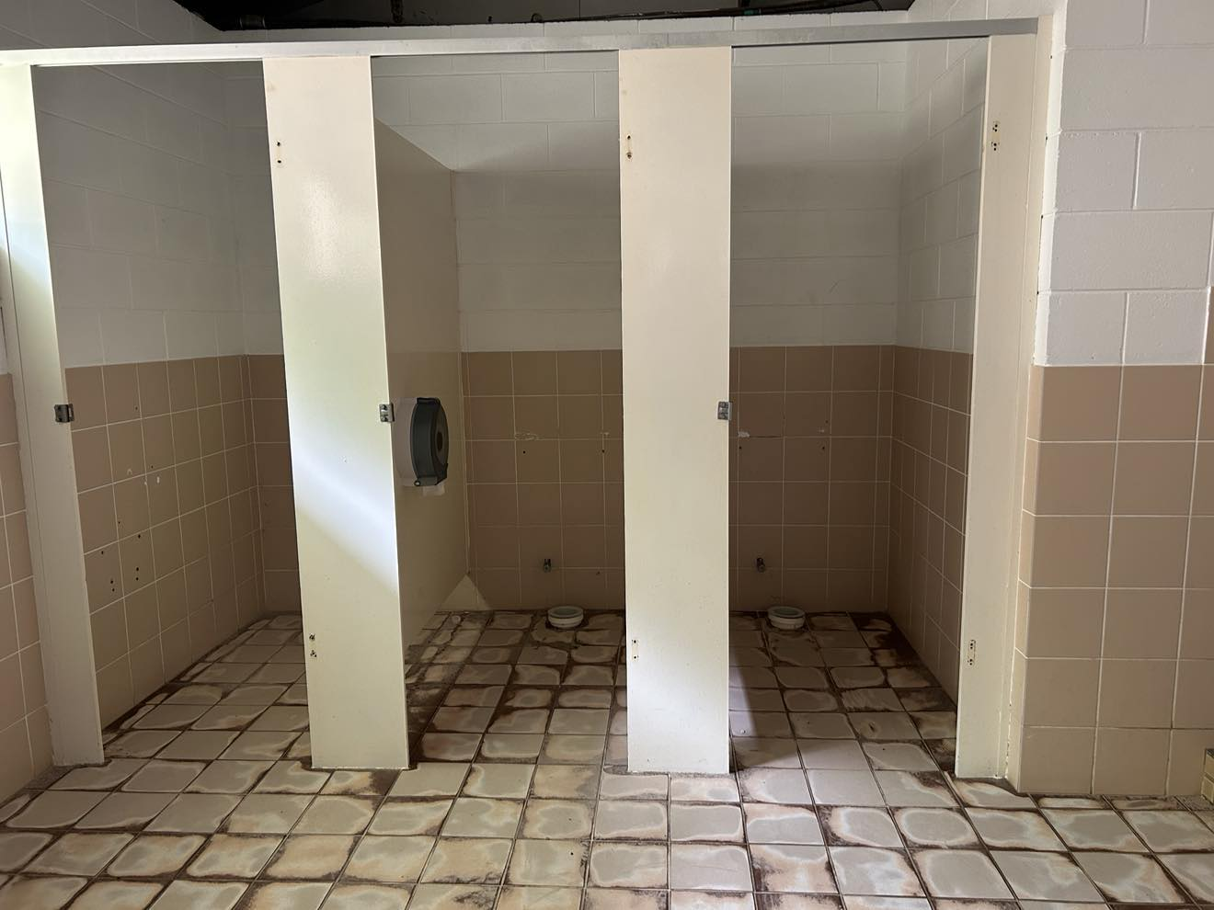
462568347_1616632785924229_8146429106700657366_n
- In addition, the following further information can assist guests:
Please note that our abolution block is currently being refurbished.

COMMON AREAS

Swimming pools, spas and waterparks
- The following swimming pools, spas and waterparks amenities are available
- Unisex change facilities with an accessible toilet
  - Pool Access Image(s)
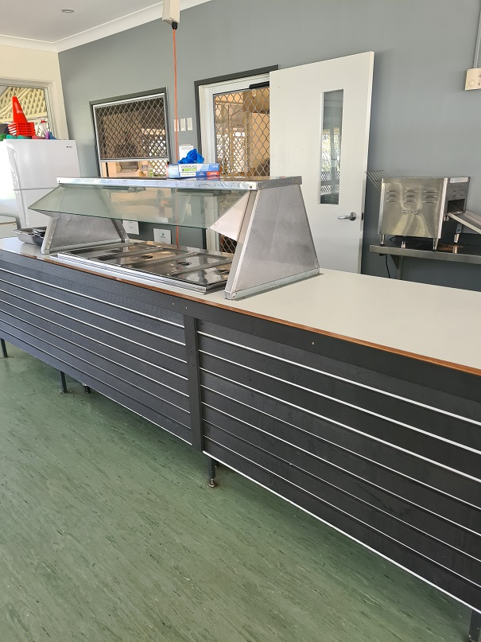
KP-Servery
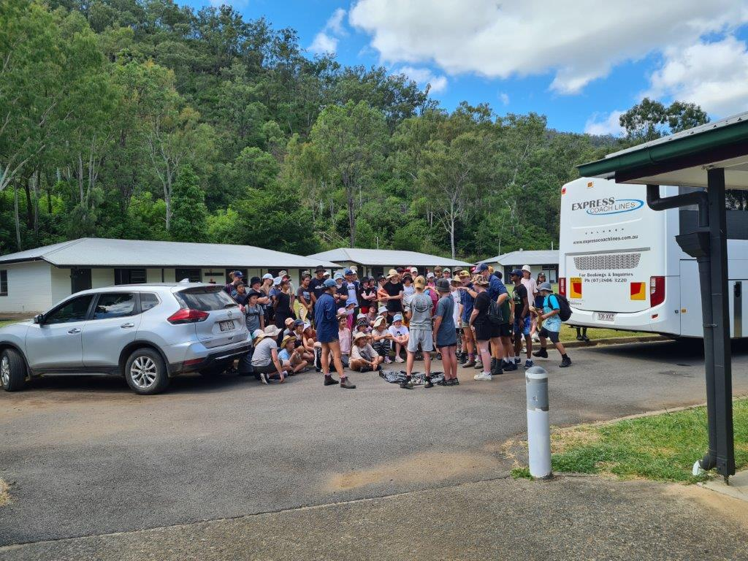
20220325_121702
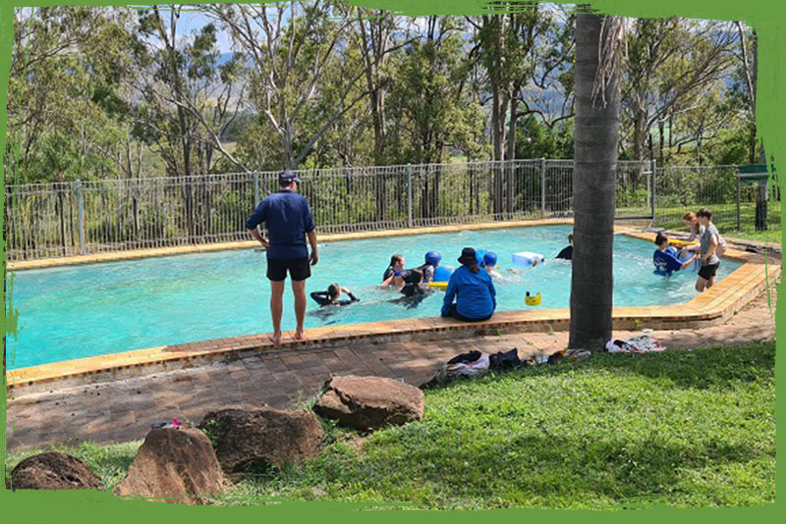
Pool-at-KP
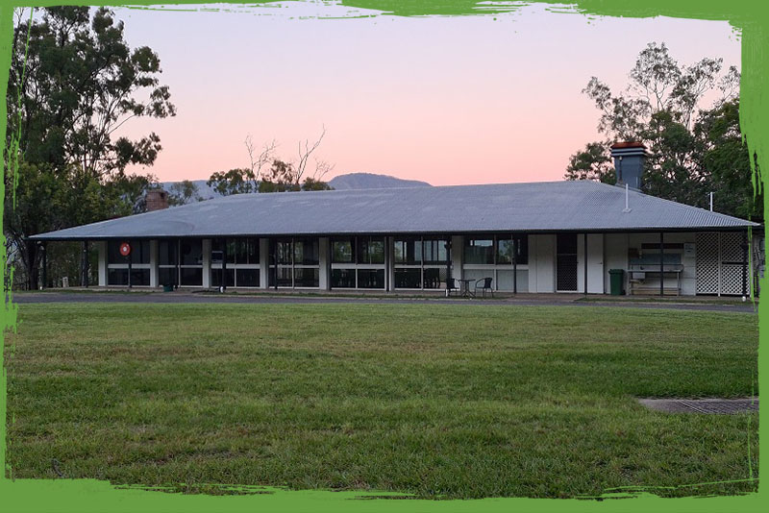
Dining-hall-at-sunrise
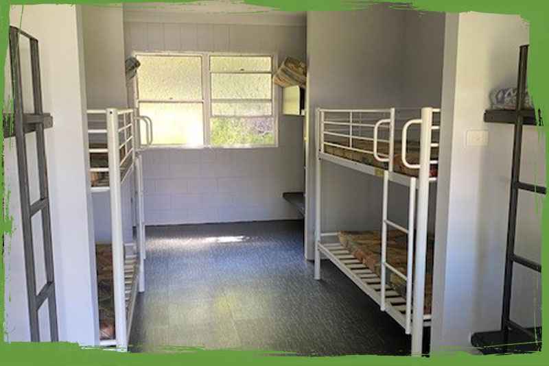
Dorm-INside-KP

FOOD AND DRINK

Dining Spaces
The dining spaces have the following facilities/amenities in place
- The entrance has level access
- The doorway is at least 850mm wide
- There is level access through the dining area
- Chairs are moveable to allow for wheelchairs to be seated at the tables
- All glass doors and full height windows have contrast markings
- There are areas of full lighting
- There are Plain English menus
- There is an accessible toilet

Our business caters for the following dietary requirements
- Sugar free (diabetic)
- Gluten free (celiac)
- Lactose free (dairy free)
- Low fat and fibre with no gastric content
- Nut free
- Vegetarian
- Vegan
- Halal
- In addition, the following further information can assist guests:
This is contained in our Food Safety Protocol document.
  - Food and Beverage Image(s)
KP-Servery
Dining-hall-at-sunrise
Dorm-INside-KP
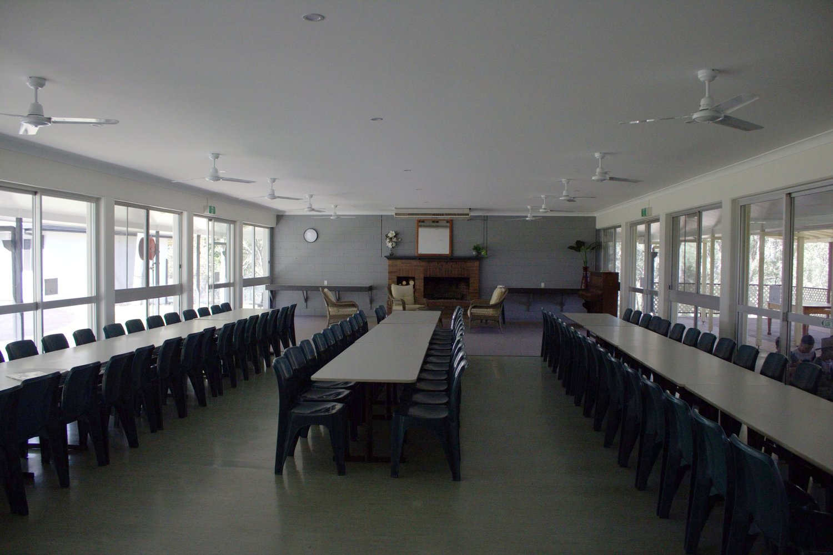
kokodapark_dininghall

ADVENTURE ACTIVITIES
  - Adventure Activity Image(s)

Archery_kokodapark_
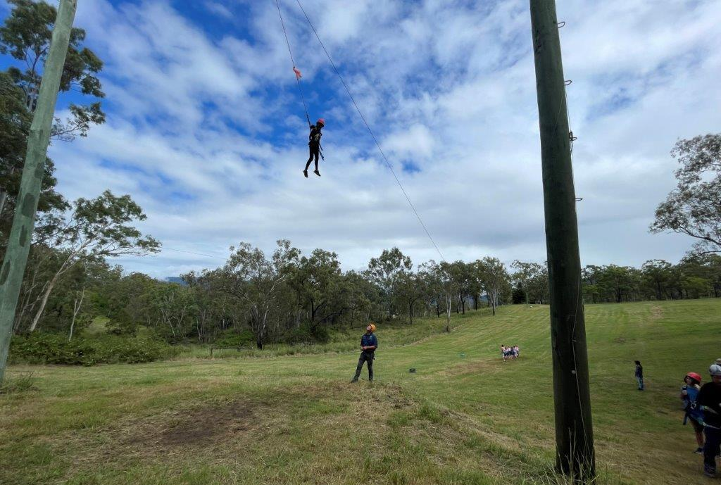
Sugar-Glider
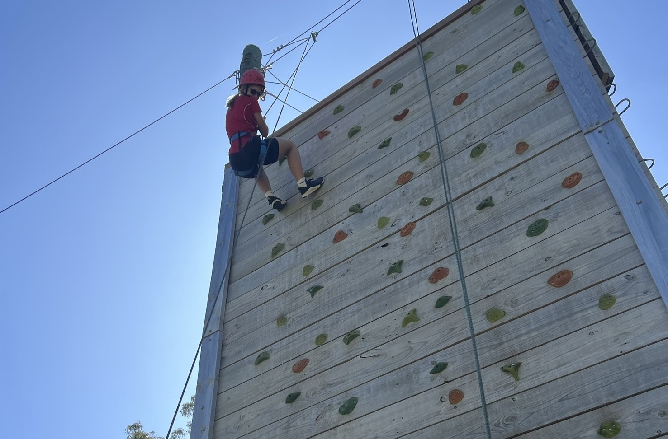
IMG_9322-Copy
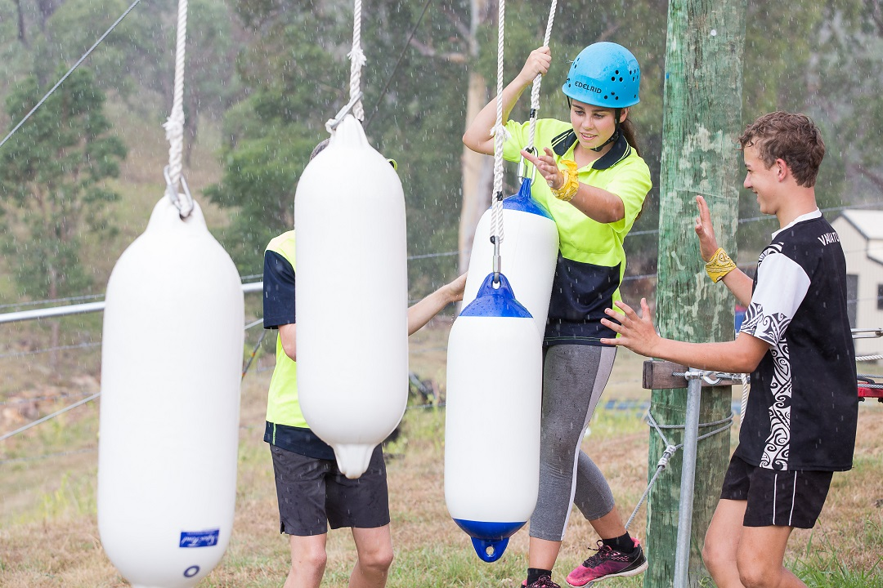
Low-Ropes-Camp-Kokoda

Report Disclaimer
Please note that this business report, provided as a result of the use of the diagnostic assessment, is for information purposes only.
Australian Tourism Industry Council (ATIC) cannot guarantee the accuracy of respondent’s answers, or that they are fully representative of your business. Therefore, ATIC does not warrant or guarantee any particular outcome in respect of your businesses self-assessment.
This report is intended as guidance only for your business and should not be relied on for future marketing considerations. ATIC recommends that you seek your own independent advice as well as the results from the diagnostic.
Links to external web sites are inserted for convenience and do not constitute endorsement of material at those sites, or any associated organisation, product or service.
ATIC does not:
- Assume any legal liability for the accuracy, completeness, or usefulness of any information from this report or any links provided; or
- Accept responsibility for any loss associated directly or indirectly from the use of this report.

