ATIC Accessibility
To support the accessible community in making informed travel decisions for their individual needs

This report prepared for:
Business name: | BIG4 Bendigo Marong Holiday Park
Address: | 1449 Calder Hwy
Town: | Marong
Contact for enquiries: | Justin Morris
Contact Number: | (03) 5435 2329
Contact Email: | sheree@pathfinderdestinations.com.au
Website: | https://big4bendigoholidaypark.com.au/
Date: | 2026-09-22 10:54

ATIC Accessibility
The following pages provides travellers with information on the businesses facilities and amenities which aims to support the traveller to make an informed decision on whether the business is suitable for their individual needs.
OVERVIEW 4
Business Overview 4
Bookings 4
Emergency Management 4
Communications 5
Guide Dog and Service Animals 5
GENERAL 6
Pre-arrival, arrival and reception 6
Cognitive Impairment Support 6
Car Park and Access amenities 6
External Paths 6
Steps 7
Ramps 7
ACCOMMODATION 8
Bedrooms 8
Room Amenities 8
Bathrooms 8
COMMON AREAS 10
Play Spaces 10
Swimming pools, spas and waterparks 11
Parks and gardens 12
Report Disclaimer 16

OVERVIEW

Business Overview

The business has the following products/services available
- Accommodation

Our business caters for the following disability types:
- Limited mobility
- Wheelchairs or mobility scooters

Bookings

The business offers the following methods for bookings and enquiries:
- Phone
- Email
- Webportal

Emergency Management
- Exit access is free and clear at all times
We ensure exit access is free and clear at all times by:
Minimal furniture, none blocking entrances.
- Exits and access to exists are greater than 900mm
- Exit doors are able to be opened by all occupants
- Exits to the emergency evacuation point does not include stairways
- The evacuation point is clearly marked by a sign
- In addition, the following further information can assist guests:
We have one accessible cabin so we would be aware of their needs at check in.
- In addition, the following further information can assist guests:
We do not have a procedure in place at the moment. We will look into this. We would though, go and check that all of the cabins are evacuated - potentially we need to check on the accessible cabin first.
- Guests with disabilities are noted in the guest log book for emergency and evacuation purposes

Communications
- An accessibility guide is available on the website

https://www.big4bendigoholidaypark.com.au/accessibility.asp
- Our business offers the following alternative communication methods
- Plain English

Not specified
- There is easy to read signage and information (e.g. menus and emergency information)

Guide Dog and Service Animals
- The business provides a secure area with shade and water for service animals
- The business provides a toilet area for service animals
The business provides the following services for services animals:
The are able to sleep in the dog-friendly cabins, which also have gated decks and some have gate grassed side areas.

GENERAL

Pre-arrival, arrival and reception
The business has the following in place to support guests during pre-arrival, arrival and reception
- There is a reception/public entryway.
- Seating available at reception
- A lower counter at reception/ticket office
- Lighting in the reception area is even and glare free

Guests do not have to fill out anything as it done prior to arrival or via their phone
- Information and maps are available in written form
- Keys are available for each guest
- Luggage assistance
- In addition, the following further information can assist guests:
We have seating in our reception area. If they were to make their disability known to us we would be sure to do our best to offer them a speedy service.

Cognitive Impairment Support
- Documents are available in plain English for people with cognitive impairment (This may include instructions, guides, menus and general information)

Car Park and Access amenities
The business has the following Car Park and Access amenities
- A drop off zone
- Level or ramped access from the car park to the entrance

External Paths
External paths of travel
- Surfaces are concrete, asphalt, smooth paving or hard packed fine gravel (max aggregate size 13mm)
- Paths or slopes longer than 15 metres have resting places or seats
- Pathways are wider than 900mm
- There 3 successive steps or less on any path or at any doorway

Steps
Steps
- There are steps.
- Handrails extend 300mm beyond the top and bottom step

Ramps
Ramps have the following amenities are in place
- There are ramps.
- All fixed ramps are 1:14 or less
- Hand rails are fitted
- Long ramps (more than 10m) are 1:20 or less
- Ramps have a raised edge of at least 100mm

ACCOMMODATION

Bedrooms
The bedrooms have the following facilities/amenities in place
- There are 1 rooms available to guests who use a wheelchair
- Bedroom furniture can be re-arranged on request

Room Amenities
- There is a clear path through the room
- Wardrobe handles are a contrasting colour to the doors and draws
- Housekeeping procedures instruct staff not to reposition furniture that has been moved
- Doors open fully against the adjoining wall
- There is a clear opening at least 850mm wide
- There at least one chair with rigid arms
- Wardrobe and drawer handles are easy to grip
- The bedside lamp switch is easy to reach from the bed
- There is at least 850mm clear space beside the bed
- The bed height is no higher than 680mm from the floor
- There is at least 130mm clearance under the bed

Bathrooms
The bathrooms have the following facilities/amenities in place
- All heating appliances and hot water pipes are protected or insulated
- All shower, bath and basin taps are clearly differentiated between hot and cold
- Fixtures and fittings have rounded edges
- The hot water is thermostatically controlled to 41 degrees
- The door is at least 850mm wide
- There is a minimum of 850mm beside the toilet
- Handrails are fitted
- There is a minimum of 1400mm of clear space in front of the toilet
- The toilet seat is a contrasting colour to the floor
- The toilet seat is 460mm above the floor
- There is a roll-in shower with fold down fixed seat or a shower chair
- There is a portable shower head on flexible hose
  - Bathroom Image(s)
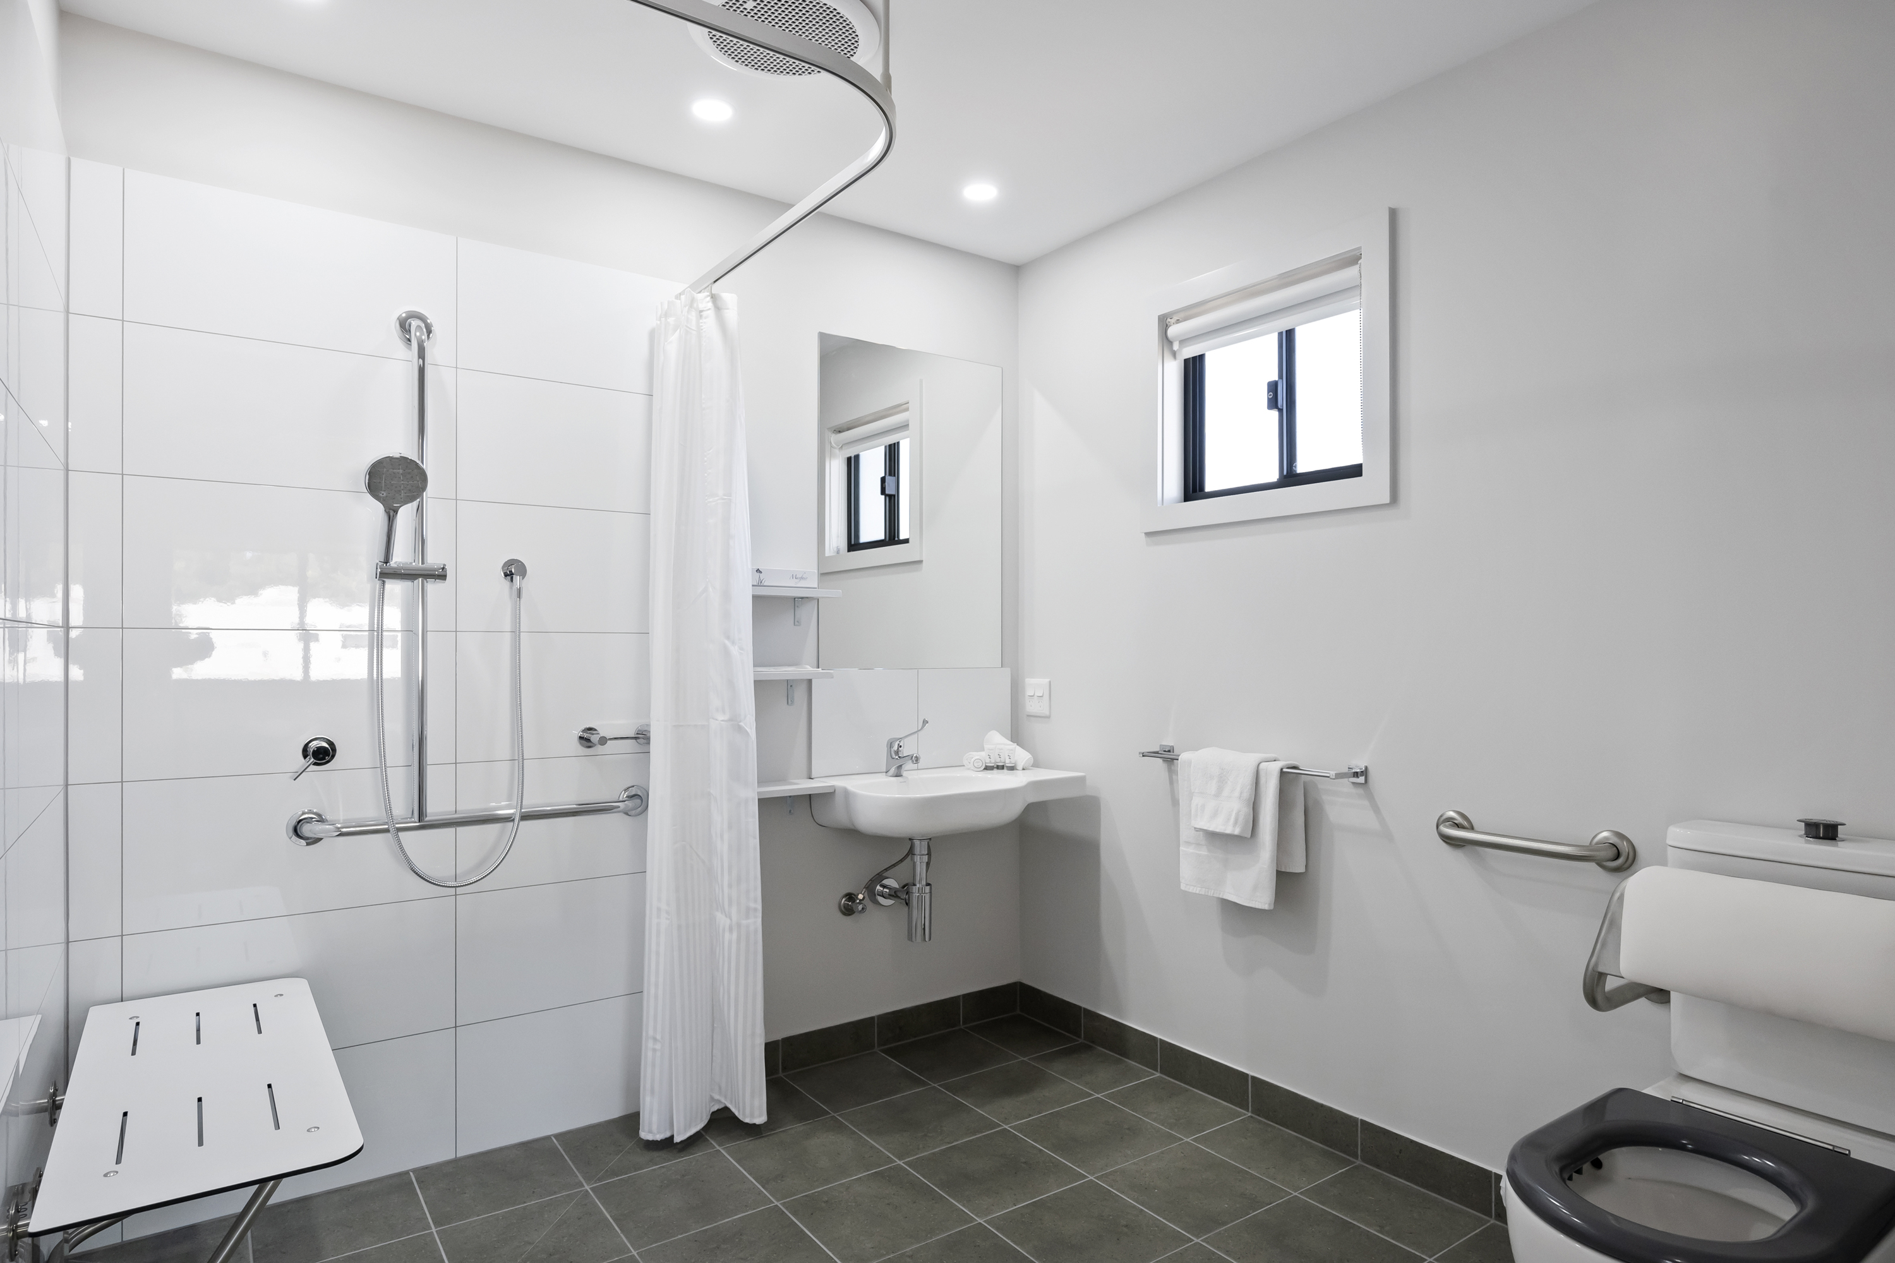
010_Open2view_ID977969-1449_Calder_Highway

COMMON AREAS

Play Spaces
- Level access is provided to play spaces
- There wheelchair accessible activities
- The space contain colour contrasting elements
  - Image(s)
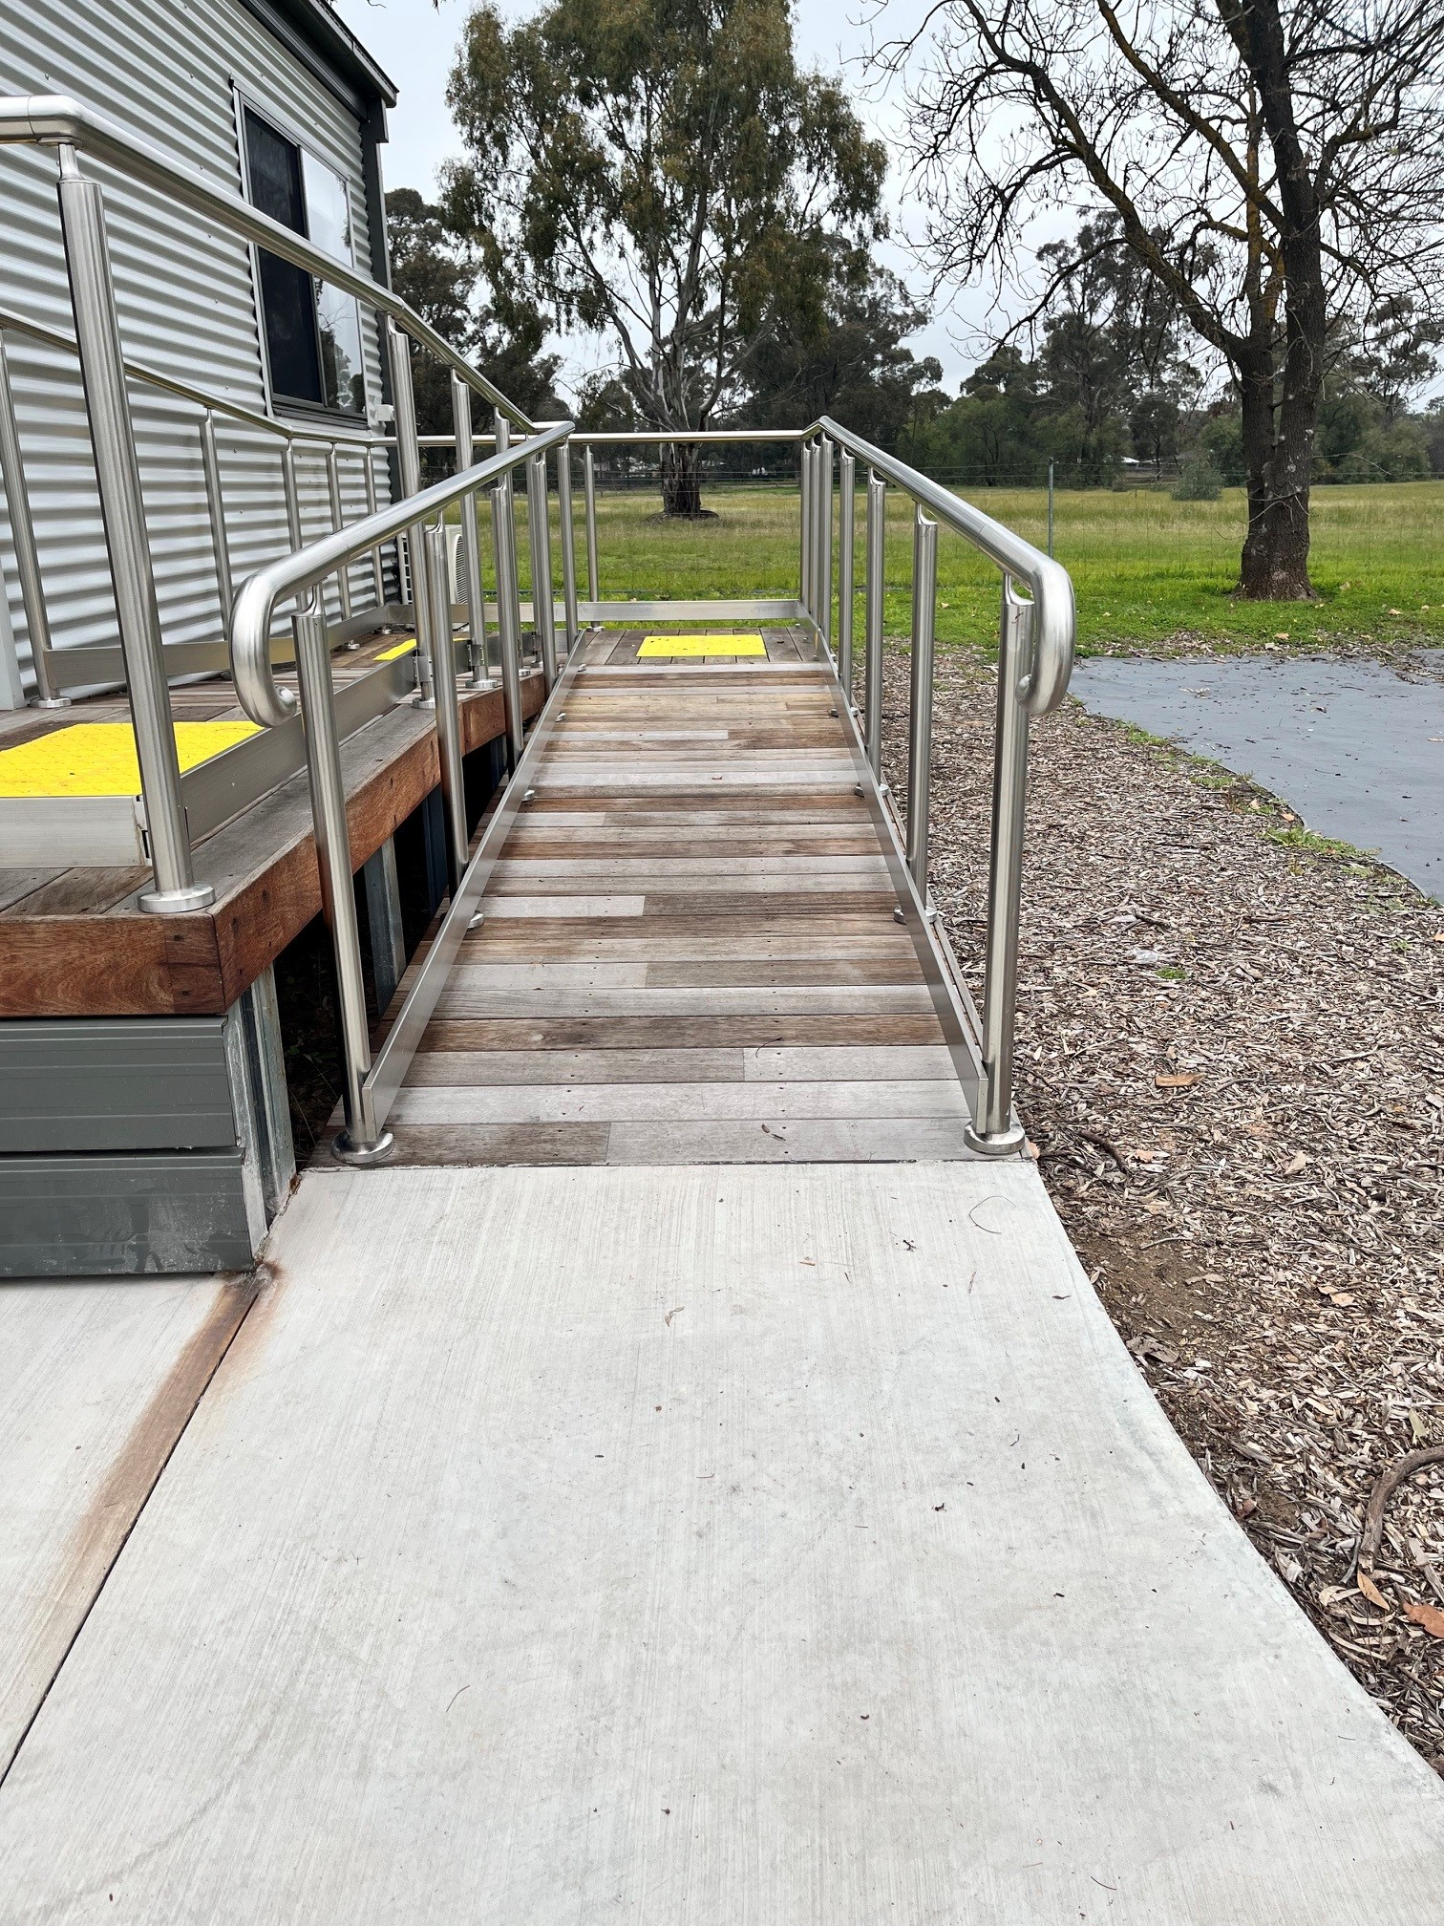
Accessible-Studio-Ramp-BIG4-Marong
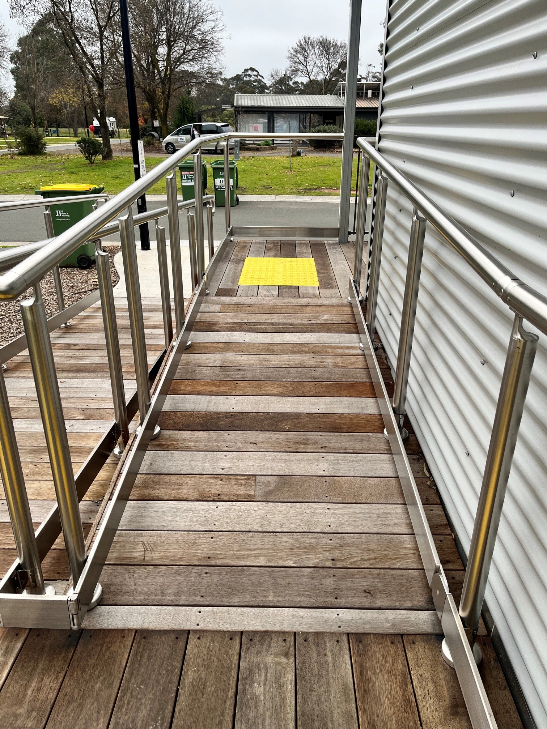
Accessible-Studio-Ramp-BIG4-Marong-2
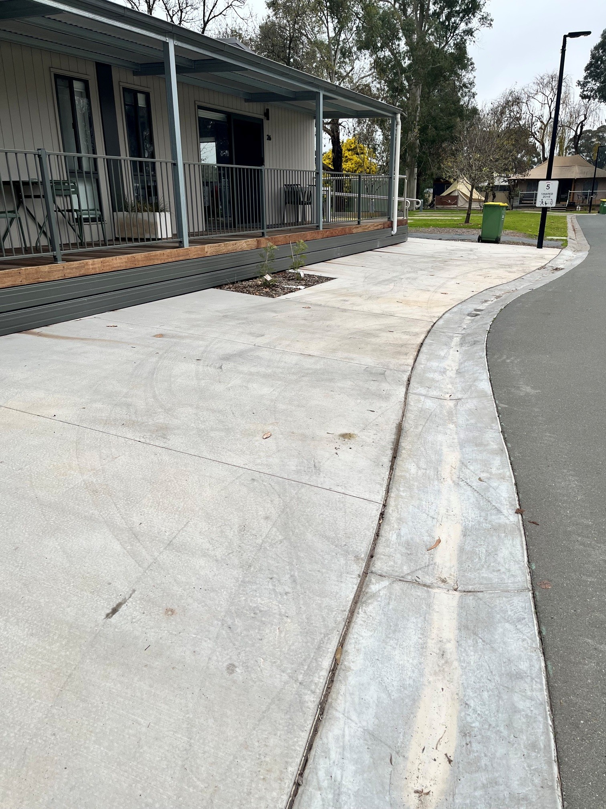
Accessible-Studio-Carpark-With-Ramp- Access
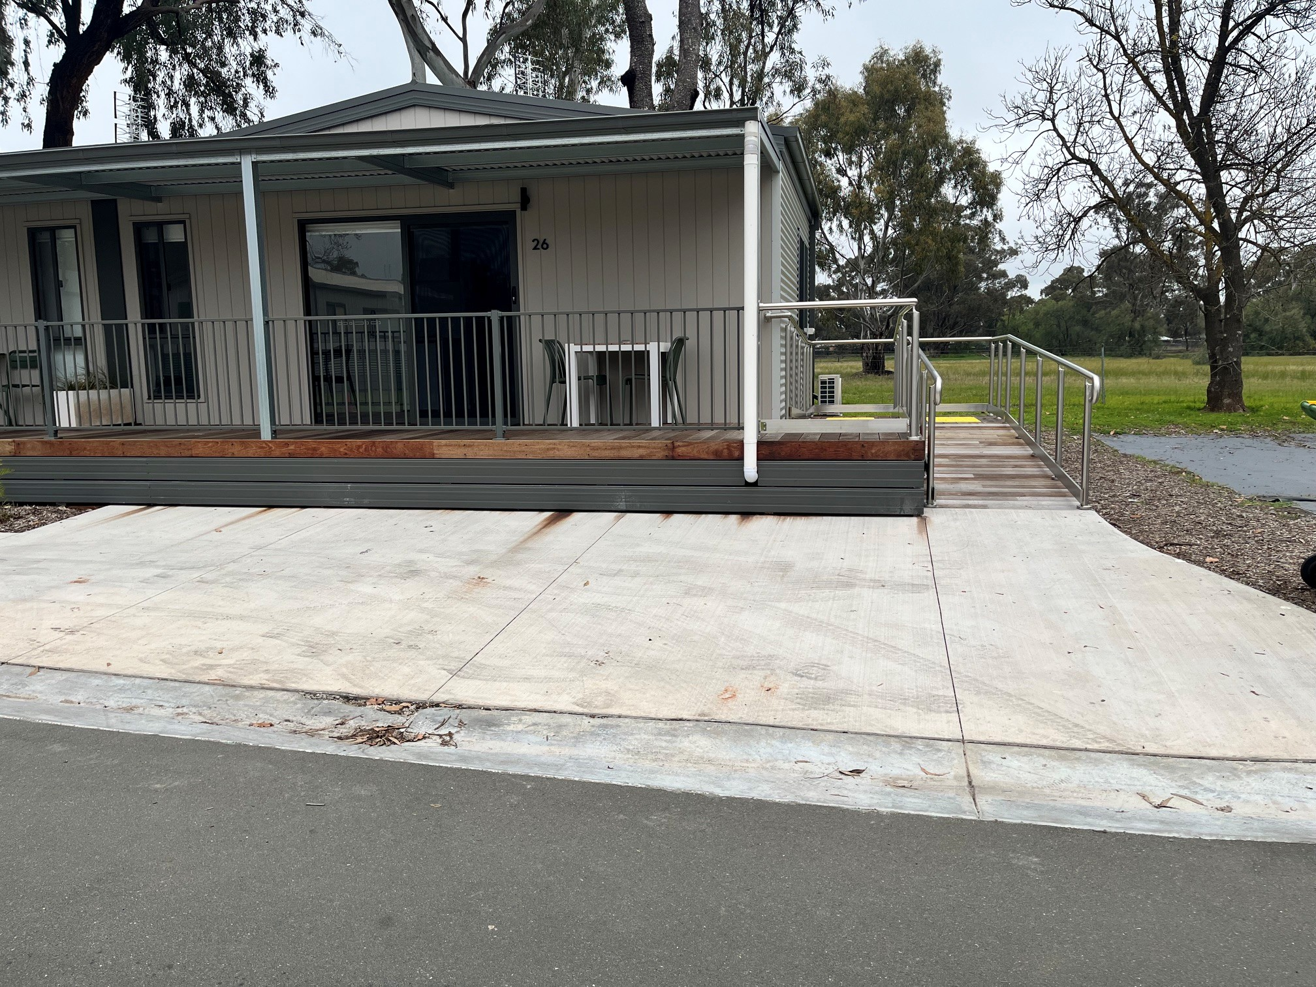
Accessible-Cabin-Parking-Ramp-Access

Swimming pools, spas and waterparks
- The following swimming pools, spas and waterparks amenities are available
- Unisex change facilities with an accessible toilet
- The park map includes a step free route
  - Pool Access Image(s)
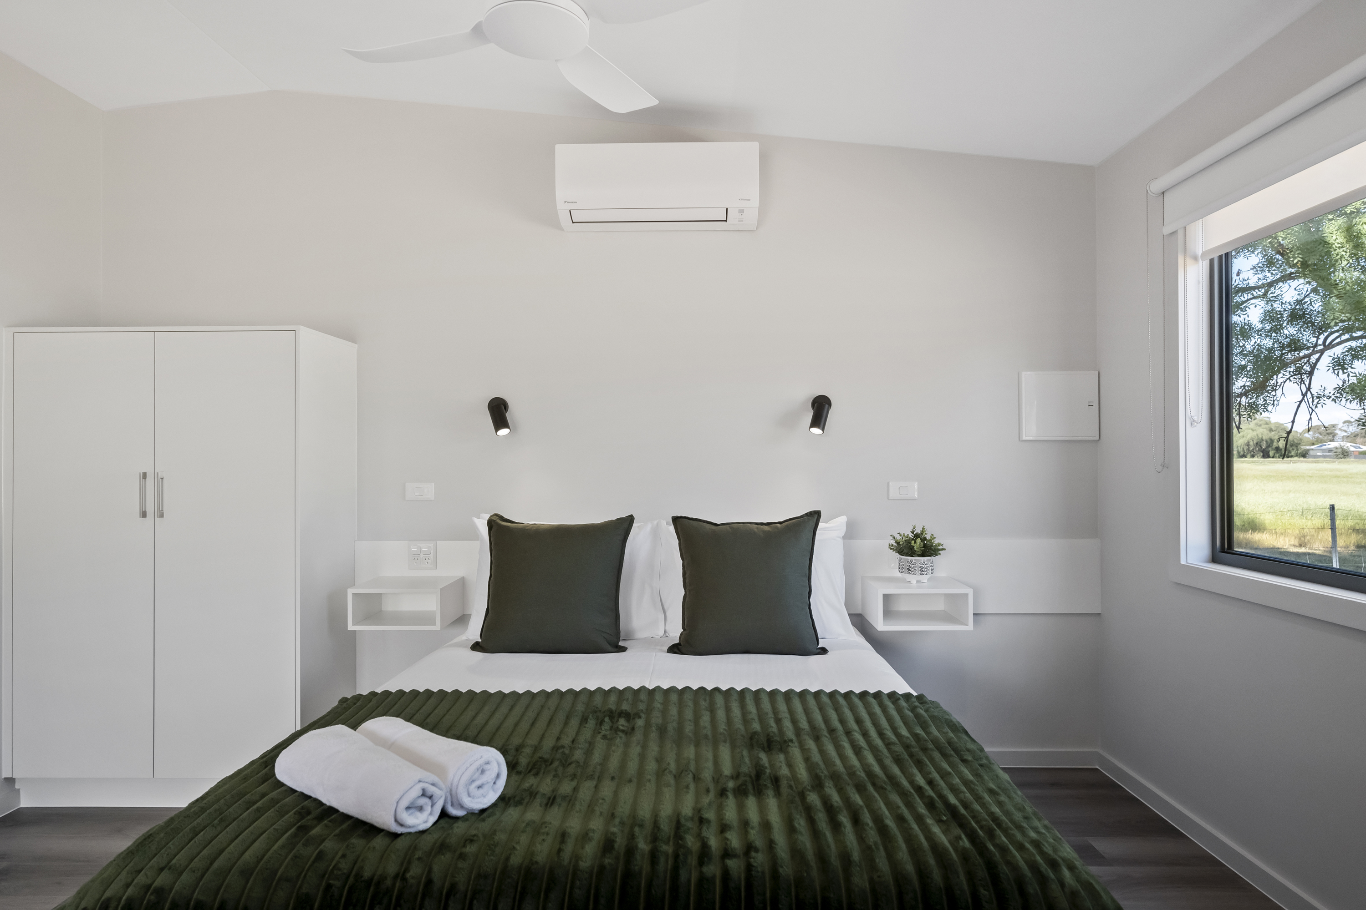
Accessible-Studio-Wide-Travl-Paths-Space -Around-Bed
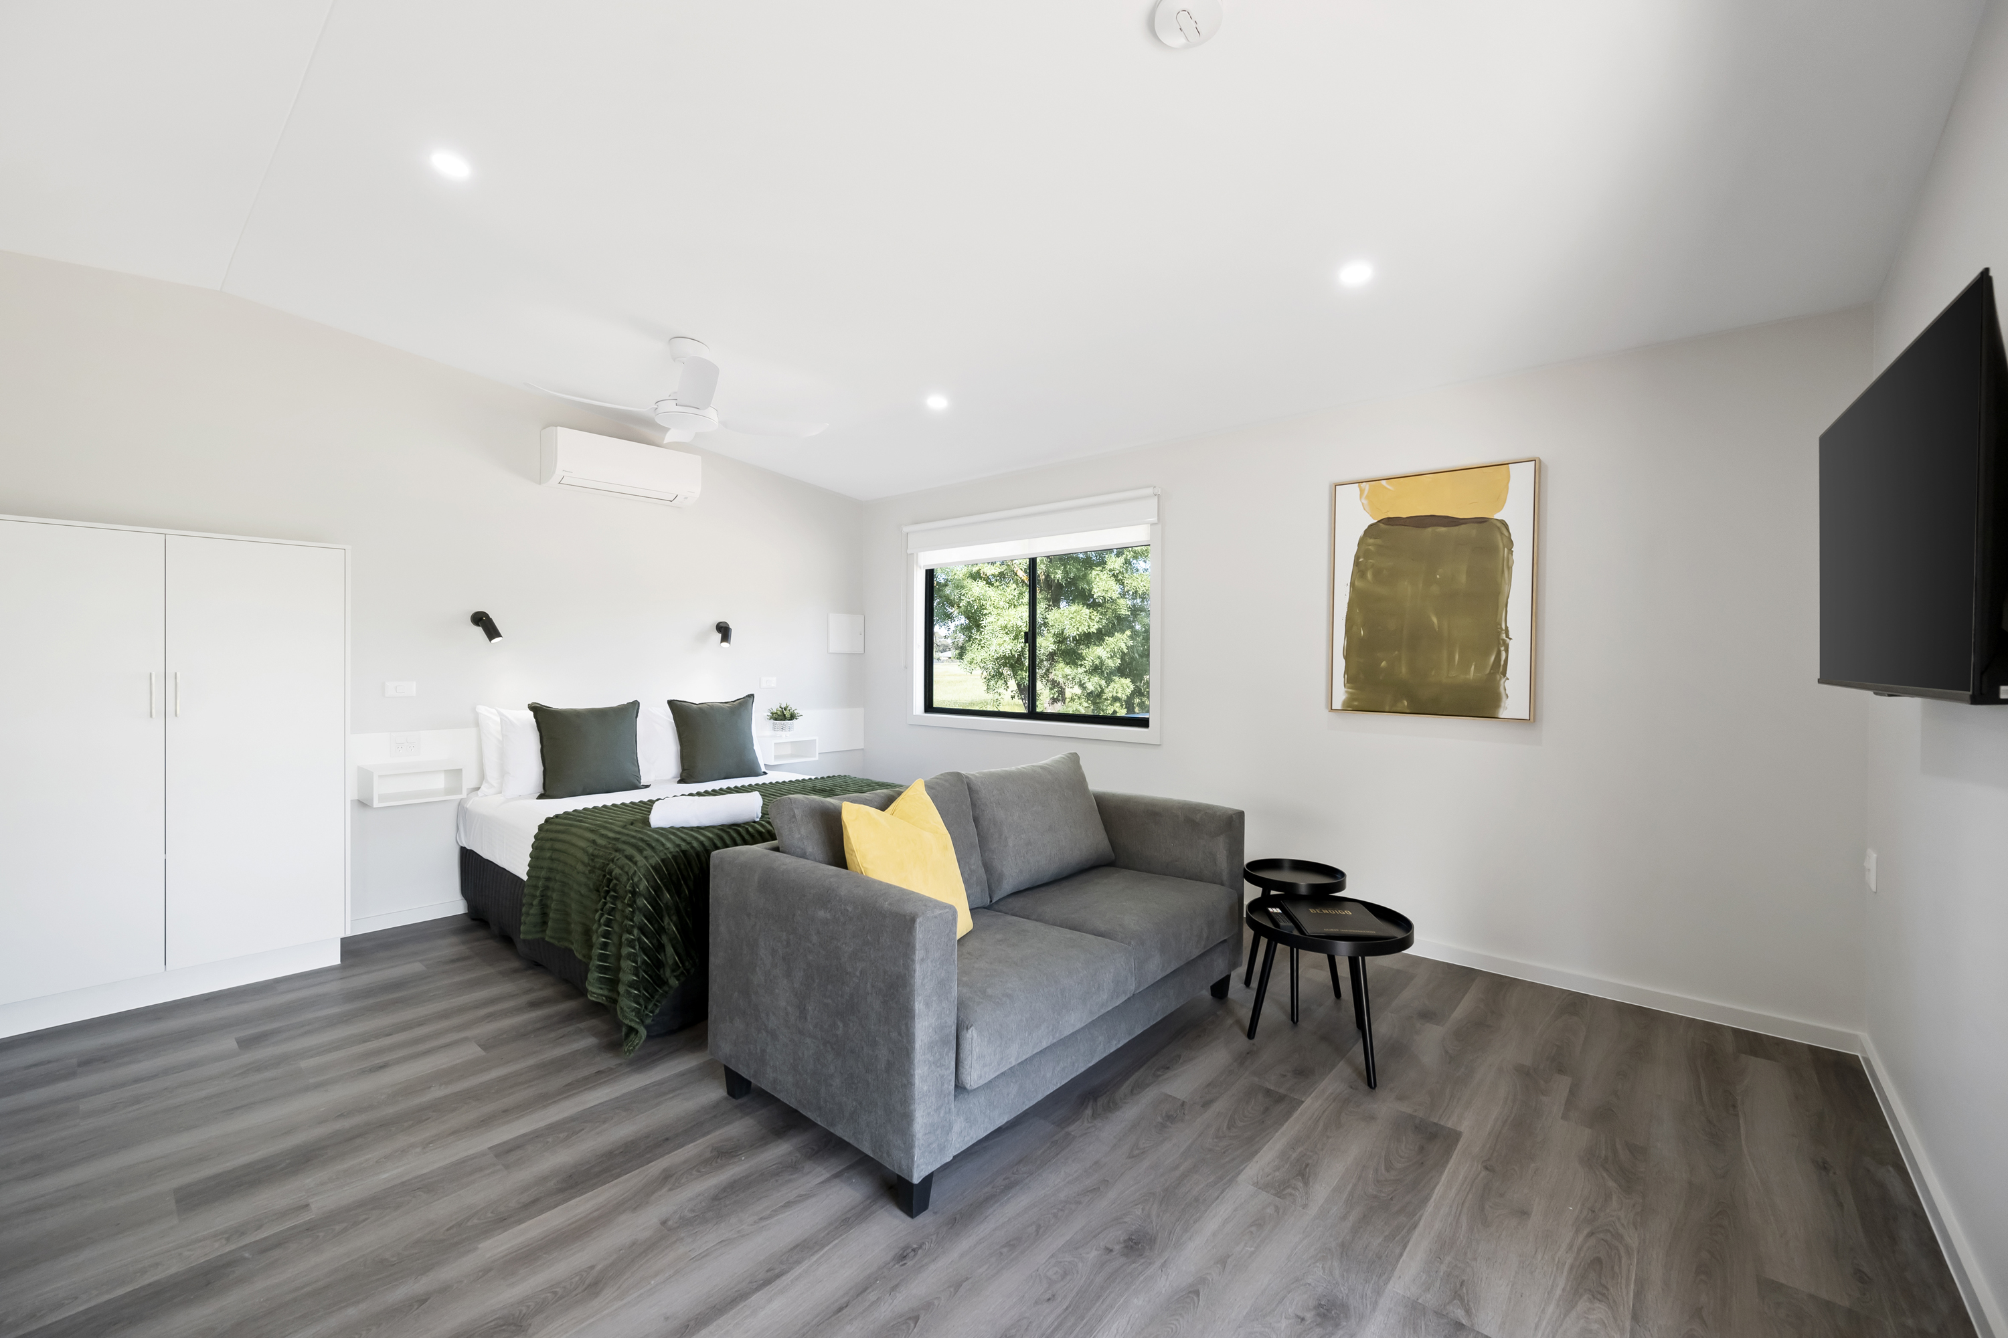
Accessible-Studio-Plenty-Turning-Circles

Parks and gardens
- The following parks and gardens amenities are available
- Accessible toilets
  - Parks and Gardens Access/Entry Image(s)
Accessible-Studio-Carpark-With-Ramp- Access
Accessible-Cabin-Parking-Ramp-Access
  - Parks and Gardens Stair entry and exit Image(s)
Accessible-Studio-Ramp-BIG4-Marong
Accessible-Bathroom-in-Cabin-with-Railing
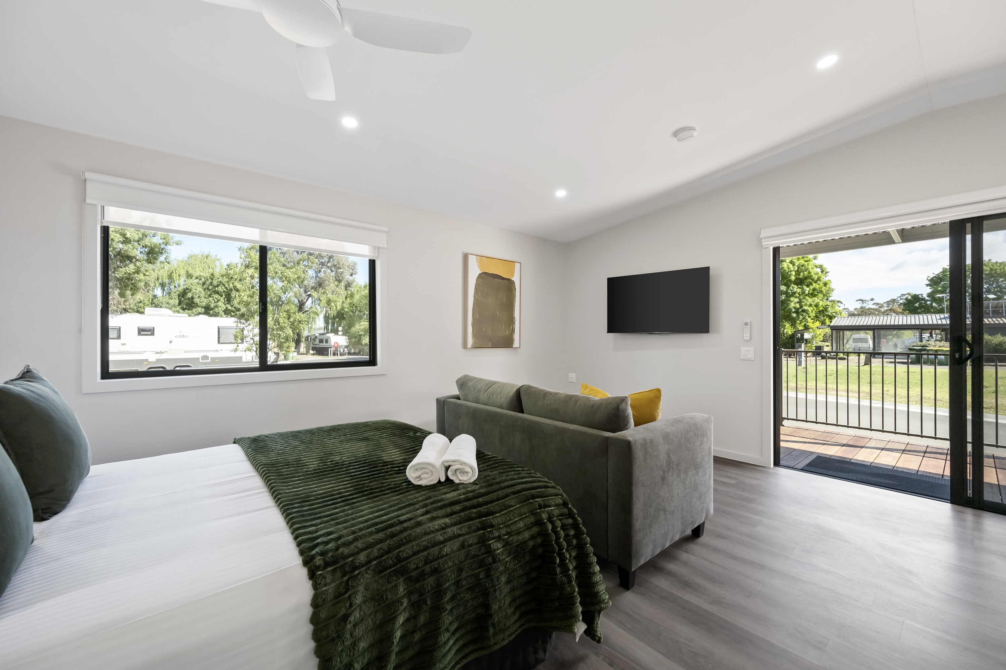
Accessible-Studio-Wide-Entry

Report Disclaimer
Please note that this business report, provided as a result of the use of the diagnostic assessment, is for information purposes only.
Australian Tourism Industry Council (ATIC) cannot guarantee the accuracy of respondent’s answers, or that they are fully representative of your business. Therefore, ATIC does not warrant or guarantee any particular outcome in respect of your businesses self-assessment.
This report is intended as guidance only for your business and should not be relied on for future marketing considerations. ATIC recommends that you seek your own independent advice as well as the results from the diagnostic.
Links to external web sites are inserted for convenience and do not constitute endorsement of material at those sites, or any associated organisation, product or service.
ATIC does not:
- Assume any legal liability for the accuracy, completeness, or usefulness of any information from this report or any links provided; or
- Accept responsibility for any loss associated directly or indirectly from the use of this report.

