ATIC Accessibility
To support the accessible community in making informed travel decisions for their individual needs

This report prepared for:
Business name: | Pinnacles
Address: | 16 Golden Orchid Drive
Town: | Airlie Beach
Contact for enquiries: | Therese Manager
Contact Number: | 07-49484800
Contact Email: | pinnacles@property-vine.com.au
Website: | http://www.pinnaclesairliebeach.com.au/
Date: | 2026-10-26 02:56

ATIC Accessibility
The following pages provides travellers with information on the businesses facilities and amenities which aims to support the traveller to make an informed decision on whether the business is suitable for their individual needs.
OVERVIEW 4
Business Overview 4
Bookings 4
Emergency Management 4
Communications 5
Guide Dog and Service Animals 5
GENERAL 6
Pre-arrival, arrival and reception 6
Cognitive Impairment Support 6
External Paths 6
Steps 7
ACCOMMODATION 8
Room Amenities 8
Bathrooms 8
COMMON AREAS 10
Swimming pools, spas and waterparks 10
Report Disclaimer 12

OVERVIEW

Business Overview

The business has the following products/services available
- Accommodation

Our business caters for the following disability types:
- Limited mobility
- Food allergies or intolerances


Bookings

The business offers the following methods for bookings and enquiries:
- Phone
- Email
- Webportal
- Our website supports Screen Readers
- Our forms have high contract boxes and submit boxes
- Staff have undergone disability awareness and training

Emergency Management
- Exit signs are clear and easy to see
- Exit access is free and clear at all times
We ensure exit access is free and clear at all times by:
Each individual apartment has a door leading to outside cleared area. Carpark area is illuminated during the evening hours.
- Exit doors are able to be opened by all occupants
- The evacuation point is clearly marked by a sign
- In addition, the following further information can assist guests:
Guest would need to advise upon check-in that in the event of an evacuation or emergency that they will require additional assistance.
- In addition, the following further information can assist guests:
Emergency Plan Integration: Identified guests are noted in our internal emergency response plan, ensuring that staff are aware of their location and needs. Trained Staff Response: Our staff are trained in emergency evacuation procedures and will assist guests if safe to do so with limited mobility or other needs as part of the evacuation protocol. Coordination with Emergency Services: In the event of a large-scale emergency, our team will liaise with emergency services to prioritise the safe evacuation of guests needing assistance. Assembly & Medical Support: Guests will be escorted to the designated evacuation point and provided with any necessary medical or support services.
- Guests with disabilities are noted in the guest log book for emergency and evacuation purposes

Communications
- Our business offers the following alternative communication methods
- Plain English

Not specified
- There is easy to read signage and information (e.g. menus and emergency information)

Guide Dog and Service Animals
The business provides the following services for services animals:
Not specified

GENERAL

Pre-arrival, arrival and reception
The business has the following in place to support guests during pre-arrival, arrival and reception
- Booking information and websites are compatible with screen readers
- There is a reception/public entryway.
- Seating available at reception
- A lower counter at reception/ticket office
- A clipboard to allow check-in/ticket purchase whilst seated
- A tablet with text to voice or pen and paper at reception to aid in communication
- Lighting in the reception area is even and glare free
- Information and maps are available in written form
- A familiarisation tour
- Keys are available for each guest
- Luggage assistance
- In addition, the following further information can assist guests:
We offer our guests online express check-in that can be completed to avoid any delays

Cognitive Impairment Support
- Documents are available in plain English for people with cognitive impairment (This may include instructions, guides, menus and general information)

External Paths
External paths of travel
The width of the smallest pathway is:
820mm
- There 3 successive steps or less on any path or at any doorway
- In addition, the following further information can assist guests:
Pinnacles is located in an elevated position high on the hill of Golden Orchid Drive offering self catering apartments. Whilst we do have a couple of rooms with minimal stairs, stairs are required to access pool and gym areas from the apartments.

Steps
Steps
- There are steps.
- All steps or staircases have enclosed risers
- The underside of all staircases are enclosed or protected to a height of at least 2 metres
- Handrails fitted to all open sets of steps

ACCOMMODATION

Room Amenities
- Televisions are equipped with closed captioning capability
- There is a clear path through the room
- Housekeeping procedures instruct staff not to reposition furniture that has been moved
- Doors open fully against the adjoining wall
- Openings are a minimum of 820mm wide
- There luggage racks for at least two suitcases
- There at least one chair with rigid arms
- The bedside lamp switch is easy to reach from the bed
- In addition, the following further information can assist guests:
For guests wishing to bring own non-allergenic bedding please discuss with staff prior to arrival.

Bathrooms
The bathrooms have the following facilities/amenities in place
- All heating appliances and hot water pipes are protected or insulated
- Fixtures and fittings have rounded edges
- The hot water is thermostatically controlled to 41 degrees
- The width of the door is 820mm.
- The width beside the toilet is Less than 700mm.
- There is 1000mm mm of clear space in front of the toilet
- The toilet seat is a contrasting colour to the floor
- The actual height of the toilet seat is 430mm.
- There is a portable shower head on flexible hose
- A door is fitted to the shower
  - Bathroom Image(s)
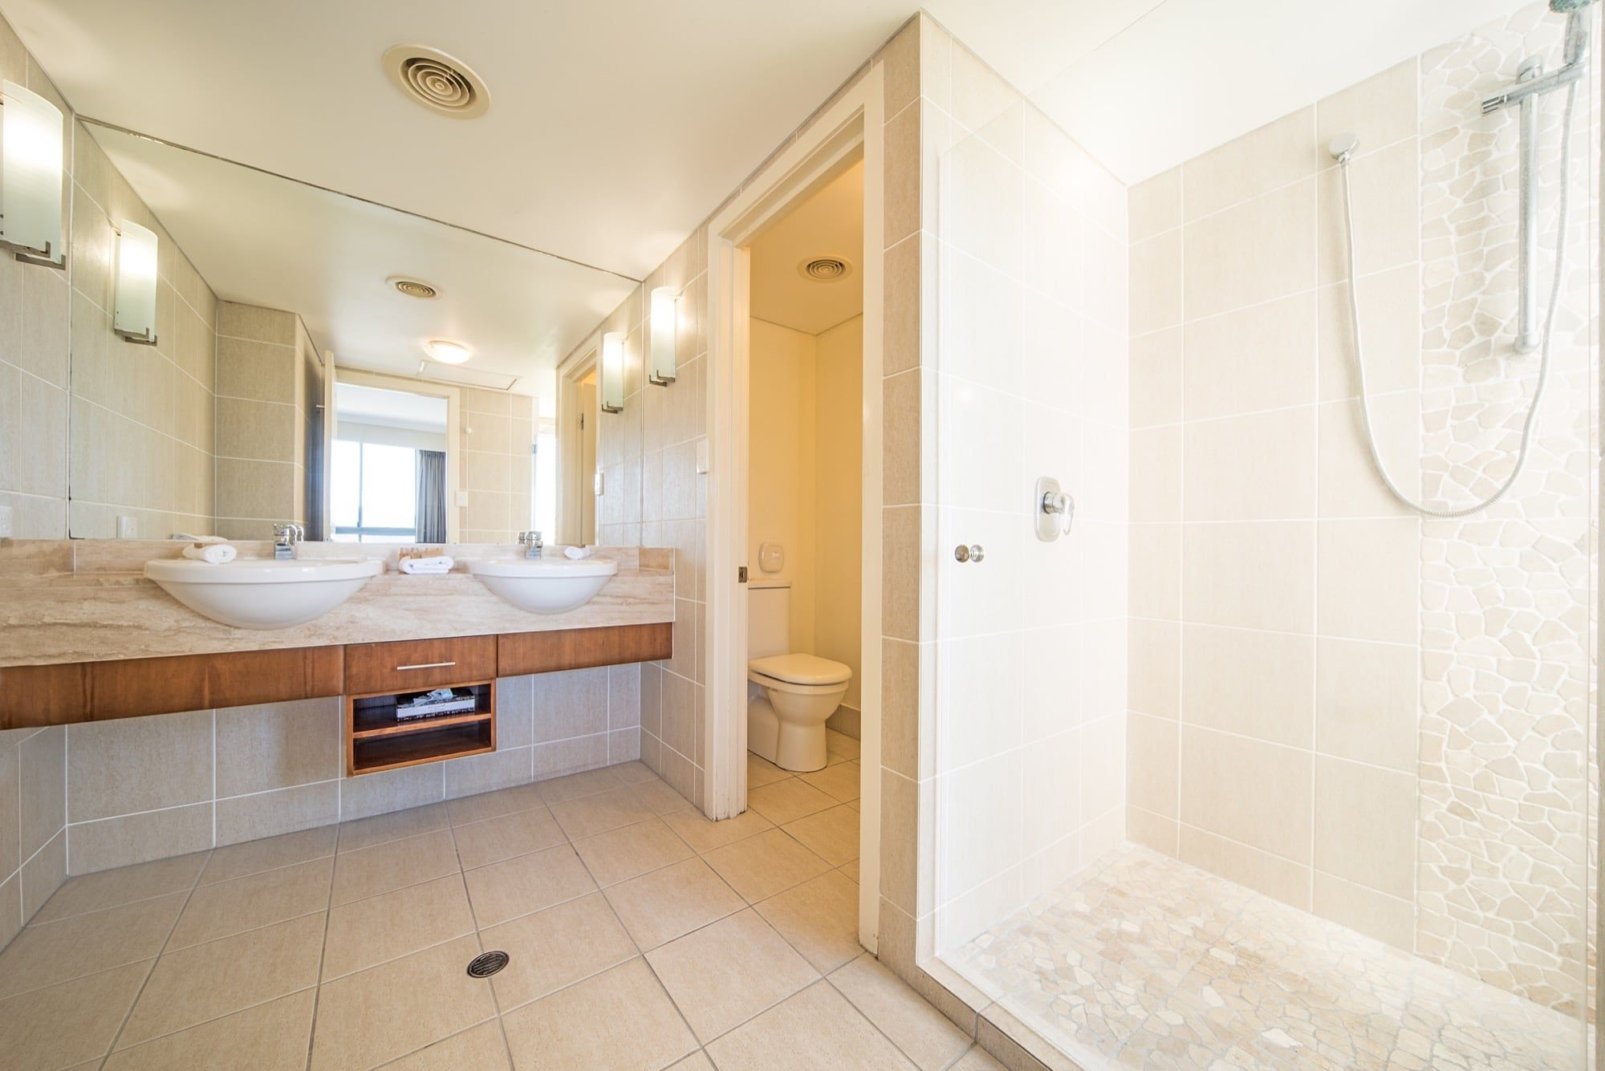
apartment-27-pinnacles-airlie-beach-1
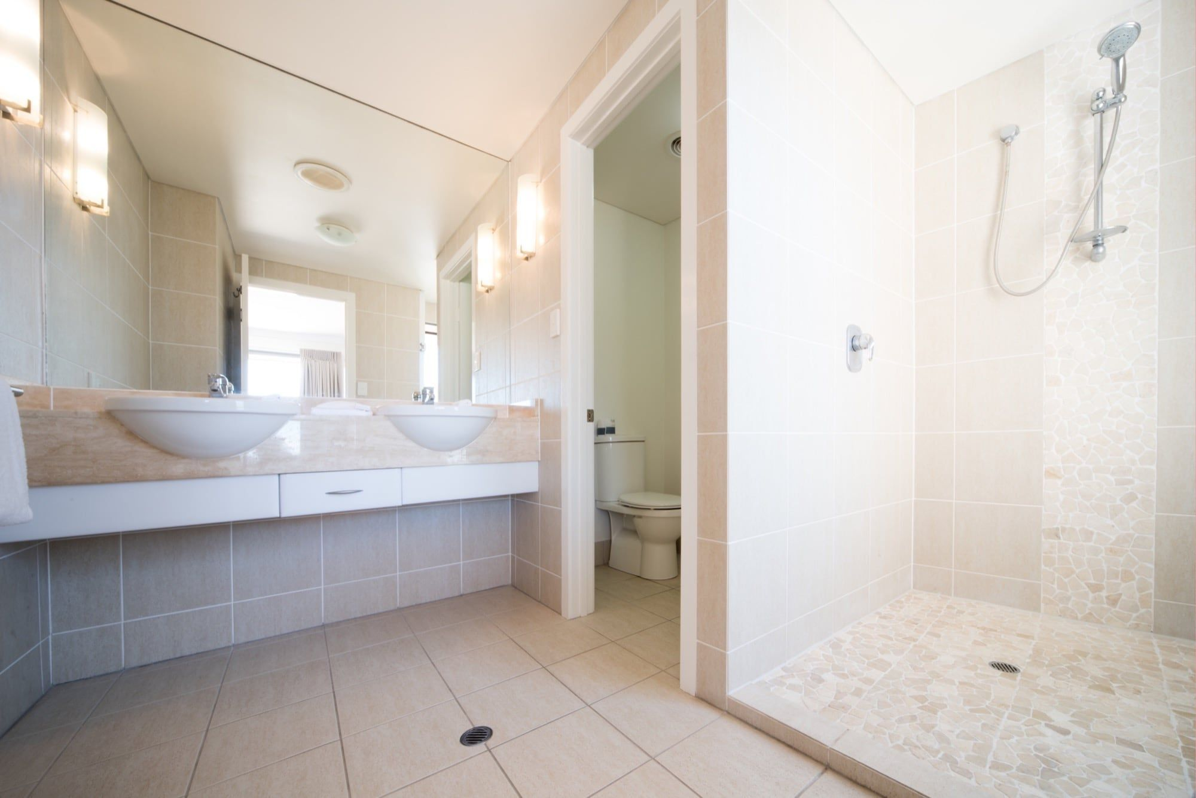
apartment-26-pinnacles-airlie-beach-9
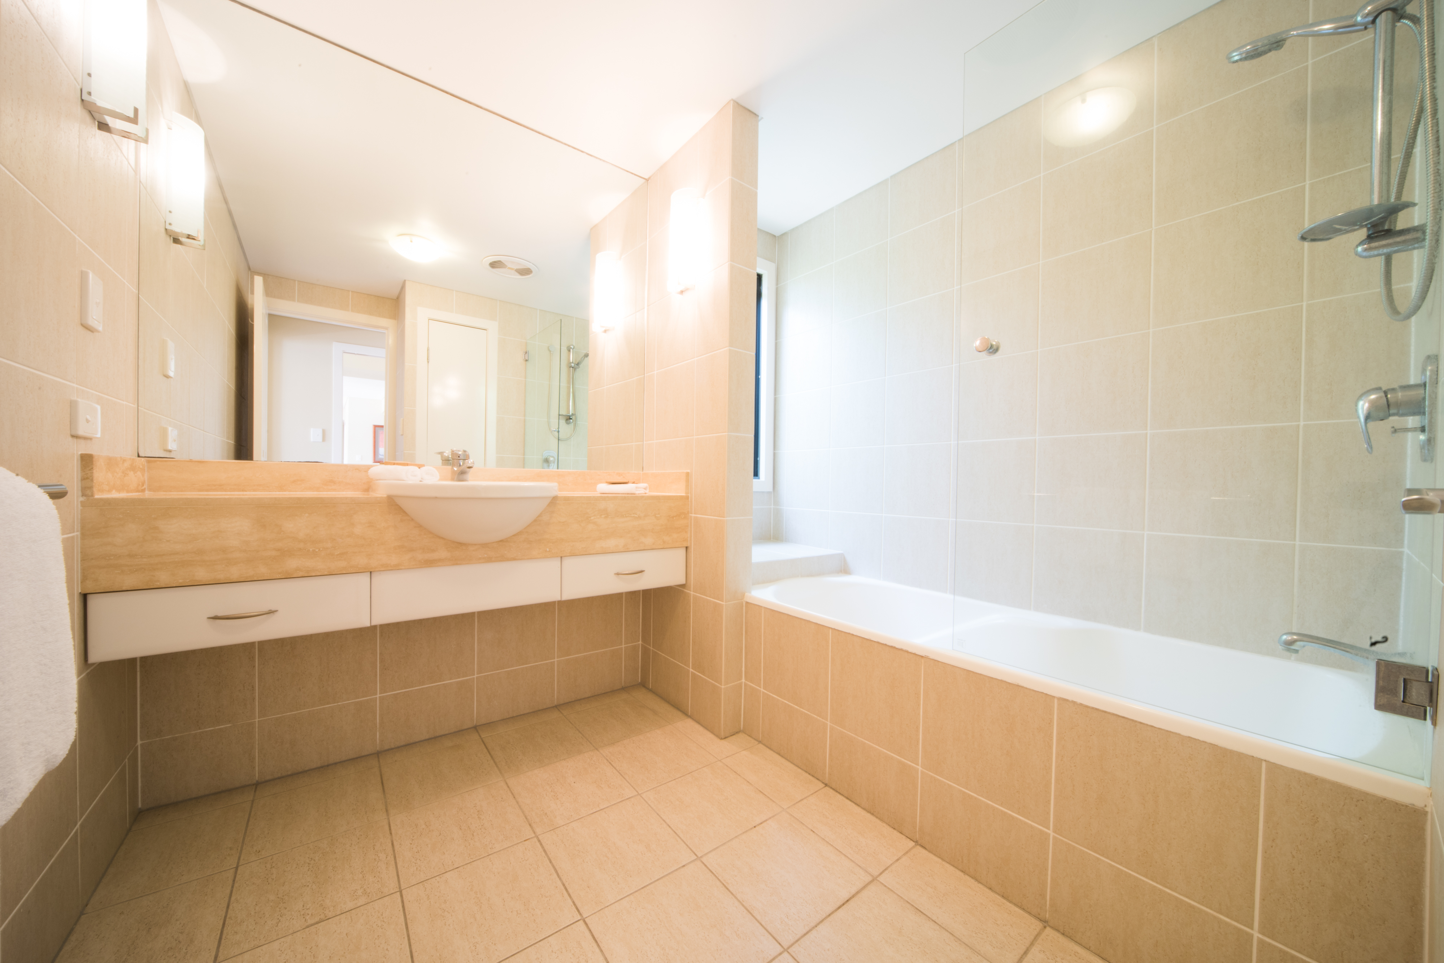
Pinnacles Rm26-007

COMMON AREAS

Swimming pools, spas and waterparks
- The following swimming pools, spas and waterparks amenities are available
  - Pool Access Image(s)
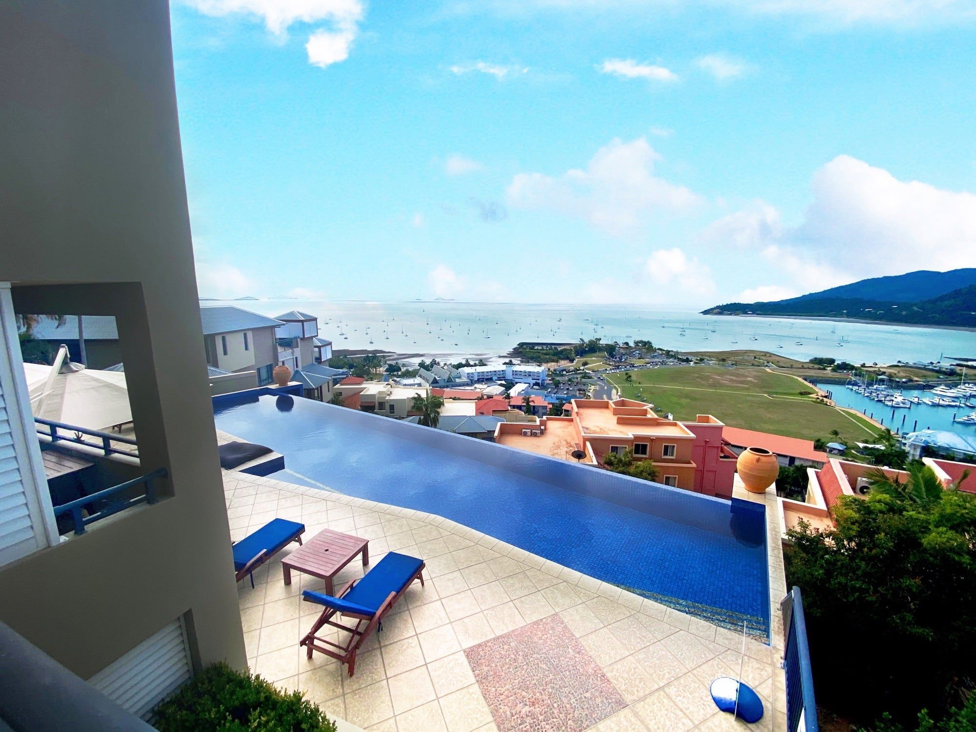
natalia-ancora-pinnacles-resort-28
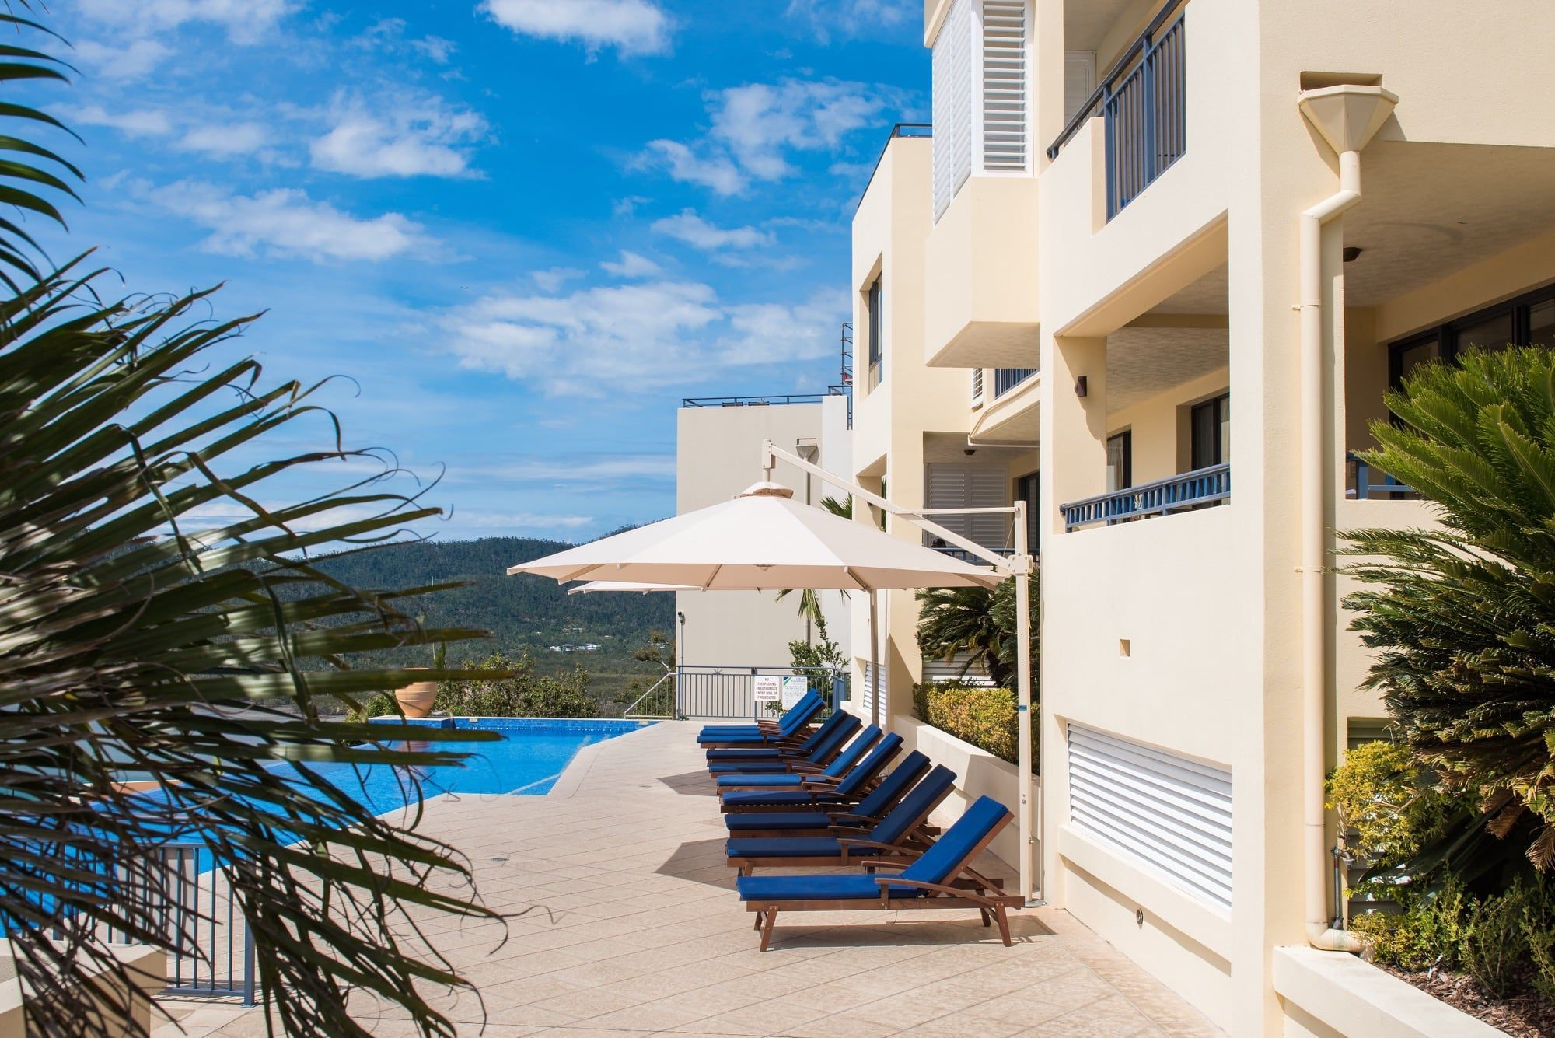
pinnacles-resort-airlie-beach-15
- In addition, the following further information can assist guests:
Small handrail to the right hand side of pool stairs available

Report Disclaimer
Please note that this business report, provided as a result of the use of the diagnostic assessment, is for information purposes only.
Australian Tourism Industry Council (ATIC) cannot guarantee the accuracy of respondent’s answers, or that they are fully representative of your business. Therefore, ATIC does not warrant or guarantee any particular outcome in respect of your businesses self-assessment.
This report is intended as guidance only for your business and should not be relied on for future marketing considerations. ATIC recommends that you seek your own independent advice as well as the results from the diagnostic.
Links to external web sites are inserted for convenience and do not constitute endorsement of material at those sites, or any associated organisation, product or service.
ATIC does not:
- Assume any legal liability for the accuracy, completeness, or usefulness of any information from this report or any links provided; or
- Accept responsibility for any loss associated directly or indirectly from the use of this report.

