ATIC Accessibility
To support the accessible community in making informed travel decisions for their individual needs

This report prepared for:
Business name: | Port Phillip Ferries
Address: | 131 Harbour Esplanade
Town: | Docklands
Contact for enquiries: | Brad Wright
Contact Number: | (03) 9514 8959
Contact Email: | info@portphillipferries.com.au
Website: | https://www.portphillipferries.com.au/
Date: | 2026-10-28 17:38

ATIC Accessibility
The following pages provides travellers with information on the businesses facilities and amenities which aims to support the traveller to make an informed decision on whether the business is suitable for their individual needs.
OVERVIEW 4
Business Overview 4
Bookings 4
Emergency Management 4
Communications 5
Other Information 6
Guide Dog and Service Animals 6
GENERAL 7
Pre-arrival, arrival and reception 7
Cognitive Impairment Support 7
Car Park and Access amenities 7
Entry 8
Internal Spaces 8
Public areas 8
Displays, exhibits, commentary and live performances 9
External Paths 9
Steps 9
Ramps 9
Public Toilets/Adult change facilities 10
TOUR OPERATORS 11
Tour/Transport Services 11
Route Planning 11
Guides 12
ATTRACTIONS 14
Attractions Basics 14
COMMON AREAS 15
ADVENTURE ACTIVITIES 16
Report Disclaimer 18

OVERVIEW

Business Overview

The business has the following products/services available
- Tour/Transport
- Attraction

Our business caters for the following disability types:
- Blind or low vision
- Deaf or low hearing
- Limited mobility
- Wheelchairs or mobility scooters
- Food allergies or intolerances
- Cognitive or people on the Autism Spectrum
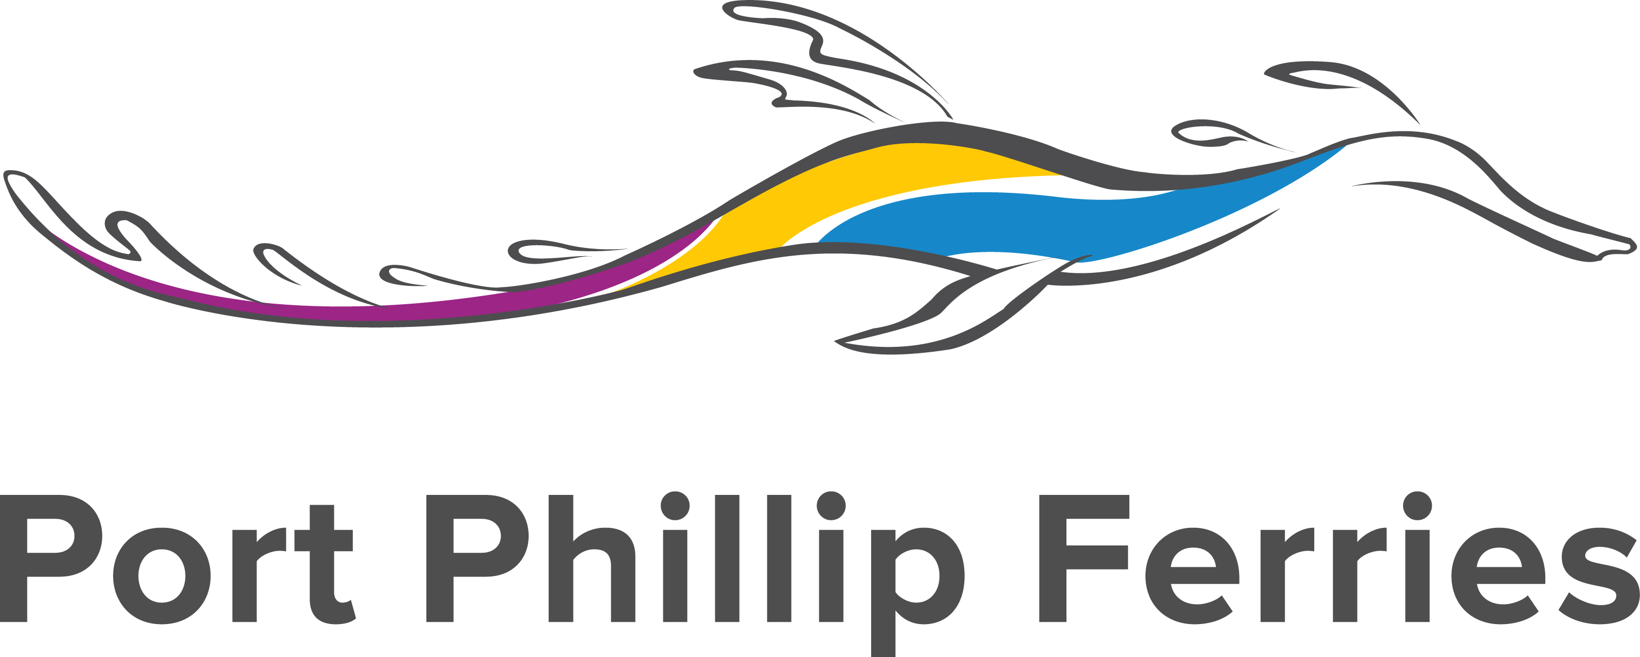

Bookings

The business offers the following methods for bookings and enquiries:
- Phone
- Email
- Webportal
- Our website supports Screen Readers
- Our forms have high contract boxes and submit boxes

Emergency Management
- The business has an emergency management and evacuation plan for guests with a disability

Communications
- An accessibility guide is available on the website

https://www.portphillipferries.com.au/accessibility/
- Our website meets WCAG 2.0 accessibility standards
- Our business offers the following alternative communication methods
- Plain English
- Braille Displays

Not specified
- There is easy to read signage and information (e.g. menus and emergency information)
- There are Picture boards
  - Picture Boards Image(s)
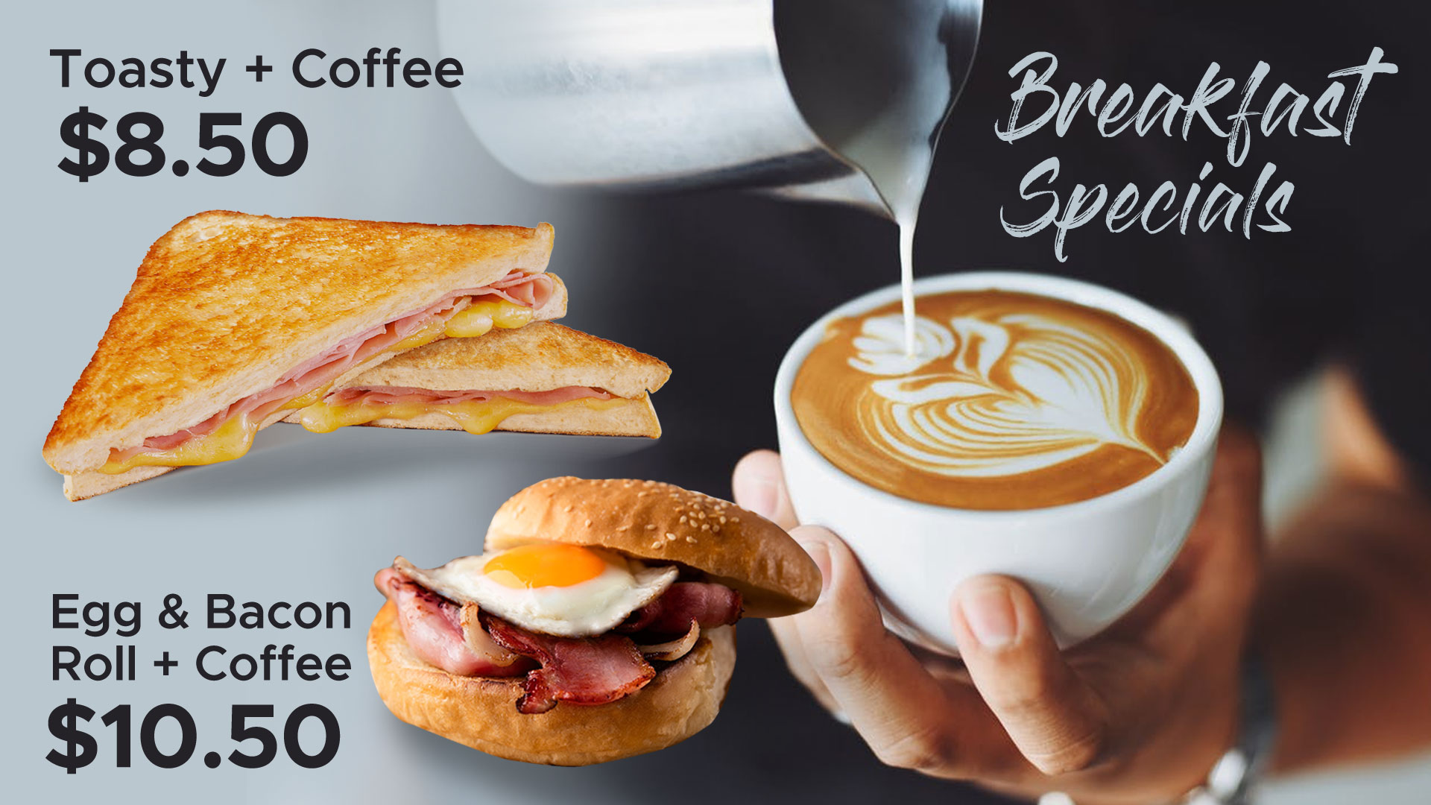
Breakfast-Deals
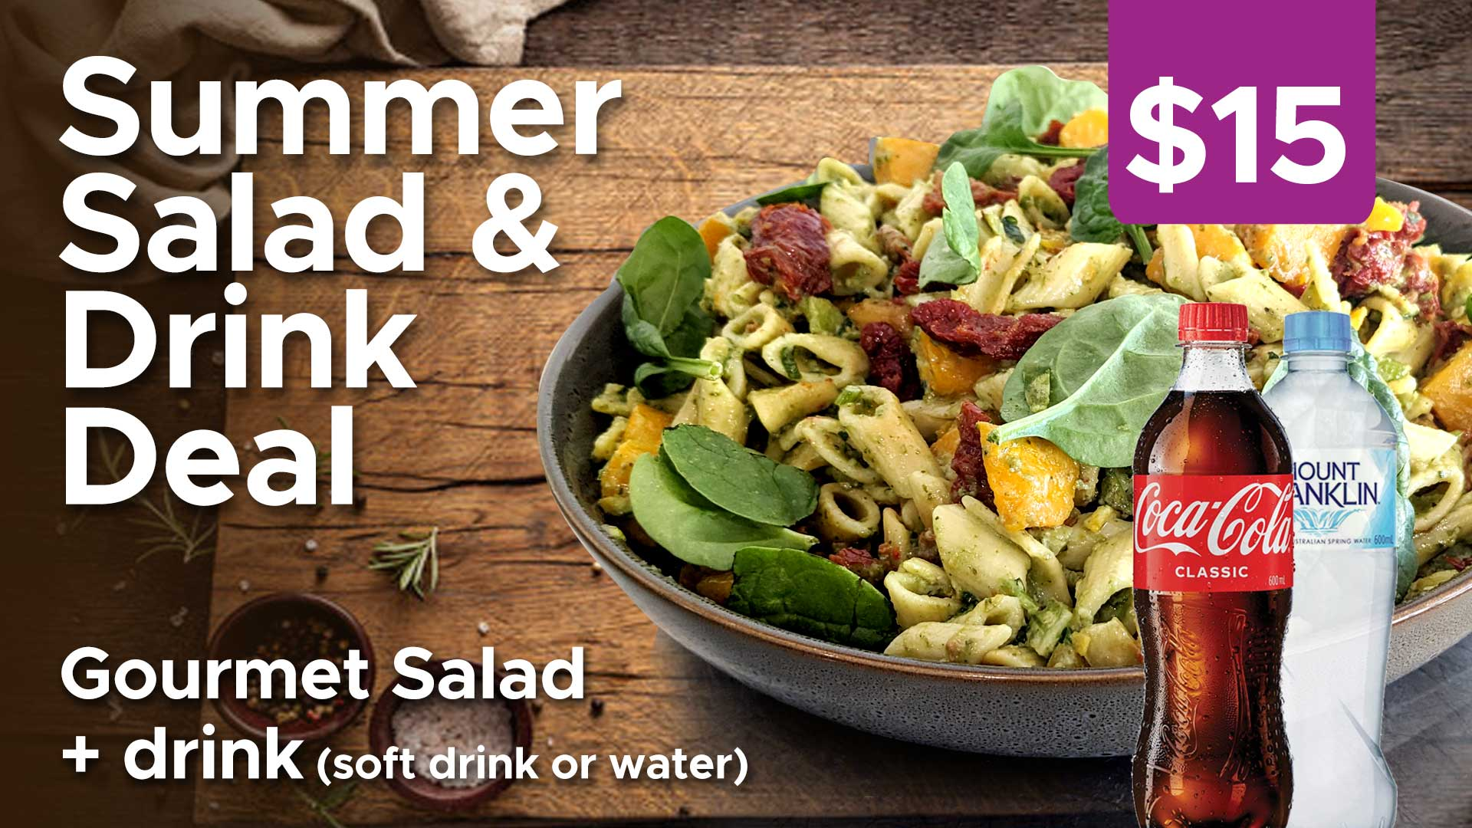
Gourmet-Salad-Deal
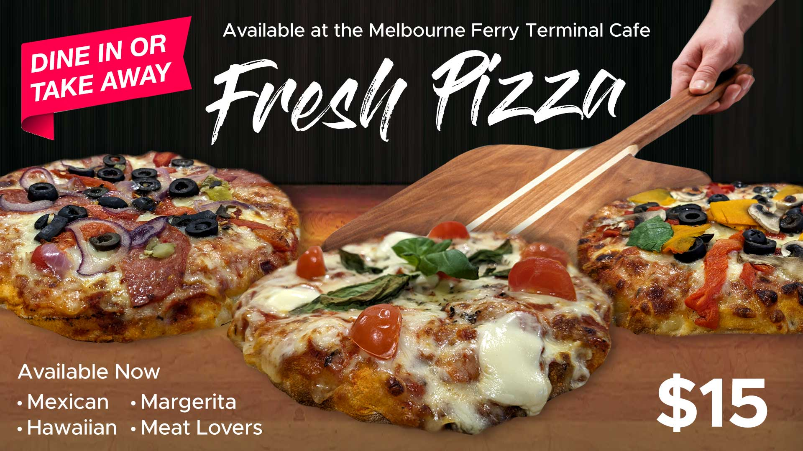
Pizza
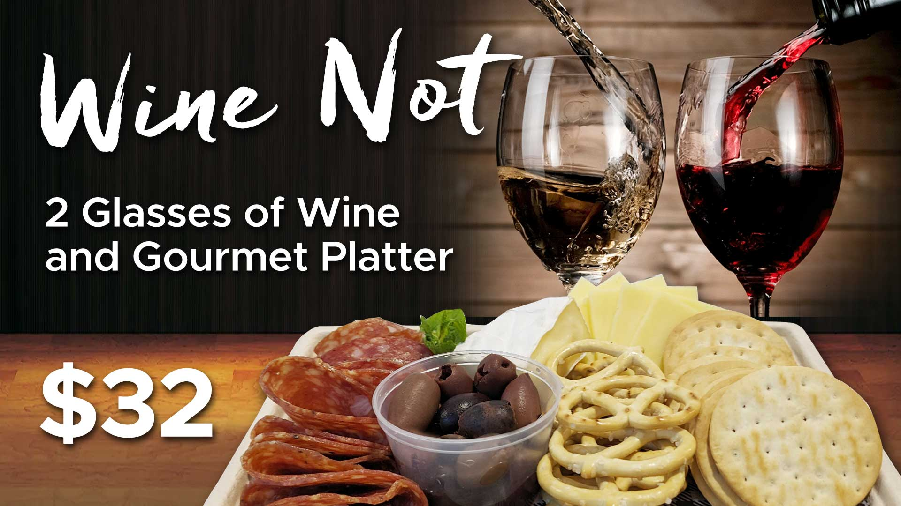
Wine-and-Cheese-Special

Other Information
- For bookings made onsite, the ticket booth/counter/box office is accessible for people using a wheelchair
- The business accepts the companion card

Guide Dog and Service Animals
- The business provides a secure area with shade and water for service animals
- The business provides a toilet area for service animals
The business provides the following services for services animals:
Guide dogs and assistance animals are welcome on board our vessels, provided you and your assistance animal carry the appropriate/valid accreditation to travel. For details on what is deemed a valid accreditation visit Public Transport Victoria or click here Other pets or animals are not permitted on board. Our vessel does not have the space or facilities to cater to animals, and the decision is made for the comfort of the pets and other passengers. We appreciate your understanding.

GENERAL

Pre-arrival, arrival and reception
The business has the following in place to support guests during pre-arrival, arrival and reception
- Booking information and websites are compatible with screen readers
- There is a reception/public entryway.
- Seating available at reception
- Picture Board at reception to aid in communication
- Hearing loop fitted to the reception area
- Lighting in the reception area is even and glare free
- Information and maps are available in written form
- A step free map/guide
- A familiarisation tour
- In addition, the following further information can assist guests:
N/A
- In addition, the following further information can assist guests:
N/A

Cognitive Impairment Support
- Documents are available in plain English for people with cognitive impairment (This may include instructions, guides, menus and general information)
- A "social script" guide to your premises or attraction describing the sights, sounds and smells to aid parents/carers prepare visitors in advance
- The 'social script' is available in word and other editable formats
- Quiet periods or early opening times for people on the Autism Spectrum

Car Park and Access amenities
The business has the following Car Park and Access amenities
- A drop off zone
- Designated disabled parking bays
- Level or ramped access from the car park to the entrance
- The accessible entrance is clearly signed from the parking bay
- The public transport services available are:

https://www.portphillipferries.com.au/locations/

Entry
The business has the following amenities/systems in place for entry
- A drop off point close to the entrance
- A path of access to the building is slip resistance and even
- A path of access to the building is clear of obstruction
- Self opening entry doors or fitted with a self closer
- Glass doors are fitted with a visual sighting strip
- Door jams/doors are of a contrasting colour to surrounding walls
- Door handles are of a contrasting colour to the door
- Signage is written in a contrasting colour
- The entry door is a minimum of 850mm wide
- The entry door has self opening or a light opening pressure (for manual operations)
- The entrance sill is less than 13mm
- There a clear space of at least 1500mm x 1500mm in front of all doors.
- The entrance door mats have a thickness less than 13mm and a width of 7500mm or greater

Internal Spaces
- Clear and unobstructed routes through and between buildings
- Interior walls are matte or low sheen
- Floors, walls, counters and furniture are of contrasting colours
- Floor surfaces are hard or short pile carpet
- Seating is available for guests unable to stand for long periods
- Accessible facilities are clearly signed and visible from all areas
- All corridors greater than 900mm

Public areas
The public areas have the following amenities in place
- Display units, Televisions, Video displays etc. are open captioned
- Hearing loops
- Hearing loop symbols are displayed
- Even lighting
- Seating

Displays, exhibits, commentary and live performances
For displays, exhibits, commentary and live performances the following amenities are in place
- Seating
- Wheelchair accessible spaces/seating

External Paths
External paths of travel
- Surfaces are concrete, asphalt, smooth paving or hard packed fine gravel (max aggregate size 13mm)
- Pathways are wider than 900mm
- There 3 successive steps or less on any path or at any doorway
- Any paths having steps are clearly identified as non-wheelchair accessible
- Step free routes clearly signed

Steps
Steps
- There are steps.
- Top and bottom steps are easily distinguished through colour contrast or the use of TGSIs (Tactile Ground Surface Indicators)
- All steps or staircases have enclosed risers
- The underside of all staircases are enclosed or protected to a height of at least 2 metres
- Handrails fitted to all open sets of steps

Ramps
Ramps have the following amenities are in place
- There are ramps.
- All fixed ramps are 1:14 or less
- Hand rails are fitted
- Temporary ramps are available

Public Toilets/Adult change facilities
Public Toilets/Adult change facilities have the following amenities are in place
- There is an accessible toilet for public use
- The door is at least 850mm wide
- There is a minimum of 850mm beside the toilet
- Handrails are fitted
- The toilet seat is 460mm above the floor
- The toilet seat of a contrasting colour to the floor
- The toilet seat is460mm above the floor
- There is a registered changing places facility

TOUR OPERATORS

Tour/Transport Services
The tour/transport services have the following facilities/amenities in place
- Buses/Coaches
- 2 vehicles have wheelchair lifts or ramps
- 2 vehicles have low floors with ramped entry
The maximum wheelchair capacity available in the fleet is:
8
- There are hearing loops
- Audio visual displays are sub titles

Route Planning
- Route Planning
- The tour route includes stops with accessible toilet facilities
- There is an accessible toilet on-board for public use
- The door is at least 850mm wide
- There is a minimum of 850mm beside the toilet
- Handrails are fitted
- The toilet seat is 460mm above the floor
- The toilet seat of a contrasting colour to the floor
- The toilet seat is 460mm above the floor
  - Accessible Toilet Image(s)
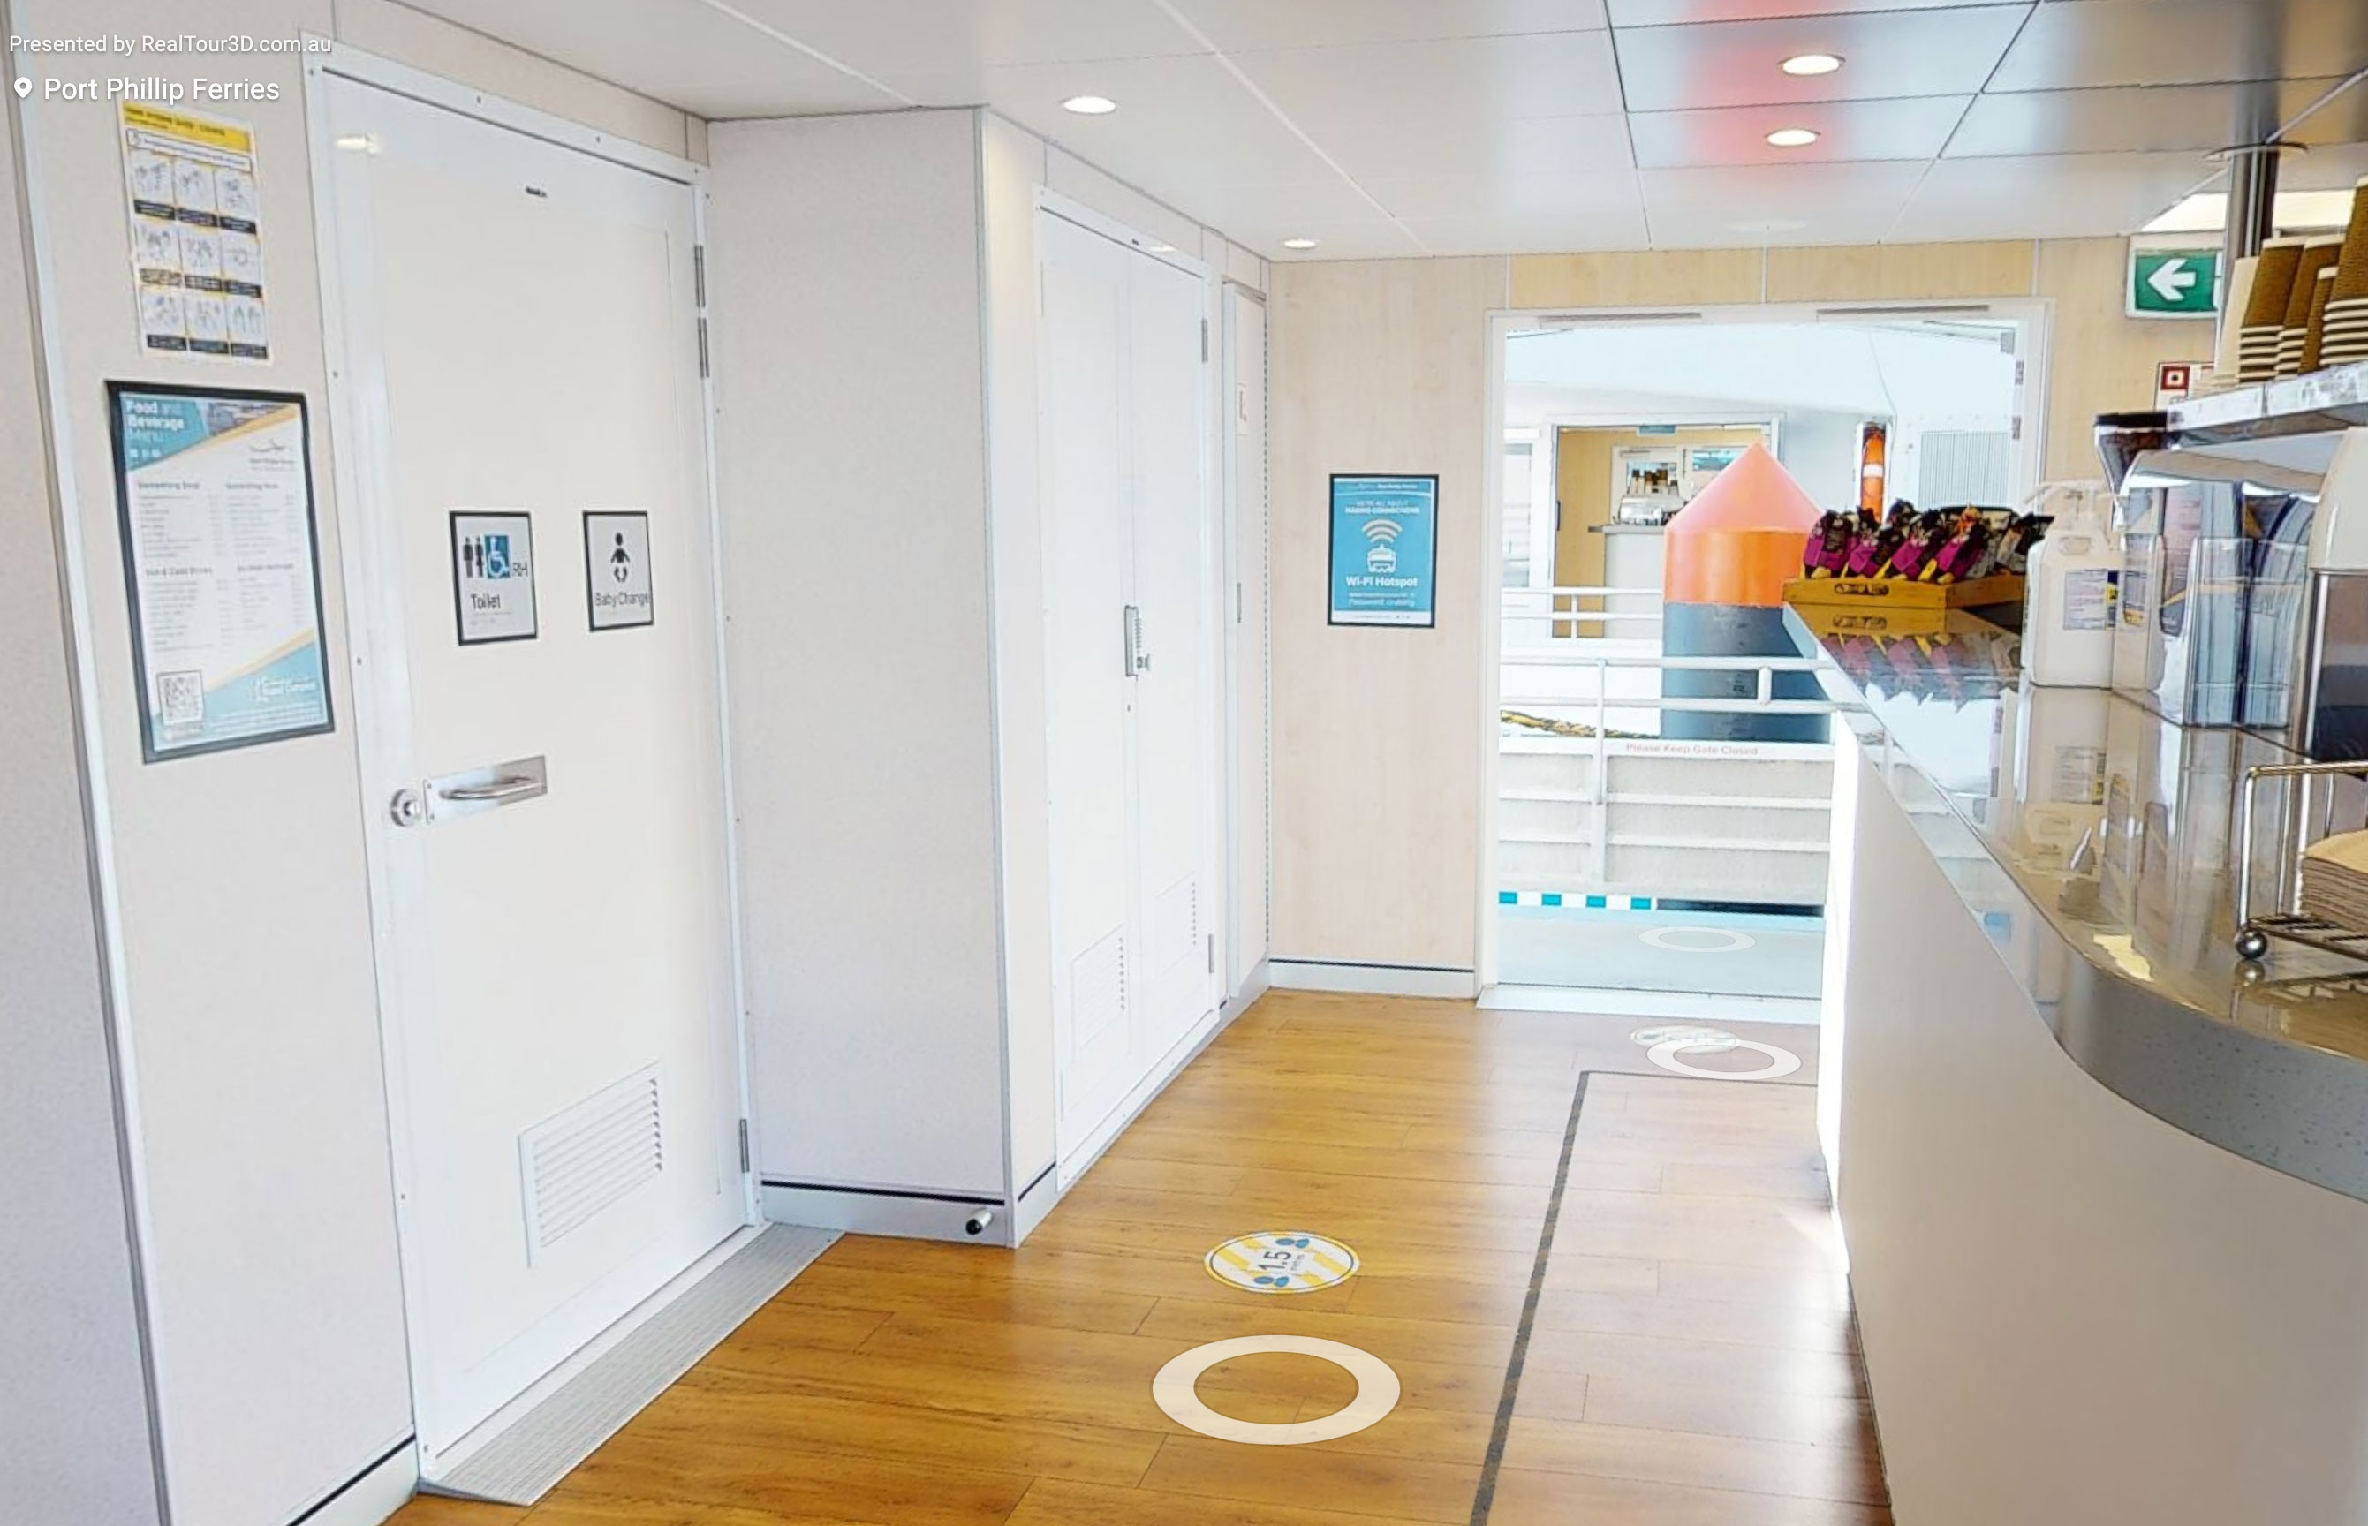
Accessible-Toilets
- A facility with an adult change table
  - Adult Change Table Image(s)
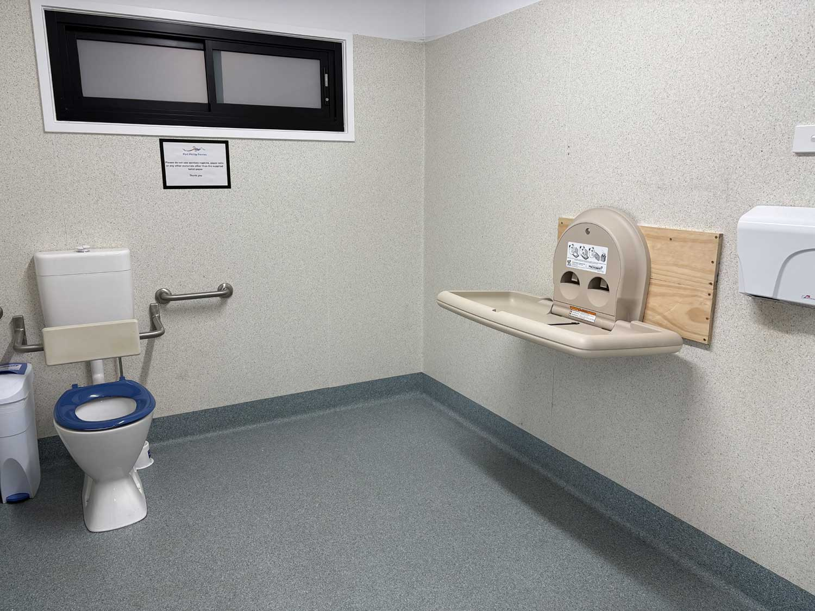
Accessible-Toilets
- Lunch stop venues are accessible

Guides
- AUSLAN
- Use of clear/simple English
- Marine
- Marine craft are wheelchair accessible
- Length (cm) 120 cm .
- Width (cm) 70 cm.
- Height (cm) 90 cm.
- Weight (kg) Between 100 kg and 140 kg.
  - Image(s)
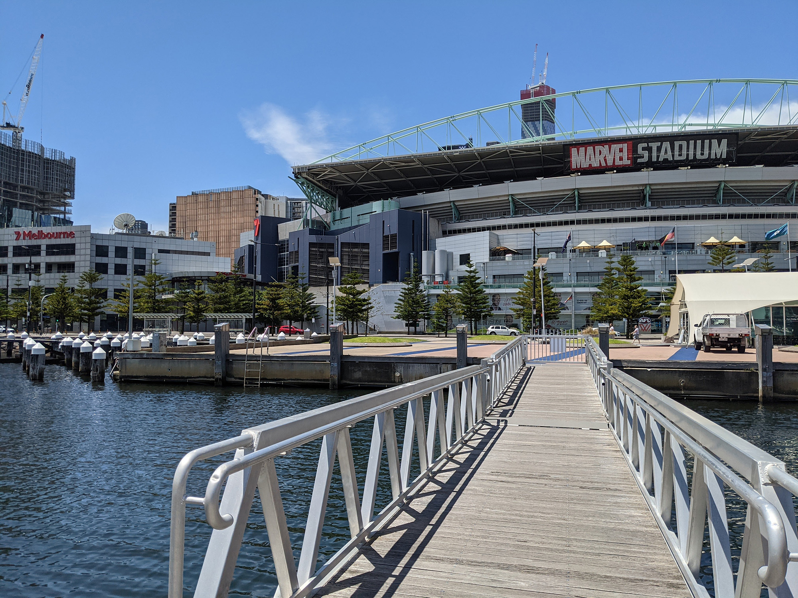
PXL_20210113_030434955
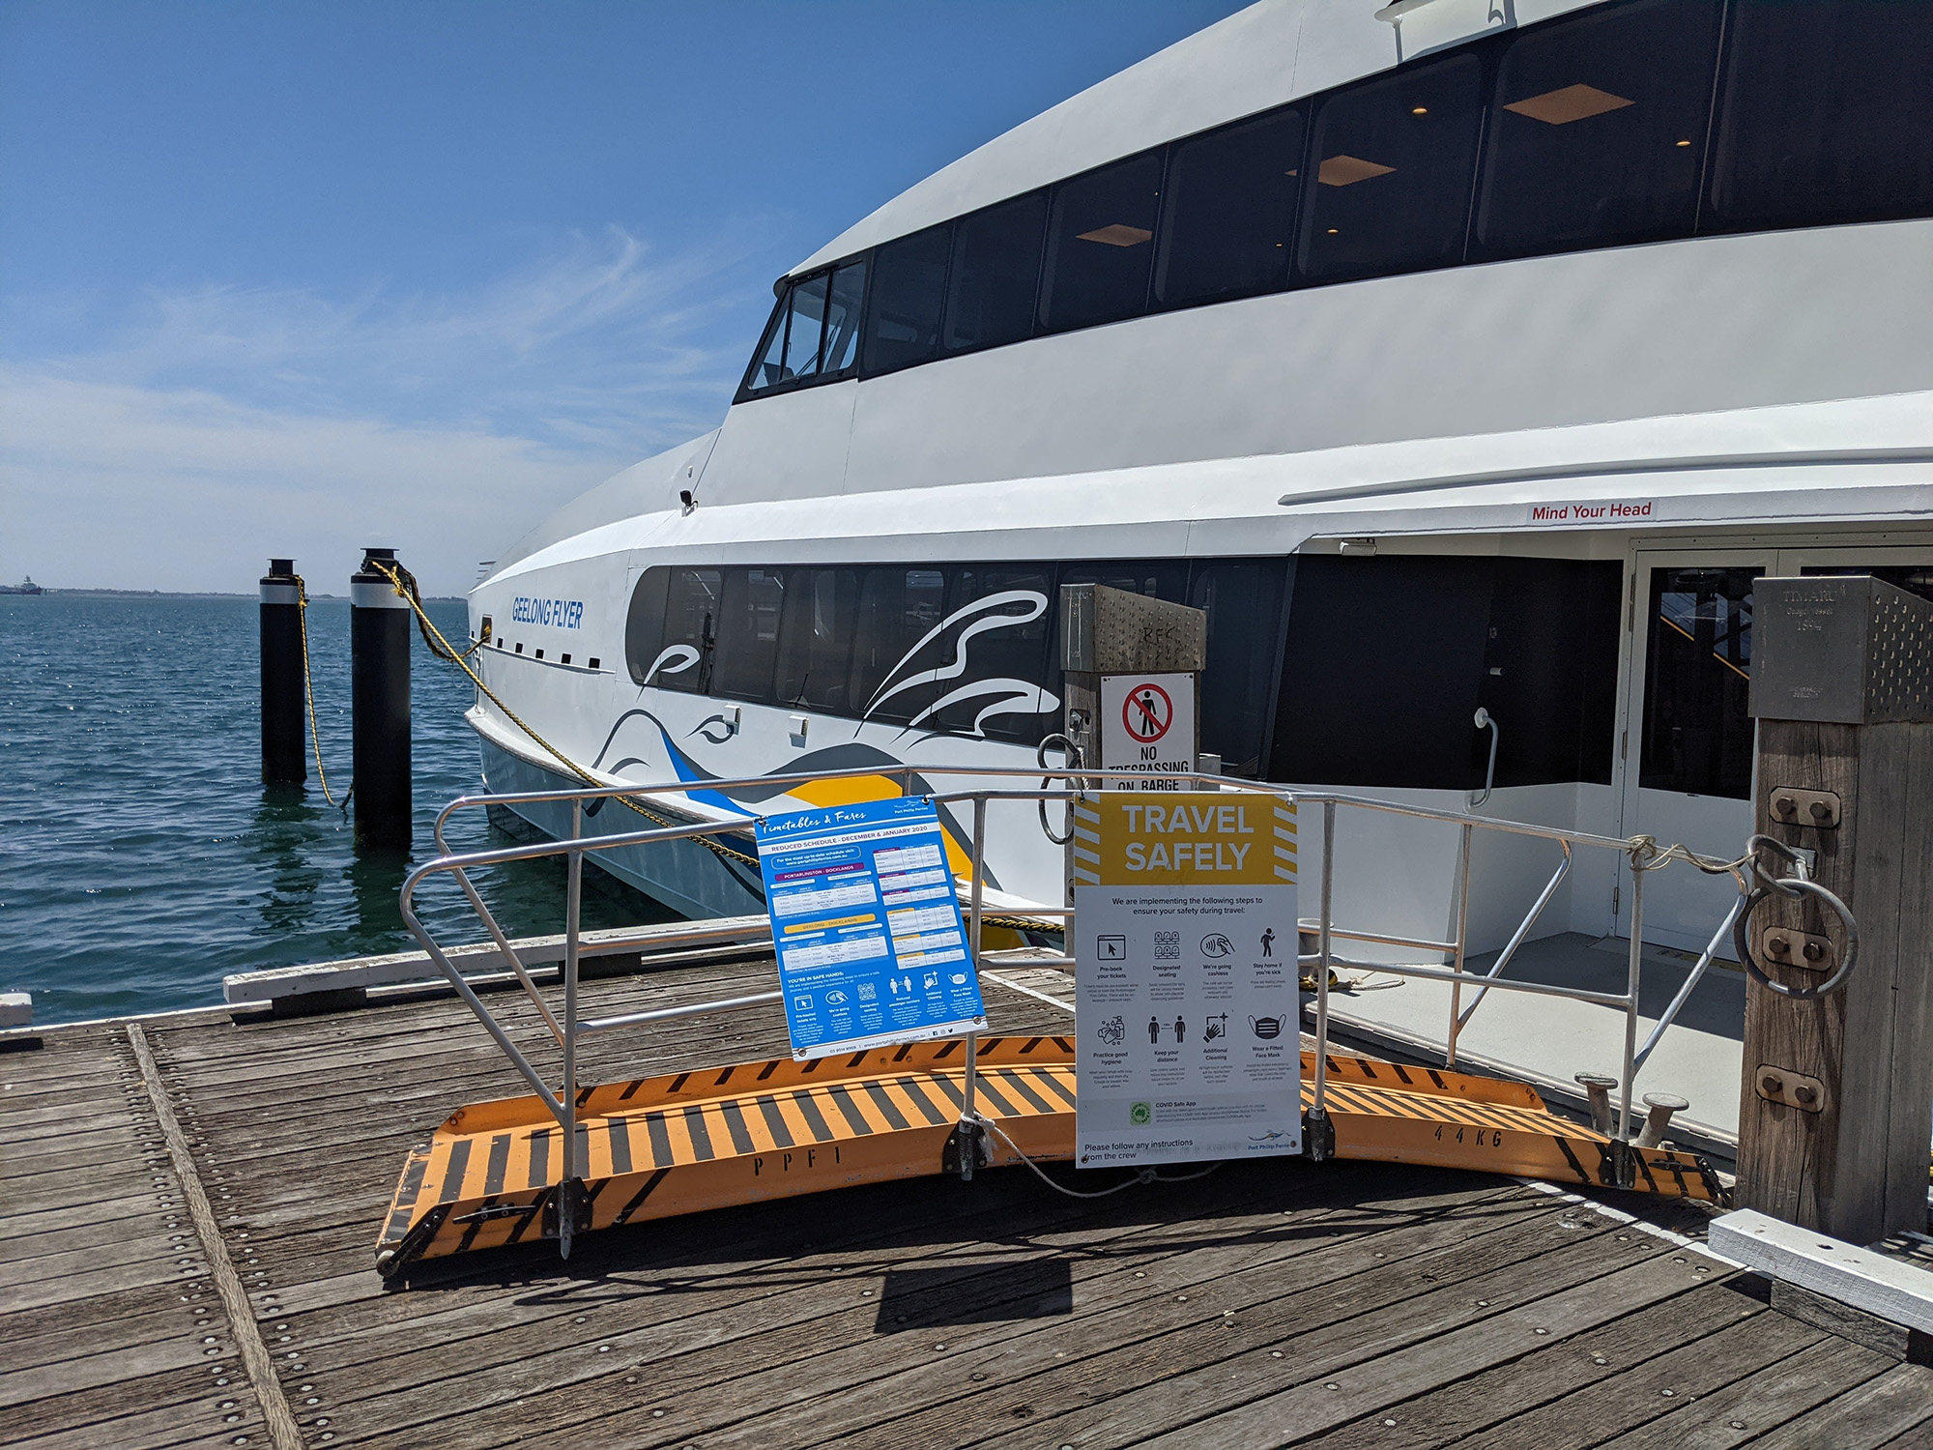
PXL_20210121_025909964

ATTRACTIONS

Attractions Basics
- A park map is available here:

https://www.portphillipferries.com.au/locations/

COMMON AREAS

ADVENTURE ACTIVITIES
- In addition, the following further information can assist guests:
Winery tours and lunch packages
- In addition, the following further information can assist guests:
Wheelchair accessible transport
- In addition, the following further information can assist guests:
No real limitation as we ttry and make these tours as accessible as possible

Report Disclaimer
Please note that this business report, provided as a result of the use of the diagnostic assessment, is for information purposes only.
Australian Tourism Industry Council (ATIC) cannot guarantee the accuracy of respondent’s answers, or that they are fully representative of your business. Therefore, ATIC does not warrant or guarantee any particular outcome in respect of your businesses self-assessment.
This report is intended as guidance only for your business and should not be relied on for future marketing considerations. ATIC recommends that you seek your own independent advice as well as the results from the diagnostic.
Links to external web sites are inserted for convenience and do not constitute endorsement of material at those sites, or any associated organisation, product or service.
ATIC does not:
- Assume any legal liability for the accuracy, completeness, or usefulness of any information from this report or any links provided; or
- Accept responsibility for any loss associated directly or indirectly from the use of this report.

